**Project Name : Multiple Niche Websites**

***Header*** : Logo and Member Login. Light-Dark Mode

***Navigation Bar*** : Home, Categories, Collection, Contact Us, About Us, Reviews/ Testimonials,.

***Main Page*** :

All about the products those are highest sold, and best selling with multiple image of single product and described with prices, description, and details of payment ad emi.

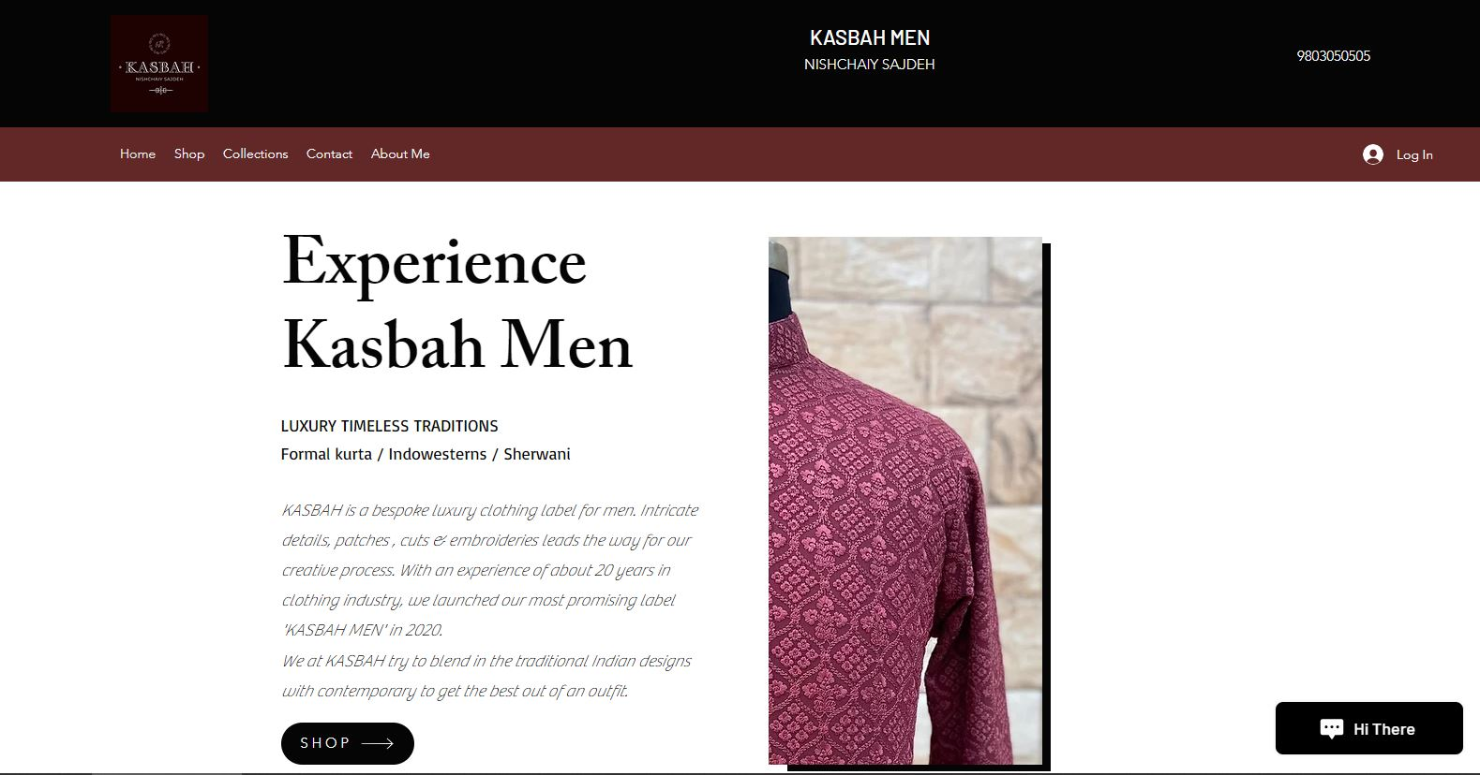

***Footer*** :

Copyright, terms and Conditions, privacy policy, Links of Social Media {facebook, Instagram, twitter, youtube, linked in and pinterest.}

Contact Us Page :

A card type structure will appears with 2 division. In 1st division, information of mail, telephone number and address of headquarters will appear. In 2nd division, image of brand appear. And footer will remain same for main and contact us page.

