NIP Project — Submission Template
Pega Platform project · This document is your complete submission
Read this before you start:
1. Fill in Section 1 completely. The Pega application name must follow the format NIP-[Project]-[YourName].
2. Create a new Operator in Pega with your full name and log in as that operator before taking any screenshot.
3. When you create your test case, enter YOUR FULL NAME in the Issue Description (Vehicle) or Movie Name (Movie) field.
4. Complete only the section for your chosen project. Delete the other project section.
5. Paste one screenshot per user story (10 total). Follow the screenshot rules in your selected project section.
6. Answer every question in Sections 3 and 4 in your own words.
7. Save the file using this format: ProjectName_FirstName_LastName.docx. Use VehicleService or MovieTicket as the ProjectName. Examples: VehicleService_Ravi_Kumar.docx or MovieTicket_Ravi_Kumar.docx.

Section 1 — Your Details
Full Name | Karan Manickam
Email ID (registered on NIP) | Karanunique36@gmail.com
Phone Number | 7904555348
College Name | KSR Institute for Engineering and Technology
Course (e.g. IT, CS) | B.E. Computer Science and Engineering
State | Tamil Nadu
Project Chosen (Vehicle Service OR Movie Ticket Booking) | Vechicle Service Management
Pega Application Name (e.g. NIP-VehicleService-YourName) | _NIP_Vehicle_Service_Mangement_Karan_Manickam
Case Type Name (exact) | Vehicle Service Request
Pega Instance URL | https://gqv6ehq9.pegaacademy.net
Operator Name (created in Pega with your full name) | Karan@mtb (Karan Manickam)

Section 2A — Vehicle Service Management Application
Complete this section only if you selected this project. Delete the other project section before submitting.

Screenshot rules — IMPORTANT before you start:
1. Name your Pega application as: NIP-VehicleService-YourName OR NIP-MovieTicket-YourName
2. Create a new Operator in Pega with your full name (Security → Operators) and log in as that operator.
3. When you create your test case, enter YOUR FULL NAME in the Issue Description (Vehicle) or Movie Name (Movie) field.
4. The logged-in operator name must be visible in every screenshot wherever the Pega interface displays it.
5. The student's full name must be visible in all running-case screenshots.
6. Configuration screenshots must clearly show the relevant application or rule name.
Screenshots that do not show these will not be accepted.

US-001 — Submit Vehicle Service Request
What is expected:
Case created, customer submits Vehicle ID, Vehicle Model, Issue Description. Validation applied.
Screenshot — paste your screenshot below this line:
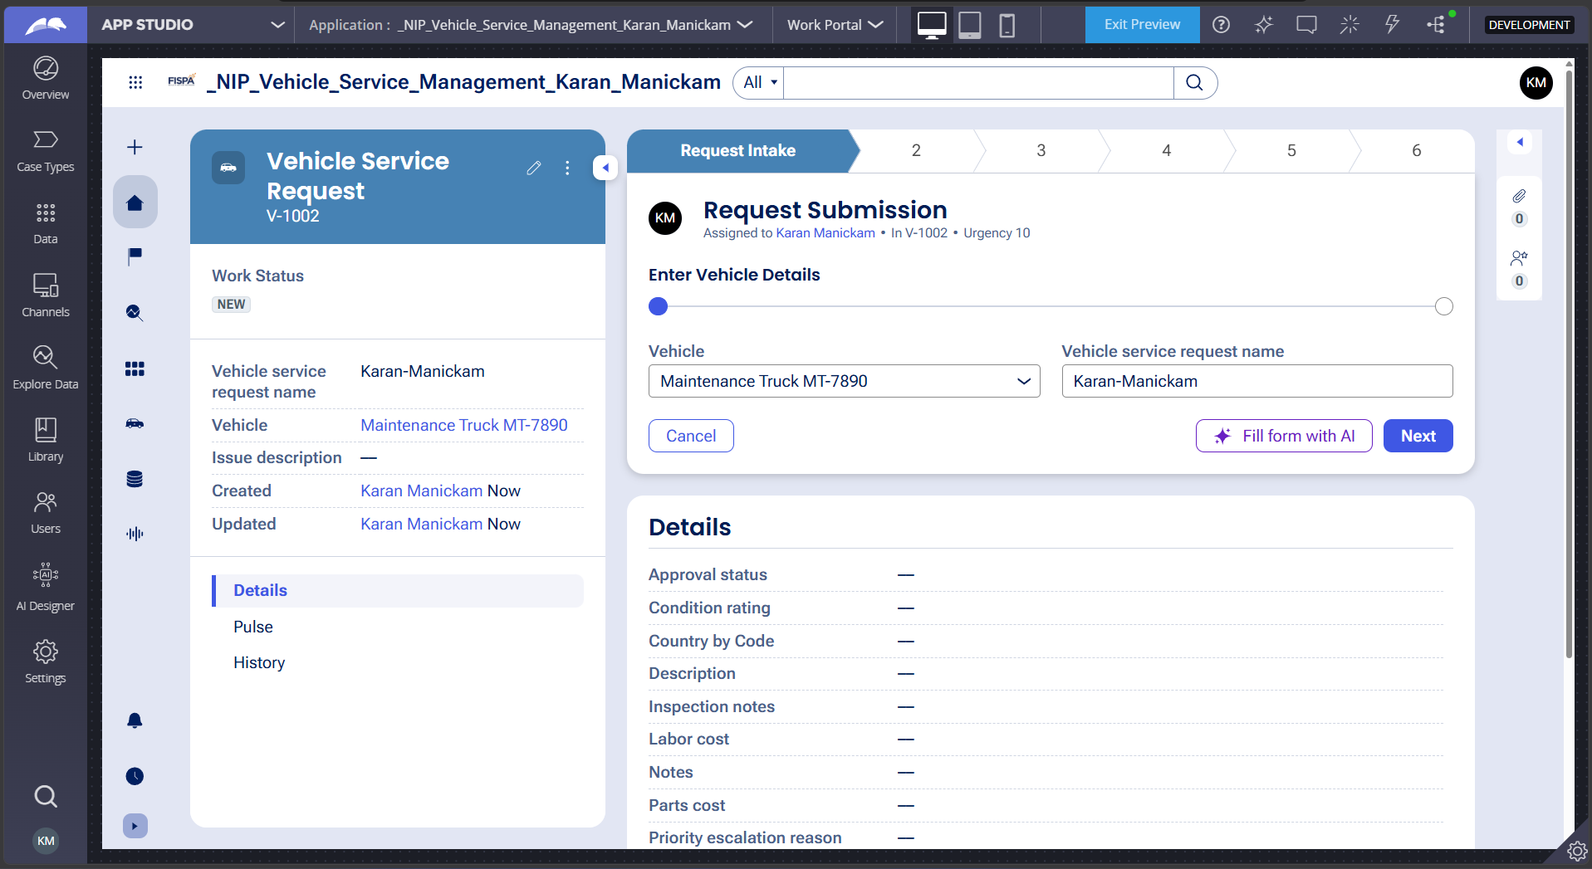
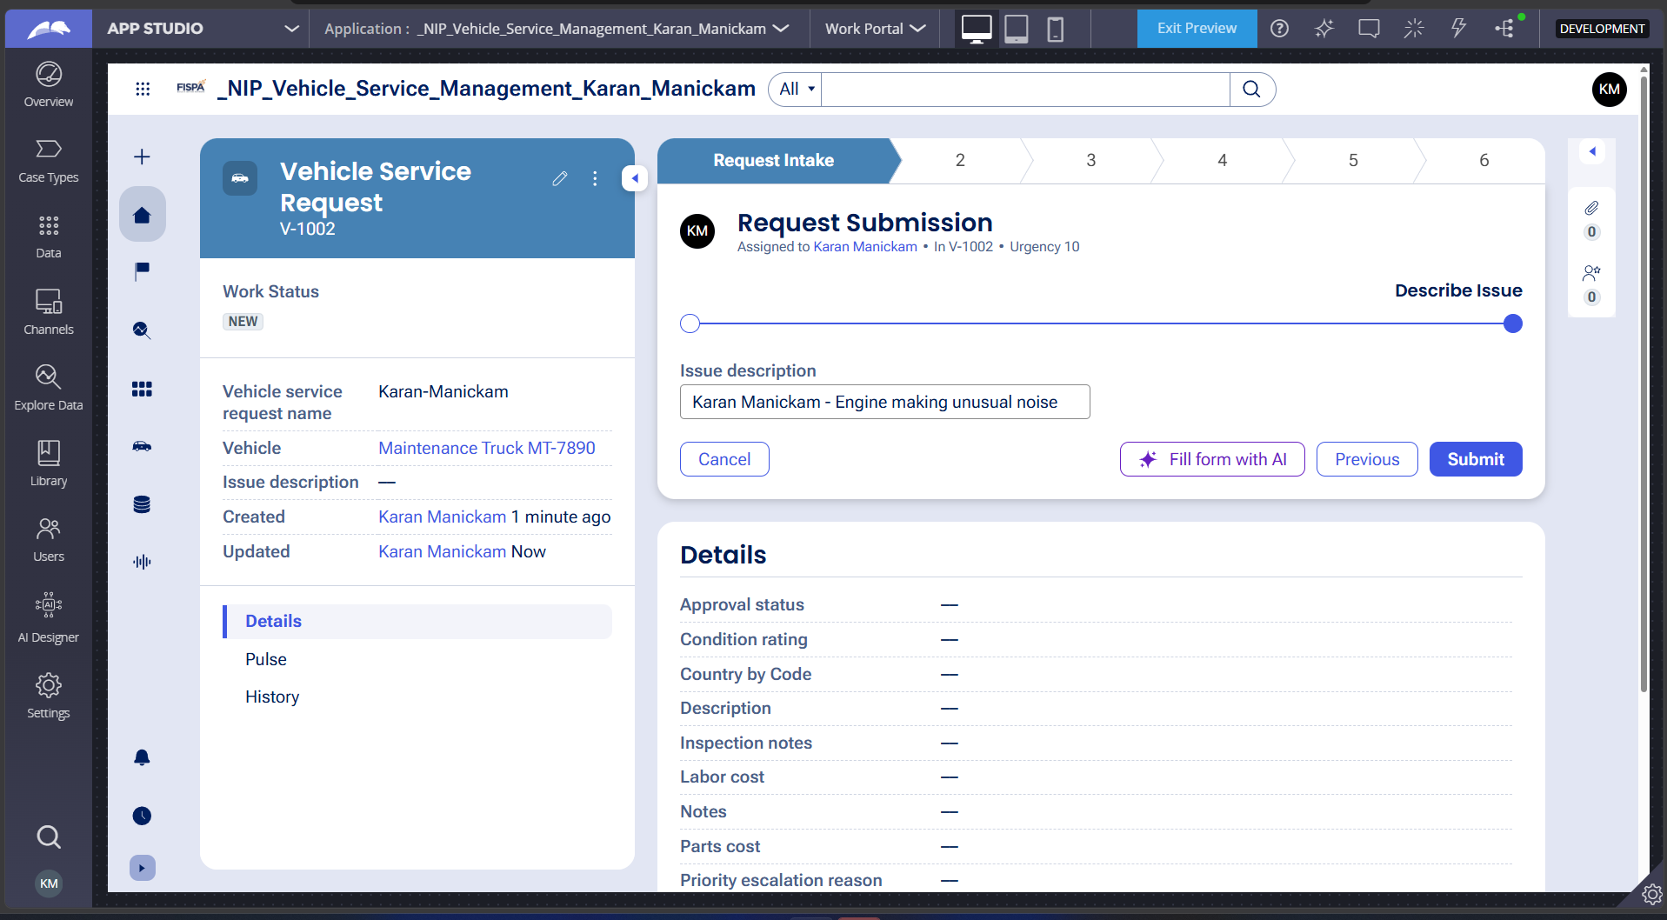

What I built for this (1–2 lines in your own words):
I built the Request Intake functionality to capture customer information, vehicle details, and the vehicle issue description through a Service Request case.

US-002 — Perform Vehicle Inspection
What is expected:
Inspection stage with Service Advisor step. Inspection Notes and Condition Rating captured.
Screenshot — paste your screenshot below this line:
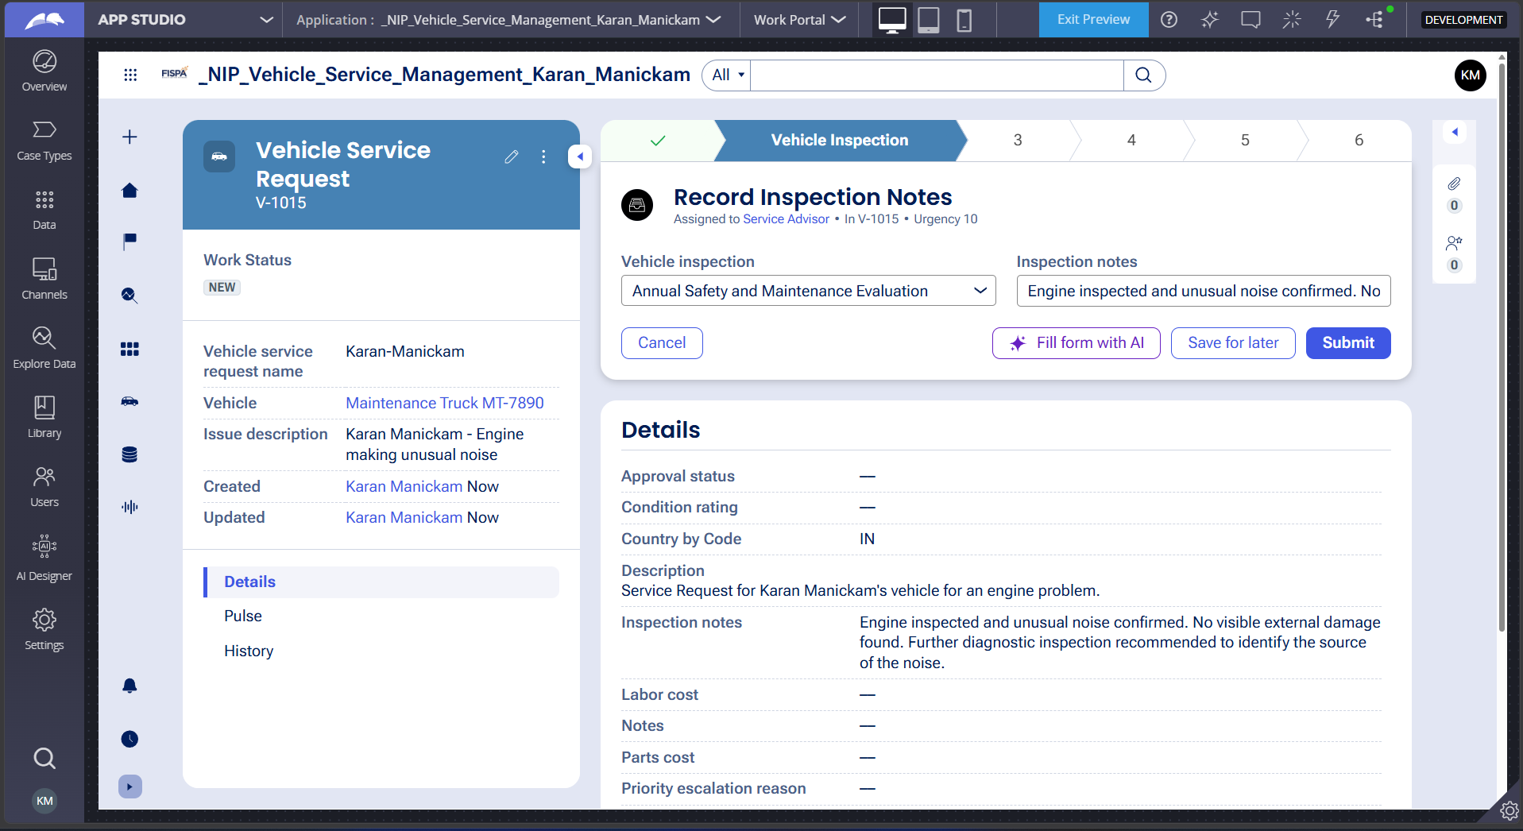

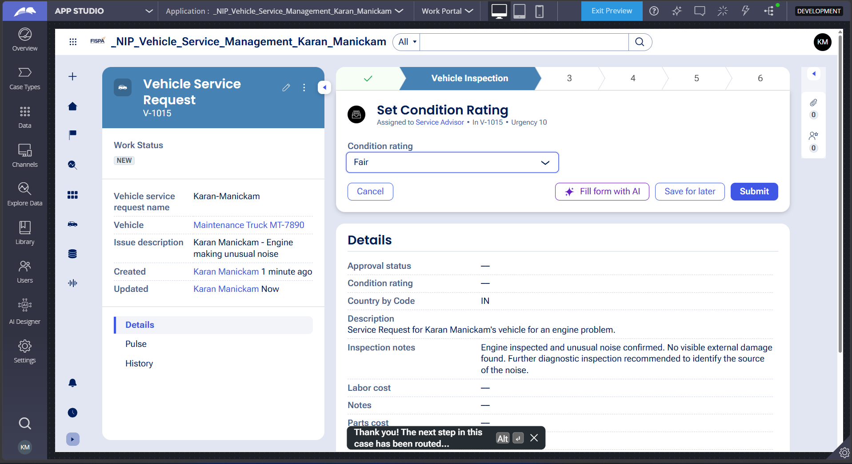

What I built for this (1–2 lines in your own words):
I built the Vehicle Inspection functionality to record inspection findings and capture the vehicle's condition rating before proceeding to the next stage.

US-003 — Generate Service Estimate
What is expected:
Labor Cost and Parts Cost captured. Total Cost calculated automatically by declare expression.
Screenshot — paste your screenshot below this line:
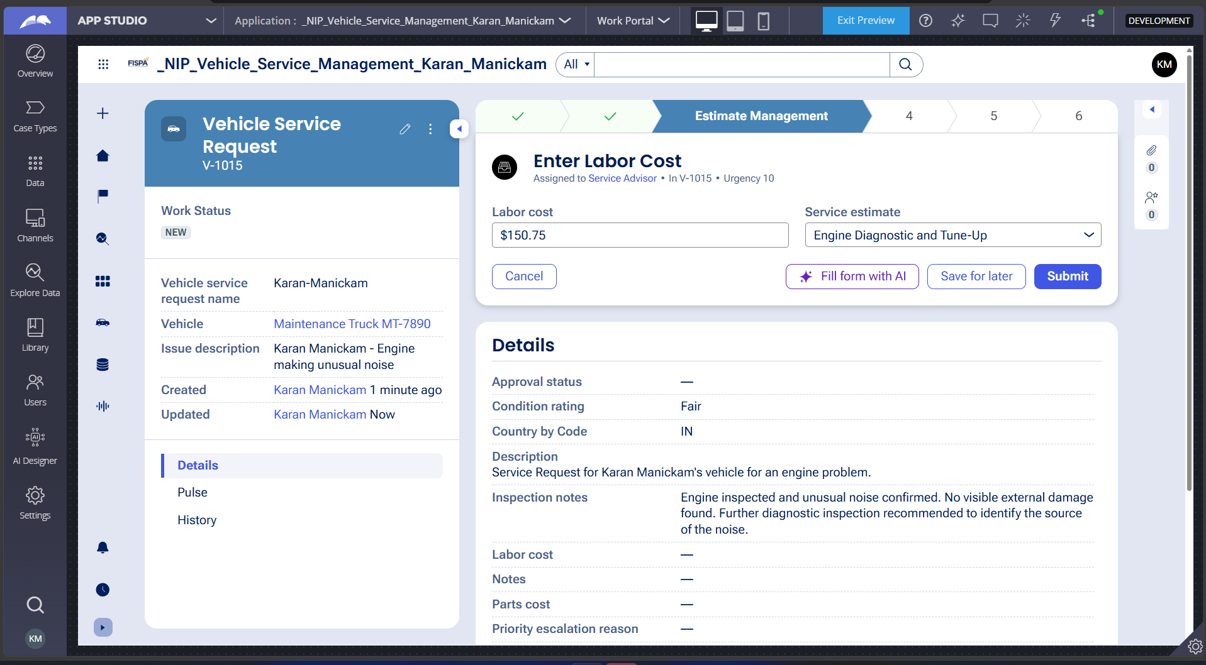

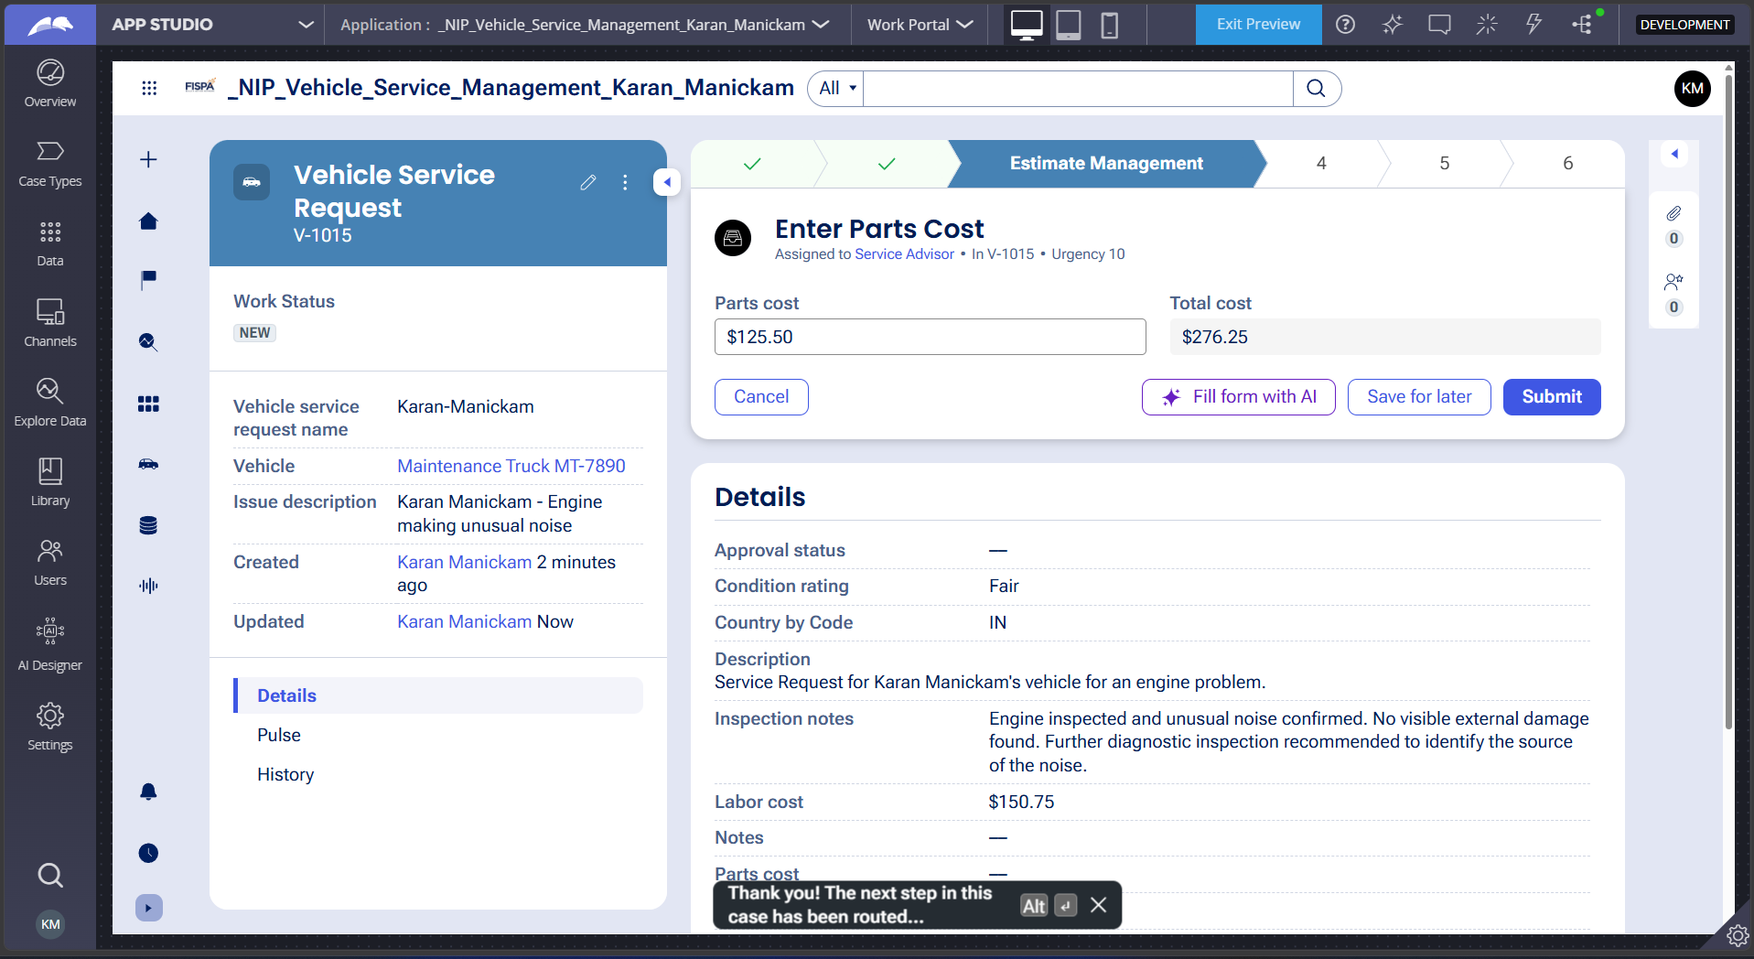

What I built for this (1–2 lines in your own words):
I added fields to capture Labor Cost and Parts Cost, with Total Cost calculated automatically from both values.

US-004 — Approve Service Estimate
What is expected:
Approval stage assigned to Customer. Approval Status captured. Flow branches on approve/reject.
Screenshot — paste your screenshot below this line:
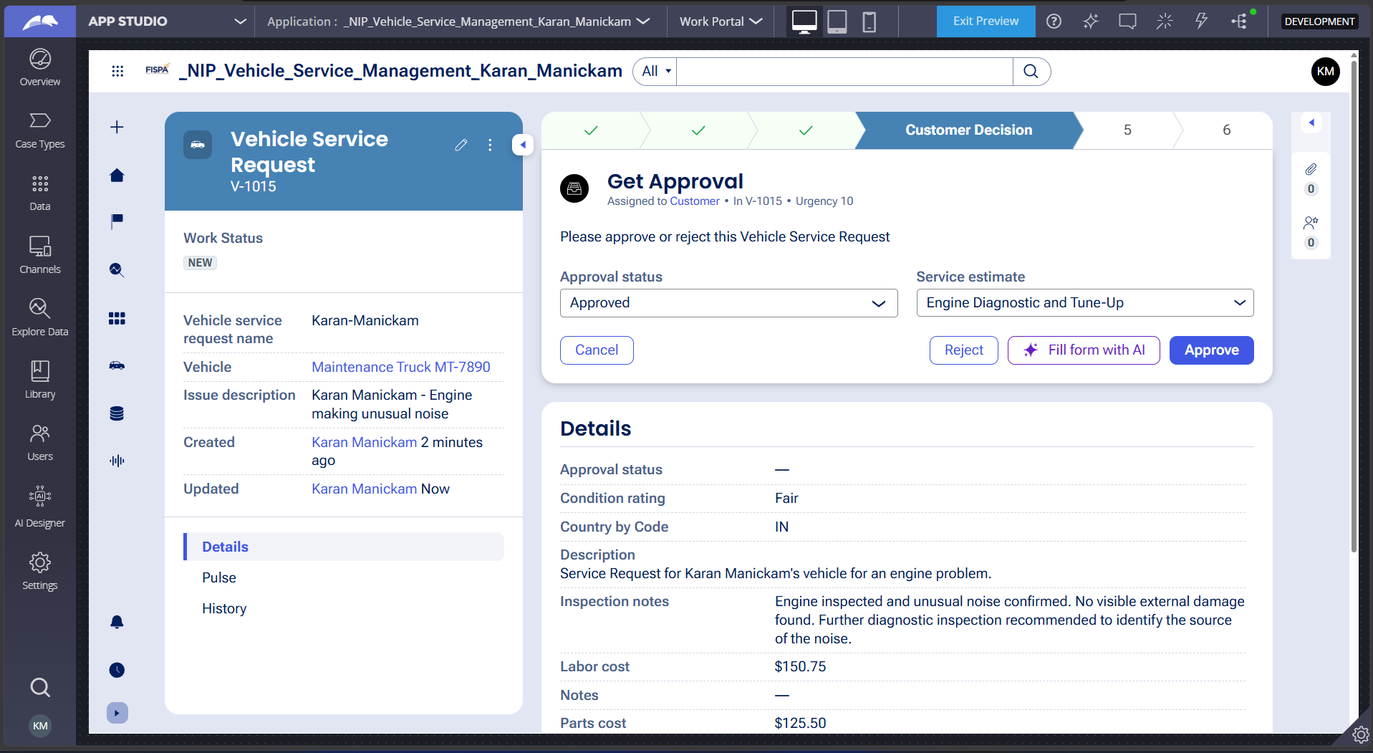

Status Approved :

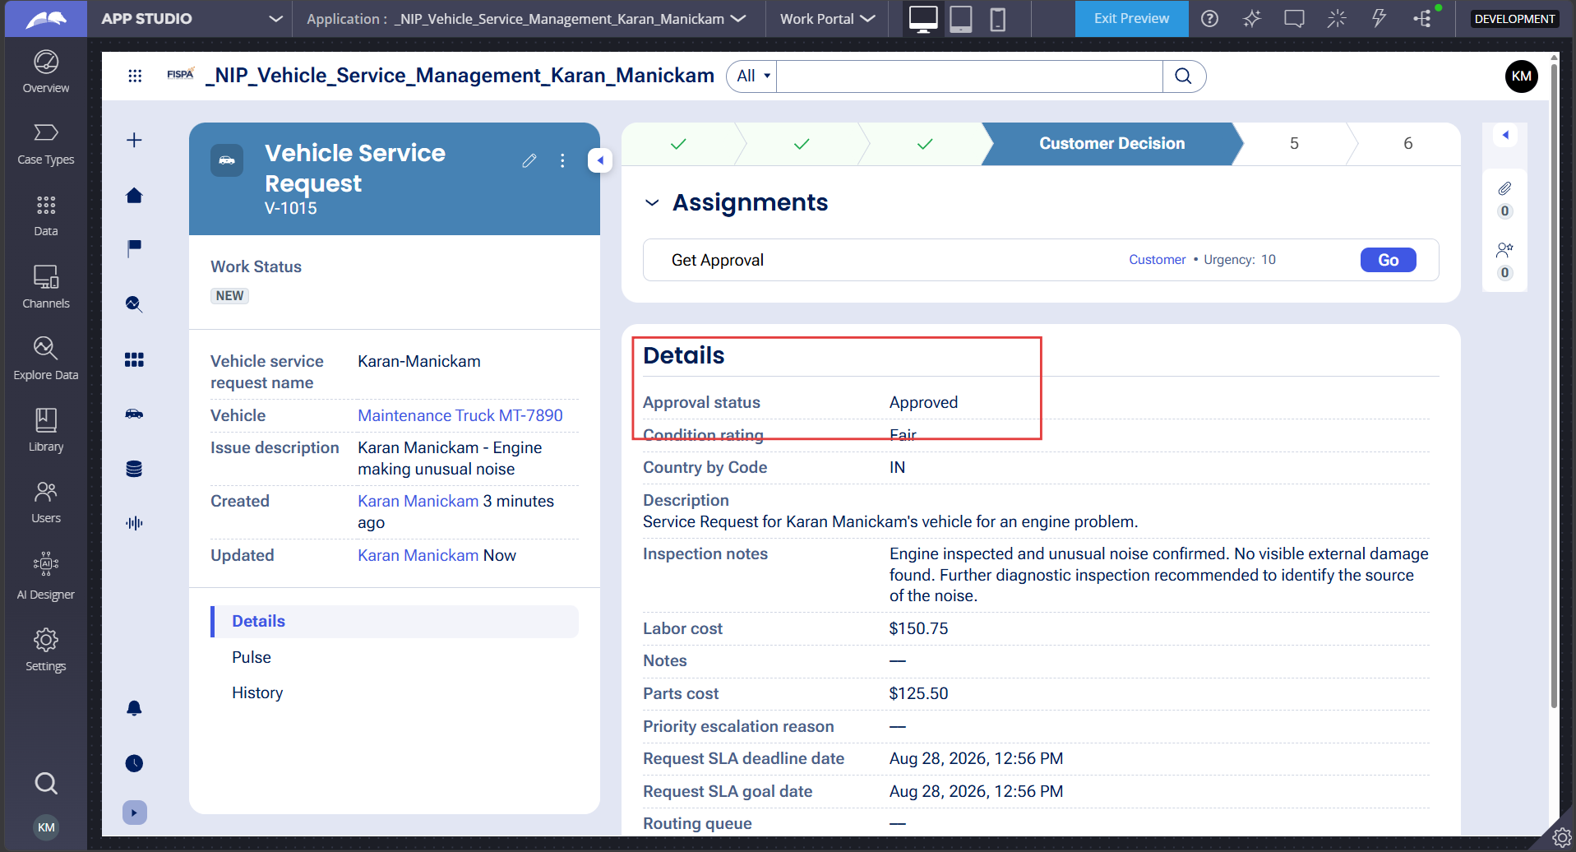

What I built for this (1–2 lines in your own words):
I added a Customer approval stage that captures the Approval Status and branches the workflow based on Approve or Reject

US-005 — Maintain Vehicle Data
What is expected:
Reusable Vehicle data object created with Vehicle ID, Model, Type — linked to case.
Screenshot — paste your screenshot below this line:
Resuable Vehicle data object:
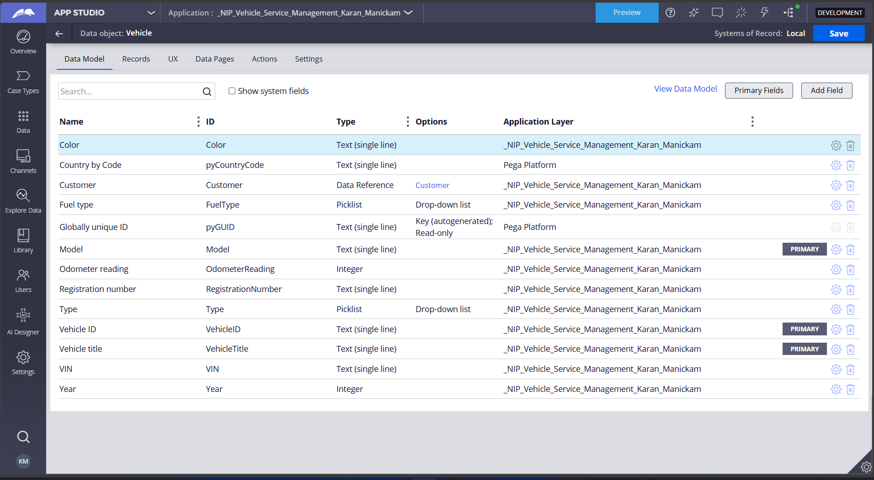
Vehicle Details on leftside panel :
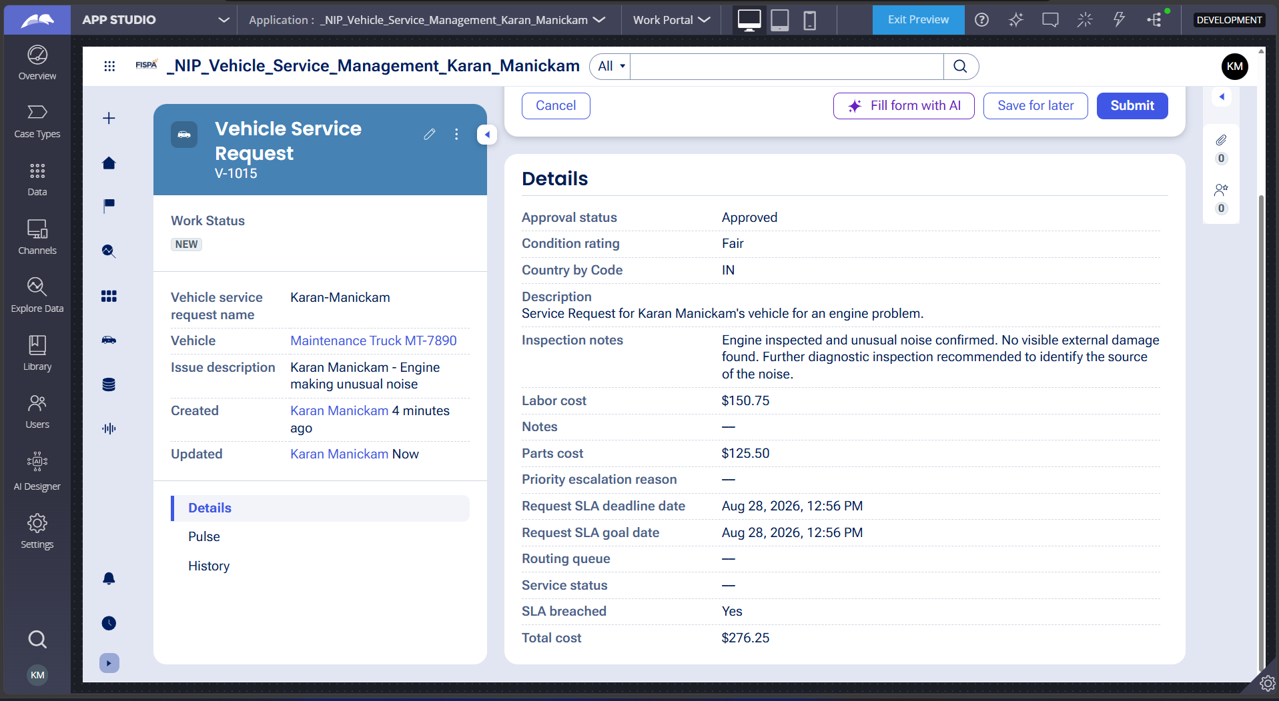

What I built for this (1–2 lines in your own words):
I created a reusable Vehicle data object with Vehicle ID, Model, and Type, and linked the vehicle data to the Service Request case.

US-006 — Review Service Estimate
What is expected:
Approval screen shows Labor Cost, Parts Cost and Total Cost clearly to the Customer persona.
Screenshot — paste your screenshot below this line:
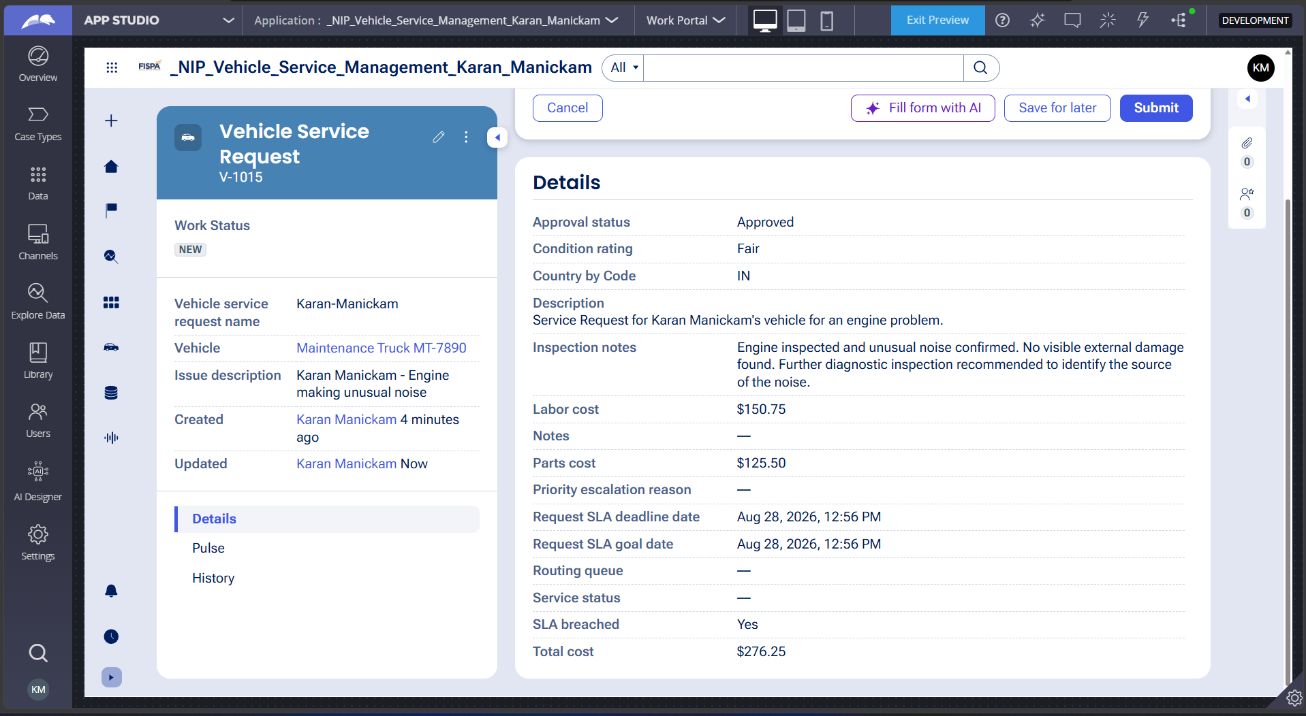

What I built for this (1–2 lines in your own words):
I created an approval screen for the Customer that clearly displays the Labor Cost, Parts Cost, and Total Cost before making an approval decision.

US-007 — Auto Assign Technician
What is expected:
Service Execution stage with routing to HeavyVehicleQueue or LightVehicleQueue. Assigned Technician and Service Status properties maintained.
Screenshot — paste your screenshot below this line:
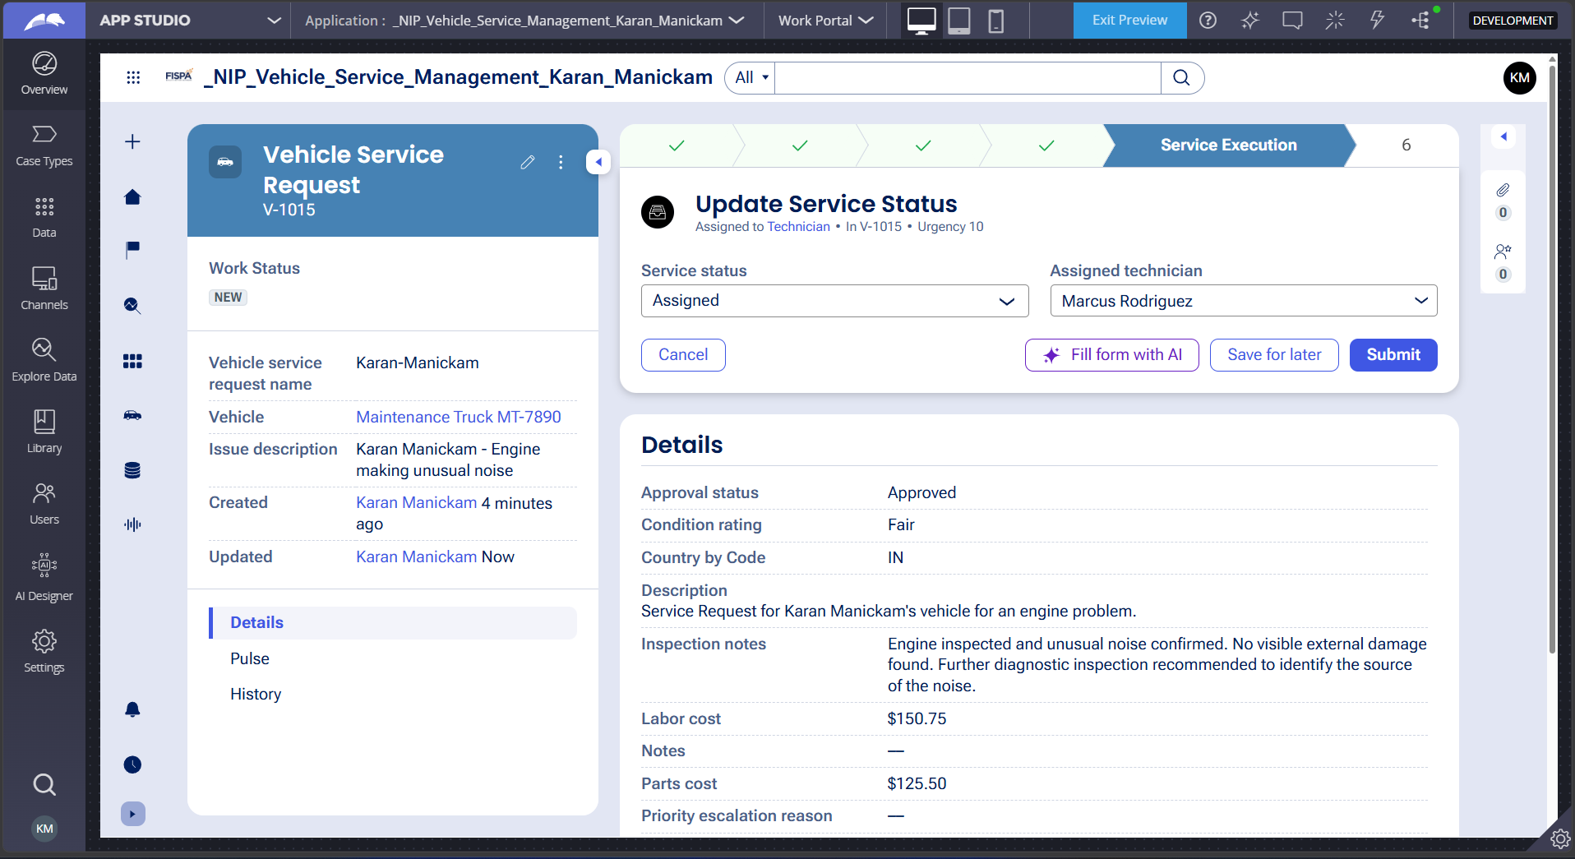

What I built for this (1–2 lines in your own words):
I configured the Service Execution stage to automatically route vehicles to HeavyVehicleQueue or LightVehicleQueue based on Vehicle Type, while maintaining the Assigned Technician and Service Status properties.

US-008 — Notify Service Completion
What is expected:
Correspondence rule created and triggered on case resolution. Email includes case and vehicle details.
Screenshot — paste your screenshot below this line:
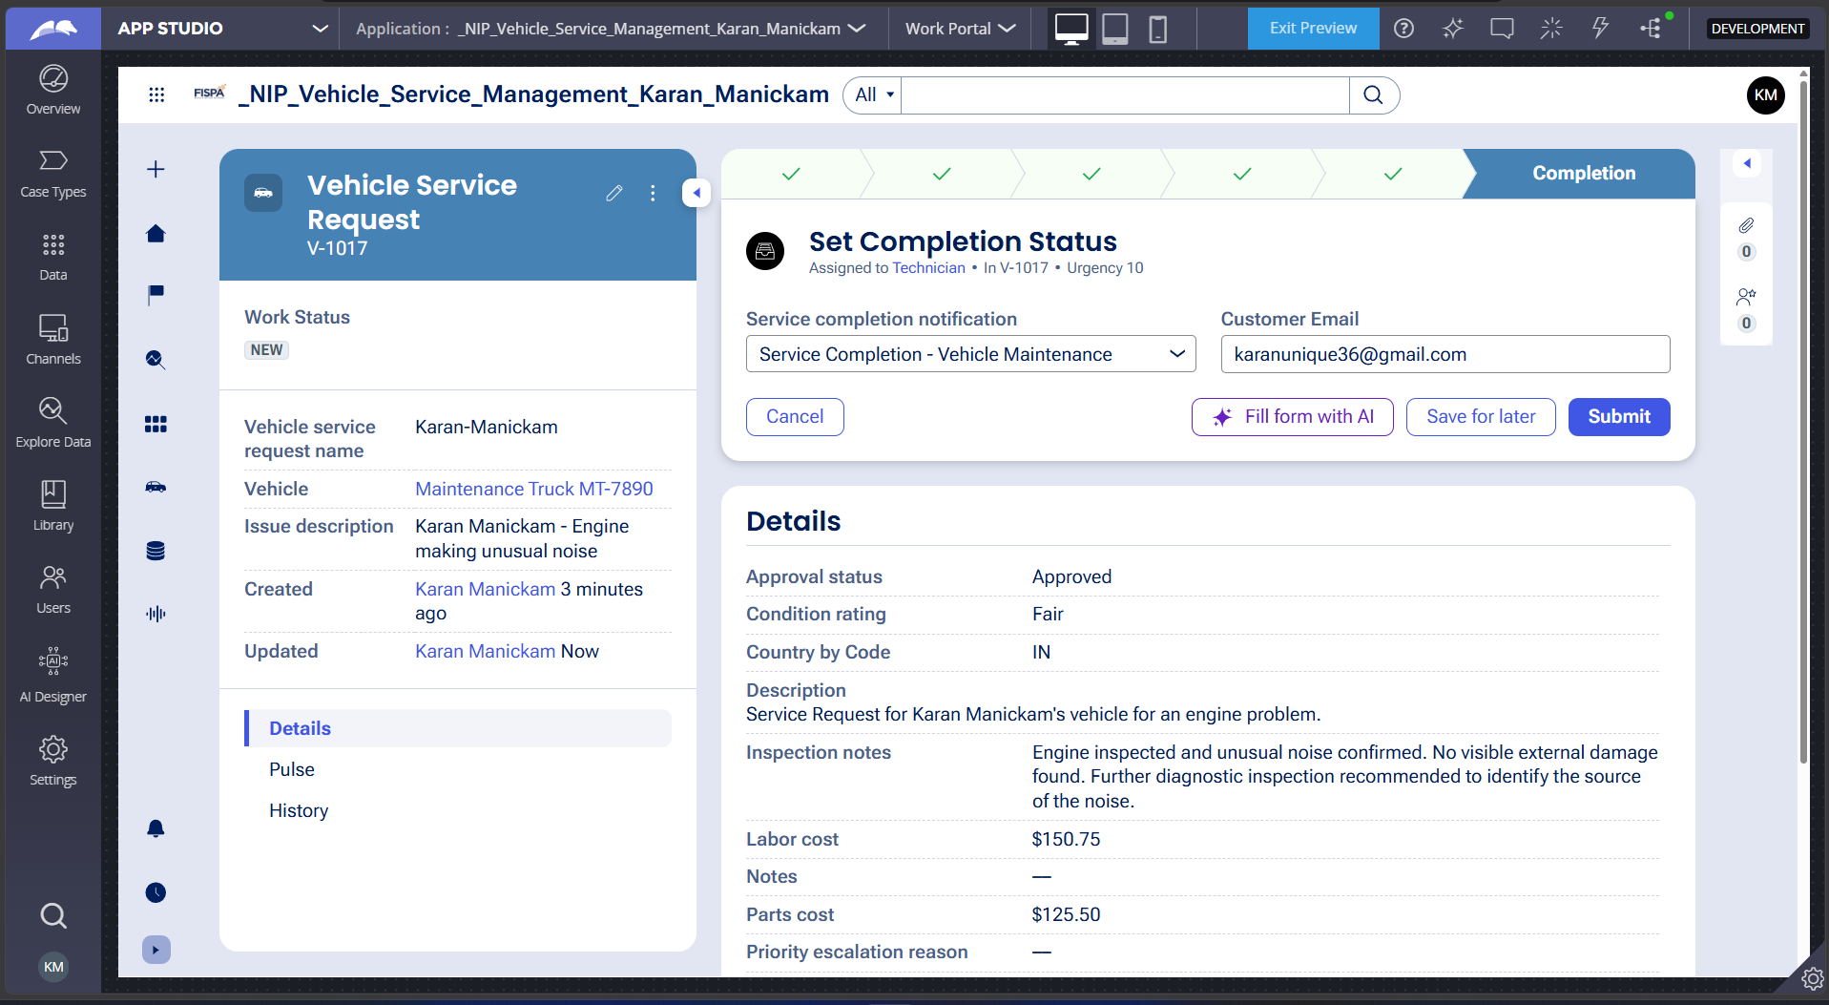

What I built for this (1–2 lines in your own words):
I created a completion notification correspondence rule that is triggered when the case is resolved and includes the case and vehicle details. The email configuration is complete, but actual email delivery is currently not working because the Pega Academy SMTP/email server connection is failing.

US-009 — Define Service SLA
What is expected:
SLA configured on the case type. Goal: 2 days. Deadline: 3 days. Priority increases on breach.
Screenshot — paste your screenshot below this line:
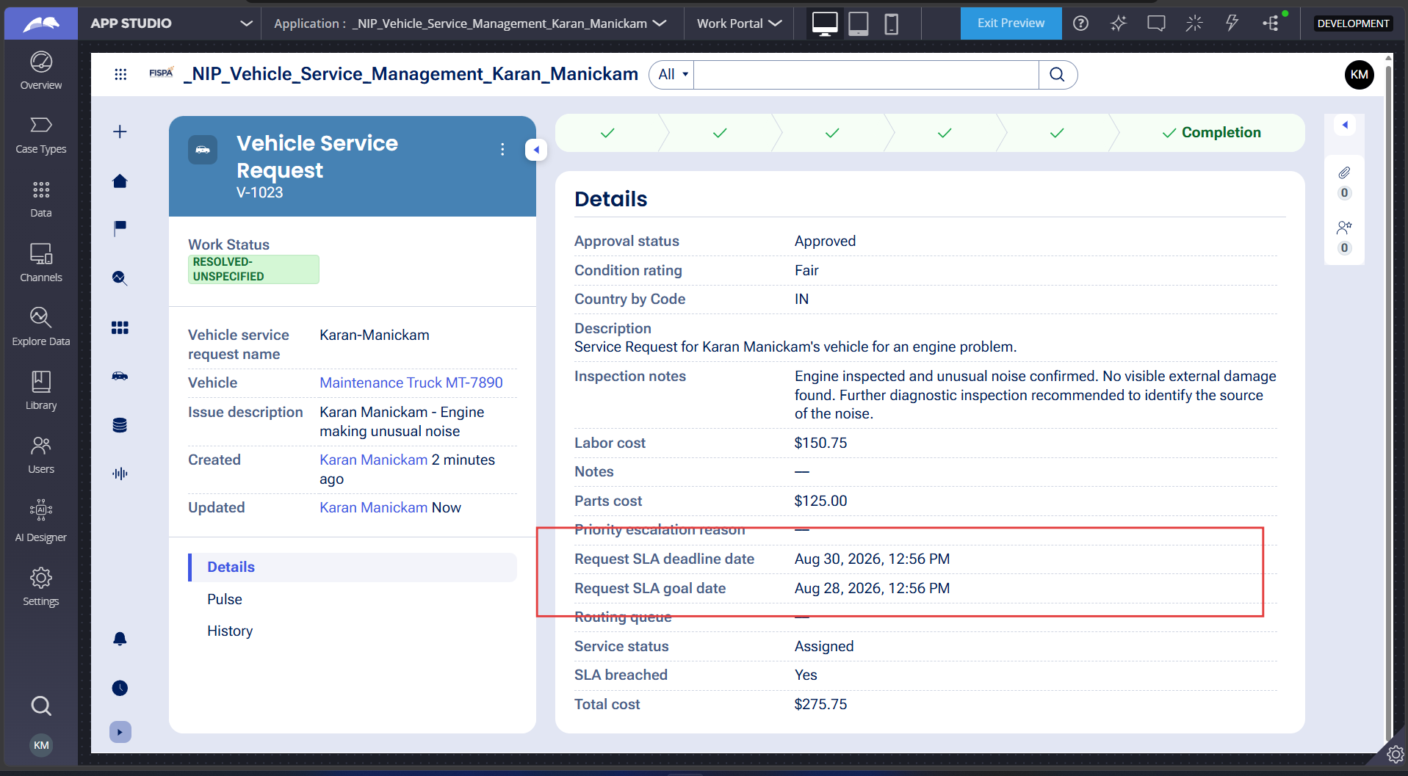

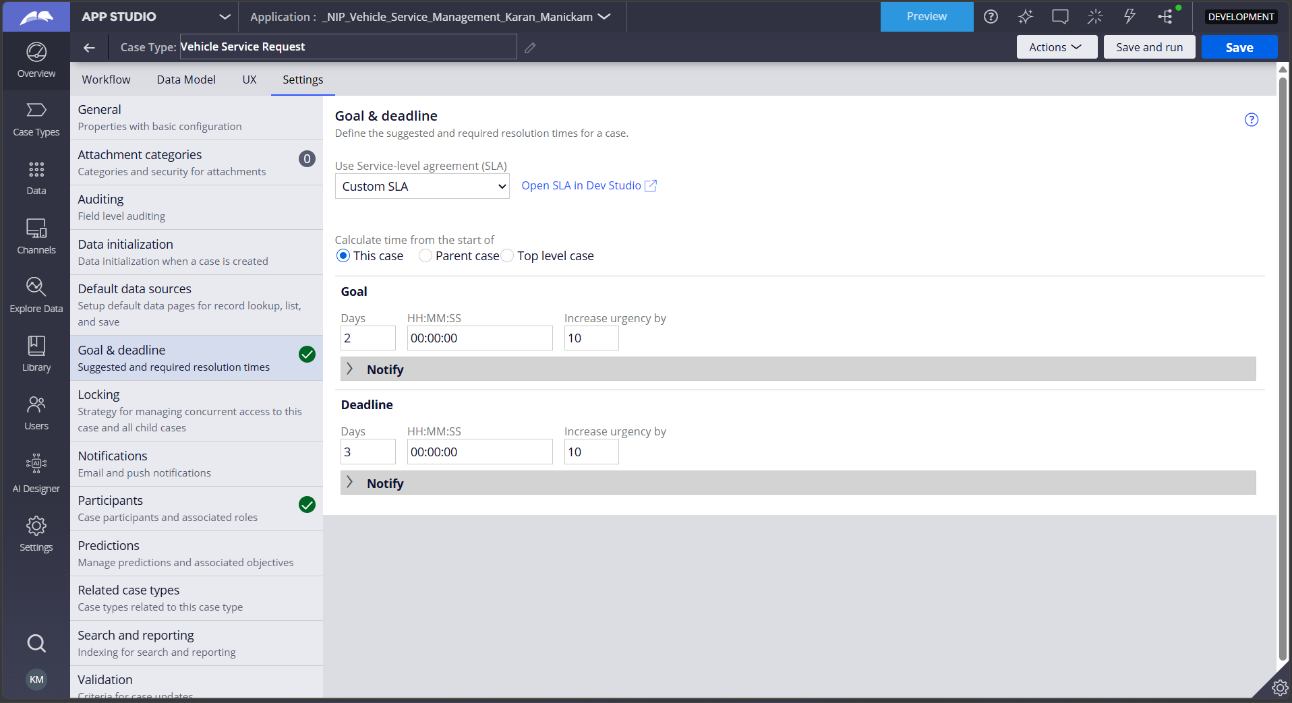

What I built for this (1–2 lines in your own words):
I configured the case-level SLA with a 2-day Goal and 3-day Deadline, with priority/urgency increased when the SLA is breached.

US-010 — Route by Vehicle Type
What is expected:
Routing rule or Decision Table routes to HeavyVehicleQueue or LightVehicleQueue based on Vehicle Type property.
Screenshot — paste your screenshot below this line:
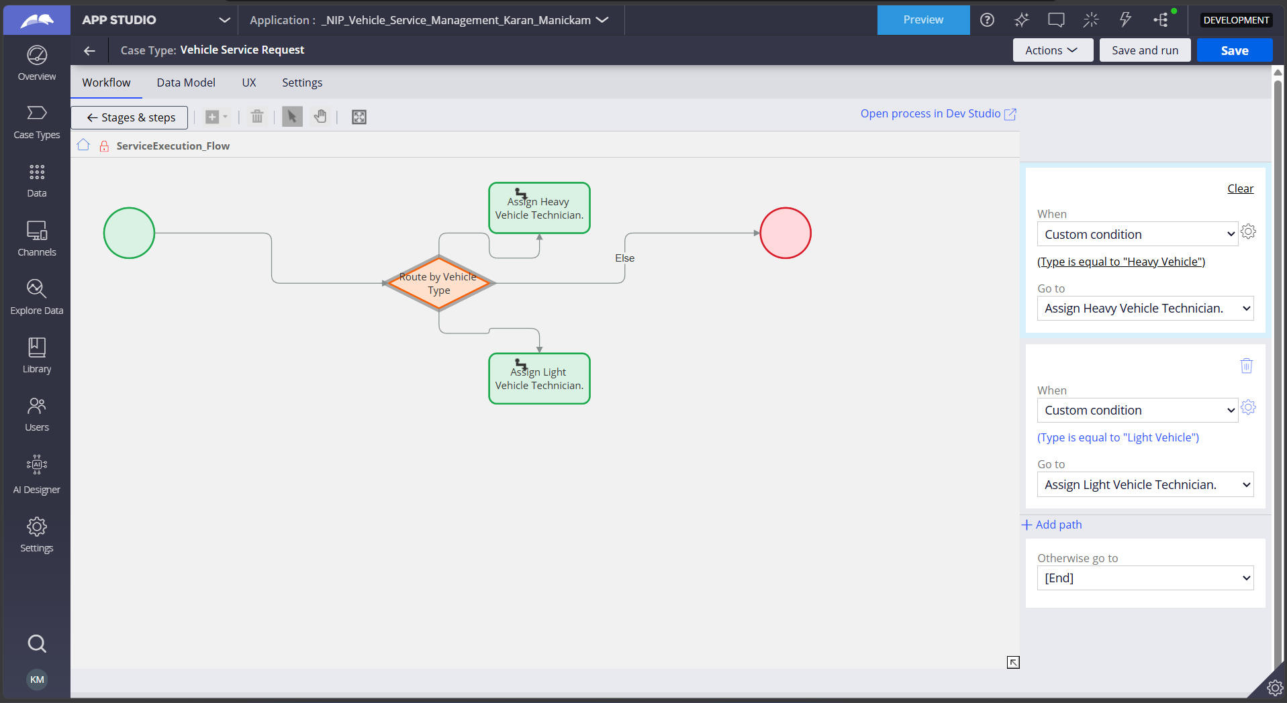

What I built for this (1–2 lines in your own words):
I configured a Vehicle Type routing decision that routes Heavy Vehicles to HeavyVehicleQueue and Light Vehicles to LightVehicleQueue based on the vehicle's Type property.

Section 2B — Movie Ticket Booking Management Application
Complete this section only if you selected this project. Delete the other project section before submitting.

Screenshot rules — IMPORTANT before you start:
1. Name your Pega application as: NIP-VehicleService-YourName OR NIP-MovieTicket-YourName
2. Create a new Operator in Pega with your full name (Security → Operators) and log in as that operator.
3. When you create your test case, enter YOUR FULL NAME in the Issue Description (Vehicle) or Movie Name (Movie) field.
4. The logged-in operator name must be visible in every screenshot wherever the Pega interface displays it.
5. The student's full name must be visible in all running-case screenshots.
6. Configuration screenshots must clearly show the relevant application or rule name.
Screenshots that do not show these will not be accepted.

US-001 — Submit Movie Ticket Request
What is expected:
Case created, customer submits Movie Name, Show Date, Show Time, Number of Tickets. Validation applied.
Screenshot — paste your screenshot below this line:
[ Paste screenshot here - follow the screenshot rules above ]

What I built for this (1–2 lines in your own words):
[ Type here ]

US-002 — Check Show Availability
What is expected:
Availability stage. Seat Availability Status and Available Seats Count captured. Booking proceeds only if available.
Screenshot — paste your screenshot below this line:
[ Paste screenshot here - follow the screenshot rules above ]

What I built for this (1–2 lines in your own words):
[ Type here ]

US-003 — Calculate Booking Cost
What is expected:
Total Cost calculated automatically from Ticket Price and Number of Tickets using a business rule.
Screenshot — paste your screenshot below this line:
[ Paste screenshot here - follow the screenshot rules above ]

What I built for this (1–2 lines in your own words):
[ Type here ]

US-004 — Confirm Booking Request
What is expected:
Approval stage assigned to Customer. Booking Status captured. Flow branches on confirm/cancel.
Screenshot — paste your screenshot below this line:
[ Paste screenshot here - follow the screenshot rules above ]

What I built for this (1–2 lines in your own words):
[ Type here ]

US-005 — Maintain Movie and Show Data
What is expected:
Reusable Movie and Show data objects created with Movie Name, Genre, Show Date, Show Time, Seat Capacity — linked to case.
Screenshot — paste your screenshot below this line:
[ Paste screenshot here - follow the screenshot rules above ]

What I built for this (1–2 lines in your own words):
[ Type here ]

US-006 — Review Booking Details
What is expected:
Confirmation screen shows Movie Name, Show Timing, Number of Tickets and Total Cost clearly.
Screenshot — paste your screenshot below this line:
[ Paste screenshot here - follow the screenshot rules above ]

What I built for this (1–2 lines in your own words):
[ Type here ]

US-007 — Process Ticket Booking
What is expected:
Booking Execution stage. Seat Numbers, Ticket ID and Booking Confirmation Status maintained.
Screenshot — paste your screenshot below this line:
[ Paste screenshot here - follow the screenshot rules above ]

What I built for this (1–2 lines in your own words):
[ Type here ]

US-008 — Notify Booking Confirmation
What is expected:
Correspondence rule triggered on case resolution. Email includes movie, show, seat and cost details.
Screenshot — paste your screenshot below this line:
[ Paste screenshot here - follow the screenshot rules above ]

What I built for this (1–2 lines in your own words):
[ Type here ]

US-009 — Define Booking SLA
What is expected:
SLA configured on the case type. Goal: 1 day. Deadline: 2 days. Priority increases on breach.
Screenshot — paste your screenshot below this line:
[ Paste screenshot here - follow the screenshot rules above ]

What I built for this (1–2 lines in your own words):
[ Type here ]

US-010 — Route by Show Type
What is expected:
Routing rule or Decision Table routes to PremiumShowQueue or StandardShowQueue based on Show Type property.
Screenshot — paste your screenshot below this line:
[ Paste screenshot here - follow the screenshot rules above ]

What I built for this (1–2 lines in your own words):
[ Type here ]

Section 3 — About Your Application
These answers are checked against your screenshots. Write exactly what is in your application.

Q1. List your stages in the order they appear in your case lifecycle.
Stage names in order, separated by commas.
Request Intake, Vehicle Inspection, Estimate Management, Customer Decision, Service Execution, Completion

Q2. Name the data object(s) you created and the properties inside them.
Data object name and its properties.
Vehicle — Vehicle ID, Model, Type.
Service Estimate — Service Estimate Name, Labor Cost, Parts Cost, Total Estimate Amount, Estimate Status, Service Request, Vehicle, Inspection Report.
Technician — Assigned Technician and related technician details.

Q3. What is the exact name and type of the rule you used to calculate Total Cost?
Provide:
• Rule Name
• Rule Type
• Properties used in the calculation
• Formula used
Rule Name: Calculate Total Cost
Rule Type: Calculated Field / Declare Expression
Properties used: LaborCost, PartsCost
Formula: .LaborCost + .PartsCost

Section 4 — Your Understanding
Short, honest and specific answers score well.

Q4. What did Blueprint generate for you, and what did you add or change yourself afterwards?
Be specific about what was already there and what you built or modified on top.
Blueprint generated the initial Vehicle Service Management application structure, including the case lifecycle, stages, processes, data fields, and basic workflow. Afterwards, I configured and modified the application to meet the user stories, including the Vehicle and Service Estimate data objects, Total Cost calculation, Customer approval flow, Vehicle Type routing, technician queues, completion notification, and case-level SLA.

Q5. Was there anything Blueprint created that you had to correct or configure further? Describe one example.
A real example from your own work.
Yes. Some of the Blueprint-generated workflow configuration did not exactly match the required user stories. I corrected the Service Execution workflow by configuring Vehicle Type-based routing and creating separate Heavy Vehicle and Light Vehicle technician assignments with their respective work queues.

Q6. Explain your case flow from creation to resolution, in order.
What happens first, who does what, when the case closes.
The customer first submits a Vehicle Service Request with the vehicle details and issue description. The Service Advisor performs the vehicle inspection and records the inspection findings. A Service Estimate is generated using Labor Cost and Parts Cost, with Total Cost calculated automatically. The Customer reviews and approves or rejects the estimate. After approval, the Service Execution stage routes the vehicle based on Vehicle Type to the appropriate technician queue. The service is completed, the Service Status is updated, and the case is resolved with a completion notification.

Q7. Pick two design choices you made in your application and explain why you made them.
For each design choice, provide:
• What you implemented
• Why you chose that approach
• What benefit it provides to the application
- Vehicle data object with Vehicle Type
I created Vehicle as a reusable data object containing Vehicle ID, Model, and Type. I chose this approach so the same vehicle information can be reused across service cases and Vehicle Type can be used for routing.

2. Vehicle Type-based technician routing
I configured separate routing paths for Heavy Vehicle and Light Vehicle. I chose this approach so service requests are automatically sent to the appropriate technician work queue instead of requiring manual routing.

Q8. What was the hardest part, and how exactly did you fix it?
Specific and honest. A real challenge scores much better than a generic answer.
The hardest part was configuring the Vehicle Type-based technician routing and resolving workflow connector errors. I fixed it by creating separate Heavy Vehicle and Light Vehicle assignment steps, creating the corresponding work queues, configuring the decision conditions, and reconnecting the workflow so both branches had valid destinations.

Q9. If the approval step was only needed when Total Cost is above a certain amount, what would you change in your application?
Explain what you would change and where. You do not need to build this.
I would add a conditional decision before the Customer Approval stage that checks the Total Cost. If Total Cost is above the defined threshold, the case would continue to Customer Approval. If it is below the threshold, the case would skip the approval stage and continue directly to Service Execution.

Q10. List three exact rule names from your application that you personally created or modified.
Include the rule name and rule type for each one (for example: CalculateTotalCost - Declare Expression).
- Calculate Total Cost — Calculated Field / Declare Expression
- Route by Vehicle Type — Decision
- Send Completion Notification — Send Email / Correspondence

Q11. List all personas used in your application.
List the persona names exactly as they appear in your application.
Customer, Service Advisor, Technician,Users

Q12. List all work queues used in your application and explain when each one is used.
For each work queue, provide its exact name and the condition or type of work routed to it.
HeavyVehicleQueue — Used when the Vehicle Type is Heavy Vehicle.
LightVehicleQueue — Used when the Vehicle Type is Light Vehicle.
Before You Submit — Check These
Read through once before uploading.
1. Section 1 filled in. Application named as NIP-[Project]-[YourName]. Names match the actual application.
2. New Operator created in Pega with my full name. I logged in as that operator for all screenshots.
3. Only my chosen project section remains — the other project section is deleted.
4. All 10 user story screenshots are pasted and follow the operator, running-case, application, and rule-name evidence requirements.
5. Every question in Sections 3 and 4, including Q10, Q11, and Q12, is answered in my own words.
6. This file is named using the required format: ProjectName_FirstName_LastName.docx (for example, VehicleService_Ravi_Kumar.docx or MovieTicket_Ravi_Kumar.docx) and uploaded as required.

