1.1. Vision, Mission and Program Educational Objectives
(Provide details of vision and mission and program educational objectives.)
1.1.1. State the Vision and Mission of the Institute and the Department
(Vision statement typically indicates aspirations and Mission statement states the broad approach to achieve aspirations.)
user need to be asked for vision , mission , PEO separately and it should be asked for university , school of computing , departments like that
1.1.2. State PEOs of the Program
(State the PEOs (3 to 5) of program seeking accreditation.)
1.1.3. Process of Defining Vision, Mission and PEOs
(Articulate the process involved in defining the Vision and Mission of the department and PEOs of the program.)
need to upload pdfs
1.1.4. Dissemination of Vision, Mission and PEOs
(Describe where (websites, curricula, posters etc.) the Vision, Mission and PEOs are published and detail the process which ensures awareness among internal and external stakeholders with effective process implementation. Internal stakeholders may include Management, Governing Board Members, faculty, support staff, students etc. and external stakeholders may include employers, industry, alumni, funding agencies, etc.)
need to upload pdfs
1.1.5. Mapping of PEOs with Mission
(Generate a Mission of the Department–PEOs matrix with justification and rationale of the mapping.)
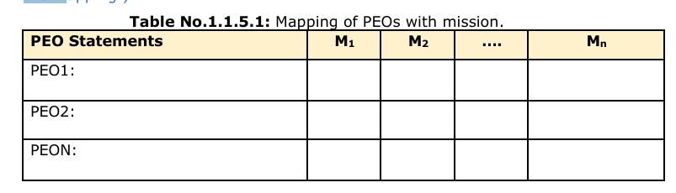
Note: ϖ M1, M2. . . Mn are distinct elements of mission statement. Enter correlation levels as Low (1), Medium (2) and High (3). If there is no correlation, put “-”
we should make this automate from the above information

1.2. Curriculum Structure and Features
1.2.1. State the Process for Developing/Revising the Program Curriculum
Describe the process that periodically documents and demonstrates how the program curriculum has evolved, considering the Washington Accord Knowledge and Attitude Profile (WKs) and the Program Outcomes (POs) defined by the NBA, as listed in Annexure-II. Describe the process involving both internal and external stakeholders in framing the curriculum.)
need to upload pdfs
1.2.2. Curriculum Structure
(Provide details of courses in terms of teaching and learning scheme and number of credits in the Program curriculum.)
Table No.1.2.2.1: Details of various courses presented in terms of teaching and learning scheme.
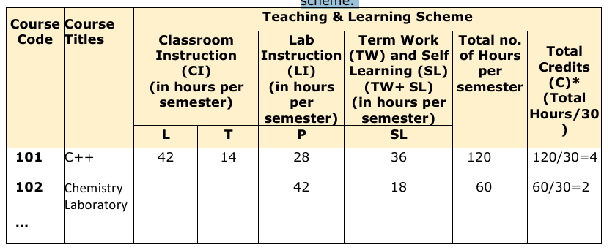
*This is as per the new National Credit Framework, which accounts for 30 hrs. of learning as equivalent to 1 credit. Those universities which are still following the LTP will transform them into no. of hours and fill in the above table. Legend: CI: Classroom Instruction (Includes different instructional/implementation strategies i.e. Lecture (L), Tutorial (T), Case method, Demonstrations, Video demonstration, Problem based learning etc. to deliver theoretical concepts) LI: Laboratory Instruction (Includes experiments/practical performances /problem based experiences in laboratory, workshop, field or other locations using different instructional/Implementation strategies) TW: Term work (includes assignments, seminars, micro projects, industrial visits, any other student activities etc.) SL: Self Learning, MOOCs, spoken tutorials, online educational resources etc.(If Provided in curriculum structure.)

1.2.3. Components of Curriculum
(Provide details of Curriculum components for all relevant Years.) Table No.1.3.3.1: Program curriculum grouping based on curriculum components.
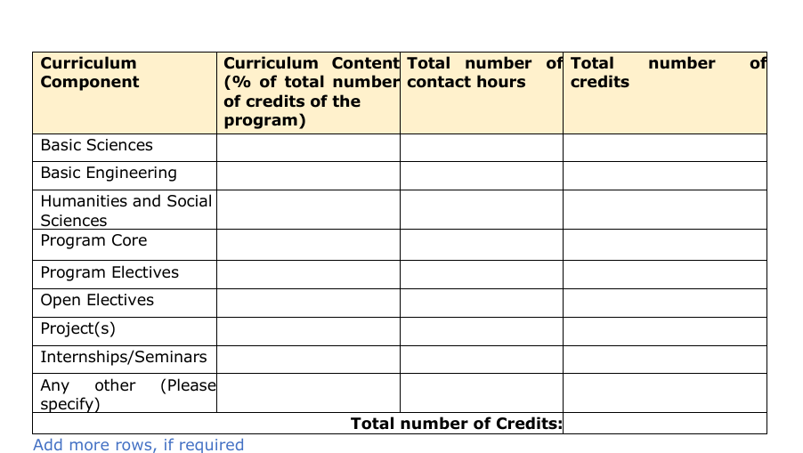
1.2.4. Strategies for Education Reforms
(A brief explanation of the plans to implement and map activities in curriculum design with multidisciplinary and interdisciplinary programs, the establishment of an academic bank of credits system, APAAR etc.)
User needs to upload pdfs

1.3. PO, PSO and their Mapping with Courses

1.3.1. POs and PSOs
(Program Specific Outcomes (PSOs) are defined by the program, with up to 3 PSOs specified.) List of POs as Defined by NBA in Annexure II. List of PSOs
(Provide details of the PSOs for the program currently seeking accreditation.)
1.3.2. Mapping between the Courses and POs/PSOs
(Mention the courses relevant to the POs/PSOs.) List of Courses Table No.1.3.1: Connection of courses with POs/PSOs.
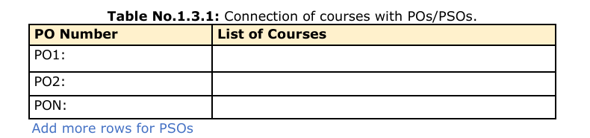
1.4. Course Outcomes and Course Articulation Matrix
1.4.1. Course Outcome (Semester Wise)
(Provide Course outcomes (COs) for two core courses per semester from 1-8 semesters as a sample. The maximum number of outcomes for a course is expected to be around 6. COs should reflect on the measurable outcomes towards attaining POs and PSOs).
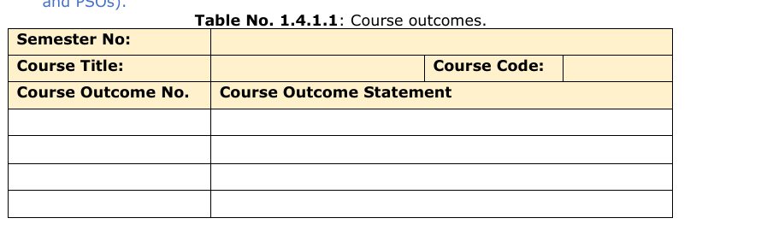
there will be 16 tables in total
1.4.2. Course Articulation Matrix
(Provide course articulation matrices for two core courses per semester from 1-8 semesters which have been provided in the section 1.4.1. Select courses to demonstrate the mapping/correlation with POs and PSOs.) Table No.1.4.2: Course articulation matrix.
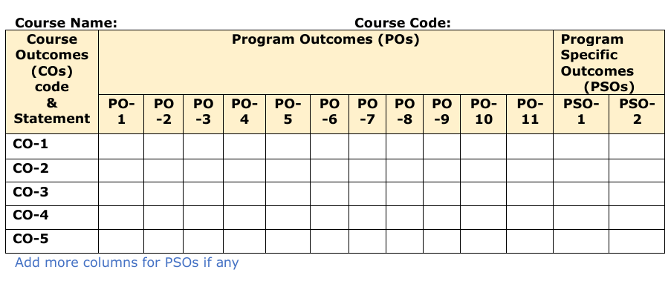
Note: ϖ Enter correlation levels 1, 2 or 3 as defined below: ϖ 1: Slight (Low) ϖ 2: Moderate (Medium) ϖ 3: Substantial (High), ϖ If there is no correlation, put “-”
1.5. Program Articulation Matrix (05) Table No.1.5.1: Program articulation matrix
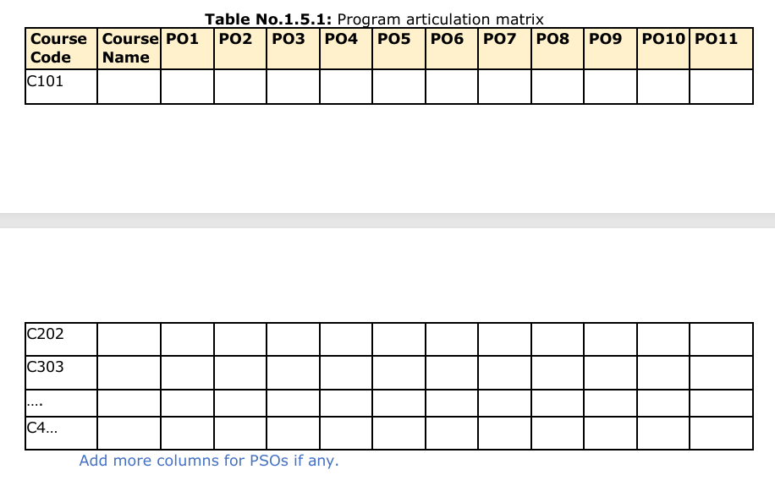
Add 2 more columns PSO1,PSO2
all the above details should be able to be visible also

