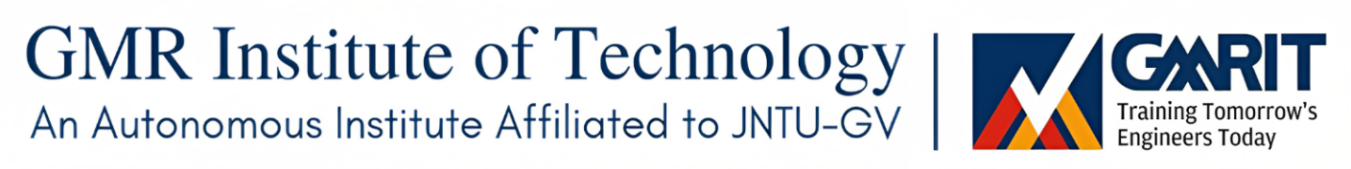
Department of Civil Engineering

Program Educational Objectives (PEOs), Program Outcomes (POs) and Program Specific Outcomes (PSOs)

Program Educational Objectives (PEOs)
PEO 1: Graduates with ability to solve core engineering problems through continuous self-paced learning in tune with changing technologies.
PEO 2: Reinforce engineering skills, critical thinking and problem-solving skills in professional engineering practices and deal with socio-economical, technical and business challenges.
PEO 3: Nurture professionalism with soft skills, managerial & leadership skills and ethical values. (Need to Change)

Program Outcomes (POs):
Engineering graduate will be able to:
- Apply the knowledge of basic sciences and fundamental engineering concepts in solving civil engineering problems (Engineering knowledge)
- Identify and define civil engineering problems and investigate to analyze and interpret data to arrive at substantial conclusions. (Problem analysis)
- Propose appropriate solutions for engineering problems complying with functional constraints such as economic, environmental, societal, ethical, safety and sustainability in accordance with Indian standard codes of practices. (Design/development of solutions)
- Perform investigations, design and conduct experiments, analyze and interpret the results to provide valid conclusions. (Conduct investigations of complex problems)
- Select/develop and apply appropriate techniques and IT tools to analyze, design and scheduling of activities with an understanding of the limitations and successfully implement and adopt to technological changes in civil engineering with intervention of IT industries (Modern tool usage)
- Give reasoning and assess societal, health, legal and cultural issues with competency in professional engineering practice. (The engineer and society)
- Demonstrate professional skills and contextual reasoning to assess environmental/societal issues for sustainable development. (Environment and sustainability)
- Demonstrate knowledge of professional and ethical practices. (Ethics)
- Function effectively as an individual, and as a member or leader in diverse teams, and in multi- disciplinary situations. (Individual and team work)
- Communicate effectively with respect to oral, written and graphical communication (Communication)
- Demonstrate and apply engineering & management principles in their own / team projects in multidisciplinary environment. (Project management and finance)
- Recognize the need for, and have the ability to engage in independent and lifelong learning. (Life-long learning)

Program Specific Outcomes (PSOs):
Engineering graduate will be able to:
- Demonstrate the quality and suitability of construction materials (Program Specific)
- Ability to apply the practical aspect of analysis, design and safe construction practices (Program Specific)

Local relevance:
The need for proper MSW collection & transportation as well as processing & disposal has been realized by all the residents, service providers and the hospitality industry of Rajam. Courses like Environmental Engineering, Environmental Impact Assessment, Environmental Pollution and Solid Waste Management are aligned with MSW issues. Moreover, there are around 80 industries like fertilizer, rice mills, Sugar Industries around Rajam, to address the ground water contamination caused by these industries courses like Water resources Engineering, Hydrology, Environmental Studies are framed to address these issues. Courses like Communicative skills and language electives will help the students to develop the communicative skills of students as major part of students are from rural background
Regional relevance:
The meet out the regional requirements of Srikakulam district like ground water recharge, earthquake resistant structures (Seismic zone III) rehabilitation of distressed RC structures, courses like Repair and Rehabilitation of structures, Earthquake resistant design of structures, Prefabricated structures are designed to meet out the needs

National relevance:
Considering the initiatives taken by Government of India like National River Conservation scheme, swatch Bharath mission, smart cities, National Disaster management plan courses like Transportation Engineering, Geometric design & Highway Materials, Highway Project formulation and economics, Disaster management courses are designed
Global Relevance:
For implementation of new technologies and Integrated technology in live hood for global needs courses like Design of Industrial structures, Geospatial Techniques, Bridge Engineering, Prestressed Concrete Structure, Green Buildings

HOD-CE
(Please Keep Department seal Here)

