

DEPARTMENT OF XXXXXXXXXXXXXXXXXXX
Academic year : 20xx-20xx
Note : 3rd to 6th semester each one course

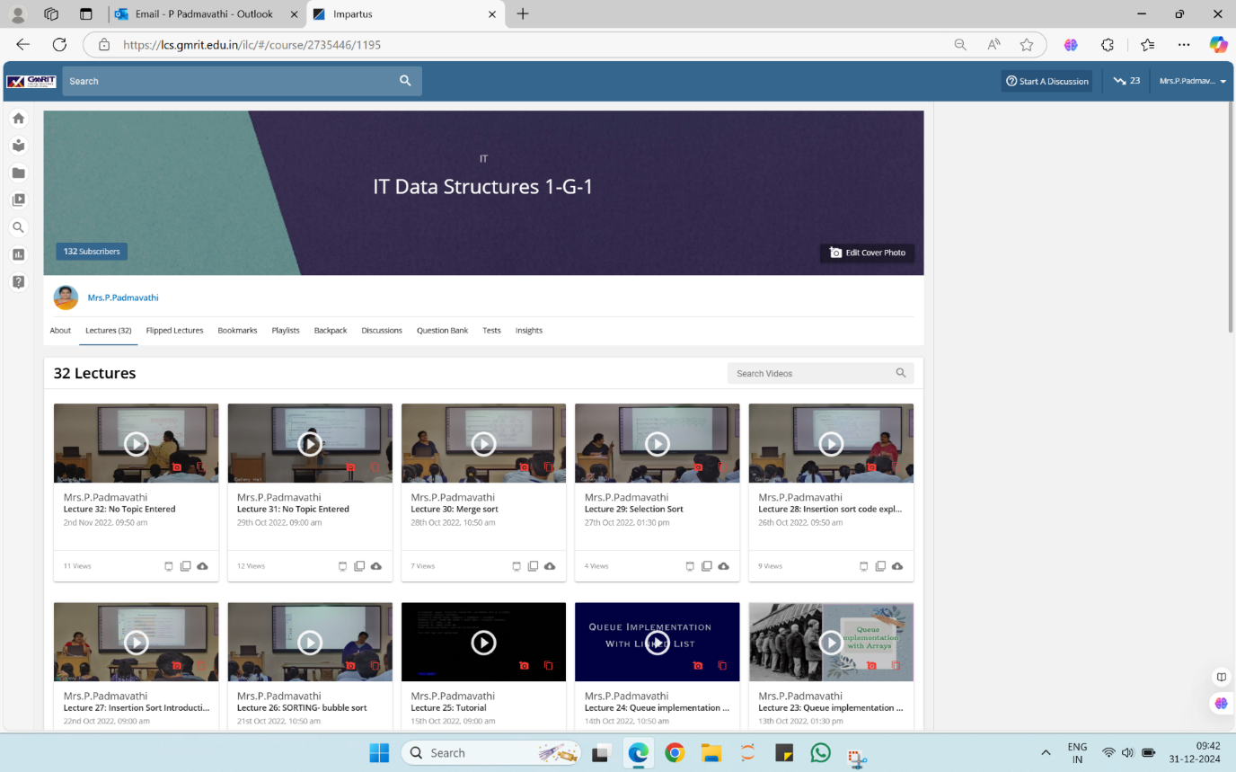
https://lcs.gmrit.edu.in/ilc/#/course/2735446/1195 - DATA STRUCTURES

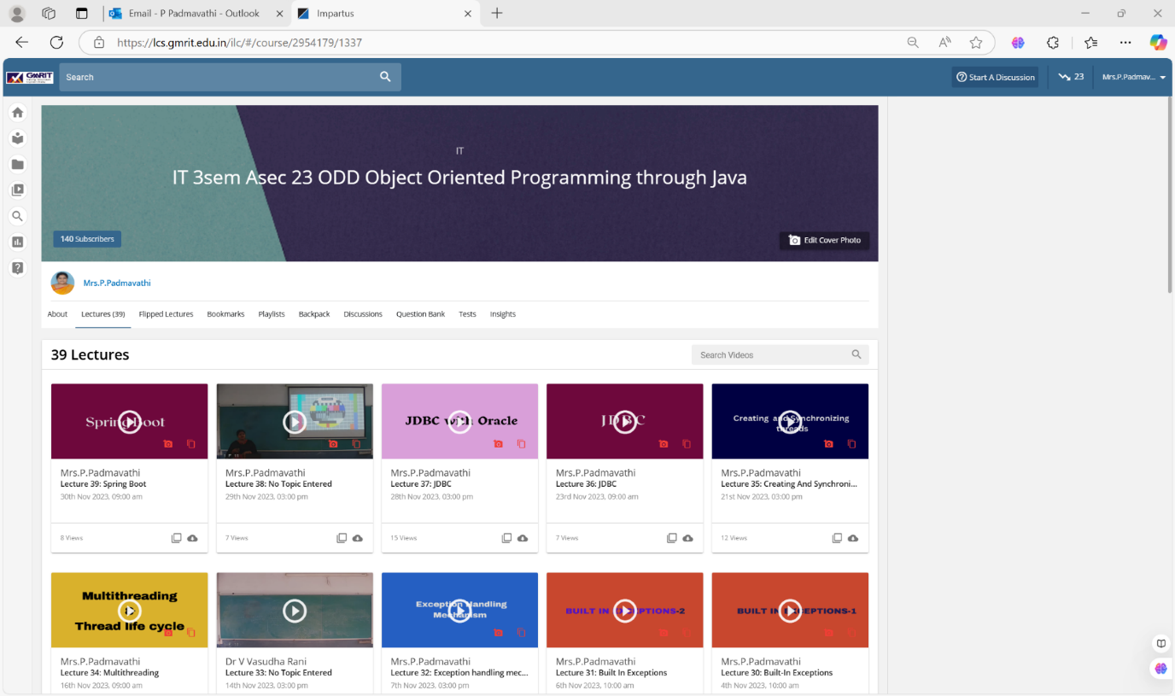

https://lcs.gmrit.edu.in/ilc/#/course/2954179/1337 - OBJECT ORIENTED PROGRAMMING THROUGH JAVA

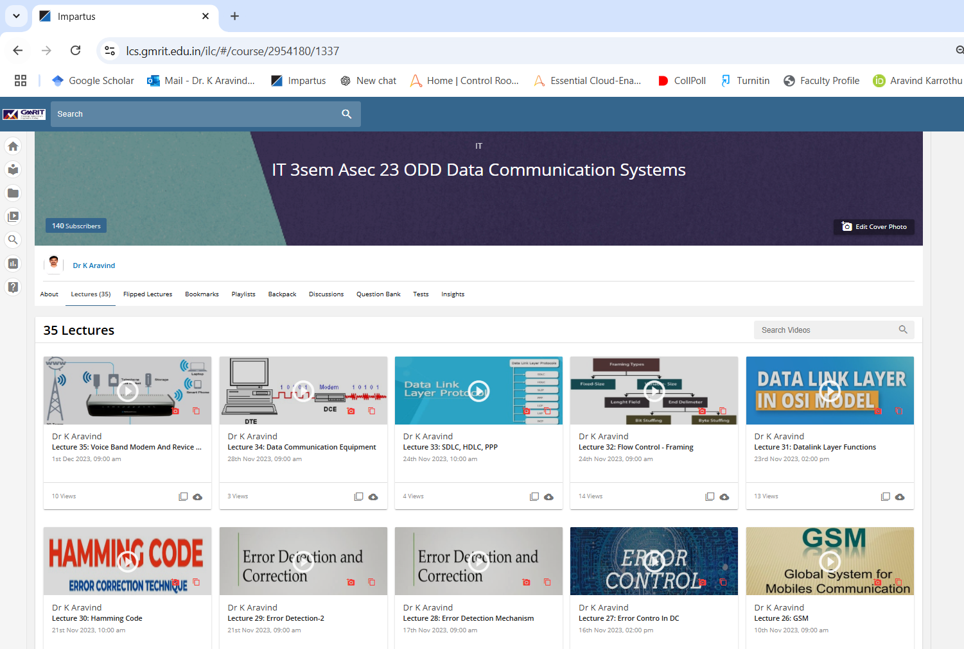

https://lcs.gmrit.edu.in/ilc/#/course/2954180/1337 - DATA COMMUNICATION SYSTEMS

