**Android**

**Project Proposal**

**Fall 2019**

**Group 7**

Project Proposal

Name of the App: - Home Finder

Team Members**:** Vijay Kumar karanam

Bhuvanesh Nakka

Harsha Vardhan Reddy Nallavolu

Lavanya Reddy uppula

Aim: -

Finding a home whenever you move to a new place is hectic task. We need to consider several things like housing cost, property type, locality, building amenities, utility amenities etc., Our app is going to address this issue by listing all the apartments available in the selected locality with filters we select like price range, number of bedrooms, property type etc., After submitting this information the contact information of owner is displayed for scheduling a visit to his home.

Activities that will be created: -

* A login screen for the users.
* A screen for selecting the filters of desired home.
* A screen showing the filtered result.
* A screen for contacting the owner of home.

Rough Sketches: - Login Screen

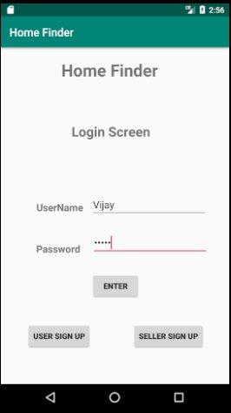

Seller’s Create Page: -

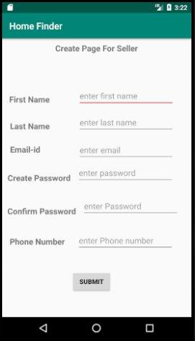

Customer’s Create Page: -

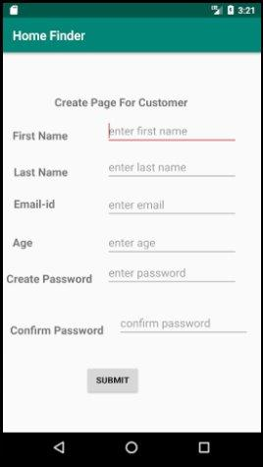

Filters for selecting required home: -

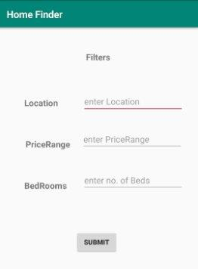

Results of the selection criteria: -

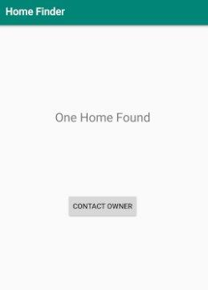

Owner’s Info: -

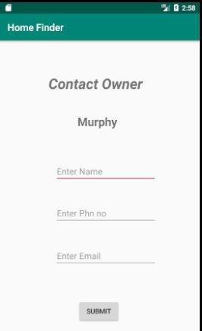

Users of the app we are thinking as of now are the Owner and the apartment seeker.

Riskycomponents**:**

* We are not using any outside API.
* Adding images to the database uploaded from the user from the seller’s account is considered one of the risky components.
* As we are working in the group of 4 there may occur some merge conflicts.

Required functionalities: Database and Maps

GitHub repo link:

<https://github.com/KaranamVijayKumar/home-finder>