Kubernetes + Monitoring
Week 4 Learning Journal
Minikube • Prometheus • Grafana • K8s Dashboard • Jenkins
22 March 2026
From container deployment to full observability stack

Complete CI/CD Journey
Week | Stack | What Built | Status
Week 1 | Jenkins + GitHub | Basic pipeline + webhook | ✅ Done
Week 2 | Docker + ECR | Containerised app | ✅ Done
Week 3 | Multi-Env | Dev/Staging/Prod + approval | ✅ Done
Week 4 | K8s + Monitoring | Minikube + full observability | ✅ Done

What You Built in Week 4
A complete Kubernetes-based deployment pipeline with a full monitoring stack. Jenkins builds and pushes Docker images to ECR, then deploys them as Kubernetes pods on Minikube. Prometheus scrapes metrics, Grafana visualises them, and the Kubernetes Dashboard gives a live visual UI of all resources.

Full Stack Overview
Tool | Purpose
Minikube | Single-node Kubernetes cluster running on EC2 via Docker driver
kubectl | CLI tool to manage Kubernetes resources
Prometheus | Scrapes and stores metrics from all pods and nodes
Grafana | Visualises Prometheus metrics in dashboards
K8s Dashboard | Web UI to view pods, deployments, services in real time
metrics-server | Enables kubectl top for live CPU/memory usage
Helm | Kubernetes package manager used to install Prometheus stack

Pipeline Flow
GitHub push → Jenkins triggers → Test → Docker Build → Push to ECR → Refresh ECR Secret → kubectl apply → Rolling update → Health check → App live on :8888

All Running Services
Service | Port | URL | Login
Node.js App | 8888 | http://<ec2-ip>:8888 | None
K8s Dashboard | 9090 | http://<ec2-ip>:9090 | Token
Grafana | 8300 | http://<ec2-ip>:8300 | admin/admin123
Prometheus | 8090 | http://<ec2-ip>:8090 | None

Live Application Screenshots

1. Node.js App — Running on Kubernetes
The Node.js Express app deployed as 2 replicas inside Minikube pods, accessible via port-forward on EC2 port 8888.

📸 Node.js App — http://<ec2-ip>:8888
http://<your-ec2-ip>:8888
Take screenshot of the green app page showing Environment, Build number and Pod name
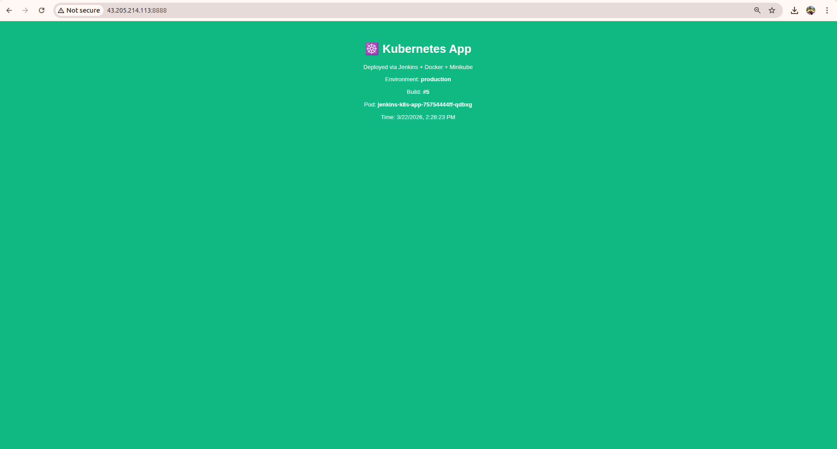

What to Look For
- Environment: production (green background)
- Build number matches your latest Jenkins build
- Pod name shows which Kubernetes pod is serving the request
- Health endpoint at /health returns JSON status

2. Jenkins Pipeline — All Stages Green
The full 7-stage pipeline running on Jenkins, triggered automatically on every GitHub push.

📸 Jenkins Pipeline — http://<ec2-ip>:8080
http://<your-ec2-ip>:8080
Take screenshot of the pipeline view showing all stages: Checkout, Test, Docker Build, Push ECR, Deploy K8s, Verify, Monitoring Check
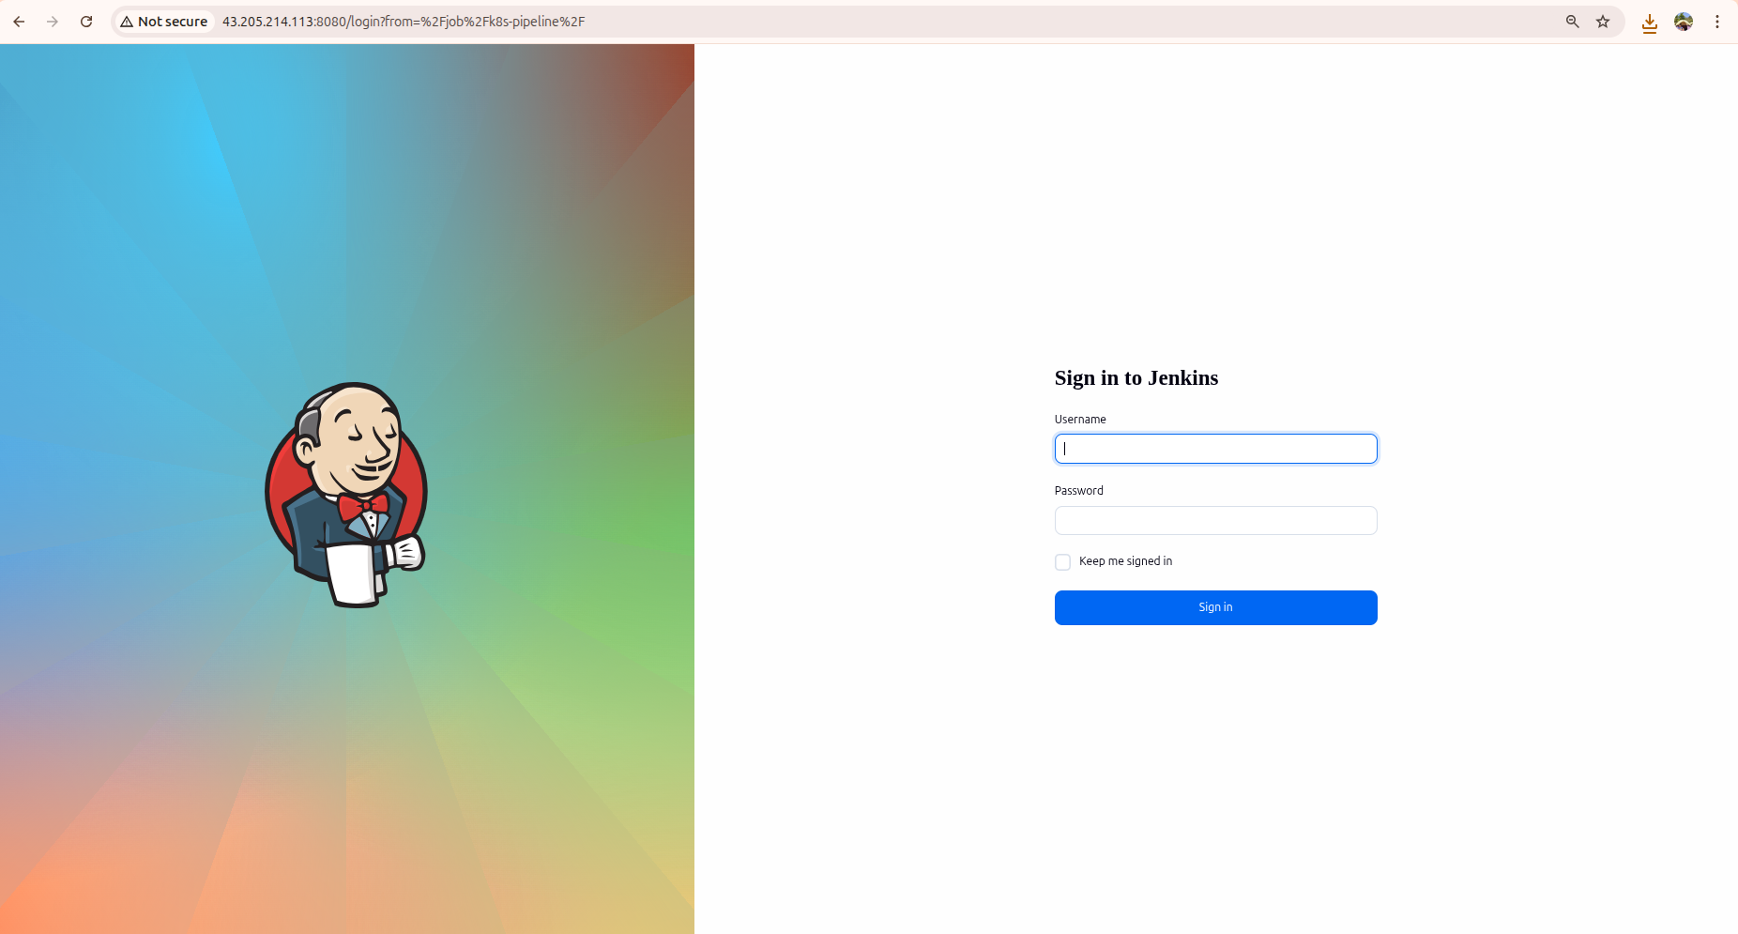

Pipeline Stages
Stage | What It Does
Checkout | Pulls latest code from GitHub
Test | Runs test.js validation
Docker Build | Builds image tagged with build number
Push to ECR | Pushes image to AWS ECR registry
Deploy to Kubernetes | Refreshes ECR secret, applies manifests, waits for rollout
Verify Deployment | Shows pods, services, deployment status
Monitoring Check | Shows pod CPU/memory usage and all service URLs

3. Kubernetes Dashboard
The Kubernetes Dashboard gives a visual UI of all pods, deployments, services and namespaces running in the Minikube cluster.

📸 Kubernetes Dashboard — Pods View
http://<your-ec2-ip>:9090
Take screenshot of the Pods section showing jenkins-k8s-app pods with Running status, CPU and memory
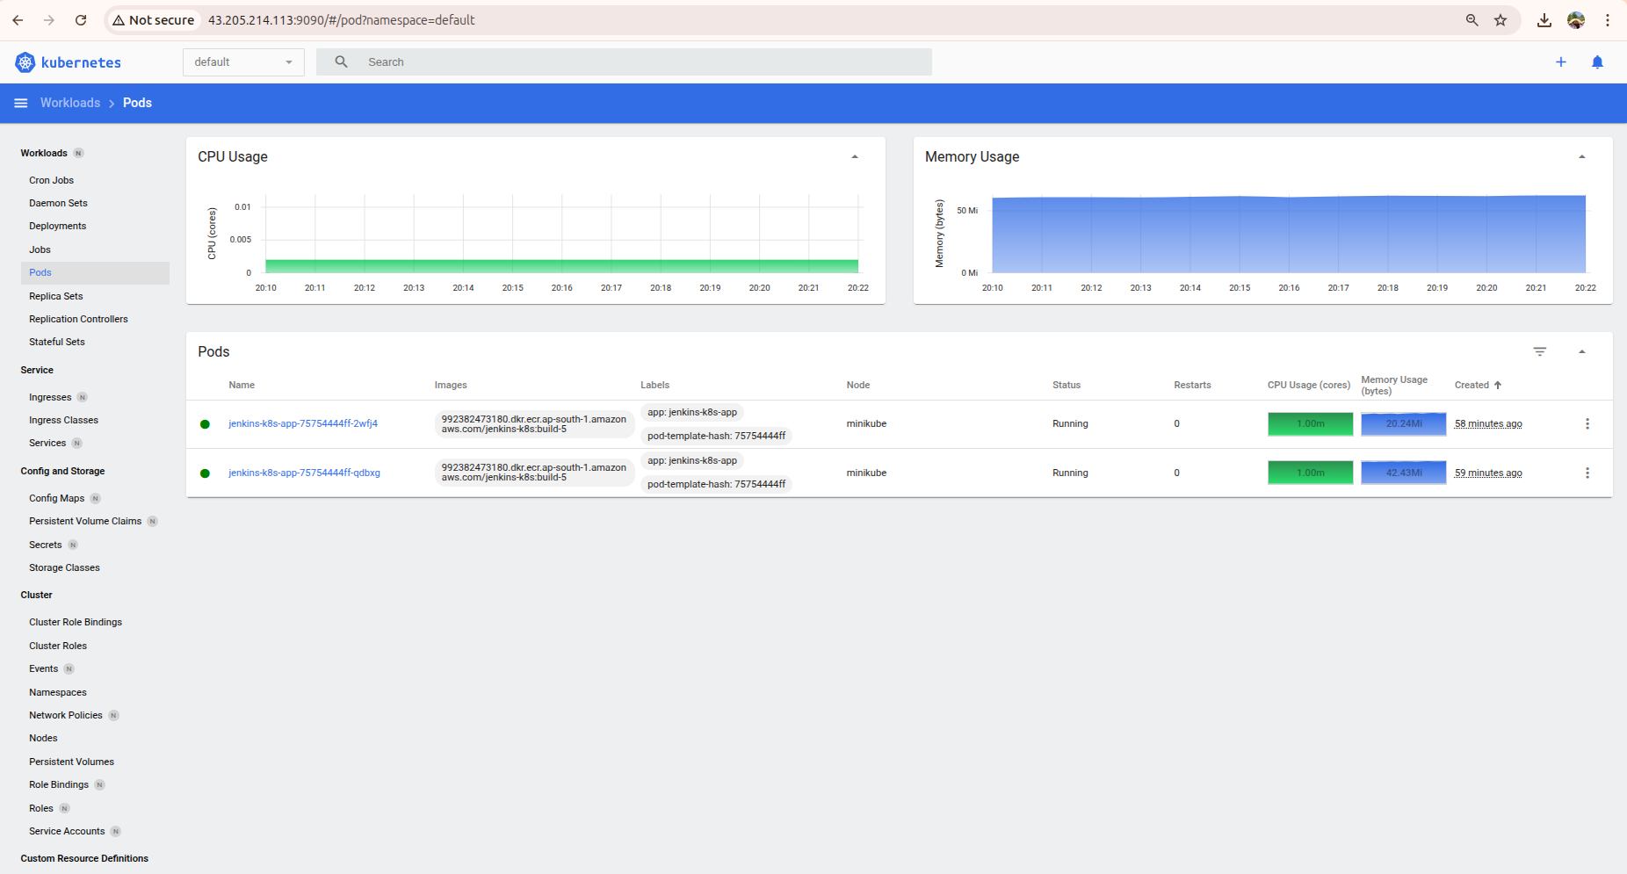

📸 Kubernetes Dashboard — Deployments View
http://<your-ec2-ip>:9090/#/deployment
Take screenshot of the Deployments section showing jenkins-k8s-app with 2/2 pods available
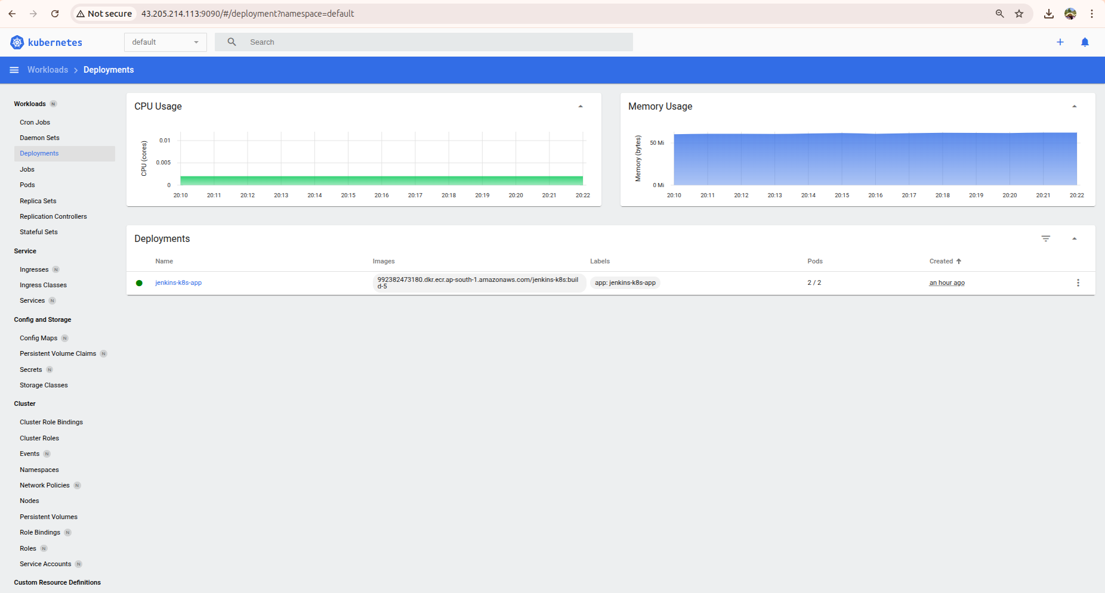

Key Things to Check in Dashboard
- Workloads → Pods — both pods show green Running status
- Workloads → Deployments — shows 2 desired, 2 available
- Service → Services — jenkins-k8s-service with NodePort 30080
- Config → Secrets — ecr-secret present for image pulling

Login Token Command
kubectl -n kubernetes-dashboard create token admin-user

4. Prometheus — Metrics Collection
Prometheus scrapes metrics from all Kubernetes pods and nodes every 15 seconds. You can query any metric using PromQL.

📸 Prometheus — Targets Page
http://<your-ec2-ip>:8090/targets
Take screenshot of the Targets page showing all scrape targets as UP (green)
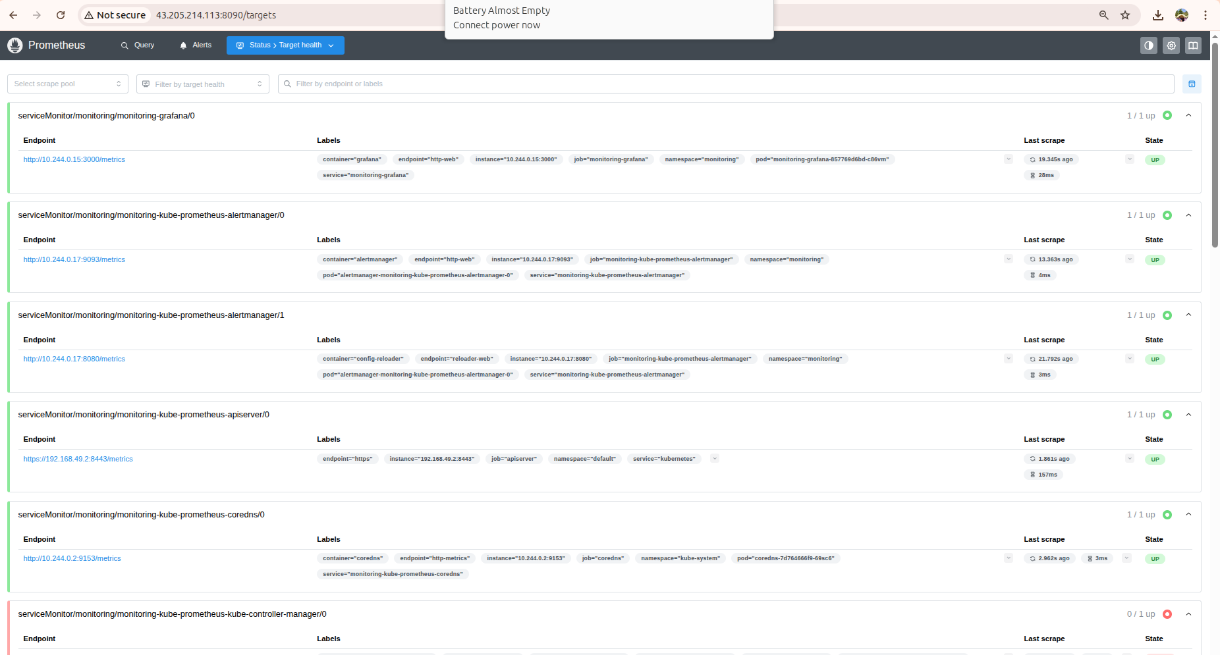

📸 Prometheus — Graph Query
http://<your-ec2-ip>:8090/graph
Take screenshot of a PromQL query result e.g. container_cpu_usage_seconds_total
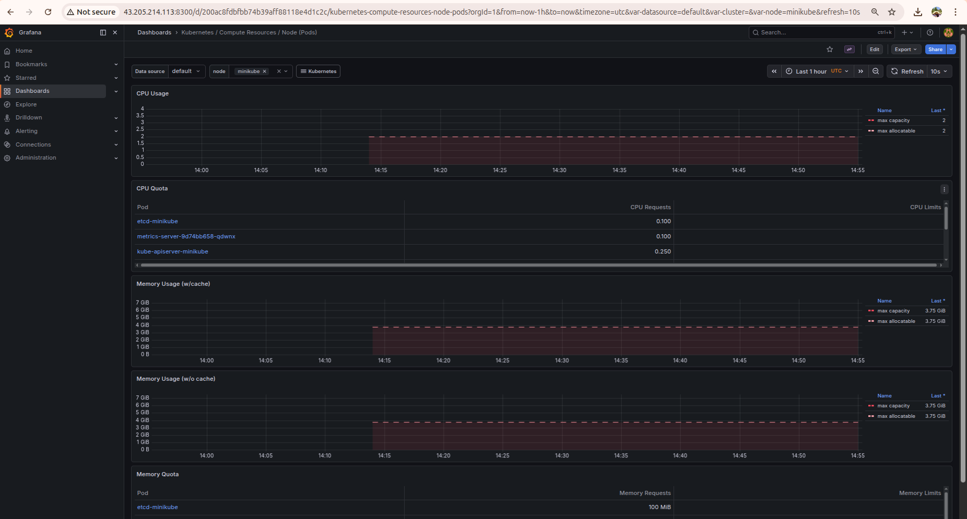

Useful PromQL Queries to Try
Query | What it Shows
up | All targets that are scraping successfully
container_memory_usage_bytes | Memory usage per container
container_cpu_usage_seconds_total | CPU usage per container
kube_pod_status_phase | Pod phase (Running/Pending/Failed)
kube_deployment_status_replicas_available | Available replicas per deployment

5. Grafana — Monitoring Dashboards
Grafana visualises Prometheus metrics in rich dashboards. The kube-prometheus-stack Helm chart pre-installs several Kubernetes dashboards automatically.

📸 Grafana — Kubernetes Pods Dashboard
http://<your-ec2-ip>:8300
Take screenshot of the Kubernetes/Pods dashboard showing CPU and memory graphs for jenkins-k8s-app pods


📸 Grafana — Node Overview Dashboard
http://<your-ec2-ip>:8300
Take screenshot of the Node Exporter dashboard showing EC2 CPU, memory and disk usage
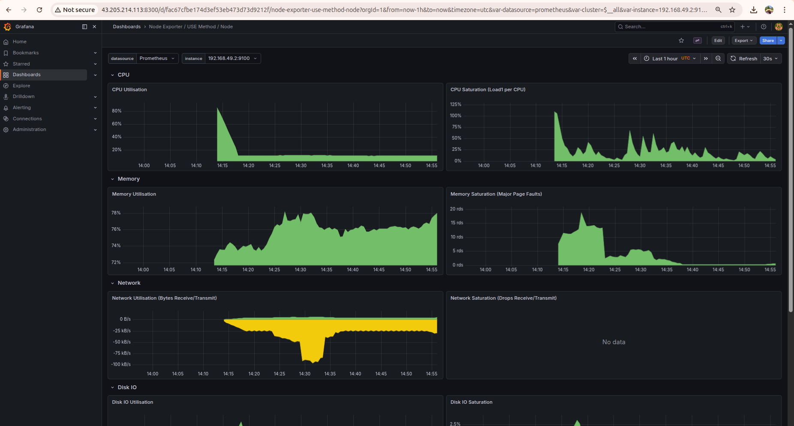

Grafana Login Details
Field | Value
URL | http://<your-ec2-ip>:8300
Username | admin
Password | admin123 (set during Helm install)

Pre-built Dashboards Available
- Kubernetes / Pods — CPU, memory, restarts per pod
- Kubernetes / Nodes — Node resource utilisation
- Kubernetes / Deployments — Replica status and rollout history
- Kubernetes / Namespaces — Overview of all namespaces
- Node Exporter Full — Deep EC2 server metrics

EC2 & Setup Reference

EC2 Instance Configuration
Setting | Value
Name | jenkins-k8s-server
OS | Ubuntu 22.04 LTS
Instance Type | t2.medium (2 vCPU, 4GB RAM — Minikube minimum)
Storage | 25GB (Docker images + K8s needs space)
IAM Role | ec2-ecr-role (AmazonEC2ContainerRegistryFullAccess)

t2.medium costs ~$0.046/hour (~$1.10/day). Always stop the instance when not learning to avoid unnecessary charges.

Security Group Ports
Port | Source | Purpose
22 | My IP | SSH
8080 | 0.0.0.0/0 | Jenkins UI
8888 | 0.0.0.0/0 | Node.js App
8300 | 0.0.0.0/0 | Grafana
8090 | 0.0.0.0/0 | Prometheus
9090 | 0.0.0.0/0 | K8s Dashboard
30000-32767 | 0.0.0.0/0 | Kubernetes NodePort range

Kubernetes Manifest Files

k8s/deployment.yaml
Defines how the app runs in Kubernetes — 2 replicas, rolling update strategy, health probes, resource limits:

apiVersion: apps/v1
kind: Deployment
metadata:
name: jenkins-k8s-app
spec:
replicas: 2
strategy:
type: RollingUpdate
rollingUpdate:
maxSurge: 1
maxUnavailable: 0
template:
spec:
imagePullSecrets:
- name: ecr-secret
containers:
- name: jenkins-k8s-app
image: IMAGE_PLACEHOLDER
readinessProbe:
httpGet:
path: /health
port: 3000
livenessProbe:
httpGet:
path: /health
port: 3000
resources:
requests:
memory: 64Mi
cpu: 100m
limits:
memory: 128Mi
cpu: 200m

k8s/service.yaml
Exposes the deployment as a NodePort service accessible from outside the cluster:

apiVersion: v1
kind: Service
metadata:
name: jenkins-k8s-service
spec:
type: NodePort
selector:
app: jenkins-k8s-app
ports:
- port: 80
targetPort: 3000
nodePort: 30080

Key Kubernetes Concepts Learned

Core Kubernetes Objects
Object | What it is
Pod | Smallest deployable unit — one or more containers running together
Deployment | Manages pods — ensures desired replica count, handles rolling updates
Service | Stable network endpoint to reach pods — pods come and go but service stays
Namespace | Virtual cluster within a cluster — isolates resources by team or environment
Secret | Stores sensitive data like ECR credentials, encoded in base64
ConfigMap | Stores non-sensitive config data as key-value pairs

Rolling Update Strategy
The deployment uses RollingUpdate with maxSurge=1 and maxUnavailable=0. This means:
- maxSurge: 1 — one extra pod can be created during update (briefly 3 pods running)
- maxUnavailable: 0 — zero pods can go down during update (zero downtime)
- Kubernetes starts new pod, waits for readiness probe to pass, then removes old pod
- If new pod fails readiness probe — rollout stops, old pods stay running

This is zero-downtime deployment. Users never see a gap in service during updates.

Health Probes
Probe | Purpose | Failure Action
Readiness | Is pod ready for traffic? | Remove from service — no traffic
Liveness | Is pod still alive? | Kill and restart the pod

ECR Secret Refresh
ECR login tokens expire every 12 hours. The pipeline refreshes the secret on every build:
ECR_PASSWORD=$(aws ecr get-login-password --region $AWS_REGION)
kubectl create secret docker-registry ecr-secret \
--docker-server=<ECR_URI> \
--docker-username=AWS \
--docker-password=$ECR_PASSWORD \
--dry-run=client -o yaml | kubectl apply -f -

The --dry-run=client -o yaml | kubectl apply -f - pattern is the correct way to create-or-update a secret. Using kubectl create alone fails if the secret already exists.

Port Forwarding
Minikube runs inside Docker on EC2. Its internal IP (192.168.49.x) is not reachable from outside. Port forwarding bridges EC2 public ports to Minikube services:
kubectl port-forward service/<name> <ec2-port>:<service-port> --address 0.0.0.0 &

Port forwards stop when SSH session closes. Run ~/port-forwards.sh after every EC2 restart or SSH reconnect.

kubectl Commands Reference

Essential Commands
Command | What it Does
kubectl get pods | List all running pods
kubectl get pods -w | Watch pods update in real time
kubectl get services | List all services
kubectl get deployments | List all deployments
kubectl get all | List everything in default namespace
kubectl describe pod <name> | Detailed info + events for a pod
kubectl logs <pod-name> | View pod application logs
kubectl logs -f <pod-name> | Follow live logs
kubectl exec -it <pod> -- sh | Open shell inside a running pod
kubectl top pods | CPU and memory usage per pod
kubectl top nodes | CPU and memory usage of the node
kubectl apply -f file.yaml | Create or update resource from file
kubectl delete -f file.yaml | Delete resource defined in file
kubectl rollout status deployment/<name> | Watch deployment rollout progress
kubectl rollout undo deployment/<name> | Roll back to previous deployment
kubectl scale deployment <name> --replicas=3 | Scale deployment to 3 replicas
kubectl get events --sort-by=.metadata.creationTimestamp | Recent cluster events sorted by time

Port Forwards Script
Run this script after every EC2 restart or SSH reconnect to bring all services back online:

#!/bin/bash
pkill -f 'kubectl port-forward' || true
sleep 2

# Node.js App
kubectl port-forward service/jenkins-k8s-service \
8888:80 --address 0.0.0.0 &

# Kubernetes Dashboard
kubectl port-forward service/kubernetes-dashboard \
9090:80 --address 0.0.0.0 \
-n kubernetes-dashboard &

# Grafana
kubectl port-forward service/monitoring-grafana \
8300:80 --address 0.0.0.0 \
-n monitoring &

# Prometheus
kubectl port-forward service/monitoring-kube-prometheus-prometheus \
8090:9090 --address 0.0.0.0 \
-n monitoring &

echo 'All services started!'
echo "App: http://$(curl -s ifconfig.me):8888"
echo "Dashboard: http://$(curl -s ifconfig.me):9090"
echo "Grafana: http://$(curl -s ifconfig.me):8300"
echo "Prometheus: http://$(curl -s ifconfig.me):8090"

Save as ~/port-forwards.sh and run with: bash ~/port-forwards.sh

What to Learn Next

Week 5 Option A — Security Scanning
- Add SonarQube stage for code quality analysis in Jenkins
- Add OWASP Dependency Check for vulnerable npm packages
- Add Trivy for Docker image vulnerability scanning
- Add secret scanning with truffleHog

Week 5 Option B — Terraform Infrastructure as Code
- Write Terraform to provision EC2, ECR, IAM roles automatically
- Replace manual AWS console clicks with code
- Manage state in S3 backend
- Create reusable modules for dev and prod environments

Week 5 Option C — Real AWS EKS
- Provision a real managed EKS cluster with eksctl
- Deploy the same app to EKS instead of Minikube
- Set up AWS Load Balancer for external access
- Configure Horizontal Pod Autoscaler

Kubernetes deployed. Prometheus scraping. Grafana visualising. ✅
App :8888 • Dashboard :9090 • Grafana :8300 • Prometheus :8090

