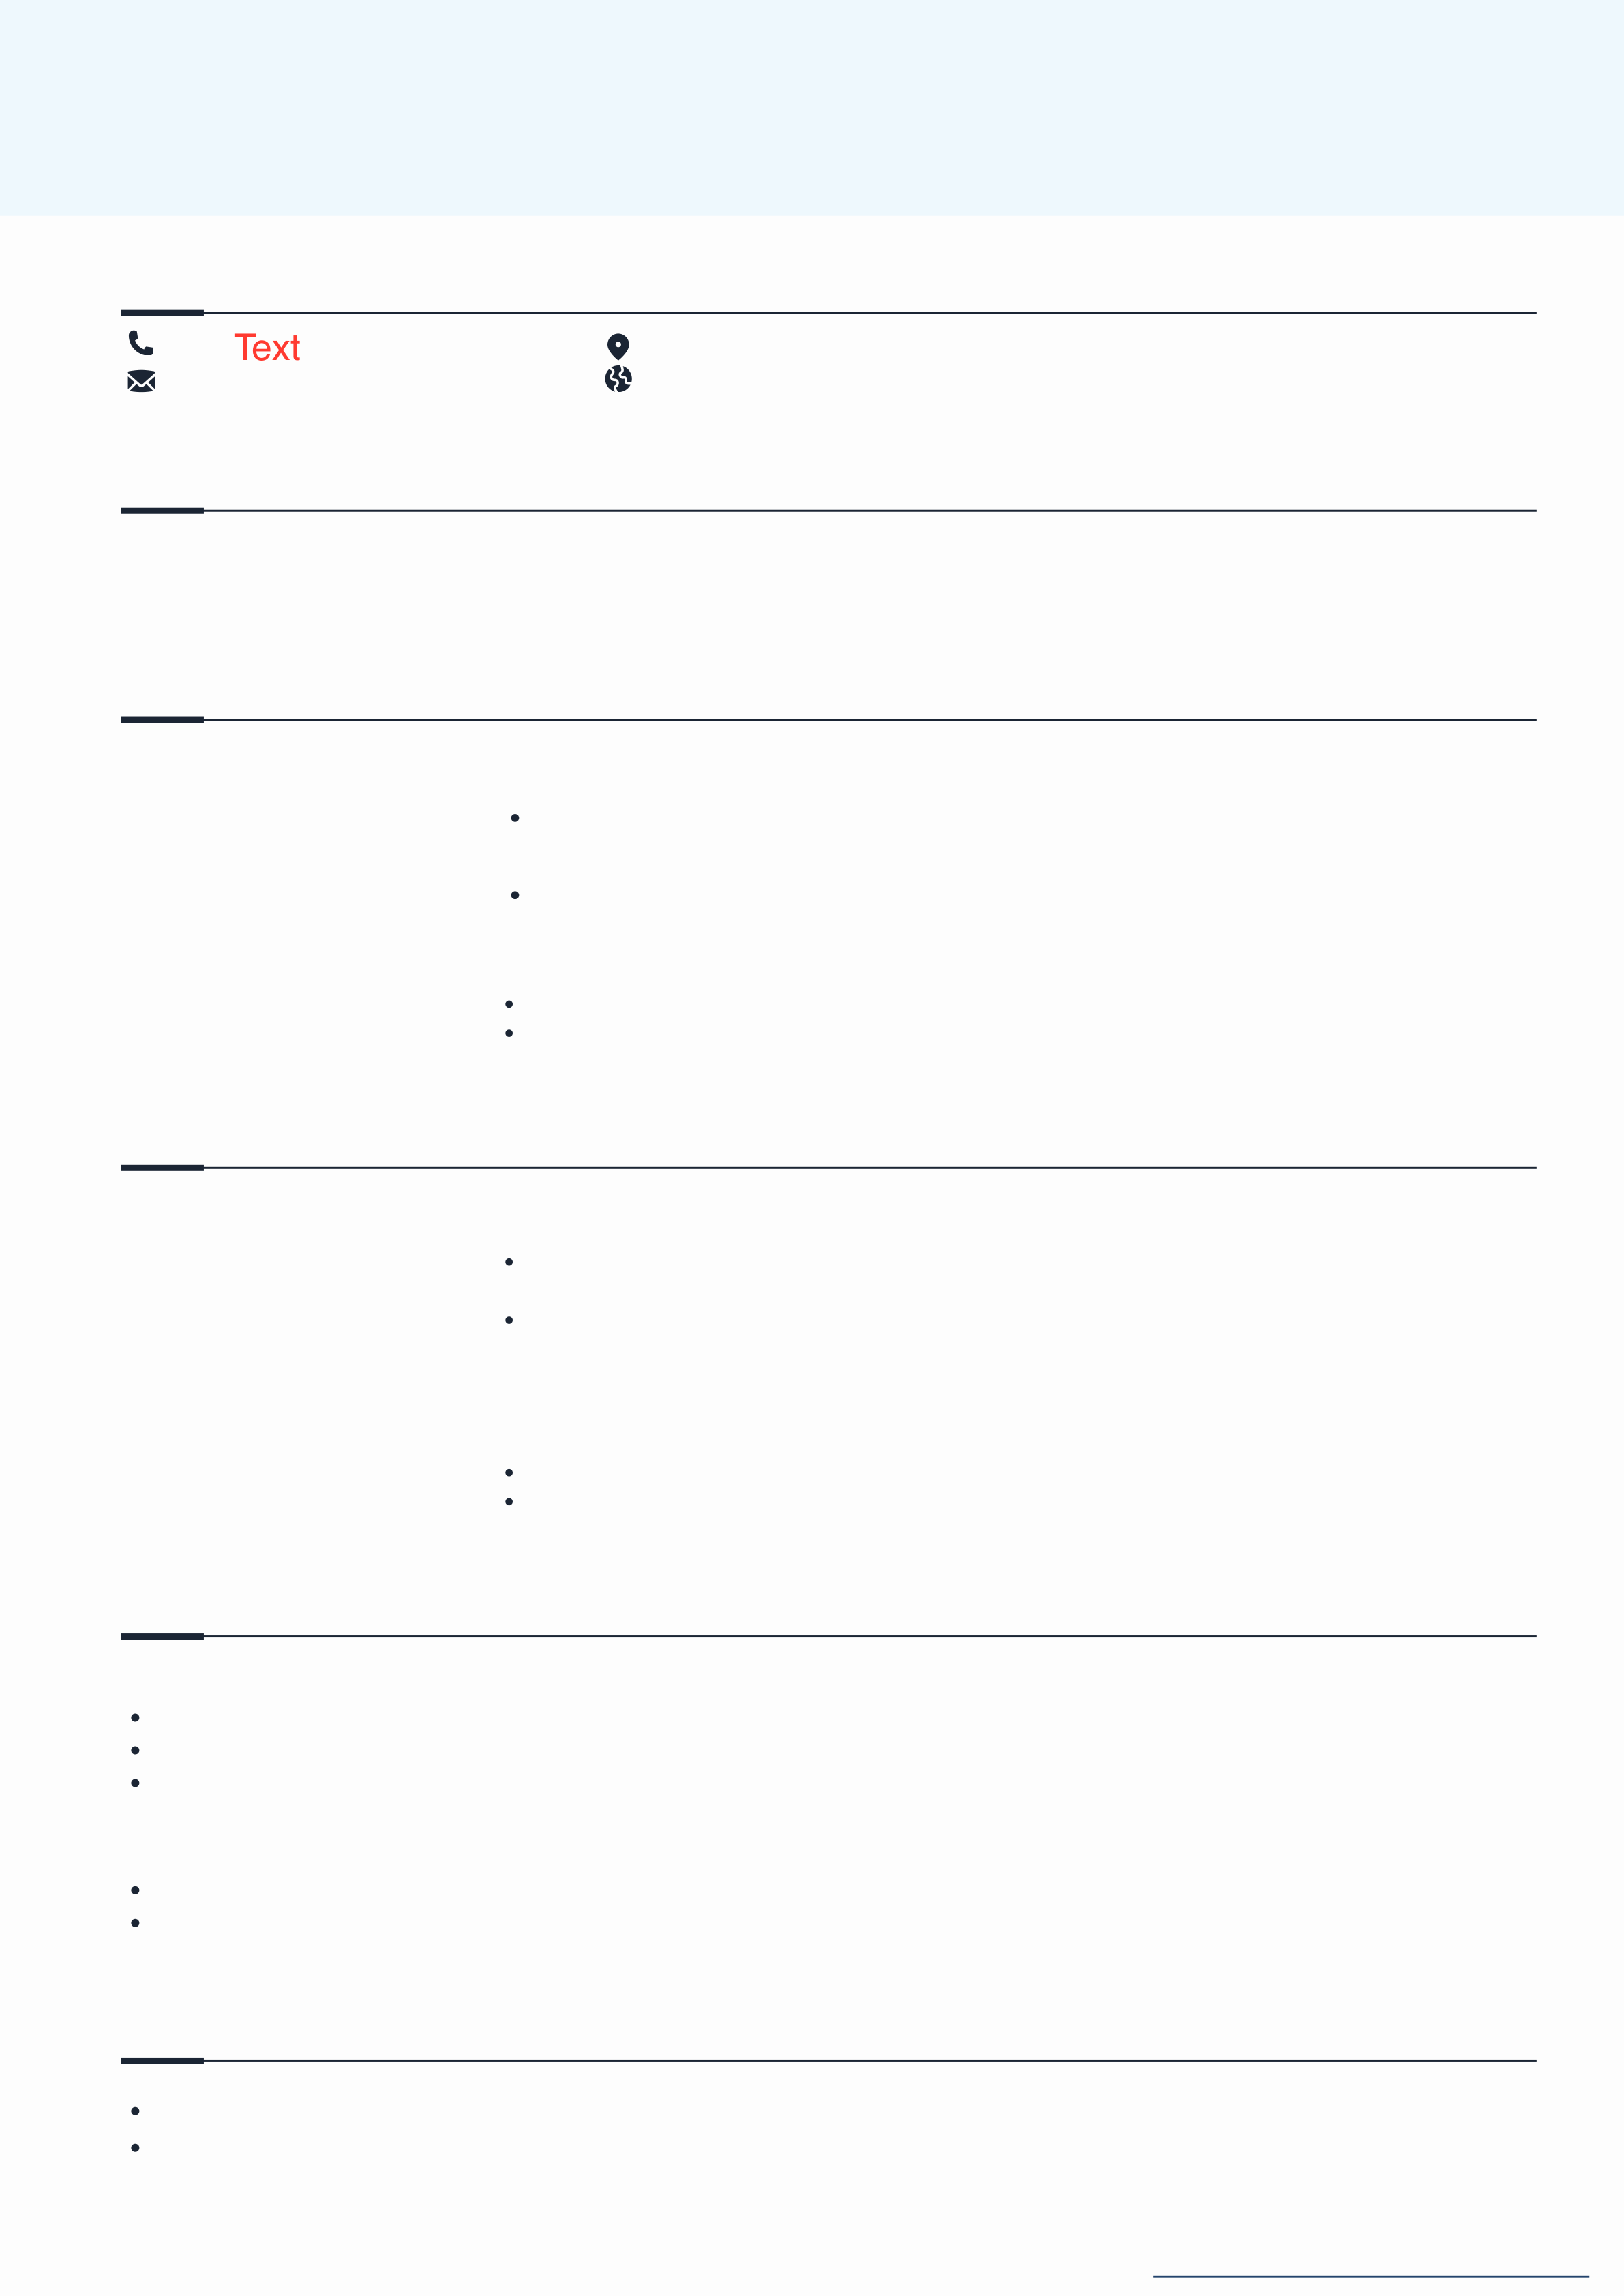

**RESUME POINTS (FRESHERS)**   
Here are a couple of reference points you can use to make your resume look more enhanced

**HEADER & CONTACT INFO**

|  |  |
| --- | --- |
| 123-456-7890 Text  hello@reallygreatsite.com | 23 Anywhere St., Any City  www.reallygreatsite.com |

**SUMMARY**

A highly motivated and detail-oriented Computer Science graduate with strong analytical skills and a passion for software development. Proficient in Python and Java, with experience in building web applications. Looking for an opportunity to apply technical and problem-solving skills in a dynamic work environment.

**EDUCATION**

|  |  |
| --- | --- |
| 2021-2025  XYZ University | **Bachelor of Technology (B.Tech) in Computer Science**   Relevant Coursework:   Data Structures & Algorithms, Database Management Systems, Machine Learning |

CGPA: 8.7/10

|  |  |
| --- | --- |
| 2020-2021  ABC School, CBSE | **Higher Secondary (Class XII)**  Scored 92% with a focus on Mathematics, Physics, and Computer Science.  Ranked among the top 5% of the class and actively participated in coding competitions. |

**INTERNSHIPS (IF ANY)**

|  |  |
| --- | --- |
| June-Aug 2024  ABC Tech Solutions  May-July 2023  DEF Marketing Agency | **Software Development Intern**  Developed a responsive web application using React.js and Firebase, reducing manual data entry by 30%.  Assisted in debugging and optimizing existing JavaScript code, improving app performance.  **Marketing Intern**  Conducted market research and competitor analysis to identify customer trends. Managed social media accounts, increasing engagement by 25% over two months. |

**ACADEMIC PROJECTS**

**AI-Based Chatbot for Customer Support**   
 Developed a chatbot using Python and NLP techniques to automate customer inquiries.

Trained the model using TensorFlow, achieving 85% accuracy in intent recognition. Deployed the bot on a website using Flask, reducing response time by 50%.

**E-Commerce Website Using MERN Stack**   
Built a full-stack e-commerce application with React.js, Node.js, Express.js, and MongoDB. Implemented user authentication and payment integration using Stripe API.

**SKILLS**

**Technical Skills:** Python, Java, C++, React.js, SQL, Git, Firebase

**Soft Skills**: Teamwork, Problem-Solving, Communication, Time Management

*[Published on Shweta Arora’s channel](https://www.instagram.com/shwetaarora.in/)*

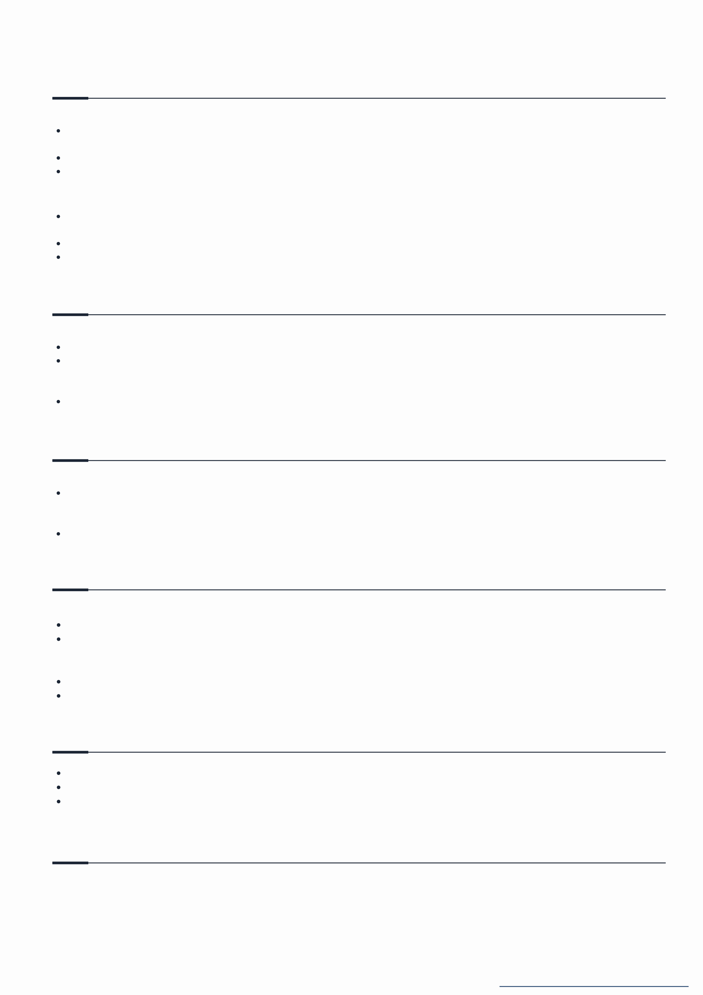

**CERTIFICATIONS & ONLINE COURSES**

**Data Structures & Algorithms Specialization – Coursera, 2023**   
Learned fundamental and advanced data structures, including arrays, linked lists, stacks, queues, trees, graphs, and hash tables.

Implemented sorting and searching algorithms like Quick Sort, Merge Sort, and Binary Search.

Solved over 100+ problems on algorithm optimization and competitive programming.

**Web Development Bootcamp – Udemy, 2022**   
Gained hands-on experience in front-end and back-end web development using HTML, CSS, JavaScript, and Bootstrap.

Built dynamic web applications using React.js and Node.js with Express.js.

Learned database management using MongoDB, SQL, and Firebase.

**EXTRACURRICULAR & LEADERSHIP ROLES**

**President – Coding Club, XYZ University (2023 – Present)**   
Organized hackathons and coding competitions, increasing club participation by 40%. Conducted workshops on Python and Web Development for 100+ students.

**Volunteer – NGO Helping Hands (2022 – 2023)**   
 Taught basic computer skills to underprivileged children as part of a community program.

**SCHOLASTIC ACHIEVEMENTS**

**Winner, Hackathon 2024**   
 Secured 1st place in a university-level hackathon for building an AI-powered recommendation system.

**Scholarship for Academic Excellence**   
 Awarded merit-based scholarship for ranking in the top 5% of the class.

**POTFOLIO PROJECTS**

**Personal Portfolio Website (React.js & Tailwind CSS)**   
Designed and developed a fully responsive portfolio website to showcase projects and skills. Integrated contact forms and blog sections, enhancing user engagement.

**Stock Price Predictor using Machine Learning**   
Built a predictive model using Python, Pandas, and Scikit-Learn to forecast stock trends. Achieved an accuracy of 80% using LSTM-based deep learning models.

**HOBBIES & INTERESTS**

Blogging about technology and career tips on Medium   
Playing chess and participating in online tournaments   
Exploring new programming frameworks and open-source contributions

**REFERENCES**

|  |  |  |  |  |  |
| --- | --- | --- | --- | --- | --- |
| **Krisha Babu** | **Phone:** | 123-456-7890 | **Sharin Varma** | **Phone:** | 123-456-7890 |
| **Social:** | @reallygreatsite | HRD of Borcelle Company | **Social:** | @reallygreatsite |
| CEO of Borcelle Company |

*[Published on Shweta Arora’s channel](https://www.instagram.com/shwetaarora.in/)*