CA - 2
NAME – KARAN RAJESH CHAVHAN
ROLL NO = AI3026
CLASS = TY CSE(AIML)
SUBJECT = ADVANCED MACHINE LEARNING
DATE = 8/5/26

Movie Recommender System

1. Introduction
The Movie Recommender System is an intelligent application designed to suggest movies based on user preferences. By leveraging advanced machine learning algorithms and content-based filtering techniques, this system analyzes movie genres and provides personalized recommendations to enhance the user's movie-watching experience.
The primary objective of this project is to create a user-friendly interface that enables movie enthusiasts to discover new films similar to their favorites. The system processes movie metadata and computes similarity scores between movies to generate accurate recommendations in real-time.
This project demonstrates practical applications of data science, machine learning, and modern web technologies in building a scalable recommendation engine suitable for deployment in production environments.

2. Working / System Architecture
- The Movie Recommender System operates through the following process:
- Data Loading: The system loads movie data from a CSV file containing movie titles and genres.
- Data Preprocessing: Missing values are handled gracefully, and data is cleaned to ensure consistency.
- Feature Vectorization: Movie genres are converted into numerical vectors using CountVectorizer from scikit-learn.
- Similarity Calculation: Cosine similarity is computed between all movies based on their genre vectors.
- Recommendation Generation: When a user enters a movie name, the system retrieves the top 5 most similar movies.
- Result Display: Recommendations are displayed in an intuitive, user-friendly interface built with Streamlit.

2.1 System Flow
1. User Input → 2. Search Movie Database → 3. Extract Movie Features (Genre)
↓
4. Compute Similarity Scores → 5. Rank Movies by Similarity → 6. Return Top 5 Recommendations
↓
7. Display Results to User

3. Technologies Used
Technology | Purpose
Python 3.x | Core programming language for backend development
Streamlit | Web framework for building interactive data applications with minimal code
Pandas | Data manipulation and analysis library for handling CSV files and dataframes
NumPy | Numerical computing library for mathematical operations and array handling
scikit-learn | Machine learning library providing CountVectorizer and cosine similarity functions
CSV Format | Data storage format for movie information

4. Algorithm: Cosine Similarity & Content-Based Filtering

4.1 Overview
The Movie Recommender System uses Content-Based Filtering with Cosine Similarity as its core algorithm. This approach analyzes movie features (specifically genres) and recommends movies that are most similar to the user's input movie.

4.2 Algorithm Steps
- Feature Extraction: Extract genre information from each movie in the dataset.
- Vectorization: Convert genre text into numerical vectors using CountVectorizer (Bag-of-Words model).
- Similarity Computation: Calculate cosine similarity between the input movie and all other movies.
- Ranking: Sort movies by similarity scores in descending order.
- Selection: Return the top N (default 5) most similar movies excluding the input movie itself.

4.3 Cosine Similarity Formula
Cosine Similarity (A, B) = (A · B) / (||A|| × ||B||) , where value ranges from 0 to 1
• A · B = dot product of vectors
• ||A|| and ||B|| = magnitude of vectors
• Value closer to 1 = higher similarity

4.4 Why Cosine Similarity?
- Efficient: Computationally fast and scalable for large datasets
- Effective: Works well with high-dimensional sparse data (genre vectors)
- Normalized: Similarity scores are bounded between 0 and 1, making interpretation straightforward
- Simple: Easy to implement and understand
- Content-Based: Does not require user ratings or collaborative data

4.5 Example
Movie 1: "The Matrix" → Genres: Action, Sci-Fi
Movie 2: "Inception" → Genres: Action, Sci-Fi, Thriller
Movie 3: "Titanic" → Genres: Romance, Drama
When user searches "The Matrix":
- Similarity with Inception: 0.89 (High - shares Action, Sci-Fi genres)
- Similarity with Titanic: 0.25 (Low - no common genres)
- Result: "Inception" will be recommended as the top suggestion

5. Key Features
- Real-time Recommendations: Instant movie suggestions based on genre similarity
- Error Handling: Graceful handling of missing files and invalid inputs
- Data Caching: Optimized performance through intelligent caching mechanisms
- User-Friendly Interface: Intuitive Streamlit-based UI with emojis and clear guidance
- Scalability: Architecture supports easy scaling and deployment to cloud platforms
- Case-Insensitive Search: Flexible movie name input without exact case matching

6. How to Use

6.1 Installation
- Create a virtual environment: python -m venv venv
- Activate virtual environment: venv\Scripts\activate (Windows)
- Install dependencies: pip install -r requirements.txt
- Run the application: streamlit run app.py

6.2 Running the Application
1. Execute the command: streamlit run app.py
2. The application will open in your default browser at http://localhost:8501
3. Enter a movie name in the text field
4. Click the "Recommend" button
5. View the 5 most similar movies

7. Advantages & Potential Applications

7.1 Advantages
- Low Latency: Fast recommendations without requiring complex database queries
- No Cold Start Problem for Items: Works well even for new movies with genres
- Transparency: Users can easily understand why a movie is recommended
- No User Data Required: Does not require user ratings or personal information
- Easy Maintenance: Simple to update with new movie data

7.2 Potential Applications
- Entertainment Platforms: Netflix, Amazon Prime, Disney+ style recommendation systems
- Movie Theaters: Interactive kiosks suggesting movies to customers
- Educational Platforms: Recommending educational documentaries or films
- Content Curation: Automated movie list generation for streaming services
- Social Networks: Friend-based movie recommendations

8. Limitations & Future Improvements

8.1 Current Limitations
- Genre-Only Analysis: Recommendations based solely on genres, ignoring other factors like cast, director, year
- Limited Features: No consideration of user ratings or popularity scores
- Scalability: May become slower with very large datasets (millions of movies)
- New Movie Problem: Requires manual genre entry for new movies
- No User Personalization: Cannot adapt recommendations to individual user preferences over time

8.2 Future Enhancements
- Hybrid Approach: Combine content-based filtering with collaborative filtering
- Additional Features: Include director, cast, release year, and user ratings
- Deep Learning: Implement neural networks for better feature representation
- User Profiles: Add user registration and personalized recommendation history
- Ratings & Feedback: Allow users to rate recommendations for continuous improvement
- Database Integration: Use SQL/NoSQL databases for better scalability

PROJECT IMAGE
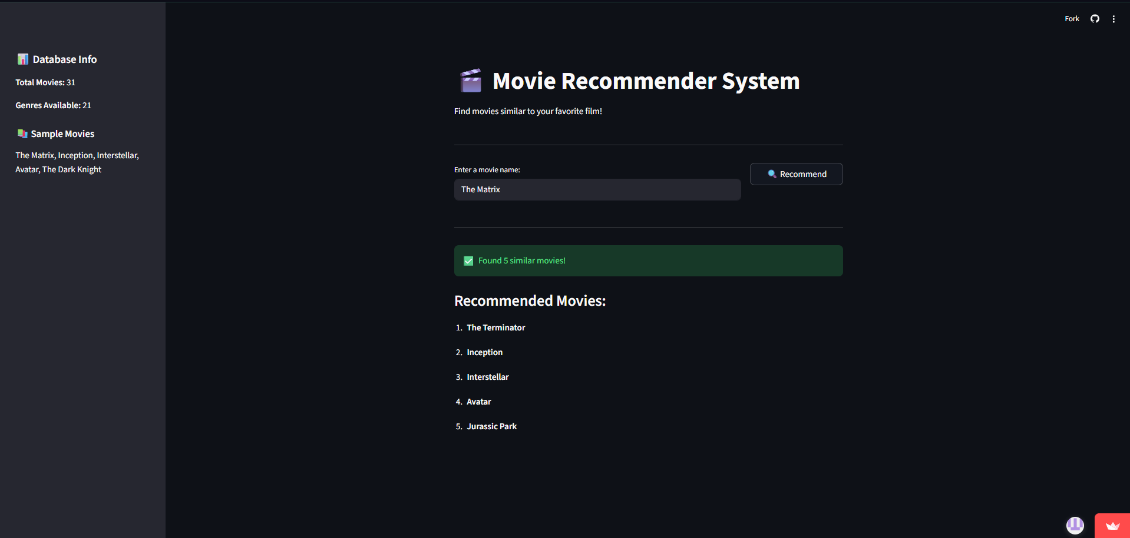

PROJECT LINK:
https://movie-recommender-idpnxyrnz24nxg4jjgqjqt.streamlit.app/

9. Conclusion
The Movie Recommender System demonstrates a practical implementation of machine learning concepts in a real-world application. By leveraging content-based filtering and cosine similarity algorithms, the system successfully recommends movies that align with user preferences based on genre similarity.
Key Achievements:
• Built an efficient, user-friendly recommendation system using Python and Streamlit
• Successfully implemented the cosine similarity algorithm for accurate recommendations
• Created a scalable architecture ready for deployment and enhancement
• Demonstrated effective error handling and data preprocessing techniques
This project serves as an excellent foundation for more advanced recommendation systems. By integrating additional features, collaborative filtering, and machine learning models, the system can be further enhanced to provide more personalized and accurate recommendations.
The Movie Recommender System represents a bridge between theoretical machine learning concepts and practical, production-ready applications. It showcases how simple yet powerful algorithms can create valuable solutions that enhance user experiences in the entertainment industry.
Potential Next Steps:
1. Integrate user ratings and feedback mechanisms
2. Expand features to include cast, director, and release year
3. Implement collaborative filtering for enhanced personalization
4. Deploy on cloud platforms (Streamlit Cloud, AWS, Azure)
5. Add database backend for better scalability and data management
This project proves that with the right combination of technologies and algorithms, creating intelligent recommendation systems is not only feasible but also practical and effective.

