**UNIFIED PL ONBOARDING - DIY JOURNEY**   
**ETB PA JOURNEY PROCESS NOTE**



**Version Tracking:**

|  |  |  |  |
| --- | --- | --- | --- |
| **Version** | **Date** | **Author** | **Version details** |
| 1.0 | 29-04-2024 | Abhinav Pachauri | Added scope for ETB PA CUG, Go-live |
| 1.0 | 27-05-2024 | Sai Padakanti | Added sections for   1. process note for disbursement failures in CORE APIs 2. Added checks for bank account validation |
| 1.0 | 05-07-2024 | Sai Padakanti | Added sections with new screenshots for   1. No Aadhaar 2. No Email 3. No PAN |

ETB PA 3

Login 3

CRN Confirmation 11

Active CRN Check 12

Rekyc pending or Partial KYC customers 13

NCIF Check 13

BCIF Email check 14

BCIF Aadhaar check 15

BCIF PAN check 15

No offer Page 16

Loan Offer Page 17

Key Fact Statement and Email: 22

Loan Disbursed Page and Partial Offer creation: 22

Disbursement flow for PA customers: 24

Process for disbursement failures in CORE/Journey 25

Checks for bank account validation 27

Customer Communication: 28

Data flow into SFDC 29

Reports: 31

OCC flow for Retargeting: 31

List of Post Go-live Gaps with Alignment: 31

Post Go-live Gaps with Tech Business Alignment: 31

Post Go-live Gaps without Tech Business Alignment: 32

Annexures: 32

Consents: 32

Privacy Policy: 33

# ETB PA

## Login

|  |  |
| --- | --- |
| **Scenario** | **Screenshot** |
| **URL to initiate onboarding journey**  This URL will be sent using SMS campaigns or emails campaigns. The URL is specific to ETB Login page. |  |
| **Journey entry page from a performance marketing URL for pre-approved customers:**  In case, the user clicks on a URL which is customized for pre-approved customers, the user should directly land on the login page of ETB customer |  |
| **ETB Login page:**   * The customer will input his   + DOB and   + mobile number. * Mobile number field must contain 10 digits * The only way to fill up the DOB is with the calendar—not by typing. * The consents to share data with bank-registered third-party vendors and consents based on calls, bureaus, and UIDAI are shown in the popup window that appears when the user clicks on the "Authorization and Consents" link. * “Get OTP to login” CTA is activated when every field is correctly filled in. * He agrees to the Declarations and Consents and Privacy Policy by clicking this CTA. * Based on Mobile Number and DOB, BCIF dedupe API will run at the backend.   + If dedupe is found, an OTP is triggered to the registered mobile number.   + If dedupe is not found, an error snack-bar is displayed to re-enter mobile number and DOB.( *Have added as an edge case scenario in one of the further pages)* * Clicking on “Back” button will take the user to the “Common Landing Page”. |  |
| **ETB login page Pop up:**   * By clicking on “Authorization and Consents”, the following pop-up will open along with a close button. * The text part has been pasted in annexure part. (Click here to view the consents) |  |
| **ETB login page Pop up:**   * By clicking on “Privacy Policy”, the following screen with close button will pop up. * The pic is a snap from a long page. * The full Privacy Policy is pasted in the annexure part. (Click here to go to the section)   Note:   * This is the standard privacy policy of Kotak uploaded on website. This can be accessed [here](https://www.kotak.com/en/privacy-policy.html) as well. | Inserting image... |
| **OTP Page:**   * The OTP delivered to the user's registered mobile number is entered by them. * The user hits the "Verify OTP to login" CTA once they have entered the 6-digit OTP. * It is possible to initiate the “Resend OTP” option if the OTP trigger is successful but has not reached the customer. * It will take 60 seconds for the “Resend OTP” to get enabled. For successive retries, the user must wait for 60 seconds. * The user can proceed with the journey if the OTP matches. * OTP trigger logs will be maintained at AWS journey, SFDC will not have this logs. * Application ID will be created at this point in Unified journey and SFDC both, if there is only one CRN for the combination ( MOB+DOB) * If there are multiple CRNs, then once CRN is selected by the customer in next screen, application gets created in Unified journey and SFDC both at the same time. |  |
| **Login page Edge Case 1:**   * If no ETB customer is found with combination of Mobile + DOB, an error message is displayed and user is asked to retry   **Possible UX Treatment:**   * Snack bar message "Invalid details entered, please re-try with correct details" |  |
| **Login Page Edge Case 2:**   * If the user doesn’t enter 10 digits in the mobile number field.   **Treatment:**   * “Get OTP to login” CTA wont get enabled. * User is not allowed to proceed. | **NA** |
| **OTP Page Edge Cases 1:**   * If the entered OTP doesn't match with OTP sent to the registered mobile number   **UX Treatment:**   * Display “Invalid OTP entered, please try again” message and option to re-enter OTP is given. |  |
| **OTP Page Edge Cases 2:**   * If the API which is responsible for triggering OTP to the registered mobile number fails or doesn't get triggered. * If the customers are landing on this screen, using Adobe analytics it can be tracked.   **Solution:**   * Retrigger API 3 times and even then, fails, then we re-direct user a specific error page called try again page * “Try Again” CTA should send the user to the login page. |  |
| **OTP Page Edge Case 3:**   * After 3 “Resend OTP” attempts, the limit gets exhausted.   **Solution:**   * The CTA for OTP verification stays disabled for 24 hrs. * User can always use “back” button to go to login page. * Snack bar message saying, “Verification suspended, please try again after 24 hours”. | **TBD** |
| **OTP Page Edge Case 4:**   * Due to network issues, if the message doesn’t reach the phone.   **Solution:**   * User can click “Resend OTP” option and another new OTP will be sent to the registered mobile number. | NA |

## CRN Confirmation

|  |  |
| --- | --- |
| **Confirm your CRN page:**   * When two or more CRNs are connected to a specific combination of Mobile Number + DOB, this page will be shown. * Name associated to CRN is visible * CRN number is masked with last 4 digits visible * The offer appears on the following page when the user hits the "Continue with selected CRN" CTA, triggering the API to see if any offer exists for the CRN * In SFDC, Application gets created only after CRN is selected [for multi CRNs scenarios] |  |

## Active CRN Check

|  |  |
| --- | --- |
| **Suspended or blacklisted or AUS CRNs:**  **In the backend once CRN is selected (**manually when there are 2 or more CRNs and automatically when there is only 1 CRN associated), CRN and associated accounts check the following checks and decisions are taken  **Suspended or blacklisted or AUS CRNs**   * If customer is detected to have as CRN is suspended or blacklister or Authorized signatory of a corporate:   + Reject with a block screen * Only active CRNs are allowed to proceed * SFDC is updated with appropriate rejection reasons, once customer gets rejected due to non-active CRN reasons. |  |
| **Technical failure while fetching the offer**   * Unable to fetch an offer from the offer table.   **Solution:**   * Retrigger API 3 times and even then, fails, then we re-direct user a specific error page called try again page * “Try Again” CTA should send the user to the previous page. |  |

## Rekyc pending or Partial KYC customers

|  |  |
| --- | --- |
| Re-Kyc pending or Partial KYC customers | As confirmed by Risk team,  These customers will not be part of the pre-approved offer base.  **Note:** Customer with valid PA offer will only be allowed to avail the disbursement |

## NCIF Check

|  |  |
| --- | --- |
| **NCIF Check:**   * NCIF database contains RBI intentional defaulters list & Terrorism list along with other negative customers * Customers who have their PAN in NCIF database get rejected with a blocker screen. * The rest of the customers proceed with the journey. |  |

## BCIF Email check

|  |  |
| --- | --- |
| **BCIF Email not found:**  BCIF Email is not found   1. If customer’s Email address is not found in BCIF, 2. Customer sees this screen 3. Customer can click on the link which takes them to    1. mobile banking [if App is installed]    2. Net-banking [if App is not installed] 4. Customer can update their Email and come back to the journey to resume their application 5. **By using this URL:** <https://onboarding.kotak.com/pl/resume-journey> |  |

## BCIF Aadhaar check

|  |  |
| --- | --- |
| **BCIF Aadhaar not found:**  BCIF Aadhaar is not found   1. If customer’s Aadhaar is not found, 2. Customer sees this screen 3. Customer can click on the link which takes them to    1. mobile banking [if App is installed]    2. Net-banking [if App is not installed] 4. Customer can update their Aadhaar and come back to the journey to resume their application 5. **By using this URL:** <https://onboarding.kotak.com/pl/resume-journey> |  |

## BCIF PAN check

|  |  |
| --- | --- |
| **BCIF PAN not found:**  BCIF PAN is not found   1. If customer’s PAN is not found, 2. Customer sees this screen 3. Customer can click on the link which takes them to    1. mobile banking [if App is installed]    2. Net-banking [if App is not installed] 4. Customer can update their PAN and come back to the journey to resume their application 5. **By using this URL:** <https://onboarding.kotak.com/pl/resume-journey> |  |

## No offer Page

|  |  |
| --- | --- |
| The system checks for a valid PAPQ offer in the background.   1. If there's no offer, the customer sees the screen shown beside 2. If there is an offer, the customer goes to the offer screen to proceed ahead in the journey |  |

## Loan Offer Page

|  |  |
| --- | --- |
| **Loan Offer page:**  **What is happening:**   * If a customer doesn’t have an offer, we reject him from the journey by showing a blocker screen. * Pre-approved offer or pre-qualified offer is shown to customer if customer has an offer. * Based on offer table details, loan amount and tenure sliders are pre-set with the limits * Customer can choose desired loan amount and tenure based on the requirement. * Loan amount and repayment tenure slider can be adjusted accordingly. * API will be triggered automatically to calculate the EMI amount and other allied factors like total amount to be repaid. |  |
| Clicking on “More details” option will show the user the following details |  |
| **Loan confirmation page:**   * All necessary details including loan details, fees and charges associated, repayment details are displayed. * The processing fee is fetched from the offer table.   + Fixed: Offer table provides a fixed processing fee.   + Percentage: Offer table provides a percentage of loan amount to be calculated. * APR is calculated at the backend based on loan amount and tenure selected by the customer. Formula and sample calculation shown below:  APR % = RATE [ Tenure, - EMI , (Loan Amount – Charges)] * 12  Charges: Loan Processing Fees * Example: APR % = RATE [ 24, -17690, (200000 – 2980)] * 12 = 14.00% [ APR] * Stamp duty is calculated based on core location from the offer table.   + Stamp-duty masters are maintained at the backend.   + Every core location has stamp duty     - Fixed     - Percentage     - Min     - Max * Rate of interest is fetched from the offer table. * EMI date is calculated in the journey, logic as follows:   + Agreement date <= 20th, EMI start date will be 02nd of next month   + Agreement date between 21st and 27th, EMI start date will be 05th of next month   + Agreement date > 27th, EMI start date will be 02nd of next+1 month * Total interest over loan tenor and total amount to be repaid are calculated at the backend in the journey and is displayed. * Amount disbursed after deductions is displayed on basis of following formula:   + Amount disbursed after deductions= Agreed loan amount – Stamp duty – Processing fees – charges (if any) * Self-declaration that the customer has accepted the loan offer and understood KFS, Fees and Charges is taken from the user. * Self-declaration to not to use the personal loan disbursed amount for speculative purposes. * Based on the above declaration, Loan purpose is stored as “Personal Expense” for APAC creation. * The disbursal account is fetched from the offer table and displayed along with the logo of the bank and whole account number is masked except for the last 4 digits. * “Change loan amount & tenure “will take the user back to the “Loan Offer” Page [previous page] to be able to change loan amount, tenure * Once checkboxes are ticked, “Agree to loan details” CTA is enabled. * Once CTA is clicked, the following details are stored in SFDC as OPS team may consume this as part of their work:   + Consents   + OTP logs   + IP address of customer   + Customer name   + CRN number   + T&C acceptance timestamp * KFS pdf is sent to the mail linked with BCIF post offer acceptance.   **Note:** Service Tax will be added while go-live. |  |
| **Terms and Conditions:**   * On clicking “Agree to loan details”, this page opens. * Customer can find the T&C content in scrollable format. * Customer after reading the T&C, clicks on “Agree to terms & conditions “. * Below details are stored as part of terms and conditions   + IP address of customer   + Customer name   + Timestamp   + CRN number * Find the full T&C pdf here: [here](https://dev.azure.com/kmbl-devops/9405cb77-33d0-42b8-9c28-eb9ae0b84ae5/_apis/wit/attachments/d2304175-e92b-421d-9896-4d327f893b1a?fileName=T%20and%20C%20doc%20in%20ETB%20Non%20PA%20journey.pdf&download=true)   **Note:**  The T&C added is an already approved document taken from the current live journey |  |

## Key Fact Statement and Email:

|  |  |
| --- | --- |
| **Key Fact Statement with Email**   1. Once customer has accepted the loan offer with fees and charges shown on the screen in last screen 2. An email will be sent to the customer along with KFS | Sample KFS pdf can be [accessed here](https://kotakeo.sharepoint.com/:b:/s/RetailAssets-UnifiedOnboarding/ES24HMbvMy5EhKhCk6a4BaYBOz3f7Z-4A_9v9w37STgIgg?e=YrMeOX) |

## Loan Disbursed Page and Partial Offer creation:

|  |  |
| --- | --- |
| **Success page:**   * Once disbursement workflow is triggered, this page is displayed. * Welcome letter is sent to mail post-disbursement through CORE system. * Welcome letter contains the welcome note having info regarding:   + Loan amount   + Repayment schedule   + First EMI date   + EMI amount   + Agreement no   + APAC no   + Digital Signature of PL head |  |
| **Partial offer:**   1. A customer has a pre-approved offer worth 5 lakhs 2. He claims 3 lacs from the journey. 3. A new offer with 2 Lacs will be generated only if it is meeting the offer creation criteria set in offer APIs   **Example offer creation:**  Balance Offer is created based on the min loan amount mentioned in the offer table and given offer is not expired:   * Consider a situation where a customer is eligible to avail an offer between 60,000 and 1.5 lacs. * Lets consider, he initially avails an offer of 1 Lac. * Now, 50,000 is the remaining limit but 60,000 is the minimum amount that he can avail. * In this case, partial offer is not created. | **NA** |

## Disbursement flow for PA customers:

|  |  |
| --- | --- |
| * **Pre-approved - SI Setup:** Upon Loan offer acceptance, the following set of API sequences gets triggered.   + Check offer is valid and available   + Update offer amount:     - Offer amount - consumed/disbursed loan amount * Post offer update API calls, based on the responses   + If the API responses are successful, then disbursement sequence of APIs gets triggered. The sequence of APIs is:     - ETB CRN mapping     - APAC Creation     - APAC Authorization     - SI Creation     - CORE Payment APIs   + If the response is a failure, then disbursement Apis does not get triggered. |  |
| **Pre-approved - NACH Extension for NKB:**   * Upon Loan offer acceptance, the following set of API sequences gets triggered.   + Check offer is valid and available   + Update offer amount:     - Offer amount - consumed/disbursed loan amount * Post offer update API calls, based on the responses   + If the API responses are successful, then disbursement sequence of APIs gets triggered. The sequence of APIs is:     - ETB CRN mapping     - APAC Creation     - APAC Authorization     - ECS Creation     - CORE Payment APIs |  |

## Process for disbursement failures in CORE/Journey

1. The PL Business team is provided with a dashboard where the disbursement statuses for each customer can be tracked that are coming from PL Unified journey
2. This dashboard is called “Temporal workflow” dashboard
3. The PL Business SPOC details:
   1. Vipin Tandon (Consumer Bank, KMBL) <[vipin.t@kotak.com](mailto:vipin.t@kotak.com)>
   2. Shweta S (Consumer Bank, KMBL) < [shweta.singh3@kotak.com](mailto:shweta.singh3@kotak.com)>
4. Failures in CORE APIs, can be due to one of the following reasons
   1. Technical issues
   2. Issue in BCIF, CORE (mismatch in data... Etc)
5. Based on CORE API failure reasons, PL business user will do following activities to complete disbursement for the customer
   1. Technical issues:
      1. user will re-call specific API
   2. Issues in BCIF, CORE:
      1. Raise it with underlying system owners for addressing issues.
      2. Once the data or mismatch issues are resolved, then retrigger the APIs using dashboard help
6. **Process for CORE APIs failure tracking:**
   1. Business user logins to the temporal dashboard to see the entire loan applications in the disbursement flow available with filters on applicationId, date, status etc..
   2. **Login dashboard:**  
      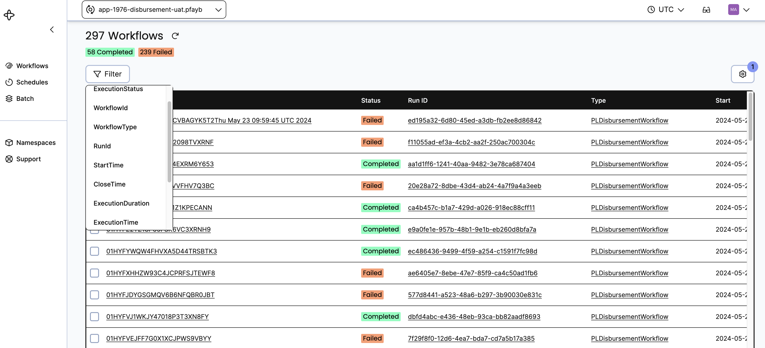
   3. Using the filters, user will filter the loan application based on status
   4. For the application where the workflow is failed, filters with status = FAILED
   5. Sequence of APIs and their status with timestamps are shown for each loan applications
   6. **Sequence of APIs and their statuses for an application:**  
      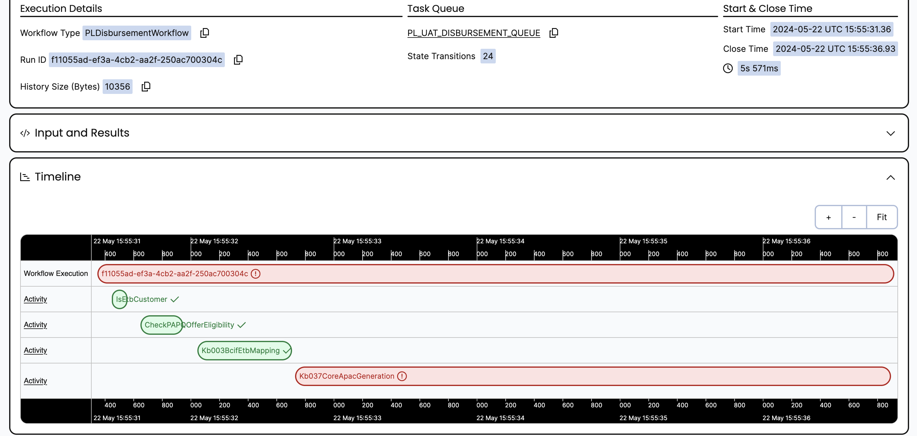
   7. The errors along with description specific to the APIs within the disbursement workflow can be taken from the individual loan application view
   8. **Logs with error description from each API:**  
      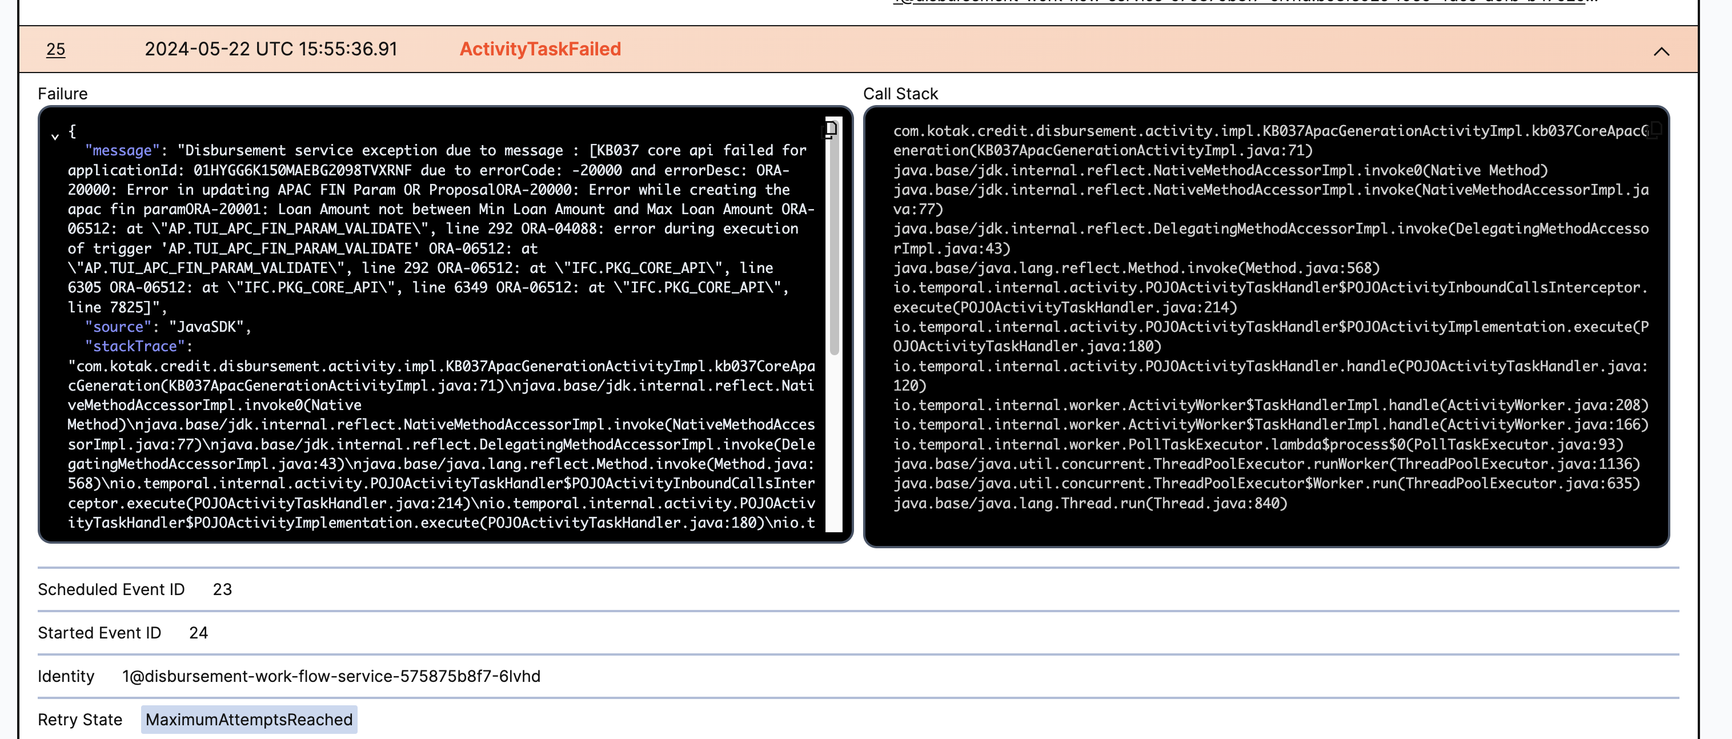
7. Tech and Tech product teams will help the business team get these reports on a time-to-time basis using dashboards, which enables business as usual to continue.
   1. Tech SPOC: Manish K (Corporate, KMBL) [manish.kumar28@kotak.com](mailto:manish.kumar28@kotak.com)
   2. Tech Product: Abhinav Pachauri (Corporate, KMBL) [abhinav.pachauri@kotak.com](mailto:abhinav.pachauri@kotak.com)

## Checks for bank account validation

1. Pre-approved offer generation follows a stringent process to propagate the information to CRMNext offer table.
2. In the journey:
   1. For Kotak Bank account customers:
      1. While SI Creation, core system has a validation in place
      2. It validates CRN and Account number mapping
   2. For Non-Kotak bank account customers:
      1. Penny drop will be completed, only if penny drop is success – Disbursement APIs will be triggered.
      2. Penny drop check will be part of Go-live release and not in CUG release

## Customer Communication:

|  |  |  |
| --- | --- | --- |
| **Alert** | **Description** | **SMS Template** |
| Login OTP | SMS will be triggered when Mobile OTP triggered to customer registered mobile number | Dear customer, OTP for your Personal Loan application process with Kotak Bank is {#var#}.Please do not share your OTP with any third party or person. |
| E-KYC success notifcation | SMS will be triggered when customer aadhaar OTP authentication successful | eKYC request for Kotak Personal Loan application at {#var#} on {#var#} using Aadhaar ending with {#var#} was successful! Authorisation Code: {#var#} |
| E-KYC decline notification | SMS will be triggered when customer aadhaar OTP authentication failed. | Kotak Personal Loan application eKYC {#var#} on {#var#} using Aadhaar x{#var#} was declined! Authorisation Code: {#var#}. We will contact you shortly. |
| VKYC [ Unable, Open] | SMS will be triggered when customer VKYC verification status is Open (or) Re-Open (or) Unable | Dear Customer, please click on the link below to complete your Kotak Bank Personal loan Video KYC for your PL application {#var#} from your mobile device.{#var#} |
| VKYC [ Agents busy] | SMS will be triggered when VKYC agents are busy | Dear Customer, All our agents are busy right now. Please click on the link {#var#} to complete your Kotak Bank Personal loan Video KYC verification between 9 am-7pm anytime (Except Sunday and holidays) |
| VKYC [ Success] | SMS will be triggered when VKYC verification is completed | Dear Customer, the video KYC conducted for your Kotak Bank Personal Loan {#var#} Is successfully approved. You will soon receive the alert for fund transfer |
| Disbursal | SMS will be triggered when Loan disbursement is completed | Dear {#var#}, We are pleased to inform you that we have initiated disbursement for Rs. {#var#} for your Kotak Personal Loan of Rs. {#var#}. It will take approximately 30 minutes to reflect funds in your bank account. |
| Loan Reject [DIY] | SMS will be triggered when Loan application is rejected | We’re sorry, your Personal Loan Application cannot be processed. As per guidelines, you cannot re-apply even via. Kotak branches or Contact Centre. Please try again after 6 months. |
| Resumption Link | SMS will be triggered when there is no activity performed by customer on the journey | Dear Customer, we noticed you left your Personal Loan application with Kotak Bank midway. Kindly complete it by clicking on the following link {#var#} |

## Data flow into SFDC

The following doc contains the detailed information on fields synced into SFDC: [Click here](https://kotakeo-my.sharepoint.com/:x:/g/personal/sanjay_joshi3_kotak_com/EQQ6pNRT7qNCnwQ7BcWWy0EBkRYtM57fhcIb4yleR25xsw?e=AQ7pbg)

**Summary:**

* The below information will give us the gist of stages, sub-stages and at what points data flow is triggered and list of objects updated for ETB PAPQ flow.
* *ACO- Accounts, Contact, Opportunity- They refer to the basic details of that particular loan applicant such as their personal details and banking details.

|  |  |  |  |
| --- | --- | --- | --- |
| **SFDC Stage** | **Unified journey milestone/Sub-Stage** | **At what point data flow is triggered** | **List of objects updated for ETB PA** |
| DIY | Application created | After customer selects CRN | ACO ( Eg: Loan application created is linked under Loan Applicant Contact ) |
| DIY | Applicant details submitted | After all applicant details are submitted | Not applicable |
| DIY | Offer generated | After BRE call is successful | ACO, Offer |
| DIY | Offer accepted | After T&C is accepted | ACO, Offer, Agreement |
| DIY | Bank details verified | After penny drop is successful | ACO, Repayment |
| DIY | Repayment setup initiated | After auto debit setup is initiated | ACO, Repayment |
| DIY | Repayment setup completed | After NACH setup is completed or SI is completed | ACO, Repayment |
| DIY | VKYC started | After customer initiates the VKYC | NA |
| DIY | Disbursement initiated | After Update offer API is triggered | ACO, DocRef |
| Disbursement | Disbursement completed | After CORE Payment APIs are successfully triggered | ACO |
| Rejected | Application rejected | If CRN is found blacklisted/suspended | ACO |
| Rejected | Application rejected | BRE reject |  |
| Rejected | Application rejected | NCIF Reject |  |
| Rejected | Application rejected | Age Reject |  |
| Rejected | Application rejected | Location Reject |  |

## Reports:

Similar Info will be shared to Business, which will be signed off part of UAT for the below reports:

1. Business Report
2. Technical Failure Report
3. BCIF missing data
4. Customer drop-off

## OCC flow for Retargeting:

* Roughly 50% of DIY cases today require intervention from OCC.
* OCC team goes into an SFDC view, sees cases, assigns as case to them, and upon assigning a case to themselves, trigger an SMS/email to customer .
* Detailed explanation along with sample screens is shown in the following document:[OCC Flow](https://kotakeo-my.sharepoint.com/:w:/g/personal/samrudh_s_kotak_com/EfHdnI1hfB1Ikjb8SapQNZsBjqatk1MiXvdQgdrz8SwGaQ?e=BBDTys)

## List of Post Go-live Gaps with Alignment:

### Post Go-live Gaps with Tech Business Alignment:

|  |  |  |
| --- | --- | --- |
| **Gap** | **Go-Live / Post Go-Live** | **Tech Business Alignment** |
| Offer data validation - mismatch in account info for SI | Post Go-Live | Yes |
| Offer data validation - mismatch in account info for NACH (or any other account problems for NKB customers) | Post Go-Live | Yes |
| Handling of changes in CRN/account status post offer generation | Post Go-Live | Yes |
| Single APAC creation for multiple active loans | Post Go-Live | Yes |
| Download App CTA | Post Go-Live | Yes |
| Slider for EMI | Post Go-Live | Yes |
| Make fees and charges configurable for business | Post Go-Live | Yes |
| PAN, aadhar, triangulation checks for ETB PAPQ customers | Post Go-Live | Yes |
| Handle NACH retries and failures from NACH | Post Go-Live | Yes |
| Ability to know about PF+ROI concerns and be able to change that automatically (capability exists in PAPQ via deactivating) - Dynamic pricing based on CIBIL score, loan amount based on drop-offs | Post Go-Live | Yes |
| Option to change EMI date | Post Go-Live | Yes |
| Show customer offer validity (validity will be 30 days) | Post Go-Live | Yes |
| Aadhaar OTP based nach mandate setup | Post Go-Live | Yes |
| Support for multilingual | Post Go-Live | Yes |

### Post Go-live Gaps without Tech Business Alignment:

|  |  |  |
| --- | --- | --- |
| **Gap** | **Go-Live / Post Go-Live** | **Tech Business Alignment** |
| Transition Telecaller workflow for PAPQ (VRMs, OCCs included) from CRMNext to new system (SFDC) | Post Go-Live | No |
| Dialler integration and priority based calling (SFDC changes) | Post Go-Live | No |
| Integration with Mobile Banking | Post Go-Live | No |
| Integration with Net Banking | Post Go-Live | No |
| Integration with Chatbot | Post Go-Live | No |
| KLI support (10-15 cr per month) | Post Go-Live | No |

# Annexures:

### Consents:

* 1. I authorize Kotak Bank to receive my personal details from UIDAI and use my Aadhar/VID details and core biometric information to authenticate and verify my identity.
  2. I also authorise Kotak Bank to make any enquiries regarding my repayment history with banks, financial institutions, credit bureaus, agencies, statutory bodies, etc. and share data with bank registered third party vendors as may be required for best offer generation.
  3. I further authorize Kotak Bank to contact me regarding my loan, including updates, offers, and reminders, through various channels such as calls, emails, WhatsApp, and other messaging platforms, even if I am registered for DND.

### Privacy Policy:

* 1. You agree that we may use Customer Information for the purpose of statistical analysis and for creation of data ("Statistical Information"), which does not contain individual Customer Information. In addition to the information that the Bank elicits from you, you are free to volunteer any other information that you feel that the Bank needs to know, but the security and confidentiality as per this Policy is guaranteed only to the information that the Bank directly asks from you.
  2. This Policy holds true for a non-customer who has provided information to the Bank, by any means, with the intentions of establishing a relationship, of whatsoever nature, with the Bank. By divulging any information to us you agree to the terms and conditions of this Policy.
  3. **Use of Customer Information / Statistical Information**
     1. We may use the Customer Information for, among other things, customer verification, provision of products and services, for personalization of products or services, marketing or promotion of our financial services or related products or that of our associates and affiliates; for creation of Statistical Information, statistical analysis or credit scoring, enforcement of your obligations, any other purpose that will help us in providing you with optimal and high quality services.
  4. **Security**
     1. We have taken reasonable measures to protect security and confidentiality of the Customer Information and its transmission through the World Wide Web. You are required to follow the Terms and Conditions while using this Website including the instructions stated therein in respect of security and confidentiality of your Log-in and Password.
     2. The Bank will give access to Customer Information to only authorised employees. Employees who violate this Privacy Policy shall be subject to disciplinary process as per the byelaws of the Bank. Any employee who withdraws from the employment of the Bank will have to undertake to abide by this Privacy Policy and keep all Customer Information secure and confidential.
  5. **Disclosure**
     1. We shall not be held liable for disclosure of the Customer Information or Statistical Information in accordance with this Privacy Commitment or in terms of any other agreements with you.
     2. We may disclose the Statistical Information to any person, without any limitation and you hereby give your consent for the same.
     3. We may disclose Customer Information to any of our associates and affiliates, without any limitation and you hereby give your consent for the same.
     4. We may disclose the Customer Information to third parties for following, among other purposes, and will make reasonable efforts to bind them to obligation to keep the same secure and confidential and an obligation to use the information for the purpose for which the same is disclosed, and you hereby give your consent for the same: -
     5. For advertising. or
     6. For facilitating joint product promotion campaigns. or
     7. We may disclose the Customer Information, to third parties, without limitation, for the following reasons;
        1. To comply with legal requirements, legal process, legal or regulatory directive/ instruction. or
        2. To enforce the Terms and Conditions of the products or services. or
        3. To protect or defend our rights, interests and property or that of our associates and affiliates, or that of our or our Affiliate's employees, consultants etc. or
        4. For fraud prevention purposes. or
     8. As permitted or required by law.
        1. For participation in any telecommunication or electronic clearing network. or
        2. For availing of the support services from third parties e.g. collecting subscription fees, and notifying or contacting you regarding any problem with, or the expiration of, any services availed by you.
        3. For the purposes of credit reporting, verification and risk management to/ with clearing house centers or credit information bureau and the like.
        4. For sharing with third-parties information obtained with your consent, from your mobile device like device location, device information (including storage, model, installed apps, Wi-Fi, mobile network) transactional and promotional SMS, communication information including contacts and call logs ,for statistical modelling, credit scoring and any other purpose that will help us in providing you with optimal and high quality services
  6. **Grievances**
     1. For discrepancies and grievances pertaining to processing of information, please get in touch with our Grievance Officer, **Mr. P Balgi** at [nodalofficer@kotak.com](mailto:nodalofficer@kotak.com).
  7. **Cookie Policy**
     1. To continually enhance your online experience, we use cookies that store your preferences and give us data about your browsing behaviour, such as the pages you visited on this website, how much time you spent on our site, etc. This information helps us understand customer interests and helps us improve our website. By visiting the website, you acknowledge, accept and expressly authorize us for the placement of cookies on your computer or hand held device. Please find below some more information regarding cookies and their application on our website:
  8. **What are Cookies?**
     1. A cookie is a simple text file that is stored on your computer or mobile device by a website’s server and only that server will be able to retrieve or read the contents of that cookie. Every cookie is unique to your particular web browser. It will contain some anonymous information such as a unique identifier and the site name with some digits and numbers. It allows the website to remember your browsing behaviour & show you relevant ads based on the browsing pattern. The cookies also allow the website to limit the number of ads shown.
  9. **How does Kotak.com use Cookies?**
     1. Kotak.com uses cookies to capture following information –
     2. Source of visit to the website
     3. Time spent on the website
     4. Pages viewed on the website
     5. Ad clicks:
        1. In addition to analyzing anonymous user behaviour on Kotak.com, aforementioned data also allows us to pre-empt requirements of prospects and existing account holders (by capturing their CRN number) & pitch relevant services through display advertising or tele calling.
  10. **Further information about cookies**
      1. If you’d like to learn more about cookies in general and how to manage them, visit [www.aboutcookies.org](http://www.aboutcookies.org/).
  11. **Changes to this policy**
      1. The above may change at any time. We will endeavor to notify you of any major changes but you may wish to check it each time you visit our website.

|  |  |  |
| --- | --- | --- |
| **SFDC Screen name** | **Section name** | **Field** |
|
| Related List | PAN details | PAN card number |
| Related List | Document references - applicant - personal info | Last 4 Aadhaar digit |