Karan & Carmela

We started with an empty repository on GitHub

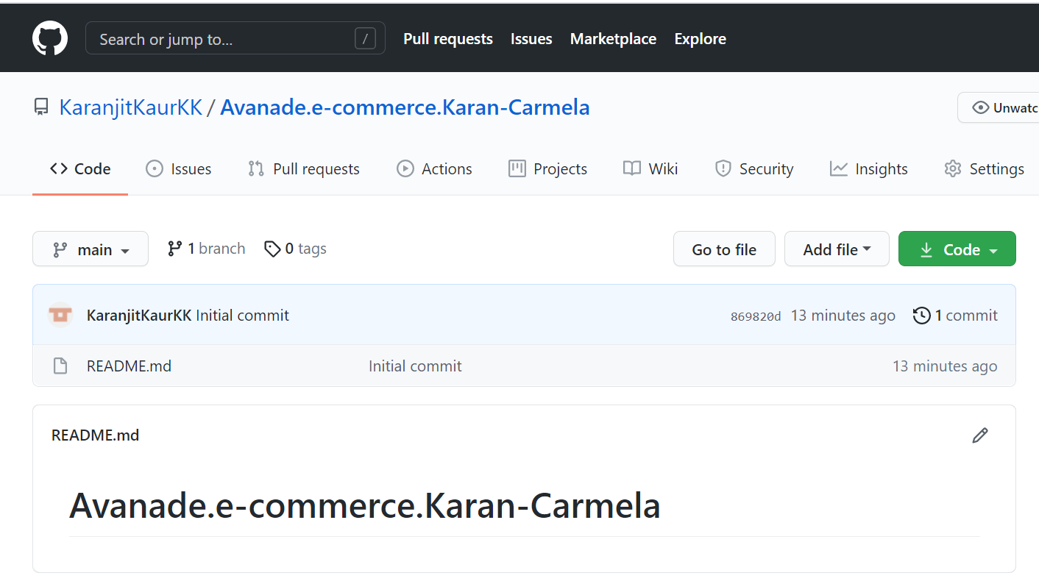

We cloned this repository in just one in order to set the basic structure for all the team members.

We opened the visual studio code after cloning the repository with the git bash, and there was an empty project.

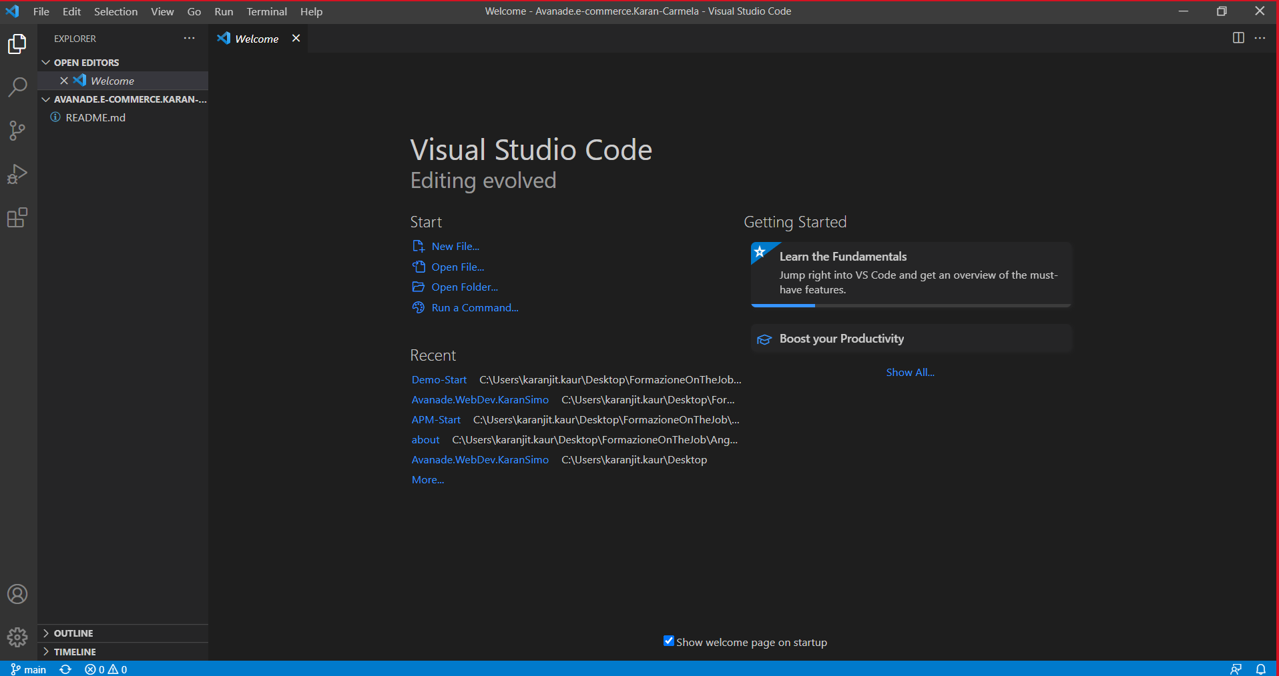

Since we already have installed “node.JS” and “Angular-CLI” we proceeded with the creation of the project with the integrated terminal:

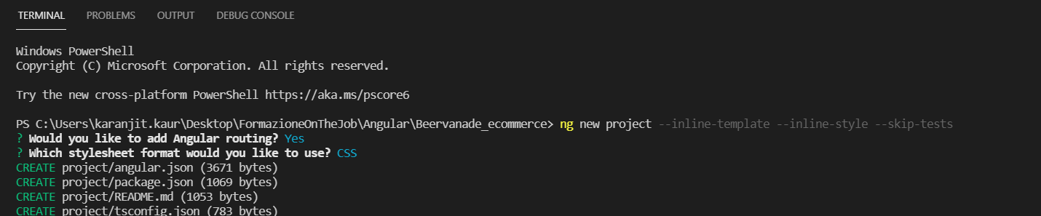

After creating the project, pushed it on the github repository

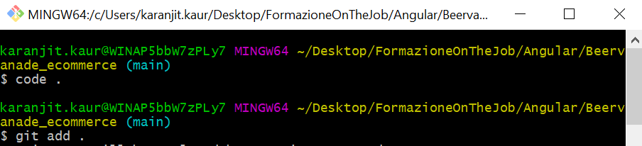

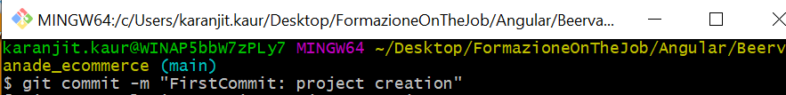

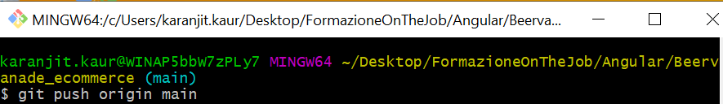

We installed bootstrap and font-awesome into the terminal:



And added these code in the angular.json:

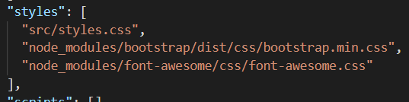

We wanted to try the webapp.

So, we created the components with the “Angular CLI”, moving into the right folder

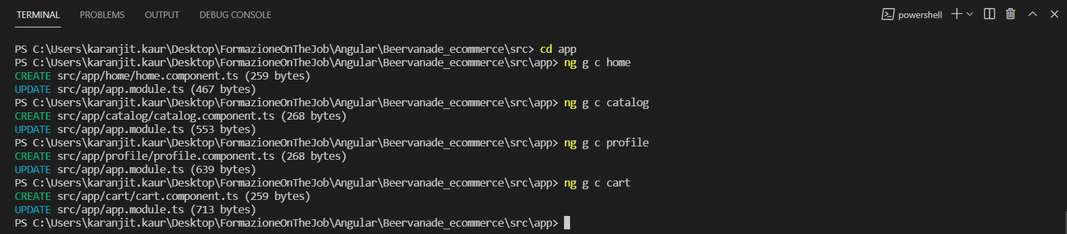

And we modified the app.module.ts in this way

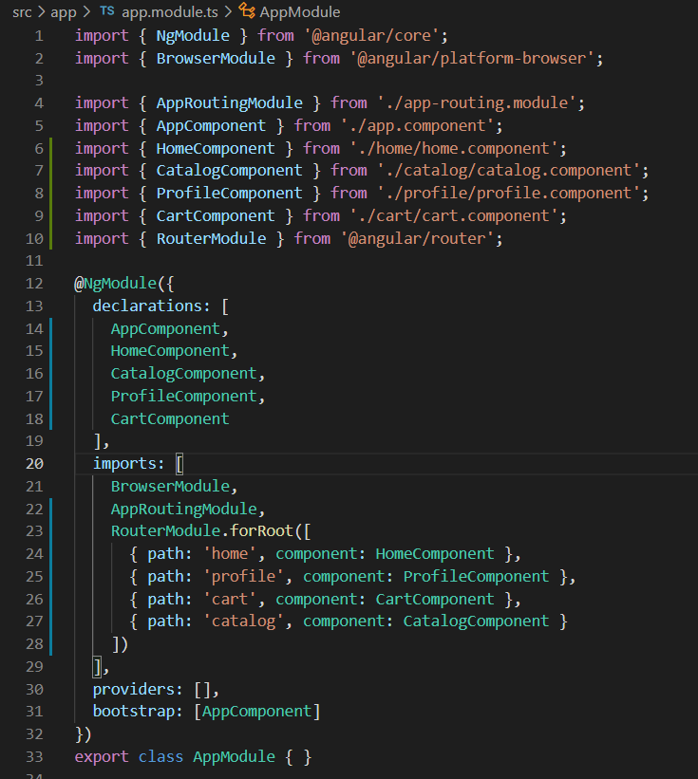

And in the app.component.ts we added the navbar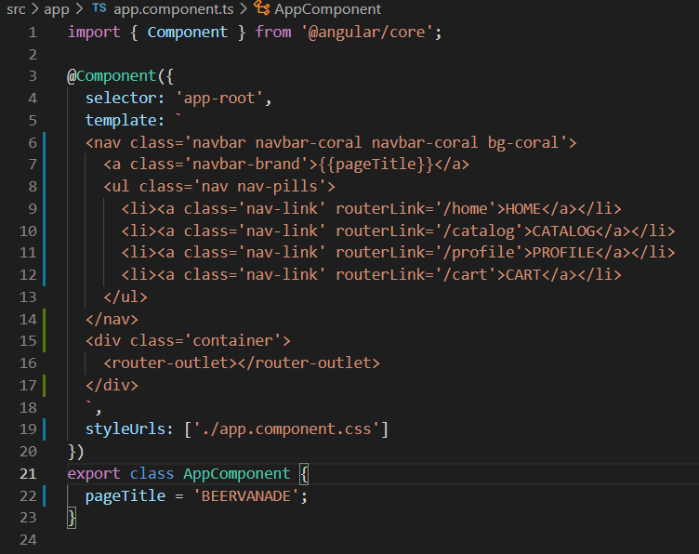

We added the routing in order to navigate from the pages.



This is what we obtained.

We proceeded to create the core, shared and the feature module