DBMS PROJECT REPORT
-IMT2020003
USE CASE DIAGRAM
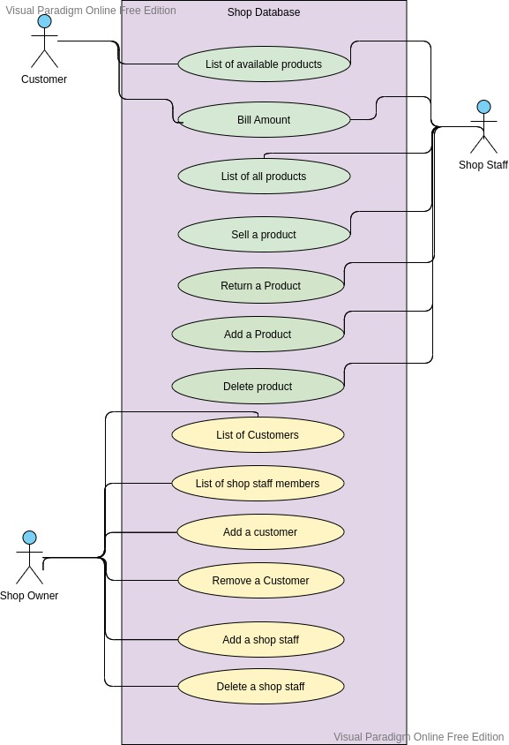

UML DIAGRAM

OR MAPPING(DB DESIGN
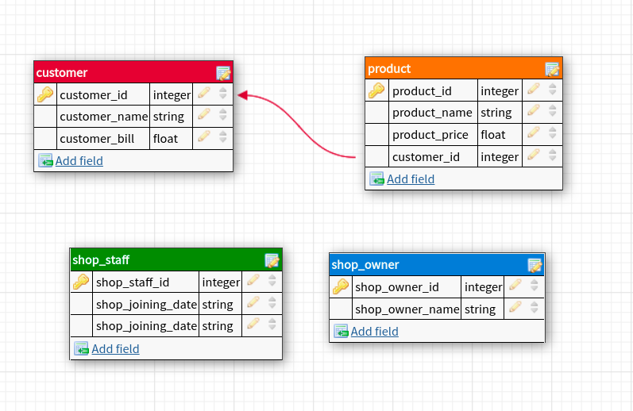
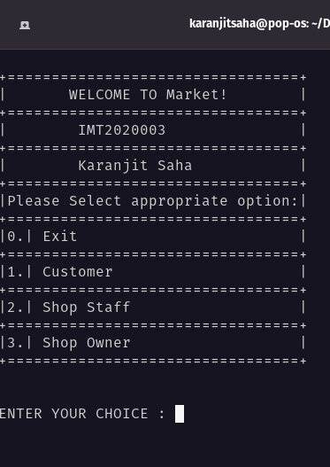
OUTPUT SCREENSHOTS

