MINI PROJECT (DBMSL)

ON
“Employee Data Entry System”


DEPARTMENT OF INFORMATION TECHNOLOGY

Sanjivani Rural Education Society’s
SANJIVANI COLLEGE OF ENGINEERING, KOPARGAON 423 603
(An Autonomous Institute affiliated to SPPU Pune)

Academic Year 2025-2026

Roll No. | PRN No. | Name
03 | 0124UITM1003 | Mhase Sudarshan Ravindra
15 | 0124UITM1015 | Lahamge Sai Kiran
57 | 0125UITM1057 | Ghode Siddhant Nanasaheb
159 | 0125UITM1012 | Omkar Waykhinde Sanjay

Under the Guidance of

DR.B.B.Pawar

- Title: Employee Management System
- Aim: To develop an Employee Management System using PHP, HTML, and MySQL (XAMPP) for efficiently managing employee records such as personal details, department, and contact information with functionalities like insert, update, delete, and search.

- Objectives:
- To store employee details like ID, name, and department.
- To add new employee records easily.
- To update existing employee information.
- To delete employee records when needed.
- To search and view employee details quickly.

Roll No. | PRN No. | Name
03 | 0124UITM1003 | Mhase Sudarshan Ravindra
15 | 0124UITM1015 | Lahamge Sai Kiran
57 | 0125UITM1057 | Ghode Siddhant Nanasaheb
159 | 0125UITM1012 | Omkar Waykhinde Sanjay

Under the Guidance of

DR.B.B.Pawar

Screenshots
- Front End :
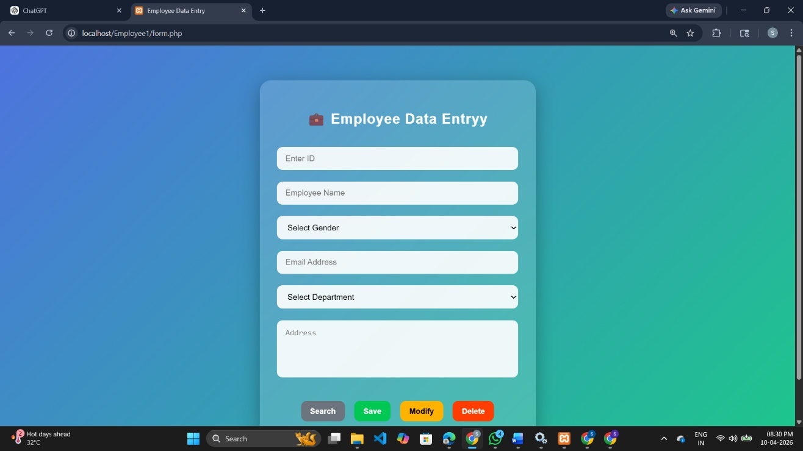

- Back End :
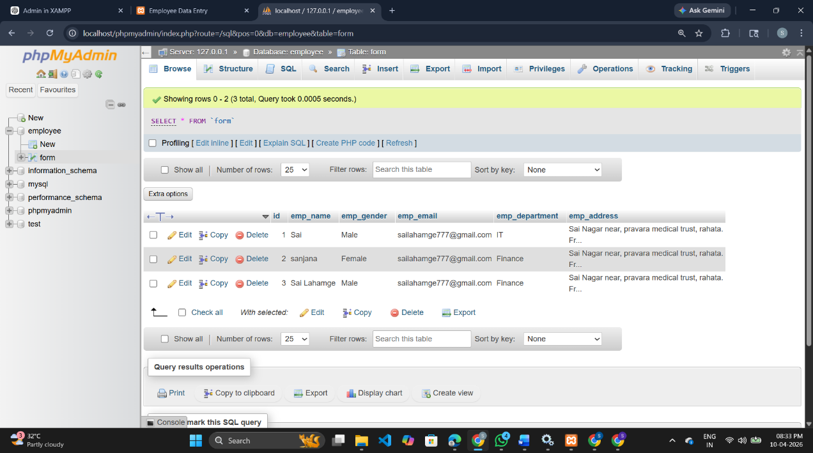

Code Implementation

1] Connection.php

<?php

$servername = "localhost";
$username = "root";
$password = "";
$dbname = "employee";

// Create connection
$conn = mysqli_connect($servername, $username, $password, $dbname);

// Check connection
if ($conn) {
// echo "Connection successful";
} else {
echo "Connection failed: " . mysqli_connect_error();
}

?>

Explanation :

This PHP code is used to establish a connection between the application and a MySQL database. It defines the server name as localhost, username as root, password as empty, and database name as employee. The mysqli_connect() function is used to create the connection and store it in the $conn variable. If the connection is successful, the program continues execution; otherwise, it displays an error message using mysqli_connect_error().

2] Employee_crud.php

<?php
include("connection.php");

$id = $name = $gender = $email = $department = $address = "";
$message = "";
$type = "";

// SAVE
if(isset($_POST['save']))
{
$id = $_POST['id'];
$name = $_POST['name'];
$gender = $_POST['gender'];
$email = $_POST['email'];
$department = $_POST['department'];
$address = $_POST['address'];

$check = mysqli_query($conn, "SELECT * FROM `form` WHERE id='$id'");

if(mysqli_num_rows($check) > 0)
{
$message = "Employee ID Already Exists";
$type = "error";
}
else
{
$query = "INSERT INTO `form`
(id, emp_name, emp_gender, emp_email, emp_department, emp_address)
VALUES
('$id','$name','$gender','$email','$department','$address')";

if(mysqli_query($conn, $query)) {
$message = "Data Saved Successfully";
$type = "success";
} else {
$message = "Error: " . mysqli_error($conn);
$type = "error";
}
}
}

// SEARCH
if(isset($_POST['search']))
{
$id = $_POST['id'];

$result = mysqli_query($conn, "SELECT * FROM `form` WHERE id='$id'");

if(mysqli_num_rows($result) > 0)
{
$row = mysqli_fetch_assoc($result);
$name = $row['emp_name'];
$gender = $row['emp_gender'];
$email = $row['emp_email'];
$department = $row['emp_department'];
$address = $row['emp_address'];

$message = "Record Found";
$type = "success";
}
else
{
$message = "No Record Found";
$type = "error";
}
}

// UPDATE
if(isset($_POST['update']))
{
$id = $_POST['id'];

$check = mysqli_query($conn, "SELECT * FROM `form` WHERE id='$id'");

if(mysqli_num_rows($check) > 0)
{
mysqli_query($conn, "UPDATE `form` SET
emp_name='$_POST[name]',
emp_gender='$_POST[gender]',
emp_email='$_POST[email]',
emp_department='$_POST[department]',
emp_address='$_POST[address]'
WHERE id='$id'");

if(mysqli_affected_rows($conn) > 0) {
$message = "Data Updated Successfully";
$type = "success";
} else {
$message = "No Changes Made";
$type = "warning";
}
}
else
{
$message = "No Record Found to Update";
$type = "error";
}
}

// DELETE
if(isset($_POST['delete']))
{
$id = $_POST['id'];

$check = mysqli_query($conn, "SELECT * FROM `form` WHERE id='$id'");

if(mysqli_num_rows($check) > 0)
{
mysqli_query($conn, "DELETE FROM `form` WHERE id='$id'");

if(mysqli_affected_rows($conn) > 0) {
$message = "Data Deleted Successfully";
$type = "warning";
} else {
$message = "Delete Failed";
$type = "error";
}
}
else
{
$message = "No Record Found to Delete";
$type = "error";
}
}
?>

Non-Functional Requirements

Performance:
The application is designed to launch within two seconds to ensure a quick and responsive user experience. In a hotel management system where staff frequently access the application for bookings, check-ins, and guest information, fast startup and smooth UI performance are crucial. A lag-free interface enhances productivity and provides a professional experience to both administrators and users.

Security:
Security is a primary concern as the application handles sensitive user and booking data. To ensure data protection, Firebase Authentication is used for secure user login and account management, while Cloud Firestore provides encrypted data storage and transmission. This guarantees that user credentials and booking records remain safe from unauthorized access or breaches.

Scalability:
The system is designed to efficiently manage over 1,000 room records and support multiple concurrent administrators. This scalability ensures that the application can grow along with the hotel’s operations, accommodating expansion without performance degradation. The use of Firebase and Room Database enables flexible scaling of both local and cloud data storage.

Compatibility:
The application supports Android devices with API level 26 (Android 8.0 Oreo) and above, ensuring wide accessibility across a broad range of smartphones and tablets. This compatibility allows both older and newer Android devices to run the application smoothly, enhancing usability for diverse users and hotel staff.

Usability:
A simple and intuitive user interface is implemented to allow users to navigate the system easily and perform hotel operations efficiently. The clear layout, logical navigation, and responsive design help minimize user training time and improve operational efficiency.

Reliability:
The system ensures consistent data synchronization between the local Room Database and Firebase Cloud Firestore. This dual storage approach guarantees that no data is lost, even in offline conditions, and that all updates are reflected accurately once the device reconnects to the internet. Such reliability is essential for maintaining accurate booking and guest information.

CHAPTER 6

SYSTEM DESIGN / ARCHITECTURE

Architecture Pattern
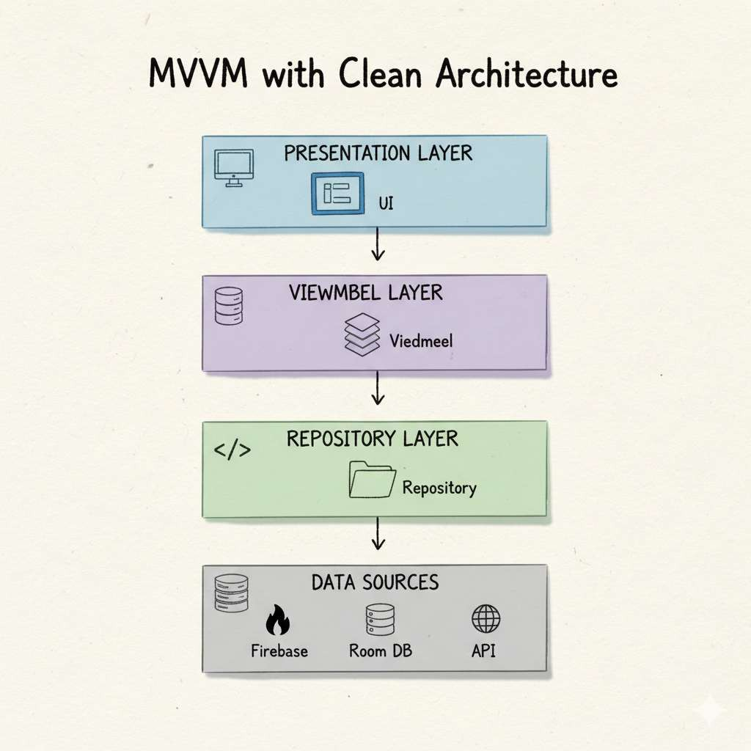

Fig 6.1:Architecture Schema

System Components

Presentation Layer:
  - Android XML-based UI components for forms and dashboards
  - Navigation handling between fragments and activities`
  - User interaction management for booking, guest, and room modules

Domain Layer:
  - ViewModels to manage and process business logic
  - Use cases for booking management, room availability, and record operations
  - LiveData/StateFlow for reactive UI updates and data synchronization

Data Layer:
  - Firebase Firestore – Cloud database for booking, guest, and room data storage
  - Room Database – Local database for offline access and synchronization
  - Repositories – Handle all data transactions between local and cloud databases

  - Database Design

Local Database (Room):
    - RoomEntity: Room details including number, type, status, and price
    - GuestEntity: Guest information and contact details
    - BookingEntity: Booking data with check-in/check-out details
    - PaymentEntity: Local record of payment information (if applicable)
    - LogEntity: Activity and record history for audit tracking

Cloud Database (Firebase Firestore):
    - users: Admin and staff authentication records
    - rooms: Room information with real-time status
    - guests: Guest details and linked booking IDs
    - bookings: Booking information, dates, and payment status
    - reports: Generated reports and analytics for admin dashboard

CHAPTER 7

TECHNOLOGY STACK

Frontend Technologies
    - Kotlin: Primary programming language
    - Jetpack Compose: Modern declarative UI framework
    - Material Design 3: UI/UX design system
    - Coil: Image loading and caching
    - Lottie: Animations

Backend & Database
    - Firebase Authentication: Secure user login and account management
    - Firebase Firestore: Real-time cloud database for bookings, rooms, and guest records
    - Firebase Storage: Storage for room and guest images or related media files
    - Firebase Cloud Messaging: Push notifications for booking confirmations and updates
    - Room Database: Local data storage for offline operations and synchronization

Architecture Components
    - MVVM Architecture: Ensures separation of UI, business logic, and data handling
    - Hilt: Dependency injection for better scalability and code management
    - ViewModel: Handles business logic and maintains UI state efficiently
    - LiveData / StateFlow: Real-time UI updates through reactive programming
    - Coroutines: Enables smooth asynchronous background operations

Third-Party Libraries
    - Retrofit: Communication with REST APIs for data exchange and server interaction
    - Gson: JSON serialization and deserialization
    - Lottie: Adds engaging animations for enhanced user experience
    - MPAndroidChart: (Optional) Used for displaying booking or revenue analytics visually

CHAPTER 8

USER INTERFACE DESIGN

Design Principles
Material Design 3: Modern and intuitive interface following Google’s design standards Consistency: Uniform layout and color scheme across all application screens Accessibility: Clear icons, readable fonts, and high-contrast themes for better usability Responsiveness: Smooth animations and seamless navigation between screens

Key Screens

Login & Registration Screen:
Firebase-based authentication for secure login and signup Input validation for username, email, and password fields “Forgot Password” and “Create Account” options

Dashboard (Home Screen):
Quick access to bookings, room status, and guest records Summary cards displaying available, booked, and vacant rooms Tabs for navigating between “Rooms,” “Guests,” and “Bookings”

Room Management Screen:
Add, edit, or delete room details (room number, type, price, and status) Room availability indicator (Available / Occupied / Under Maintenance) Search and filter options for quick access

Guest Management Screen:
Form to register new guests with contact and stay details View all registered guests with booking history
Option to edit or delete guest records

Booking Screen:
Booking form with date picker for check-in and check-out Room selection dropdown based on real-time availability Auto-calculated total stay cost and booking summary Confirm and cancel booking buttons

Reports & Analytics Screen:
Daily, weekly, and monthly report generation
Bar or pie charts showing room occupancy and revenue trends Export and share options for admin use

Figma Design

https://tinyurl.com/3ne74m8j

Color Scheme
Primary: #1976D2 (Royal Blue)
Secondary: #64B5F6 (Sky Blue)
Background: #FFFFFF (Light Mode), #121212 (Dark Mode)
Success: #4CAF50 (Green)
Error: #F44336 (Red)

CHAPTER 9

IMPLEMENTATION

Key Features Implementation

Authentication (Firebase):
Email/password login for hotel administrators User session management with auto-login Password reset and validation support

Room Management:
Add, edit, and delete room records (number, type, price, status) Category-based room organization (e.g., Deluxe, Standard, Suite) Real-time availability tracking
Image loading for room photos

Booking Management:
Create bookings with check-in and check-out dates
Automatic total price calculation based on stay duration and room rate Booking modification: extend, cancel, or update bookings
Dual storage in Room (local) and Firebase Firestore (cloud)

Guest Management:
Register guest details including personal info, ID, and vehicle information Link guests to bookings
Edit and view guest records
Real-time updates synchronized across devices

Search & Filter System:
Search rooms by number, type, or availability Filter by date, type, or price range
Maintain search history for easy access

Admin Features:
Real-time monitoring of bookings Room CRUD operations
Booking status updates Guest management
Analytics dashboard for occupancy and revenue

CHAPTER 10

TESTING

Testing Strategy
- Unit Testing: ViewModel logic Repository operations Utility functions

Integration Testing:

Firebase authentication and Firestore connectivity Room database operations
Repository-DAO integration

- UI Testing: Screen navigation User interactions Form validation

Manual Testing:

End-to-end booking flows

Payment simulations (Cash/Online)

Cross-device and offline functionality testing

  - Test Result

Features | Result
User Registration & Login | Pass ⬛
Add/Edit/Delete Room | Pass ⬛
Create Booking | Pass ⬛
Modify/Cancel Booking | Pass ⬛
Add Guest Details | Pass ⬛
Real-time Data Sync | Pass ⬛
Reports & Analytics | Pass ⬛

  - Performance Metrics

Metric | Value | Status
App Launch Time | 1.5 seconds | ⬛
Room & Booking Search Response | 250ms | ⬛
Image Loading Time | 300ms average | ⬛
Database Query Time | < 100ms | ⬛
UI Frame Rate | 60 FPS | ⬛

CHAPTER 11

GEO TAG PHOTO

Project Development Location
Institution: Sanjivani College of Engineering, Kopargaon
Department: Information Technology Lab: Mobile Application Development Lab City: Kopargaon, Maharashtra
Country: India

Screenshots and Key Features

Home Screen
Displays hotel room categories, availability status, and quick navigation to booking.

Room Detail Screen
Shows room images, description, pricing, amenities, and option to book or add to favorites.

Booking Cart / Reservation Screen
Lists selected rooms, check-in/check-out dates, guest details, and total cost calculation.

Checkout / Payment Screen
Guest information entry, multiple payment options (UPI, Cards, Net Banking, Wallets), and booking summary.

Booking Confirmation Screen
Confirms successful booking with reservation ID and summary of stay.

Booking History Screen
Displays past and upcoming bookings with status (confirmed, pending, canceled) and options to modify or cancel.

Admin Dashboard
Shows hotel analytics, room occupancy, total bookings, and revenue metrics.

Admin Booking Management
Enables updating booking status, managing check-ins/check-outs, and sending notifications to guests.

Guest Search & Filter Screen
Allows filtering guests or bookings by date, room type, or status, with search functionality for quick lookup.
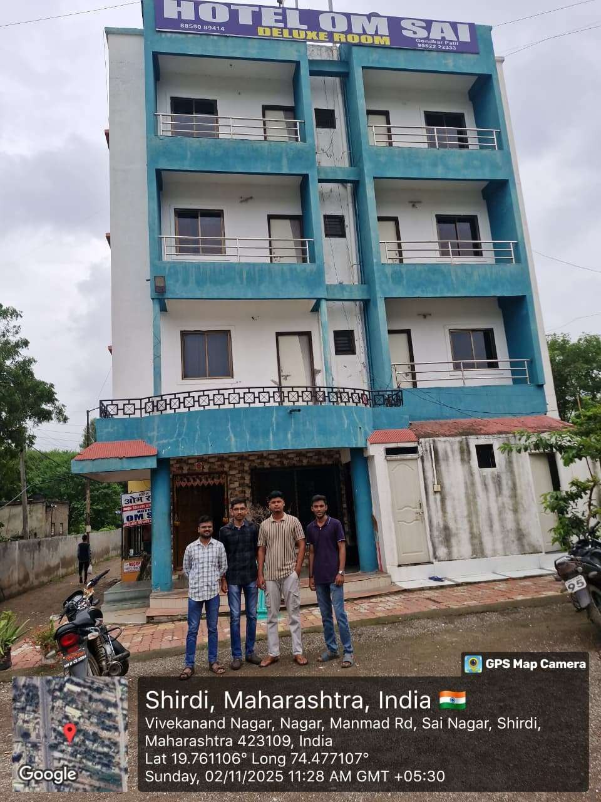
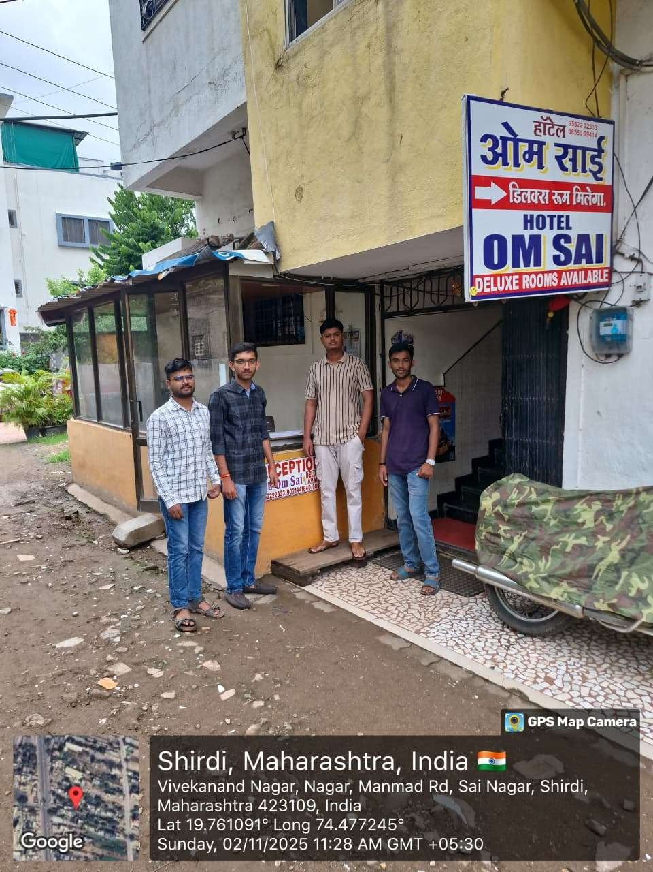

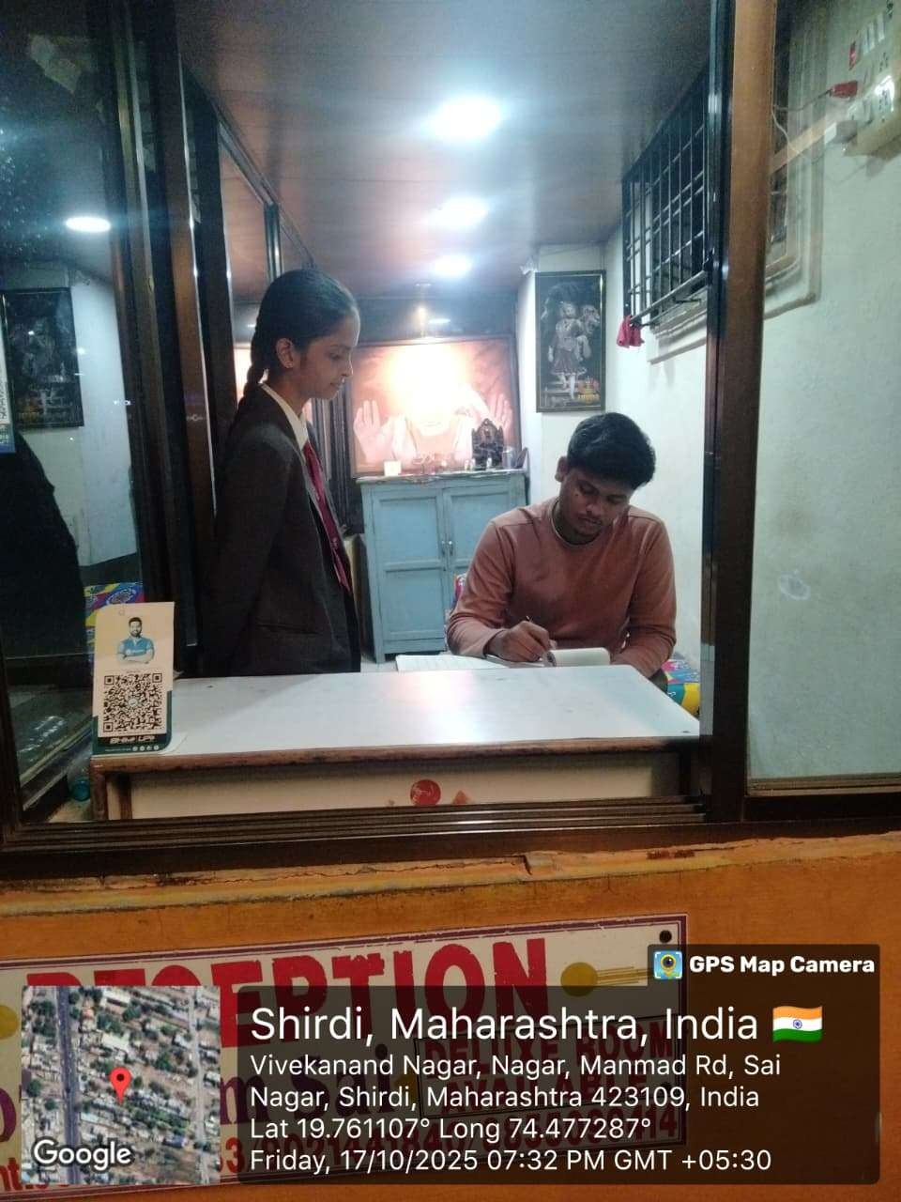

CHAPTER 12 ARCHITECTURE SYSTEM

  - MVVM Architecture
    - The application follows MVVM (Model-View-ViewModel) architecture pattern: Model: Data entities (RoomEntity, BookingEntity, GuestEntity)
View: Activities and UI components ViewModel: Business logic and data management
Repository: Data access layer (Room Database + Firestore)

  - Component Diagram
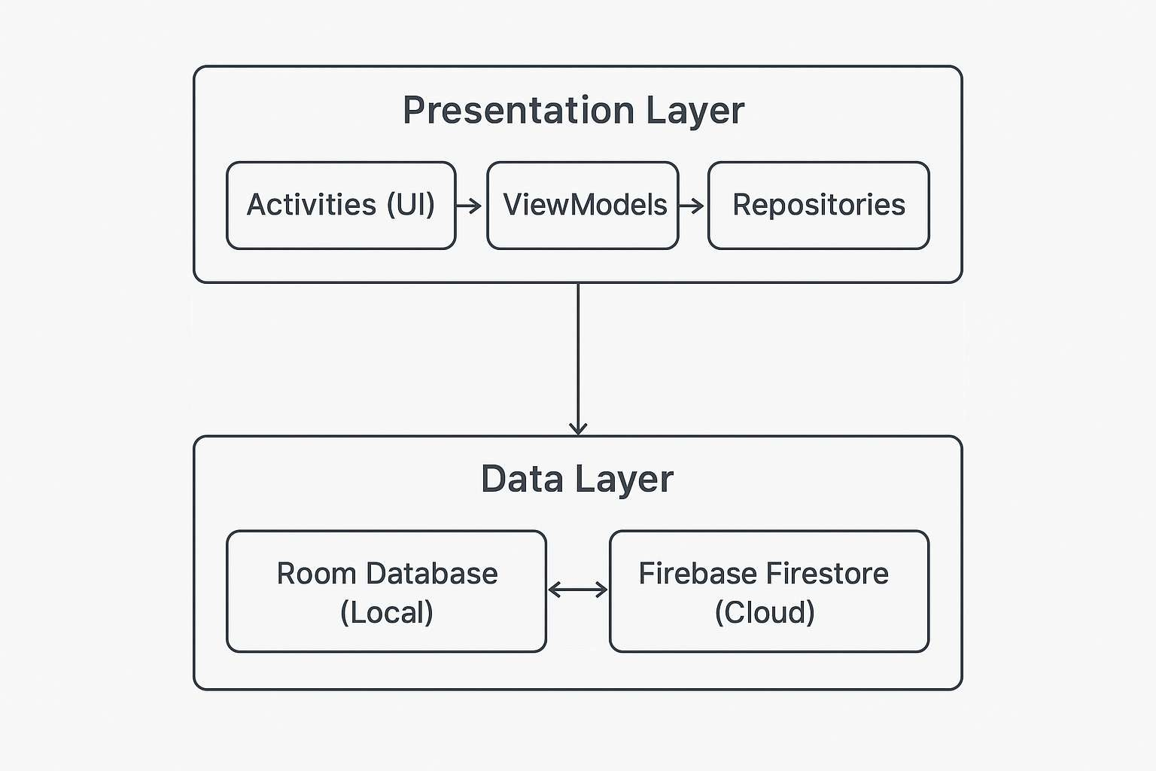

Fig 12.1:Component Diagram

6.2 Database Schema
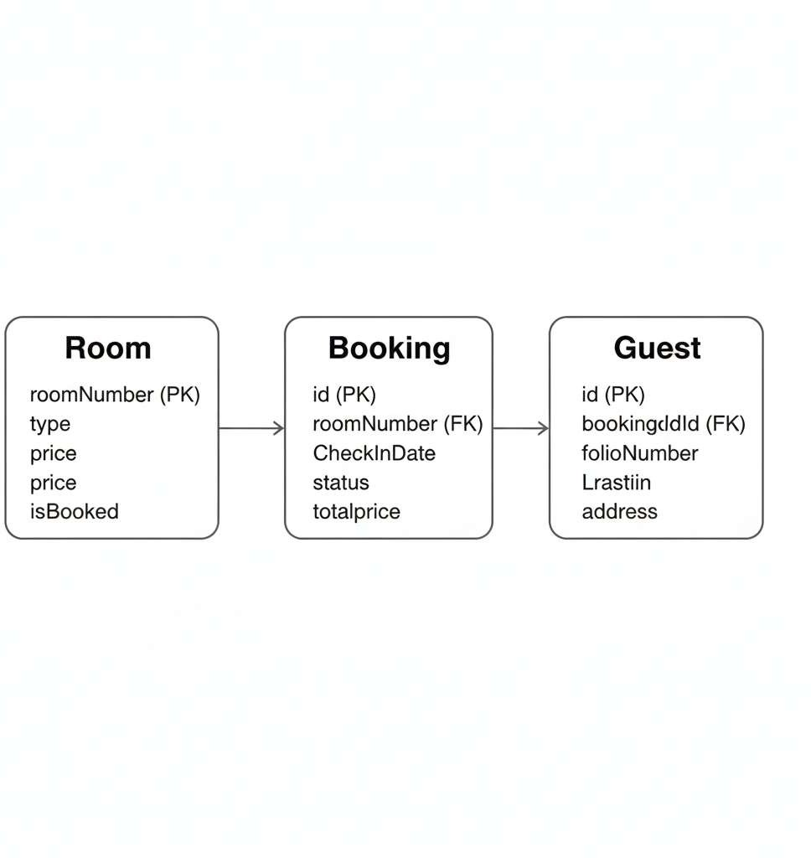

Fig 12.2:Database Schema

Rooms Table:
roomNumber (INTEGER PRIMARY KEY) type (TEXT)
price (INTEGER)

isBooked (INTEGER, default: 0)

Bookings Table:
id (INTEGER PRIMARY KEY AUTOINCREMENT)

roomNumber (INTEGER) checkInDate (TEXT) checkOutDate (TEXT)
status (TEXT) - "Active" or "Cancelled" totalPrice (INTEGER)
paymentMethod (TEXT) - "Cash" or "Online"

Guests Table:
id (INTEGER PRIMARY KEY AUTOINCREMENT) bookingId (INTEGER, FOREIGN KEY)
folioNumber (TEXT) lastName (TEXT) firstName (TEXT) address (TEXT) company (TEXT) idType (TEXT) idNumber (TEXT) vehicle (TEXT) vehicleModel (TEXT) plateNumber (TEXT)

Database Schema
- Screen Flow:
Splash Screen
Dashboard
Add Room
All Rooms
Modify Booking
Guest Info
All
Rooms(Filter)
Modify Booking

Fig 12.3:Screen Flow

- UI Components:
Material Design : Modern Material components Glassmorphism: Transparent card designs Animations: Smooth transitions and effects Color Scheme: Dark theme with neon accents Navigation: Bottom navigation bar

CHAPTER 13

App Implementation

- Room Entity: Class Diagram:
kotlin
@Entity(tableName = "rooms") data class RoomEntity(
@PrimaryKey val roomNumber: Int, val type: String,
val price: Int,
val isBooked: Boolean = false
)

Booking Creation:
kotlin
val booking = BookingEntity( roomNumber = selectedRoom, checkInDate = checkInDate, checkOutDate = checkOutDate, status = "Active",
totalPrice = calculateTotalPrice()
)
bookingVm.addBooking(booking)

Firebase Authentication:

kotlin
suspend fun signInWithEmailAndPassword( email: String,
password: String
): Result<FirebaseUser> { return try {
val result = auth.signInWithEmailAndPassword(email, password).await() Result.success(result.user!!)
} catch (e: Exception) { Result.failure(e)
}
}

Rooms Table:
sql
CREATE TABLE rooms (
roomNumber INTEGER PRIMARY KEY, type TEXT NOT NULL,
price INTEGER NOT NULL,
isBooked INTEGER DEFAULT 0
);

Rooms Table:
sql
CREATE TABLE rooms (
roomNumber INTEGER PRIMARY KEY, type TEXT NOT NULL,
price INTEGER NOT NULL,
isBooked INTEGER DEFAULT 0
);

Bookings Table:
sql
CREATE TABLE bookings (
id INTEGER PRIMARY KEY AUTOINCREMENT,
roomNumber INTEGER NOT NULL, checkInDate TEXT NOT NULL, checkOutDate TEXT NOT NULL, status TEXT NOT NULL,
totalPrice INTEGER DEFAULT 0, paymentMethod TEXT DEFAULT 'Cash'
);

Guests Table:
sql
CREATE TABLE guests (
id INTEGER PRIMARY KEY AUTOINCREMENT,
bookingId INTEGER NOT NULL, folioNumber TEXT NOT NULL, lastName TEXT NOT NULL, firstName TEXT NOT NULL, address TEXT NOT NULL, company TEXT,
idType TEXT NOT NULL,
idNumber TEXT NOT NULL, vehicle TEXT,
vehicleModel TEXT, plateNumber TEXT,
FOREIGN KEY(bookingId) REFERENCES bookings(id) ON DELETE CASCADE
);

Source Code

Add Room
<?xml version="1.0" encoding="utf-8"?>
<androidx.coordinatorlayout.widget.CoordinatorLayout xmlns:android="http://schemas.android.com/apk/res/android"
xmlns:app="http://schemas.android.com/apk/res-auto" android:layout_width="match_parent" android:layout_height="match_parent" android:background="@drawable/bg_light_gradient">

<com.google.android.material.appbar.MaterialToolbar android:id="@+id/topAppBar" style="@style/Widget.Material3.Toolbar" android:layout_width="match_parent" android:layout_height="?attr/actionBarSize" android:layout_marginTop="16dp" android:backgroundTint="#FFFFFF" android:titleTextColor="@color/text_primary" android:navigationIcon="@android:drawable/ic_media_previous" app:navigationIconTint="@color/accent_green"
app:title="ADD ROOM" />

<ScrollView
android:layout_width="match_parent" android:layout_height="match_parent"

android:fillViewport="true" app:layout_behavior="@string/appbar_scrolling_view_behavior">

<androidx.constraintlayout.widget.ConstraintLayout android:layout_width="match_parent" android:layout_height="wrap_content" android:minHeight="600dp" android:padding="24dp">

<com.google.android.material.card.MaterialCardView android:layout_width="0dp" android:layout_height="wrap_content" app:cardCornerRadius="24dp" app:cardElevation="4dp" app:cardBackgroundColor="#FFFFFF" app:strokeWidth="1dp" app:strokeColor="#E2E8F0" android:background="@drawable/bg_card_light" app:layout_constraintTop_toTopOf="parent" app:layout_constraintBottom_toBottomOf="parent" app:layout_constraintStart_toStartOf="parent" app:layout_constraintEnd_toEndOf="parent" app:layout_constraintVertical_bias="0.3" android:layout_marginHorizontal="16dp" android:layout_marginTop="80dp">

<LinearLayout

android:layout_width="match_parent" android:layout_height="wrap_content" android:orientation="vertical" android:padding="24dp">

<com.google.android.material.textfield.TextInputLayout style="@style/Widget.Material3.TextInputLayout.OutlinedBox" android:layout_width="match_parent" android:layout_height="wrap_content"
android:hint="Room Number" app:boxStrokeColor="#804CAF50" app:hintTextColor="@color/text_secondary"
app:startIconDrawable="@android:drawable/ic_menu_sort_by_size" app:startIconTint="@color/accent_green">
<com.google.android.material.textfield.TextInputEditText android:id="@+id/etRoomNumber" android:layout_width="match_parent" android:layout_height="wrap_content" android:inputType="number" android:textColor="@color/text_primary" android:textColorHint="@color/text_tertiary" />
</com.google.android.material.textfield.TextInputLayout>

<com.google.android.material.textfield.TextInputLayout

style="@style/Widget.Material3.TextInputLayout.OutlinedBox.ExposedDropdownMenu" android:layout_width="match_parent"

android:layout_height="wrap_content" android:hint="Room Type" app:boxStrokeColor="#804CAF50" app:hintTextColor="@color/text_secondary"
app:startIconDrawable="@android:drawable/ic_menu_view" app:startIconTint="@color/accent_green" android:layout_marginTop="16dp">
<AutoCompleteTextView android:id="@+id/spType" android:layout_width="match_parent" android:layout_height="wrap_content" android:inputType="none" android:textColor="@color/text_primary" />
</com.google.android.material.textfield.TextInputLayout>

<com.google.android.material.textfield.TextInputLayout style="@style/Widget.Material3.TextInputLayout.OutlinedBox" android:layout_width="match_parent" android:layout_height="wrap_content"
android:hint="Room Price (₹)" app:boxStrokeColor="#804CAF50" app:hintTextColor="@color/text_secondary"
app:startIconDrawable="@android:drawable/ic_menu_info_details" app:startIconTint="@color/accent_green" android:layout_marginTop="16dp">
<com.google.android.material.textfield.TextInputEditText
android:id="@+id/etPrice"

android:layout_width="match_parent" android:layout_height="wrap_content" android:inputType="number" android:textColor="@color/text_primary" android:textColorHint="@color/text_tertiary" />
</com.google.android.material.textfield.TextInputLayout>

<com.google.android.material.button.MaterialButton android:id="@+id/btnAdd" android:layout_width="match_parent" android:layout_height="56dp" android:text="ADD ROOM" android:textStyle="bold" android:textColor="@color/white" android:textSize="16sp" android:letterSpacing="0.1" android:layout_marginTop="24dp"
android:background="@drawable/bg_button_green" android:elevation="4dp" />

<com.google.android.material.button.MaterialButton android:id="@+id/btnUpdate" style="@style/Widget.Material3.Button.OutlinedButton" android:layout_width="match_parent" android:layout_height="56dp"
android:text="UPDATE ROOM"
android:textStyle="bold"

android:textColor="@color/accent_green" app:strokeColor="#804CAF50" android:layout_marginTop="12dp" />

<com.google.android.material.button.MaterialButton android:id="@+id/btnDelete" style="@style/Widget.Material3.Button.OutlinedButton" android:layout_width="match_parent" android:layout_height="56dp"
android:text="DELETE ROOM" android:textStyle="bold" android:textColor="@color/neon_pink" app:strokeColor="#80E91E63" android:layout_marginTop="12dp" />

</LinearLayout>
</com.google.android.material.card.MaterialCardView>
</androidx.constraintlayout.widget.ConstraintLayout>
</ScrollView>
</androidx.coordinatorlayout.widget.CoordinatorLayout>

All Bookings
<?xml version="1.0" encoding="utf-8"?>
<androidx.constraintlayout.widget.ConstraintLayout xmlns:android="http://schemas.android.com/apk/res/android"
xmlns:app="http://schemas.android.com/apk/res-auto" android:layout_width="match_parent" android:layout_height="match_parent" android:background="@drawable/bg_light_gradient">

<!-- Top App Bar -->
<com.google.android.material.appbar.MaterialToolbar android:id="@+id/topAppBar" style="@style/Widget.Material3.Toolbar" android:layout_width="match_parent" android:layout_height="?attr/actionBarSize" android:layout_marginTop="16dp" android:backgroundTint="#FFFFFF" android:titleTextColor="@color/text_primary" android:navigationIcon="@android:drawable/ic_media_previous" app:navigationIconTint="@color/accent_green"
app:title="ALL BOOKINGS" app:layout_constraintTop_toTopOf="parent" app:layout_constraintStart_toStartOf="parent" app:layout_constraintEnd_toEndOf="parent" />

<!-- Search Bar Card -->
<com.google.android.material.card.MaterialCardView

android:id="@+id/searchBarCard" android:layout_width="0dp" android:layout_height="wrap_content" android:layout_marginHorizontal="16dp" android:layout_marginTop="16dp" android:layout_marginBottom="16dp" app:cardCornerRadius="24dp" app:cardElevation="4dp" app:cardBackgroundColor="#FFFFFF" app:strokeWidth="1dp" app:strokeColor="#E2E8F0" android:background="@drawable/bg_card_light"
app:layout_constraintTop_toBottomOf="@id/topAppBar" app:layout_constraintStart_toStartOf="parent" app:layout_constraintEnd_toEndOf="parent">

<androidx.constraintlayout.widget.ConstraintLayout android:layout_width="match_parent" android:layout_height="wrap_content" android:padding="24dp">

<!-- Search Input -->
<com.google.android.material.card.MaterialCardView android:id="@+id/searchInputCard" android:layout_width="0dp" android:layout_height="wrap_content"
android:layout_marginBottom="20dp"

app:cardCornerRadius="20dp" app:cardElevation="2dp" app:cardBackgroundColor="#F8FAFC" app:strokeWidth="1.5dp" app:strokeColor="#E2E8F0" android:background="@drawable/bg_search_light" app:layout_constraintTop_toTopOf="parent" app:layout_constraintStart_toStartOf="parent" app:layout_constraintEnd_toEndOf="parent">

<LinearLayout android:layout_width="match_parent" android:layout_height="wrap_content" android:orientation="horizontal" android:gravity="center_vertical" android:padding="20dp">

<ImageView android:layout_width="36dp" android:layout_height="36dp"
android:src="@android:drawable/ic_menu_search" android:tint="@color/accent_green" android:layout_marginEnd="16dp" />

<com.google.android.material.textfield.TextInputEditText
android:id="@+id/etSearchBookings" android:layout_width="0dp"

android:layout_height="wrap_content" android:layout_weight="1" android:background="@android:color/transparent" android:hint="Search bookings..." android:textColor="@color/text_primary" android:textColorHint="@color/text_tertiary" android:textSize="17sp"
android:padding="0dp" android:minHeight="48dp" android:fontFamily="sans-serif-medium" android:letterSpacing="0.02" />
</LinearLayout>
</com.google.android.material.card.MaterialCardView>

<!-- Filter Label -->
<TextView android:id="@+id/tvFilterLabel" android:layout_width="wrap_content" android:layout_height="wrap_content" android:text="Filter by Status" android:textColor="@color/text_primary" android:textSize="14sp" android:textStyle="bold" android:letterSpacing="0.05" android:layout_marginBottom="12dp"
app:layout_constraintTop_toBottomOf="@id/searchInputCard"
app:layout_constraintStart_toStartOf="parent" />

<!-- Filter Chips -->
<com.google.android.material.chip.ChipGroup android:id="@+id/chipGroupFilters" android:layout_width="0dp" android:layout_height="wrap_content" android:orientation="horizontal" app:singleSelection="true" app:selectionRequired="false" app:chipSpacing="12dp"
app:layout_constraintTop_toBottomOf="@id/tvFilterLabel" app:layout_constraintStart_toStartOf="parent" app:layout_constraintEnd_toEndOf="parent" app:layout_constraintBottom_toBottomOf="parent">

<com.google.android.material.chip.Chip android:id="@+id/chipFilterAll" android:layout_width="wrap_content" android:layout_height="wrap_content" style="@style/Widget.Material3.Chip.Filter" android:text="All"
android:checked="true" android:background="@drawable/bg_chip_light_active" android:textColor="@color/accent_green" android:textSize="14sp"
android:textStyle="bold"
android:minHeight="44dp"

android:paddingHorizontal="24dp" android:elevation="2dp" />

<com.google.android.material.chip.Chip android:id="@+id/chipFilterActive" android:layout_width="wrap_content" android:layout_height="wrap_content" style="@style/Widget.Material3.Chip.Filter" android:text="Active" android:background="@drawable/bg_chip_light_inactive" android:textColor="@color/success_green" android:textSize="14sp"
android:textStyle="bold" android:minHeight="44dp" android:paddingHorizontal="24dp" />

<com.google.android.material.chip.Chip android:id="@+id/chipFilterCompleted" android:layout_width="wrap_content" android:layout_height="wrap_content" style="@style/Widget.Material3.Chip.Filter" android:text="Completed" android:background="@drawable/bg_chip_light_inactive" android:textColor="@color/text_secondary" android:textSize="14sp"
android:textStyle="bold"
android:minHeight="44dp"

android:paddingHorizontal="24dp" />
</com.google.android.material.chip.ChipGroup>
</androidx.constraintlayout.widget.ConstraintLayout>
</com.google.android.material.card.MaterialCardView>

<!-- Bookings RecyclerView - Positioned directly below searchBarCard -->
<androidx.recyclerview.widget.RecyclerView android:id="@+id/recyclerBookings" android:layout_width="0dp" android:layout_height="0dp" android:padding="16dp" android:paddingTop="0dp" android:paddingBottom="16dp" android:clipToPadding="false"
app:layout_constraintTop_toBottomOf="@id/searchBarCard" app:layout_constraintStart_toStartOf="parent" app:layout_constraintEnd_toEndOf="parent" app:layout_constraintBottom_toBottomOf="parent" />

</androidx.constraintlayout.widget.ConstraintLayout>

All Guest
<?xml version="1.0" encoding="utf-8"?>
<androidx.constraintlayout.widget.ConstraintLayout xmlns:android="http://schemas.android.com/apk/res/android"
xmlns:app="http://schemas.android.com/apk/res-auto" android:layout_width="match_parent" android:layout_height="match_parent" android:background="@drawable/bg_light_gradient">

<!-- Top App Bar -->
<com.google.android.material.appbar.MaterialToolbar android:id="@+id/topAppBar" style="@style/Widget.Material3.Toolbar" android:layout_width="match_parent" android:layout_height="?attr/actionBarSize" android:layout_marginTop="16dp" android:backgroundTint="#FFFFFF" android:titleTextColor="@color/text_primary" android:navigationIcon="@android:drawable/ic_media_previous" app:navigationIconTint="@color/accent_green" app:title="GUEST DETAILS" app:layout_constraintTop_toTopOf="parent" app:layout_constraintStart_toStartOf="parent" app:layout_constraintEnd_toEndOf="parent" />

<!-- Search Bar Card -->
<com.google.android.material.card.MaterialCardView

android:id="@+id/searchBarCard" android:layout_width="0dp" android:layout_height="wrap_content" android:layout_marginHorizontal="16dp" android:layout_marginTop="16dp" android:layout_marginBottom="16dp" app:cardCornerRadius="24dp" app:cardElevation="4dp" app:cardBackgroundColor="#FFFFFF" app:strokeWidth="1dp" app:strokeColor="#E2E8F0" android:background="@drawable/bg_card_light"
app:layout_constraintTop_toBottomOf="@id/topAppBar" app:layout_constraintStart_toStartOf="parent" app:layout_constraintEnd_toEndOf="parent">

<androidx.constraintlayout.widget.ConstraintLayout android:layout_width="match_parent" android:layout_height="wrap_content" android:padding="24dp">

<!-- Search Input -->
<com.google.android.material.card.MaterialCardView android:id="@+id/searchInputCard" android:layout_width="0dp" android:layout_height="wrap_content"
android:layout_marginBottom="20dp"

app:cardCornerRadius="20dp" app:cardElevation="2dp" app:cardBackgroundColor="#F8FAFC" app:strokeWidth="1.5dp" app:strokeColor="#E2E8F0" android:background="@drawable/bg_search_light" app:layout_constraintTop_toTopOf="parent" app:layout_constraintStart_toStartOf="parent" app:layout_constraintEnd_toEndOf="parent">

<LinearLayout android:layout_width="match_parent" android:layout_height="wrap_content" android:orientation="horizontal" android:gravity="center_vertical" android:padding="20dp">

<ImageView android:layout_width="36dp" android:layout_height="36dp"
android:src="@android:drawable/ic_menu_search" android:tint="@color/accent_green" android:layout_marginEnd="16dp" />

<com.google.android.material.textfield.TextInputEditText
android:id="@+id/etSearchGuests" android:layout_width="0dp"

android:layout_height="wrap_content" android:layout_weight="1" android:background="@android:color/transparent" android:hint="Search guests..." android:textColor="@color/text_primary" android:textColorHint="@color/text_tertiary" android:textSize="17sp"
android:padding="0dp" android:minHeight="48dp" android:fontFamily="sans-serif-medium" android:letterSpacing="0.02" />
</LinearLayout>
</com.google.android.material.card.MaterialCardView>

<!-- Date Filter Label -->
<TextView android:id="@+id/tvDateFilterLabel" android:layout_width="wrap_content" android:layout_height="wrap_content" android:text="Filter by Date" android:textColor="@color/text_primary" android:textSize="14sp" android:textStyle="bold" android:letterSpacing="0.05" android:layout_marginBottom="12dp"
app:layout_constraintTop_toBottomOf="@id/searchInputCard"
app:layout_constraintStart_toStartOf="parent" />

<!-- Date Filter Card -->
<com.google.android.material.card.MaterialCardView android:id="@+id/dateFilterCard" android:layout_width="0dp" android:layout_height="wrap_content" android:layout_marginBottom="12dp" app:cardCornerRadius="16dp" app:cardElevation="2dp" app:cardBackgroundColor="#F8FAFC" app:strokeWidth="1dp" app:strokeColor="#E2E8F0"
app:layout_constraintTop_toBottomOf="@id/tvDateFilterLabel" app:layout_constraintStart_toStartOf="parent" app:layout_constraintEnd_toEndOf="parent">

<LinearLayout android:layout_width="match_parent" android:layout_height="wrap_content" android:orientation="horizontal" android:gravity="center_vertical" android:padding="16dp">

<ImageView android:layout_width="24dp" android:layout_height="24dp"
android:src="@android:drawable/ic_menu_today"

android:tint="@color/accent_green" android:layout_marginEnd="12dp" />

<TextView android:id="@+id/tvSelectedDate" android:layout_width="0dp" android:layout_height="wrap_content" android:layout_weight="1" android:text="All Dates" android:textColor="@color/text_primary" android:textSize="15sp" android:textStyle="bold" />

<com.google.android.material.button.MaterialButton android:id="@+id/btnSelectDate" style="@style/Widget.Material3.Button.OutlinedButton" android:layout_width="wrap_content" android:layout_height="wrap_content" android:text="Select Date"
android:textSize="12sp" app:strokeColor="#804CAF50" android:textColor="@color/accent_green" />

<com.google.android.material.button.MaterialButton android:id="@+id/btnClearDate" style="@style/Widget.Material3.Button.TextButton"
android:layout_width="wrap_content"

android:layout_height="wrap_content" android:text="Clear" android:textSize="12sp" android:textColor="@color/text_secondary" android:layout_marginStart="8dp" />
</LinearLayout>
</com.google.android.material.card.MaterialCardView>

<!-- Filter Label -->
<TextView android:id="@+id/tvFilterLabel" android:layout_width="wrap_content" android:layout_height="wrap_content" android:text="Quick Filters" android:textColor="@color/text_primary" android:textSize="14sp" android:textStyle="bold" android:letterSpacing="0.05" android:layout_marginBottom="12dp"
app:layout_constraintTop_toBottomOf="@id/dateFilterCard" app:layout_constraintStart_toStartOf="parent" />

<!-- Filter Chips -->
<com.google.android.material.chip.ChipGroup android:id="@+id/chipGroupFilters" android:layout_width="0dp"
android:layout_height="wrap_content"

android:orientation="horizontal" app:singleSelection="false" app:selectionRequired="false" app:chipSpacing="12dp"
app:layout_constraintTop_toBottomOf="@id/tvFilterLabel" app:layout_constraintStart_toStartOf="parent" app:layout_constraintEnd_toEndOf="parent" app:layout_constraintBottom_toBottomOf="parent">

<com.google.android.material.chip.Chip android:id="@+id/chipFilterAll" android:layout_width="wrap_content" android:layout_height="wrap_content" style="@style/Widget.Material3.Chip.Filter" android:text="All"
android:checked="true" android:background="@drawable/bg_chip_light_active" android:textColor="@color/accent_green" android:textSize="14sp"
android:textStyle="bold" android:minHeight="44dp" android:paddingHorizontal="24dp" android:elevation="2dp" />

<com.google.android.material.chip.Chip
android:id="@+id/chipFilterToday" android:layout_width="wrap_content"

android:layout_height="wrap_content" style="@style/Widget.Material3.Chip.Filter" android:text="Today" android:background="@drawable/bg_chip_light_inactive" android:textColor="@color/text_secondary" android:textSize="14sp"
android:textStyle="bold" android:minHeight="44dp" android:paddingHorizontal="24dp" />

<com.google.android.material.chip.Chip android:id="@+id/chipFilterThisWeek" android:layout_width="wrap_content" android:layout_height="wrap_content" style="@style/Widget.Material3.Chip.Filter" android:text="This Week" android:background="@drawable/bg_chip_light_inactive" android:textColor="@color/text_secondary" android:textSize="14sp"
android:textStyle="bold" android:minHeight="44dp" android:paddingHorizontal="24dp" />

</com.google.android.material.chip.ChipGroup>
</androidx.constraintlayout.widget.ConstraintLayout>
</com.google.android.material.card.MaterialCardView>

<!-- Guests RecyclerView -->
<androidx.recyclerview.widget.RecyclerView android:id="@+id/recyclerGuests" android:layout_width="0dp" android:layout_height="0dp" android:padding="16dp" android:paddingTop="0dp" android:paddingBottom="16dp" android:clipToPadding="false"
app:layout_constraintTop_toBottomOf="@id/searchBarCard" app:layout_constraintStart_toStartOf="parent" app:layout_constraintEnd_toEndOf="parent" app:layout_constraintBottom_toBottomOf="parent" />

</androidx.constraintlayout.widget.ConstraintLayout>

All Rooms
<?xml version="1.0" encoding="utf-8"?>
<androidx.constraintlayout.widget.ConstraintLayout xmlns:android="http://schemas.android.com/apk/res/android"
xmlns:app="http://schemas.android.com/apk/res-auto" android:layout_width="match_parent" android:layout_height="match_parent" android:background="@drawable/bg_light_gradient">

<!-- Top App Bar -->
<com.google.android.material.appbar.MaterialToolbar android:id="@+id/topAppBar" style="@style/Widget.Material3.Toolbar" android:layout_width="match_parent" android:layout_height="?attr/actionBarSize" android:layout_marginTop="16dp" android:backgroundTint="#FFFFFF" android:titleTextColor="@color/text_primary" android:navigationIcon="@android:drawable/ic_media_previous" app:navigationIconTint="@color/accent_green"
app:title="ALL ROOMS" app:layout_constraintTop_toTopOf="parent" app:layout_constraintStart_toStartOf="parent" app:layout_constraintEnd_toEndOf="parent" />

<!-- Search Bar Card -->
<com.google.android.material.card.MaterialCardView

android:id="@+id/searchBarCard" android:layout_width="0dp" android:layout_height="wrap_content" android:layout_marginHorizontal="16dp" android:layout_marginTop="16dp" android:layout_marginBottom="16dp" app:cardCornerRadius="24dp" app:cardElevation="4dp" app:cardBackgroundColor="#FFFFFF" app:strokeWidth="1dp" app:strokeColor="#E2E8F0" android:background="@drawable/bg_card_light"
app:layout_constraintTop_toBottomOf="@id/topAppBar" app:layout_constraintStart_toStartOf="parent" app:layout_constraintEnd_toEndOf="parent">

<androidx.constraintlayout.widget.ConstraintLayout android:layout_width="match_parent" android:layout_height="wrap_content" android:padding="24dp">

<!-- Search Input -->
<com.google.android.material.card.MaterialCardView android:id="@+id/searchInputCard" android:layout_width="0dp" android:layout_height="wrap_content"
android:layout_marginBottom="20dp"

app:cardCornerRadius="20dp" app:cardElevation="2dp" app:cardBackgroundColor="#F8FAFC" app:strokeWidth="1.5dp" app:strokeColor="#E2E8F0" android:background="@drawable/bg_search_light" app:layout_constraintTop_toTopOf="parent" app:layout_constraintStart_toStartOf="parent" app:layout_constraintEnd_toEndOf="parent">

<LinearLayout android:layout_width="match_parent" android:layout_height="wrap_content" android:orientation="horizontal" android:gravity="center_vertical" android:padding="20dp">

<ImageView android:layout_width="36dp" android:layout_height="36dp"
android:src="@android:drawable/ic_menu_search" android:tint="@color/accent_green" android:layout_marginEnd="16dp" />

<com.google.android.material.textfield.TextInputEditText
android:id="@+id/etSearchRooms" android:layout_width="0dp"

android:layout_height="wrap_content" android:layout_weight="1" android:background="@android:color/transparent" android:hint="Search rooms..." android:textColor="@color/text_primary" android:textColorHint="@color/text_tertiary" android:textSize="17sp"
android:padding="0dp" android:minHeight="48dp" android:fontFamily="sans-serif-medium" android:letterSpacing="0.02" />
</LinearLayout>
</com.google.android.material.card.MaterialCardView>

<!-- Filter Label -->
<TextView android:id="@+id/tvFilterLabel" android:layout_width="wrap_content" android:layout_height="wrap_content" android:text="Filter by Status" android:textColor="@color/text_primary" android:textSize="14sp" android:textStyle="bold" android:letterSpacing="0.05" android:layout_marginBottom="12dp"
app:layout_constraintTop_toBottomOf="@id/searchInputCard"
app:layout_constraintStart_toStartOf="parent" />

<!-- Filter Chips -->
<com.google.android.material.chip.ChipGroup android:id="@+id/chipGroupFilters" android:layout_width="0dp" android:layout_height="wrap_content" android:orientation="horizontal" app:singleSelection="true" app:selectionRequired="false" app:chipSpacing="12dp"
app:layout_constraintTop_toBottomOf="@id/tvFilterLabel" app:layout_constraintStart_toStartOf="parent" app:layout_constraintEnd_toEndOf="parent" app:layout_constraintBottom_toBottomOf="parent">

<com.google.android.material.chip.Chip android:id="@+id/chipFilterAll" android:layout_width="wrap_content" android:layout_height="wrap_content" style="@style/Widget.Material3.Chip.Filter" android:text="All"
android:checked="true" android:background="@drawable/bg_chip_light_active" android:textColor="@color/accent_green" android:textSize="14sp"
android:textStyle="bold"
android:minHeight="44dp"

android:paddingHorizontal="24dp" android:elevation="2dp" />

<com.google.android.material.chip.Chip android:id="@+id/chipFilterAvailable" android:layout_width="wrap_content" android:layout_height="wrap_content" style="@style/Widget.Material3.Chip.Filter" android:text="Available" android:background="@drawable/bg_chip_light_inactive" android:textColor="@color/success_green" android:textSize="14sp"
android:textStyle="bold" android:minHeight="44dp" android:paddingHorizontal="24dp" />

<com.google.android.material.chip.Chip android:id="@+id/chipFilterBooked" android:layout_width="wrap_content" android:layout_height="wrap_content" style="@style/Widget.Material3.Chip.Filter" android:text="Booked" android:background="@drawable/bg_chip_light_inactive" android:textColor="@color/neon_pink" android:textSize="14sp"
android:textStyle="bold"
android:minHeight="44dp"

android:paddingHorizontal="24dp" />
</com.google.android.material.chip.ChipGroup>
</androidx.constraintlayout.widget.ConstraintLayout>
</com.google.android.material.card.MaterialCardView>

<!-- Rooms RecyclerView - Positioned directly below searchBarCard -->
<androidx.recyclerview.widget.RecyclerView android:id="@+id/recyclerRooms" android:layout_width="0dp" android:layout_height="0dp" android:padding="16dp" android:paddingTop="0dp" android:paddingBottom="16dp" android:clipToPadding="false"
app:layout_constraintTop_toBottomOf="@id/searchBarCard" app:layout_constraintStart_toStartOf="parent" app:layout_constraintEnd_toEndOf="parent" app:layout_constraintBottom_toBottomOf="parent" />

</androidx.constraintlayout.widget.ConstraintLayout>

Dashboard
<?xml version="1.0" encoding="utf-8"?>
<androidx.coordinatorlayout.widget.CoordinatorLayout xmlns:android="http://schemas.android.com/apk/res/android"
xmlns:app="http://schemas.android.com/apk/res-auto" android:layout_width="match_parent" android:layout_height="match_parent" android:background="#F5F8F6">

<!-- Main Content -->
<androidx.core.widget.NestedScrollView android:layout_width="match_parent" android:layout_height="match_parent" android:fillViewport="true" android:padding="20dp" android:paddingBottom="100dp">

<androidx.constraintlayout.widget.ConstraintLayout android:layout_width="match_parent" android:layout_height="wrap_content" android:minHeight="600dp">

<!-- Statistics Section -->
<TextView android:id="@+id/tvStatsTitle" android:layout_width="wrap_content" android:layout_height="wrap_content"

android:text="QUICK STATS" android:textColor="@color/text_primary" android:textStyle="bold" android:textSize="16sp" android:letterSpacing="0.1" app:layout_constraintTop_toTopOf="parent" app:layout_constraintStart_toStartOf="parent" android:layout_marginTop="24dp" android:layout_marginBottom="20dp" />

<!-- Total Rooms Card -->
<com.google.android.material.card.MaterialCardView android:id="@+id/statCardRooms" android:layout_width="0dp" android:layout_height="100dp" android:layout_marginEnd="8dp" app:cardCornerRadius="20dp" app:cardElevation="6dp" app:cardBackgroundColor="#FFFFFF" app:strokeWidth="1dp" app:strokeColor="#E2E8F0"
android:background="@drawable/bg_card_light_stats" android:clickable="true"
android:focusable="true" android:foreground="?attr/selectableItemBackground" app:layout_constraintTop_toBottomOf="@id/tvStatsTitle"
app:layout_constraintStart_toStartOf="parent"

app:layout_constraintEnd_toStartOf="@+id/statCardBookings" app:layout_constraintWidth_percent="0.48">

<LinearLayout android:layout_width="match_parent" android:layout_height="match_parent" android:orientation="horizontal" android:gravity="center_vertical" android:padding="20dp">

<LinearLayout android:layout_width="0dp" android:layout_height="wrap_content" android:layout_weight="1" android:orientation="vertical">

<TextView android:id="@+id/tvTotalRooms" android:layout_width="wrap_content" android:layout_height="wrap_content" android:text="0" android:textColor="@color/accent_green" android:textStyle="bold" android:textSize="32sp" android:letterSpacing="0.02" />

<TextView

android:layout_width="wrap_content" android:layout_height="wrap_content" android:text="Total Rooms" android:textColor="@color/text_secondary" android:textSize="13sp" android:layout_marginTop="6dp" />
</LinearLayout>

<ImageView android:layout_width="48dp" android:layout_height="48dp"
android:src="@android:drawable/ic_menu_agenda" android:tint="@color/text_tertiary" android:alpha="0.5" />
</LinearLayout>
</com.google.android.material.card.MaterialCardView>

<!-- Active Bookings Card -->
<com.google.android.material.card.MaterialCardView android:id="@+id/statCardBookings" android:layout_width="0dp" android:layout_height="100dp" android:layout_marginStart="8dp" app:cardCornerRadius="20dp" app:cardElevation="6dp" app:cardBackgroundColor="#FFFFFF"
app:strokeWidth="1dp"

app:strokeColor="#E2E8F0" android:background="@drawable/bg_card_light_stats" android:clickable="true"
android:focusable="true" android:foreground="?attr/selectableItemBackground" app:layout_constraintTop_toBottomOf="@id/tvStatsTitle" app:layout_constraintStart_toEndOf="@id/statCardRooms" app:layout_constraintEnd_toEndOf="parent" app:layout_constraintWidth_percent="0.48">

<LinearLayout android:layout_width="match_parent" android:layout_height="match_parent" android:orientation="horizontal" android:gravity="center_vertical" android:padding="20dp">

<LinearLayout android:layout_width="0dp" android:layout_height="wrap_content" android:layout_weight="1" android:orientation="vertical">

<TextView android:id="@+id/tvTotalBookings" android:layout_width="wrap_content"
android:layout_height="wrap_content"

android:text="0" android:textColor="@color/accent_green" android:textStyle="bold" android:textSize="32sp" android:letterSpacing="0.02" />

<TextView android:layout_width="wrap_content" android:layout_height="wrap_content" android:text="Active Bookings" android:textColor="@color/text_secondary" android:textSize="13sp" android:layout_marginTop="6dp" />
</LinearLayout>

<ImageView android:layout_width="48dp" android:layout_height="48dp"
android:src="@android:drawable/ic_menu_today" android:tint="@color/text_tertiary" android:alpha="0.5" />
</LinearLayout>
</com.google.android.material.card.MaterialCardView>

<!-- Actions Section Title -->
<TextView android:id="@+id/tvActionsTitle"

android:layout_width="wrap_content" android:layout_height="wrap_content" android:text="QUICK ACTIONS" android:textColor="@color/text_primary" android:textStyle="bold" android:textSize="16sp" android:letterSpacing="0.1" android:layout_marginTop="32dp"
app:layout_constraintTop_toBottomOf="@id/statCardRooms" app:layout_constraintStart_toStartOf="parent" android:layout_marginBottom="20dp" />

<!-- Add Room Card -->
<com.google.android.material.card.MaterialCardView android:id="@+id/cardAddRoom" android:layout_width="0dp" android:layout_height="150dp" android:layout_marginEnd="8dp" app:cardCornerRadius="24dp" app:cardElevation="6dp" app:cardBackgroundColor="#FFFFFF" app:strokeWidth="1dp" app:strokeColor="#E2E8F0"
android:background="@drawable/bg_card_light_action" android:clickable="true"
android:focusable="true"
android:foreground="?attr/selectableItemBackground"

app:layout_constraintTop_toBottomOf="@id/tvActionsTitle" app:layout_constraintStart_toStartOf="parent" app:layout_constraintEnd_toStartOf="@+id/cardAllRooms" app:layout_constraintWidth_percent="0.48">

<LinearLayout android:layout_width="match_parent" android:layout_height="match_parent" android:gravity="center" android:orientation="vertical" android:padding="20dp">

<com.google.android.material.card.MaterialCardView android:layout_width="64dp" android:layout_height="64dp" app:cardCornerRadius="32dp" app:cardElevation="8dp" app:cardBackgroundColor="@color/accent_green" app:strokeWidth="0dp">

<ImageView android:layout_width="36dp" android:layout_height="36dp" android:layout_gravity="center"
android:src="@android:drawable/ic_input_add" android:tint="@color/white" />
</com.google.android.material.card.MaterialCardView>

<TextView android:layout_width="wrap_content" android:layout_height="wrap_content" android:text="ADD ROOM" android:textStyle="bold" android:textColor="@color/text_primary" android:textSize="13sp" android:letterSpacing="0.1" android:layout_marginTop="12dp" />

<TextView android:layout_width="wrap_content" android:layout_height="wrap_content" android:text="Create new room" android:textColor="@color/text_secondary" android:textSize="11sp" android:layout_marginTop="4dp" />
</LinearLayout>
</com.google.android.material.card.MaterialCardView>

<!-- All Rooms Card -->
<com.google.android.material.card.MaterialCardView android:id="@+id/cardAllRooms" android:layout_width="0dp" android:layout_height="150dp"
android:layout_marginStart="8dp"

app:cardCornerRadius="24dp" app:cardElevation="6dp" app:cardBackgroundColor="#FFFFFF" app:strokeWidth="1dp" app:strokeColor="#E2E8F0"
android:background="@drawable/bg_card_light_action" android:clickable="true"
android:focusable="true" android:foreground="?attr/selectableItemBackground" app:layout_constraintTop_toBottomOf="@id/tvActionsTitle" app:layout_constraintStart_toEndOf="@id/cardAddRoom" app:layout_constraintEnd_toEndOf="parent" app:layout_constraintWidth_percent="0.48">

<LinearLayout android:layout_width="match_parent" android:layout_height="match_parent" android:gravity="center" android:orientation="vertical" android:padding="20dp">

<com.google.android.material.card.MaterialCardView android:layout_width="64dp" android:layout_height="64dp" app:cardCornerRadius="32dp" app:cardElevation="8dp"
app:cardBackgroundColor="@color/accent_green"

app:strokeWidth="0dp">

<ImageView android:layout_width="36dp" android:layout_height="36dp" android:layout_gravity="center"
android:src="@android:drawable/ic_menu_view" android:tint="@color/white" />
</com.google.android.material.card.MaterialCardView>

<TextView android:layout_width="wrap_content" android:layout_height="wrap_content" android:text="ALL ROOMS" android:textStyle="bold" android:textColor="@color/text_primary" android:textSize="13sp" android:letterSpacing="0.1" android:layout_marginTop="12dp" />

<TextView android:layout_width="wrap_content" android:layout_height="wrap_content" android:text="View all rooms" android:textColor="@color/text_secondary" android:textSize="11sp"
android:layout_marginTop="4dp" />

</LinearLayout>
</com.google.android.material.card.MaterialCardView>

<!-- Book Room Card -->
<com.google.android.material.card.MaterialCardView android:id="@+id/cardBookRoom" android:layout_width="0dp" android:layout_height="150dp" android:layout_marginTop="16dp" android:layout_marginEnd="8dp" app:cardCornerRadius="24dp" app:cardElevation="6dp" app:cardBackgroundColor="#FFFFFF" app:strokeWidth="1dp" app:strokeColor="#E2E8F0"
android:background="@drawable/bg_card_light_action" android:clickable="true"
android:focusable="true" android:foreground="?attr/selectableItemBackground" app:layout_constraintTop_toBottomOf="@id/cardAddRoom" app:layout_constraintStart_toStartOf="parent" app:layout_constraintEnd_toStartOf="@+id/cardAllBookings" app:layout_constraintWidth_percent="0.48">

<LinearLayout
android:layout_width="match_parent" android:layout_height="match_parent"

android:gravity="center" android:orientation="vertical" android:padding="20dp">

<com.google.android.material.card.MaterialCardView android:layout_width="64dp" android:layout_height="64dp" app:cardCornerRadius="32dp" app:cardElevation="8dp" app:cardBackgroundColor="@color/accent_green" app:strokeWidth="0dp">

<ImageView android:layout_width="36dp" android:layout_height="36dp" android:layout_gravity="center"
android:src="@android:drawable/ic_menu_edit" android:tint="@color/white" />
</com.google.android.material.card.MaterialCardView>

<TextView android:layout_width="wrap_content" android:layout_height="wrap_content" android:text="BOOK ROOM" android:textStyle="bold" android:textColor="@color/text_primary"
android:textSize="13sp"

android:letterSpacing="0.1" android:layout_marginTop="12dp" />

<TextView android:layout_width="wrap_content" android:layout_height="wrap_content" android:text="New booking" android:textColor="@color/text_secondary" android:textSize="11sp" android:layout_marginTop="4dp" />
</LinearLayout>
</com.google.android.material.card.MaterialCardView>

<!-- All Bookings Card -->
<com.google.android.material.card.MaterialCardView android:id="@+id/cardAllBookings" android:layout_width="0dp" android:layout_height="150dp" android:layout_marginTop="16dp" android:layout_marginStart="8dp" app:cardCornerRadius="24dp" app:cardElevation="6dp" app:cardBackgroundColor="#FFFFFF" app:strokeWidth="1dp" app:strokeColor="#E2E8F0"
android:background="@drawable/bg_card_light_action"
android:clickable="true"

android:focusable="true" android:foreground="?attr/selectableItemBackground" app:layout_constraintTop_toBottomOf="@id/cardAllRooms" app:layout_constraintStart_toEndOf="@id/cardBookRoom" app:layout_constraintEnd_toEndOf="parent" app:layout_constraintWidth_percent="0.48">

<LinearLayout android:layout_width="match_parent" android:layout_height="match_parent" android:gravity="center" android:orientation="vertical" android:padding="20dp">

<com.google.android.material.card.MaterialCardView android:layout_width="64dp" android:layout_height="64dp" app:cardCornerRadius="32dp" app:cardElevation="8dp" app:cardBackgroundColor="@color/accent_green" app:strokeWidth="0dp">

<ImageView android:layout_width="36dp" android:layout_height="36dp" android:layout_gravity="center"
android:src="@android:drawable/ic_menu_today"

android:tint="@color/white" />
</com.google.android.material.card.MaterialCardView>

<TextView android:layout_width="wrap_content" android:layout_height="wrap_content" android:text="ALL BOOKINGS" android:textStyle="bold" android:textColor="@color/text_primary" android:textSize="13sp" android:letterSpacing="0.1" android:layout_marginTop="12dp" />

<TextView android:layout_width="wrap_content" android:layout_height="wrap_content" android:text="View bookings" android:textColor="@color/text_secondary" android:textSize="11sp" android:layout_marginTop="4dp" />
</LinearLayout>
</com.google.android.material.card.MaterialCardView>

<!-- Modify Booking Card - Full Width -->
<com.google.android.material.card.MaterialCardView
android:id="@+id/cardModifyBooking" android:layout_width="0dp"

android:layout_height="150dp" android:layout_marginTop="24dp" app:cardCornerRadius="24dp" app:cardElevation="6dp" app:cardBackgroundColor="#FFFFFF" app:strokeWidth="1dp" app:strokeColor="#E2E8F0"
android:background="@drawable/bg_card_light_action" android:clickable="true"
android:focusable="true" android:foreground="?attr/selectableItemBackground" app:layout_constraintTop_toBottomOf="@id/cardBookRoom" app:layout_constraintStart_toStartOf="parent" app:layout_constraintEnd_toEndOf="parent" app:layout_constraintBottom_toBottomOf="parent" android:layout_marginBottom="24dp">

<LinearLayout android:layout_width="match_parent" android:layout_height="match_parent" android:gravity="center" android:orientation="vertical" android:padding="20dp">

<com.google.android.material.card.MaterialCardView
android:layout_width="64dp" android:layout_height="64dp"

app:cardCornerRadius="32dp" app:cardElevation="8dp" app:cardBackgroundColor="@color/accent_gray" app:strokeWidth="0dp">

<ImageView android:layout_width="36dp" android:layout_height="36dp" android:layout_gravity="center"
android:src="@android:drawable/ic_menu_manage" android:tint="@color/white" />
</com.google.android.material.card.MaterialCardView>

<TextView android:layout_width="wrap_content" android:layout_height="wrap_content" android:text="MODIFY BOOKING" android:textStyle="bold" android:textColor="@color/text_primary" android:textSize="13sp" android:letterSpacing="0.1" android:layout_marginTop="12dp" />

<TextView android:layout_width="wrap_content" android:layout_height="wrap_content"
android:text="Update or cancel"

android:textColor="@color/text_secondary" android:textSize="11sp" android:layout_marginTop="4dp" />
</LinearLayout>
</com.google.android.material.card.MaterialCardView>

</androidx.constraintlayout.widget.ConstraintLayout>
</androidx.core.widget.NestedScrollView>

<!-- Bottom Navigation Bar -->
<com.google.android.material.card.MaterialCardView android:id="@+id/bottomNavBar" android:layout_width="match_parent" android:layout_height="wrap_content" android:layout_gravity="bottom" app:cardCornerRadius="24dp" app:cardElevation="12dp" app:cardBackgroundColor="#FFFFFF" app:strokeWidth="1dp" app:strokeColor="#E2E8F0" android:background="@drawable/bg_navbar_light" android:layout_marginHorizontal="16dp" android:layout_marginBottom="16dp">

<!-- Navigation Icons -->
<LinearLayout android:layout_width="match_parent"

android:layout_height="wrap_content" android:orientation="horizontal" android:gravity="center_vertical" android:padding="12dp">

<!-- Dashboard -->
<LinearLayout android:id="@+id/navDashboard" android:layout_width="0dp" android:layout_height="wrap_content" android:layout_weight="1" android:orientation="vertical" android:gravity="center"
android:background="@drawable/bg_nav_item_light_active" android:paddingVertical="8dp"
android:clickable="true" android:focusable="true">

<ImageView android:id="@+id/navDashboardIcon" android:layout_width="24dp" android:layout_height="24dp" android:src="@android:drawable/ic_menu_view" android:tint="@color/accent_green" />

<TextView android:id="@+id/navDashboardText"

android:layout_width="wrap_content" android:layout_height="wrap_content" android:text="Dashboard" android:textSize="10sp" android:textColor="@color/accent_green" android:textStyle="bold" android:layout_marginTop="4dp" />
</LinearLayout>

<!-- Rooms -->
<LinearLayout android:id="@+id/navRooms" android:layout_width="0dp" android:layout_height="wrap_content" android:layout_weight="1" android:orientation="vertical" android:gravity="center"
android:background="@drawable/bg_nav_item_light_inactive" android:paddingVertical="8dp"
android:clickable="true" android:focusable="true">

<ImageView android:id="@+id/navRoomsIcon" android:layout_width="24dp" android:layout_height="24dp"
android:src="@android:drawable/ic_menu_agenda"

android:tint="@color/text_tertiary" />

<TextView android:id="@+id/navRoomsText" android:layout_width="wrap_content" android:layout_height="wrap_content" android:text="Rooms" android:textSize="10sp" android:textColor="@color/text_tertiary" android:layout_marginTop="4dp" />
</LinearLayout>

<!-- FAB Add Room -->
<com.google.android.material.floatingactionbutton.FloatingActionButton android:id="@+id/fabAddRoom"
android:layout_width="56dp" android:layout_height="56dp" android:layout_marginHorizontal="12dp" android:src="@android:drawable/ic_input_add" app:backgroundTint="@color/accent_green" app:tint="@color/white"
app:elevation="12dp" app:fabSize="normal" app:borderWidth="0dp" />

<!-- Bookings -->
<LinearLayout

android:id="@+id/navBookings" android:layout_width="0dp" android:layout_height="wrap_content" android:layout_weight="1" android:orientation="vertical" android:gravity="center"
android:background="@drawable/bg_nav_item_light_inactive" android:paddingVertical="8dp"
android:clickable="true" android:focusable="true">

<ImageView android:id="@+id/navBookingsIcon" android:layout_width="24dp" android:layout_height="24dp"
android:src="@android:drawable/ic_menu_today" android:tint="@color/text_tertiary" />

<TextView android:id="@+id/navBookingsText" android:layout_width="wrap_content" android:layout_height="wrap_content" android:text="Bookings" android:textSize="10sp" android:textColor="@color/text_tertiary" android:layout_marginTop="4dp" />
</LinearLayout>

<!-- Guest Details -->
<LinearLayout android:id="@+id/navGuests" android:layout_width="0dp" android:layout_height="wrap_content" android:layout_weight="1" android:orientation="vertical" android:gravity="center"
android:background="@drawable/bg_nav_item_light_inactive" android:paddingVertical="8dp"
android:clickable="true" android:focusable="true">

<ImageView android:id="@+id/navGuestsIcon" android:layout_width="24dp" android:layout_height="24dp"
android:src="@android:drawable/ic_menu_myplaces" android:tint="@color/text_tertiary" />

<TextView android:id="@+id/navGuestsText" android:layout_width="wrap_content" android:layout_height="wrap_content" android:text="Guests"
android:textSize="10sp"

android:textColor="@color/text_tertiary" android:layout_marginTop="4dp" />
</LinearLayout>

<!-- Settings -->
<LinearLayout android:id="@+id/navMore" android:layout_width="0dp" android:layout_height="wrap_content" android:layout_weight="1" android:orientation="vertical" android:gravity="center"
android:background="@drawable/bg_nav_item_light_inactive" android:paddingVertical="8dp"
android:clickable="true" android:focusable="true">

<ImageView android:id="@+id/navMoreIcon" android:layout_width="24dp" android:layout_height="24dp"
android:src="@android:drawable/ic_menu_preferences" android:tint="@color/text_tertiary" />

<TextView
android:id="@+id/navMoreText" android:layout_width="wrap_content"

android:layout_height="wrap_content" android:text="Settings" android:textSize="10sp" android:textColor="@color/text_tertiary" android:layout_marginTop="4dp" />
</LinearLayout>

</LinearLayout>
</com.google.android.material.card.MaterialCardView>

</androidx.coordinatorlayout.widget.CoordinatorLayout>

App Screenshots
1.Login Screen 2.Dashboard
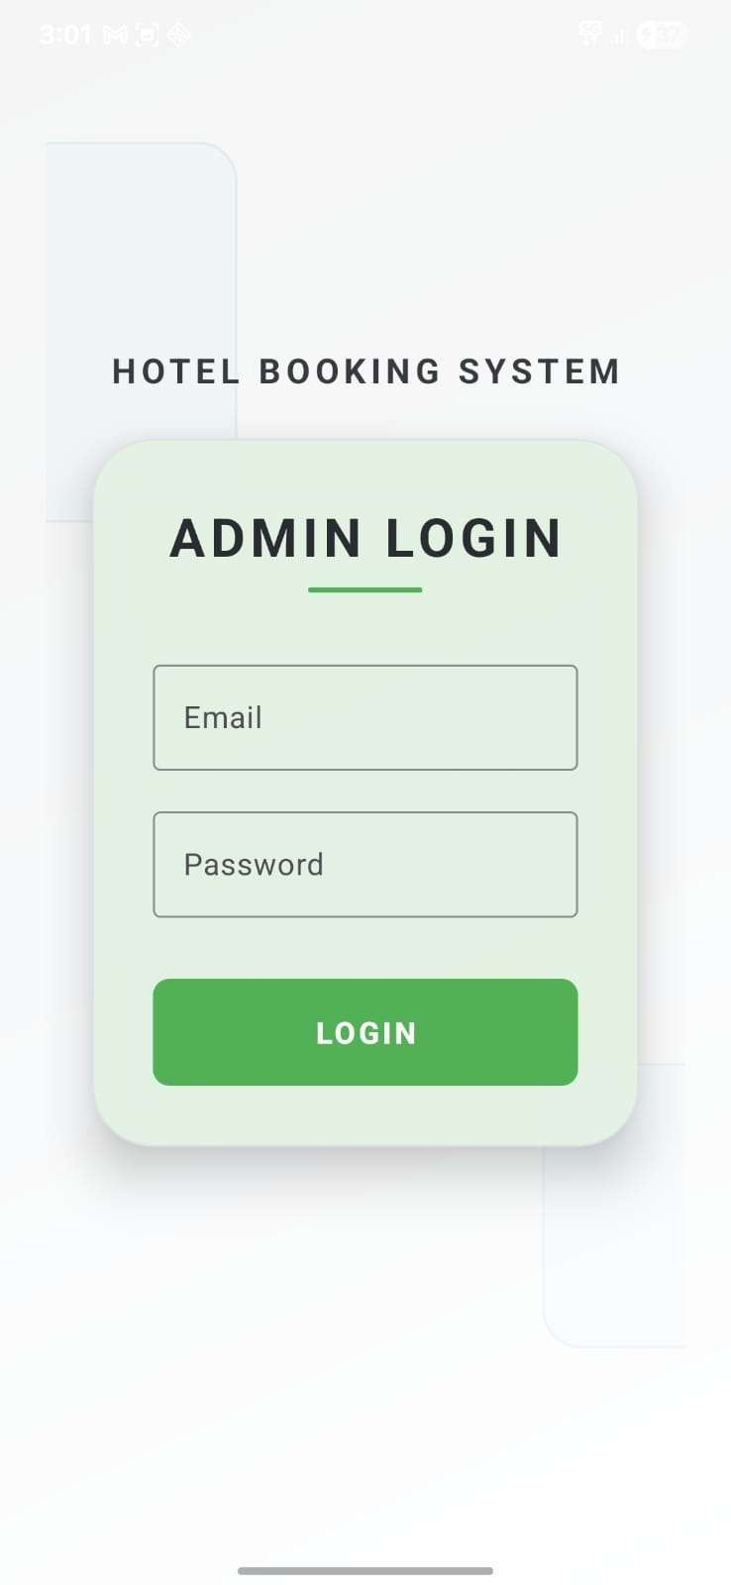

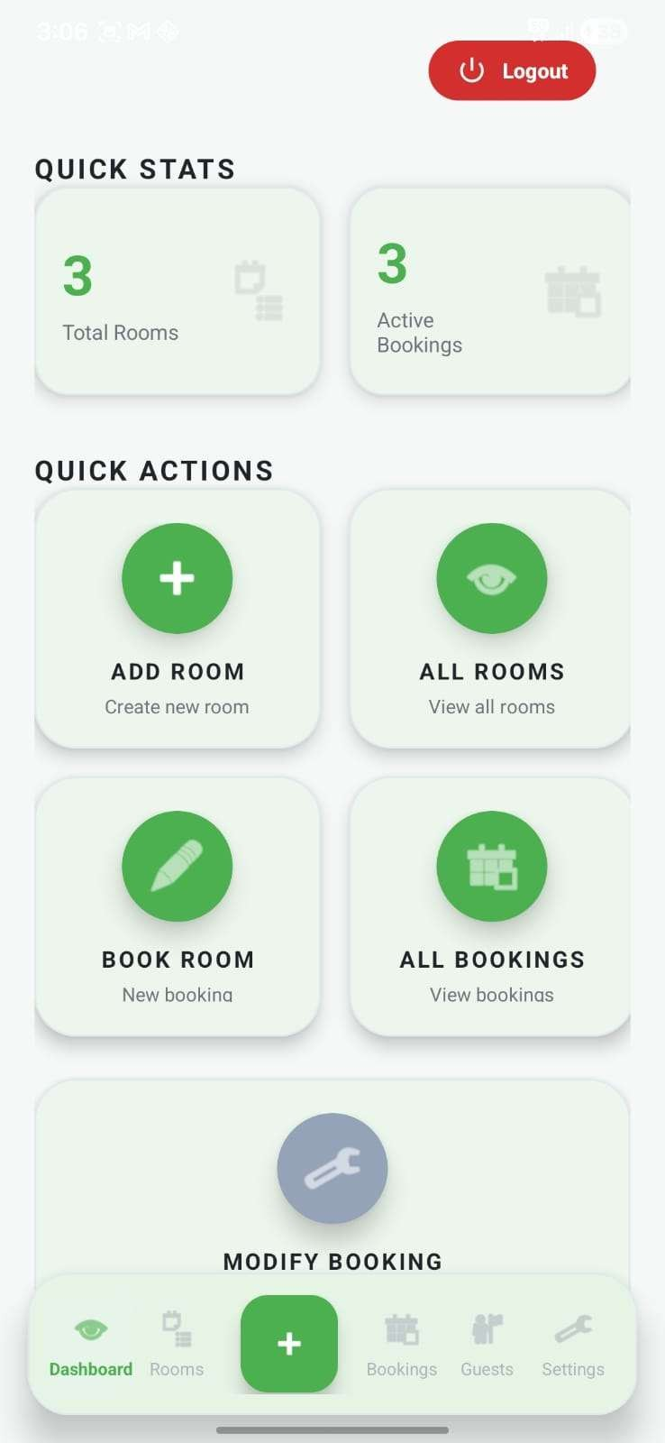

3.Room Management 4.All Rooms
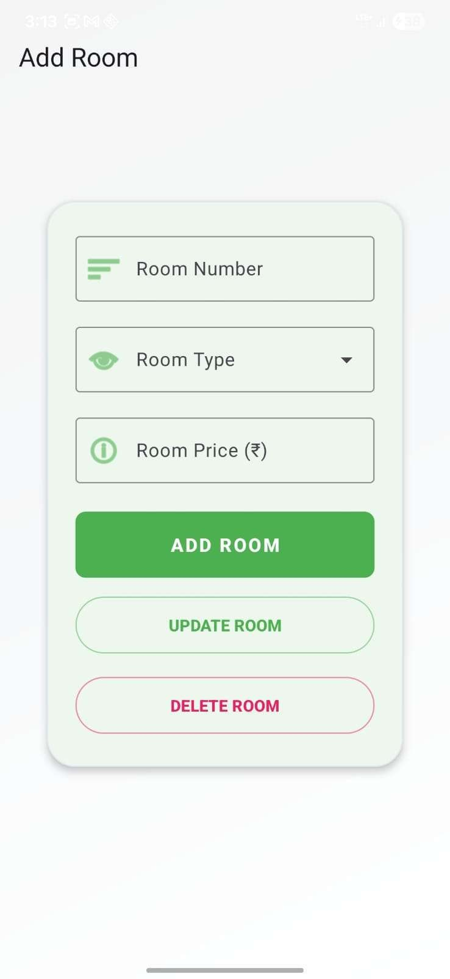
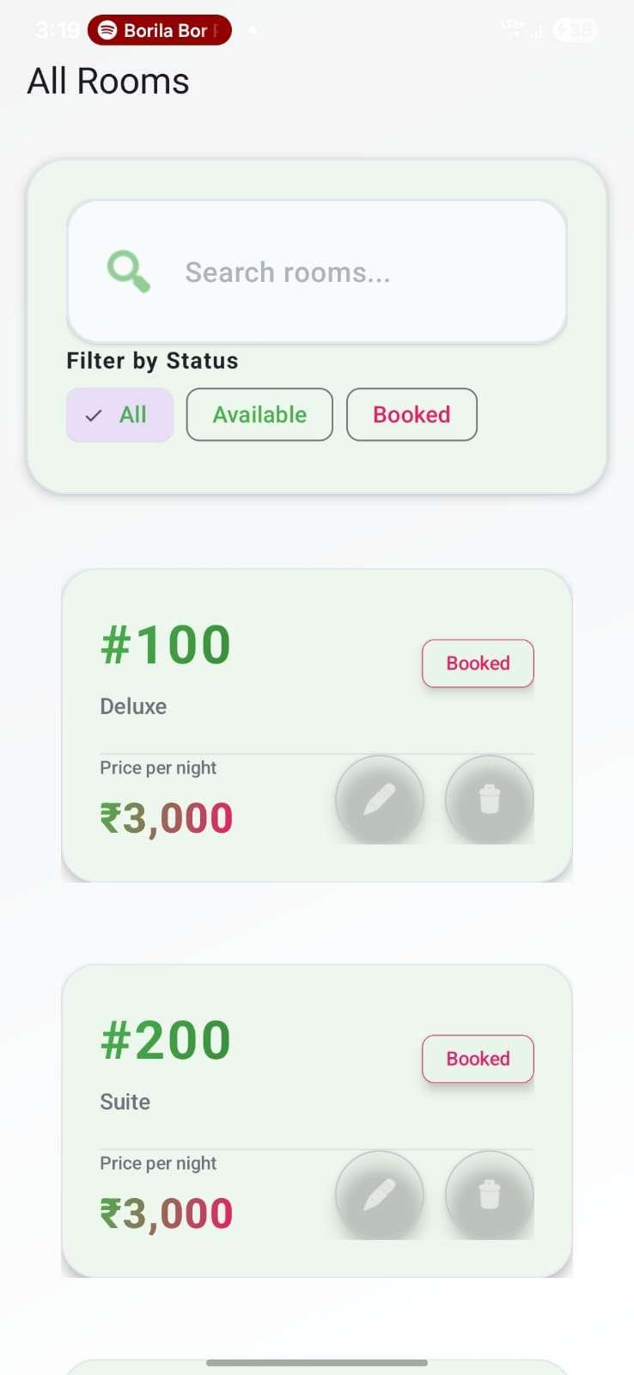

5.Booking Screen 6.Guest Details
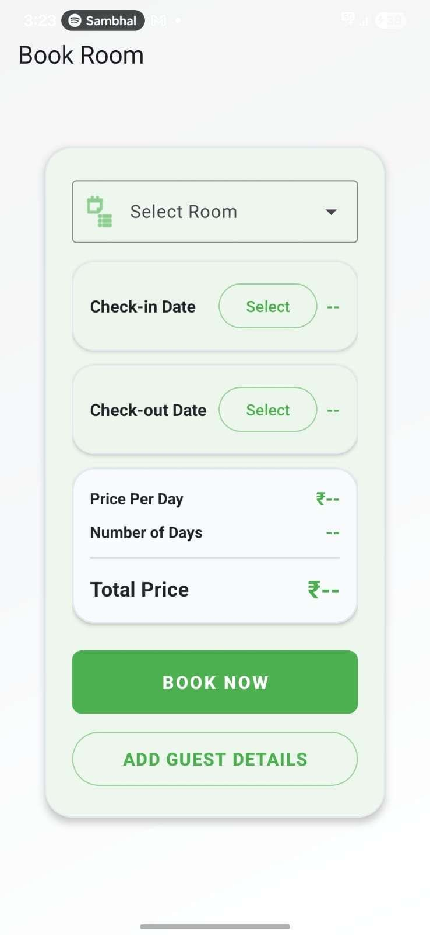
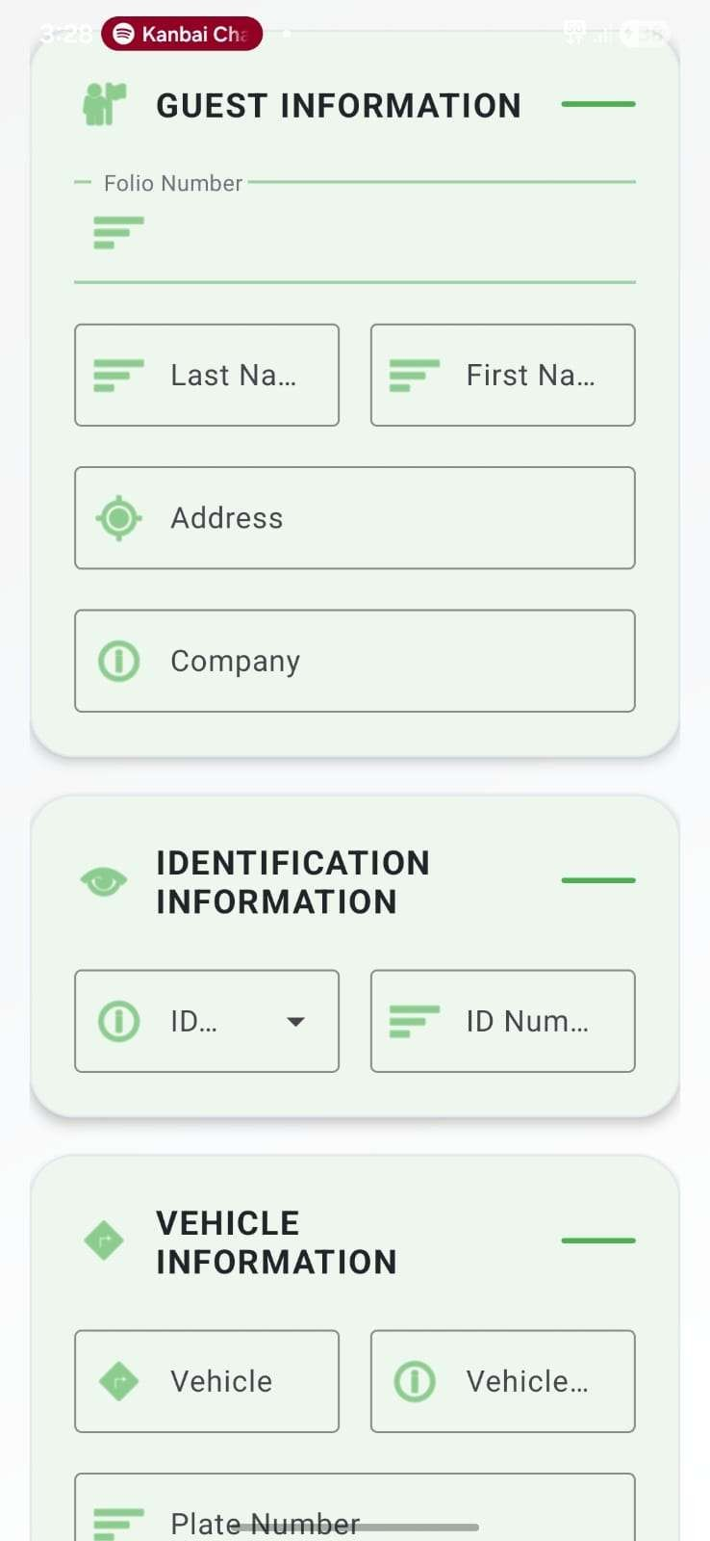

7.Modify Booking 8.Guest Details
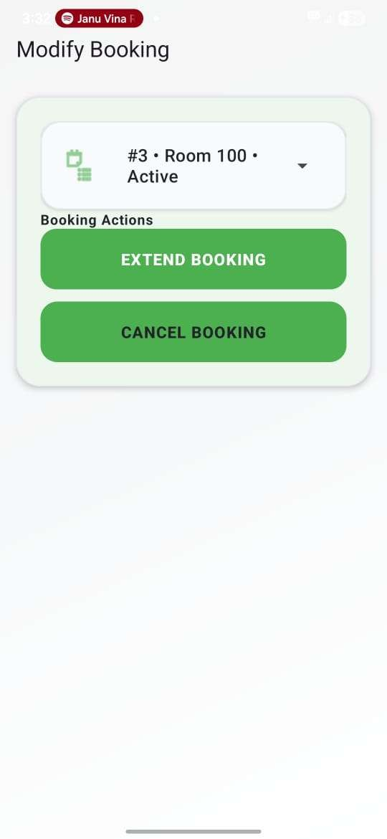
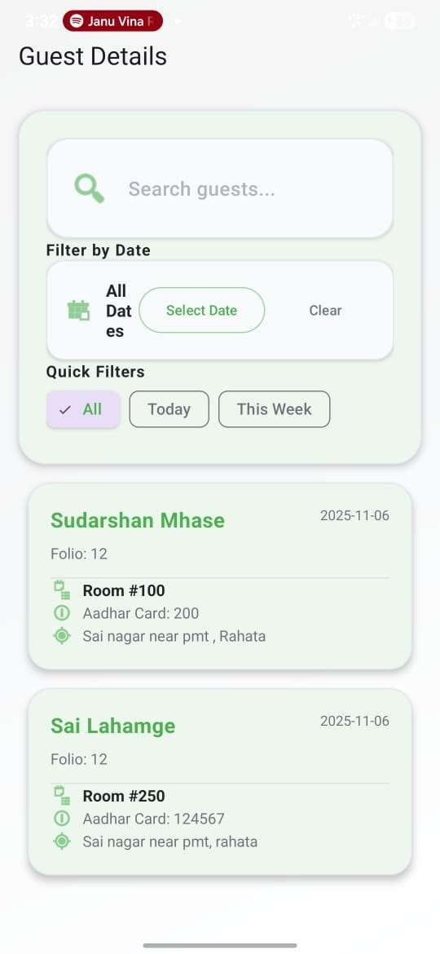

CHAPTER 14

Firebase Integration

Firebase Authentication
  - Email/Password provider enabled
  - User management
  - Session handling

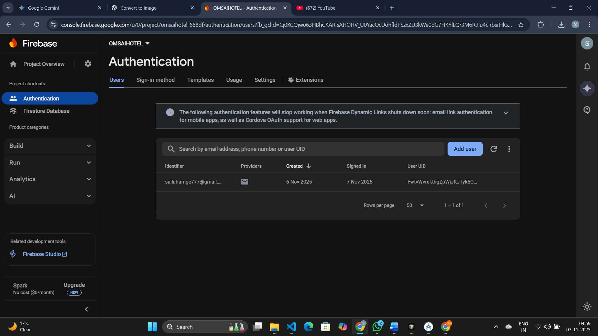

Firebase Firestore
  - Collections: bookings, guests
  - Real-time synchronization
  - Security rules for authenticated users

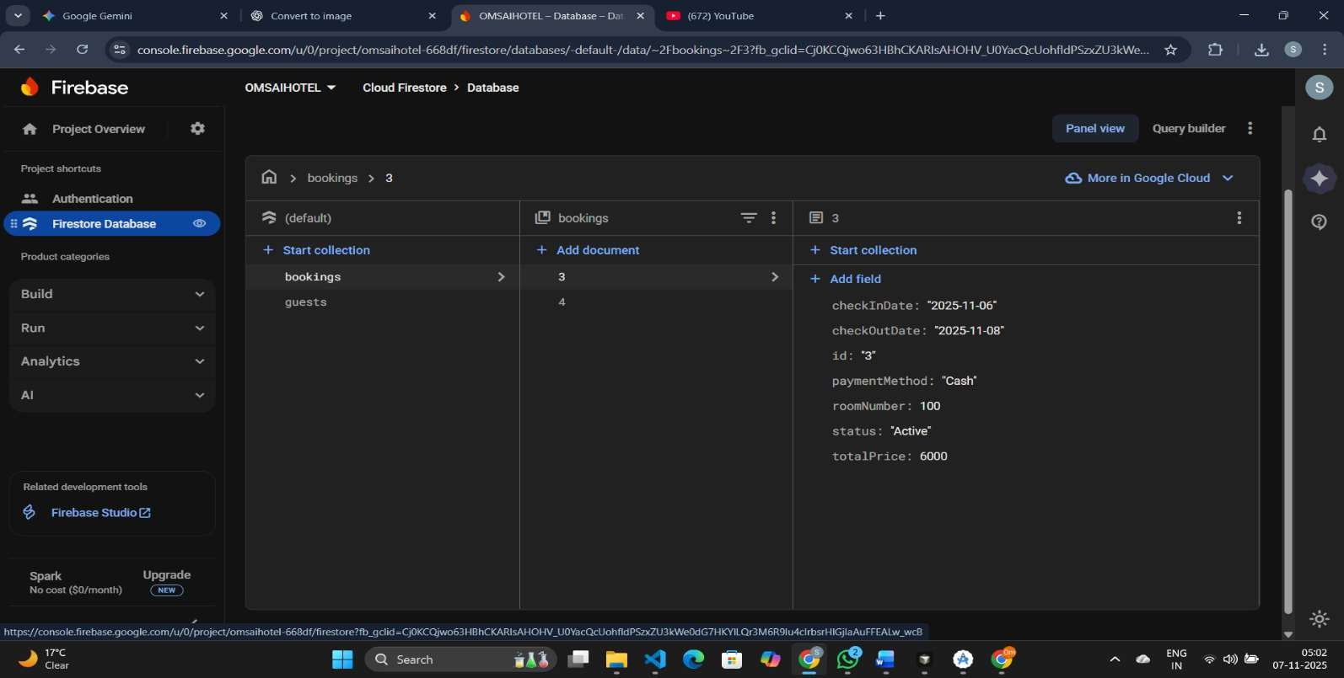

CHAPTER 15

Git-Hub Repository

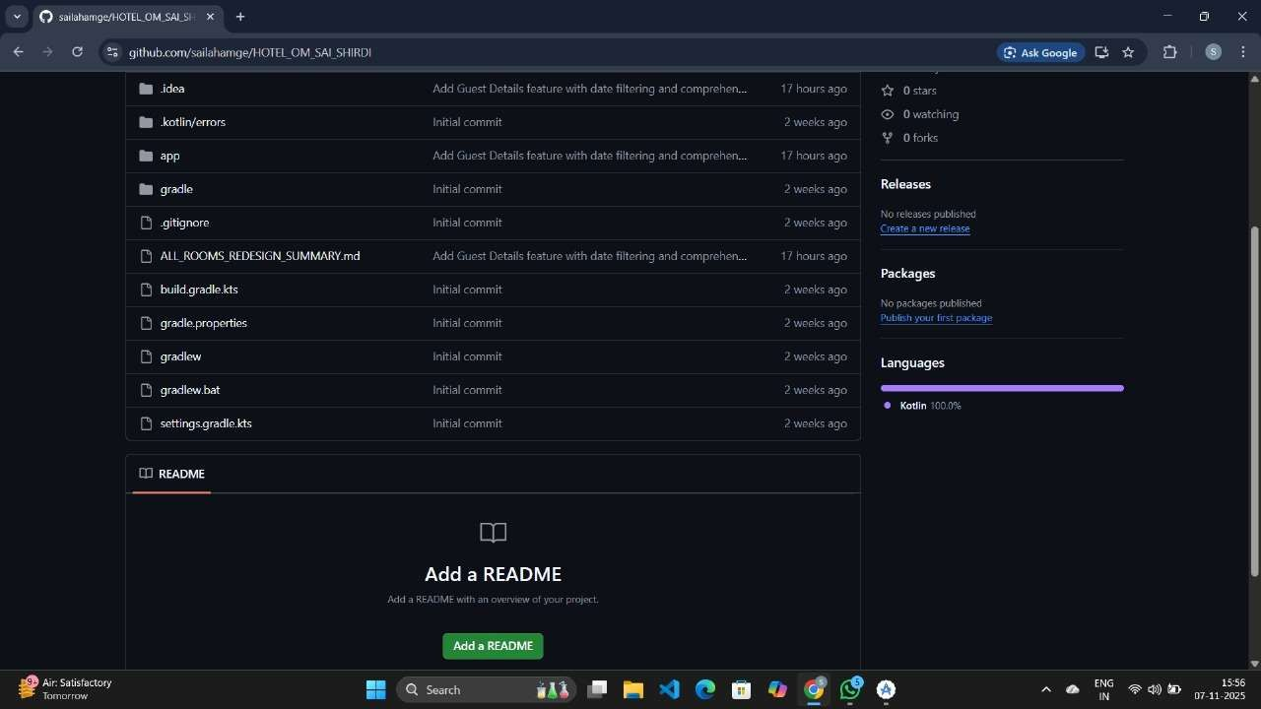

App Download Link

https://github.com/sailahamge/HOTEL_OM_SAI_SHIRDI

CHAPTER 16 CONCLUSION
The OM SAI HOTEL app is an Android-based hotel management system built with Kotlin, MVVM, Room, and Firebase. It digitalizes hotel operations, managing room availability, bookings, and guest details on a single platform. Key features include secure Firebase Authentication and automatic room price calculation. The app ensures data reliability through a dual-storage system utilizing real-time Firestore and offline Room Database support. It efficiently streamlines tasks such as adding, extending, or canceling bookings and tracking payment methods. The system is designed for high maintainability and scalability using a modular architecture. Future plans involve integrating an online payment gateway and developing an admin dashboard with analytics. Ultimately, it replaces manual processes with an efficient, user-friendly mobile application featuring an intuitive Material Design UI.

CHAPTER 17

REFERENCES

Documentation
The project relied on the following official documentation for its core technologies:
    - Android Developers - Jetpack Compose: https://developer.android.com/jetpack/compose
    - Firebase Documentation: https://firebase.google.com/docs
    - Material Design 3: https://m3.material.io/
    - Kotlin Documentation: https://kotlinlang.org/docs/home.html
    - Hilt Dependency Injection: https://dagger.dev/hilt/

Libraries & Tools

These third-party libraries and tools were integrated to add critical functionality and performance:
    - Coil Image Loading: https://coil-kt.github.io/coil/
    - Retrofit: https://square.github.io/retrofit/
    - Room Database: https://developer.android.com/training/data-storage/room
    - Lottie Animations: https://airbnb.io/lottie/

