Project Report: Pairs Trading Strategy – Results & Analysis

# 1. Overview of the Strategy

This project implements a Pairs Trading strategy using statistical arbitrage techniques. The main idea is to identify pairs of historically correlated stocks, observe divergences in their price relationship, and then trade on the expectation that they will revert to their historical mean. We selected Coca-Cola (KO) and PepsiCo (PEP) due to their strong correlation and industry similarity.

# 2. Regression and Spread Calculation

Using Ordinary Least Squares (OLS) regression, we modeled KO as a linear function of PEP. The regression results revealed a strong relationship with an R-squared value of 0.912, indicating a very good fit. We then calculated the spread between KO and its predicted value from the regression equation, and standardized this spread using the Z-score.

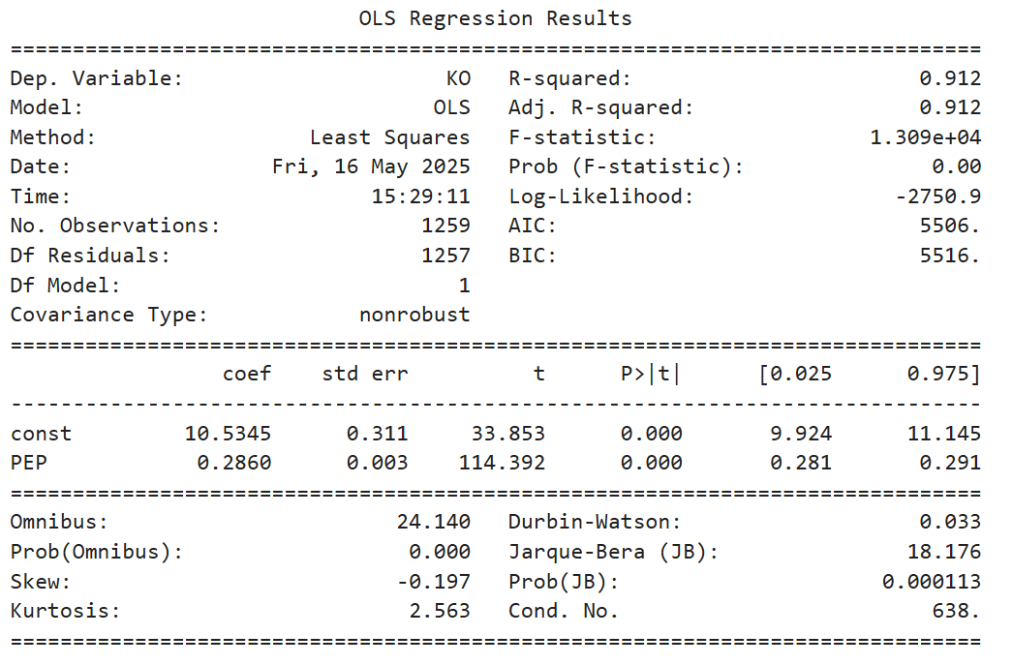

# 3. Signal Generation Using Z-Score

Trading signals were generated when the Z-score of the spread exceeded predefined thresholds:  
- Z > 2: The spread is overbought – initiate a short position (Sell KO, Buy PEP).  
- Z < -2: The spread is oversold – initiate a long position (Buy KO, Sell PEP).  
- -2 < Z < 2: No trade – market is considered neutral.

In our dataset, the most recent Z-score was 0.29, which lies within the neutral zone, and thus no trading action is suggested at that point.

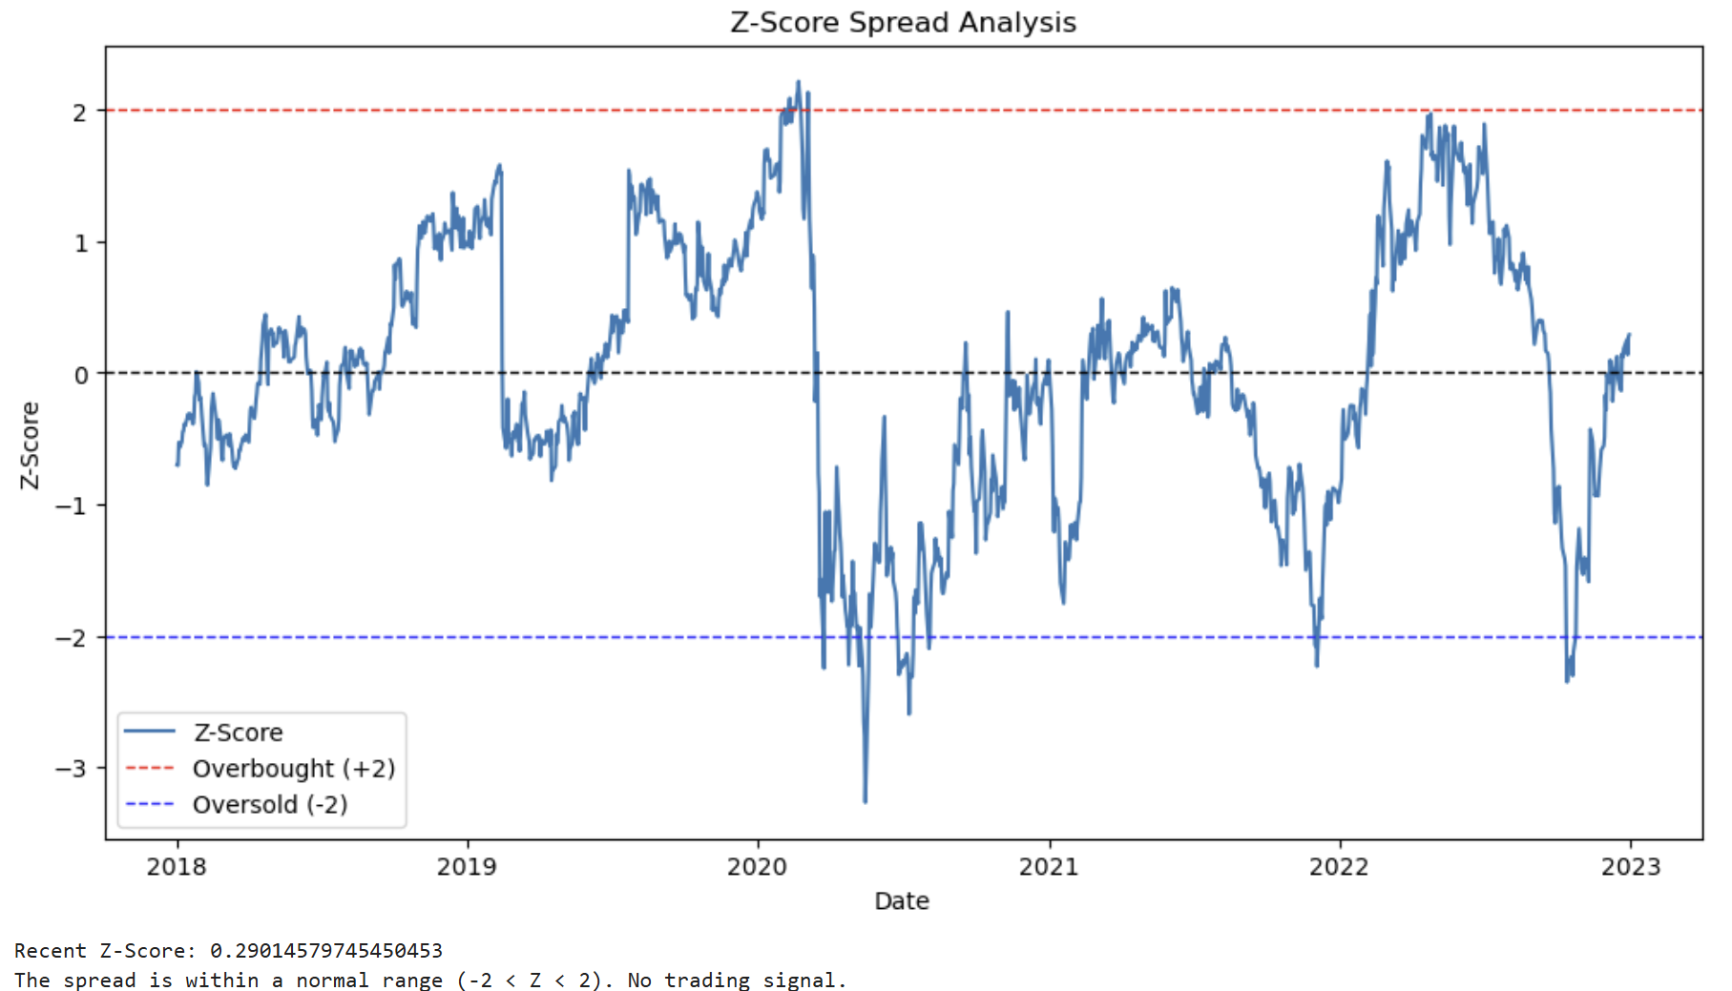

# 4. Backtesting and Strategy Performance

The backtesting logic involved shifting signals by one day to avoid lookahead bias, calculating the percentage returns for both stocks, and applying the strategy based on those signals. The returns from the strategy were then accumulated over time.

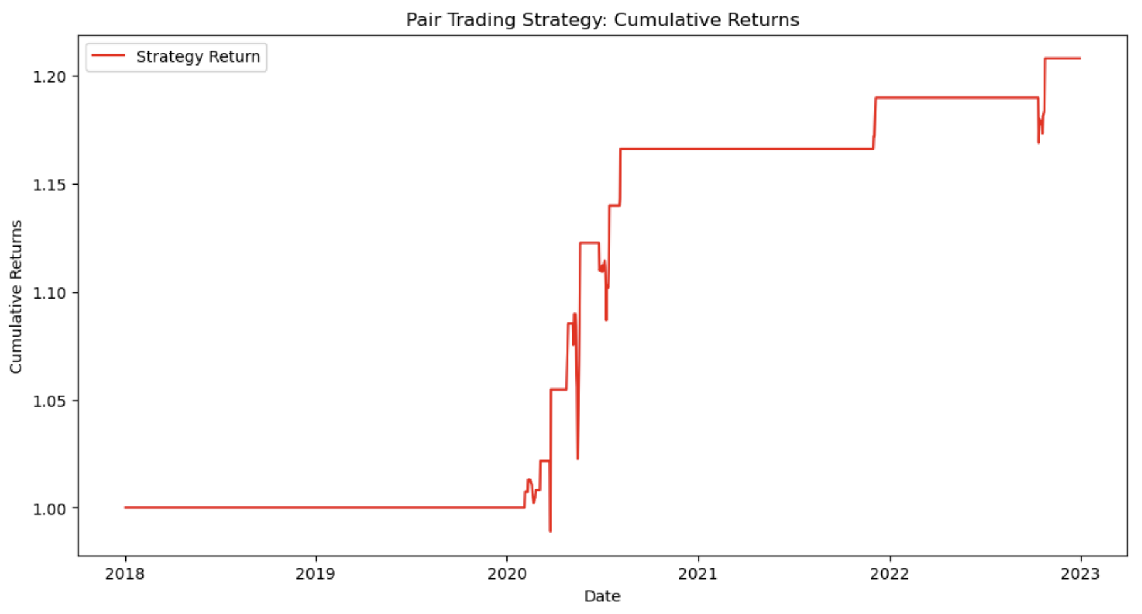

The final performance metrics of the strategy over the 5-year backtest period are:

- Total Return: 20.80%

- Sharpe Ratio: 0.73

- Maximum Drawdown: -6.16%

These results indicate that the strategy was profitable and relatively stable, although the Sharpe ratio suggests moderate risk-adjusted returns. The low drawdown also reflects the defensive nature of the strategy.

# 5. Conclusion

The pairs trading strategy using KO and PEP showed promising results with a decent total return and limited drawdown. This confirms the potential for statistical arbitrage when carefully selecting correlated asset pairs. Future work could include optimizing thresholds, testing more stock pairs, and applying machine learning to improve prediction accuracy and signal quality.