PROJECT – I (4IT31)
PROGRESS REPORT – I
Contextual Meeting Intelligence System
An AI-Powered Platform for Automated Meeting Documentation, Context Extraction and On-Demand Report Generation

Contents

1 Project Definition
The project “Contextual Meeting Intelligence System (CMIS)” focuses on automating the documentation and knowledge management of meetings, calls, and lectures using speech recognition and natural language processing techniques. The system listens to a recorded or live audio session, converts it into a speaker-labelled transcript, and extracts a structured, persistent understanding of what was discussed — including topics, decisions, action items, and urgency levels. This structured context is stored centrally and can be used to generate multiple outputs on demand, such as minutes of meeting, executive summaries, presentations, and agendas for follow-up sessions. Unlike conventional transcription tools that only produce a flat text record, CMIS builds a reusable, searchable context that persists across multiple related meetings, allowing recurring discussion points to be tracked automatically over time.

2 Project Objective
The objective of this project is to develop an AI-based system that automatically transcribes, structures, and summarizes meetings, calls, and lectures, and generates multiple documentation formats from a single, persistent understanding of the discussion.

2.1 Specific Objectives
- To convert recorded or live meeting audio into an accurate, speaker-labelled transcript
- To segment transcripts into topics and identify recurring discussion points
- To extract action items, decisions, and urgency levels from natural conversation
- To maintain a persistent, searchable context store across multiple meetings
- To automatically generate minutes of meeting, summaries, and presentations on demand

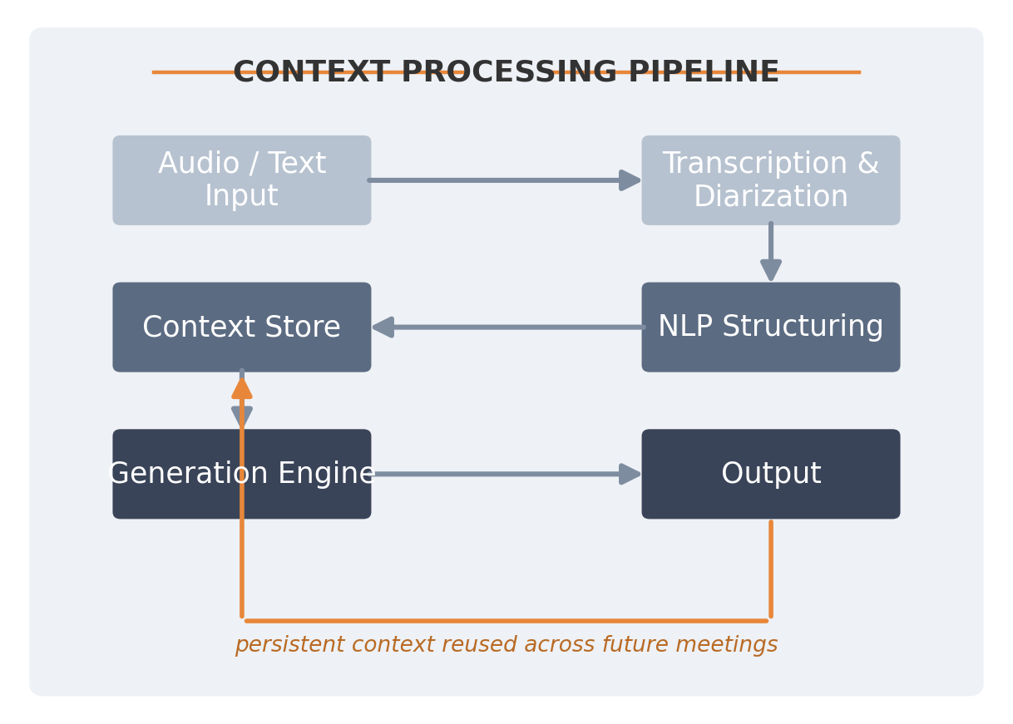
Fig 2.1: Context Processing Pipeline of CMIS

3 Project Scope
The scope of this project is limited to post-session documentation and knowledge extraction from recorded or uploaded audio of meetings, calls, and lectures. The system accepts a completed audio recording as input and produces a structured context along with generated documentation as output. Live, real-time transcription during an ongoing session is treated as a future extension and is not part of the current scope. The project focuses on English and commonly used Indian-accented speech, with support for a limited set of regional languages depending on the capability of the underlying speech-to-text engine. The system does not perform video analysis, facial recognition, or any biometric identification of speakers; speaker labelling is limited to voice-based diarization (e.g., Speaker 1, Speaker 2).

4 Project Modules
The proposed system is divided into well-defined modules to ensure modular development, scalability, and ease of maintenance. Each module handles a specific stage of the pipeline, from raw audio ingestion to final report generation, allowing the team to develop and test components independently before integration.

4.1 Audio Ingestion Module
The Audio Ingestion Module is responsible for accepting recorded audio or video files of meetings, calls, or lectures, either through direct upload or export from common conferencing platforms. This module validates the input format, extracts the audio stream where necessary, and prepares it for downstream processing. It also captures basic session metadata such as meeting title, date, and participant list where available.

4.2 Transcription and Diarization Module
This module converts the ingested audio into a clean, time-aligned text transcript using an automatic speech recognition engine, and separates the transcript by speaker using diarization. Support for multiple accents and Indian languages is incorporated by evaluating speech engines suited to the target speaker population. The output of this module is a speaker-labelled transcript that forms the input to the structuring stage.

4.3 NLP Structuring Module
The NLP Structuring Module analyses the transcript to identify topic boundaries, classify statements as decisions or action items, and assign urgency levels based on language cues. Topic segmentation groups related discussion into coherent sections, while a text-similarity technique (MinHash / Locality-Sensitive Hashing) is used to detect recurring topics across different meetings. This module transforms unstructured text into a structured, machine-readable representation of the meeting.

4.4 Context Store Module
The Context Store Module maintains a persistent, queryable record of every processed meeting — including topics, decisions, action items, participants, and timestamps. This store allows information from earlier meetings to be referenced when processing later ones, enabling the system to track recurring agenda items and outstanding action items across a project's lifetime, rather than treating each meeting in isolation.

4.5 Report and Presentation Generation Module
This module generates the final, user-facing outputs from the structured context stored in the system. Supported outputs include minutes of meeting (MoM), executive summaries, action-item trackers, agendas for the next meeting, and slide presentations. Each output is generated on demand from the same underlying context, avoiding duplicate manual effort for each format.

4.6 Dashboard and Visualization Module
The Dashboard Module provides a user-facing interface to browse past meetings, search the context store, review generated reports, and track the status of action items over time. It presents summarized statistics such as the number of open action items, recurring topics, and meeting frequency, helping users and faculty coordinators quickly assess ongoing project or committee activity.

5 Project Basic Requirements

5.1 Software Requirements
- Operating System: Windows 10 / Ubuntu 22.04
- Programming Language: Python, JavaScript
- Python Libraries: scikit-learn, spaCy, NumPy, Pandas
- Speech-to-Text Engine: Sarvam AI / OpenAI Whisper
- Backend Framework: FastAPI
- Frontend Framework: React (Vite) with Tailwind CSS
- Database: PostgreSQL
- Document Generation: python-docx, pptxgenjs
- IDE: VS Code / Jupyter Notebook

6 Literature Review
Several studies related to meeting summarization, speech recognition, and dialogue structuring have been reviewed to understand the current state of research and identify gaps that this project aims to address.

6.1 Meeting Summarization Approaches
Rennard et al. [1] provide a comprehensive survey of abstractive meeting summarization, outlining the datasets, models, and evaluation metrics used to address the challenges of multi-party conversational summarization. Their work highlights that meeting transcripts are considerably harder to summarize than single-author documents due to speaker overlap, disfluencies, and topic drift.
Golia and Kalita [2] introduced an action-item-driven summarization approach that recursively summarizes topic-segmented sections of long meeting transcripts, using cosine-similarity-based segmentation to divide transcripts before summarization. Their approach demonstrated measurable improvement over prior abstractive baselines on the AMI meeting corpus, reinforcing the value of topic segmentation as a pre-processing step, which this project also adopts.

6.2 Dialogue Summarization and Structured Extraction
Feng et al. [3] surveyed dialogue summarization research broadly, categorizing approaches by dialogue type (meetings, chat, customer service) and noting that most systems still struggle to reliably separate factual statements from decisions and commitments within free-flowing conversation.
FM et al. [4] presented a practical system for automating minutes-of-meeting generation using NLP techniques, demonstrating that rule-based and statistical text-processing pipelines can produce usable structured minutes without requiring large annotated training corpora — a relevant consideration for a project of this scope.
Gliwa et al. [5] released the SAMSum corpus, a human-annotated dialogue dataset for abstractive summarization that has since become a standard benchmark for evaluating dialogue and chat summarization models, and is referenced in this project for evaluating the summarization component.

6.3 Speech Recognition and Speaker Diarization
Radford et al. [6] introduced Whisper, a speech recognition model trained on 680,000 hours of multilingual and multitask supervision, which generalizes well to noisy, accented, and domain-specific audio in a zero-shot setting without additional fine-tuning — making it a strong candidate transcription backbone for this project's varied meeting recordings.
Park et al. [7] surveyed recent advances in deep-learning-based speaker diarization, outlining the shift from traditional clustering-based methods toward end-to-end neural diarization systems that jointly model speaker segmentation and identification.
Bredin [8] described the pyannote.audio speaker diarization pipeline, an openly available neural diarization toolkit that achieves competitive accuracy on standard benchmarks and is practical to integrate into research and student-built systems without requiring proprietary infrastructure.

6.4 Research Gap and Project Contribution
While existing research addresses meeting summarization, action-item extraction, and speech transcription as largely separate problems, most available tools focus on a single stage of the pipeline — either producing a flat transcript, or a one-off summary of a single session. Few systems maintain a persistent, structured context that spans multiple related meetings over time, and fewer still generate multiple downstream artefacts (minutes, presentations, agendas) from that same shared context. This project addresses this gap by integrating transcription, topic-aware structuring, action-item and urgency extraction, recurring-topic detection using similarity hashing, and multi-format generation into a single, cohesive system built around one persistent context store.

7 Project Feasibility Study
The feasibility study assesses whether the proposed meeting intelligence system can be developed and implemented effectively. The study evaluates the project from technical, economic, and operational perspectives to ensure its practicality.

7.1 Technical Feasibility
The project is technically feasible due to the availability of mature, well-documented speech-to-text engines (Sarvam AI, OpenAI Whisper) and open-source NLP libraries such as spaCy and scikit-learn. Standard web technologies (React, FastAPI, PostgreSQL) are used for the dashboard and backend, all of which are well-supported and widely documented. The system can be developed and executed on standard computer systems without requiring specialized hardware, though a modest GPU accelerates transcription for longer recordings.

7.2 Economic Feasibility
The project is economically feasible as it primarily relies on open-source software and free-tier APIs for prototyping. Python and JavaScript libraries used for NLP, backend, and frontend development are freely available, and the speech-to-text engines under evaluation offer free usage tiers sufficient for academic development and testing. Therefore, the project does not require significant financial investment, making it suitable for academic and educational purposes.

7.3 Operational Feasibility
The system is designed to be easy to operate: users upload or select a recorded meeting, and the system automatically produces a transcript, structured context, and requested outputs without requiring manual intervention. The dashboard presents results through familiar, readable formats (documents, slides, summaries), requiring minimal technical knowledge from end users such as faculty, project teams, or committee coordinators.

8 Project Requirement Gathering

8.1 Requirement Gathering Techniques
- Study of existing meeting-transcription and note-taking tools
- Review of academic literature on meeting summarization and diarization
- Analysis of recurring documentation needs within student project teams
- Discussion with faculty guide

8.2 Comparison of Existing Applications with Proposed Application
Feature | Existing Applications | Proposed Application
Meeting Documentation | Manual note-taking by attendees | Automated, AI-generated minutes
Action Item Tracking | Not available | Available, with owner & urgency tags
Output Formats | Single text note only | MoM, presentation, summary, agenda
Cross-Meeting Context | Not retained between sessions | Persistent, searchable context store
Recurring Topic Detection | Not available | Available (LSH-based similarity)
Table 8.1: Comparison of Existing Applications with Proposed Application

9 Project Timeline Chart
Phase | Duration
Requirement Analysis | First Week of January
Dataset & Sample Meeting Collection | Second Week of January
Transcription & Diarization Pipeline | Third Week of January
NLP Structuring Module Development | February
Testing and Evaluation | Early March
Report / Presentation Generation Module | Mid March
Documentation and Presentation | Last Week of March
Table 9.1: Project Timeline Chart

10 Project Work Distribution Among Team Members

10.1 Team Member 1: Desai Karansinh (23IT402)
Responsible for the transcription and diarization module, speech-to-text engine integration, and overall system architecture and backend development.

10.2 Team Member 2: Krunalkumar Rohit (23IT419)
Responsible for the NLP structuring module, including topic segmentation, action-item and decision classification, and recurring-topic detection.

10.3 Team Member 3: Dev Chavda (23IT441)
Responsible for the context store design, database schema, and the report and presentation generation module.

10.4 Team Member 4: Saksham Sharma (23IT553)
Responsible for the dashboard and visualization module, frontend development, testing, and documentation.

11 References
1. V. Rennard, G. Shang, J. Hunter, and M. Vazirgiannis, “Abstractive Meeting Summarization: A Survey,” Transactions of the Association for Computational Linguistics, vol. 11, pp. 861–884, 2023.
2. L. Golia and J. Kalita, “Action-Item-Driven Summarization of Long Meeting Transcripts,” in Proc. 2023 7th International Conference on Natural Language Processing and Information Retrieval (NLPIR 2023), Seoul, Republic of Korea, pp. 91–98, 2023.
3. X. Feng, X. Feng, and B. Qin, “A Survey on Dialogue Summarization: Recent Advances and New Frontiers,” arXiv preprint arXiv:2107.03175, 2022.
4. M. F. A. FM, S. Pawankumar, M. Guruprasath, and J. Jayaprakash, “Automation of Minutes of Meeting (MoM) using Natural Language Processing (NLP),” in 2022 International Conference on Communication, Computing and Internet of Things (IC3IoT), pp. 1–6, 2022.
5. B. Gliwa, I. Mochol, M. Biesek, and A. Wawer, “SAMSum Corpus: A Human-annotated Dialogue Dataset for Abstractive Summarization,” in Proc. 2nd Workshop on New Frontiers in Summarization, pp. 70–79, 2019.
6. A. Radford, J. W. Kim, T. Xu, G. Brockman, C. McLeavey, and I. Sutskever, “Robust Speech Recognition via Large-Scale Weak Supervision,” in Proc. International Conference on Machine Learning (ICML), vol. 202, pp. 28492–28518, 2023.
7. T. J. Park, N. Kanda, D. Dimitriadis, K. J. Han, S. Watanabe, and S. Narayanan, “A Review of Speaker Diarization: Recent Advances with Deep Learning,” Computer Speech & Language, vol. 72, p. 101317, 2022.
8. H. Bredin, “pyannote.audio 2.1 Speaker Diarization Pipeline: Principle, Benchmark, and Recipe,” in Proc. INTERSPEECH 2023, 2023.

