**Control of Robotics Systems (ENPM667) Final-Project Report**

### 

### **Authors:** Karan Sutradhar (117037672)

Ajinkya Parwekar (117030389)

Date: 12/18/2020



## Abstract:

The focus of this project is to understand and implement the core concepts of controls, including State Space Representation, Nonlinear System Design, Linear Quadratic Regulator (LQR) Controller, Linear Quadratic Tracker (LQT) Controller and Luenberger Observer for Double Pendulum on a cart. We used concepts like Controllability, Observability, for systems to develop a robust controller. For the scope, simulations, and validation of this project we will use Mat-Lab and Simulink to model our system.

## Project Goals:

* Understand and implement the core concepts of controls, including State Space Representation, Nonlinear System Design, Linear Quadratic Regulator (LQR) Controller, Linear Quadratic Tracker (LQT) Controller and Luenberger Observer for Double Pendulum on a cart.
* Usage of concepts like Controllability, Observability, for systems to develop a robust controller.
* To simulate and validate the scope of this project we will use Mat-Lab and Simulink to model our system.

## **Table of Contents**

**Problem** **Statement 4**

**Equations of motion for Nonlinear State Representation 4**

**Problem Statement:**

For this project we have considered a friction-less crane of mass M actuated by an external force F that constitutes the input of the system. There are two loads suspended from cables attached to the crane. The loads have mass m1 and m2, and the lengths of the cables are l1 and l2, respectively. The following figure depicts the crane and associated variables used throughout this project.

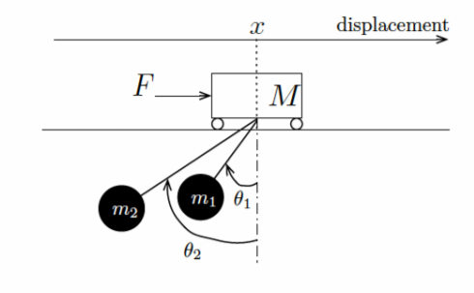

**Equations of motion for Nonlinear State Representation:**

To obtain the dynamics of the system given in the problem statement, we have to find out the linear velocity, linear acceleration of the crane along with, angular velocity and angular acceleration of the masses of the pendulum m1 and m2 which are the states of the system.

From the fig 2.0, we are considering (X,Y) as the origin of the reference frame in the system, and then we model the system with the same consideration.

We will use Eurler-Lagrange equation to formulate the motions equations and use it to fabricate the non-linear state space representation. To compute the Eurler-Lagrange equation we need to calculate the kinetic and potential energy of the system.

First we find out the kinetic energy of individual masses, then we add them.

Position of m1 w.r.t the reference frame is given by

|  |  |
| --- | --- |
| $$x_{1}=\left(x-\left(l_{1}\right)\sin\left(θ_{1}\right)\right)X+{(l}_{1})\cos\left(θ_{1}\right)Y$$ | (1) |

The position of m2 w.r.t the reference frame is given by

|  |  |
| --- | --- |
| $$x_{2}=\left(x-\left(l_{2}\right)\sin\left(θ_{2}\right)\right)X+{(l}_{2})\cos\left(θ_{2}\right)Y$$ | (2) |

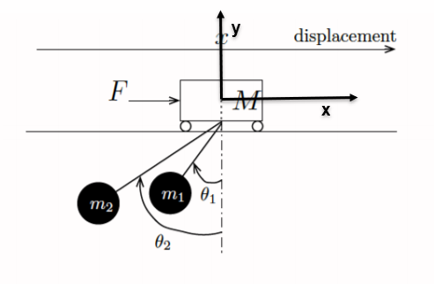

The total energy of the system is given from the Kinetic energy equation

|  |  |
| --- | --- |
| $$K=1/2[M{\left(\frac{dx}{dt}\right)}^{2}]$$ | (3) |

From equation (3), we have the equation of the Kinetic energy for the individual masses of the system.

Let us first find the kinetic energy of mass1

|  |  |
| --- | --- |
| $$K_{1}=1/2[M\left(m_{1}\dot{x}-m_{1}l_{1}{\dot{θ}}_{1}\cos{{\left(θ_{1}\right)}^{2}}+\left(-m_{1}l_{1}{\dot{θ}}_{1}\sin{{\left(θ_{1}\right)}^{2}}\right)\right)]$$ |  |
| $$K_{1}=1/2[M\left(m_{1}\dot{x^{2}}+m_{1}{l_{1}}^{2}{\dot{θ}}_{1}^{2}\cos^{2}\left(θ_{1}\right)-2m_{1}\dot{x}l_{1}{\dot{θ}}_{1}cosθ_{1}+m_{1}{l_{1}}^{2}{\dot{θ}}_{1}^{2}\sin^{2}\left(θ_{1}\right)\right)]$$ |

Solving the equation, we get

|  |  |
| --- | --- |
| $$K_{1}=1/2[M\left(m_{1}\dot{x^{2}}+{{m_{1}l}_{1}}^{2}{\dot{θ}}_{1}^{2}-2m_{1}\dot{x}l_{1}{\dot{θ}}_{1}cosθ_{1}\right)]$$ | (4) |

Let us find the kinetic energy of mass2 using the equation (4),

We will get the kinetic energy of mass2 as similarly as we got the kinetic energy for mass1

|  |  |
| --- | --- |
| $$K_{2}=1/2[M\left(\dot{{m_{2}x}^{2}}+{m_{2}l_{2}}^{2}{\dot{θ}}_{2}^{2}-2m_{2}\dot{x}l_{2}{\dot{θ}}_{2}cosθ_{2}\right)]$$ | (5) |

Now, we calculate the potential energy for the system:

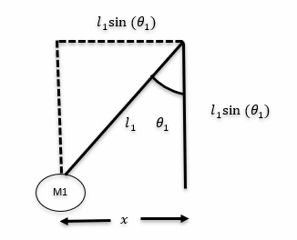

|  |  |
| --- | --- |
|  |  |

|  |  |
| --- | --- |
|  | (6) |

Similarly, for mass2

|  |  |
| --- | --- |
| $$P_{2}=m_{2}gl_{2}(1-cosθ_{2})$$ | (7) |

As we mentioned above, we need to use the Euler-Lagrange Equation,

|  |  |
| --- | --- |
| $$L= K- P$$ | (8) |

For this system

|  |  |
| --- | --- |
| $$K= K_{1}+ K_{2}+ K_{Crane}$$ | (9) |

Similarly,

|  |  |
| --- | --- |
| $$P= P_{1}+ P_{2}+ P_{Crane}$$ | (10) |

From equations (3), (4), (5)

|  |
| --- |
| $$K_{crane}=1/2[M{\left(\frac{dx}{dt}\right)}^{2}]$$ |
| $$K_{1}=1/2[M\left(m_{1}\dot{x^{2}}+{{m_{1}l}_{1}}^{2}{\dot{θ}}_{1}^{2}-2m_{1}\dot{x}l_{1}{\dot{θ}}_{1}cosθ_{1}\right)]$$ |  |
| $$K_{2}=1/2[M\left(\dot{{m_{2}x}^{2}}+{m_{2}l_{2}}^{2}{\dot{θ}}_{2}^{2}-2m_{2}\dot{x}l_{2}{\dot{θ}}_{2}cosθ_{2}\right)]$$ |  |

We know that, $P_{crane}=0$, as the reference height is zero, h = 0

From equations (6), (7)

$$P_{1}=m_{1}gl_{1}(1-cosθ_{1})$$

$$P_{2}=m_{2}gl_{2}(1-cosθ_{2})$$

Substituting all the values in equation (8) we have

|  |  |
| --- | --- |
| $$L=\frac{1}{2}{\dot{x}}^{2} \left(M+m_{1}+m_{2}\right)- m_{1}\dot{x}l_{1}{\dot{θ}}_{1} cosθ_{1}- m_{2}\dot{x}l_{2}{\dot{θ}}_{2} cosθ_{2}+\frac{1}{2}m_{1}l_{1}{\dot{θ}}_{1}^{2}+\frac{1}{2}m_{2}l_{2}{\dot{θ}}_{2}^{2}-m_{1}gl_{1}\left(1-cosθ_{1}\right)- m_{2}gl_{2}(1-cosθ_{2})$$ | (11) |

From Euler- Lagrange Equation we know that,

|  |  |
| --- | --- |
| $$\frac{d}{dt}\left(\frac{∂L}{∂\dot{q}}\right)-\frac{∂L}{∂q}$$ | (12) |

We know that q is the state variables.

From the system, $q=x,$ $θ_{1}, { θ}_{2}$

|  |
| --- |
| $$F=x\frac{d}{dt}\left(\frac{∂L}{∂\dot{x}}\right)-\frac{∂L}{∂x}$$ |

$$x-\frac{∂L}{∂θ_{1}}=0$$

$$x\frac{d}{dt}\left(\frac{∂L}{∂{\dot{θ}}_{2}}\right)-\frac{∂L}{∂θ_{2}}=0$$

Now we have,

|  |  |
| --- | --- |
| $$\frac{d}{dt}\left(\frac{∂L}{∂\dot{x}}\right)= \ddot{x}\left(M+m_{1}+m_{2}\right)- m_{1}l_{1}{\ddot{θ}}_{1} cosθ_{1}-m_{2}l_{2}{\ddot{θ}}_{2} cosθ_{2}+{{m_{1}l}_{1}}^{2}{\dot{θ}}_{1}^{2}sinθ_{1}+{m_{2}l_{2}}^{2}{\dot{θ}}_{2}^{2}sinθ_{2}$$ | (13) |