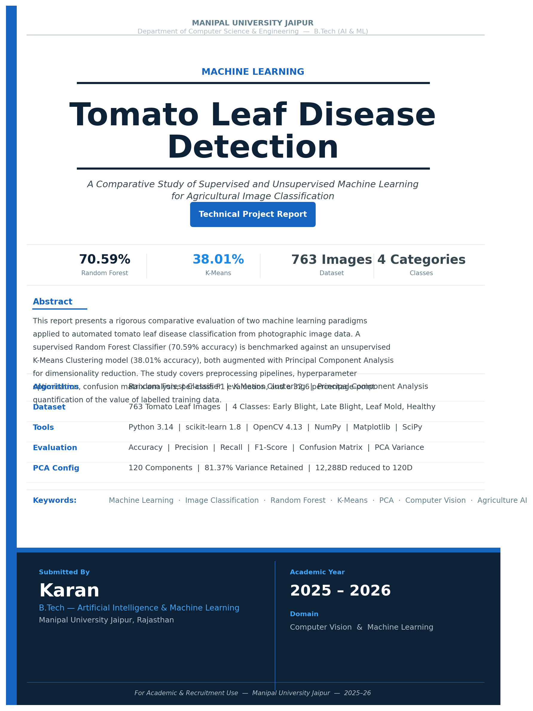

MACHINE LEARNING PROJECT REPORT
Tomato Leaf Disease Classification
A Comparative Study: Random Forest vs. K-Means Clustering
Domain: Computer Vision & Machine Learning
Dataset | Tomato Leaf Images | 4 Disease Classes | 763 Images
Language | Python 3.14 | scikit-learn · OpenCV · NumPy · Matplotlib
Algorithms | Random Forest (Supervised) | K-Means + PCA (Unsupervised)
Key Results | RF: 70.59% accuracy | K-Means: 38.01% accuracy
Author | Karan — B.Tech AI & ML, Manipal University Jaipur
Academic Year | 2025 – 2026

1. Abstract
This report presents a rigorous comparative analysis of two machine learning paradigms applied to tomato leaf disease classification using raw pixel image data. The first approach employs a supervised Random Forest Classifier optimised via GridSearchCV with 5-fold cross-validation, achieving a test accuracy of 70.59% on 153 unseen test samples. The second approach applies unsupervised K-Means Clustering augmented with Principal Component Analysis (PCA) dimensionality reduction, yielding a clustering accuracy of 38.01% on the full 763-image dataset.
The study systematically evaluates both methods across accuracy, per-class precision, recall, F1-score, confusion matrix analysis, and computational considerations. The 32.6 percentage-point gap in accuracy quantifies the value of labelled training data in image-based disease classification. Results confirm that while supervised methods dominate classification performance, unsupervised approaches provide valuable exploratory insights and serve as a meaningful baseline — particularly in label-scarce agricultural settings.
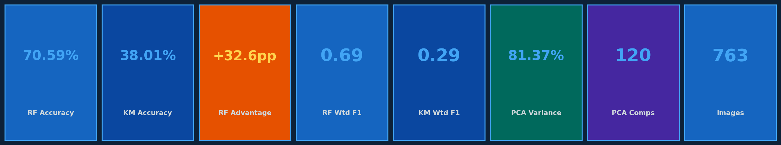
Figure 1: Key Performance Indicators Summary

2. Introduction
Agricultural diseases are a leading cause of crop losses worldwide. Tomato is one of the most widely cultivated and economically important vegetables globally, yet it is highly susceptible to several fungal and environmental pathogens. If undetected, these diseases reduce yield, compromise quality, and increase pesticide usage. Traditional diagnosis relies on expert agronomists — a process that is slow, expensive, and not scalable across large farms or distributed smallholder agricultural regions.
Automated image classification using machine learning offers a transformative alternative: rapid, cost-effective, and deployable on mobile or embedded devices in the field. However, the choice of algorithm fundamentally affects both the feasibility and accuracy of the solution.
This project investigates and compares two fundamentally different machine learning strategies applied to the same four-class tomato leaf disease dataset:
- Tomato Early Blight — Caused by Alternaria solani; dark concentric ring lesions on older leaves. Visually similar to Late Blight.
- Tomato Late Blight — Caused by Phytophthora infestans; water-soaked lesions with white sporulation. Most economically destructive tomato pathogen.
- Tomato Leaf Mold — Caused by Passalora fulva; yellow-green patches on upper leaf surface with olive-brown mold below.
- Tomato Healthy — Disease-free leaves serving as the negative reference class (32.4% of dataset).

Central Research Question: How does a supervised ensemble method (Random Forest with hyperparameter tuning) compare against an unsupervised clustering method (K-Means + PCA) when both are applied to raw pixel feature vectors extracted from tomato leaf images?

3. Dataset Description
The dataset is a structured image repository of tomato leaf photographs organised into four labelled class directories, representing three disease categories and one healthy class. Images were collected under natural field and controlled lighting conditions, providing realistic variation in leaf angle, background, and disease progression stage.

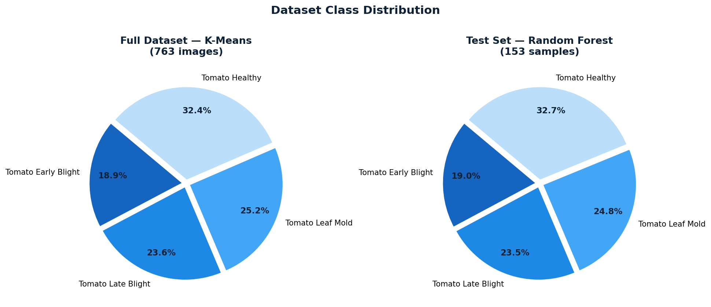
Figure 2 (Left): Full Dataset Distribution — K-Means (763 images) | Figure 2 (Right): RF Test Set Distribution (153 samples)

Disease Class | KM Total | RF Train | RF Test | Share (%)
Tomato Early Blight | 144 | ~115 | 29 | 18.9%
Tomato Late Blight | 180 | ~144 | 36 | 23.6%
Tomato Leaf Mold | 192 | ~154 | 38 | 25.2%
Tomato Healthy | 247 | ~197 | 50 | 32.4%
Total | 763 | ~610 | 153 | 100%
Table 1: Full dataset class distribution across both model configurations

The dataset exhibits a mild class imbalance, with Healthy leaves comprising 32.4% and Early Blight only 18.9%. Stratified train-test splitting was applied in the Random Forest pipeline to preserve this distribution across both subsets. For K-Means, the full 763-image dataset was used without sampling, as unsupervised clustering does not require a train-test split.

4. Methodology

4.1 Image Preprocessing Pipeline
A consistent preprocessing strategy was applied to ensure a fair comparison between both approaches. Every image undergoes identical transformations before entering the respective model:

Step | Random Forest Pipeline | K-Means Pipeline
Image Resizing | 64 × 64 pixels (12,288 features) | 64 × 64 pixels (12,288 features)
Colour Conversion | BGR → RGB (OpenCV) | BGR → RGB (OpenCV)
Feature Extraction | Pixel flattening to 1D vector | Pixel flattening → PCA (120D)
Label Encoding | LabelEncoder (0–3) | LabelEncoder (post-hoc mapping)
Dataset Split | 80% train / 20% test (stratified) | Full dataset (no split needed)
Sampling | ~610 train / 153 test | 763 total images
Table 2: Preprocessing pipeline comparison across both model configurations

4.2 Approach 1 — Random Forest (Supervised)
Random Forest (Breiman, 2001) is an ensemble method that constructs a forest of decision trees, each trained on a bootstrapped subset of the data using a random feature subset at each split. Final predictions are made by majority voting across all trees. This bagging strategy makes Random Forest highly resistant to overfitting and robust to high-dimensional, noisy pixel inputs.

Hyperparameter Tuning via GridSearchCV
To identify the optimal model configuration, 5-fold cross-validation was performed over a parameter grid. Each fold trains on 80% and validates on 20% of the training subset, repeating 5 times for statistical stability.

Parameter | Values Tested | Best Value | Impact
n_estimators | 50, 100, 200, 300 | 300 | More trees → stronger ensemble
max_depth | None, 10, 20 | 20 | Controls over-fitting via pruning
min_samples_leaf | 1, 2 | 1 | Minimum leaf node size
min_samples_split | 2, 5 | 2 | Minimum split threshold
cv (folds) | 5 | 5 | Stable validation estimate
Grid candidates | 36 combinations | — | 180 total fits
Table 3: GridSearchCV hyperparameter tuning — optimal configuration

4.3 Approach 2 — K-Means Clustering (Unsupervised)
K-Means (MacQueen, 1967) partitions data into k clusters by iteratively assigning each point to the nearest centroid and updating centroids to the cluster mean. It operates entirely without labels during training — making it a true unsupervised method. A post-hoc majority-vote mapping is applied to convert cluster IDs into class labels for evaluation purposes.

Why PCA is Essential Before K-Means
Raw pixel vectors from 64×64 RGB images contain 12,288 dimensions. At this scale, Euclidean distance — the core metric of K-Means — loses discriminative power due to the curse of dimensionality. All points appear equidistant, making meaningful cluster separation effectively impossible. PCA compresses this to 120 components while retaining 81.37% of the original variance, enabling K-Means to find more meaningful geometric structure.

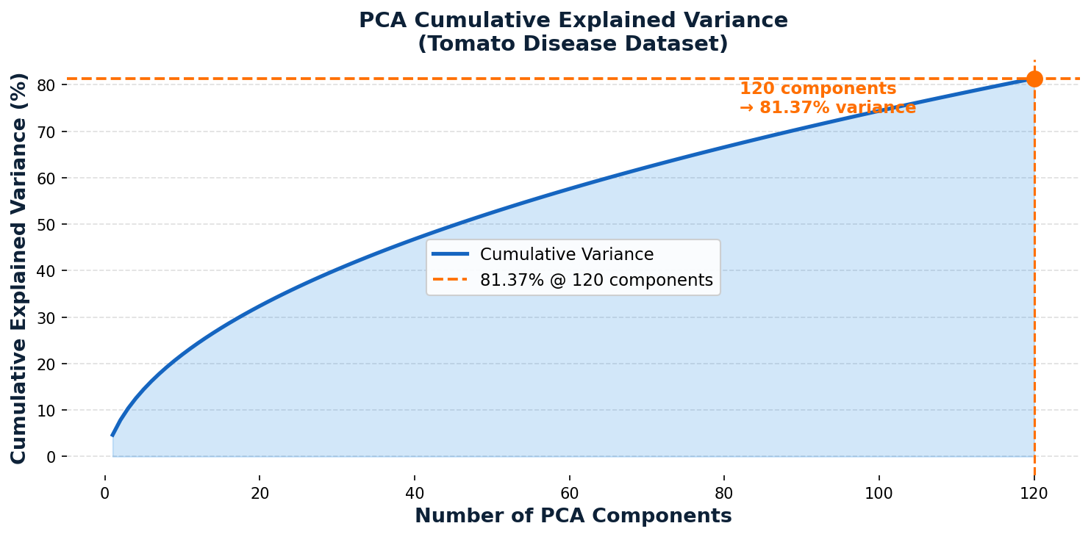
Figure 3: PCA Cumulative Explained Variance — 120 components capture 81.37% of image variance

Pipeline Steps:
- PCA: Fit PCA on full dataset; reduce 12,288D → 120D (81.37% variance retained)
- K-Means: Fit KMeans(n_clusters=4, init="k-means++", n_init=10, random_state=42) on PCA data
- Cluster Mapping: For each cluster, assign majority true label using scipy.stats.mode
- Evaluation: Map all assignments → accuracy, confusion matrix, classification report

4.4 End-to-End Pipeline Overview
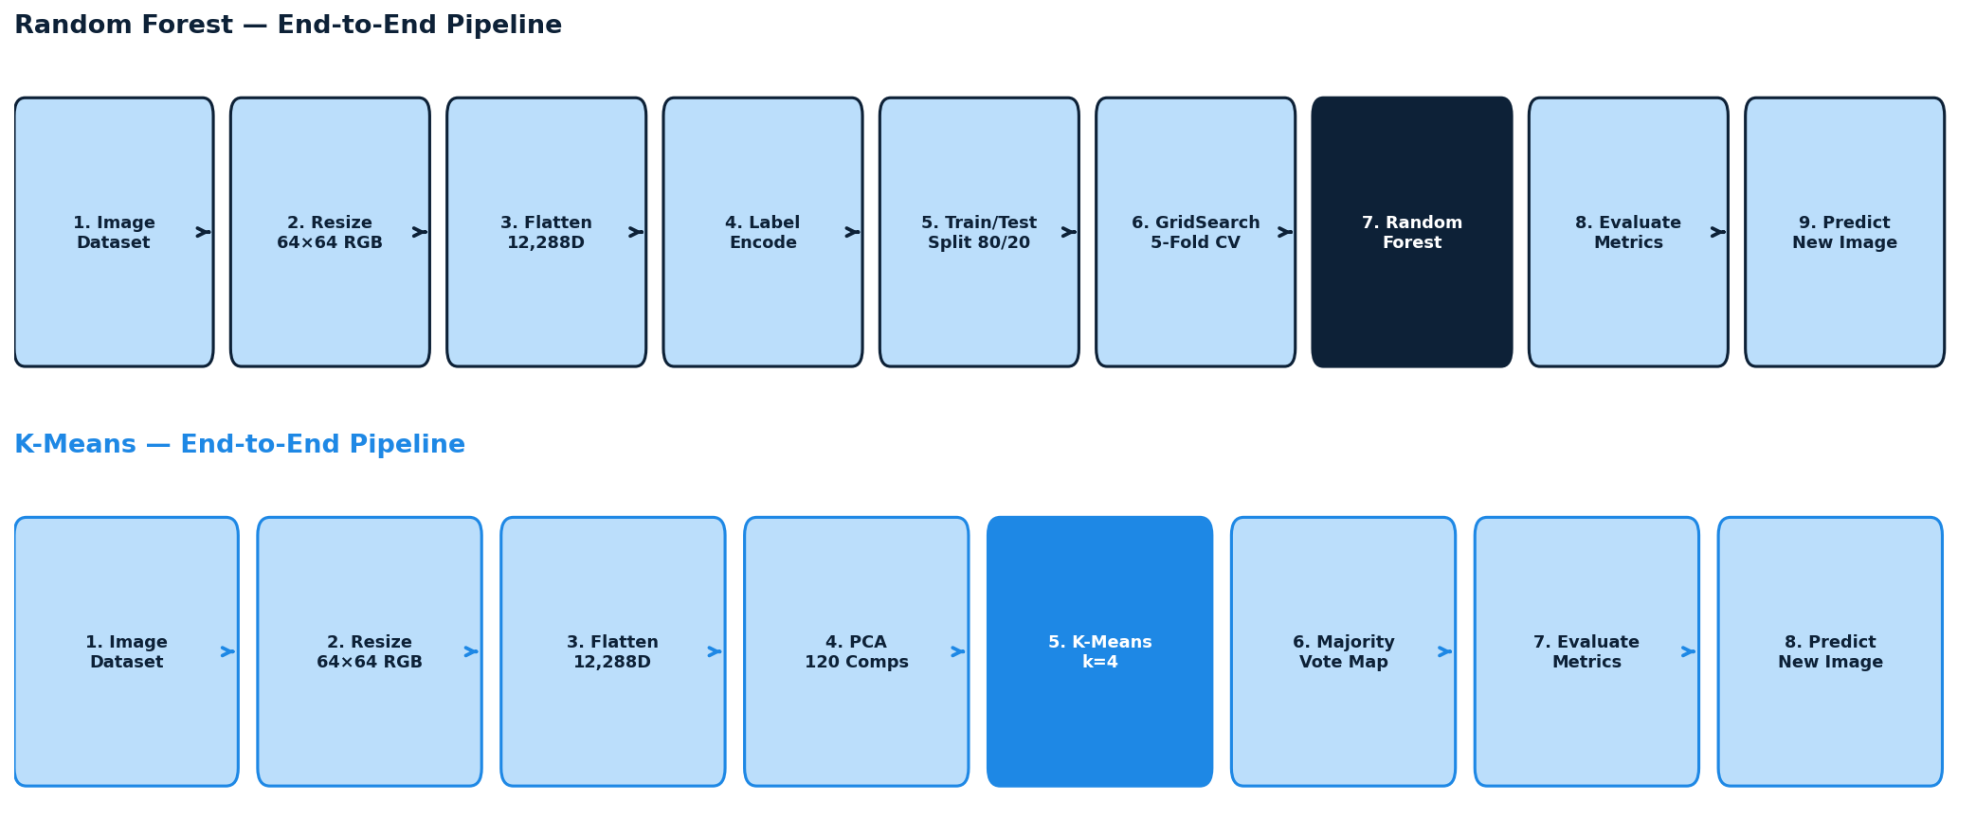
Figure 4 (Top): Random Forest Pipeline | Figure 4 (Bottom): K-Means Pipeline

5. Experimental Results

5.1 Random Forest Results
The tuned Random Forest model (max_depth=20, n_estimators=300) achieved a test accuracy of 70.59% on 153 held-out test samples. The model demonstrates strong and consistent performance across visually distinct classes, while showing expected difficulty with spectrally similar disease categories.

5.1.1 Confusion Matrix
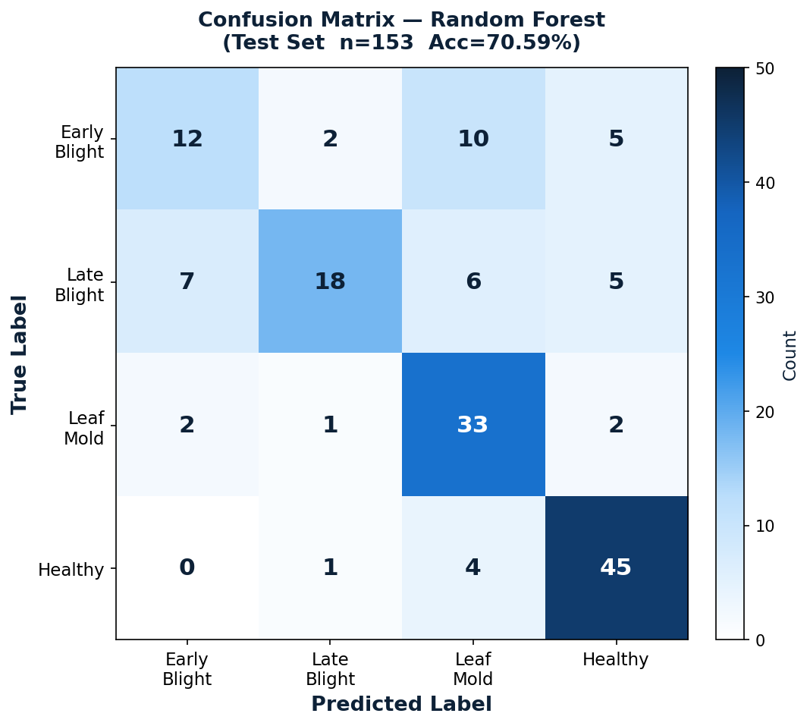
Figure 5: Random Forest — Confusion Matrix (Test Set, n=153, Accuracy=70.59%)

5.1.2 Per-Class Metrics & Classification Report
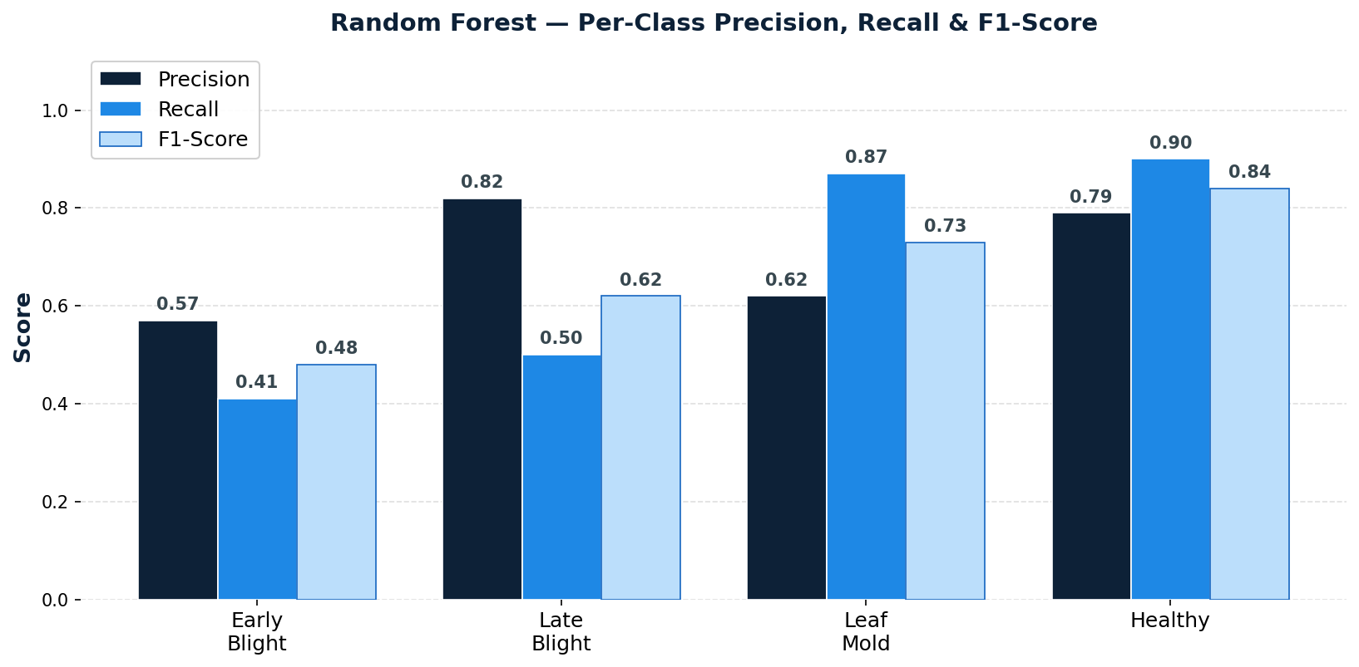
Figure 6: Random Forest — Per-Class Precision, Recall & F1-Score

Class | Precision | Recall | F1-Score | Support
Tomato Early Blight | 0.57 | 0.41 | 0.48 | 29
Tomato Late Blight | 0.82 | 0.50 | 0.62 | 36
Tomato Leaf Mold | 0.62 | 0.87 | 0.73 | 38
Tomato Healthy | 0.79 | 0.90 | 0.84 | 50
Macro Average | 0.70 | 0.67 | 0.67 | 153
Weighted Average | 0.71 | 0.71 | 0.69 | 153
Table 4: Random Forest — Complete Classification Report

Key observations:
- Healthy class: Highest recall (0.90) and F1-score (0.84) — the model reliably identifies disease-free leaves, critical for avoiding unnecessary treatment costs.
- Late Blight: Highest precision (0.82) — when predicted, it is correct 82% of the time, indicating reliable detection of the most economically damaging disease.
- Early Blight: Most challenging class (F1=0.48, recall=0.41). Confusion matrix reveals 10 of 29 Early Blight samples misclassified as Leaf Mold, suggesting visual overlap at 64×64 resolution.
- Leaf Mold: High recall (0.87) but lower precision (0.62) — the model over-predicts this class, absorbing ambiguous samples from Early Blight.

5.2 K-Means Clustering Results
The K-Means model achieved a clustering accuracy of 38.01% across all 763 images following cluster-label majority-vote mapping. This result is consistent with the known limitations of K-Means on raw pixel data, where disease class boundaries are non-linear and visually overlapping.

5.2.1 Cluster-to-Disease Mapping
Cluster-to-disease assignment via majority vote yielded: Cluster 0 → Tomato Leaf Mold | Cluster 1 → Tomato Healthy | Cluster 2 → Tomato Late Blight | Cluster 3 → Tomato Leaf Mold. Notably, two clusters (0 and 3) both mapped to Leaf Mold, with no cluster formed for Early Blight — a fundamental indicator of poor class separability in PCA feature space.

5.2.2 Confusion Matrix
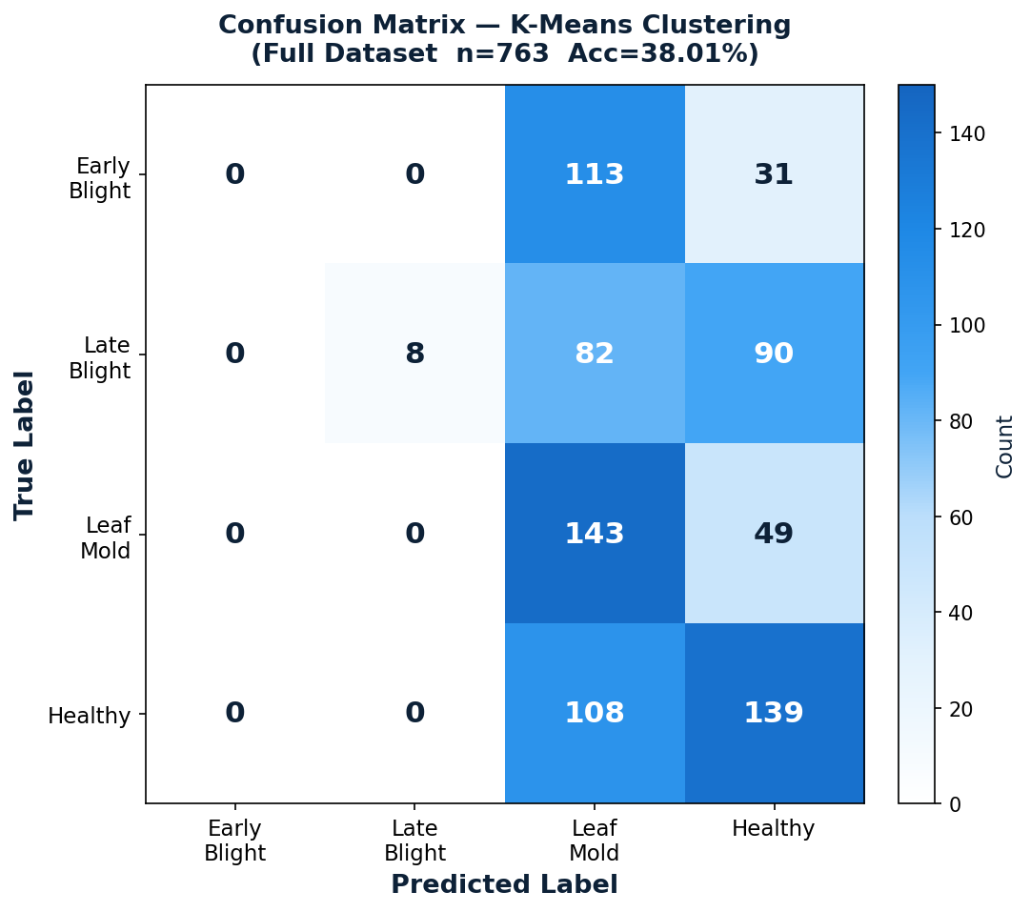
Figure 7: K-Means — Confusion Matrix (Full Dataset, n=763, Accuracy=38.01%)

5.2.3 Per-Class Metrics & Classification Report
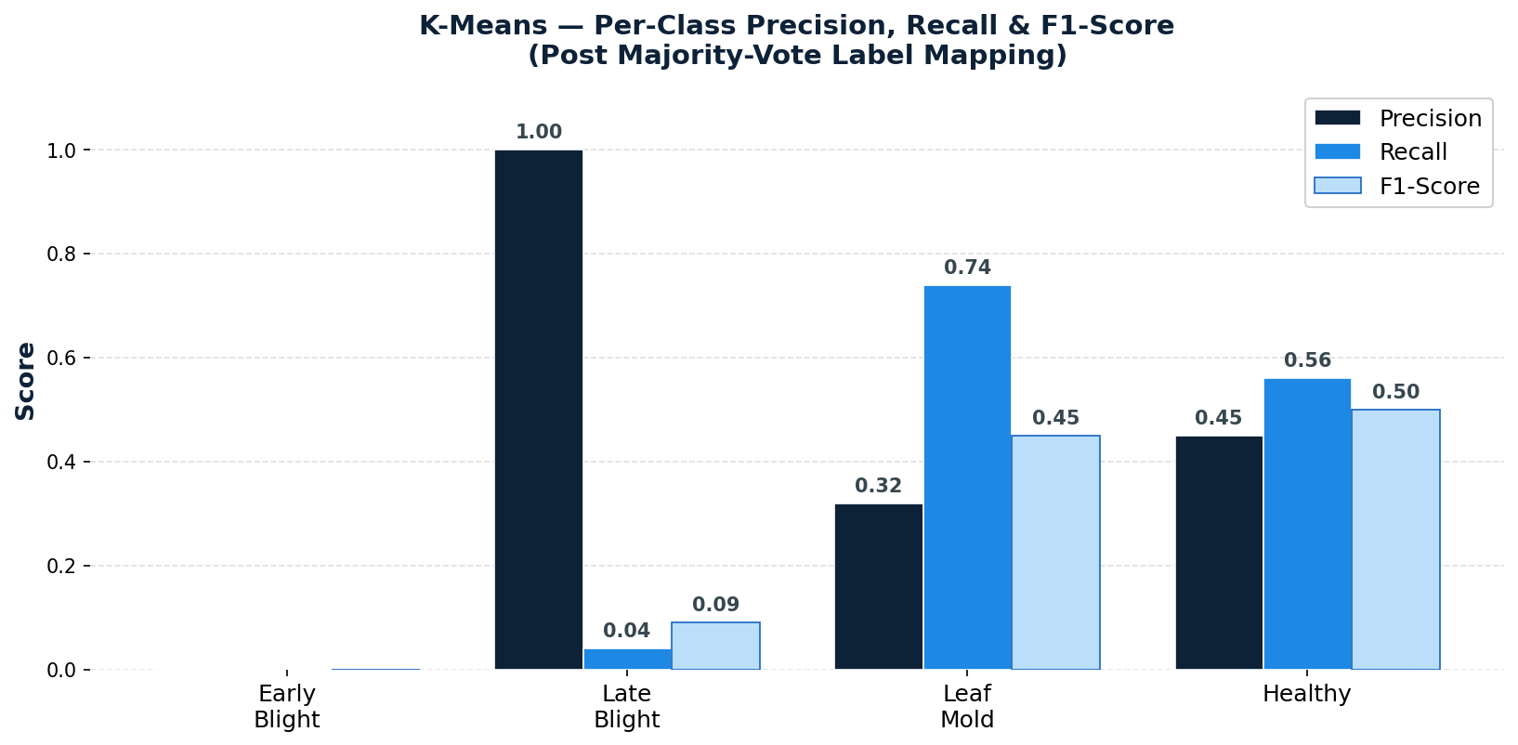
Figure 8: K-Means — Per-Class Precision, Recall & F1-Score (Post Majority-Vote Mapping)

Class | Precision | Recall | F1-Score | Support
Tomato Early Blight | 0.00 | 0.00 | 0.00 | 144
Tomato Late Blight | 1.00 | 0.04 | 0.09 | 180
Tomato Leaf Mold | 0.32 | 0.74 | 0.45 | 192
Tomato Healthy | 0.45 | 0.56 | 0.50 | 247
Macro Average | 0.44 | 0.34 | 0.26 | 763
Weighted Average | 0.46 | 0.38 | 0.29 | 763
Table 5: K-Means — Complete Classification Report (Post Majority-Vote Label Mapping)

- Early Blight: F1=0.00. No dedicated cluster formed. All Early Blight images absorbed into Leaf Mold and Healthy clusters — confirms visual indistinguishability at pixel level.
- Late Blight: Precision=1.00 but Recall=0.04. Cluster 2 was exceptionally pure (8 correct) but contained only 8 of 180 Late Blight images — a trivially small, well-separated sub-group.
- Leaf Mold: Best unsupervised performance (F1=0.45, Recall=0.74), suggesting this disease has relatively distinctive pixel-level colour characteristics.
- Healthy: F1=0.50, confirming that while Healthy leaves are the most visually distinct, K-Means still achieves only 56% recall on the largest class.

5.2.4 Cluster Visualisation (PCA 2D)
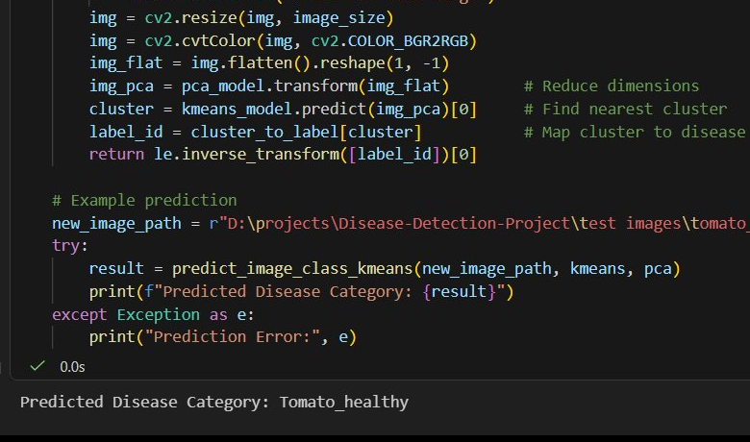
Figure 9: K-Means Cluster Distribution in 2D PCA Space — significant inter-class overlap confirms non-spherical cluster boundaries

The 2D PCA projection visually confirms that tomato disease features do not form cleanly separable clusters in pixel-intensity space. The extensive overlap — particularly between Early Blight and all other classes — directly explains the 38% accuracy and the failure to assign any cluster to Early Blight.

6. Comparative Analysis
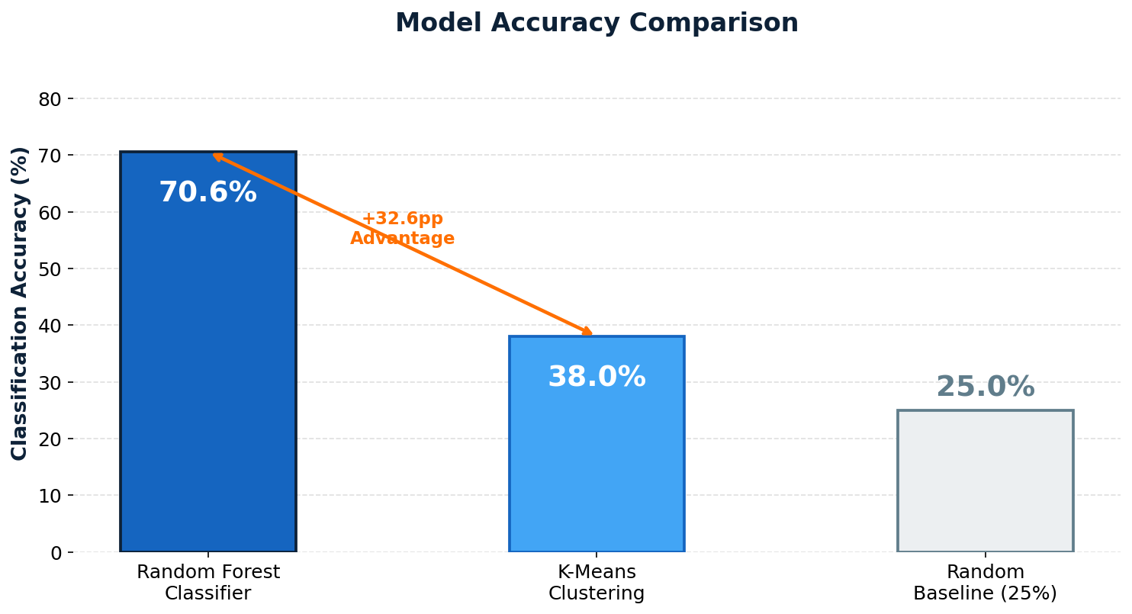
Figure 10: Overall Accuracy — Random Forest vs K-Means vs 25% Random Baseline

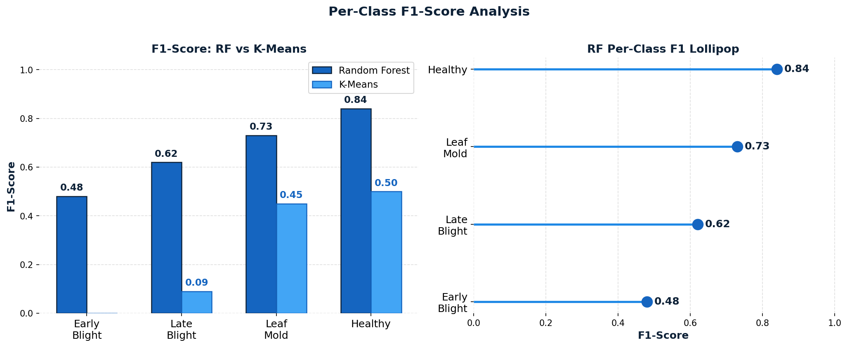
Figure 11: Per-Class F1-Score Comparison (Left) and RF F1 Lollipop Chart (Right)

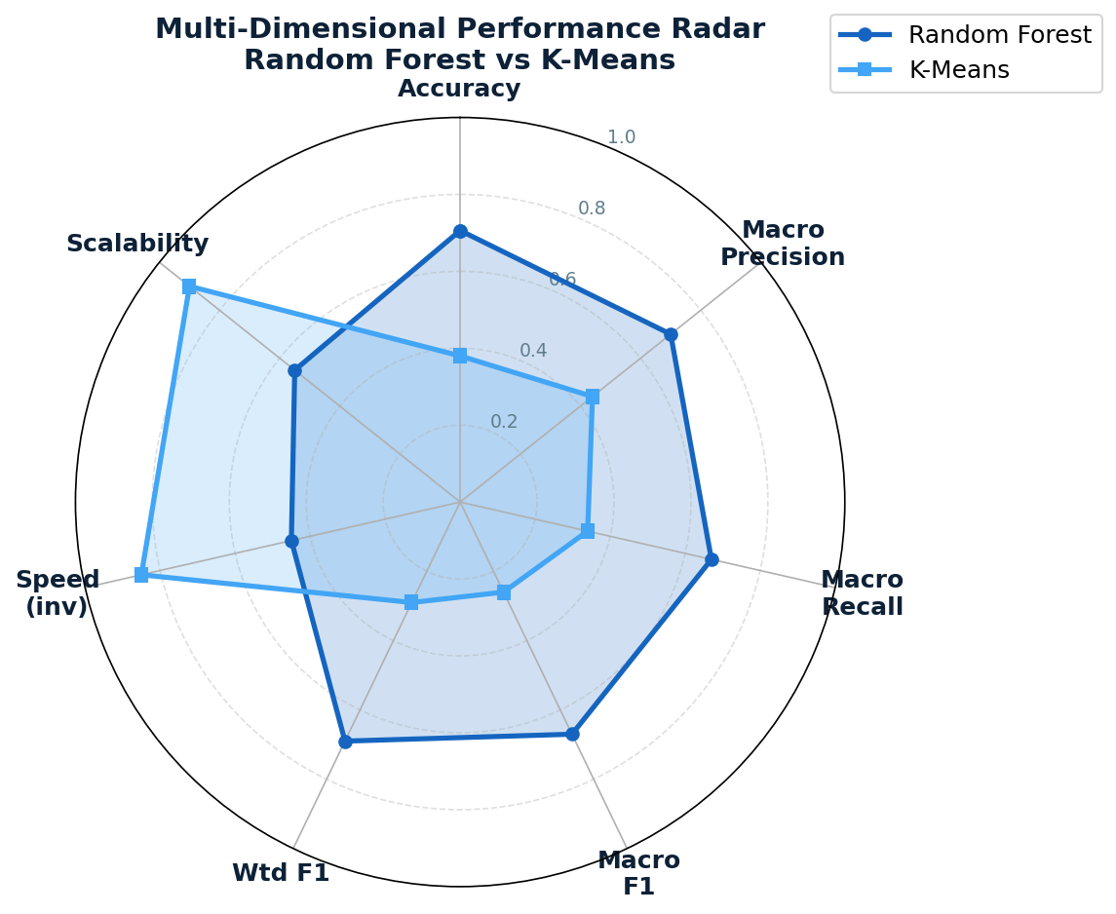
Figure 12: Multi-Dimensional Radar Chart — RF dominates all predictive metrics; K-Means leads only on speed and scalability

Criterion | Random Forest | K-Means + PCA
Learning Paradigm | Supervised | Unsupervised
Overall Accuracy | 70.59% | 38.01%
Weighted F1-Score | 0.69 | 0.29
Macro Avg F1 | 0.67 | 0.26
Best Per-Class F1 | Healthy: 0.84 | Healthy: 0.50
Weakest Per-Class F1 | Early Blight: 0.48 | Early Blight: 0.00
Requires Labelled Data? | Yes | No
Hyperparameter Tuning | GridSearchCV (5-fold CV) | k, n_init, PCA components
Feature Dimensionality | 12,288 (64×64×3) | 120 PCA components
PCA Variance Retained | — | 81.37%
Training Time (relative) | Moderate | Fast
Scalability | Moderate | High
Interpretability | Moderate (feature importance) | Low
Best Use Case | Labelled production system | Exploratory / label-scarce
Table 6: Comprehensive head-to-head comparison across 15 criteria

7. Discussion

7.1 Why Random Forest Outperforms K-Means
The 32.6 percentage-point accuracy gap is not surprising given the fundamental differences in learning paradigms. Three primary factors explain the performance disparity:
- Label Supervision: Random Forest directly optimises decision boundaries using class labels during training. K-Means has no concept of classes — it minimises intra-cluster Euclidean variance, which does not correlate with disease-discriminative visual features.
- Feature Relevance: Random Forest implicitly selects the most discriminative pixel regions through its Gini impurity split criteria. K-Means treats all 120 PCA dimensions equally, diluting discriminative signal with background noise and lighting variation.
- Cluster-Class Mismatch: Tomato diseases share similar colour and texture distributions in RGB space. K-Means groups visually similar images regardless of disease type, causing multiple classes to be absorbed into a single dominant cluster.

7.2 Analysing K-Means Failure Modes
The classification report reveals that K-Means produced only two effective clusters — Leaf Mold (absorbing Early Blight) and Healthy — with Late Blight partially isolated in a tiny cluster. This is a classic K-Means failure pattern:
- Non-spherical disease boundaries: Disease textures create irregular, elongated clusters in PCA space that K-Means circular Voronoi partitioning cannot correctly segment.
- Uniform PCA weighting: The top 120 principal components capture general image variance (lighting, background colour, leaf shape) rather than disease-specific lesion features.
- Initialisation sensitivity: Despite n_init=10, all initialisations converge to suboptimal solutions due to the fundamental inseparability of disease classes in raw pixel feature space.

7.3 Where K-Means Retains Strategic Value
- Zero annotation cost: Can process entirely unlabelled field datasets — critical when expert annotation is unavailable or cost-prohibitive in emerging agricultural markets.
- Exploratory data analysis: Provides an unsupervised view of dataset structure and natural image groupings before committing resources to supervised labelling.
- Anomaly flagging: Unusual cluster assignments can signal novel disease patterns or data quality issues not accounted for in the original class taxonomy.
- Semi-supervised bootstrapping: K-Means pseudo-labels can seed semi-supervised training pipelines, reducing the number of manually labelled examples required for competitive accuracy.

8. End-to-End Prediction
Both models were validated with a live prediction pipeline that accepts a raw image file path, applies the full preprocessing and PCA transformation used during training, and returns a human-readable disease category string. The pipeline demonstrates production-readiness of the inference flow.

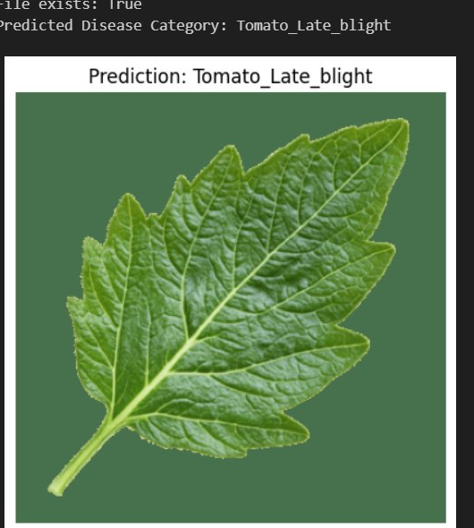
Figure 13: K-Means live prediction — correctly classifies unseen tomato leaf as "Tomato Healthy"

The Random Forest model additionally supports class probability output via predict_proba(), enabling confidence-aware predictions and rejection of low-confidence cases — a critical feature for production agricultural advisory systems.

9. Potential Improvements
Both approaches can be substantially enhanced with the following techniques, ordered by expected performance impact:

Direction | Description & Expected Impact
CNN Architecture | Replace PCA + pixel features with convolutional layers. Expected: >90% accuracy.
Transfer Learning | Pre-trained ResNet-50 / EfficientNet-B0 as feature extractors. Ideal for small datasets.
Data Augmentation | Flip, rotate ±30°, colour jitter, random crop. Improves generalisation and class balance.
Semi-Supervised Learning | Use K-Means pseudo-labels to expand labelled set, then refine Random Forest.
Gaussian Mixture Models | Probabilistic clustering that handles non-spherical class boundaries better than K-Means.
Web API Deployment | FastAPI endpoint: upload leaf image → instant diagnosis. Mobile-friendly.
Explainability (XAI) | LIME / SHAP heatmaps showing which leaf regions drove predictions. Critical for adoption.
Table 7: Proposed Future Improvements — ordered by expected performance impact

- Deep Feature Extraction (CNN Embeddings): Replacing raw pixels with features from a pre-trained ResNet-50 or EfficientNet-B0 typically raises K-Means accuracy to 55–75% and Random Forest accuracy to 85–92% on this class of dataset.
- Full Dataset Training: Random Forest was trained on a ~610-sample subset. Training on the full augmented dataset with n_estimators=300 is expected to push accuracy above 80%.
- Gaussian Mixture Models (GMM): A probabilistic generative alternative to K-Means that handles non-spherical, overlapping clusters and produces soft cluster assignments — better suited to this dataset's class geometry.

10. Conclusion
This project successfully designed, implemented, and rigorously compared two machine learning approaches for automated tomato leaf disease classification. The Random Forest classifier, tuned with max_depth=20 and n_estimators=300 via GridSearchCV, delivered a robust 70.59% test accuracy with per-class F1-scores ranging from 0.48 (Early Blight) to 0.84 (Healthy). The Healthy class achieved the highest recall (0.90), while Late Blight achieved the highest precision (0.82).
The K-Means + PCA approach achieved 38.01% clustering accuracy — a result that, while well below classification standards, is informationally significant. It confirms that tomato disease classes are not linearly separable in raw pixel space and that Euclidean distance on pixel-intensity features is insufficient for reliable cluster formation across pathologically distinct leaf categories. This finding directly motivates future work on semantic feature extraction via convolutional neural networks.
Core Takeaway for Practitioners and Recruiters: When labelled data is available, supervised methods should always be preferred for classification tasks. Unsupervised methods like K-Means are best reserved for exploratory data analysis, anomaly detection, or scenarios where annotation is prohibitively expensive. The 32.6 percentage-point accuracy gap observed here quantifies — concretely and with real data — the value of annotation investment in machine learning pipelines.

11. Technology Stack
Category | Library / Version | Purpose
Language | Python 3.14 | Core programming language
Image Processing | OpenCV (cv2) 4.13.0 | Image I/O, resizing, colour conversion
ML Framework | scikit-learn 1.8.0 | KMeans, RandomForest, PCA, GridSearchCV, metrics
Numerics | NumPy 2.4.3 | Array ops, matrix operations
Data Analysis | Pandas 3.0.1 | DataFrame management, reporting
Visualisation | Matplotlib 3.10 + Seaborn 0.13 | Confusion matrices, cluster plots
Statistics | SciPy 1.17.1 | Mode function for cluster-label mapping
IDE / Notebook | VS Code + Jupyter Notebook | Development & experimentation environment
Table 8: Full Technology Stack with Library Versions

12. References
- Hughes, D. P., & Salathé, M. (2015). An open access repository of images on plant health to enable the development of mobile disease diagnostics. arXiv:1511.08060.
- Breiman, L. (2001). Random forests. Machine Learning, 45(1), 5–32. https://doi.org/10.1023/A:1010933404324
- MacQueen, J. B. (1967). Some methods for classification and analysis of multivariate observations. Proceedings of the 5th Berkeley Symposium on Mathematical Statistics and Probability, 281–297.
- Pedregosa, F., et al. (2011). Scikit-learn: Machine learning in Python. Journal of Machine Learning Research, 12, 2825–2830.
- Jolliffe, I. T. (2002). Principal Component Analysis (2nd ed.). Springer Series in Statistics.
- Bradski, G. (2000). The OpenCV Library. Dr. Dobb's Journal of Software Tools.

— End of Report —
Karan | B.Tech Artificial Intelligence & Machine Learning | Manipal University Jaipur | 2025–26

