DEPARTMENT OF ELECTRONIC ENGINEERING MEHRAN UNIVERSITY OF ENGINEERING AND

TECHNOLOGY, JAMSHORO

Complex Engineering Problem (CEP) Instructions
Subject: Introduction to Embedded Systems (ES-314)
Subject Teacher: Dr. Attiya Baqai
Batch: 20 ES -Sect I+II
Semester: 5th (12.12.2022 to 07.04.2023)

CEP Statement:

Due to recent damage compelled by the massive earthquakes in Turkey and Syria observed in Feb 2023 and in Pakistan in March 2023 there is a dire need to develop an Earthquake Detection and Warning System. Design an Earthquake Detection and Warning System that utilizes suitable sensors to detect and measure seismic activity. The system should be able to distinguish between different types of seismic waves and provide a warning to evacuate the buildings along with the severity levels of the earthquake. It should also be designed with robustness in mind, ensuring minimal false alarms and reliable operation in harsh environmental conditions. Additionally, the system should incorporate data processing techniques to analyze and interpret sensor data in real time, allowing for timely and effective responses to earthquake events. Finally, the system should be scalable and cost-effective, allowing for deployment in a wide range of settings, from individual homes to entire cities

S.No | CEP – Characteristics | Mapping | Justification | PLO
1 | Depth of knowledge Required | ✔ | Require knowledge of microcontroller, interfacing, availability and function of different sensors that can be used for the said application, debugging and simulation software | PLO1
2 | Range of Conflicting Requirements | ✔ | The system takes input using sensors to detect shaking and trembling causing damage and its level. | PLO2
3 | Depth of Analysis Required | ✔ | Pattern analysis of sensor data and output for earthquake detection ensuring minimal false alarms. | PLO3
4 | Infrequently Encountered Issues Involved | ✗
5 | Beyond codes/standards of practice | ✗ | Relate the sensors’ raw data results and their ranges with the different standards used for measuring earthquake severity | PLO2
6 | Diverse groups of stakeholders with widely varying needs involved | ✗

7 | Interdependence (high level problems including many component parts/sub-problems) | ✔ | Includes a) Programming concepts b) interfacing concepts with the components c) sensors usage concepts d) actuators/ output devices, warning displays e) software illustrations | PLO3
8 | Have significant consequences in a range of contexts | ✗
9 | Judgement (Require judgement in decision making) | ✔ | Code and circuit design working properly? | PLO3
Table 1: Complex engineering problem characteristics

Outcomes:

After solving this CEP, the students will be able to:
- Write the AVR code for the interfacing of the microcontroller with suitable sensor(s) chosen and suitable output devices.
- Analyse the raw values of the sensors and their graphs to predict the severity of the earthquake and relate them with standard scales. Also display/ actuate output devices accordingly for warnings and remedy actions.
- Write the code in AVR Studio and simulate the earthquake detection and warning system in Proteus.
- Prepare a comprehensive report.

General Requirements:

- Atmel AVR Studio for coding and debugging.
- Circuit diagram using fritzing software
- Proteus software for simulation for Test Equipment and components
- Write a technical report presenting your CEP learning outcomes in word and submit using MS Teams Assignment by clicking “Turn In” after finishing.
- Submit the technical report before, 10th April, 2023 (Monday) before 11:59 pm.

Rules of the Solution:
Technical Report:
The results are to be presented in a written report format of approximately 5-6 pages (not including contents, acknowledgement and appendix pages). It must be written in English. The content of the technical report should at least consist of the following components:
- Introduction of the task, maximum 200 words.
- Working principle of the problem.
- Schematic/ Circuit Diagram for the CEP.
- Microcontroller code for the solution. (Assembly or Embedded C or Arduino Sketch)
- AVR Studio code for visualisation

- Presentation of the results, including simulation results and screenshots showing the earthquake severity and sensors’ data interpretation.
- Conclusion
- References. (use IEEE citation style)

CEP Statement Solution:

On Monday 6 February, a 7.8 magnitude earthquake hit Southeast Türkiye, close to the town of Gaziantep, near the Syrian border. Several hours later another 7.5 magnitude quake hit nearby. This is Türkiye’s most powerful earthquake since 1939 and is believed to have caused an estimated $34.2 billion in direct physical damages - the equivalent of 4% of the country’s 2021 GDP. The disaster also impacted Northwest Syria where 4.1 million people currently rely on humanitarian assistance.
As of 28 March, over 57,000 deaths have been reported in Türkiye and north-west Syria. In Türkiye 273,000 buildings have been destroyed while in Northwest Syria over 9,100 buildings have collapsed, leaving tens of thousands of people homeless.
Dozens of earthquakes occur around the world every day. Fortunately, most of them are too small to seriously jeopardize human activities. A severe problem arises only with a massive earthquake of great intensity. Due to recent damage compelled by the massive earthquakes in Turkey and Syria observed in Feb 2023 and in Pakistan in March 2023. At least 230,000 buildings were damaged or destroyed across 11 provinces in Turkey and at least 10,600 buildings have been completely or partially destroyed in northwest Syria. there is a dire need to develop an Earthquake Detection and Warning System. The exact moment when a strong earthquake hit cannot be predicted yet. Therefore, it is even more critical to build a sufficiently fast, effective, and efficient warning system in endangered areas, bringing people valuable seconds to rescue their lives and property. In this, we will learn how to design Arduino Earthquake Detector Alarm. We have used ADXL335 3 axis Accelerometer as a sensor for detecting tilting, trembling, or any shaking movement of an earthquake. We have an interfaced ADXL335 Accelerometer with Arduino and LCD display for designing Arduino Earthquake Detector Alarm.

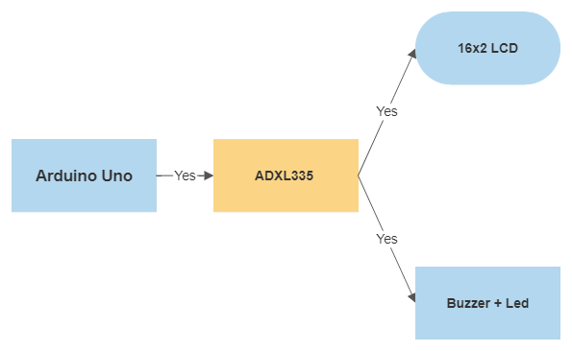

Working Principle:

The major components are Arduino Uno Board, ADXL335 Accelerometer, 16 x 2 LCD Display, Buzzer and LED. we have used Arduino that reads accelerometer’s analogue voltage and convert them into the digital values. Arduino also drives the buzzer, LED, 16x2 LCD and calculate and compare values and take appropriate action. Next part is Accelerometer which detects vibration of earth and generates analog voltages in 3 axes (X, Y, and Z). LCD is used for showing X, Y and Z axis’s change in values and showing alert message over it. This LCD is attached to Arduino in 4-bit mode. RS, GND, and EN pins are directly connected to 9, GND and 8 pins of Arduino and rest of 4 data pins of LCD namely D4, D5, D6 and D7 are directly connected to digital pin 7, 6, 5 and 4 of Arduino. The buzzer is connected to pin 12 of Arduino through an NPN BC547 transistor. A 10k pot is also used for controlling the brightness of the LCD. The Accelerometer module is based on the popular ADXL335 three-axis analog accelerometer IC, which reads off the X, Y, and Z acceleration as analog voltages. By measuring the amount of acceleration due to gravity, an accelerometer can figure out the angle it is tilted at with respect to the earth. By sensing the amount of dynamic acceleration, the accelerometer can find out how fast and in what direction the device is moving. The accelerometer is very easy to interface to an Arduino Micro-controller using 3 analog input pins and can be used with most other microcontrollers, such as the PIC or AVR. Whether the Arduino uno, voltage levels are compared. In cases of earthquakes, where the movement is excessive enough to cross a value beyond a defined threshold value and create a large impact, some preventive actions are followed. Firstly, a LED glows and a buzzer alarm sounds high enough to alert all the people about the scenario. Out of these devices, the LED and buzzer fit perfectly for earthquake indication a home. First, upload the Arduino Code/program to the Arduino UNO board. Then the next step is hit on the run. So shake the accelerometer and observe the Results. You can saw the results by the processing IDE code that helps in drawing the graph of the tilting state.
Download the processing IDE from here: Processing IDE Link

Schematic/ Circuit Diagram for the CEP
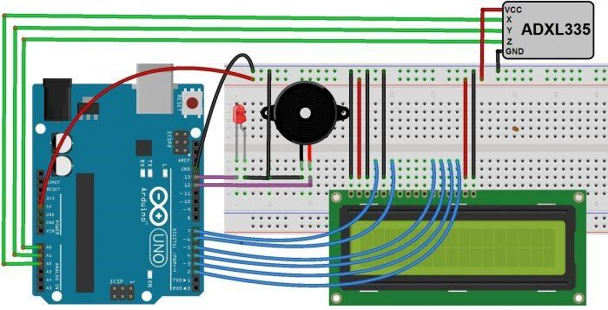

Microcontroller code for the solution. (Assembly or Embedded C or Arduino Sketch)

//EARTHQUACK DETECTION USING ADXL335 BY 20ES036
#include<LiquidCrystal.h>
LiquidCrystal lcd(7,6,5,4,3,2); // pins for LCD Connection
#define buzzer 12 // buzzer pin
#define led 13 //led pin
#define x A0 // x_out pin of Accelerometer
#define y A1 // y_out pin of Accelerometer
#define z A2 // z_out pin of Accelerometer
/*variables*/
int xsample=0;
int ysample=0;
int zsample=0;
long start;
int buz=0;
/*Macros*/
#define samples 60
#define maxVal 25 // max change limit
#define minVal -25 // min change limit
#define buzTime 5000 // buzzer on time
void setup()
{
lcd.begin(16,2);
Serial.begin(9600);
delay(1000);
lcd.print("EarthQuake ");
lcd.setCursor(0,1);
lcd.print("Detector ");
delay(2000);
lcd.clear();
lcd.print("Calibrating.....");
lcd.setCursor(0,1);
lcd.print("Please wait...");
pinMode(buzzer, OUTPUT);
pinMode(led, OUTPUT);
buz=0;
digitalWrite(buzzer, buz); //making buzzer low
digitalWrite(led, buz); /making led low
for(int i=0;i<samples;i++) // taking samples for calibration
{
xsample+=analogRead(x); //samples of x
ysample+=analogRead(y); //samples of x
zsample+=analogRead(z); //samples of x
}
xsample/=samples; // average value for x
ysample/=samples; // average value for y
zsample/=samples; // average value for z

delay(3000);
lcd.clear(); //clear lcd
lcd.print("Calibrated");
delay(1000);
lcd.clear(); //clear lcd
lcd.print("Device Ready");
delay(1000);
lcd.clear();
lcd.print(" X Y Z ");
}

void loop() //continous loop
{
int value1=analogRead(x);
int value2=analogRead(y);
int value3=analogRead(z);

int xValue=xsample-value1; // finding change in x
int yValue=ysample-value2; // finding change in y
int zValue=zsample-value3; // finding change in z

/*displying change in x,y and z axis values over lcd*/
lcd.setCursor(0,1);
lcd.print(xValue); //print value of x
lcd.setCursor(6,1);
lcd.print(yValue); //print value of y
lcd.setCursor(12,1);
lcd.print(zValue); //print value of z
delay(100);

/* comparing change with predefined limits*/
if(xValue < minVal || xValue > maxVal || yValue < minVal || yValue > maxVal || zValue < minVal || zValue > maxVal) //check minimum and maximum values
{
if(buz == 0)
start=millis(); // timer start
buz=1; // buzzer / led flag activated
}

else if(buz == 1) // buzzer flag activated then alerting earthquake
{
lcd.setCursor(0,0);
lcd.print("Earthquake Alert ");
if(millis()>= start+buzTime)
buz=0;
}

else
{
lcd.clear();
lcd.print(" X Y Z ");
}

digitalWrite(buzzer, buz); // buzzer on and off command
digitalWrite(led, buz); // led on and off command

/*sending values to processing for plot over the graph*/
Serial.print("x=");
Serial.println(xValue);
Serial.print("y=");
Serial.println(yValue);
Serial.print("z=");
Serial.println(zValue);
Serial.println(" $");
}

Simulation Results

Including simulation results and screenshots showing the earthquake severity and sensors’ data interpretation.

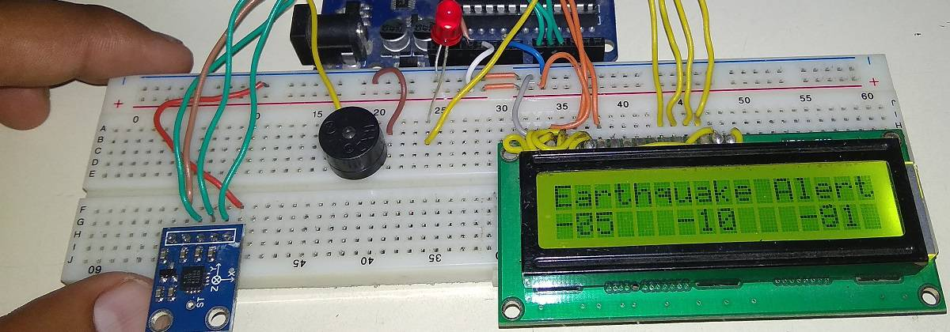

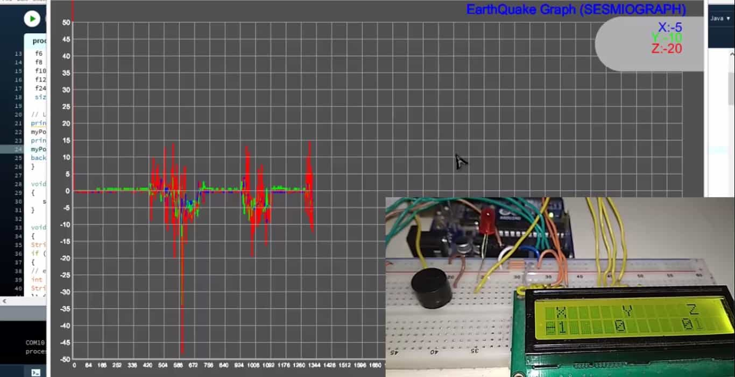
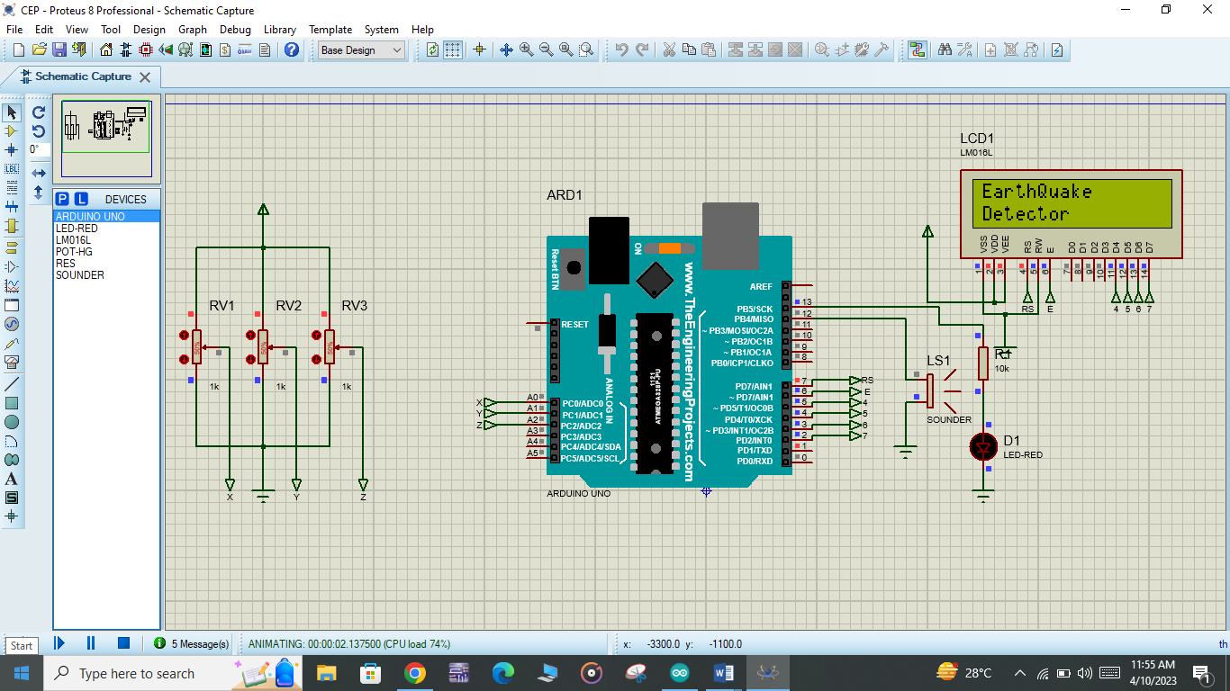

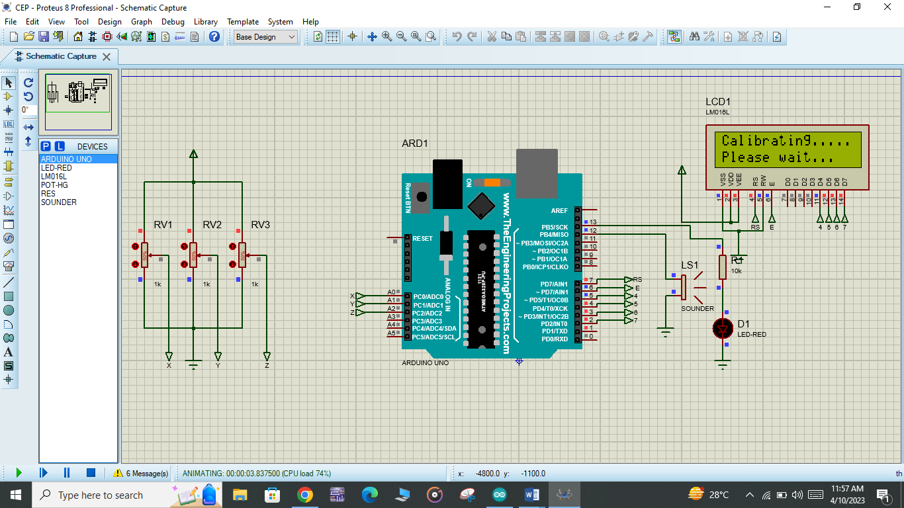

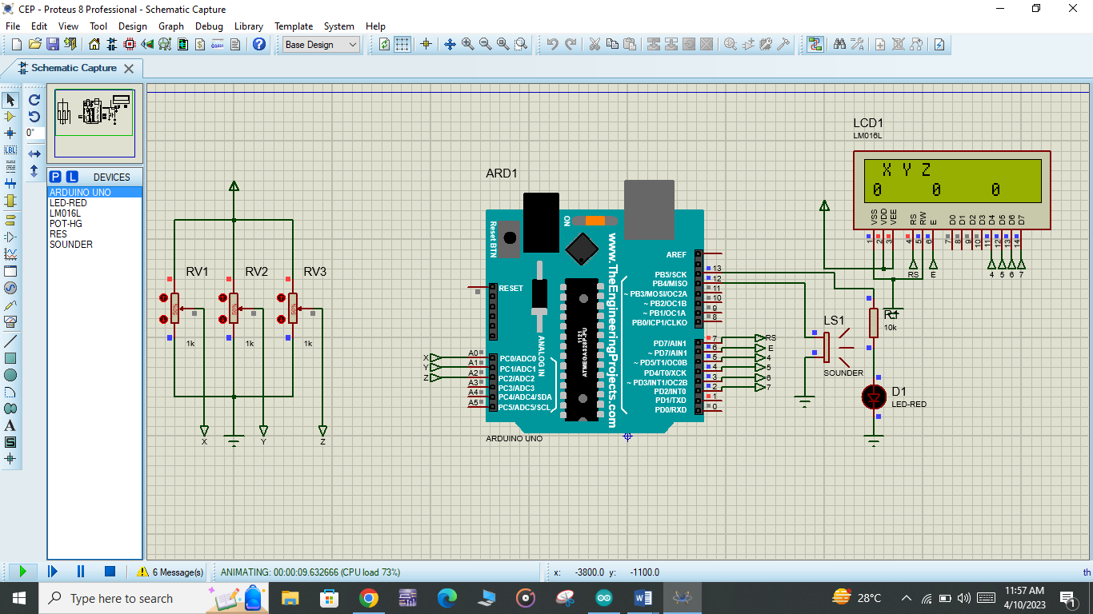

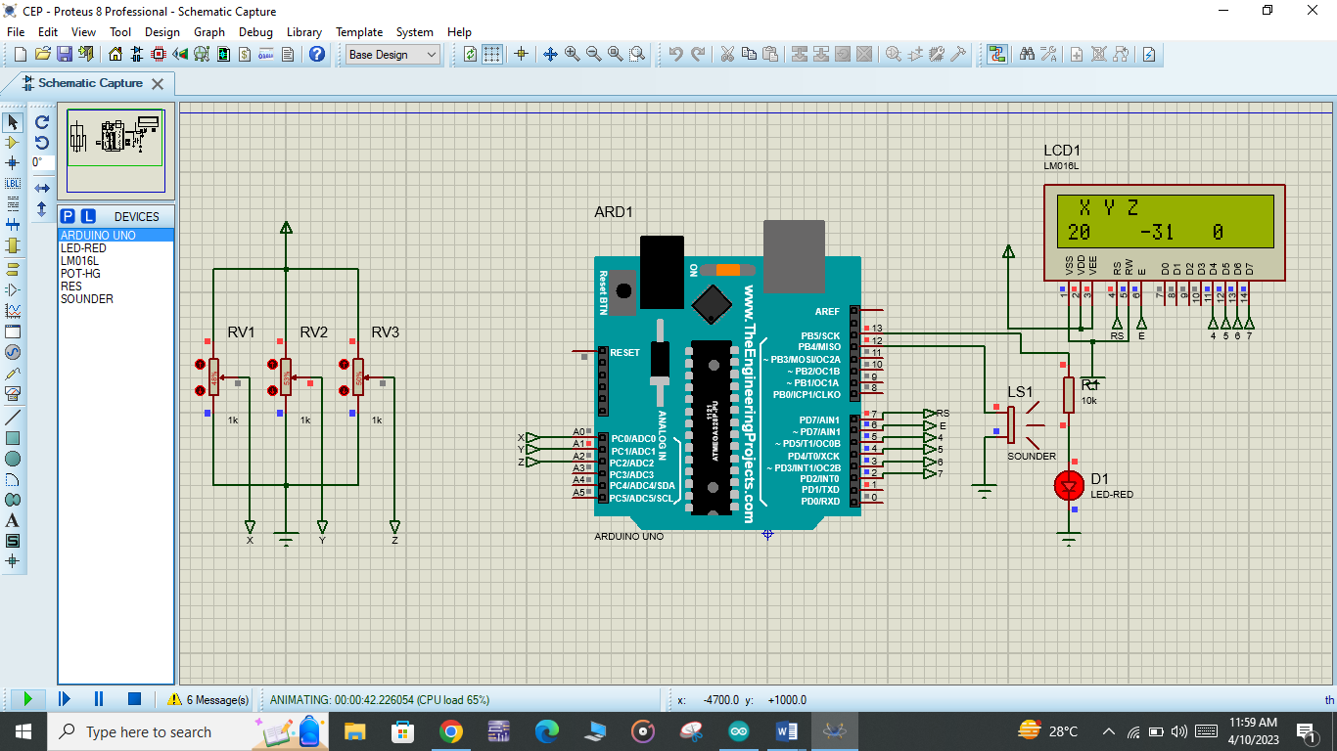

Conconclusion

This work “Arduino based earthquake detection using accelerometer”, is successfully developed and working satisfactory. Thus to sum up we have introduced this product with a view to reduce the destruction caused by earthquake by alerting the people. We have presented a novel technique to solve the automatic detection and classification problem of earth tremor in single step by using Arduino based earthquake-detecting device. In our system, the majority of cases offer real practical benefits in the event of an earthquake to safeguard lives and resources.

References

https://how2electronics.com/arduino-earthquake-detector-accelerometer/
https://www.undp.org/policy-centre/istanbul/turkiye-syria-earthquakes-february-2023
https://en.wikipedia.org/wiki/2023_Turkey%E2%80%93Syria_earthquake
https://circuitdigest.com/microcontroller-projects/arduino-earthquake-detector-alarm-circuit
https://microcontrollerslab.com/earthquake-detector-arduino/

