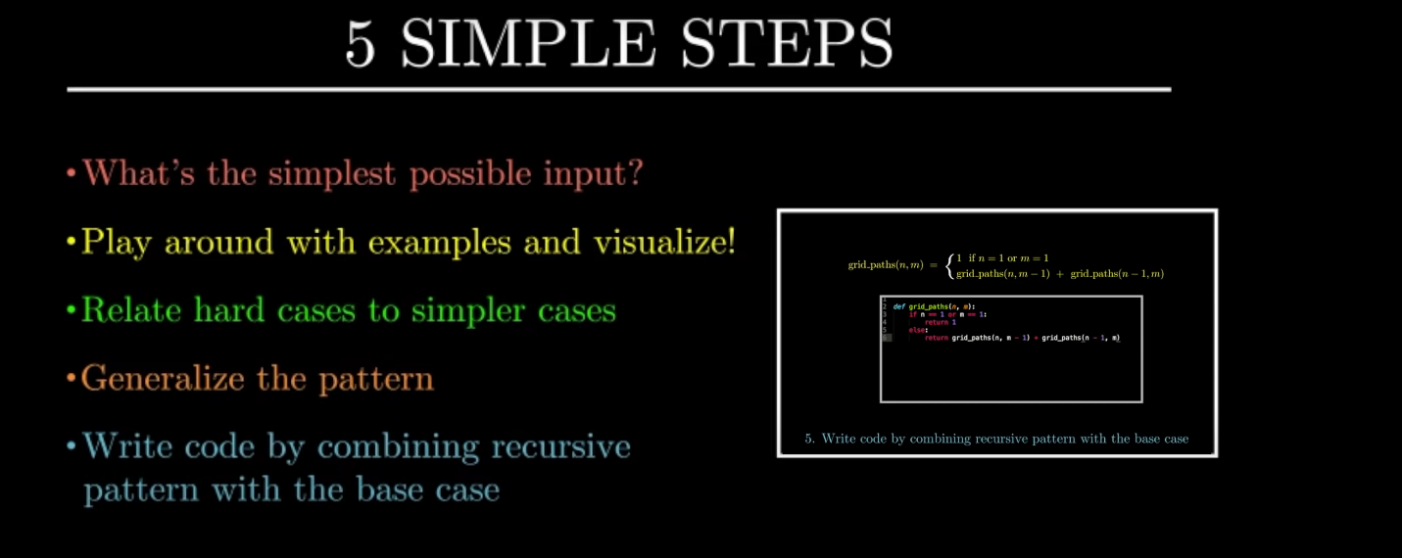Simple recursion steps by Reducible [(3) 5 Simple Steps for Solving Any Recursive Problem - YouTube](https://www.youtube.com/watch?v=ngCos392W4w&t=855s)