Karanvir Singh

CUNY ID (Last 4 digits) – 5441

Class Section: CSCI 331-35 8:00-9:15PM

Submission Date: April 15th, 2019

Project 2

**New York Times Database**

**SQL**

1. Identify published articles in this month about The Upshot and Elections. Display the article title, publish date and authors.

select a.article_title "title", a.publish_date "date", r.r_FName "First", r.r_LName "Last"

from article a, reporter r, reporter_article ra

where a.article_id = ra.article_id

and r.r_id = ra.r_id

and a.publish_date >= date '2019-04-01'

and a.article_id in (select article_id

from topic

where topic_type = 'Elections'

or topic_type = 'The Upshot');

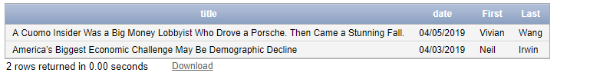

1. Identify articles in the last two years about the topic baseball and the article body includes references to country and financial terms. Display the article title and publish date. Use a nested select to answer this question. Order the articles chronologically.

select a.article_title "title", a.publish_date "date"

from article a

where a.article_body like '%country%'

or a.article_body like '%finance%'

and a.publish_Date >= date '2017-04-01'

and a.article_id in (select article_id

from topic

where topic_type = 'Baseball');

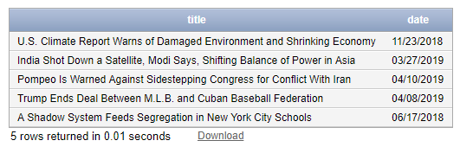

1. Identify topics not assigned to published articles in the last twenty-seven months. Display the topics. Use a nested select to answer this question.

select topic_type “topic”

from topic

where article_id in (select article_id

from article

where article.publish_date >= date '2017-01-12'

and article.article_id in (select article_id

from status

where status.status_Type != 'Published'));

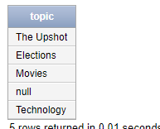

1. Identify the top five topics in the last three years. Display two columns: topic and number of articles. Display the topic with the most articles first. Display one row for each distinct topic. Use a function to answer this question.

select t.topic_type "type", count(1) "numbers of topics"

from topic t, article a

where a.publish_Date >= date '2016-04-01'

and t.article_id = a.article_id

group by t.topic_type

order by 2 desc

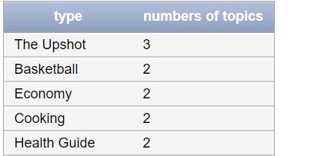

1. Identify the number of articles by reporter in this year. Display three columns: Reporter, year published and number of articles. Display one row for each distinct reporter and year. Order the output by reporter name. Use a function to answer this question.

select r_FName “First”, to_char(publish_date, 'yyyy') “date”, count(1) “total articles”

from reporter, article, reporter_article

where reporter.r_id = reporter_article.r_id

and article.article_id = reporter_article.article_id

and article.publish_date >= date '2019-01-01'

group by r_FName, publish_date

order by r_FName

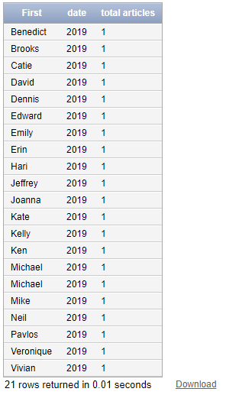

1. Identify photo only articles about the Knicks in the last eight months. Display the article title and publish date. Use a nested select to answer this question. Note, a photo only article has no text in the body and a photo.

select article_title “title”, publish_date “date”

from article

where article_body is null

and publish_date >= date ‘2018-08-07’

and article_id in (select article_id

from photo);

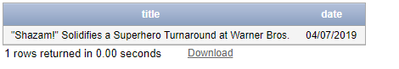

1. Identify Los Angeles reporters with no completed or draft articles in the last five months. Display the reporter. Order the output by reporter name. Use a nested select to answer this question.

select r_FName “First Name”, r_LName “Last Name”

from reporter

where r_id in (select r_id

from reporter_office

where office_id in (select office_id

from office

where office_city like '%Los Angeles%'))

and r_id not in (select r_id

from reporter_article

where article_id in (select article_id

from article

where publish_date >= date '2018-11-01'

and article_id in (select article_id

from status

where status_type = 'draft')))

order by r_FName

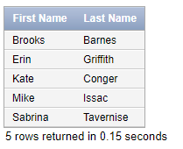

1. Identify all articles published yesterday. Display the section, article title, authors, topics and page numbers. Order the output by section, page number (where the article appears in the newspaper) and article title.

select section_type "Section Type", article_title "Title", r_FName "First", r_LName "Last", topic_type "Topic Type", page_number "Page Number"

from section, article, reporter, topic, reporter_article, page

where article.publish_date = date '2019-04-10'

and article.article_id = section.article_id

and article.article_id = topic.article_id

and reporter.r_id = reporter_article.r_id

and article.article_id = reporter_article.article_id

and article.article_id = page.article_id

order by section_type, article_title

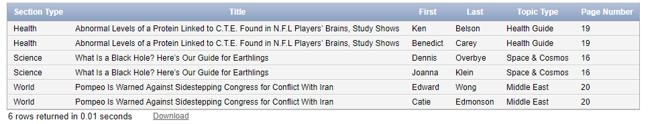

1. Identify articles published today without a topic. Display the article and authors. Use a nested select to answer this question.

select article_title "title", r_FName "first", r_LName "last"

from article, reporter, reporter_article

where article.publish_date = date '2019-04-07'

and article.article_id = reporter_article.article_id

and reporter.r_id = reporter_article.r_id

and article.article_id in (select article_id

from topic

where topic.article_id = article.article_id

and topic_type = 'null');

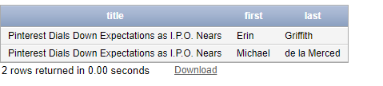

1. Identify number of articles and the total salary by office in the last two years. Display three columns: office location, number of articles and total salary. Display one row for each distinct office. The office with the highest salary will be displayed first. Use a function to answer this question.

*** FOR NUMBER 10, I ANSWERED THIS QUESTION AFTER QUESTION 11, WHICH MEANS THAT IT TOOK INTO ACCOUNT THAT THERE WERE NO MORE REPORTERS ASSIGNED TO THE WASHINGTON DC OFFICE. THEY WERE ALL REASSIGNED TO THE NEW YORK OFFICE. THIS MADE IT ONLY DISPLAY THE REMAINING OFFICES OF NEW YORK AND LOS ANGELES.

select office_street "Street Location", count(1) "number of articles", sum(r_salary) "total salary"

from article, office, reporter, reporter_office, reporter_article

where article.publish_Date >= date '2017-04-12'

and article.article_id = reporter_article.article_id

and reporter.r_id = reporter_article.r_id

and reporter.r_id = reporter_office.r_id

and office.office_id = reporter_office.office_id

group by office_street

order by 3 desc

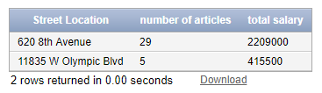

1. Close the Washington D.C. office and re-assign all reporters to the New York office. Identify the SQL code to implement.

update reporter_office

set office_id = 201

where r_id in

(select r_id

from reporter_office

where office_id = 204);

**BEFORE RE-ASSIGNING REPORTERS**

**REPORTER_OFFICE TABLE**

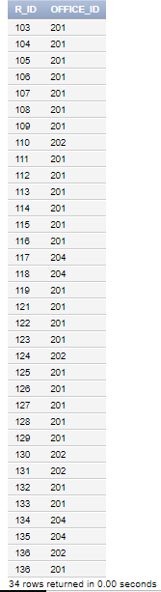

**AFTER REASSIGNING REPORTERS:**

**REPORTER_OFFICE TABLE**

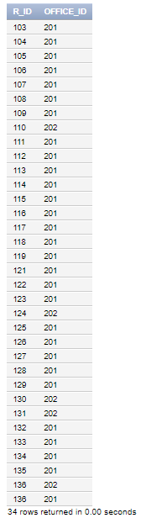

Q11 – CONTINUED

delete from office

where office_id = 204;

BEFORE DELETING THE DC OFFICE

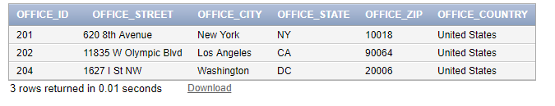

AFTER DELETING THE DC OFFICE

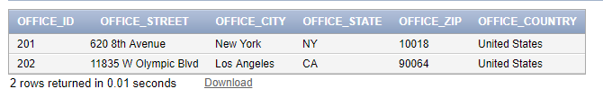

12. Display the structure of ALL tables using SQL Describe.

Describe reporter

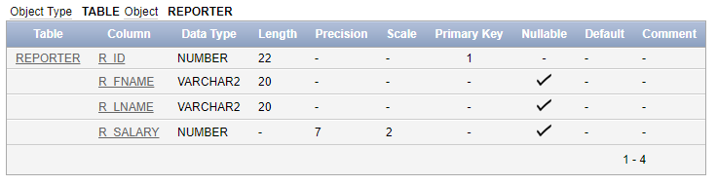

Describe Article

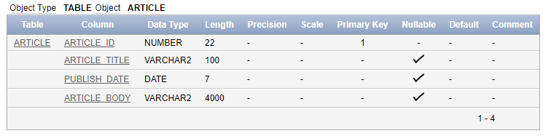

Describe Section

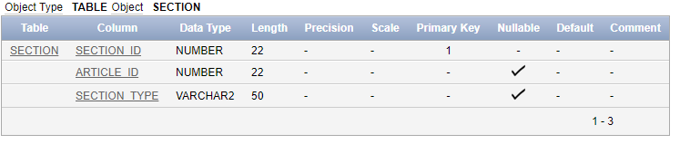

Describe Topic

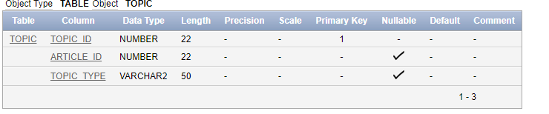

Describe Office

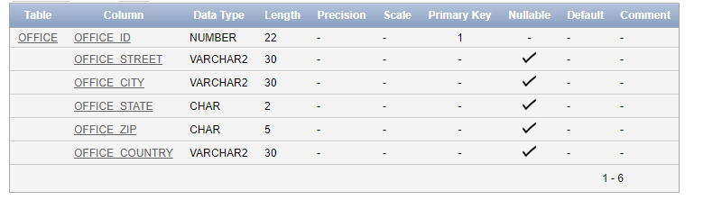

Describe Photo

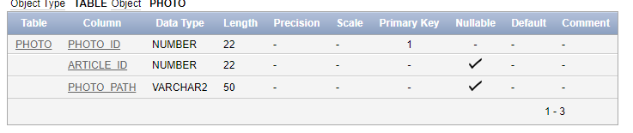

Describe reporter_article

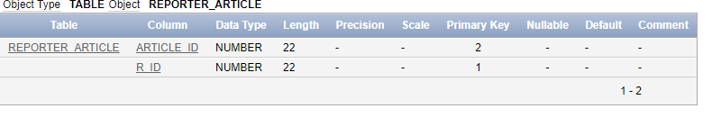

Describe reporter_office

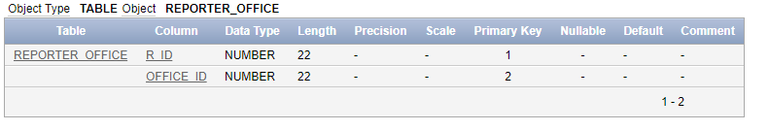

Describe status

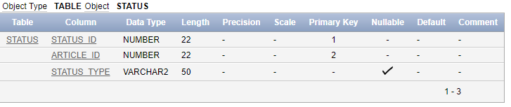

Describe page

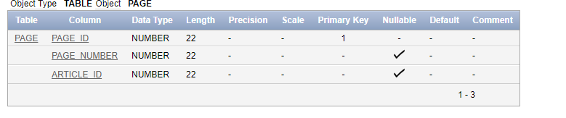

13. Display the version of Oracle. Enter: SELECT * FROM v$version

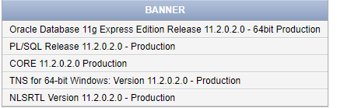

**New York Times Article Database**

**SQL COMMANDS**

**CREATING REPORTER TABLE**

create table reporter

(

r_ID number Primary Key,

r_FName varchar(20),

r_LName varchar(20),

r_Salary decimal(7,2)

);

**DATA FOR REPORTER TABLE**

insert into reporter

values(r_seq.nextval, 'Vivian', 'Wang', 60000);

insert into reporter

values(r_seq.nextval, 'David', 'Waldstein', 70000)

insert into reporter

values(r_seq.nextval, 'Michael', 'Tackett', 75000);

insert into reporter

values(r_seq.nextval, 'Eliza', 'Shapiro', 80000)

insert into reporter

values(r_seq.nextval, 'Liz', 'Robbins', 80000)

insert into reporter

values(r_seq.nextval, 'Tyler', 'Pager', 80000)

insert into reporter

values(r_seq.nextval, 'Campbell', 'Robertson', 85000)

insert into reporter

values(r_seq.nextval, 'Sabrina', 'Tavernise', 87500)

insert into reporter

values(r_seq.nextval, 'Anahad', 'OConnor', 90000)

insert into reporter

values(r_seq.nextval, 'Bari', 'Weiss', 90000)

insert into reporter

values(r_seq.nextval, 'Winnie', 'Hu', 77000)

insert into reporter

values(r_seq.nextval, 'Elizabeth', 'Harris', 82000)

insert into reporter

values(r_seq.nextval, 'Jon', 'Pareles', 65000)

insert into reporter

values(r_seq.nextval, 'Kelly', 'Whiteside', 90000)

insert into reporter

values(r_seq.nextval, 'Neil', 'Irwin', 95000)

insert into reporter

values(r_seq.nextval, 'Coral', 'Davenport', 75000)

insert into reporter

values(r_seq.nextval, 'Kendra', 'Pierre-Louis', 83000)

insert into reporter

values(r_seq.nextval, 'Veronique', 'Greenwood', 60000)

insert into reporter

values(r_seq.nextval, 'Emily', 'Weinstein', 74000)

insert into reporter

values(r_seq.nextval, 'Pavlos', 'Zarifopoulos', 75000)

insert into reporter

values(r_seq.nextval, 'Zach', 'Schonbrun', 60000)

insert into reporter

values(r_seq.nextval, 'Brooks', 'Barnes', 95000)

insert into reporter

values(r_seq.nextval, 'Pavlos', 'Zafiropoulos', 70000)

insert into reporter

values(r_seq.nextval, 'Joanna', 'Klein', 75000)

insert into reporter

values(r_seq.nextval, 'Dennis', 'Overbye', 70000)

insert into reporter

values(r_seq.nextval, 'Jeffrey', 'Gettleman', 80000)

insert into reporter

values(r_seq.nextval, 'Hari', 'Kumar', 80000)

insert into reporter

values(r_seq.nextval, 'Mike', 'Issac', 85000)

insert into reporter

values(r_seq.nextval, 'Kate', 'Conger', 85000)

insert into reporter

values(r_seq.nextval, 'Ken', 'Belson', 65000)

insert into reporter

values(r_seq.nextval, 'Benedict', 'Carey', 65000)

insert into reporter

values(r_seq.nextval, 'Catie', 'Edmonson', 85000)

insert into reporter

values(r_seq.nextval, 'Edward', 'Wong', 85000)

insert into reporter

values(r_seq.nextval, 'Erin', 'Griffith', 63000)

insert into reporter

values(r_seq.nextval, 'Michael', 'de la Merced', 63000)

**CREATING ARTICLE TABLE**

create table article(

article_ID number Primary Key,

article_title varchar(100),

publish_Date date,

article_body varchar(4000)

);

**DATA FOR ARTICLE TABLE**

values(article_seq.nextval, 'A Cuomo Insider Was a Big Money Lobbyist Who Drove a Porsche. Then Came a Stunning Fall.', date '2019-04-05', 'For years, Todd R. Howe reaped the rewards of being a Cuomo family loyalist.He had worked for Gov. Mario M. Cuomo in the 1980s, and then for his son, Andrew, in the 1990s. He traded on his reputation as an Albany insider and earned up to $750,000 a year as a lobbyist and consultant. He vacationed in St. Lucia and drove a Porsche. Then came a precipitous fall that took him from influencing the powerful in Albany to working as a groundskeeper in Idaho. In 2016, Mr. Howe pleaded guilty to eight felonies and agreed to testify for the prosecution in a sprawling public corruption case that has loomed over Gov. Andrew M. Cuomo’s administration for more than two years. Seven people were eventually convicted or pleaded guilty in cases that hinged on testimony from Mr. Howe. For that, he was rewarded on Friday with a sentence that included no prison time. The fallout from the case has relentlessly shadowed Mr. Cuomo. Though prosecutors never accused the governor of any wrongdoing, and he has distanced himself from Mr. Howe, political opponents have repeatedly asked what Mr. Cuomo knew. During Mr. Cuomo’s re-election campaign last year, his rivals outright accused him of complicity.)

insert into article

values(article_seq.nextval, 'Trump Ends Deal Between M.L.B. and Cuban Baseball Federation', date '2019-04-08','President Trump, reversing an agreement negotiated by the Obama administration, abruptly ended a deal between Major League Baseball and the Cuban Baseball Federation that had eased the path for players to compete in the United States without defecting from their country. The Trump administration said that the deal constituted a violation of trade laws because the Cuban federation was part of the government in Havana — a departure from the previous administration’s stance. In a letter to M.L.B.’s outside counsel, which was obtained by The New York Times, Nikole Thomas, the acting assistant director for licensing at the Office of Foreign Assets Control, outlined the U.S. government’s opposition to the deal, which stipulated that the Cuban federation would receive 25 percent of a player’s signing bonus for a minor league player and between 15 and 25 percent for a major league player. The letter said that the O.F.A.C. had “determined that M.L.B.’s payments to the Cuban Baseball Federation are not authorized” because “a payment to the Cuban Baseball Federation is a payment to the Cuban government.” News of the administration’s rejection of M.L.B.’s plan was first reported by The Wall Street Journal and ESPN. Cuban sports entities, including its baseball federation and Olympic committee, have argued they are independent of the central government, but the Trump administration rejected that assessment. “The U.S. does not support actions that would institutionalize a system by which a Cuban government entity garnishes the wages of hard-working athletes who simply seek to live and compete in a free society,” said Garrett Marquis, a spokesman for the National Security Council. “The administration looks forward to working with M.L.B. to identify ways for Cuban players to have the individual freedom to benefit from their talents, and not as property of the Cuban state.”In a statement, M.L.B. said: “We stand by the goal of the agreement, which is to end the human trafficking of baseball players from Cuba.” ')

insert into article

values(article_seq.nextval, 'New Yorkers’ Christmas Traditions: Chinese Food, the Knicks, Meals for the Homeless', date '2018-12-25','On Christmas Day, a Brooklyn street was bustling. Couples carrying grocery bags ran into friends on street corners, double-parked cars lined the avenue and one man complained that he’d been circling the block for half an hour, looking for a parking spot. But there were no Christmas carols, no spruce trees lining the sidewalk outside of delis and nary a twinkling light in sight. In Borough Park, home to one of the largest communities of Orthodox Jews outside of Israel, it was not Christmas. It was just Tuesday. In most of New York City, tourists and locals did what they usually do to celebrate: They attended Christmas Mass at St. Patrick’s Cathedral or spent the afternoon in pajamas watching “A Christmas Story.” (Or “Die Hard.” Please argue among yourselves.) But there were also other rituals to be followed: Thousands of oft-disappointed but resolute Knicks fans steeled themselves for the team’s almost-annual Christmas Day game, this year against the Milwaukee Bucks. Some families flocked to homeless shelters and soup kitchens, including local politicians, who donned plastic aprons and spooned out yellow rice and collard greens at a must-stop event in Harlem. And of course, Chinese restaurants in every corner of the city were preparing for one of their busiest days of the year, when people him at the door. According to the police, Mr. Bowers exchanged gunfire with officers before retreating back inside and barricading himself inside a third-floor room. He eventually surrendered. Mr. Bowers, 46, was injured by gunfire, although the authorities said it was unclear whether those wounds were self-inflicted or whether the police had shot him. He was taken to Allegheny General Hospital.Federal officials charged Mr. Bowers with 29 criminal counts. They included obstructing the free exercise of religious beliefs — a hate crime — and using a firearm to commit murder. He also faces state charges, including 11 counts of criminal homicide, six counts of aggravated assault and 13 counts of ethnic intimidation.The authorities said that he had no previous criminal history.')

insert into article

values(article_seq.nextval, 'When We Eat, or Don’t Eat, May Be Critical for Health', date '2018-07-24',' Nutrition scientists have long debated the best diet for optimal health. But now some experts believe that it’s not just what we eat that’s critical for good health, but when we eat it. A growing body of research suggests that our bodies function optimally stand in line for hours in the cold for soup dumplings and Peking duck after a trip to the movies. There were no lines at China Glatt, Borough Park’s main Chinese restaurant. Around noon, orders started to roll in for chicken and broccoli with brown rice. It was a perfectly unremarkable lunch service. A man came out of the kitchen, sipping egg drop soup. Efraim P., who declined to give his last name because he did not have his boss’s permission, is a mashgiach, or an inspector of food in kosher restaurants. He had just finished his morning routine of picking over the restaurant’s new deliveries of potatoes, carrots and frozen french fries. ')

insert into article

values(article_seq.nextval, '11 Killed in Synagogue Massacre; Suspect Charged With 29 Counts', date '2018-10-27',' Armed with an AR-15-style assault rifle and at least three handguns, a man shouting anti-Semitic slurs opened fire inside a Pittsburgh synagogue Saturday morning, killing at least 11 congregants and wounding four police officers and two others, the authorities said. In a rampage described as among the deadliest against the Jewish community in the United States, the assailant stormed into the Tree of Life Congregation, where worshipers had gathered in separate rooms to celebrate their faith, and shot indiscriminately into the crowd, shattering what had otherwise been a peaceful morning. The assailant, identified by law enforcement officials as Robert D. Bowers, fired for several minutes and was leaving the synagogue when officers, dressed in tactical gear and armed with rifles, met when we align our eating patterns with our circadian rhythms, the innate 24-hour cycles that tell our bodies when to wake up, when to eat and when to fall asleep. Studies show that chronically disrupting this rhythm — by eating late meals or nibbling on midnight snacks, for example — could be a recipe for weight gain and metabolic trouble.That is the premise of a new book, “The Circadian Code,” by Satchin Panda, a professor at the Salk Institute and an expert on circadian rhythms research. Dr. Panda argues that people improve their metabolic health when they eat their meals in a daily 8- to 10-hour window, taking their first bite of food in the morning and their last bite early in the evening. This approach, known as early time-restricted feeding, stems from the idea that human metabolism follows a daily rhythm, with our hormones, enzymes and digestive systems primed for food intake in the morning and afternoon. Many people, however, snack and graze from roughly the time they wake up until shortly before they go to bed. Dr. Panda has found in his research that the average person eats over a 15-hour or longer period each day, starting with something like milk and coffee shortly after rising and ending with a glass of wine, a late night meal or a handful of chips, nuts or some other snack shortly before bed. That pattern of eating, he says, conflicts with our biological rhythms. Scientists have long known that the human body has a master clock in the brain, located in the hypothalamus, that governs our sleep-wake cycles in response to bright light exposure. A couple of decades ago, researchers discovered that there is not just one clock in the body but a collection of them. Every organ has an internal clock that governs its daily cycle of activity.')

insert into article

values(article_seq.nextval, 'Aziz Ansari Is Guilty. Of Not Being a Mind Reader.', date '2018-01-15',' I’m apparently the victim of sexual assault. And if you’re a sexually active woman in the 21st century, chances are that you are, too. That is what I learned from the “exposé” of Aziz Ansari published last weekend by the feminist website Babe — arguably the worst thing that has happened to the #MeToo movement since it began in October. It transforms what ought to be a movement for women’s empowerment into an emblem for female helplessness. The headline primes the reader to gird for the very worst: “I went on a date with Aziz Ansari. It turned into the worst night of my life.” Like everyone else, I clicked. The victim in this 3,000-word article is called Grace — not her real name — and her experience with Mr. Ansari began at a 2017 Emmys after-party. As recounted by the woman to the reporter Katie Way, she approached him, and they bonded over their admiration of the same vintage camera. The woman was at the party with someone else, but she and Mr. Ansari exchanged numbers and soon arranged a date in Manhattan. After arriving at his TriBeCa apartment on the appointed evening — she was “excited,” having carefully chosen her outfit after consulting with friends — they exchanged small talk and drank wine. “It was white,” she said. “I didn’t get to choose and I prefer red, but it was white wine.” Yes, we are apparently meant to read the nonconsensual wine choice as foreboding.')

insert into article

values(article_seq.nextval, 'A Shadow System Feeds Segregation in New York City Schools', date '2018-06-17',' No other city in the country screens students for as many schools as New York — a startling fact all but lost in the furor that has erupted over Mayor Bill de Blasio’s recent proposal to change the admissions process for the city’s handful of elite high schools. One in five middle and high schools in New York, the nation’s largest school district, now choose all of their students based on factors like grades or state test scores. That intensifies an already raw debate about equity, representation and opportunity that has raged since Mr. de Blasio proposed scrapping the one-day test now required to gain entry into New York’s eight elite high schools. Black and Hispanic students are underrepresented in many of the most selective screened middle and high schools, just as they are in the specialized high schools. In Los Angeles, the country’s second-largest district, there are only two selective high schools and two “highly gifted” magnet schools. Boston has seven schools that screen — all high schools — including the prestigious Boston Latin School, a feeder for Harvard University that has an entrance exam akin to New York’s specialized high school test. In Seattle, the only screened schools are two elementary schools with accelerated curriculums for “highly capable” students who pass a district-administered gifted test.')

insert into article

values(article_seq.nextval, 'Beyoncé and Jay-Z: The State of the Union Is Strong', date '2018-06-17',' The strife, sorrow, fury, self-doubt and atonement are over; it’s time for a victory lap. That’s the basis of “Everything Is Love” by the Carters: Beyoncé and Jay-Z’s first full-length album together after years of marriage, parenthood, musical collaborations and shared touring, including the London stadium concert on Saturday where they abruptly announced the release of the new album. The nine-song “Everything Is Love” and a bonus track, “Salud!,” were released at first only on Tidal, the streaming service they partly own.“Everything Is Love” arrives as the capstone of a trilogy. It proclaims a happy ending to the sequence of albums that began with Beyoncé’s prodigious 2016 “Lemonade”: a grand statement, magnified by its dreamlike full-length video and interludes of poetry, that set personal betrayal and resolve alongside a multigenerational history of African-American women’s travails. It continued in 2017 with Jay-Z’s “4:44,” a stripped-down, strikingly exposed album about accepting responsibility as a grown man, husband and father. With their new album as the Carters, Jay-Z (born Shawn Carter) and Beyoncé are once again a united force, celebrating their success on every front: artistic, financial, marital, erotic, historic. The joint album has been long in the making, Jay-Z said in an interview with The New York Times; the care shows in tracks that can hark back to vintage R&B or delve into eerie, disorienting electronic soundscapes.')

insert into article

values(article_seq.nextval, '‘Hello, Kevin Knox.’ A Knicks Rookie Breaks Out.', date '2019-03-18',' In a rookie season that has resembled a seismograph, Knicks forward Kevin Knox needed a performance like Sunday’s against the Los Angeles Lakers. He scored 19 points with an array of shots, slashing to the basket, hitting a step-back 3-pointer while guarded by LeBron James and finishing with finesse on a driving, left-handed layup. “Hello, Kevin Knox. It was good to see him play well,” Knicks Coach David Fizdale said. “He’s had his bumps. We know it’s there, it’s in there. It’s just a matter of the ball going in and him getting his confidence up. But I really thought he came with a mind-set that he was going to get out of this rut. The way he was attacking, the force he was playing with.” Knox shot 8 of 14 from the field and 3 of 5 from 3-point range in the Knicks’ 124-123 victory over the Lakers, their 14th win in a dismal season. “I’d been struggling a little bit, but the whole team and coaching staff had confidence in me,” Knox said. “I came to work every single day, got up extra shots. I knew I was going to come out of the streak, so I just wanted to make sure I kept shooting.” Last year the Knicks selected Knox, a freshman from Kentucky, in the first round of the draft, ninth over all. After an ankle sprain sidelined him at the start of the season, Knox’s play took off in December, when he averaged 17.1 points and was named the Eastern Conference rookie of the month. Knox, 19, hit the rookie wall beginning in mid-January, with a 20-game stretch in which he shot 31.8 percent from the field and 27.7 from beyond the 3-point arc. The slump started soon after he scored 31 points, his highest total in the N.B.A., during a game against the Philadelphia 76ers.')

insert into article

values(article_seq.nextval, 'America’s Biggest Economic Challenge May Be Demographic Decline', date '2019-04-03',' For many years, American economists have spoken of Japan and Western Europe as places where the slow grind of demographic change — masses of workers reaching retirement age, and smaller generations replacing them — has been a major drag on the economy. But it is increasingly outdated to think of that as a problem for other countries. The deepest challenge for the United States economy may really be about demographics. And our understanding of the implications is only starting to catch up. A new report from the Economic Innovation Group, a Washington think tank funded in large part by tech investors and entrepreneurs, adds rich new detail, showing that parts of the United States are already grappling with Japanese-caliber demographic decline — 41 percent of American counties with a combined population of 38 million. At the national level, slower growth in America’s working-age population is a major reason that mainstream forecasters now expect the economy to expand around 2 percent each year rather than the 3 percent common in the second half of the 20th century. As a matter of simple arithmetic, lower growth in the number of people working will almost certainly mean slower growth in economic output.')

insert into article

values(article_seq.nextval, 'U.S. Climate Report Warns of Damaged Environment and Shrinking Economy', date '2018-11-23',' A major scientific report issued by 13 federal agencies on Friday presents the starkest warnings to date of the consequences of climate change for the United States, predicting that if significant steps are not taken to rein in global warming, the damage will knock as much as 10 percent off the size of the American economy by century’s end. The report, which was mandated by Congress and made public by the White House, is notable not only for the precision of its calculations and bluntness of its conclusions, but also because its findings are directly at odds with President Trump’s agenda of environmental deregulation, which he asserts will spur economic growth. Mr. Trump has taken aggressive steps to allow more planet-warming pollution from vehicle tailpipes and power plant smokestacks, and has vowed to pull the United States out of the Paris Agreement, under which nearly every country in the world pledged to cut carbon emissions. Just this week, he mocked the science of climate change because of a cold snap in the Northeast, tweeting, “Whatever happened to Global Warming?” But in direct language, the 1,656-page assessment lays out the devastating effects of a changing climate on the economy, health and environment, including record wildfires in California, crop failures in the Midwest and crumbling infrastructure in the South. Going forward, American exports and supply chains could be disrupted, agricultural yields could fall to 1980s levels by midcentury and fire season could spread to the Southeast, the report finds. “There is a bizarre contrast between this report, which is being released by this administration, and this administration’s own policies,” said Philip B. Duffy, president of the Woods Hole Research Center. All told, the report says, climate change could slash up to a tenth of gross domestic product by 2100, more than double the losses of the Great Recession a decade ago.')

insert into article

values(article_seq.nextval, 'Flying Squirrels That Glow Pink in the Dark', date '2019-02-01',' One spring night in Wisconsin, John Martin, a biologist, was in his backyard with an ultraviolet flashlight. Suddenly, a hot-pink squirrel flew by. It was a southern flying squirrel, a small, furry creature most active at dawn and dusk. Under most circumstances, it has a warm brown color. But in the beam of Dr. Martin’s flashlight, it sported a gaudy Day-Glo hue closer to something you might see in a nightclub or a Jazzercise class circa 1988. “He told his colleagues at Northland College, but of course, everyone was pretty skeptical,” said Allison Kohler, a graduate student at Texas A&M University. Dr. Martin asked Ms. Kohler, then a student at Northland, to look into it. After examining more than 100 specimens of flying squirrels across two museum collections and spotting five more squirrels under UV light in the wild, the researchers and their colleagues reported surprising results last week in the Journal of Mammalogy: The pink is real.')

insert into article

values(article_seq.nextval, 'How Often Should You Cook?', date '2019-04-05',' Hi and welcome to Five Weeknight Dishes. One question I’ve gotten a lot since I started writing this newsletter is how many nights I cook dinner during the workweek. The answer is not five. I typically cook a meal from scratch on two weeknights, maybe three. You don’t need to do more than that! Pick at least one recipe that makes good leftovers, doubling or stretching them with eggs, vegetables, toast or grains if necessary. Or supplement with something else in the fridge or cabinet. Dinner can be a fun, crazy mishmash; photographers will not be showing up to document the meal. As for the other nights: My partner cooks, or occasionally we order chicken parm or go out (luxuries of urban and suburban life), or eat our preferred brand of freezer pizza with a nice big salad. The reason I share five dishes is not because I want to map out Monday to Friday, but because I want to give you options! At least two vegetarian dishes, and chicken, and pasta and seafood too. (And not a lot of red meat, for many reasons, and also because it’s just not my thing.) As always, let me know what you think at dearemily@nytimes.com.')

insert into article

values(article_seq.nextval, 'Creating a Golf Destination in the Hills of Greece', date '2019-03-09',' On the southwestern Peloponnese coast of Greece, in walking distance from the beach, Thodoris Poulis, a construction foreman, pointed up recently at half a dozen newly built homes on the hillside, each with a sweeping view of the Bay of Navarino. “The older sort of development with a few small houses is going away,” he said, “and we’re getting more large stand-alone homes — expensive builds, in the style of villas.” As he spoke, he was overseeing work on what will become just such a villa; dubbed the Lemon Project, this home near the town of Pylos will have a pool, a sea view and landscaped gardens, complete with citrus orchard. The developer of that property, Iliopoulos Real Estate and Constructions, is a small family business run by two brothers, Minas and Vasilis Iliopoulos. Until recently, their business usually involved building or renovating modest homes on plots owned by others here in the Messenia region. But with the Lemon Project, they have become developers, buying the land themselves and building a luxury home that they will put on the market for about 800,000 euros, or about $900,000.')

insert into article

values(article_seq.nextval, 'Giants Make Odell Beckham Jr. the N.F.L.’s Highest-Paid Receiver', date '2018-08-27',' The Giants have made their top playmaker, Odell Beckham Jr., the highest-paid wide receiver in the N.F.L. The team announced Monday that the fifth-year receiver had agreed to a five-year contract extension, ensuring that quarterback Eli Manning’s favorite target will not head elsewhere. The deal, worth a maximum of $95 million, reportedly includes a guaranteed $65 million, more than any other non-quarterback in the league besides Von Miller, the star linebacker of the Denver Broncos. Upon arriving in 2014, Beckham, 25, almost immediately established himself as one of the game’s most entertaining and dynamic stars, with breakaway potential and a preternatural knack for one-handed, highlight-reel catches. Beckham shattered the franchise records for receptions, yards and touchdowns by a player in his first three seasons, averaging more than 1,377 yards and 12.5 touchdowns per season. He recorded 200 receptions and 3,000 yards faster than any player in N.F.L. history. The blazing fast start to his career was slowed last season by an ankle injury in October that required surgery. The team has held him out of preseason games this year as a cautionary measure, although he is practicing and is expected to play in the regular season opener. After the team found out about Beckham’s deal, players danced in the locker room, according to videos posted on social media. Beckham’s mother, Heather Van Norman, was at the facility for the signing. It was not always a given that the Giants would choose to extend Beckham after picking up the fifth-year option on his contract for 2018. He is making $8.45 million this season.')

insert into article

values (article_seq.nextval, '"Shazam!" Solidifies a Superhero Turnaround at Warner Bros.', date '2019-04-07', null)

insert into article

values(article_seq.nextval, 'What Is a Black Hole? Here’s Our Guide for Earthlings', date '2019-04-10', ' Welcome, earthlings, to the place of no return: a region in space where the gravitational pull is so strong, not even light can escape it. This is a black hole. It’s O.K. to feel lost here. Even Albert Einstein, whose theory of general relativity made it possible to conceive of such a place, thought the concept was too bizarre to exist. But Einstein was wrong, and here you are. You shouldn’t be here. Surely you will be pulled in. But fear not, dear earthling: Your brain has taken millions of years to get here, and it’s ready for this gaze into the darkness. So let’s get started. It swallows up everything too close, too slow or too small to fight its gravitational force. With every planet, gas, star or bit of mass consumed, the black hole grows. The edge of a black hole, its event horizon, is the point of no return. At the event horizon, light is drawn in to a black hole, never to escape. And nothing is faster than light.')

insert into article

values(article_seq.nextval, 'India Shot Down a Satellite, Modi Says, Shifting Balance of Power in Asia', date '2019-03-27', ' Prime Minister Narendra Modi announced on Wednesday that India had test-fired a rocket that shot down one of its own satellites, escalating the country’s rivalry with China and Pakistan, and demonstrating a strategic capability in space that few countries possess. This technological leap, which was confirmed by the Pentagon, puts India in an exclusive club of nations, along with the United States, Russia and China, that have proved their ability to destroy targets in space. But it has potentially ominous repercussions, accelerating the space race with China and destabilizing the uneasy balance of power between India and Pakistan, which are both armed with nuclear weapons. It could allow India essentially to blind an enemy by taking out its space-based communication and surveillance satellites. Shooting down a satellite is no easy feat. In this case, scientists estimate that the satellite that India blasted apart was moving around the Earth at 17,000 miles per hour. Mr. Modi made the announcement to a rapt nation just weeks before the country heads into a hotly contested election. “India stands tall as a space power!” Mr. Modi tweeted after his announcement. He added that the entire effort had been “indigenous,” accomplished entirely by Indians.')

insert into article

values(article_seq.nextval,' Uber, Losing $1.8 Billion a Year, Reveals I.P.O. Filing', date '2019-04-11', 'Uber, the ride-hailing service that has upended transportation around the world, took a major step toward the largest initial public offering in years when it officially unveiled its finances in a prospectus on Thursday.The offering, which could value Uber at around $100 billion, is expected to reverberate through global financial markets and to solidify the company’s position as one of the most consequential technology firms of the past decade. The share sale would be the biggest since the Alibaba Group of China began trading on the New York Stock Exchange in 2014, and would peg Uber’s value at more than four times that of United Airlines’ parent and double that of FedEx. But the prospectus renewed questions about how sustainable Uber’s business actually is.')

insert into article

values(article_seq.nextval,'Abnormal Levels of a Protein Linked to C.T.E. Found in N.F.L Players’ Brains, Study Shows', date '2019-04-10', 'Experimental brain scans of more than two dozen former N.F.L. players found that the men had abnormal levels of the protein linked to chronic traumatic encephalopathy, the degenerative brain disease associated with repeated hits to the head. Using positron emission tomography, or PET, scans, the researchers found “elevated amounts of abnormal tau protein” in the parts of the brain associated with the disease, known as C.T.E., compared to men of similar age who had not played football.The authors of the study and outside experts stressed that such tau imaging is far from a diagnostic test for C.T.E., which is likely years away and could include other markers, from blood and spinal fluid.The results of the study, published in The New England Journal of Medicine on Wednesday, are considered preliminary, but constitute a first step toward developing a clinical test to determine the presence of C.T.E. in living players, as well as early signs and potential risk. Thus far, pathologists have been able to confirm the diagnosis only posthumously, by identifying the tau signature in donated brains.')

insert into article

values(article_seq.nextval, 'Pompeo Is Warned Against Sidestepping Congress for Conflict With Iran', date '2019-04-10', 'Secretary of State Mike Pompeo left open the possibility on Wednesday of entering a conflict with Iran without first seeking explicit congressional approval, telling senators “there is no doubt there is a connection” between Al Qaeda and Iran. His comments came two days after the Trump administration designated Iran’s Islamic Revolutionary Guards Corps as a foreign terrorist group, and were likely to fuel concerns of American military action against the country. Senator Rand Paul, Republican of Kentucky, pushed Mr. Pompeo to commit that the Trump administration would not attack Iran under a war authorization allowing the use of military force against Al Qaeda and other extremist groups responsible for the terrorist attacks of Sept. 11, 2001. Mr. Pompeo demurred, saying he would “prefer to just leave that to lawyers.” Mr. Paul, a libertarian who promotes isolationist policies, said he was troubled by Mr. Pompeo’s response. “I can tell you explicitly, you have not been given power or authority by Congress to have war with Iran,” he said in the exchange at a hearing of the Senate Foreign Relations Committee.')

insert into article

values(article_seq.nextval, 'Pinterest Dials Down Expectations as I.P.O. Nears', date '2019-04-07', 'Pinterest set a price range for its initial public offering that will value the company below its last private-market peg of $12 billion, raising questions about investor demand for prominent but unprofitable technology companies that are stampeding toward the stock market. In an updated prospectus on Monday, Pinterest said it planned to price its offering at $15 to $17 a share. At the high end of that range, the digital pin board company would be valued at about $11.3 billion, accounting for stock options and restricted stock. The business was first valued at $12 billion in 2015, and again in 2017, by venture capitalists and other private investors. Pinterest’s price range dampens some of the fervor over a wave of tech offerings this year, which had promised to generate piles of new wealth in Silicon Valley. It follows last month’s I.P.O. of Lyft, the ride-hailing company, which is deeply unprofitable. While the offering created a great deal of hype and Lyft’s shares rose on their first day of trading, the stock fell below its offering price on its second day of trading, as it faced questions about its business.')

**CREATING SECTION TABLE**

create table section(

section_id number Primary Key,

article_id number,

section_type varchar(50),

foreign key (article_id) references article(article_id)

);

**DATA FOR SECTION TABLE**

insert into section

values(section_seq.nextval, 300, 'Politics')

insert into section

values(section_seq.nextval, 301, 'Sports')

insert into section

values(section_seq.nextval, 302, 'Food')

insert into section

values(section_seq.nextval, 303, 'U.S.')

insert into section

values(section_seq.nextval, 304, 'Health')

insert into section

values(section_seq.nextval, 305, 'Opinion')

insert into section

values(section_seq.nextval, 306, 'NY')

insert into section

values(section_seq.nextval, 307, 'Arts')

insert into section

values(section_seq.nextval, 308, 'Sports')

insert into section

values(section_seq.nextval, 309, 'U.S.')

insert into section

values(section_seq.nextval, 310, 'Science')

insert into section

values(section_seq.nextval, 311, 'Science')

insert into section

values(section_seq.nextval, 312, 'Cooking')

insert into section

values(section_seq.nextval, 313, 'Real Estate')

insert into section

values(section_seq.nextval, 314, 'Sports')

insert into section

values(section_seq.nextval, 315, 'Science')

insert into section

values(section_seq.nextval, 316, 'Science')

insert into section

values(section_seq.nextval, 317, 'World')

insert into section

values(section_seq.nextval, 318, 'Business')

insert into section

values(section_seq.nextval, 319, 'Health')

insert into section

values(section_seq.nextval, 320, 'World')

insert into section

values(section_seq.nextval, 321, 'Tech')

**CREATING TOPIC TABLE**

create table topic (

topic_id number Primary Key,

article_id number,

topic_type varchar(50),

foreign key (article_id) references article(article_id)

);

**DATA FOR TOPIC TABLE**

insert into topic

values(topic_seq.nextval, 300, 'The Upshot')

insert into topic

values(topic_seq.nextval, 300, 'Elections')

insert into topic

values(topic_seq.nextval, 301, 'Baseball')

insert into topic

values(topic_seq.nextval, 302, 'Cooking')

insert into topic

values(topic_seq.nextval, 304, 'Health Guide')

insert into topic

values(topic_seq.nextval, 304, 'Eat')

insert into topic

values(topic_seq.nextval, 305, 'Editorials')

insert into topic

values(topic_seq.nextval, 306, 'Education')

insert into topic

values(topic_seq.nextval, 307, 'Music')

insert into topic

values(topic_seq.nextval, 307, 'Pop Culture')

insert into topic

values(topic_seq.nextval, 308, 'Basketball')

insert into topic

values(topic_seq.nextval, 309, 'The Upshot')

insert into topic

values(topic_seq.nextval, 309, 'Economy')

insert into topic

values(topic_seq.nextval, 310, 'Climate')

insert into topic

values(topic_seq.nextval, 310, 'Economy')

insert into topic

values(topic_seq.nextval, 311, 'Environment')

insert into topic

values(topic_seq.nextval, 312, 'Cooking')

insert into topic

values(topic_seq.nextval, 313, 'Commercial')

insert into topic

values(topic_seq.nextval, 313, 'Golf')

insert into topic

values(topic_seq.nextval, 314, 'Football')

insert into topic

values(topic_seq.nextval, 315, 'Movies')

insert into topic

values(topic_seq.nextval, 316, 'Space & Cosmos')

insert into topic

values(topic_seq.nextval, 317, 'Asia Pacific')

insert into topic

values(topic_seq.nextval, 318, 'Technology')

insert into topic

values(topic_seq.nextval, 319, 'Health Guide')

insert into topic

values(topic_seq.nextval, 320, 'Middle East')

insert into topic

values(topic_seq.nextval, 321, 'Personal Tech')

**CREATING STATUS TABLE**

create table status (

status_id number Primary Key,

article_id number,

status_type varchar(50),

foreign key (article_id) references article(article_id)

);

**DATA FOR STATUS TABLE**

insert into status

values(status_seq.nextval, 300, 'Draft' )

insert into status

values(400, 301, 'Published' )

insert into status

values(400, 302, 'Published' )

insert into status

values(400, 304, 'Published' )

insert into status

values(400, 303, 'Published' )

insert into status

values(400, 305, 'Published' )

insert into status

values(400, 306, 'Published' )

insert into status

values(400, 307, 'Published' )

insert into status

values(400, 308, 'Published' )

insert into status

values(400, 309, 'Published' )

insert into status

values(400, 310, 'Published' )

insert into status

values(400, 311, 'Published' )

insert into status

values(400, 312, 'Published' )

insert into status

values(400, 313, 'Published' )

insert into status

values(400, 314, 'Published' )

insert into status

values(400,315, 'Draft')

insert into status

values(400,316, 'Published')

insert into status

values(400,317, 'Published')

insert into status

values(400,318, 'Draft')

insert into status

values(400,319, 'Published')

insert into status

values(400,320, 'Published')

insert into status

values(400,321, 'Waiting for Approval')

update status

set status_type = 'Draft'

where status_id = 400

and article_id = 300

**CREATING PHOTO TABLE**

create table photo (

photo_id number Primary Key,

article_id number,

photo_path varchar(50),

foreign key (article_id) references article(article_id)

);

**DATA FOR PHOTO TABLE**

insert into photo

values(photo_seq.nextval, 315, 'C:\Users\ksin3\Desktop\superhero.jpg')

**CREATING REPORTER_ARTICLE TABLE**

create table reporter_article (

article_id references article(article_id),

r_id references reporter(r_id),

constraint reporter_article_pk Primary Key (r_id, article_id)

);

DATA FOR REPORTER_ARTICLE TABLE

insert into reporter_Article

values(302,106)

insert into reporter_Article

values(302,107)

insert into reporter_Article

values(302,108)

insert into reporter_Article

values(303,109)

insert into reporter_Article

values(303,110)

insert into reporter_Article

values(304,111)

insert into reporter_Article

values(305,112)

insert into reporter_Article

values(306,113)

insert into reporter_Article

values(306,114)

insert into reporter_Article

values(307,115)

insert into reporter_Article

values(308,116)

insert into reporter_Article

values(309,117)

insert into reporter_Article

values(310,118)

insert into reporter_Article

values(310,119)

insert into reporter_Article

values(311,121)

insert into reporter_Article

values(312,122)

insert into reporter_article

values(313,127)

insert into reporter_article

values(314,123)

insert into reporter_article

values(315,124)

insert into reporter_article

values(316,125)

insert into reporter_article

values(316,126)

insert into reporter_article

values(317,128)

insert into reporter_article

values(317,129)

insert into reporter_article

values(318,130)

insert into reporter_article

values(318,131)

insert into reporter_article

values(319,132)

insert into reporter_article

values(319,133)

insert into reporter_article

values(320,134)

insert into reporter_article

values(320,135)

insert into reporter_article

values(321,136)

insert into reporter_article

values(321,137)

**CREATING OFFICE TABLE**

create table office (

office_id number,

r_ID number,

office_Street varchar(30),

office_City varchar(30),

office_state char(2),

office_zip char(5),

office_Country varchar(30)

foreign key(r_ID) references reporter(r_ID),

constraint office_pk primary key (office_id, r_id)

);

**--THE BELOW WAS DONE TO ALTER THE PRIMARY KEY FOR THE OFFICE TABLE. BEFORE I HAD MADE IT A COMPOSITE BY ACCIDENT BUT CHANGED IT IMMEDIATELY**

alter table office

drop primary key

alter table office

add primary key(office_id)

**DATA FOR OFFICE TABLE**

insert into office

values(office_seq.nextval, '620 8th Avenue', 'New York', 'NY', '10018', 'United States')

insert into office

values(office_seq.nextval, '11835 W Olympic Blvd', 'Los Angeles', 'CA', '90064', 'United States')

insert into office

values(office_seq.nextval, '1627 I St NW', 'Washington', 'DC', '20006', 'United States')

CREATING REPORTER_OFFICE

create table reporter_office (

r_ID number not null,

office_id number not null,

constraint reporter_office_pk primary Key(r_id, office_id)

);

**DATA FOR REPORTER OFFICE**

insert into reporter_office

values(103,201)

insert into reporter_office

values(104,201)

insert into reporter_office

values(105,201)

insert into reporter_office

values(106,201)

insert into reporter_office

values(107,201)

insert into reporter_office

values(108,201)

insert into reporter_office

values(109,201)

insert into reporter_office

values(110,202)

insert into reporter_office

values(111,201)

insert into reporter_office

values(112,201)

insert into reporter_office

values(113,201)

insert into reporter_office

values(114,201)

insert into reporter_office

values(115,201)

insert into reporter_office

values(116,201)

insert into reporter_office

values(117,204)

insert into reporter_office

values(118,204)

insert into reporter_office

values(119,201)

insert into reporter_office

values(121,201)

insert into reporter_office

values(122,201)

insert into reporter_office

values(123,201)

insert into reporter_office

values(124,202)

insert into reporter_office

values(125,201)

insert into reporter_office

values(126,201)

insert into reporter_office

values(127,201)

insert into reporter_office

values(128,201)

insert into reporter_office

values(129,201)

insert into reporter_office

values(130,202)

insert into reporter_office

values(131,202)

insert into reporter_office

values(132,201)

insert into reporter_office

values(133,201)

insert into reporter_office

values(134,204)

insert into reporter_office

values(135,204)

insert into reporter_office

values(136,202)

insert into reporter_office

values(137,201)

**CREATING PAGE TABLE**

create table page (

page_id number Primary Key,

page_number number,

article_id number,

foreign key (article_id) references article(article_id));

**DATA FOR PAGE TABLE**

insert into page

values(page_seq.nextval, 1, 300)

insert into page

values(page_seq.nextval, 2, 301)

insert into page

values(page_seq.nextval, 3, 302)

insert into page

values(page_seq.nextval, 4, 304)

insert into page

values(page_seq.nextval, 5, 305)

insert into page

values(page_seq.nextval, 6, 306)

insert into page

values(page_seq.nextval, 7, 307)

insert into page

values(page_seq.nextval, 8, 308)

insert into page

values(page_seq.nextval, 9, 309)

insert into page

values(page_seq.nextval, 10, 310)

insert into page

values(page_seq.nextval, 11, 311)

insert into page

values(page_seq.nextval, 12, 312)

insert into page

values(page_seq.nextval, 13, 313)

insert into page

values(page_seq.nextval, 14, 314)

insert into page

values(page_seq.nextval, 15, 315)

insert into page

values(page_seq.nextval, 16, 316)

insert into page

values(page_seq.nextval, 17, 317)

insert into page

values(page_seq.nextval, 18, 318)

insert into page

values(page_seq.nextval, 19, 319)

insert into page

values(page_seq.nextval, 20, 320)

insert into page

values(page_seq.nextval, 21, 321)

**SQL SEQUENCE COMMANDS**

create sequence r_seq

start with 100

increment by 1;

create sequence office_seq

start with 200

increment by 1;

create sequence article_seq

start with 300

increment by 1;

create sequence status_seq

start with 400

increment by 1;

create sequence photo_seq

start with 500

increment by 1;

create sequence section_seq

start with 600

increment by 1;

create sequence topic_seq

start with 700

increment by 1;

create sequence page_seq

start with 900

increment by 1;