OMS — Online Monitoring System
Supplementary Technical Specification

2026

Glossary & Acronyms
Acronyms
Acronym | Definition
API | Application Programming Interface
CI | Continuous Integration
CD | Continuous Delivery / Continuous Deployment
DTO | Data Transfer Object
GUI | Graphical User Interface
HSE | Health, Safety and Environment
HTTP | Hypertext Transfer Protocol
HTTPS | Hypertext Transfer Protocol Secure
JWT | JSON Web Token
KMP | Kotlin Multiplatform
ORM | Object-Relational Mapping
RBAC | Role-Based Access Control
REST | Representational State Transfer
SIR | Site Inspection Report
SDK | Software Development Kit
SMTP | Simple Mail Transfer Protocol
SQL | Structured Query Language
TLS | Transport Layer Security
UI | User Interface
UUID | Universally Unique Identifier
Wasm | WebAssembly

Glossary
Term | Definition
Administrator | User responsible for system configuration, user management, and administrative functions.
Audit Log | Chronological record of significant system events and user actions for security and traceability purposes.
Backend Layer | Server-side application responsible for REST APIs, authentication, business services, integrations, and data access.
Business Logic Layer | Application layer implementing business rules, workflows, validations, calculations, and permission enforcement.
Customer | Organization that owns, operates, and administers the OMS deployment.
Dashboard | Main application screen providing key performance indicators, statistics, charts, and quick access to system modules.
Data Layer | Database and storage layer responsible for persistent storage of structured and unstructured information.
Document | Electronic file uploaded to or generated by the system and associated with one or more projects.
Frontend Layer | Client-side web application implemented using Kotlin Multiplatform and Compose Multiplatform.
Inspection | Site visit performed to monitor project implementation and record observations, photographs, and findings.
Inspection Report | Structured electronic report containing inspection results, photographs, comments, and related project information.
MinIO/S3 adapter | Future object-storage adapter; not deployed in Phase 1.
Notification | System-generated message informing users about important events or required actions.
Upload Storage | Filesystem volume (OMS_UPLOAD_DIR); future MinIO/S3 adapter
Project | Primary entity representing an investment, infrastructure, or development initiative monitored by the system.
Repository | Software component responsible for interaction between business services and the persistence layer.
REST API | Standardized interface used by the frontend and external systems to communicate with backend services over HTTP.
Role | Collection of permissions defining the actions available to a user within the system.
Subproject | Individual contract, lot, or implementation unit associated with a parent project.
Workflow | Sequence of business operations performed by users or the system to complete a defined business process.

1 Project Description: OMS
1. Project Overview and Context
OMS (Online Monitoring System) is a comprehensive, multi-platform information system designed for the centralized monitoring, reporting, and financial auditing of projects. It serves as a "single source of truth" for all stakeholders, integrating real-time field data with financial indicators and geographic visualization.
The system provides a full project management cycle: from registering the facility and displaying it on an interactive map to conducting inspections, document control, financial monitoring, and reporting.
Main usage scenarios:
- Construction project monitoring
- On-site inspection
- Budget usage verification
- Documentation control
- Public progress monitoring

2. Key Objectives
The system is designed to address the following challenges:
- Transparency: Closing the gap between actual work performed on-site and financial reporting.
- Operational Efficiency: Reducing the time required to prepare and transmit reports from construction sites to the central office.
- Audit & Verification: Providing digital evidence (photos, GPS tags) to verify acts of completed works.
- Geographic Control: Visualizing the entire project portfolio on an interactive map for intuitive navigation and oversight.
Target users:
- government agencies
- international donors
- investors
- contractors
- project managers
- inspectors
- auditors

3. Functional Modules
A. Interactive Map & Project Registry The core of the interface is an interactive map where every object is represented by a marker. Marker colors dynamically change based on the project status (Planned, Active, Suspended, Completed, Archived). Users can instantly access a detailed project page containing the full construction history.
B. Inspection Module (SIR — Site Inspection Report) Inspectors generate reports directly at the project sites. The system supports uploading completed reports in xls format or entering data via a structured digital form with photo attachments.
C. Financial Monitoring & Documentation The system visualizes budget utilization progress (Planned vs. Actual). Data regarding payments and acts of completed works are imported via XLS files, enabling dynamic charts and payment timelines. Payment and advance records are classified by purpose: works, equipment, technical supervision, or engineer-consultant contracts. All financial charts are displayed in EUR. When a UAH financial record is saved, OMS retrieves the official daily NBU EUR rate for the act date, calculates the EUR equivalent and permanently stores the rate, effective date and converted amount with that record.

4. Main advantages of the system
4.1. Business Value / Benefits:
- increased transparency of project implementation
- operational control of work performance
- reduced risks of financial violations
- digital evidence base of inspections
- centralized storage of documentation
- convenient monitoring via map and analytical panel

4.2. Technical Advantages
The system is built using the modern Kotlin Multiplatform (KMP) and Compose Multiplatform stack, ensuring:
- Unified Codebase: shared Kotlin Multiplatform code supports the delivered Web client and provides an extension point for future Phase 2 mobile clients.
- High Performance: High-speed UI responsiveness delivered through WebAssembly (Wasm).
- Security: A robust Role-Based Access Control (RBAC) model ensures that sensitive data is protected and accessible only to authorized personnel.

5. Expected Outcomes
OMS aims to increase transparency, manageability, and accountability of infrastructure and social projects at all stages of their implementation.
The implementation of OMS will significantly increase project accountability, automate routine reporting processes, and provide donors and communities with up-to-date, real-time information on the progress of social initiatives.

1.1 Implementation Scope & Delivery Phases

The OMS platform will be delivered in multiple implementation phases.

Phase 1 — Basic functionality (MVP)

Phase 1 includes:

- authentication and RBAC
- dashboard and KPI dashboards
- project registry
- interactive map
- project detail page
- inspection reports (SIR)
- upload photos, reports, invoices
- document management
- user administration
- financial monitoring and reporting

The business logic and user flows must remain fully compatible with the current production system wherever applicable.

Phase 2 — Functional Expansion (scope of work is not included in this project)

The following modules are planned for subsequent implementation phases and are explicitly excluded from the current delivery scope:

- notification system
- offline synchronization enhancements
- external integrations and webhooks
- advanced analytics
- audit and compliance extensions

These modules are documented in this specification as future roadmap functionality and may be implemented in later releases based on approved budget and priorities.

2 Data Layer
This section defines the full relational data model for OMS. All tables use MySQL syntax with UTF8MB4 character set.
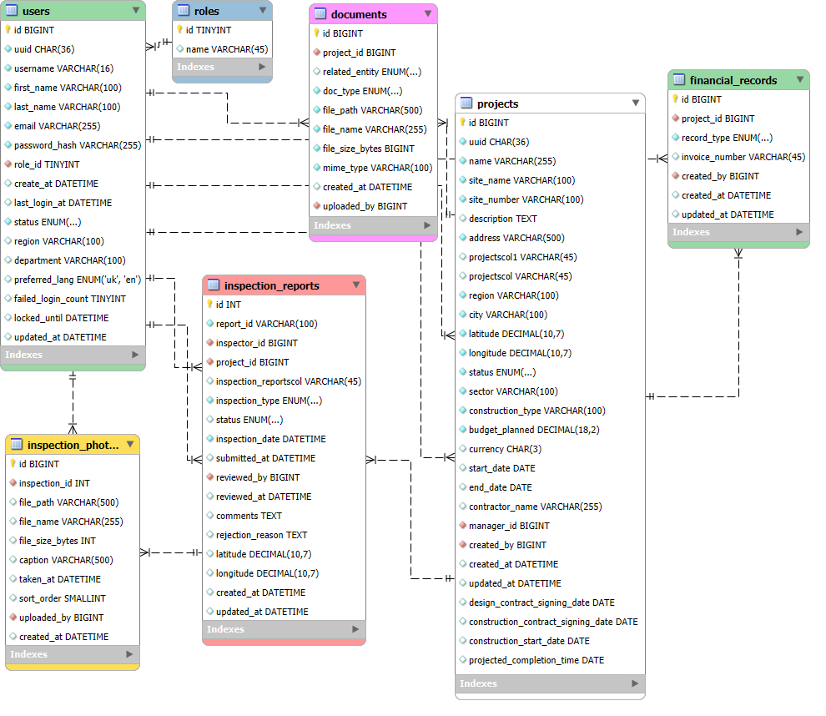

2.1 Entity Overview
Entity | Description | Key Relations
users | System users with roles and status | → inspection_reports, projects (PM)
projects | Infrastructure construction projects | → inspection_reports, financial_records, documents, incidents
inspection_reports | Site inspection reports (SIR) | → projects, users, inspection_photos
inspection_photos | Photos attached to an inspection | → inspection_reports
financial_records | Invoices, acts, payments and advances; payment_purpose is works or equipment | → projects, documents
documents | All uploaded files (PDF, XLS, images) | → projects, inspection_reports, financial_records
incidents | HSE (health, safety, environment) incidents | → projects, users
roles | Lookup table of user roles | → users
audit_log | Immutable record of all write operations | → users

2.2 Table Definitions

2.2.1 users
Column | Type | Constraints | Description
id | BIGINT | PK, AUTO_INCREMENT, NOT NULL | Surrogate primary key
uuid | CHAR(36) | UNIQUE, NOT NULL | Public identifier
first_name / last_name | VARCHAR(100) | NOT NULL | User display name
username | VARCHAR(100) | UNIQUE, NOT NULL | MVP login name (intentional addition)
email | VARCHAR(255) | UNIQUE, NOT NULL | Login credential
password_hash | VARCHAR(255) | NOT NULL | bcrypt password hash
role_id | BIGINT | FK → roles.id | Assigned role
status | ENUM | pending | active | disabled | Account lifecycle
region / department | VARCHAR(100) | NULL | Assignment metadata
preferred_lang | ENUM | uk | en; DEFAULT uk | UI language
last_login_at / failed_login_count / locked_until | DATETIME / TINYINT | NULL / DEFAULT 0 / NULL | Authentication metadata
created_at / updated_at | DATETIME | DEFAULT CURRENT_TIMESTAMP | Record timestamps

2.2.2 roles
id | name | description
1 | ADMIN | Full access to all modules and system settings
2 | PROJECT_MANAGER | Manage only assigned projects, reports, documents and financial data; no user-management access
3 | INSPECTOR | Create and edit draft inspection reports
4 | CONTRACTOR | Legacy compatibility role
5 | VIEWER | Authenticated read-only access to permitted operational data

2.2.3 projects
Column | Type | Constraints | Description
id | BIGINT | PK, AUTO_INCREMENT | Surrogate primary key
uuid | CHAR(36) | UNIQUE, NOT NULL | Public identifier
project_type / parent_project_id | ENUM / BIGINT | project | subproject / FK | Project hierarchy
name, site_name, site_number, description | TEXT / VARCHAR / TEXT | NOT NULL for name | Project identity; full formal names are retained
address, region, city | VARCHAR | NOT NULL | Location data
latitude / longitude | DECIMAL(10,7) | NOT NULL | WGS84 coordinates
status | ENUM | planned | active | suspended | completed | archived | DLP | Project lifecycle
sector / construction_type | VARCHAR(100) | NOT NULL | Classification
budget_planned | BIGINT | NOT NULL | Approved budget in UAH
engineer_consultant_contract_amount / technical_supervision_amount | BIGINT | NULL | MVP contract-cost extensions
subproject_contract_amount | BIGINT | NULL | Subproject contract amount
start_date, end_date, contract_signed_date, planned_end_date | DATE | NULL | MVP schedule fields
design_contract_signing_date, construction_contract_signing_date, construction_start_date, projected_completion_time | DATE | NULL | Contract and construction milestones
currency / contractor_name | CHAR(3) / VARCHAR(255) | UAH default / NULL | Commercial data
manager_id / created_by | BIGINT | FK → users.id | Responsible users
created_at / updated_at | DATETIME | DEFAULT CURRENT_TIMESTAMP | Record timestamps
completed_at | DATETIME | NULL; indexed | Set once when the project status changes to completed; source for the Completed This Month KPI.
📌 INDEX: (status), (region), (sector), (manager_id), spatial index on (latitude, longitude)

2.2.4 inspection_reports
Column | Type | Constraints | Description
id | BIGINT | PK, AUTO_INCREMENT | Surrogate primary key
uuid | CHAR(36) | UNIQUE, NOT NULL | REST API identifier
report_code | VARCHAR(100) | UNIQUE, NULL | Human-readable SIR code when imported
project_id / created_by | BIGINT | FK → projects/users | Parent project and inspector
inspection_type | ENUM | planned | unplanned | final | Visit type
status | ENUM | draft | pending_review | completed | Workflow state
inspection_date | DATE | NOT NULL | Site-visit date (MVP uses date precision)
summary / rejection_reason | TEXT | NULL | Inspector notes and review feedback
submitted_at / reviewed_at / reviewed_by | DATETIME / BIGINT | NULL | Review workflow metadata
latitude / longitude | DECIMAL(10,7) | NULL | Coordinates at inspection time
created_at / updated_at | DATETIME | DEFAULT CURRENT_TIMESTAMP | Record timestamps

2.2.5 inspection_photos
Column | Type | Constraints | Description
id | BIGINT | PK, AUTO_INCREMENT | Surrogate primary key
uuid | CHAR(36) | UNIQUE, NOT NULL | Photo API identifier
inspection_report_id | BIGINT | FK → inspection_reports.id | Parent inspection
original_name / storage_path / thumbnail_path | VARCHAR | NOT NULL | Original name and file-system paths
content_type / file_size_bytes | VARCHAR / BIGINT | NOT NULL | JPEG/PNG file metadata
caption / taken_at / sort_order | VARCHAR / DATETIME / SMALLINT | NULL / NULL / DEFAULT 0 | Slider metadata
is_main / uploaded_by | BOOLEAN / BIGINT | DEFAULT FALSE / FK, NULL | Primary-photo and uploader metadata
created_at | DATETIME | DEFAULT CURRENT_TIMESTAMP | Upload timestamp

2.2.6 financial_records
Column | Type | Constraints | Description
id / uuid | BIGINT / CHAR(36) | PK / UNIQUE | Identifiers
project_id | BIGINT | FK → projects.id | Parent project or subproject
record_type | ENUM | invoice | act | payment | advance | MVP primarily records acts of completed works
reference_number | VARCHAR(100) | NOT NULL | Act/invoice reference
amount | BIGINT | NOT NULL | Whole UAH amount
currency | CHAR(3) | DEFAULT UAH | ISO 4217 code
record_date / payment_date | DATE | NOT NULL / NULL | Financial dates
description / milestone | TEXT / VARCHAR(255) | NULL | Supporting information
import_source | ENUM | manual | xls; DEFAULT manual | Creation source
created_by / created_at / updated_at | BIGINT / DATETIME | FK / timestamps | Audit metadata

2.2.7 documents
Column | Type | Constraints | Description
id / uuid | BIGINT / CHAR(36) | PK / UNIQUE | Identifiers
project_id | BIGINT | FK → projects.id | Parent project
related_entity / related_id | ENUM / BIGINT | NULL | Optional inspection, financial-record or incident link
doc_type | ENUM | contract | design | estimate | invoice | act | photo | other | Document category
description | TEXT | NULL | Optional document description
original_name / storage_path | VARCHAR | NOT NULL | Display name and file-system path
content_type / file_size_bytes | VARCHAR / BIGINT | NOT NULL | File metadata
created_by / created_at | BIGINT / DATETIME | FK / timestamp | Upload metadata
MVP storage decision: documents, imported SIR files and photos are stored on the application file system; the database stores metadata and absolute storage paths. Document versioning is not implemented.

2.2.8 incidents (HSE)
Column | Type | Constraints | Description
id | BIGINT | PK, AUTO_INCREMENT | Surrogate primary key
project_id / reported_by | BIGINT | FK → projects/users | Project and reporter
severity | ENUM | low | medium | high | critical | Impact level
description / incident_date | TEXT / DATETIME | NOT NULL | Incident details
latitude / longitude | DECIMAL(10,7) | NULL | Incident location
status | ENUM | open | in_progress | resolved | closed | Resolution state
assigned_to / resolution_notes / resolved_at | BIGINT / TEXT / DATETIME | NULL | Resolution data
created_at / updated_at | DATETIME | DEFAULT CURRENT_TIMESTAMP | Record timestamps

2.2.9 audit_log

2.2.10 financial_cash_flow_plan
Column | Type | Constraints | Description
id | BIGINT | PK, AUTO_INCREMENT | Surrogate primary key
project_id | BIGINT | FK -> projects.id, NOT NULL | Project / subproject
plan_month | DATE | NOT NULL; first day of month | Cash-flow month; UNIQUE with project_id (one baseline per project/month)
planned_amount | BIGINT | NOT NULL; >= 0 | Planned amount under acts of completed works, UAH
source | ENUM | manual | xls; NOT NULL | Origin of the baseline
created_by / created_at / updated_at | BIGINT / DATETIME | FK -> users.id / timestamps | Audit metadata
The table is the source for the planned series in the Financial Monitoring plan-versus-actual chart. The actual series is the monthly sum of financial_records with record_type=act. Financial chart values are aggregated from stored EUR equivalents; no forecast is inferred when a monthly baseline is absent.
Column | Type | Constraints | Description
id | BIGINT | PK, AUTO_INCREMENT | Surrogate primary key
user_id | BIGINT | FK → users.id, NULL | Actor; NULL for system events
action / entity_type / entity_id | VARCHAR / VARCHAR / BIGINT | NOT NULL | Affected operation and entity
old_values / new_values | JSON | NULL | Before/after snapshots. Mandatory for every create, edit, delete, upload, status change, login and role change where applicable.
ip_address | VARCHAR(45) | NULL | IPv4 or IPv6 address
created_at | DATETIME | DEFAULT CURRENT_TIMESTAMP | Immutable event timestamp

2.3 Design Decisions & Limitations

This section documents intentional architectural decisions where certain common features are explicitly NOT implemented.

Soft Delete

The system does NOT implement soft delete (no `deleted_at` field).

All deletions are physical (hard delete).

Rationale:
- Simplifies database structure and queries
- Reduces storage overhead
- The system is not intended to support data recovery after deletion

Implications:
- Deleted records cannot be restored
- Audit_log retains deletion events but not data recovery capability

Document Versioning

The system does NOT support document versioning.

Each uploaded document replaces or coexists independently without version tracking.

Rationale:
- MVP scope prioritization
- No requirement for document history tracking at this stage

Implications:
- No historical versions of documents are stored
- Users must re-upload files manually if needed

3 Backend Layer

3.1 API Specification
Base URL: /api/v1 | Format: JSON | Auth: secure HTTP-only cookie session or Authorization: Bearer JWT.
All timestamps use ISO 8601 UTC. Pagination is supported where list endpoints require it. External business entities use UUIDs; internal relations use BIGINT IDs.
Identifier Strategy:
- All external API endpoints use UUIDs
- Internal database relations use numeric IDs (BIGINT)
- UUIDs are exposed to clients to prevent enumeration attacks

3.1.1 Authentication
POST /auth/login
Authenticate using a username or email and password. A successful login establishes the HTTP-only OMS session and returns a short-lived bearer accessToken for non-browser/API clients.
Field | Type | Required | Description
username_or_email | string | ✓ | User login name or email address
password | string | ✓ | Plain-text password (HTTPS only)
Response 200:
Field | Type | Description
user | object | Authenticated user: id, username, email and role. Session is delivered as an HTTP-only cookie.
Errors: 401 invalid credentials | 423 account locked after five failed attempts (15-minute lockout).
The Phase 1 browser client uses the HTTP-only cookie session. Successful login also returns a short-lived Bearer accessToken for non-browser clients; refresh tokens are not issued.
POST /auth/guest
Creates an anonymous browser session for public read-only access. No username, password or user record is required. Response 204 No Content.
POST /auth/logout
Clears the current OMS session. Response 204 No Content.

Password reset email delivery is deferred until SMTP infrastructure is provided by the Customer.

Errors: 400 token expired (links valid 24h) | 422 passwords do not match

3.1.2 Projects
GET /projects
List projects with filtering, sorting, and pagination. Required role: viewer+
Query param | Type | Description
status | string | Filter by status: planned | active | suspended | completed | archived
region | string | Partial match on region field
sector | string | Exact match on sector
construction_type | string | Exact match on construction_type
manager_id | integer | Filter by assigned Project Manager
search | string | Full-text search on name, address, contractor_name
sort_by | string | name | budget_planned | start_date | status (default: name)
sort_dir | string | asc | desc (default: asc)
bbox | string | Bounding box filter: "lat1,lng1,lat2,lng2" for map view
Response 200: { data: [Project], meta: { page, per_page, total, total_pages } }
POST /projects
Create a new project. Required role: project_manager, admin.
Field | Type | Req | Description
name | string | ✓ | max 255 chars
site_name | string | ✓ | Short code, uppercase, max 20 chars
site_number | string | ✓ | Numeric string, max 10 chars
description | string
address | string | ✓
region | string | ✓
city | string | ✓
latitude | number | ✓ | WGS84, range -90..90
longitude | number | ✓ | WGS84, range -180..180
status | string | ✓ | Initially: planned
sector | string | ✓
construction_type | string | ✓
budget_planned | number | ✓ | Positive decimal
currency | string |  | ISO 4217, default UAH
start_date | date |  | YYYY-MM-DD
end_date | date |  | YYYY-MM-DD, must be ≥ start_date
contractor_name | string
manager_id | integer | ✓ | Must be a user with role project_manager or admin
design_contract_signing_date | date
construction_contract_signing_date | date
construction_start_date | date
projected_completion_time | date
Response 201: { data: Project }
GET /projects/:uuid
Retrieve full project detail including computed financial summary. Required role: viewer+
Response 200 includes: project fields + { financial_summary: { budget_planned, amount_spent, budget_remaining, completion_pct } }
PATCH /projects/:uuid
Update project fields. Required role: project_manager, admin. Both roles can manage all projects; only administrators can manage user accounts.
Response 200: { data: Project }
PATCH /projects/:uuid
Partially update project fields. Required role: project_manager, admin. Both roles can update every project; omitted fields retain their current values, and status may be updated by an authorised Project Manager or Administrator.
Request body may include all editable business fields: name, siteName, siteNumber, description, address, region, city, latitude, longitude, status, sector, constructionType, budgetPlanned, engineerConsultantContractAmount, technicalSupervisionAmount, subprojectContractAmount, all project and construction dates, currency and contractorName.
Response 200: { data: Project }
PATCH /projects/:uuid/status
Change project status. Body: { "status": "active" }
Allowed transitions: planned→active, active→suspended, active→completed, suspended→active, completed→archived
Response 200: { data: Project }

3.1.3 Inspection Reports

3.1.3.3 SIR XLSX Import and Source File Download (MVP)
The MVP supports importing the original Site Inspection Report (SIR) XLSX file and downloading the unchanged source file from the completed inspection report.
POST /projects/:uuid/inspection-reports/import. Content-Type: multipart/form-data. Required field: file. Accepted type: XLSX only; maximum size: 20 MB. The filename must end with _DDMMYYYY.xlsx or _DD.MM.YYYY.xlsx, for example SIR-UMITAF_ Borodyanka_04112025.xlsx or SIR-UMITAF_ Slobozhanske_CIH_25.09.2025.xlsx. The date suffix becomes the inspection date. A successful import creates an inspection report with status=completed and returns 201.
GET /inspection-reports/:uuid/source-file. Returns the original uploaded XLSX as an attachment. The returned bytes must be identical to the uploaded file.
Storage decision for MVP: files are stored locally in uploads/inspection-reports. The REST contract and file repository are designed so that local storage can later be replaced with MinIO without changing clients.
GET /projects/:uuid/inspection-reports
List Inspection Reports for a project. Query params: status (draft|pending_review|completed), sort_by (inspection_date, default newest first).
Response 200: { data: [Inspection], meta: { page, per_page, total, total_pages } }
POST /projects/:uuid/inspection-reports
Create a new inspection (status=draft). Required role: inspector+
Field | Type | Req | Description
inspection_type | string | ✓ | planned | unplanned | final | DLP
inspection_date | datetime | ✓ | ISO 8601
comments | string |  | Inspector notes
latitude | number |  | GPS at time of inspection
longitude | number
Response 201: { data: Inspection } (report_id auto-generated)
POST /inspection-reports/:id/photos
Upload photos to an inspection. Required role: inspector+. Content-Type: multipart/form-data
Field: photos[] — array of files. Validation: JPEG/PNG only, max 10 MB each, max 30 photos per inspection.
Response 201: { data: [InspectionPhoto] }
POST /inspection-reports/:id/submit
Submit inspection for review (draft → pending_review). Triggers notification to Project Manager.
Response 200: { data: Inspection }
POST /inspection-reports/:id/review
Approve or reject inspection. Required role: project_manager, admin.
Body: { "action": "approve" } or { "action": "reject", "rejection_reason": "..." }
approve → status=completed | reject → status=draft (with rejection_reason)
Response 200: { data: Inspection }

3.1.3.1 Image Pre-processing
The delivered Web client validates image uploads before transmission. Client-side camera/gallery compression is a future Phase 2 mobile optimization; the backend remains authoritative for format and size validation.
- Resizing: Images exceeding 2000px on the longest side are downscaled.
- Format: Automatic conversion to WebP format where supported to reduce file size while maintaining quality.
- Metadata: Stripping sensitive EXIF data, except for GPS coordinates and timestamp (captured for audit purposes).

3.1.3.2 Data Integrity Rule
- Editability and audit trail: An Inspector may edit their own inspection report, including its photos and form data, in any status. Every report or photo change must create an audit-log event with actor, timestamp, entity, action and before/after values where applicable.
- Audit Requirement: Changes to completed reports are retained in the audit log; no separate Correction entity or additional approval workflow is required for the MVP.

3.1.4 Financials
GET /projects/:uuid/financials
List financials. Required role: project_manager+ (viewers excluded). Query params: record_type, date_from (YYYY-MM-DD), date_to.
Response 200: { data: [Financials], meta, summary: { budget_planned, amount_spent, budget_remaining } }
POST /projects/:uuid/financials
Create a financials. Required role: project_manager, admin.
Field | Type | Req | Description
record_type | string | ✓ | invoice | act | payment | advance
invoice_number | string | ✓
amount | number | ✓ | Positive decimal
currency | string |  | ISO 4217, default UAH
record_date | date | ✓ | YYYY-MM-DD
payment_date | date |  | YYYY-MM-DD
description | string
milestone | string |  | Construction milestone label
POST /projects/:uuid/financials/import
Bulk import from XLS file. Content-Type: multipart/form-data. Field: file.
Response 200: { imported: N, skipped: M, errors: [{ row, message }] }

3.1.5 Documents
GET /projects/:uuid/documents
List documents. Query params: doc_type, related_entity, search. Response 200: { data: [Document], meta }
POST /projects/:uuid/documents
Upload a document. Content-Type: multipart/form-data. Fields: file (required), doc_type (required), related_entity (optional), related_id (optional).
Limits: PDF max 50 MB | XLSX max 20 MB | Images max 10 MB
Response 201: { data: Document }
Deletion Behavior:
- All DELETE operations permanently remove records from the database
- No recovery mechanism is provided
GET /documents/:id/download
Returns the stored file directly as an attachment with its original UTF-8 filename. MVP files are stored on the application file system; MinIO remains a future storage adapter.

3.1.6 User Management
GET /users
List all users. Required role: admin. Response 200: [User].
PATCH /users/:id
Partially update a user. Required role: admin. Body may include username, email, roleCode and write-only password. Response 200: User.

3.1.7 Dashboard and Map API
GET /dashboard. Required active account role: viewer, inspector, project_manager or admin. Anonymous Guest sessions cannot access the dashboard. Returns permitted project, inspection, financial and procurement analytics: monthly project starts, subproject funding by oblast, subproject completion, monthly act payments in EUR, equipment payments in EUR, procurement-status counts, signed-construction-contract counts, monthly SIR counts and monthly ESHS finding counts. For Project Managers, project aggregates and inspection rows are limited to assigned projects.
Recent inspection items include report UUID, project UUID and name, inspector display name, inspection date and status. Recent activity items include actor display name, action, related entity, entity UUID when available and timestamp. The response contains only entities the current user may access.
GET /projects/map
Returns an array of marker objects containing UUID, name, status, latitude and longitude. Project Managers receive only markers for assigned projects.
The endpoint is available to authenticated active accounts and anonymous Guest sessions created through POST /auth/guest. Guests may view only the public map, project registry and project general-information card; no mutation, dashboard, reports, documents, financials, procurement or administration endpoint is available to them. Status filtering, marker clustering and popups are applied by the web client.
Response 200: [MapMarker]

3.2 Notification System
This module is not part of the current implementation phase.
It is documented here for roadmap visibility and future expansion.

3.2.1 Delivery Channels
Channel | Used for | Implementation
Email | All notifications except real-time alerts | SMTP via Ktor-Mailer or external service (SendGrid/Mailgun)
In-app (web) | Real-time alerts while user is logged in | Server-Sent Events (SSE) on /api/v1/notifications/stream
Push (future mobile) | Inspection status updates for inspectors | Firebase Cloud Messaging (FCM) for Android; APNs for iOS

3.2.2 Notification Events
Event | Recipient(s) | Channel | Template key
Inspection submitted for review | Project Manager of the project | Email + In-app | inspection.submitted
Inspection approved (completed) | Inspector who submitted | Email + Push | inspection.approved
Inspection rejected (back to draft) | Inspector who submitted | Email + Push | inspection.rejected
New user account created | The new user | Email | user.welcome
Password reset requested | The requesting user | Email | user.password_reset
Project status changed | Project Manager + Admin | In-app | project.status_changed
File upload failed (import error) | User who triggered import | In-app | import.error
Account locked (5 failed logins) | Account owner | Email | user.account_locked

3.2.3 Email Templates
Email templates are stored in /resources/email-templates/{lang}/{key}.html.
Available languages: uk (Ukrainian, default), en (English).
All templates use the same base layout (header logo, body, footer with unsubscribe link).
Template variables (available in all templates):
- {{user.first_name}} — recipient first name
- {{system.base_url}} — application base URL
- {{system.support_email}} — support contact email
Template: inspection.submitted
- {{inspection.report_id}} — e.g. SIR-KYIV-042_20260318_001
- {{inspection.project_name}}
- {{inspection.inspector_name}}
- {{inspection.date}}
- {{inspection.review_url}} — deep link to review page

3.2.4 In-App Notification Object
Field | Type | Description
id | uuid | Unique notification ID
type | string | Template key, e.g. inspection.submitted
title | string | Short notification title (localised)
body | string | Full notification text (localised)
action_url | string | Deep link to the relevant entity page
read | boolean | false until user clicks or marks as read
created_at | datetime | ISO 8601 UTC

3.2.5 Notification Preferences
Users can configure notification preferences in their profile settings:
- Enable / disable each channel per event type
- Email digest frequency: immediate | daily summary | weekly summary
- Push notifications: enable / disable per device
Preferences stored in a user_notification_prefs table (user_id, event_type, channel, enabled).

3.3 Audit & Logging
Tracks:
- authentication events
- data changes
- approvals

3.4 Error Handling
HTTP Code | Error code | When used
400 | VALIDATION_ERROR | Missing or invalid request fields. Includes errors[] array.
401 | UNAUTHORIZED | Missing or invalid/expired JWT
403 | FORBIDDEN | Valid JWT but insufficient role
404 | NOT_FOUND | Entity does not exist or is not accessible to caller
409 | CONFLICT | Duplicate unique key (e.g. email, invoice_number)
413 | FILE_TOO_LARGE | Uploaded file exceeds the limit for its type
422 | INVALID_FILE_TYPE | MIME type not permitted for the target field
423 | ACCOUNT_LOCKED | Too many failed login attempts. Includes locked_until.
429 | RATE_LIMITED | API rate limit exceeded. Includes retry_after seconds.
500 | INTERNAL_ERROR | Unexpected server error — logged with correlation_id
Error body: { "error": { "code": "...", "message": "...", "details": {} } }

3.5 Offline Data Synchronization
This module is not part of the current implementation phase.
It is documented here for roadmap visibility and future expansion.
Offline Store-and-Forward synchronization is not implemented in Phase 1. It is a Phase 2 design option for a future mobile client and must not be treated as current runtime behaviour.
- Local Persistence: All inspection data, including drafted reports and high-resolution photos, are first saved to a local encrypted database (SQLDelight) on the device.
- Background Sync: A background worker monitors network availability. Once a stable connection is detected, the system resumes uploading queued reports and media files.
- Conflict Resolution: In case of concurrent edits, the "Last Write Wins" strategy is applied by default, but users are notified if a conflict occurs during synchronization.

Retry Strategy:
- Exponential backoff (5s, 15s, 30s, 60s)
- Max retry attempts: unlimited until success

Upload Queue:
- FIFO queue stored locally
- Each item has status: pending, uploading, failed

Photo Handling:
- Photos stored locally until successful upload confirmation
- After upload → marked as synced and optionally deleted from local storage

3.5.1 Platform-Specific Storage
- Mobile (Android/iOS) offline caching is a Phase 2 option. The Phase 1 repository contains no Android/iOS application target or SQLDelight offline store.
- Web (WASM): Offline support is limited to Session Caching via Browser IndexedDB. Full offline persistence is not guaranteed for the Web platform.

3.6 External Integrations (Webhooks)
This module is not part of the current implementation phase.
It is documented here for roadmap visibility and future expansion.
The system can notify external services about key lifecycle events via outbound HTTP POST requests.
- Supported Events: project.completed, inspection.rejected, incident.critical_reported.
- Security: Each webhook payload is signed with an X-OMS-Signature (HMAC-SHA256) to ensure authenticity.

3.7 Data Import & Export

3.7.1 Financials Import Template
File: OMS_Financials_Import_Template.xlsx | Sheet: financials | Encoding: UTF-8

3.7.1.1 Column Definitions
Col | Header (exact) | Type | Required | Validation rules
A | invoice_number | text | ✓ | Max 100 chars, unique within project
B | record_type | text | ✓ | invoice | act | payment | advance (case-insensitive)
C | amount | number | ✓ | Positive decimal, max 2 decimal places
D | currency | text |  | ISO 4217 (UAH, USD, EUR). Default: UAH
E | record_date | date | ✓ | DD/MM/YYYY or DD.MM.YYYY or YYYY-MM-DD
F | payment_date | date |  | DD/MM/YYYY or DD.MM.YYYY or YYYY-MM-DD  Can be empty.
G | description | text |  | Max 500 chars
H | milestone | text |  | Max 255 chars
/projects/{project_uuid}/documents/{doc_type}/{file}

3.7.1.2 Import Rules
- Row 1 is the header row — exact column names required (case-insensitive)
- Empty rows are skipped without error
- Duplicate invoice_number within the same project → row is SKIPPED with warning (not error)
- Invalid date format → row ERROR, import continues for remaining rows
- Unknown currency → row ERROR
- Maximum 1 000 rows per import file

3.7.1.3 Import Response
POST /projects/:uuid/financials/import returns:
- imported: number of successfully created records
- skipped: number of duplicate rows silently skipped
- errors: array of { row_number, field, message } for each failed row
- Date in MVP is processed in the format DD/MM/YYYY or DD.MM.YYYY or YYYY-MM-DD.
  - During import, the system checks the correctness of the dates and notifies the user about format errors.
  - Support for additional international date formats may be implemented in the next stages of system development.

3.7.2 AVK Software Export Format
AVK support is planned for future versions and is not part of the current implementation scope.
AVK (АВК) is Ukrainian quantity-surveying software. Its export produces an XLS/XLSX with the following known column mapping:
AVK column name (UK) | OMS field | Transformation required
№ акту | invoice_number | Prefix with "AVK-" to avoid collisions
Дата акту | record_date | Parse Ukrainian date format DD.MM.YYYY
Сума | amount | Remove spaces, replace comma with decimal point
Вид робіт | milestone | Direct mapping
Підрядник | description | Prepend "Contractor: " to value
📌 The AVK format varies between versions. The import parser should be tolerant of missing columns and log unrecognised columns.

3.7.3 Inspection Bulk Import Template
File: OMS_Inspection_Import_Template.xlsx | Sheet: inspection_reports
Col | Header | Type | Required | Validation
A | project_uuid | text | ✓ | Must match an existing project UUID
B | inspection_type | text | ✓ | planned | unplanned | final
C | inspection_date | date | ✓ | DD.MM.YYYY or YYYY-MM-DD
D | inspector_email | text | ✓ | Must match an existing user with inspector role
E | comments | text |  | Max 2000 chars
F | latitude | number |  | WGS84
G | longitude | number |  | WGS84
Note: Imported Inspection Reports are created with status=completed (bypassing the workflow). Only admins can use bulk inspection import.
/projects/{project_uuid}/inspections/{inspection_id}/photos/{file}

3.8 Map Provider

3.8.1 Provider Comparison
Criterion | Leaflet + OpenStreetMap ✓ | Mapbox | Google Maps
Cost | Free, no API key | Free tier 50k loads/mo | Paid from ~$2/1000 loads
Offline support | Yes — tile caching | Yes (SDK) | Limited
Kotlin/WASM integration | Via JS interop | Via JS interop | Via JS interop
Clustering | Leaflet.markercluster | Built-in | Built-in
Custom markers | Full control via CSS/SVG | Yes | Yes
Ukraine coverage | Excellent (OSM community) | Good | Good
GDPR / data residency | Data stays on device | US servers | US servers
Vendor lock-in | None — open standard | Medium | High

⭐ RECOMMENDATION: Leaflet.js + OpenStreetMap tiles
Leaflet with OpenStreetMap tiles is used by the delivered Web UI because it requires no vendor API key and provides suitable Ukrainian coverage. Offline mobile mapping is outside Phase 1.

3.8.2 Web Implementation (Leaflet via JS Interop)
Because the frontend uses Compose Multiplatform (WASM), Leaflet is integrated via Kotlin↔JS interop.

3.8.2.1 Tile Provider
- Primary tiles: https://{s}.tile.openstreetmap.org/{z}/{x}/{y}.png
- Attribution: © OpenStreetMap contributors (required by ODbL licence)
- The delivered Phase 1 Web client loads online OpenStreetMap tiles. Service-worker tile caching and offline map fallback are not implemented.

3.8.2.2 Marker Colours
Status | Marker colour | Hex
active | Blue | #185FA5
planned | Amber | #BA7517
completed | Green | #1D9E75
suspended | Red | #A32D2D
archived | Grey | #888888

3.8.2.3 Clustering
- Library: Leaflet.markercluster
- Cluster radius: 58px
- Cluster icon: primary-colour circle with the exact number of visible projects, subprojects and subproject parts in the cluster
- Zoom-in to expand cluster → individual markers
- Clusters expand automatically as the user zooms in; overlapping markers are spiderfied at maximum zoom

3.8.2.4 Popup on Marker Click
- Thumbnail photo (from latest inspection, 80×80px, lazy-loaded)
- Project name (bold)
- Address (one line)
- Status badge with colour
- "View Details" button → navigates to /projects/:uuid

3.8.2.5 Map API Endpoint
Use GET /api/v1/map/projects with bbox param to load only visible markers. Re-fetch on map move/zoom with 300ms debounce.

3.9 Backend Component Diagram
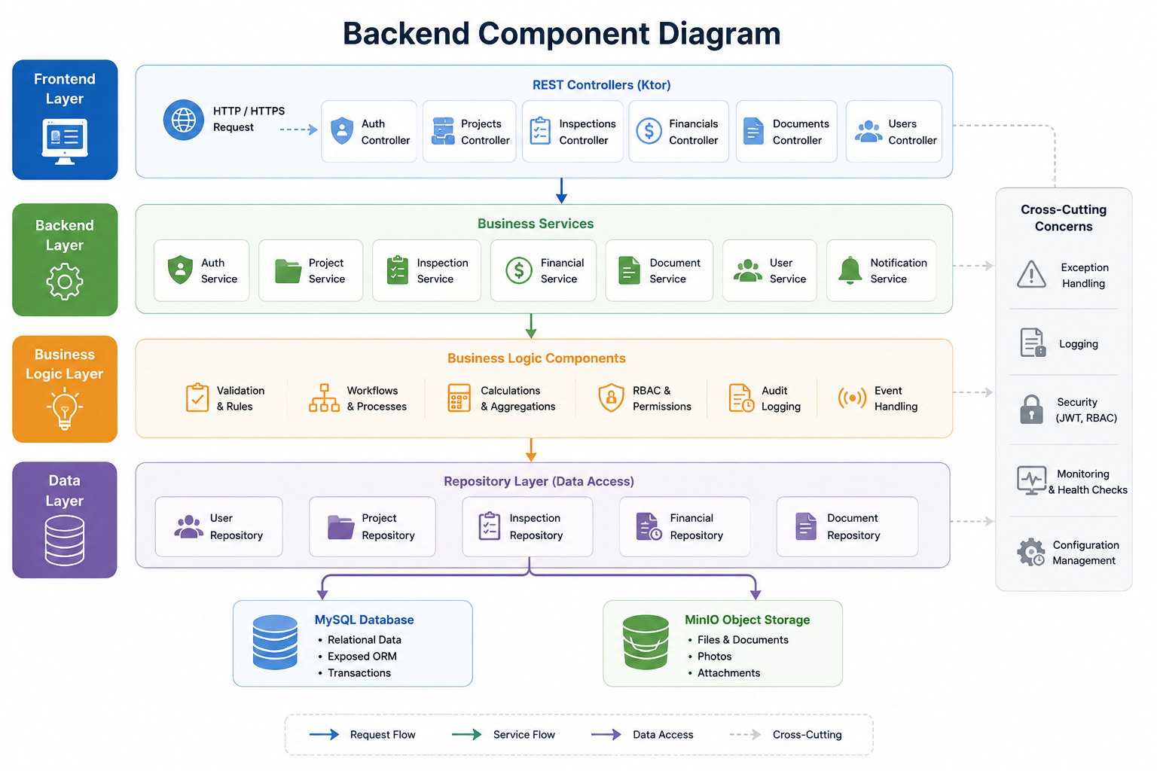
The diagram above is a target layered architecture. The delivered Phase 1 backend separates Ktor routes, business services, Exposed repositories and persistence; MySQL stores structured data and OMS_UPLOAD_DIR filesystem storage holds uploaded binary files. The depicted MinIO/notification components are future adapters, not deployed Phase 1 services.

4 Frontend Layer

4.1 UI Screen Specifications
Each screen below is described as a wireframe specification: what elements appear, their behaviour, and interaction rules.
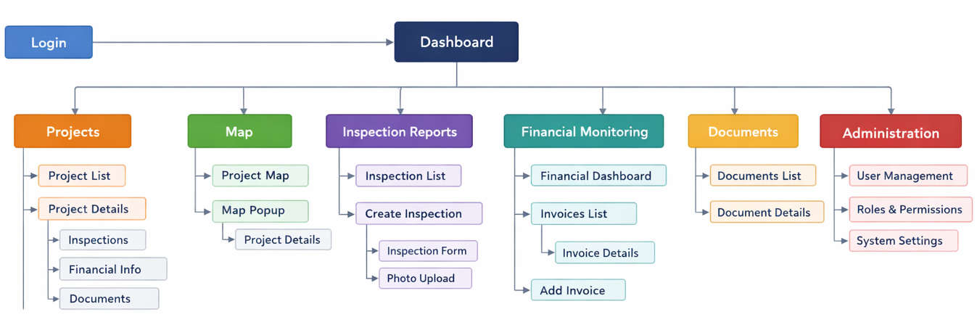

4.1.1 Login Screen
Screen: Login
First screen seen by all users. No sidebar. Centered card layout.
Logo | Organisation logo centred at top of card
Heading | "Online Monitoring System" — H1
Username or email field | Label: "Username or email". Accepts either the unique username or a valid email address. Validates that the field is not empty on blur.
Password field | Label: "Password". Input masked. Eye icon toggles visibility.
"Remember me" checkbox | Optional. Keeps session for 30 days if checked.
"Login" button | Primary CTA. Full width of form. Disabled during API call (shows spinner).
"Forgot password?" link | Below button. Navigates to /forgot-password.
Error state | Red banner above button: specific message per error type (see Section 2.1).
Lockout state | After 5 failures: banner "Account locked until HH:MM". Button disabled.
⚠ No registration link — accounts are created by Admin only.

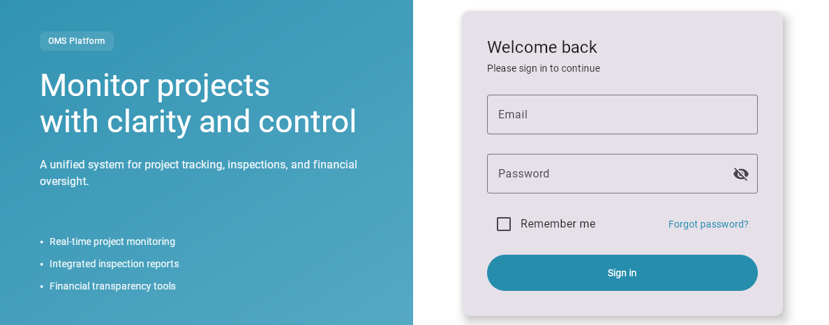

4.1.2 Dashboard
Dashboard calculation rules: the project-start chart counts subprojects by work start month. Approved funding is the subproject contract amount, falling back to its planned budget, grouped visually by oblast. Subproject completion is the sum of completed-work acts for the subproject and its parts divided by its contract amount. Monthly act payments are grouped by payment date (or act date when no payment date is recorded). The Approved Funding by Oblast chart has an EUR/UAH selector. The selected currency is shown once above the chart; bar values do not repeat a currency suffix. Both values use the frozen conversion stored with the project amount, so loading the dashboard never requests a live NBU rate.
The dashboard uses live aggregated API data and refreshes after project, report, financial-record or procurement changes. Every analytic widget has an empty state. Individual subproject funding and completion bars open the corresponding project-detail page. Recent audit activity is shown in Administration rather than on the dashboard.
Dashboard financial and procurement analytics: the dashboard presents monthly agreed-act payments in EUR, approved subproject funding by oblast, subproject completion, and the number of subprojects in each procurement status. The Financial Monitoring module additionally presents monthly payments in EUR for equipment, technical supervision, and engineer-consultant contracts. For UAH records, the EUR amount is calculated at save time as UAH divided by the official NBU EUR rate for the act date; the applied rate, its effective date and the EUR-cent amount are stored and never recalculated for historical charts.
Screen: Dashboard
Common home screen after login for every authenticated role. Provides an operational overview of projects and inspections. Sidebar visible. Responsive grid layout.
Sidebar | Left side. Items: Dashboard, Projects, Map, Inspection Reports, Financials, Documents, Administration (admin only).
Top bar | Page title left. User avatar + name right (Profile, Change Language, Logout).
Global filters | Period, Region, Sector and Project Status. Filters apply to KPI cards and charts; active filters are visible and can be cleared.
Metric cards | No standalone KPI-card strip in the current MVP. The dashboard uses live analytical cards and a last-inspection photo slider.
Attention list | Not displayed on the dashboard; recent audit activity is available in Administration.
Project chart | Monthly project-start chart: number of subprojects by work start month.
Inspection reports chart | Available on the Inspection Reports screen: monthly SIR count and monthly ESHS finding count.
Regional chart | Approved funding by oblast. Each subproject has its own shade and amount; clicking its bar opens the subproject detail.
Latest inspection photos | Horizontal slider of photos from the latest available inspection report. Click opens a fullscreen lightbox; show an empty state if no photos exist.
Recent activity | Last 10 permitted audit-log events: actor, action, related entity and relative timestamp. Each item links to the related entity when the user has access.
Financial analytics | Monthly agreed-act payments, subproject completion (acts ÷ contract amount), and procurement status by unique subproject. Widgets refresh from live API data after related mutations.
Data states | Every widget displays an empty state when no data exists. The dashboard does not contain a mini-map in the WASM MVP; the full Map screen remains separate.
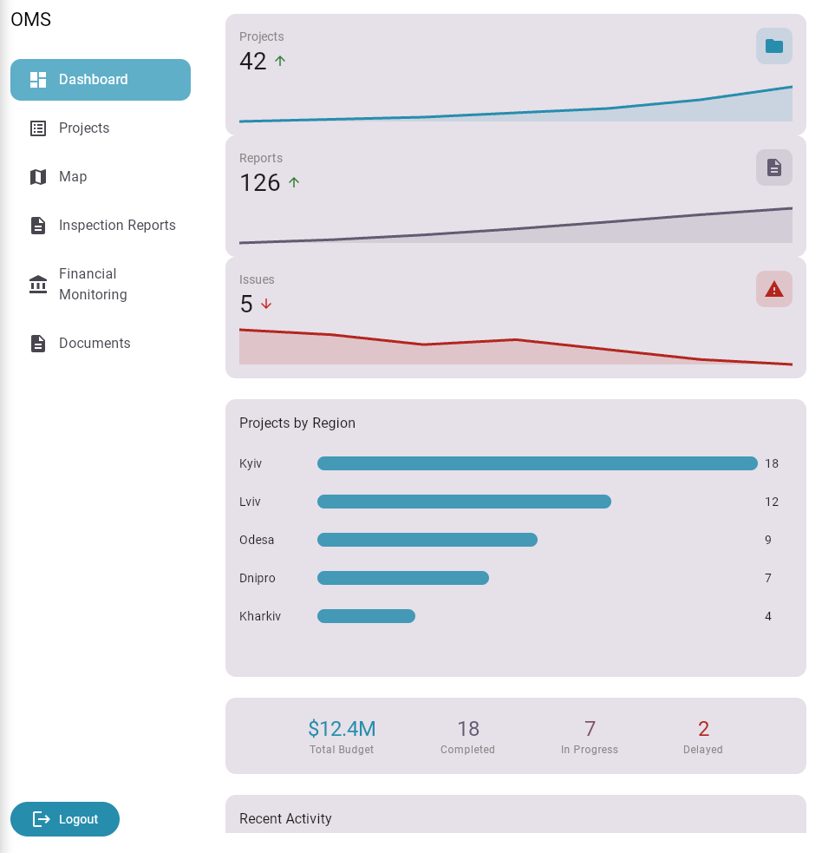

4.1.3 Projects
Screen: Projects
Purpose: Central module for managing infrastructure projects. Paginated table of all projects accessible to the current user.
Search bar | Full-width text input at top. Searches name, address, contractor. Debounced 300ms.
Filter bar | Dropdowns: Status | Region | Sector | Construction Type. Active filters shown as dismissible chips.
Sort controls | All data-column headers are clickable and sortable, including Project / Subproject ID, name, region, city, sector, status, budget, start date and contractor. The active sort column shows an arrow. The default is Project / Subproject ID ascending using natural alphanumeric ordering.
Table columns | Project / Subproject ID (business code, e.g. KH08_09 or RV09_01) | Project / Subproject name | Region | City | Sector | Status (badge) | Budget | Start Date | Contractor | Actions
Actions column | "View" button → Project Details. "Edit" (PM/admin only).
Map view toggle | Switch between table view and map view (shows same filtered set as markers).
"New Project" button | Top right. Opens project creation form. PM and Admin only.
Pagination | Bottom: rows per page selector (10/20/50) + page navigation.
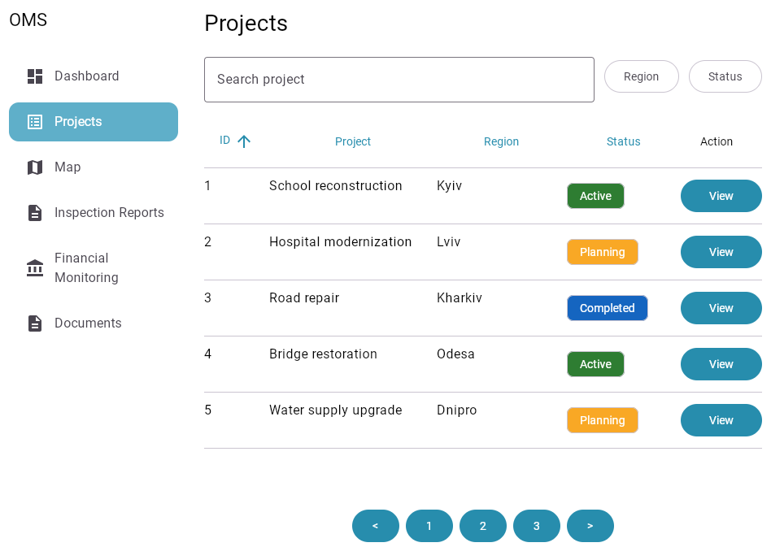

4.1.3.1 Bulk Operations
The Project and Inspection list views shall support multi-select checkboxes for the following actions:
- Bulk Status Change: Update multiple projects to 'Archived' or 'Suspended'.
- Batch Export: Generate a single PDF/XLS bundle containing selected reports or financial summaries.
- Assignment: Re-assign multiple projects to a different Project Manager in one action.

4.1.3.2 Subprojects
The system supports the ability to create subprojects (SPs), which are logical components of the main project.
Each subproject allows for the detailed structure of the project (for example: individual buildings, sites, infrastructure facilities).
Each subproject stores its contract amount (UAH), Start Date, Contract Signing Date, and Planned End Date. Contract Duration is calculated as Planned End Date minus Contract Signing Date, in days.

4.1.3.3 Project Create / Edit Contract and Currency Fields
The create and edit views use one shared field definition and three primary light-background sections with Material icons: General information, Designer information, and Construction contractor information.
Designer fields. Designer name, contract number, contract date, and a free-text design term.
Construction contractor fields. Contractor name, contract number, contract date, construction start date, planned completion date, and construction-contract amount.
Currency entry. Every monetary field independently supports EUR and UAH; EUR is the default for new values. The form displays and permits editing of the opposite-currency equivalent and the UAH-per-EUR rate.
Rate snapshot. The official NBU EUR rate for the current Kyiv date is loaded by default. The saved snapshot contains the source amount/currency, converted amount, rate, effective rate date, and a manual-edit flag. Previously saved snapshots retain their historical rate unless the user explicitly refreshes it.
Compatibility. Exact values use decimal storage. Existing whole-UAH project totals remain compatibility projections used by current aggregate calculations.

4.1.4 Project / Subproject Details
Project / Subproject Details clarification:

Project / Subproject Details also displays
Screen: Project Details
Central workspace for a single project. Contains tabbed sub-sections.
Breadcrumb | Projects > [Project Name]. Clicking "Projects" returns to list.
Project header | Project name (H1) + status badge + Edit button (PM/Admin). Below: address, sector, construction type.
Key metrics row | 5 stat cards: Construction Contract Amount | Amount under Acts of Completed Works | Financial Completion (% = Amount under Acts / Construction Contract Amount) | Engineer Consultant Contract Amount | Technical Supervision Amount. Visible to PM+ roles.
Photo slider | Horizontal carousel of photos from latest inspection. 5–7 images. Click for fullscreen lightbox. Shows "No Inspection Reports yet" if none.  The date of the last inspection is displayed above the slider.
Financials chart | Compact bar chart: monthly payment amounts. Clickable months → payment detail drawer.
Tab: General Info | All project metadata fields in 2-column layout. Map preview (200px). Contractor, Technical Supervisor and Engineer Consultant information.
Tab: Inspection Reports | The Inspection Reports (IR) tab displays a list of all inspection reports related to the selected project or subproject.  For each report, the following is displayed:  • inspection date  • status  • responsible inspector  When clicking on an entry, the user is taken to the detailed inspection report page.
Tab: Financials | The Financials tab displays all financial records associated with a project or subproject.  The user can:  • view a list of transactions/acts  • filter records  • drill down to detailed information for each record  • view financial completion against the construction contract; the percentage is calculated from acts of completed works  *Within the MVP, all financial indicators are displayed in hryvnias (UAH).  Support for multiple currencies (EUR, USD, and others) may be added in subsequent phases of system development.
Tab: Documents | The Documents tab contains all related files of a project or subproject.  The user can:  • view the list of documents  • open or download files
Tab: Incidents (HSE) | The "Incidents (HSE)" tab is designed to record and monitor incidents related to occupational health, safety and environment.  The system allows users to:  • create incident records  • classify them by severity  • add photos and documents  • view the list of incidents  • filter incidents by status, date, project
⚠ Tabs on the project / subproject page provide access to related data and system modules.
When switching between tabs, the corresponding content is dynamically loaded without reloading the page.
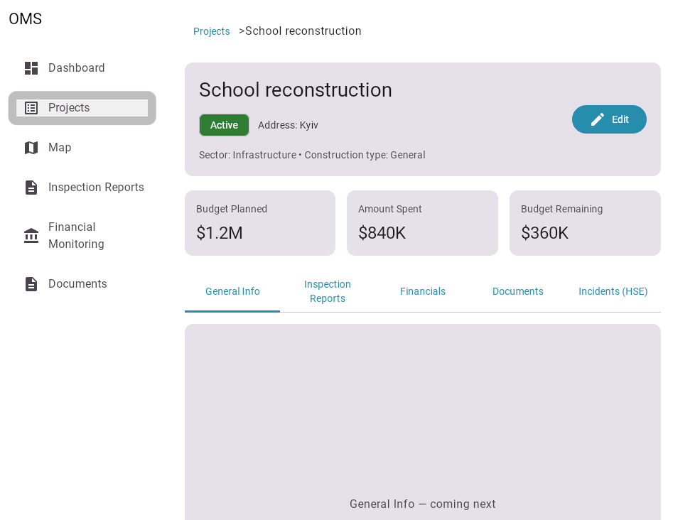

4.1.5 Inspection List
Screen: Inspection Reports
Purpose: Management of site inspection reports (SIR). List of all inspection reports for the current project.
"New Inspection" button | Top right. Inspector+ role. Opens inspection creation form.
Filter bar | Status filter: All | Draft | Pending Review | Completed.
Table columns | Report ID | Project / Subproject | Type | Inspector | Date | Status (badge) | Actions
Status badges | Draft (grey) | Pending Review (amber) | Completed (green)
Actions | "View" → opens report. "Edit" → only for Draft status and owner/admin.
Default sort | Inspection date descending (newest first).
Purpose | Management of all site inspection reports (SIR). The chart header occupies the upper part of the screen and the sortable/filterable report list follows below.
Analytics header | Two horizontal cards: Number of inspections (month → SIR count) and Number of ESHS violations (month → count of ESHS/HSE finding categories).
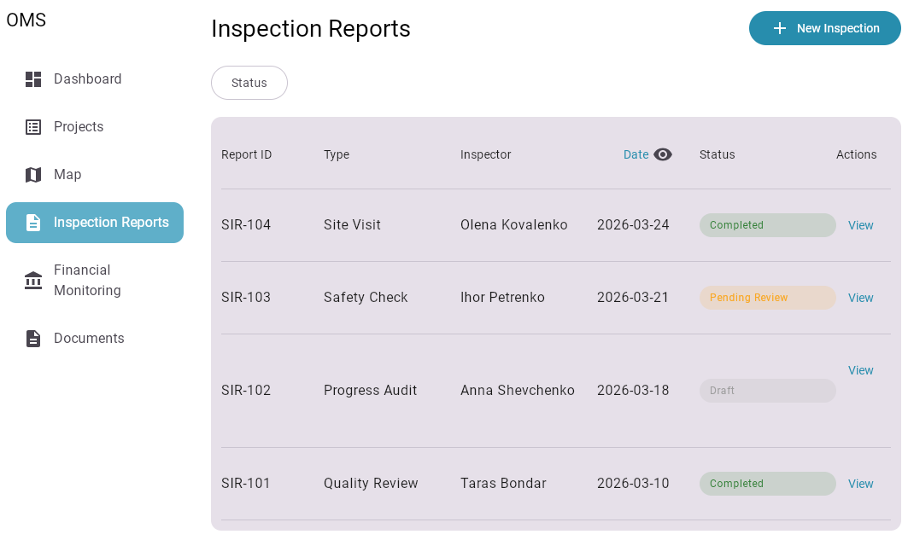

4.1.6 Create / Edit Inspection Form
Screen: Create Inspection
Form for creating or editing a site inspection report.
Inspector field | Auto-filled from current user profile. Read-only for non-admin.
Date field | Date picker. Defaults to today. Cannot be a future date.
Inspection type | Dropdown: Planned | Unplanned | DLP.
GPS coordinates | Future mobile: device GPS. Delivered Web: optional manual entry or map pin. Shows accuracy warning if > 50m or has been entered and saved in advance.
Comments | Textarea. Max 2000 characters. Counter shown.
Photo upload area | Drag-and-drop/file picker in the delivered Web client. Future mobile may use camera/gallery. Shows thumbnail previews. Delete X on each thumbnail. Max 30 photos, 10MB each, JPEG/PNG only.
"Download SIR in XLS format" button | The system supports the ability to upload an inspection report (SIR) in XLS / XLSX format  The user can import a pre-prepared report template filled out outside the system.  During upload, the system:  • checks the file format  • validates required fields  • displays error messages in case of incorrect format or missing required data  • automatically fills in the appropriate fields of the digital form  After successful import, the user can view and edit the data before saving.
"Save Draft" button | Saving a draft is performed locally within the current user session and does not provide full offline synchronization.  Full offline support with data synchronization between the device and the server is included in Phase 2.
"Submit Report" button | Primary action. Triggers status → Pending Review. Confirms before submit: "Submit this report for review?". The system changes the status of the report and makes it available for review by the project manager.  Automatic user notifications are not included in the current MVP scope and can be implemented in subsequent stages..
Rejected state | If report was rejected: amber banner with rejection reason. All fields editable again.
⚠ Report ID is generated server-side on first save. Not shown during draft creation.
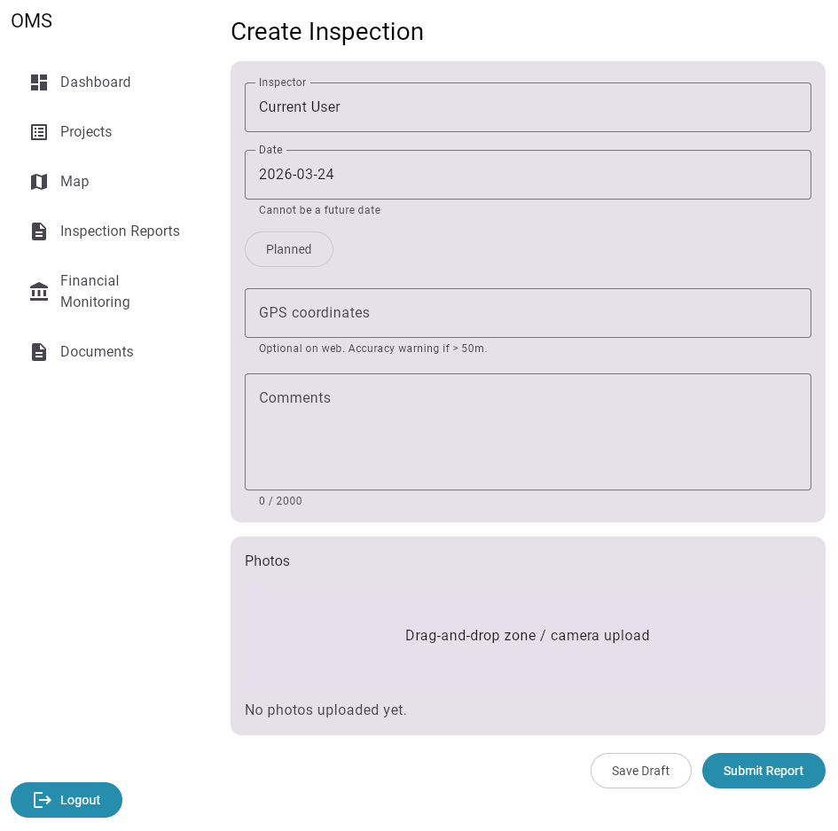
Example of “SITE INSPECTION REPORT”:
https://docs.google.com/spreadsheets/d/1TpJKcD5vtw9eUbKgn7eI0--xoy_0Hb0s/
United Nations Development Programme (UNDP)
SITE INSPECTION REPORT
CONTRACTOR |  |  |  | SITE / SITE # |  |  |  | DATE
LLC"Avega" |  |  |  | Kyiv region,  SP 28-32-8, Borodyanka, Semashka str., 3. |  |  |  | 04.11.2025
CONTRACTOR'S REPRESENTATIVE |  |  |  | M4H QA STAFF |  |  |  | MCTD / MOH REPRESENTATIVE
- |  |  |  | 1 |  |  |  | 1
SKILLED LABOR |  | UNSKILLED LABOR |  | MANAGEMENT ON SITE |  |  |  | WEATHER CONDITIONS
3 |  | 8 |  | 2 |  |  |  | rainy, +10*С
ONGOING ACTIVITIES
BLOCK / LOCATION |  | DESCRIPTION OF WORK (PER BOQ ITEM) |  |  |  |  | PER SCHEDULE? |  | REMARKS
indoor |  | Water supply system installation. |  |  |  |  | yes
 |  | Heating system installation. |  |  |  |  | yes
 |  | Electrical system installation. |  |  |  |  | no
 |  | Sewerage system installation. |  |  |  |  | yes
outdoor |  | Roof installation. |  |  |  |  | no
 |  | Walls insulation. |  |  |  |  | no
OBSERVANCES ON ONGOING ACTIVITIES
Installation of cold and hot water supply pipes in insulation tubes.
Installation heating system pipes in insulation tubes.
Heating radiators installation with thermostatic valves.
Installation of electrical cables in corrugated pipe.
Junction boxes installation.
Installation of wooden elements of the roof frame.
Installation of insulation mineral wool plates on the wall along axes A and 4.
IHP equpment installation.
OBSERVANCES ON HEALTH & SAFETY
 |  |  |  |  |  |  | YES/NO |  | COMMENTS
All workers wear PPE equipment as relevant.
The fire shield / firefighting equipment is present at site.
The site is appropriately fenced.
There is lavatories on the site.
There are safety briefing logs.
Safety information plate is in tact.
Scaffolding equipment have not secuerily base. |  |  |  |  |  |  |  |  | must be made and installed in accordance with clause 7.3 of DBN A.3.2-2-2009.
IC drew attantion on the using temporary wiring on the site.
NARRATIVE ASSESSMENT - COMMENTS ON QUALITY
WORK |  | COMMENTS ON QUALITY |  |  |  | RECTIFICATION REMARKS (NNC / NTC) |  |  | STATUS OF RECTIFICATION
PURCHASED MATERIALS
MATERIALS AND EQUIPMENT |  | CHARACTERISTICS |  |  |  | PER DED? (yes/no) |  |  | NOTES
Plaster |  | Ceresit CT29 |  |  |  | yes
NARRATIVE ASSESSMENT - COMMENTS ON PROGRESS |  |  |  |  |  |  |  |  | SCHEDULE REVISION REMARKS
Construction works is carried out slightly behind the Schedule. |  |  |  |  |  |  |  |  | IC recommends increasing the quantity of workers, especially skilled labor to keep up with the Schedule.
M4H QA STAFF
NAME |  |  | TITLE |  | DATE |  | SIGNATURE
Pawel Neugebauer |  |  | TL IC MCTD |  | 04.11.2025
Report can be filled in electronically, no signature needed. |  |  |  |  |  |  |  |  |  | END OF REPORT

SIR. Page 1
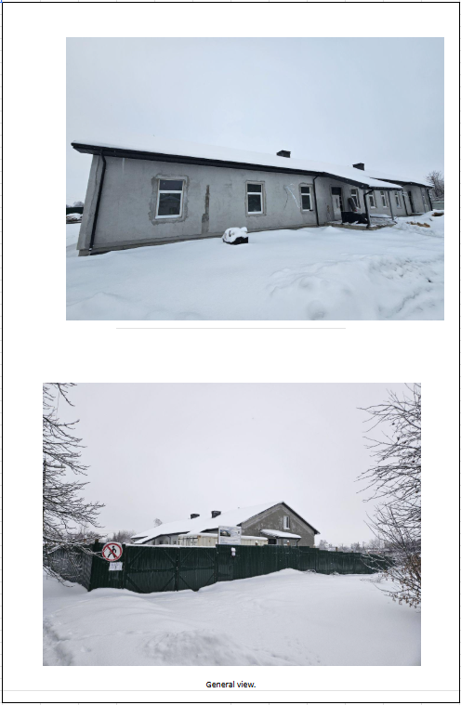

SIR. Page 2. Photo Attachment

4.1.7 Financials Tab
Screen: Financials Tab
Purpose: Tracking and managing project financial data.
Financial records and budget summary for a project. Visible to PM+ roles only.
Budget summary bar | Horizontal progress bar: amount under acts of completed works (green fill) / remaining construction contract amount (grey fill). Shows values and financial-completion percentage (acts ÷ construction contract amount). *Within the MVP, all financial indicators are displayed in hryvnias (UAH).  Support for multiple currencies (EUR, USD, and others) may be added in subsequent phases of system development.
Chart: monthly payments | Bar chart of payments and advances by month. Values are EUR equivalents stored with each financial record at save time.
Filter bar | Record Type (all/invoice/act/payment/advance) | Date range picker.
Table columns | Project / Subproject | Contract | Invoice No. | Type | Date | Payment Date | Amount | Currency | Milestone | Actions
"Add Record" button | Opens a light, scrollable editor (PM/Admin only). Saving a UAH record retrieves the official NBU EUR rate for its record date and stores the EUR equivalent, rate and rate date.
"Import XLS" button | Opens file picker. XLS/XLSX imports and exports support the optional payment_purpose column (works|equipment); omitted values default to works.
Export button | "Export to Excel" → downloads filtered records as .xlsx.
No access state | Viewers and Inspectors see: "Financial data is restricted. Contact your Project Manager."
Chart: equipment procurement | Bar chart of payments and advances with payment_purpose=equipment, grouped by month and displayed in EUR.
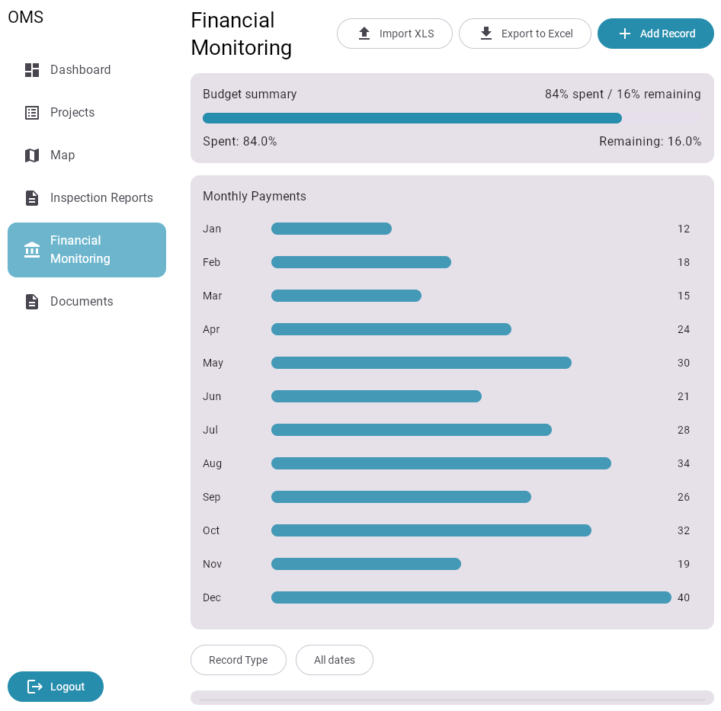

4.1.8 Documents Tab
Document types use color-coded chips in the table. Available filter tabs: All | Contract | Project / Subproject | Design | Estimate | Financial Doc (Invoice, Act) | Photo.
Document actions use accessible Material icons: Open and Delete. Deletion remains subject to the current user role.
Screen: Documents Tab
Purpose: Centralised storage and management of project-related files.
Document repository for the project.
Type filter tabs | All | Contract | Project / Subproject | Design | Estimate | Financial Doc (invoice, act) | Photo
Search | Searches filename and description.
Document list | Icon (by MIME type) | Filename | Type | Uploaded by | Date | Size | Actions
Actions | "Download" (all roles) | "Delete" (PM/Admin only)
"Upload Document" button | Opens upload drawer: file picker + type selector + optional description. Validates format and size.
Empty state | "No documents uploaded yet. Click Upload Document to add the first one."
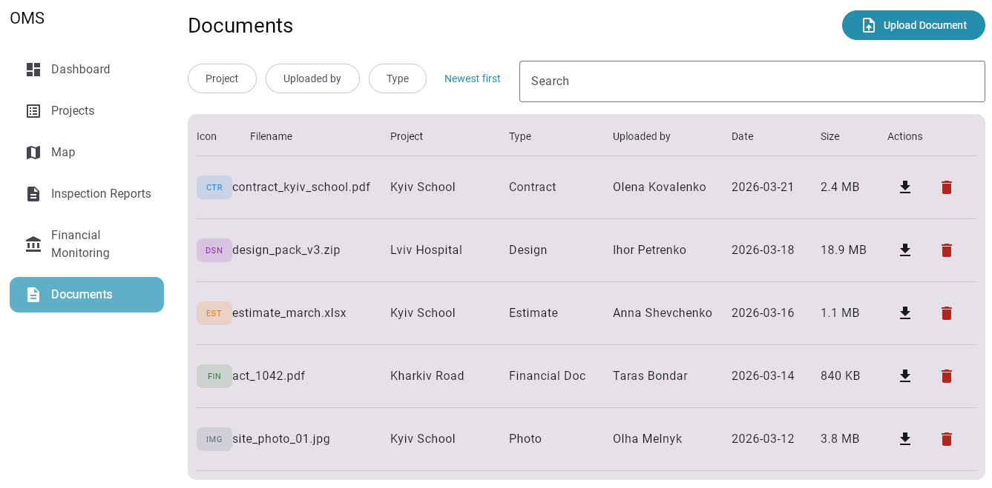

4.1.9 Map Screen
Screen: Interactive Map
Purpose: Geospatial visualization of all accessible projects.
Full-page map view. All accessible projects displayed as markers.
Map area | Full available height. Leaflet map with OpenStreetMap tiles. Zoom controls top-left.
Search bar (map) | Overlaid top-centre. Searches address or city name. Pan map to result.
Status filter | Overlaid top-right. Checkboxes for each status. Controls marker visibility.
Markers | Colour-coded by status. Clustered when zoomed out. Click cluster → zoom in.
Marker popup | Thumbnail | Project name | Address | Status badge | Completion % | "View Details" button.
Legend | Small overlay bottom-right: colour → status label.
My location button | Future mobile only; not implemented in Phase 1.

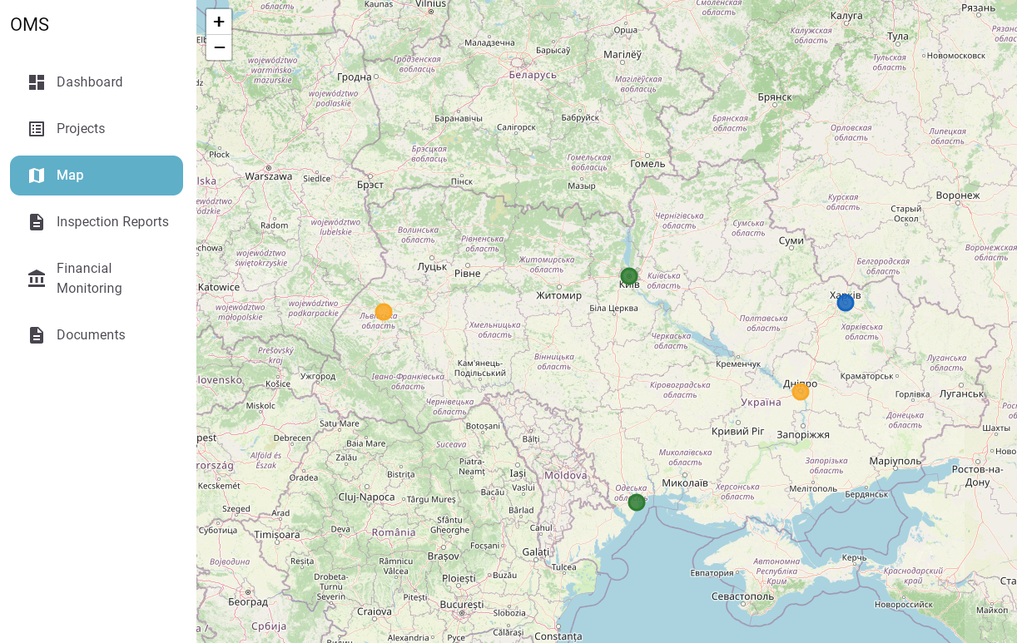

4.1.10 Administration — User Management
Screen: User Management (Admin only)
Purpose: System-level configuration and user management.
Create and manage all system user accounts.
User table | Name | Email | Role (badge) | Region | Status (badge) | Last Login | Actions
Status badges | Pending (grey) | Active (green) | Disabled (red)
Actions | "Edit" | "Disable" (cannot disable yourself) | "Resend activation email" (Pending users only)
"New User" button | Opens creation form: First Name, Last Name, Email, Role, Region, Department.
New user flow | After creation: system sends activation email. User status = Pending until first login.
Role filter | Filter table by role.
Search | Searches name and email.
⚠ Admins cannot delete users — only disable. Audit log records all user management actions.
The Administration screen displays a sortable table of all users (ID, login, email, role). Administrators can edit user data, change roles and reset a password without exposing the existing password. Roles are shown as color-coded chips; table actions use Material icons with accessible labels.

4.1.11 Notifications Panel
This module is not part of the current implementation phase.
It is documented here for roadmap visibility and future expansion.
Screen: Notifications Panel
Slide-in panel from top-right (bell icon in top bar). Available on all screens.
Bell icon | Top bar. Shows red badge with unread count (max 99+).
Panel header | "Notifications" title + "Mark all as read" button.
Notification item | Icon (by type) | Title (bold if unread) | Body text | Relative timestamp (e.g. "2 hours ago") | Action link.
Unread indicator | Blue dot on left of unread notifications.
Empty state | "No notifications yet."
Click behaviour | Clicking a notification marks it as read and navigates to action_url.
"View all" link | Bottom of panel. Opens full notifications page with history.

5 Business Logic and Application Workflows

5.1 User Flows
This section describes the primary end-to-end interaction scenarios within the system. These flows define how users interact with modules to accomplish business tasks.

5.1.1 Authentication Flow
Sequence:
- User opens Login screen
- Enters username or email and password
- System validates credentials
- On success → Dashboard
- On failure → error message
Error Handling:
- Empty or invalid username/email → validation error
- Wrong password → authentication error
- 5 failed attempts → account lock (temporary)
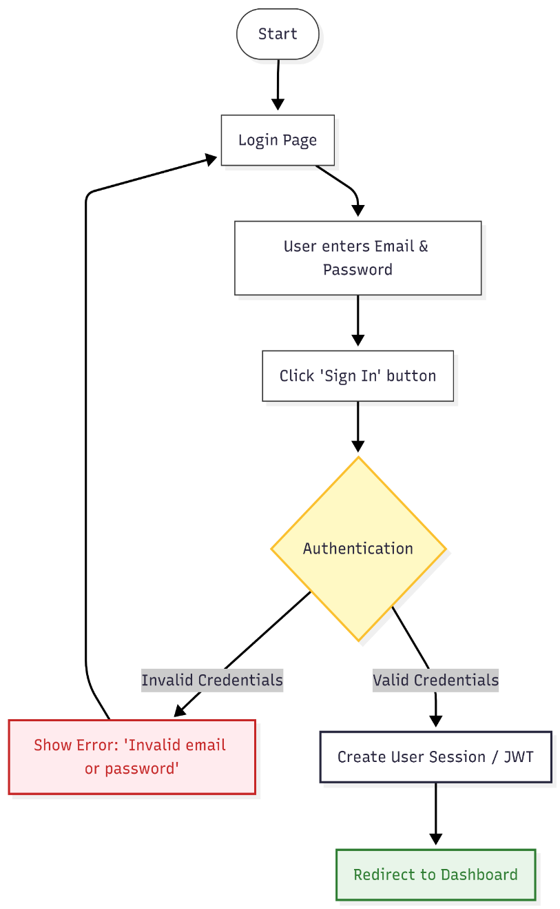

5.1.2 Project Management Flow
Sequence:
- User opens Projects
- Applies filters / search
- Selects project
- Opens Project Details
Navigation:
- Breadcrumbs allow return to Projects
Optional Actions:
- Edit project (PM/Admin)
- Change project status
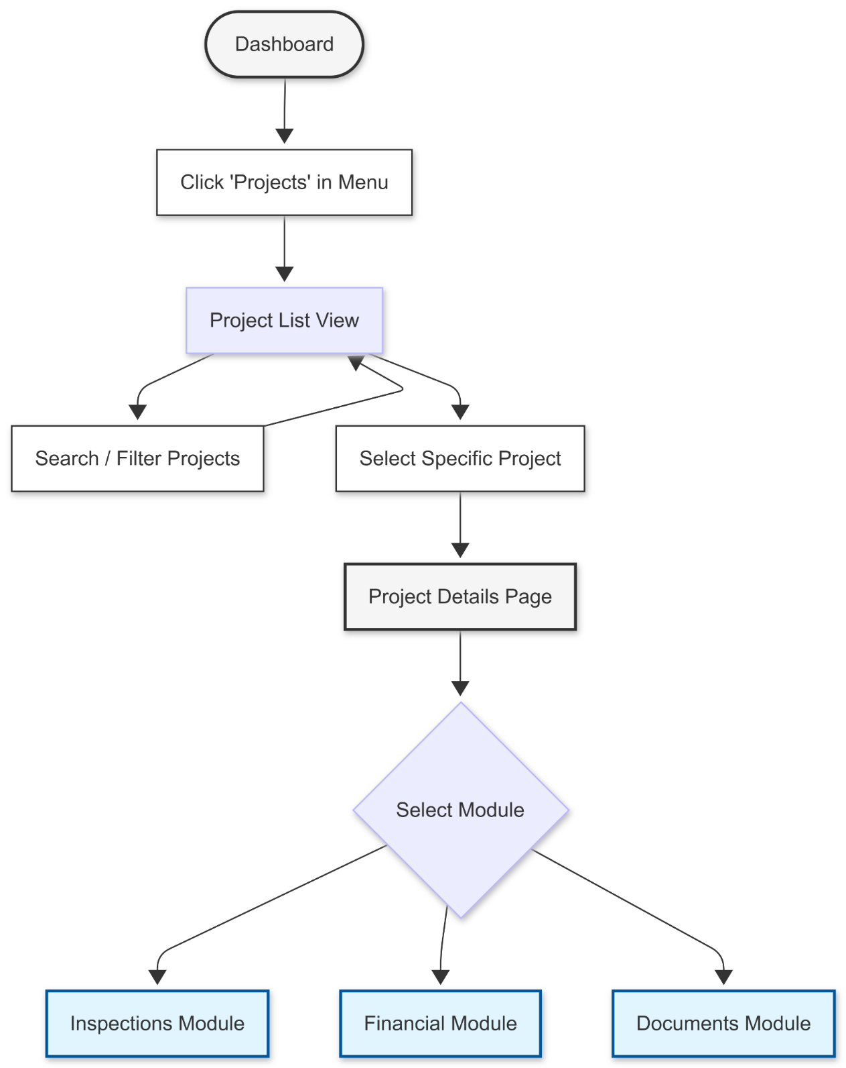

5.1.3 Map Interaction Flow
Sequence:
- User opens Map screen
- System loads markers via API
- User zooms / pans map
- User clicks marker
- Popup appears with project preview
- User clicks “View Details”
- System navigates to Project Details
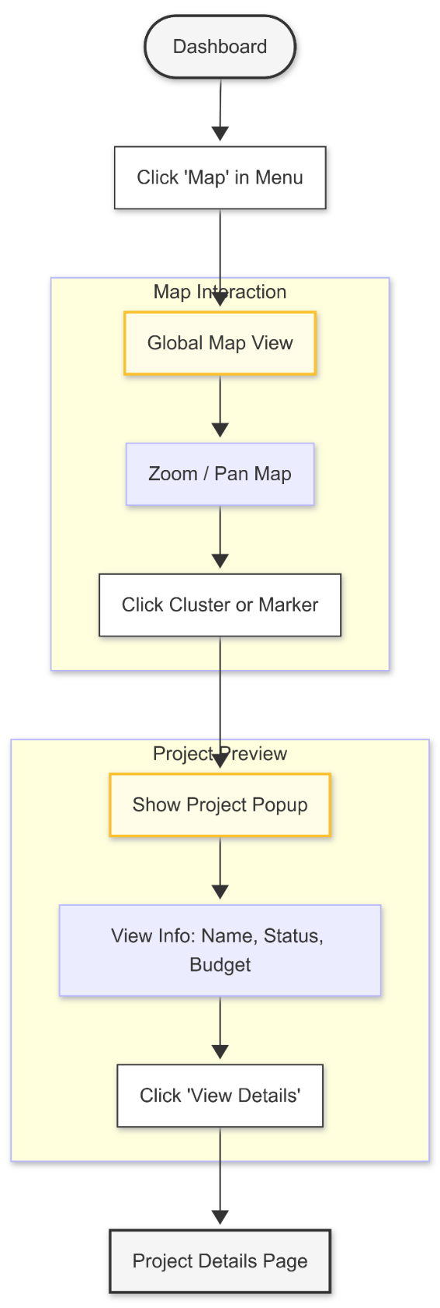

5.1.4 Inspection Workflow
Sequence:
- Inspector opens project
- Navigates to Inspection Reports tab
- Clicks “New Inspection”
- Fills form and uploads photos
- Saves Draft or submits report
State Transitions:
- Draft → Pending Review (on submit)
- Pending Review → Completed (approval)
- Pending Review → Draft (rejection)
Roles:
- Inspector → creates
- Project Manager → reviews
- Admin → override
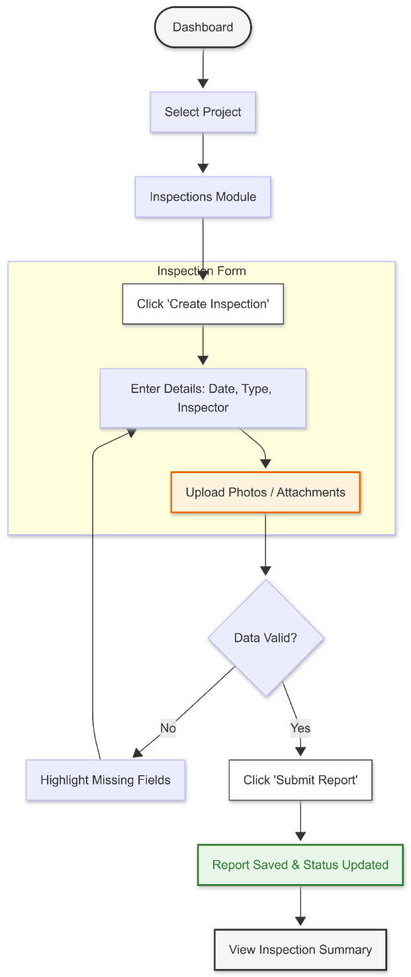

5.1.5 Financials Workflow
Sequence:
- Project Manager opens Financials tab
- Adds financials OR imports XLS
- System validates data
- Record stored and linked to project
- Financial summary updated
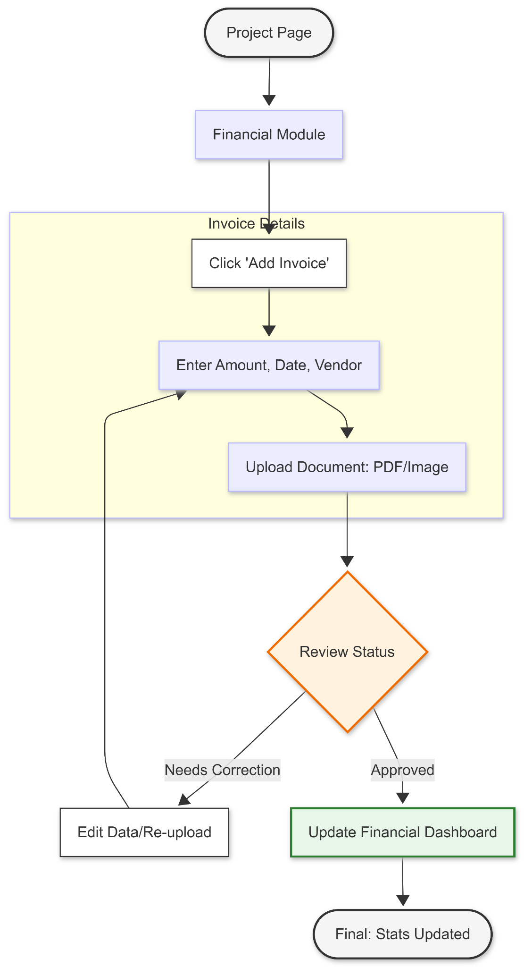

5.1.6 Document Management Flow
Sequence:
- User opens Documents tab
- Uploads file
- Selects document type
- File stored in OMS_UPLOAD_DIR filesystem storage (Phase 1)
- File becomes available for download

5.1.7 Notification Flow
Trigger Events:
- Inspection submitted
- Inspection approved/rejected
- User created
- Password reset
Sequence:
- Event occurs in system
- Notification generated
- Delivered via configured channels:
  - Email
  - In-app
  - Push (future Phase 2 mobile)
- User interacts with notification → navigates to related entity

5.2 User Administration
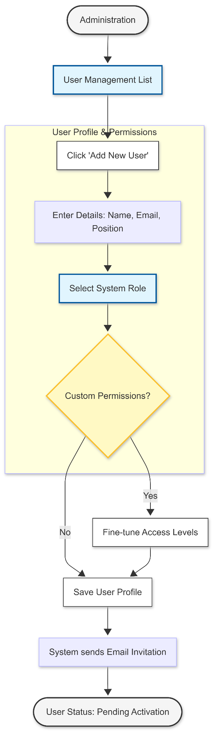

5.2.1 User Creation
- Profile: first name, last name, unique username, unique contact email, position, and link to region/department. A user may authenticate with either username or email.
- Activation: after creation, the user receives an email with a temporary link to set a password. Until the first login, the user status is Pending.
Status | Description
Pending | User account created but password not set yet
Active | User account is active and allowed to access the system
Disabled | User account access is blocked by the administrator

5.2.2 Roles & Permissions
Database role codes are ADMIN, PROJECT_MANAGER, INSPECTOR, CONTRACTOR and VIEWER. V30 removes the former GUEST database role and migrates any historical Guest accounts to VIEWER. Guest access is an anonymous session mode, not a users-table record, and is never assignable in user administration.
Every authenticated user has exactly one database role. Phase 1 roles are Admin, Project Manager, Inspector and Viewer; the legacy Contractor role is retained for compatibility. An anonymous Guest session has no user record and is outside the RBAC role list.
The system must support RBAC (Role-Based Access Control). Main roles:
Access scope: Administrators may access all projects. Project Managers may access and manage only projects assigned to them and cannot access Administration or manage users.
Inspection workflow: Admin, Project Manager and Inspector may create and edit draft reports. A completed report is locked for all mutations; only Admin and Project Manager may review a submitted report.
Guest access: the login page offers Continue as Guest. It creates an anonymous, read-only browser session without credentials. Guests may view the public map, project registry and general project information only; they cannot access dashboard, inspection reports, documents, financials, procurement, administration or any mutation.
Role | Access rights
Admin | Full access to all projects, finances, and system settings.
Project Manager | Manage all projects, reports, documents and financial data. No access to the Administration page or user management.
Inspector | Create and edit own inspection reports in any status; view projects and documents. All changes are recorded in the audit log.
Viewer | Read-only without the ability to make changes.
Guest | Anonymous browser session, not a user role or account. View-only access to the public map, project registry and general project information.

5.2.3 Role-Based Access Control (RBAC) Matrix
Below is a table of rights for the system's main modules.

Module / Screen | Guest | Viewer | Inspector | Project Manager | Admin
Login Page | View | View | View | View | View
Dashboard (General Stats) | — | View | View | View | View
Map (Public Projects) | View | View | View | View | View
Projects | View | View | View | View | View
Project Details | View | View | View | Full Access | Full Access
Inspection Reports (View List) | — | View | View | View | View
Inspection Reports (Create/Edit) | — | — | Create/Edit own (any status) | Full Access | Full Access
Financials (View Stats) | — | — | — | View | View
Financials (Add Invoice) | — | — | — | Full Access | Full Access
Documents (Download) | — | View | View | Full Access | Full Access
User Management | — | — | — | — | Full Access
System Settings | — | — | — | — | Full Access

5.2.4 RBAC Enforcement
Private-read enforcement: dashboard, inspection reports, documents, financials, procurement and audit activity require an authenticated active user account and the module permission stated in the RBAC matrix. Anonymous Guest sessions are restricted server-side to public map and project-information endpoints. Viewer has only the read permissions explicitly granted by each endpoint.
Inspection workflow enforcement: report and finding mutations require Admin, Project Manager or Inspector; completed reports cannot be changed. Review requires Admin or Project Manager. Project Manager project assignment is checked server-side for all project-scoped operations.
Audit enforcement: the server records implemented administrative and domain mutations, including user creation, role/status changes, activation and relevant project/report operations. Records do not contain passwords, JWTs or raw activation tokens.
RBAC is enforced at the backend API layer.
Implementation rules:
- Each endpoint declares required roles
- Middleware validates JWT and user role before request processing
- Project-level access is restricted:
  - Project Managers and Administrators can access all projects. Project Managers have no access to user management or the Administration page.
  - Admin has unrestricted access
- All permission violations return HTTP 403 (FORBIDDEN)

A simplified Use case diagram would look like this.
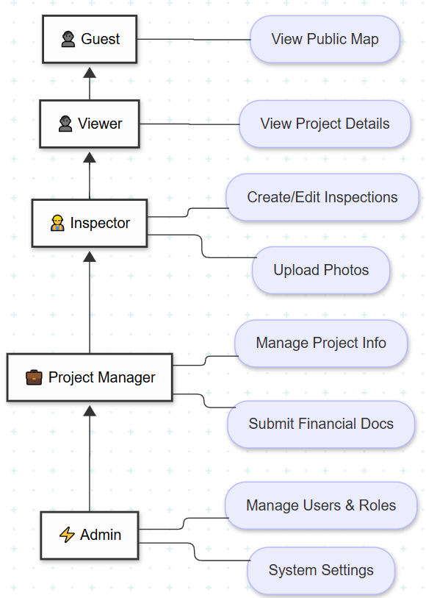

6 Technical Architecture, Infrastructure and Deployment

6.1 Overall System Architecture (Target / Reference)
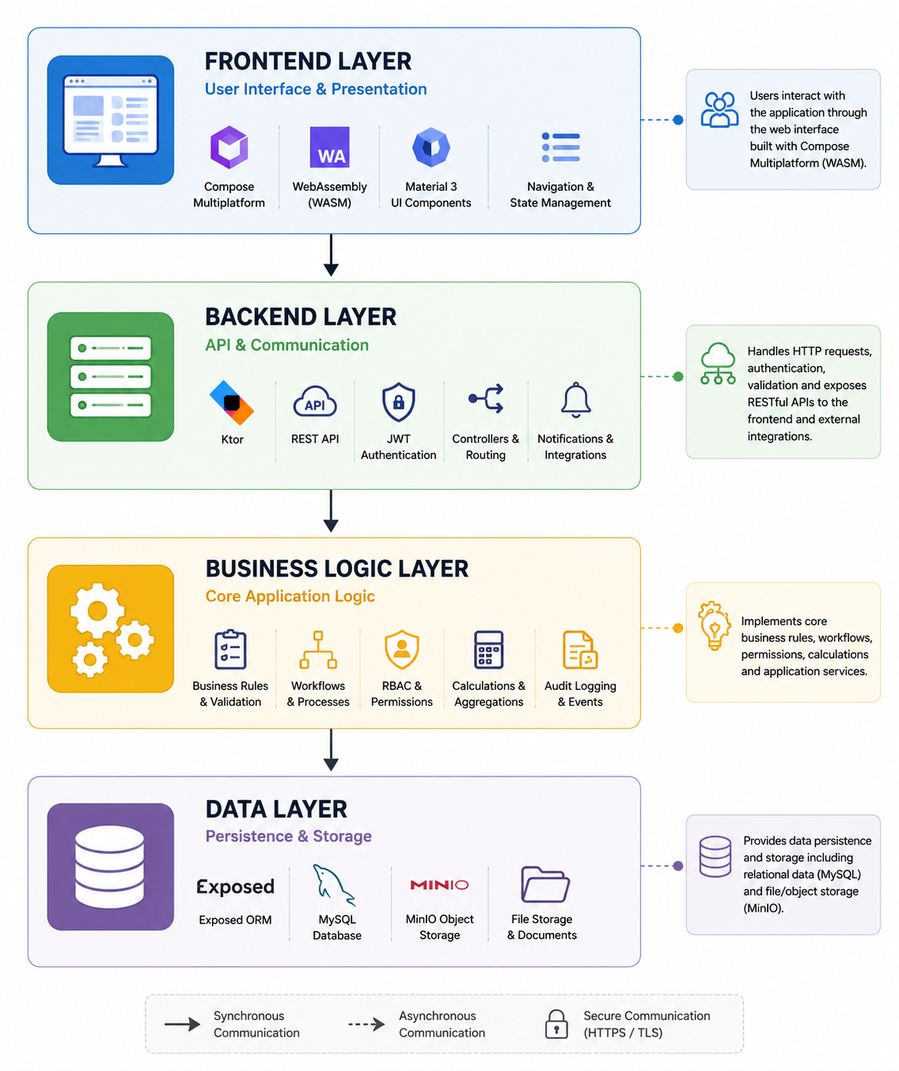
The diagram above is a target/reference architecture. The delivered Phase 1 runtime uses the Web client, Ktor, MySQL and filesystem-backed OMS_UPLOAD_DIR storage. MinIO, notification integrations and mobile components shown in legacy/reference diagrams are future adapters unless an implementation addendum explicitly states otherwise.
The OMS architecture is organised into four major architectural layers, each of which is described in detail in the following sections of this specification.
Specification Layer | Main Components
Frontend Layer | Compose Multiplatform, WebAssembly, Material 3 UI, Navigation, Localization
Backend Layer | Ktor, REST API, JWT Authentication, Controllers, Notifications, External Integrations
Business Logic | RBAC, Validation, Workflows, Calculations, Audit Logging
Data Layer | Exposed ORM, MySQL Database, Filesystem Upload Storage (MVP)

All communication between the client application and backend services is performed over HTTPS using REST APIs with JSON payloads.
The architecture has been designed to support future extensions, including mobile applications, external integrations, notification services, offline synchronization, and advanced analytics without requiring major architectural refactoring.

6.2 Technology Stack
The OMS MVP is implemented using modern, open-source technologies that provide long-term support, high maintainability, and cross-platform compatibility.
Frontend
- Kotlin Multiplatform
- Compose Multiplatform
- WebAssembly (Wasm)
- Material 3
- Kotlin Coroutines
- kotlinx.serialization
Backend
- Kotlin
- Ktor
- Exposed ORM
- JWT Authentication
- REST API
- Kotlin Coroutines
Database
- MySQL 8.x
File Storage
- Filesystem storage via OMS_UPLOAD_DIR (Phase 1); MinIO/S3 adapter is future Phase 2
Build System
- Gradle Kotlin DSL
Version Control
- Git
Target Platforms
- Web (MVP)
- Android (Phase 2)
- iOS (Phase 2)
The selected technology stack enables maximum code reuse between supported platforms while minimizing maintenance costs and ensuring long-term sustainability.

6.3 Development Environment
The development environment has been standardized to ensure consistent builds, simplify onboarding, and reduce environment-specific issues during development.
Development IDE
- IntelliJ IDEA Ultimate (recommended)
Programming Language
- Kotlin
Java Runtime
- OpenJDK 21 or newer (LTS version recommended)
Build System
- Gradle Kotlin DSL
Source Code Repository
- Git
Database
- MySQL 8.x
File Storage
- Filesystem upload directory (OMS_UPLOAD_DIR)
Local Development
Developers run the Web frontend, Ktor backend and MySQL database locally or through Docker Compose. Upload storage is an automatically created filesystem directory or Compose volume. MinIO is not a Phase 1 prerequisite. Configuration parameters are externalized through environment variables and application configuration.

6.4 Deployment Environment
The OMS MVP is deployed within the Customer's existing on-premises infrastructure currently hosting the legacy OMS system. The deployment architecture is designed to minimize infrastructure changes while allowing future scalability and maintainability.
The production environment consists of:
- Linux-based application server;
- MySQL database server;
- Filesystem-backed upload storage on a persistent application volume for the approved MVP; MinIO/S3-compatible object storage remains a future scalable option.
- Deployment secrets, including database passwords and the JWT signing secret, shall be injected through the deployment environment and must not be committed. The application service shall wait for database health, run ordered Flyway migrations at startup, and expose health checks for operational verification.
- Nginx reverse proxy with HTTPS termination;
- Automated backup procedures.
At the current stage, cloud infrastructure (Microsoft Azure, AWS, Google Cloud Platform, etc.) is not required. However, the application architecture remains cloud-ready and may be migrated to cloud infrastructure in future project phases without significant architectural changes.
The deployment process shall support separate Development, Test, and Production environments whenever infrastructure resources allow.

6.5 Server Requirements
The following hardware configuration is considered sufficient for the expected MVP workload.
Component | Recommended
CPU | 4 vCPU or higher
Memory | 8 GB RAM minimum (16 GB recommended)
Storage | 100 GB SSD or higher
Database | MySQL 8.x
Upload Storage | Filesystem volume (OMS_UPLOAD_DIR); future MinIO/S3 adapter
Operating System | Ubuntu Server 24.04 LTS (or compatible Linux distribution)
Java Runtime | OpenJDK 21 LTS or newer
Reverse Proxy | Nginx

The proposed configuration supports the expected operational workload and may be adjusted based on future performance monitoring and system growth.

6.6 Managed Services
The MVP deployment is based entirely on self-managed infrastructure operated by the Customer.
The following managed cloud services are not planned for Phase 1:
- managed databases;
- managed object storage;
- managed Kubernetes;
- managed monitoring platforms;
- cloud identity providers.
All infrastructure components remain fully under Customer control.
The application architecture does not depend on vendor-specific cloud services and therefore remains portable between on-premises and cloud environments.

6.7 Network Architecture
OMS follows a standard three-tier secure network architecture designed according to security best practices.
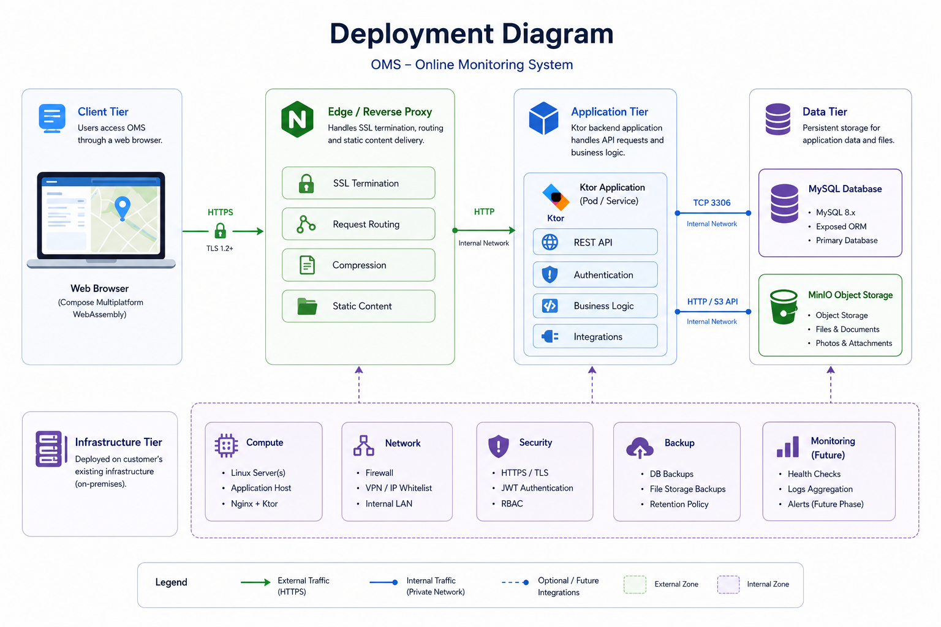
The network architecture includes:
- secure HTTPS access using TLS encryption (port 443);
- reverse proxy (Nginx) responsible for SSL termination and request routing;
- isolated backend application server;
- database server accessible only from the application server;
- The filesystem upload volume is accessible only to the backend service; clients download through authorized API routes.
- restricted administrative access using VPN and/or IP whitelisting;
- firewall configured to expose only required public services.
All communication between system components shall occur over secured internal network connections.
Direct client access to the database or upload storage is not permitted.

6.8 Responsibilities
- Infrastructure ownership and operational administration remain the responsibility of the Customer.
- The Development Team is responsible for:
- application development;
- source code delivery;
- database schema delivery;
- deployment documentation;
- installation instructions;
- technical support during deployment;
- correction of software defects within the agreed support period.
- The Customer is responsible for:
- server provisioning;
- operating system administration;
- database administration;
- network configuration;
- SSL certificates;
- backup infrastructure;
- disaster recovery infrastructure;
- user administration after Go-Live.

6.9 Project Structure
The OMS project follows a modular Kotlin Multiplatform structure that separates the frontend application, backend services, and shared code into independent Gradle modules. This modular organization improves maintainability, enables code reuse across platforms, and simplifies future system expansion.
The top-level project structure is illustrated below.
OMS/
├── composeApp/ Web frontend (Compose Multiplatform)
├── server/ Backend application (Ktor)
├── shared/ Shared multiplatform code
├── gradle/ Gradle Wrapper and build configuration
├── docs/ Project documentation (optional)
├── build.gradle.kts
├── settings.gradle.kts
└── gradle.properties
composeApp
Contains the Web user interface implemented using Kotlin Multiplatform and Compose Multiplatform (WebAssembly).
Main responsibilities include:
- user interface components;
- navigation;
- application state management;
- localization resources;
- client-side validation;
- communication with the backend REST API.
Typical structure:
composeApp/
└── src/
├── webMain/
│ ├── kotlin/
│ ├── resources/
│ └── composeResources/
└── webTest/

server
Contains the backend application implemented using the Ktor framework.
Main responsibilities include:
- REST API;
- authentication and authorization;
- business services;
- database access;
- file management;
- integrations;
- application configuration.
Typical structure:
server/
└── src/
├── main/
│ ├── kotlin/
│ └── resources/
│ └── db/
│ └── migration/
└── test/

shared
Contains common Kotlin Multiplatform code shared between frontend and future mobile applications.
The shared module is intended for reusable components, including:
- common data models (DTOs);
- serialization classes;
- validation rules;
- utility functions;
- shared business objects;
- constants and enumerations.
Typical structure:
shared/
└── src/
├── commonMain/
├── commonTest/
├── wasmJsMain/
├── jsMain/
└── jvmMain/

Build Configuration
Project build configuration is managed using Gradle Kotlin DSL.
The root project contains:
- build.gradle.kts – root build configuration;
- settings.gradle.kts – Gradle project structure;
- gradle.properties – common project settings;
- gradle/ – Gradle Wrapper.

Design Principles
The project structure follows the following principles:
- clear separation between frontend, backend, and shared code;
- independent Gradle modules;
- maximum code reuse through Kotlin Multiplatform;
- platform-independent shared models;
- modular architecture supporting future system extensions.

6.10 Configuration Management
The OMS application uses externalized configuration to simplify deployment across multiple environments and to ensure that sensitive information is not embedded within the application source code.
Configuration values are stored separately from the application binaries and are loaded during application startup.
The following configuration categories are supported:
- application settings;
- database connection parameters;
- JWT authentication settings;
- SMTP server configuration;
- filesystem upload location (OMS_UPLOAD_DIR); future object-storage adapter configuration when implemented;
- logging configuration;
- deployment environment settings.
Sensitive information, including passwords, access keys, and secret tokens, shall never be hardcoded within the source code repository.
The application supports environment-specific configuration for Development, Test, and Production deployments.
Typical configuration sources include:
- application.yaml;
- environment variables;
- deployment-specific configuration files.
This approach simplifies deployment, improves security, and minimizes configuration changes between environments.

6.11 Dependency Management
The OMS project uses Gradle Kotlin DSL for dependency management and project build automation.
External libraries and framework versions are centrally managed using Gradle Version Catalog (libs.versions.toml), ensuring consistent dependency versions across all project modules.
Dependency management follows the following principles:
- centralized version management;
- reproducible builds;
- minimal external dependencies;
- preference for stable Long-Term Support (LTS) libraries;
- compatibility between frontend and backend modules.
Project dependencies are grouped according to their purpose, including:
- Kotlin Multiplatform;
- Compose Multiplatform;
- Ktor Server;
- Exposed ORM;
- MySQL Connector;
- Kotlinx Serialization;
- JWT authentication;
- testing libraries.
All third-party libraries should be periodically reviewed and updated to maintain security, compatibility, and long-term maintainability.

6.12 Logging & Monitoring
The OMS application implements centralized application logging to support troubleshooting, operational monitoring, and system maintenance.
The logging subsystem records application events generated by both the backend services and infrastructure components.
The following categories of events shall be logged:
- application startup and shutdown;
- user authentication events;
- application errors and exceptions;
- REST API requests and responses (where appropriate);
- integration events;
- system warnings;
- unexpected failures.
Business-level audit events are described separately in Section 3.3 Audit & Logging.
Application logs should support multiple log levels:
- ERROR
- WARN
- INFO
- DEBUG
Production environments should normally operate using the INFO logging level.
The application shall expose a health-check endpoint that can be used by administrators or monitoring tools to verify application availability.
Future project phases may introduce centralized monitoring and alerting solutions without requiring changes to the application architecture.

6.13 Development Standards
To ensure maintainability, readability, and consistency across the project, development activities shall follow a common set of engineering standards.
The OMS project adopts the following development principles:
- modular architecture;
- separation of concerns;
- clean and readable code;
- RESTful API design;
- API-first development;
- configuration over hardcoded values;
- maximum code reuse through Kotlin Multiplatform;
- security by default;
- future extensibility.
General coding standards include:
- Kotlin Coding Conventions;
- meaningful class, method, and variable names;
- UUID identifiers for primary business entities;
- UTC as the standard time zone for timestamps;
- consistent error handling and exception management;
- comprehensive code documentation for public APIs.
All new functionality should be accompanied by appropriate unit or integration tests whenever practical.
Source code shall be maintained under version control using Git and developed through feature branches with peer review prior to merging into the main branch.

7 Non‑Functional Requirements

7.1 Performance
- Target NFR (not load-tested in D9): API 95th-percentile response time below 500 ms under normal load of up to 200 concurrent users.
- Target NFR (not performance-tested in D9): initial dashboard first contentful paint below 2 seconds on typical broadband and cached navigation below 500 ms.
- Target NFR (not load-tested in D9): render up to 1,000 project markers within 3 seconds after a map bounding-box change.
- File upload: Max 10 MB for photos, 50 MB for documents; upload progress indicator required.

7.2 Scalability
- Phase 2 scalability target: horizontal application replicas require shared upload/object storage and any required distributed coordination. Redis and MinIO/S3 are not deployed in Phase 1.
- Phase 2 database-scaling option: reporting read replicas with a primary writer; not configured in Phase 1.
- Capacity target (not load-tested in D9): 10,000 active projects and 500 concurrent users.

7.3 Availability & Reliability
- Operational availability target: 99.5% during business hours (08:00-20:00); production monitoring evidence is outside the local Phase 1 handover.
- Planned maintenance window: Sundays 00:00–02:00 UTC, announced at least 72 hours in advance.
- All state changes must be durable: after a successful API response, data must be persisted to at least two storage replicas.

7.4 Security

7.4.1 Security Requirements
The system shall provide a basic level of security for data and user access.
The following shall be implemented:
- User authentication using email and password.
- Role-based access control (RBAC).
- Use of secure communication via HTTPS.
- Validation of all user input data.
- Protection against excessive number of requests (rate limiting).
- Logging of user actions for critical operations (create, update, delete).
Two-factor authentication (2FA / MFA) is not included in the current development scope and may be implemented in future phases.
Integration with external identity providers (Active Directory / Azure AD) is not planned in the current system version and may be considered in future.

7.4.2 Password Policy
Password requirements:
- Minimum length: 8 characters.
- Use of both letters and numbers.
- Possibility to extend password complexity requirements in future.
Password change policy may be defined additionally.

7.4.3 Technical Security Implementation
System security is implemented using the following technical mechanisms:
- Encryption: data transmission is performed using TLS; data stored in file storage may be encrypted using AES-256.
- Authentication: use of JWT access tokens and refresh tokens.
- Authorization: RBAC enforcement at the backend API level.
- Input validation: use of validation schemas and parameterized queries.
- Rate limiting: applied to API requests.
- Audit logging: recording of data changes within the system.
Specific technical parameters (algorithms, token lifetimes, limits) may be adjusted during the implementation phase.

7.5 Localization (i18n)
The system should support a multilingual interface to ensure the work of both local specialists and international partners.
- Supported languages:
  - English (for international reporting and management)
  - Ukrainian (by default for local operations)
- Switching mechanism: the ability to change the language should be available in the user profile settings or via a quick switch in the system's header (top panel).
- Localization scope: all interface elements (menus, buttons, tooltips, system messages) and templates of exported documents (PDF reports) are subject to localization.
- User-entered comments, project names, and descriptions remain in the language in which they were created.
- Date format: DD.MM.YYYY for user input (localised); all API timestamps in ISO 8601 UTC.
- Number formatting: decimal separator “.” for API, localised in UI (space as thousand separator for Ukrainian, comma for English).
- Currency formatting: symbol based on currency code (UAH, USD, EUR).

7.6 Accessibility (WCAG 2.1 AA)
- Minimum contrast ratio 4.5:1 for text.
- Keyboard navigable all interactive elements.
- Screen reader support with semantic HTML and ARIA labels.
- Alternative text for images and map markers.

7.7 Data Retention Policy
Inspection photos and documents:
- Stored for minimum 5 years
Financial records:
- Stored for minimum 7 years (audit compliance)
Deleted data:
- Permanent purge after retention period
Optional:
- Archive old projects to cold storage after completion (2+ years)

8 Build and CI/CD

8.1 Version Control and Continuous Integration
Source code is stored in a private repository (e.g., GitHub).
Access to the repository is restricted and granted only to authorized project participants.
Basic CI pipeline is configured to run on each push:
- project build;
- automated tests;
- code style checks.

8.2 Build and Artifacts
The system supports automated build of:
- backend (Kotlin / Ktor);
- frontend (Compose Multiplatform WASM).
Build artifacts are prepared for deployment and provided to the Customer.

8.3 Deployment Approach
Automated deployment (CD) is not required at the current stage.
Production deployment is performed manually by the Customer’s internal IT team.
The development team:
- provides the source code;
- provides deployment instructions and recommendations.

8.4 Backup and Recovery
The system shall provide basic data backup and recovery capabilities.
Backup:
- database: regular backups (daily);
- file storage: backup of uploaded files;
Backup retention:
- retention period is defined by the Customer;
- backups may be stored on a separate server or storage;
Recovery:
- the system shall allow restoration from backups in case of failure;
Testing:
- backup restoration should be tested periodically.

9 Implementation and Support

9.1 Deployment Approach
Initial deployment is performed by the Customer’s internal IT team.
The development team provides code and deployment instructions.

9.2 Migration
Transition from the existing system is performed by the Customer.
The new system operates independently from the current one.
Data migration from the existing PostgreSQL system to the new MySQL system is not planned.
The new system will operate with new data only.
Decommissioning of the existing system is not planned at this stage.
Future decisions are made by the Customer.

9.3 Support and Maintenance

9.3.1 Technical Support
Technical support from the development team includes:
- bug fixing;
- issue resolution within implemented functionality.
Further development and enhancements require a separate agreement.

9.3.2 Data Management
All data is entered and managed by system users.
The development team is not responsible for data entry or processing.

10 Quality Assurance
Provided:
- Unit tests
- Integration tests
- UI tests
- User acceptance tests

11 Documentation
After the project is completed, the following will be prepared:
- Technical documentation
- API documentation
- User manual
- Administrator manual
- Deployment guide

12 Advantages of the proposed system
1 Single technology stack
- What makes support and development easier is that Kotlin is used for:
  - backend
  - web
  - mobile
2 Modern UI
- Compose Multiplatform allows you to create a modern interface without relying on JavaScript frameworks.
3 High performance
- WebAssembly provides high UI speed.
4 Scalability
- The architecture provides extension points for future horizontal scaling after filesystem uploads and other instance-local state are externalized.

13 MVP Implementation Baseline (August 2026)
This section is the English source-of-truth addendum for the delivered Phase 1 MVP. It records decisions and behaviour implemented after the original specification was drafted.

13.1 Implemented Phase 1 modules
Authentication uses secure browser sessions and a short-lived bearer JWT for API/mobile clients. The Web Remember me option stores only the login identifier; passwords and bearer tokens are never written to browser storage.
The dashboard uses live backend project, inspection, financial and procurement aggregates. It provides start-month, approved-funding-by-oblast, subproject-completion, procurement-status and monthly-act-payment charts, followed by the last-inspection photo slider. Individual subproject bars open the relevant project detail. Recent audit activity is displayed in Administration. The dashboard content has explicit mouse-accessible Up/Down scroll controls and keyboard navigation: Arrow Up/Down, Page Up/Page Down, Home and End.
Project registry supports search, region and status filters, sortable data columns, CRUD, project details and a three-level hierarchy: project → subproject → subproject part.
Project Registry bulk operations support multi-select and a single API operation to suspend or archive all selected projects.
Construction type is a database ENUM and is selected from Reconstruction, Capital repair or New construction. It is rendered as a localised colour badge.
Inspection reports support creation, submission, review/approval/rejection, findings, XLSX SIR import, source-file download, report reassignment, and JPEG/PNG photo upload with thumbnails and a main photo. The screen places monthly SIR and ESHS-finding charts above the report list.
The project Incidents (HSE) tab reads the OBSERVANCES ON HEALTH & SAFETY checklist directly from each uploaded SIR XLSX, including the answer and comment columns. It does not create duplicate incident-register records; if no SIR exists, the UI explicitly states that reports have not been uploaded.
Financial monitoring supports acts, invoices, payments and advances; XLSX import/export; completed-work totals; project financial summary based on acts of completed works; a live vertical monthly payments chart; and dedicated monthly charts for equipment procurement, technical supervision, and engineer-consultant contract payments. Payment and advance records require one of the business purposes Works, Equipment, Technical Supervision, or Engineer-consultant; imports and exports include the payment_purpose column. Financial charts are always shown in EUR. Saving a UAH record obtains the official NBU EUR rate for its record (act) date and stores eur_exchange_rate, eur_exchange_date and amount_eur_cents with the record.
Document management supports file-system storage, typed upload, filtering, original-filename download and role-controlled permanent deletion. Document filter tabs are All, Contract, Project / Subproject, Design, Estimate, Financial Doc (invoice or act), Photo and Other; document types are rendered as colour badges.
Administration provides a sortable user table, role and status colour badges, and full CRUD for user business data (identity, role, status, region, department and preferred language). Administrators can set or reset a password but cannot read an existing password or delete their own account.
The Leaflet/OpenStreetMap map opens at Ukraine-wide extent, filters records locally, and clusters nearby projects, subprojects and subproject parts when zoomed out.
Audit-log events are recorded for relevant authentication and data-change operations and exposed in Administration as recent activity.

13.2 Project data model and editing
projects.project_type is ENUM('project', 'subproject', 'subproject_part') NOT NULL DEFAULT 'project'. A subproject must have a project parent; a subproject part must have a subproject parent.
The reproducible local MVP dataset is seeded from `TVET II_Energy efficiency indicator status check_07.07.2026.xlsx`: the TVETII programme is the project, each source code (for example, 34-46-1) is a subproject, and each full facility title is a subproject part. Programme code is stored in the root project's site-number field; source codes are stored as the subproject name and site number.
projects.construction_type is ENUM('reconstruction', 'capital_repair', 'new_construction') NOT NULL. UI labels are localised in Ukrainian and English.
The edit form exposes all editable business data: identity and location, description, status, sector, construction type, budgets and contract amounts, contractor, ISO currency, coordinates and the complete project/design/construction date set. Technical UUID and creator-audit metadata remain immutable.
Dates are entered with calendar controls and displayed as DD.MM.YYYY in the user interface while the REST API stores ISO YYYY-MM-DD values.

13.3 Storage, download and deletion
The Phase 1 deployment stores uploaded documents, imported SIR source files and inspection photos on the application file system. Database tables contain metadata and storage paths; binary data is not stored in BLOB columns.
Downloads stream the original file as an attachment and preserve the original UTF-8 filename. DELETE operations are hard deletes and are role-controlled; there is no recovery or version history in the MVP.

13.4 Localisation and interaction standards
The web UI is localised for Ukrainian and English through the shared localisation catalogue. Tables use light surfaces, sortable headers, colour-coded statuses/types/roles and Material action icons with tooltips.
Numeric fields restrict text input to the permitted numeric notation. Date fields use calendar pickers. Long creation and edit forms provide vertical scrolling.

13.5 Phase 1 backlog identified by specification audit
Project Registry bulk operations include multi-select status changes, administrator-only reassignment to an active Project Manager, and authorised XLSX export of selected project records. Inspection-report bundle export remains outside the delivered MVP.
The map currently filters already loaded data. Server-side bounding-box loading with debounced re-fetch, map geocoding search and a marker thumbnail are not yet delivered.
Customer analytics delivered: dashboard funding, completion, procurement and monthly act-payment charts; Inspection Reports monthly SIR and ESHS charts; Financial Monitoring monthly equipment-payment, technical-supervision-payment, and engineer-consultant-payment charts; and Procurement status and signed-contract charts. A dashboard mini-map remains out of scope for the WASM MVP; the full Map screen remains available separately.
Notification delivery, offline synchronisation, external webhooks, advanced analytics and document versioning remain outside the current MVP scope as specified in Phase 2.

14 Verified D0-D8 implementation baseline
This section supersedes conflicting aspirational wording elsewhere in this specification. It records the repository implementation as reviewed on 20 August 2026 and distinguishes implemented MVP behaviour from Phase 2 or infrastructure-dependent work.

14.1 D0 - Architecture and deployment
OMS is a Gradle Kotlin Multiplatform repository with composeApp (Compose Web/Wasm UI), server (Ktor), and shared modules. The Ktor server exposes /api/v1 and can package the generated Web/Wasm distribution for a single-origin deployment.
Persistence uses MySQL-compatible JDBC, Exposed and Flyway migrations. Runtime uploads use the configurable OMS_UPLOAD_DIR application file system location. MinIO/S3 is not implemented in this MVP; its adoption requires a storage-adapter change and deployment credentials.

14.2 D1 - Authentication and RBAC
Phase 1 supports two compatible authentication mechanisms: an HTTP-only oms_session browser cookie for the Web UI and a one-hour HMAC-SHA256 JWT bearer token for API/mobile clients. Tokens are issued at login and validated before protected routes resolve the current database user record. BCrypt password hashes, five-attempt/15-minute login lockout and server-side role checks remain in force. OMS_JWT_SECRET must be a deployment secret of at least 32 characters; local development uses an ephemeral process key.
Database roles are Admin, Project Manager, Inspector, Viewer and legacy Contractor. Guest is not a role or user account: the login page can create an anonymous browser session for read-only map, project-registry and general-project-information access. The server rejects Guest as a user role and V30 migrates historical Guest accounts to Viewer. Protected authenticated requests resolve the current user record on each request: Pending or Disabled accounts are rejected and a changed role takes effect without relying on the role stored in an older session. Administrative operations return 403 for a valid but unauthorised session.
Project Managers are restricted in the project registry, project detail, document and project-mutation flows to projects whose projects.manager_id equals their user ID. Admin has unrestricted project access. The authorization policy is server-side; UI visibility is only a usability aid.

14.3 D2-D4 - Dashboard, registry, map and project detail
The dashboard is fed by aggregated backend project, inspection, financial, procurement and audit data. The Web UI provides project-start, funding-by-oblast, completion, procurement-status and financial visualisations; the full Leaflet/OpenStreetMap view supplies markers, status filtering, popups and client-side clustering.
The registry supports search, status/region filtering, pagination, sorting, table/map switching and bulk status updates. Projects form a project -> subproject -> subproject-part hierarchy with parent/type validation. Project details include general information, inspection reports, financials, documents and HSE observations extracted from imported SIR workbooks.

14.4 D5-D7 - Inspections, financials and documents
SIR reports support Draft -> Pending Review -> Completed, server-side transition validation, XLS/XLSX import, source-file download, findings, and JPEG/PNG photo uploads with a 30-photo ceiling. Photo uploads enforce 10 MB per file, filename normalisation, binary-signature checks and project-level authorization. Imported workbooks and financial imports are validated by the service layer; invalid input returns a validation error.
Financial records support manual entry, XLS and XLSX import/export, payment/act/advance/invoice records, a Works/Equipment/Technical Supervision/Engineer-consultant payment-purpose classification, per-project summaries, monthly payment charts, and monthly charts for equipment procurement, technical supervision, and engineer-consultant contract payments. Financial charts use the frozen stored EUR equivalent: EUR records use rate 1; UAH records are converted using the official NBU EUR rate for the record date. Imports accept at most 1,000 rows and return per-row validation errors while continuing valid rows; duplicate project reference numbers are skipped. Financial endpoints are restricted to Admin and Project Manager.
Documents are typed, metadata-backed and linked to a project. Upload and deletion require Admin or Project Manager; listing and download require an authenticated role and are project-authorised. Allowed upload formats are PDF, XLS, XLSX, JPEG and PNG with size limits by format; the server validates both the extension and binary signature, sanitises the displayed filename and streams downloads through the API rather than exposing unrestricted storage URLs.

14.5 D8 - User administration and audit
Administrators can list, create, edit, enable, disable and delete users, and assign one of the defined roles. Username/email uniqueness, password policy, status values (pending, active, disabled) and preferred language are validated by the service layer. An administrator cannot delete their own account.
Account status is authoritative on the backend: only Active accounts can establish or continue an authenticated session. Pending and Disabled accounts receive no active-user API access even if a previously rendered UI still shows controls.
Administrators create Pending users. The server generates a cryptographically random one-time activation token, stores only its SHA-256 hash with a 24-hour expiry, and writes the activation message to the local activation-outbox under OMS_UPLOAD_DIR for the MVP. POST /api/v1/auth/activate accepts the token and a policy-compliant password, atomically activates the account and clears the token. Raw tokens are never persisted in the database or audit log. SMTP can replace the outbox delivery adapter when credentials are supplied.
The immutable audit_log table records the actor, action, target entity and timestamp. User creation, updates, role changes, status changes, password resets and deletion include safe role/status before-and-after context where relevant. Passwords, activation tokens, session values and bearer tokens are never logged. Recent audit activity is available to administrators through the existing dashboard activity feed.

14.6 Verification and non-goals
Verification baseline: .\gradlew.bat :server:compileKotlin and .\gradlew.bat :composeApp:compileKotlinWasmJs completed successfully on 2026-08-20. The JWT unit tests also passed. The unsupported Flyway TiDB module declaration was removed because the selected version is unavailable from Maven Central.
Notifications, offline synchronisation, external integrations, advanced analytics, document versioning, S3/MinIO storage and a general compliance/audit platform remain outside D0-D8 unless separately authorised. The D8 audit entries above are the limited MVP administrative audit requirement.
Implementation clarification (2026-08-20): financial XLS/XLSX imports now return separate imported, skipped (duplicate reference) and row-error counts. New users are created in Pending state without an administrator-specified password; the server stores an undisclosed random placeholder and sends an activation outbox message, while the user sets the password only through the one-time 24-hour activation link.

Appendix A - URP III Operational Data Baseline
This appendix is normative for the current Phase 1 operational dataset and supersedes prototype/demo-data assumptions elsewhere in this specification. The Ukrainian copy is not maintained as a separate source; this English specification remains authoritative.

A.1 Authoritative programme
Programme | Ukraine Recovery Programme III
Implementor | Ministry for Development of Communities and Territories of Ukraine
Financing institution | European Investment Bank
Finance contract | EIB FI 97043
Serapis | 2023-0227
Agreement date | 11 June 2024
Loan amount | EUR 100,000,000
Operational hierarchy | 1 programme -> 134 subprojects -> 0 subproject parts

A.2 Source and deterministic import
DB_Monitoring table.xlsx is the primary source. Tranche A + B selected.xlsx is a supplementary source for programme and procurement-plan facts. The checked-in generator tools/generate_urp3_seed.py produces canonical UTF-8 JSON and SQL with stable UUIDs.
Mapping: One logical monitoring record is one OMS subproject.
Result: 136 physical rows produce 134 logical subprojects.
Deduplication: Duplicate source rows SM08_09 and KH08_07#Lot6 are merged by stable lot ID.
No fabrication: No inspections, financial transactions, documents or subproject parts are fabricated.
Unknown values: Unknown values are nullable. Confirmed addresses use address coordinates; otherwise the settlement is used, with the relevant oblast centre reserved as a final explicit fallback and the accuracy is recorded.

A.3 Data model alignment
Structure | Purpose | Key content
projects | Hierarchy and reusable OMS project concepts | Programme/subproject type, parent, name/code, status, nullable location, contracts and dates
programme_details | One-to-one programme agreement facts | Implementor, EIB/Serapis identifiers, agreement date, loan amount and provenance
project_monitoring_details | One-to-one source monitoring metadata | Stable source/lot IDs, bilingual names, municipality, beneficiary, DREAM/application identifiers and source statuses
project_amounts | Exact monetary snapshots | Source amount/currency, converted amount, UAH-per-EUR rate and rate date
procurement_records | Source-backed procurement state | Owning subproject, contract type, method, planned tender/contract dates, comments and contract facts

A.4 Migration and preservation rule
Flyway V38 is an intentional operational-data replacement boundary. Before deployment, back up the database and upload storage. The migration deletes project-linked operational records and loads the canonical URP III dataset, while preserving users, password hashes, roles, account state and authentication data required for existing credentials to continue working.
The map displays subprojects and subproject parts using verified address coordinates, settlement coordinates or an explicitly labelled oblast-centre fallback. All existing CRUD modules and the three-level hierarchy remain available.

Appendix B - UMITAF UI and Data Clarifications
This appendix records the accepted UMITAF review comments for the Phase 1 MVP. It is normative and supersedes conflicting prototype UI descriptions.

B.1 Navigation and interaction
• The web client maintains browser history for screen navigation. Browser Back returns to the previous OMS screen without resetting the authenticated session.
• Selecting the already active Map navigation item resets the map to the Ukraine-wide overview.
• Interactive navigation items, tabs, links and icon actions use a pointer cursor and expose accessible labels or tooltips.

B.2 Project details
• General information begins with the customer-facing project, subproject or subproject-part name, followed by location data.
• Project detail sections are independently collapsible and use explicit expand/collapse icons.
• For records with coordinates, the location section provides an OpenStreetMap URL that can be opened or copied.

B.3 Analytics and tables
• Approved funding by oblast and subproject completion use horizontally scrollable vertical bar charts with separate controls.
• Procurement status includes every configured status, including zero values, and is rendered as a vertically readable list.
• Inspection-report and financial-record empty states fit the available width and do not show a redundant horizontal scrollbar.
• The procurement register supports 20, 50, 100 or all rows per page, Previous/Next navigation, sticky column headings and horizontal scrolling only for populated wide tables.

B.4 Localisation
• Imported bilingual monitoring fields are selected according to the active UI language. The English UI prefers English project, settlement, municipality, beneficiary, project-manager and contractor names when supplied; the Ukrainian UI prefers Ukrainian values.
• Procurement status values are displayed in one language only, according to the active UI language.

B.5 Map data quality
• Map popups use an opaque high-contrast background, stay inside the map viewport and auto-pan when necessary.
• Each imported subproject is geocoded once and the result is persisted. A confirmed street address is preferred; otherwise the settlement coordinate is used; only when the settlement cannot be resolved is the relevant oblast centre used as an explicit fallback.
• The checked-in URP III baseline contains 134 resolved subprojects and records geocode accuracy, query, provider display name and OpenStreetMap provenance for auditability.

B.6 Financial terminology
• Disbursement means programme financing allocated to screened projects and is not a synonym for money paid under certified acts.
• The act-based monthly chart is labelled Payments against certified works by month. It aggregates actual act/payment data converted to EUR using the stored exchange rate for the financial-record date.
• Allocated/disbursed programme funding and actual payments must remain separate datasets and visualisations; the system must not infer one from the other.

B.7 Inspection registry performance
GET /inspection-reports/analytics is the dedicated authenticated endpoint for the inspection registry charts. It returns only monthly inspection counts and monthly ES/HS finding counts, scoped to the caller's permitted projects.
The inspection registry loads this lightweight endpoint instead of GET /dashboard. Dashboard reads are side-effect free: they must not backfill financial EUR equivalents, recalculate exchange rates or call an external rate provider. EUR conversion is stored when a financial record is created or updated.

