**test**

1. Given the cashflows below, which of the following is correct?

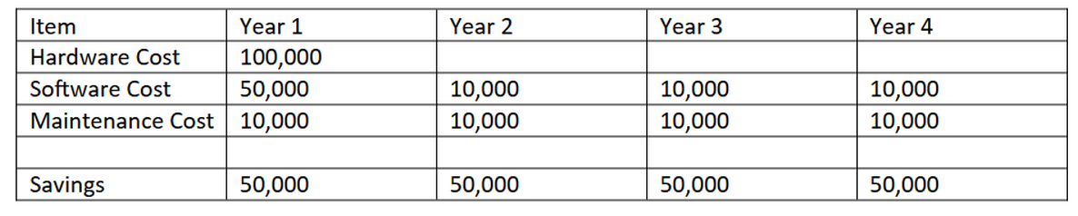

1. The project pays back in year 4 of the project.
   1. Bad answer
2. The project does not pay back within the four year period.
   1. The project pays back after break-even is reached. But Break-even is not reached within the first 4 years as it would be reached in year 5 after the project started.
3. The project pays back in year 2 of the project.
   1. Bad answer
4. The project pays back in year 3 of the project.
   1. Bad answer
5. When should benefits realisation be carried out?
6. Immediately at the end of the project.
   1. Bad answer
7. At the beginning of the project.
   1. Business Knowledge because it is one of the three fundamental competency categories for a business analyst. The other anschECKwer choices either do not accurately represent the main competency categories or are skills that are important but not classified as primary categories of competencies for a business analyst.
8. At the end of the finalised feasibility study.
   1. Bad answer
9. Months or year after the end of the project.
   1. Bad answer