Kleanthis E Karavangelas, Basem Saleh
Assignment 2, ECES 435
Part 1 1
Part 2 6
Encode function 9
Decode function 10

Part 1
original images
peps = imread('peppers.tif');
peps_size = dir('peppers.tif').bytes;
bab = imread('baboon.tif');
bab_size = dir('baboon.tif').bytes;
Quality factor 90
figure(1)
imwrite(peps, 'peppers90.jpg','Quality', 90);
peps90_size = dir('peppers90.jpg').bytes;
psnr_peps = psnr(imread('peppers90.jpg'), peps);
imwrite(bab, 'baboon90.jpg','Quality', 90);
bab90_size = dir('baboon90.jpg').bytes;
psnr_bab = psnr(imread('baboon90.jpg'), bab);
sgtitle('Quality factor = 90');
subplot(2,2,1), imshow(peps), xlabel('Original peppers.tif');
subplot(2,2,2), imshow('peppers90.jpg'), xlabel(sprintf('PSNR = %f', psnr_peps));
subplot(2,2,3), imshow(bab), xlabel('Original baboon.tif');
subplot(2,2,4), imshow('baboon90.jpg'), xlabel(sprintf('PSNR = %f', psnr_bab));
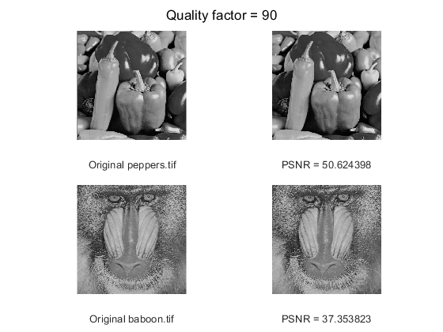
The original peppers.tif image has a size of 259376 bytes, while the QF = 90 image has a size of 48956. The original baboon.tif image has a size of 264750, and the QF = 90 image has a size of 105820 bytes.
Quality factor 10
figure(2)
imwrite(peps, 'peppers10.jpg','Quality', 10);
peps10_size = dir('peppers10.jpg').bytes;
psnr_peps = psnr(imread('peppers10.jpg'), peps);
imwrite(bab, 'baboon10.jpg','Quality', 10);
bab10_size = dir('baboon10.jpg').bytes;
psnr_bab = psnr(imread('baboon10.jpg'), bab);
sgtitle('Quality factor = 10');
subplot(2,2,1), imshow(peps), xlabel('Original peppers.tif');
subplot(2,2,2), imshow('peppers10.jpg'), xlabel(sprintf('PSNR = %f', psnr_peps));
subplot(2,2,3), imshow(bab), xlabel('Original baboon.tif');
subplot(2,2,4), imshow('baboon10.jpg'), xlabel(sprintf('PSNR = %f', psnr_bab));
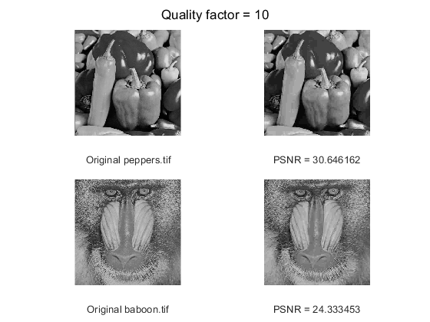
The original peppers.tif image has a size of 259376 bytes, while the QF = 10 image has a size of 8221. The original baboon.tif image has a size of 264750, and the QF = 10 image has a size of 13258 bytes.
Quality factor 70
figure(3)
imwrite(peps, 'peppers70.jpg','Quality', 70);
peps70_size = dir('peppers70.jpg').bytes;
psnr_peps = psnr(imread('peppers70.jpg'), peps);
imwrite(bab, 'baboon70.jpg','Quality', 70);
bab70_size = dir('baboon70.jpg').bytes;
psnr_bab = psnr(imread('baboon70.jpg'), bab);
sgtitle('Quality factor = 70');
subplot(2,2,1), imshow(peps), xlabel('Original peppers.tif');
subplot(2,2,2), imshow('peppers70.jpg'), xlabel(sprintf('PSNR = %f', psnr_peps));
subplot(2,2,3), imshow(bab), xlabel('Original baboon.tif');
subplot(2,2,4), imshow('baboon70.jpg'), xlabel(sprintf('PSNR = %f', psnr_bab));
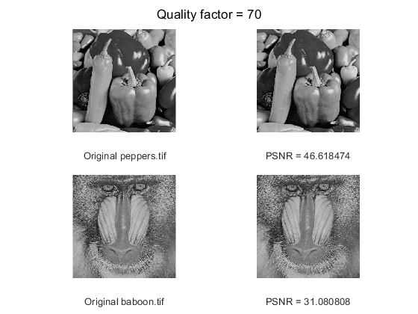
The original peppers.tif image has a size of 259376 bytes, while the QF = 70 image has a size of 33276. The original baboon.tif image has a size of 264750, and the QF = 70 image has a size of 57172 bytes.
Quality factor 50
figure(4)
imwrite(peps, 'peppers50.jpg','Quality', 50);
peps50_size = dir('peppers50.jpg').bytes;
psnr_peps = psnr(imread('peppers50.jpg'), peps);
imwrite(bab, 'baboon50.jpg','Quality', 50);
bab50_size = dir('baboon50.jpg').bytes;
psnr_bab = psnr(imread('baboon50.jpg'), bab);
sgtitle('Quality factor = 50');
subplot(2,2,1), imshow(peps), xlabel('Original peppers.tif');
subplot(2,2,2), imshow('peppers50.jpg'), xlabel(sprintf('PSNR = %f', psnr_peps));
subplot(2,2,3), imshow(bab), xlabel('Original baboon.tif');
subplot(2,2,4), imshow('baboon50.jpg'), xlabel(sprintf('PSNR = %f', psnr_bab));
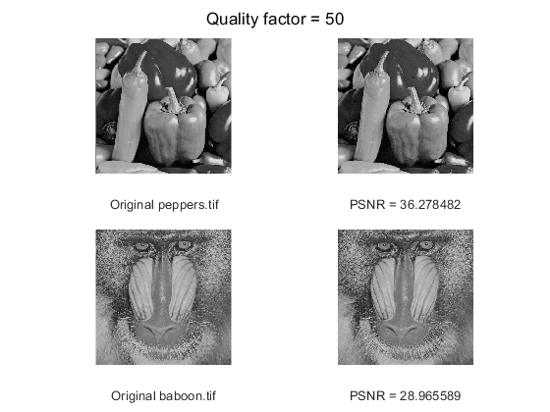
The original peppers.tif image has a size of 259376 bytes, while the QF = 50 image has a size of 27405. The original baboon.tif image has a size of 264750, and the QF = 50 image has a size of 41548 bytes.
Quality factor 30
figure(5)
imwrite(peps, 'peppers30.jpg','Quality', 30);
peps30_size = dir('peppers30.jpg').bytes;
psnr_peps = psnr(imread('peppers30.jpg'), peps);
imwrite(bab, 'baboon30.jpg','Quality', 30);
bab30_size = dir('baboon30.jpg').bytes;
psnr_bab = psnr(imread('baboon30.jpg'), bab);
sgtitle('Quality factor = 30');
subplot(2,2,1), imshow(peps), xlabel('Original peppers.tif');
subplot(2,2,2), imshow('peppers30.jpg'), xlabel(sprintf('PSNR = %f', psnr_peps));
subplot(2,2,3), imshow(bab), xlabel('Original baboon.tif');
subplot(2,2,4), imshow('baboon30.jpg'), xlabel(sprintf('PSNR = %f', psnr_bab));
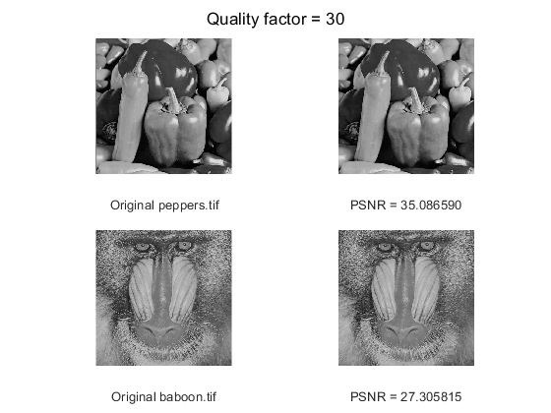
The original peppers.tif image has a size of 259376 bytes, while the QF = 30 image has a size of 15902. The original baboon.tif image has a size of 264750, and the QF = 30 image has a size of 29624 bytes.
As the quality factor of the image decreases, the file size decreases as well. When using JPEG compression, the compressed image seems to have lines and small square blocks appear all over it, which are referred to as artifacts. This is because JPEG is a lossy compression, and throws away information that the human eye cannot easily see. As the quality level decreases, the distortions become more visible. Looking at the 70 and 90 quality factor images, you can barely spot any differences between them and the original image. Moving down the scale, for quality factors of 50 and 30, you can see some lines and squares, but the image is still acceptable. Below 30, and especially as you approach 0, the distortions become more and more noticeable to the human eye.

Part 2
Encode
Qmat = [16 11 10 16 24 40 51 61;
12 12 14 19 26 58 60 55;
14 13 16 24 40 57 69 56;
14 17 22 29 51 87 80 62;
18 22 37 56 68 109 103 77;
24 35 55 64 81 104 113 92;
49 64 78 87 103 121 120 101;
72 92 95 98 112 100 103 99];
enfile = encode("peppers.tif", Qmat);
Decode
origZ = decode();
% compute psnr
peps = imread('peppers.tif');
npsnr = psnr(peps, origZ);
% display recovered image
figure(6);
imshow(origZ);
title("Decompressed image")
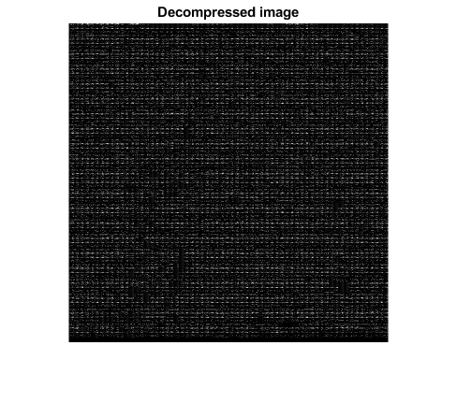
The PSNR between the original and decompressed image is 7.7402. The size of the decompressed image is 51928 bytes, compared to the original size of 259376 bytes. It should be noted that the recovered image is not recognizable. The group tried to follow the steps written in the lab assignment as close as possible, but still ended up with the image above.

Encode with different Q table
Qmat = [ 17 18 24 47 99 99 99 99;
18 21 26 66 99 99 99 99;
24 26 56 99 99 99 99 99;
47 66 99 99 99 99 99 99;
99 99 99 99 99 99 99 99;
99 99 99 99 99 99 99 99;
99 99 99 99 99 99 99 99;
99 99 99 99 99 99 99 99;];
enfile = encode("peppers.tif", Qmat);
Decode
origZ = decode();
% compute psnr
peps = imread('peppers.tif');
npsnr = psnr(peps, origZ);
% display recovered image
figure(7);
imshow(origZ);
title("Decompressed image")

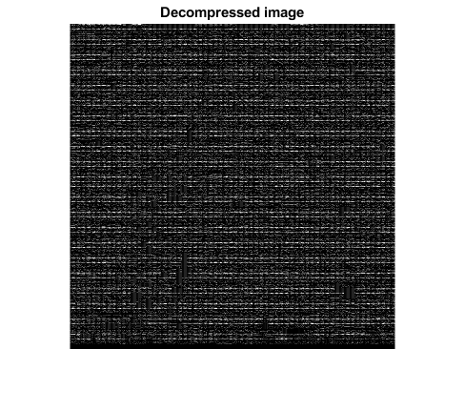
When using a different quantization table, the PSNR increases to 8.1340. The file size in this case remains the same.

Encode function
function enfile = encode(image, Qmat)
% read the input image
I = imread(image);
% convert to double type
I = im2double(I);
% compute the dct on 8x8 blocks
dctt = @(blkstruct) dct(blkstruct.data);
D = blockproc(I, [8 8], dctt);
% quantize the dct coefficients using the above table
quant = @(blkstruct) (blkstruct.data) ./ Qmat;
Q = blockproc(D, [8 8], quant);
Q = ceil(Q);
% convert matrix to vector
ZigZag = @(blkstruct) ZigzagMtx2Vector(blkstruct.data);
Z = blockproc(Q, [8 8], ZigZag);
[rowN, colN] = size(Z);
Z = Z';
Z = uint8(Z);
% entropy encoding
enfile = JPEG_entropy_encode(rowN, colN, 8, Qmat, Z, '', 0);
end

Decode function
function origZ = decode()
% entropy decoding
[irowN, icolN, idtc_block_size, iQmat, iZ] = JPEG_entropy_decode('');
iZ = iZ';
% reconstructing the matrix from the vector
Vect = @(blkstruct) Vector2ZigzagMtx(blkstruct.data);
Z = blockproc(iZ, [1 64], Vect);
% dequantizing the matrix
dequant = @(blkstruct) (iQmat .* blkstruct.data);
DCT = blockproc(Z, [8 8], dequant);
% performing inverse dct on matrix to retrieve image
indct = @(blkstruct) idct(blkstruct.data);
origZ = blockproc(DCT, [8 8], indct);
origZ = uint8(origZ);
end
Published with MATLAB® R2019b

