Kleanthis E Karavangelas, Basem Saleh
Assignment 3, ECES 435
Part 1: Least Significant Bit Data Hiding 1
LSB 8
Part 2 Yeung-Mintzer Watermarking 9

Part 1: Least Significant Bit Data Hiding
peppers bit plane
figure(1);
GetBitPlane(4, 'peppers.tif');
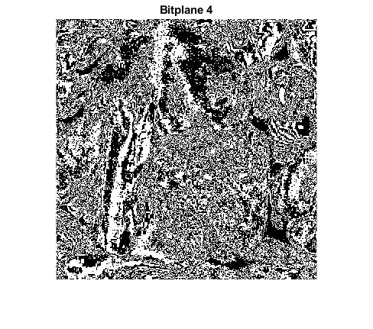
baboon bit plane
figure(2);
GetBitPlane(5, 'baboon.tif');

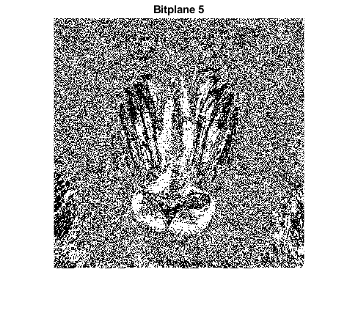
For the peppers.tif image, the highest bit plane that does not resemble image content based on our group’s opinion, is bit plane 4. For the baboon.tif image, the highest bit plane that doesn't resemble image content, is bit plane 5, where you can barely recognize the baboon. These are two different pictures, so it makes sense that not each bit plane will represent an equal amount of information. The peppers image has more details such as edges, that can be preserved and seen through a greater amount of bit planes. Instead, the baboon has less of those features, which makes the noticable content be a lot less visible after fewer bit planes.
LSBwmk1.tiff
figure(3);
I1 = imread('LSBwmk1.tiff');
imshow(I1);
figure(4);
GetBitPlane(2, 'LSBwmk1.tiff');

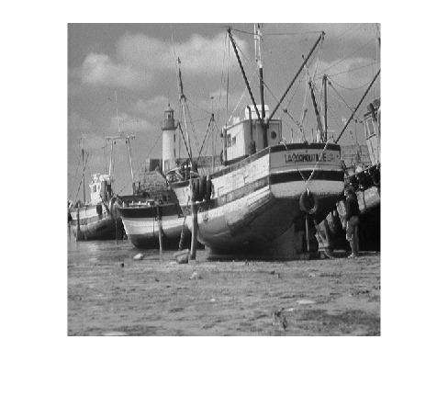

The hidden image is the Drexel logo and is found on bit plane 2.
LSBwmk2.tiff
figure(5);
I2 = imread('LSBwmk2.tiff');
imshow(I2);
figure(6);
GetBitPlane(1, 'LSBwmk2.tiff');

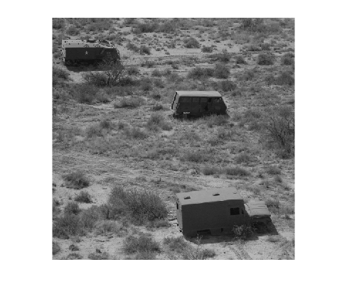
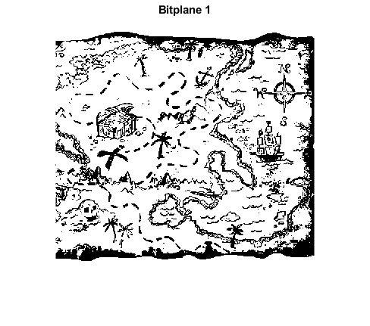
The hidden image is a treasure map and is found on bit plane 1.
LSBwmk3.tiff
figure(7);
I3 = imread('LSBwmk3.tiff');
imshow(I3);
figure(8);
bp = GetBitPlane(1, 'LSBwmk3.tiff');

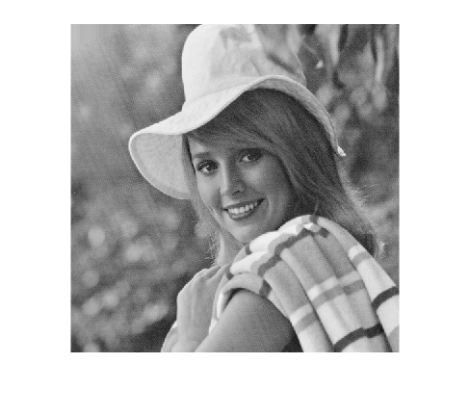
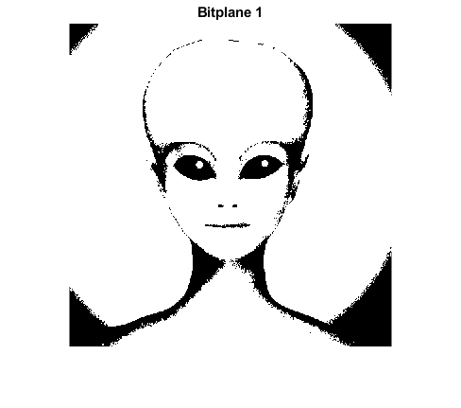
The hidden image is an alien and is found on bit plane 1.

LSB
peppers.tif + Barbara.bmp
figure(9);
Im = ReplaceNLSB("peppers.tif", "Barbara.bmp", 1);
imshow(Im);
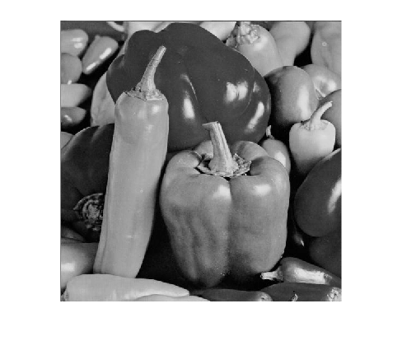
For peppers.tif, we start seeing distortion after N = 4. At N = 6, you can start seeing the watermark.
baboon.tif + Barbara.bmp
figure(10);
Im = ReplaceNLSB("baboon.tif", "Barbara.bmp", 1);
imshow(Im);
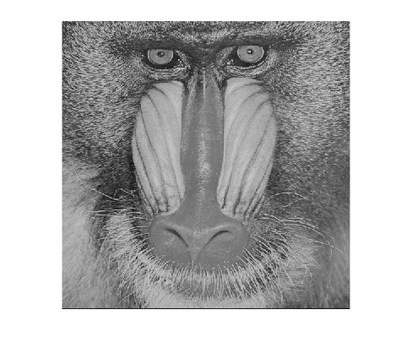
For baboon.tif, you start seeing distortion at N = 5. At N = 7, you are able to identify the watermark.
The reason that we see more or less distortion at different bitplanes of the host images, is because the are constructed differently. Our best guess is that the baboon.tif image has more information in the center of the image, and thus makes it harder for us to identify the watermark, which also has more information at the center of the image.

Part 2 Yeung-Mintzer Watermarking
Embed Barbara.bmp in peppers.tif and baboon.tif
% Get MSBP of watermark, convert to binary to embed
B = imread("Barbara.bmp");
B = double(B);
B = bitget(B, 8);
B = imbinarize(B);
peps = YMalgorithm('peppers.tif', B, 1);
babs = YMalgorithm('baboon.tif', B, 1);
imwrite(peps, "peps.tif");
imwrite(babs, "babs.tif");
Examine bit planes of peps.tif and babs.tif respectively
figure(11)
PepperWM = GetBitPlane(1, "peps.tif");
xlabel("Peppers");
figure(12)
BaboonWM = GetBitPlane(1, "babs.tif");
xlabel("Baboon");

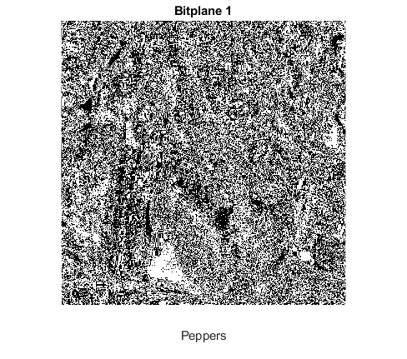
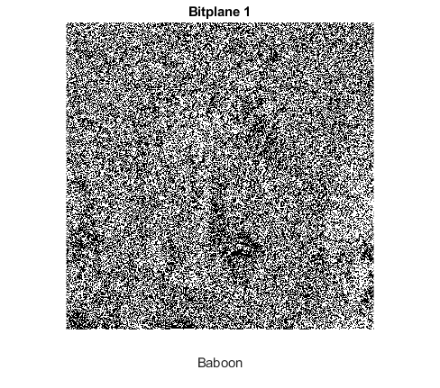
The hidden watermark is not detected in either image, even in the lower bit planes.
PSNR (Yeung-Mintzer algorithm) Between peppers.tif and peps.tif
A = imread("peppers.tif");
psnrA = psnr(A, peps);
% Between baboon.tif and babs.tif
B = imread("baboon.tif");
psnrB = psnr(B, babs);
PSNR between watermarked and original peppers using YM: 47.8592 PSNR between watermarked and original baboon using YM: 47.8092
PSNR (LSB algorithm) For peppers
pepsLSB = ReplaceNLSB("peppers.tif", "Barbara.bmp", 1);
psnrALSB = psnr(A, pepsLSB);
babsLSB = ReplaceNLSB("baboon.tif", "Barbara.bmp", 1);
psnrBLSB = psnr(B, babsLSB);
PSNR between watermarked and original peppers using LSB: 51.14.22 PSNR between watermarked and original baboon using LSB: 51.1391
The PSNR is higher when using the LSB method compared to the Yeaung-Mintzer algorithm. This agrees with our initial intuition, since the LSB method in this case only replaces the least significant bit plane of an image, and in contrast the Yeung-Mintzer method replaces many pixel values.
Extraction
key = 435;
W = Extraction("YMwmkedKey435.tiff", key);
figure(13);
imshow(W);


Last part
LSBbabs = ReplaceNLSB("baboon.tif", "Barbara.bmp", 1);
LSBpeps = ReplaceNLSB("peppers.tif", "Barbara.bmp", 1);
B = imread("Barbara.bmp");
B = double(B);
B = bitget(B, 8);
B = imbinarize(B);
YMbabs = YMalgorithm("baboon.tif", B, 10);
YMpeps = YMalgorithm("peppers.tif", B, 10);
LSB method
LSBpeps = double(LSBpeps);
LSBbabs = double(LSBbabs);
% get lower planes of LSBpeps
low = {};
for i=1:4
low{i} = bitget(LSBpeps, i);
end
% get lower LSBbabs bit planes
low2 = {};
for j=1:4
low2{j} = bitget(LSBbabs,j);
end
LSBim = cell(1,8);
for i=1:4
LSBim{i} = low2{i};
LSBim{i+4} = low{i};
end
for i = 0:7
LSBim{i+1} = LSBim{i+1} * 2^i;
end
Im = imadd(LSBim{1}, LSBim{2});
Im = imadd(Im, LSBim{3});
Im = imadd(Im, LSBim{4});
Im = imadd(Im, LSBim{5});
Im = imadd(Im, LSBim{6});
Im = imadd(Im, LSBim{7});
Im = imadd(Im, LSBim{8});
Im = uint8(Im);
Im = double(Im);
x = bitget(Im, 1);
figure(14);
imshow(x);
title("Watermark (LSB)")

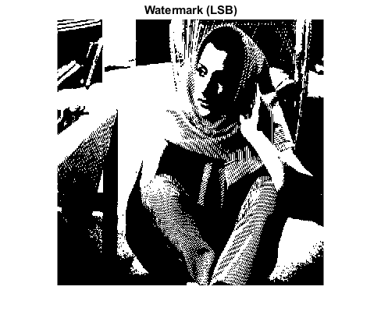
YM method
YMpeps = double(YMpeps);
YMbabs = double(YMbabs);
% get lower planes of YMpeps
low = {};
for i=1:4
low{i} = bitget(YMpeps, i);
end
% get lower YMbabs bit planes
low2 = {};
for j=1:4
low2{j} = bitget(YMbabs,j);
end
% construct new image
YMim = cell(1,8);
for i=1:4
YMim{i} = low2{i};
YMim{i+4} = low{i};
end
for i = 0:7
YMim{i+1} = YMim{i+1} * 2^i;
end
Im = imadd(YMim{1}, YMim{2});
Im = imadd(Im, YMim{3});
Im = imadd(Im, YMim{4});
Im = imadd(Im, YMim{5});
Im = imadd(Im, YMim{6});
Im = imadd(Im, YMim{7});
Im = imadd(Im, YMim{8});
Im = uint8(Im);
imwrite(Im, "YMmix.tif");
watermark = Extraction("YMmix.tif", 10);
figure(15);
imshow(watermark);
title("Watermark (YM)")
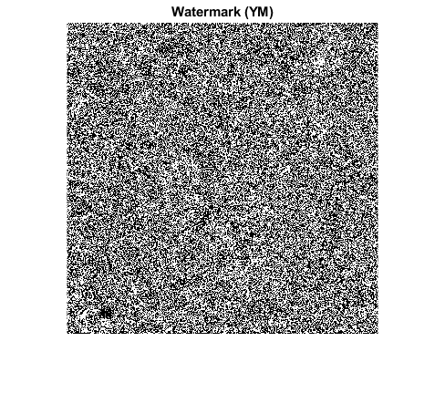
When using the LSB method, the group was able to extract the watermark correctly. When using the YM algorithm, the group was not able to recover the original watermark embedded using the algorithm. The error is attributed to either the YM algorithm we wrote, or the extraction function we created.
function bp = GetBitPlane(bp, img)
% read input image
I = imread(img);
% convert to double
ID = double(I);
% get specified bitplane
B = bitget(ID, bp);
% display specified bitplane
imshow(B);
title(sprintf('Bitplane %i', bp));
end

function Im = ReplaceNLSB(A, B, N)
% read contents of image A
A = imread(A);
A = double(A);
% read contents of image B
B = imread(B);
B = double(B);
C = {};
% save top 8-N layers of image A
for i = N+1:8
C{i} = bitget(A , i);
end
% save N most significant bit planes of image B
for j = 8-(N-1):8
D{j} = bitget(B,j);
end
% construct the new image array
ImArray = cell(1,8);
for i = 1:N
ImArray{i} = D{8-(N-i)};
end
for j = N+1:8
ImArray{j} = C{j};
end
for i = 0:7
ImArray{i+1} = ImArray{i+1} * 2^i;
end
% add each bitplane to form the new image
Im = imadd(ImArray{1}, ImArray{2});
Im = imadd(Im, ImArray{3});
Im = imadd(Im, ImArray{4});
Im = imadd(Im, ImArray{5});
Im = imadd(Im, ImArray{6});
Im = imadd(Im, ImArray{7});
Im = imadd(Im, ImArray{8});
Im = uint8(Im);
end
function NewIM = YMalgorithm(OI, B, key)
% develop LUT based on specific key
rng(key);
LUTvals = rand(1,256)>0.5;
% original image
A = imread(OI);
% get rows and columns of original image
[rowsA, colsA] = size(A);
% get rows and columns of binary watermark image
[rowsB, colsB] = size(B);
for i = 1:rowsA
for j = 1:rowsB
% identify each pixel value on original image
pixel = A(i,j);
% change 0 to 1 so errors are avoided
if pixel==0
pixel = 1;
end
% flag that helps identify if binary value matches LUT value
found = 0;
inc = 1;
while found == 0
% if values match, then move on to next pixel
if B(i,j) == LUTvals(1, pixel)
found = 1;
else
% otherwise look for near pixels
if B(i,j) == LUTvals(1, pixel+inc)
A(i,j) = pixel+inc;
found = 1;
elseif B(1,j) == LUTvals(1, pixel-inc)
A(i,j) = pixel-inc;
found = 1;
else
inc = inc + 1;
end
end
end
end
end
NewIM = uint8(A);
end
function watermark = Extraction(A, key)
A = imread(A);
rng(key);
LUT = rand(1,256)>0.5;
[rows, cols] = size(A);
for i=1:rows
for j=1:cols
pixel = A(i,j);
watermark(i,j) = LUT(pixel+1);
end
end
end
Published with MATLAB® R2019b

