II. Introduction/ Rationale
Our educational tour in Cebu was one of the most meaningful experiences in our journey as IT students. It was organized to help us gain knowledge outside the four walls of the classroom and to see how technology is being applied in different industries. The tour was not just about visiting places but also about learning directly from professionals who shared their skills, stories, and advice about their careers.
Through this activity, we were introduced to companies and seminars that are connected to our field of study. We learned about animation and creativity through Emottoons, and we also discovered the importance of Geographical Information System (GIS) in mapping and city planning. These experiences gave us new perspectives about how IT is used in real life and inspired us to work hard for our future.

III. Narrative Report
Emottoons
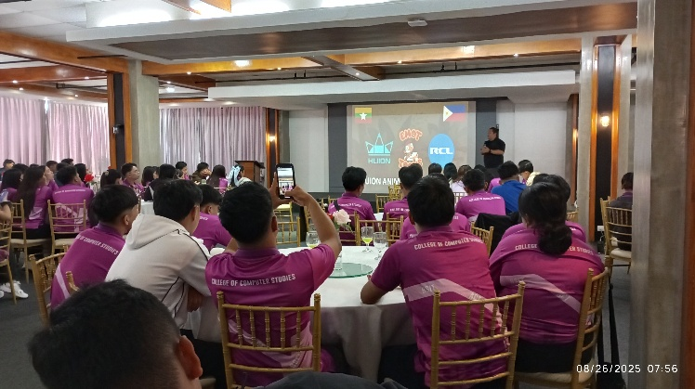
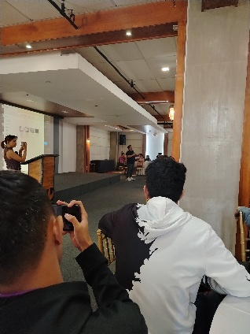

One of the highlights of our tour was our visit to Emottoons. Sir Emot introduced us to the world of animation in a very creative way. He shared his personal experiences and advice about working in the animation industry. What made it more was when he showed us the step-by-step process of how they create animations. From making storyboards and designing characters to producing the final output, he explained everything clearly. From my own experience, I was truly amazed by how they create the animations. Watching the process made me appreciate the hard work, creativity, and patience behind every project. It opened my eyes to the idea that animation is not only entertaining but also a serious craft that requires both talent and technology.

Geographic Information System (GIS)
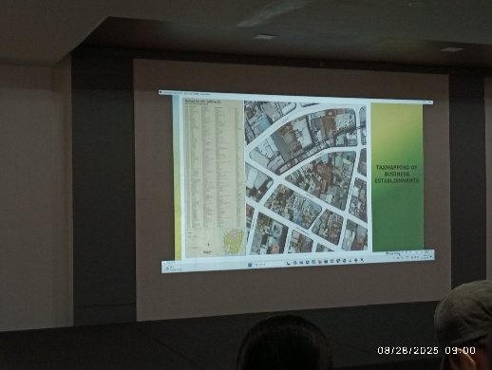
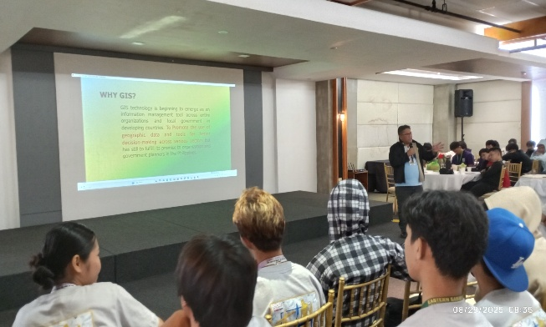

Another important seminar we attended was about Georgraphic Information System (GIS). The speakers introduced us to the basics of mapping and explained how GIS is applied in real life, especially in city planning and development. They discussed how data is collected, processed, and analyzed to create useful maps that help in decision-making. What impressed me most was how they shared real examples of how GIS is applied in their own city. It showed us how technology can help solve community problems are improve people’s daily lives

IV. Industry Exposure
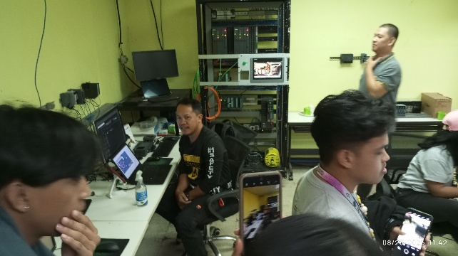
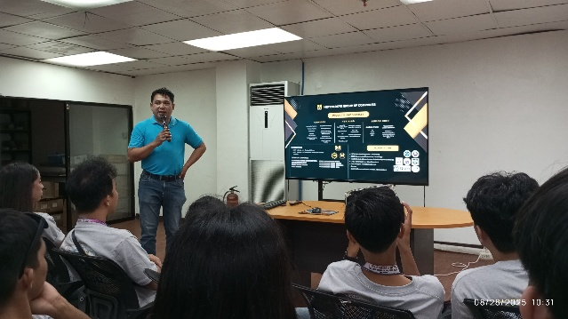
Metrologyx

Our visit to Metrologyx was very information because it introduced us to the world of automation. The staff explained to us how automation works and how it is becoming more important in different industries today. They also shared how our IT course is connected to this field, since automation relies on technology, software, and systems that need to be maintained and developed. They also showed us some of the tools they use in their projects. This visit made me realize that IT is not only about programming or troubleshooting computers, but it also plays a big role in industries that aim for innovation and productivity.

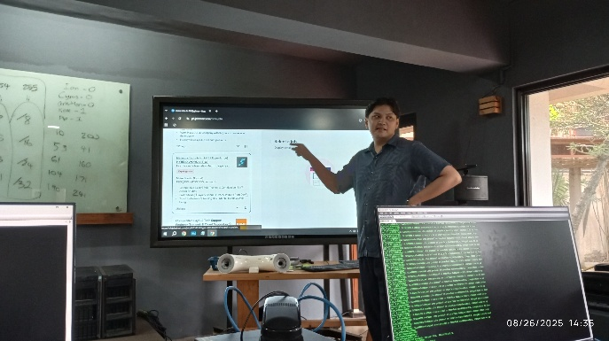
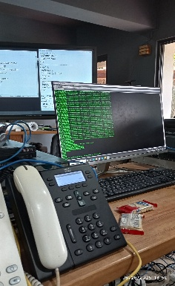
Rivan IT

In Rivan IT, the discussion was about networking. The staff explained how networks work and why they are very important in IT. What made this visit memorable was that they gave us a quick hands-on activity using actual network devices. We were able to practice basic networking tasks, which helped us understand better how the devices function in real-life situations.

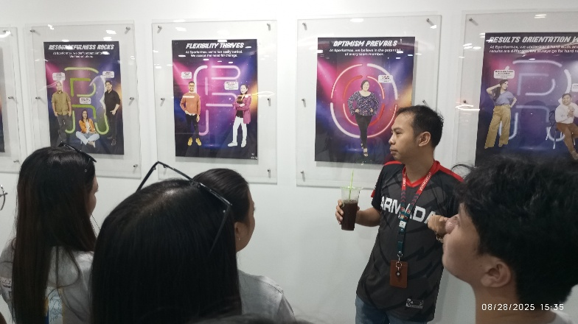
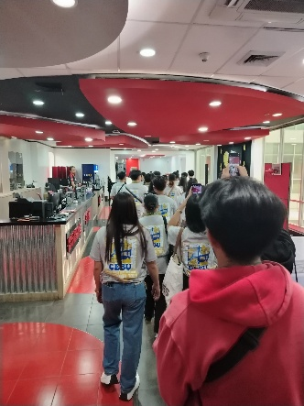
Eperformax

We also visited Eperformax, where we were given a tour or their office. They introduced us to the world of the call center industry and explained the importance of communication skills when dealing with clients. This visit helped us understand that IT is not only about technical knowledge but also about technical knowledge but also about building soft skills like communication and customer service.

V. Reflection
During our educational tour in Cebu, I learned a lot of new things that I don’t usually see in the classroom. The seminars and company visits helped me understand how IT is really applied in different kinds of work. I was amazed at how Emotoons create their animations step by step, and it made me appreciate the effort and creativity behind it. The GIS seminar also taught me how mapping and technology are used to improve city planning, which I found very interesting.
When we visited companies like Metrologyx, Rivan IT, and Eperformax, I saw how wide the IT field really is. From automation, networking, and even communication skills in the BPO industry, I realized that IT is not just about computers but also about solving problems and helping people.
This tour inspired me to continue learning and improving my skills. It also gave me an idea of the possible career paths I can take in the future. Overall, it was a meaningful and memorable experience that I will always value as part of my journey as an IT student.

Name:
Student Number:
E-mail:
Contact Number:
Birth date:
Address:
Guardian:
Preliminary Education
Elementary:
Secondary:
College:

