Docel Benidic G.

BSIT 3A

**Concept Map** – Network Addressing and Basic Troubleshooting Module 3

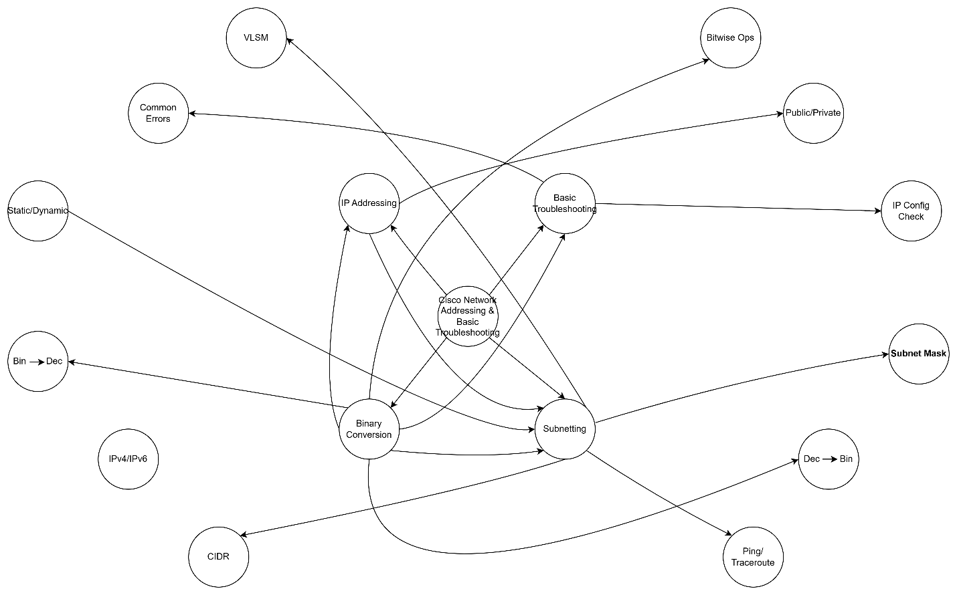

# **1. IP Addressing**

IP addressing is the foundation of all network communication. Each device in a network must have a unique IP address to send or receive data.  
  
- IPv4: A 32-bit address, written as four decimal numbers like 192.168.1.1.  
- IPv6: A 128-bit address, used to handle the shortage of IPv4 addresses.  
- Static IP: Manually assigned, consistent over time.  
- Dynamic IP: Assigned by a DHCP server temporarily.  
- Public vs. Private IP: Public IPs are routable on the internet, private IPs are used within local networks.  
  
Relationship: IP addressing provides the logical structure for identifying hosts, which is necessary before applying subnetting or any troubleshooting process.

# **2. Subnetting**

Subnetting is dividing a larger network into smaller, manageable sub-networks (subnets).  
  
- Subnet Mask: Separates the network and host portions of an IP address.  
- CIDR Notation (e.g., /24): More efficient IP allocation than class-based systems.  
- VLSM (Variable Length Subnet Masking): Allows different-sized subnets to save address space.  
  
Relationship: Subnetting builds on IP addressing to organize networks more efficiently and is essential for routing and network segmentation.

# **3. Binary Conversion**

Understanding binary is critical to interpreting how IP addresses and subnet masks function at a low level.  
  
- Decimal to Binary: Converts human-readable IPs into binary for calculations.  
- Binary to Decimal: Converts results back to readable form.  
- Bitwise Operations (ANDing): Used to find network addresses from IPs and subnet masks.  
  
Relationship: Binary knowledge is essential for subnetting, configuring IPs, and troubleshooting errors. It bridges theory and application in networking.

# **4. Basic Network Troubleshooting**

Troubleshooting involves identifying and fixing network issues. It uses diagnostic tools and knowledge of addressing.  
  
- Ping: Tests basic connectivity.  
- Traceroute: Shows the path packets take to reach a destination.  
- IP Configuration: Verifying if devices have correct IP addresses, subnet masks, gateways, etc.  
- Common Issues: IP conflicts, incorrect subnet masks, DNS issues.  
  
Relationship: Troubleshooting relies on knowledge of IP addressing, subnetting, and binary interpretation to diagnose and resolve issues correctly.

# **How They Are Related**

- Binary Conversion is required to understand IP Addressing and Subnetting.  
- IP Addressing is the basis for Subnetting, and both are essential in Troubleshooting.  
- Subnetting mistakes often lead to network problems, so understanding it is critical for Basic Troubleshooting.  
- All these concepts work together to ensure devices can communicate properly and problems can be resolved quickly.