

郑嘉诚 队长

李知恒 队员

史话 博士 指导老师

山东大学 东北亚学院 国际政治+国际经济与贸易双学位实验班

2022级

[karcen_zheng@mail.sdu.edu.cn](mailto:19992761017karcen_zheng@mail.sdu.edu.cn)

19992761017

马克思说的都队

决战 24H

Content

1 Executive Summary Overview of Operation Status, Selling Points, China Market 2

1.1 Overview of Operation Status 2

1.2 Overview of Selling Points 4

1.3 Overview of China Market 4

1.4 Basic Analysis 5

2 Customers Orientation 6

2.1 Customers Needs 6

2.2 Ruby Co. Current Situation 7

3 Methodology 7

3.1 Expand Market Share 7

3.2 Enhance Brand Awareness 8

4 DTC and Other Possible Methods in Process 10

4.1 DTC Model 10

4.2 In Process 12

5 ADs, Tax with Legal 14

6.1 ADs with Legal 14

6.2 Legal Tax Avoidance 14

6 Prospective Results 15

7.1 Operating Margin 15

****7.2 Market Share 15

# Executive Summary Overview of Operation Status, Selling Points, China Market

## Overview of Operation Status

According to the question, the total revenue of small cakes kept increasing in the past three years (2018--2020), while large cake and Traditional waffles have remained basically the same, and breakfast muffins have decreased year by year. *Figure 1*

Figure 1 Percent of Goods Revenue

There was a large decline in 2019-2020, which we speculate is related to the epidemic lockdown, 2018-2019 has a poor revenue performance. Among the products sold, small cakes accounted for approximate 42% of the four products (small cakes, large cakes, traditional waffles, breakfast muffins) in 2020, remaining the largest proportion. The sales of small cakes witnessed fast growth. *Figure 2*

Figure 2 Percent of Goods Sold

However, the proportion of distribution, selling and marketing expenses of small cakes increased significantly from 2019 to 2020, while that of large cakes has declined. Given that small cakes are the most popular but we believe that reducing the distribution, selling and marketing expenses of small cakes is a breakthrough point, and our objective is to seek for cost reduction. *Figure 3*

Figure 3 Percent of Distribution, selling and marketing expenses

Tax matters our company’s consolidated income. The percentage of the tax of Ruby Co. in net profit shows a downward trend, but still occupies a large proportion. The relative downward trend is not obvious. Tax accounted for 42.9% of net profit in 2018, 42.8% in 2019 and 42.7% in 2020. *Figure 4*

Figure 4 Tax/(Profit/loss after tax)

Operating costs increased year by year, from 120.8million in 2018 to 222million in 2020. The operating margin has increased year on year, which is a good sign that the company's profitability is strengthening. Specifically, the company's operating margin has increased from 15.4% in 2018 to 22.7% in 2022. *Figure 5*

Figure 5 Operating Margin

## Overview of Selling Points

|  |  |  |
| --- | --- | --- |
| *Environment (Friendly?)* | *Taste (Sweetness and Flavor)* | *Attitude towards Service* |
| Food Safety (Safe?) | **Types of Food (Multiple?)** | **The Price (Acceptable?)** |

## Overview of China Market

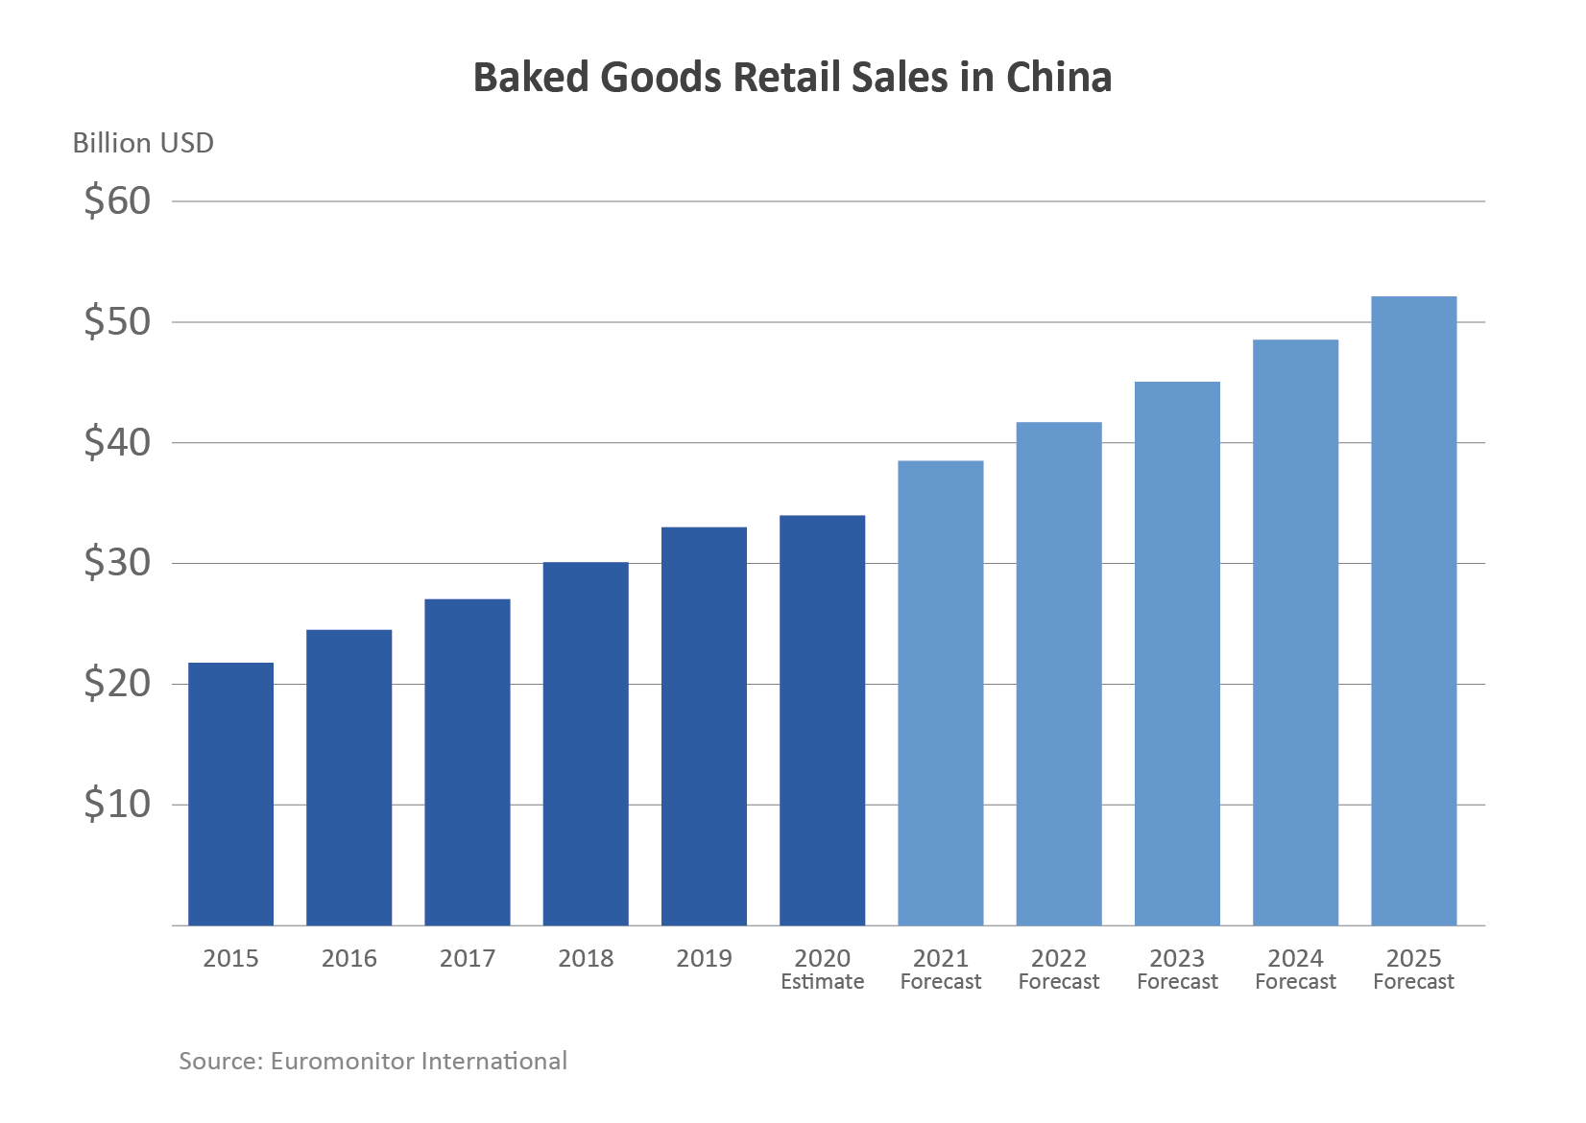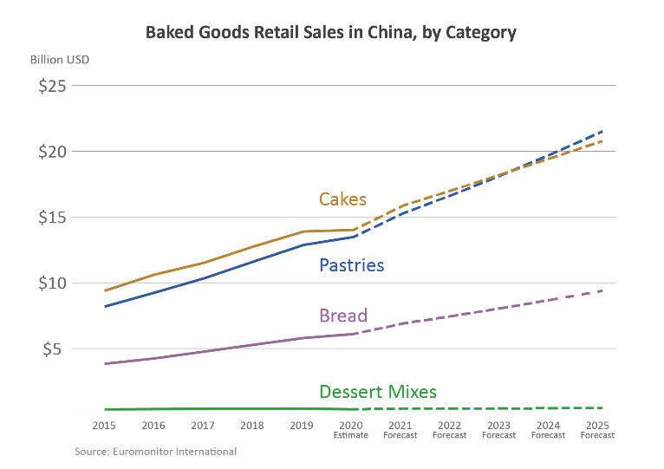

Figure 6 Baked Goods Retail Sales in China and Baked Goods Retail Sales in China, by Category From *International Agricultural Trade Report*

China’s **bakery sector** has been expanding rapidly in recent years, underpinned by the country’s rising middle class, ongoing Westernization of lifestyles and diets, and increasing demand for convenient food options. Furthermore, the growth potential for China’s bakery sector is unparalleled, given the country’s population and relatively low consumption base. Per capita consumption of baked products is currently 7.2 kilograms (kg) per year, compared to 22.5 kg in Japan, and 40.2 kg in the United States.1 Euromonitor International forecasts that retail sales of baked goods in China will grow to $53 billion by 2025, a 53-percent jump from current levels.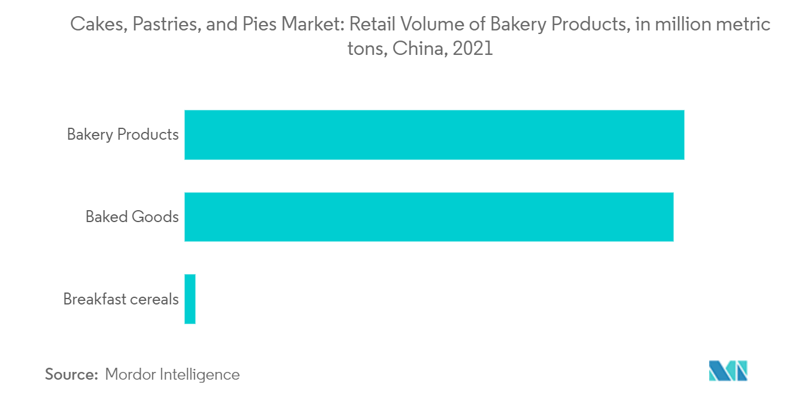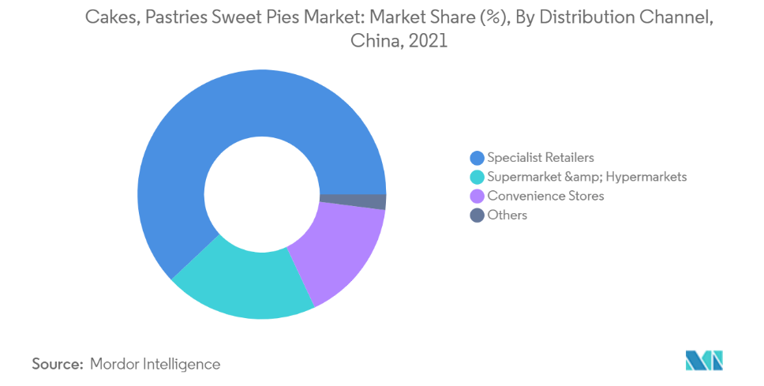

Figure 7 Cakes, Pastries, and Pies Market: Retail Volume of Bakery Products, in million metric tons,China,2021 and Cakes, Pastries Sweet Pies Market: Market Share (%), By Distribution Channel,

China,2021 From *International Agricultural Trade Report*

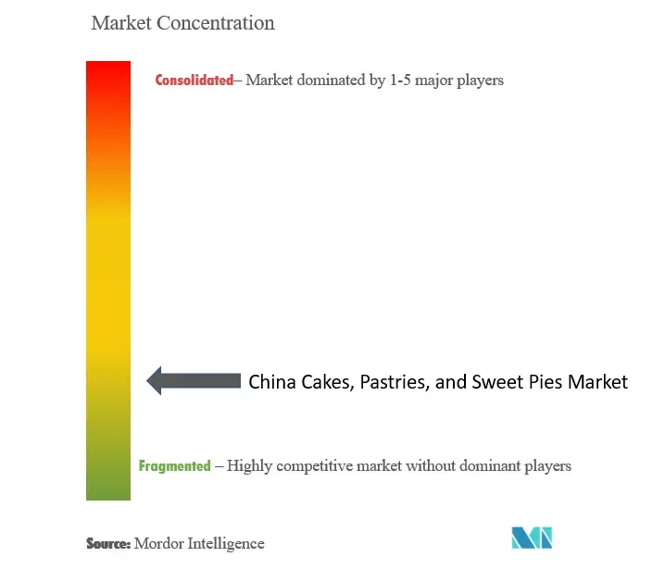The Chinese cakes, pastries, and sweet pies market is highly fragmented and competitive. Foodservice channels offering customized baked goods are a tough competition to the retail companies. As their key marketing strategy, companies focus on new product launches with healthier ingredients/organic claims. Increased private label brands pose tough competition to the existing players.

Figure 8 Market Concentration

## Basic Analysis

High tax rates and the cost of small cakes are the breakthrough. First of all, compared with the other three products, small cakes are the most popular but cost the most. The costs are still on the rise. Secondly, how can we conduct tax avoidance whilst avoiding being side-tracked into moral criticism or penalty for tax evasion? We will focus on the DTC model expected by Roby Co., as well as branding and identifying target, audience in the first year of transformation. How to adhere to values and standards of Ruby Co. throughout the transformation process, such as always delivering the highest quality products and services? Based on the analysis of the customer survey, we suspected that the orange shaded bar chart represents first-tier cities, while the dark orange bar chart with a brown color represent second-tiers cities. The reason is that the orange-shaded bar is relatively more concerned with health than with price, which is often found in high-income cities, where price elasticity is weaker. We predict that Ruby Co. 's newly developed low-sugar and sugar-substitute cakes will be popular in first-tier cities. Our reasons are based on Customer survey and analysis of Green & Health's competitors. According to Chinese law, productive foreign-invested enterprises located in the coastal economic open zones, special economic zones and the old urban areas of the cities where economic and technological development zones are located shall be taxed at a reduced rate of 24 per cent enterprise income tax.

We will not only offer a plan from the five stages of cake production, storage, transportation, sales and after-sales, but also especially consider and optimize breakfast muffins and traditional waffles with low revenue and low cost.

# Customers Orientation

## Customers Needs

We use [*WebPlotDigitizer*](https://apps.automeris.io/wpd/) , a semi-automated tool, to extract data from the question file so as to conduct comprehensive quantitative analysis, and redraw the figure. *Figure 9*

Figure 9 Customer Survey

## Ruby Co. Current Situation

Ruby Co. needs to expand its marketing channels and improve its marketing model.

# Methodology



## Expand Market Share

* + 1. **Take Out**

Figure 10 Meituan Logo

With the acceleration of the pace of life, Western franchised restaurants have become hotspots in China for its convenience, speed, labor-saving and delicious characteristics. Data shows that in China, restaurant sales have decreased by 44.3% since the outbreak of Covid-19 pandemic, However, the epidemic had a smaller impact on the Western-franchised catering industry. In 2021, the market size of Western fast food in China was 280.07 billion yuan, and it is expected to reach 320.20 billion yuan in 2022.

We believe that as a franchise of the w the western fast-food market, cakes and desserts still remain a large space and potential for development in China. Consumers' high demand for food diversity requires fast-food enterprises to carry out "whole category" integration, and the combination of Chinese and Western fast food is more popular with consumers. *Figure 11*

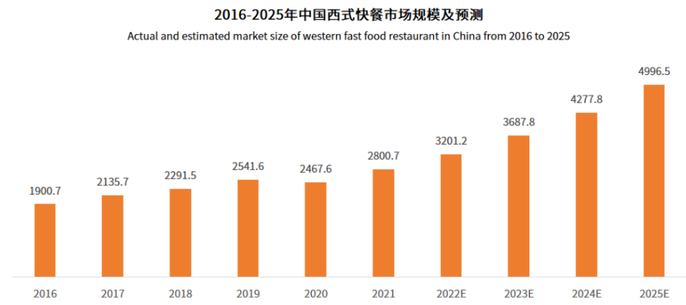

Figure 11 Actual and estimated market size of western fast food restaurant in China from 2016 to 2025 and Annual Revenue and Growth Rate of Chinese Restaurant Industry from 2015 to 2025

* + 1. **Localization**

The success of Green & Health highlights that low sugar, sugar substitute and health is a good marketing tool. We noticed that less than 15% of consumers can distinguish the new low-sugar taste from the original one. Therefore, the focus of the localization of low-sugar products is that Chinese consumers concern nutrition and food health, yet have no ability to identify the the quality of food raw materials.

* + 1. **Multi-platform Sales**

Based on the analysis of the COF group, multi-platform sales are a good way to capture market share. Expand cooperation with local distributors, such as chain cake shops, food courts and high-end hotels, and open online stores on platforms such as Jingdong, Taobao and Meituan to sell their own goods at relatively low prices online and do activities from time to time, which can not only sell their own products, but also improve consumers' brand awareness and brand identity.

Figure 12 Jingdong Logo

## Enhance Brand Awareness

* + 1. **Ads**

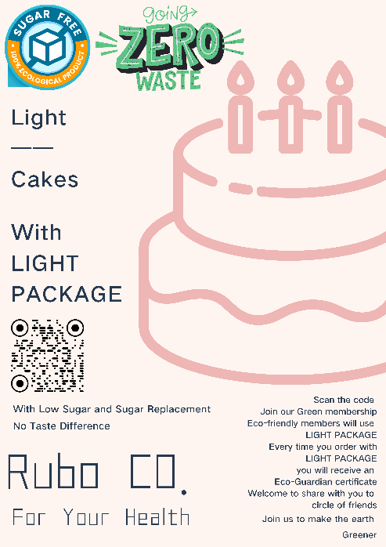For low-sugar and sugar-substitute cakes with small taste difference, we can focus on marketing through advertising. Low sugar and sugar replacement are directly related to health. Through the analysis of customer survey, advertising with health meanwhile highlighting the unchanged taste as the brand can attract consumers' attention. Meanwhile, environmental protection strategies can be attached, such as scanning the code to buy online, reflecting the light package, that is, simple packaging, and can get the electronic environmental protection assistant certificate, which can be shared in the circle of friends, triggering another immediate action from prospects, and creating a reliable and responsible brand image.

Figure 13 Ads Sample

With the help of digital means, we carry out product innovation, actively promote product online, and build a marketing system that integrates online and offline, so as to meet the needs of consumers for rapid iteration. For example, Yuanqi Forest focuses on sugar-free drinks. We can use big data to analyze user preferences and accurately place advertisements on Douyin and Weibo, so as to realize online and offline consumer data, commodity master data, inventory information and price promotion strategy.

* + 1. **Collaboration**

We can co-brand with young environmental protection brands to produce limited-edition co-branded goods and cooperate in sales.

* + 1. **Environmental Protection and Sustainable Development**

Environmental protection is conducive to improving brand identity, and more environmentally friendly and sustainable marketing methods are more acceptable to higher educated people in first and second tier cities, which may become a fashion. Therefore, we expounded our plan from two aspects of product packaging and electricity consumption.

First of all, in terms of product packaging, we advocate simple packaging, using recycled plastic and recycled paper products, and encourage consumers to return plastic packagings to offline stores instead of simply throwing them away, and earn store points in this way. Points can redeem peripheral products. On the one hand, encouraging customers to use the plastic or paper products we provide in the first sale more than once can also reduce our costs. Recycled plastic bags and paper products will be reused or sold to recycling manufacturers after treatment. . On the other hand, encouraging customers revisit our stores will expand brand recognition, which may form a fashion trend among young people started by Ruby Co..

Although it is inevitable to use more human resources and increase costs in the preliminary stage, but we firmly believe that this is conducive to our long-term interests. Actively responding to national policies will help us win relevant state support and funding for enterprises. More importantly, in the near future consumers will firmly trust businesses that prioritize sustainability and eco-friendly strategies, which can also make our program more feasible through the following programs.

* 1. *Publicize environmental protection in advertisements to arouse public opinion, which itself is a kind of advertising promotion.*
  2. *Cooperate with the government to establish a trustworthy environmental brand.*
  3. *Consumers can exchange goods or get coupons through environmental protection behaviors.*

# DTC and Other Possible Methods in Process

## DTC Model

According to our research indicates using the Direct-to-Consumer(DTC) model can help lower costs and enhance profits by removing retailers’ sales commissions and display space costs.

Our team recommends 5 steps to implement DTC model,



Challenges We Probably Face and Solutions

*High initial investment costs.*

**Solutions:**

We can adopt the store-value strategy to quickly withdraw funds and appropriately use the funds for investment to increase Interest receivable and other financial income.

In the storage of value, we should reflect the "sense of superior value" and "differentiation". Giving gifts makes people feel worthwhile we can store value to send gifts, each gift is different according to the amount of stored value, the higher the amount of stored value, the more attractive the gift. At the same time, three types of gifts(￥200, ￥100, ￥50) are set up to increase the sense of urgency of stored value.

We can also show young elements in advertising to get close to help consumer groups. At the same time, digital operation of customers, through customer data, targeted push preferential activities, to achieve thousands of faces at the strategic level. For example, new members give some coupons to attract customers to spend in the store, and then recommend value storage activities to them. Secondly, we should pay close attention to the gift culture to achieve emotional resonance. For example, the star gift card of Starbucks has a high level of appearance and is matched with limited amount of small items, such as key chain, card buckle and coin purse. So as to touch the hearts of consumers and close the distance. Adopt the "online + online" linkage communication mode, build online membership mechanism, from time to time and high frequency of group, second kill, full reduction, coupon and other activities. Set up a good stored value member system, subdivide member levels, set the corresponding growth value, points to encourage customers to spend. For example, if you spend more than ￥10,000 , you can get a limited edition peripheral and a ￥1,000 voucher, with a limit of 50.

In the weakest industry off-season, value storage activities can slow down the performance pressure during this period.

In holidays to carry out festival promotion activities, mainly combined with the Internet promotion time, launched stored value marketing activities. For example, 618, Double 11, etc. On the one hand, can rub heat, save a large amount of promotion costs; On the other hand, make full use of "online + offline" consumption channels to expand the results.

## In Process



• Telephone support services • Professional customer service

After Sales

# ADs, Tax with Legal



## ADs with Legal

Our advertising program does not violate the Advertising Law of the People's Republic of China. *Figure 13*

## Legal Tax Avoidance

We can adjust the allocation of resources in first - and second-tier cities and choose to allocate more stores in coastal open economic zones and special economic zones, so that the tax revenue will drop by 24%.

Income Tax Law of the People's Republic of China for Enterprises with Foreign Investment and Foreign Enterprises:

**Article 5**

*……Local income tax shall be calculated on the basis of taxable income at a rate of 3%.*

**Article 7**

*……The enterprise income tax shall be levied at a reduced rate of 24 percent for productive enterprises with foreign investment located in the coastal economic open zones and in the old urban areas of the cities where the special economic zones and economic and technological development zones are located…….*

*The result can be seen at* Figure 14.

# Prospective Results

## Operating Margin

Figure 14 Operating Margin

## Market Share

Figure 15 Prospective Market Share in 2023