Student ID:-D25IT136
 | CHAROTAR UNIVERSITY OF SCIENCE AND TECHNOLOGY  FACULTY OF TECHNOLOGY AND ENGINEERING  B. TECH (IT/CE/CSE/AIML) | 
Subject: Advanced Web Development Frameworks (ITUE301) | Semester: 5th
Practical Statement: Practical 10: Asynchronous Processing with Event-Driven Architecture.
• Add a background notification system to the Task Management application using Node.js built-in EventEmitter.
• When a new task is created via the API, emit a task-created event handled asynchronously.
• The event handler must log a notification (task title, timestamp, assigned user) without blocking the main response.
• The main API response must return immediately, before the event handler finishes executing.
• Demonstrate the difference between synchronous and asynchronous handling by logging timestamps at both the API response point and the event handler execution point.
Screenshots :
Figure 1: React Web Application Dashboard: Task Creation with Live EventEmitter Stream & Toast Alert
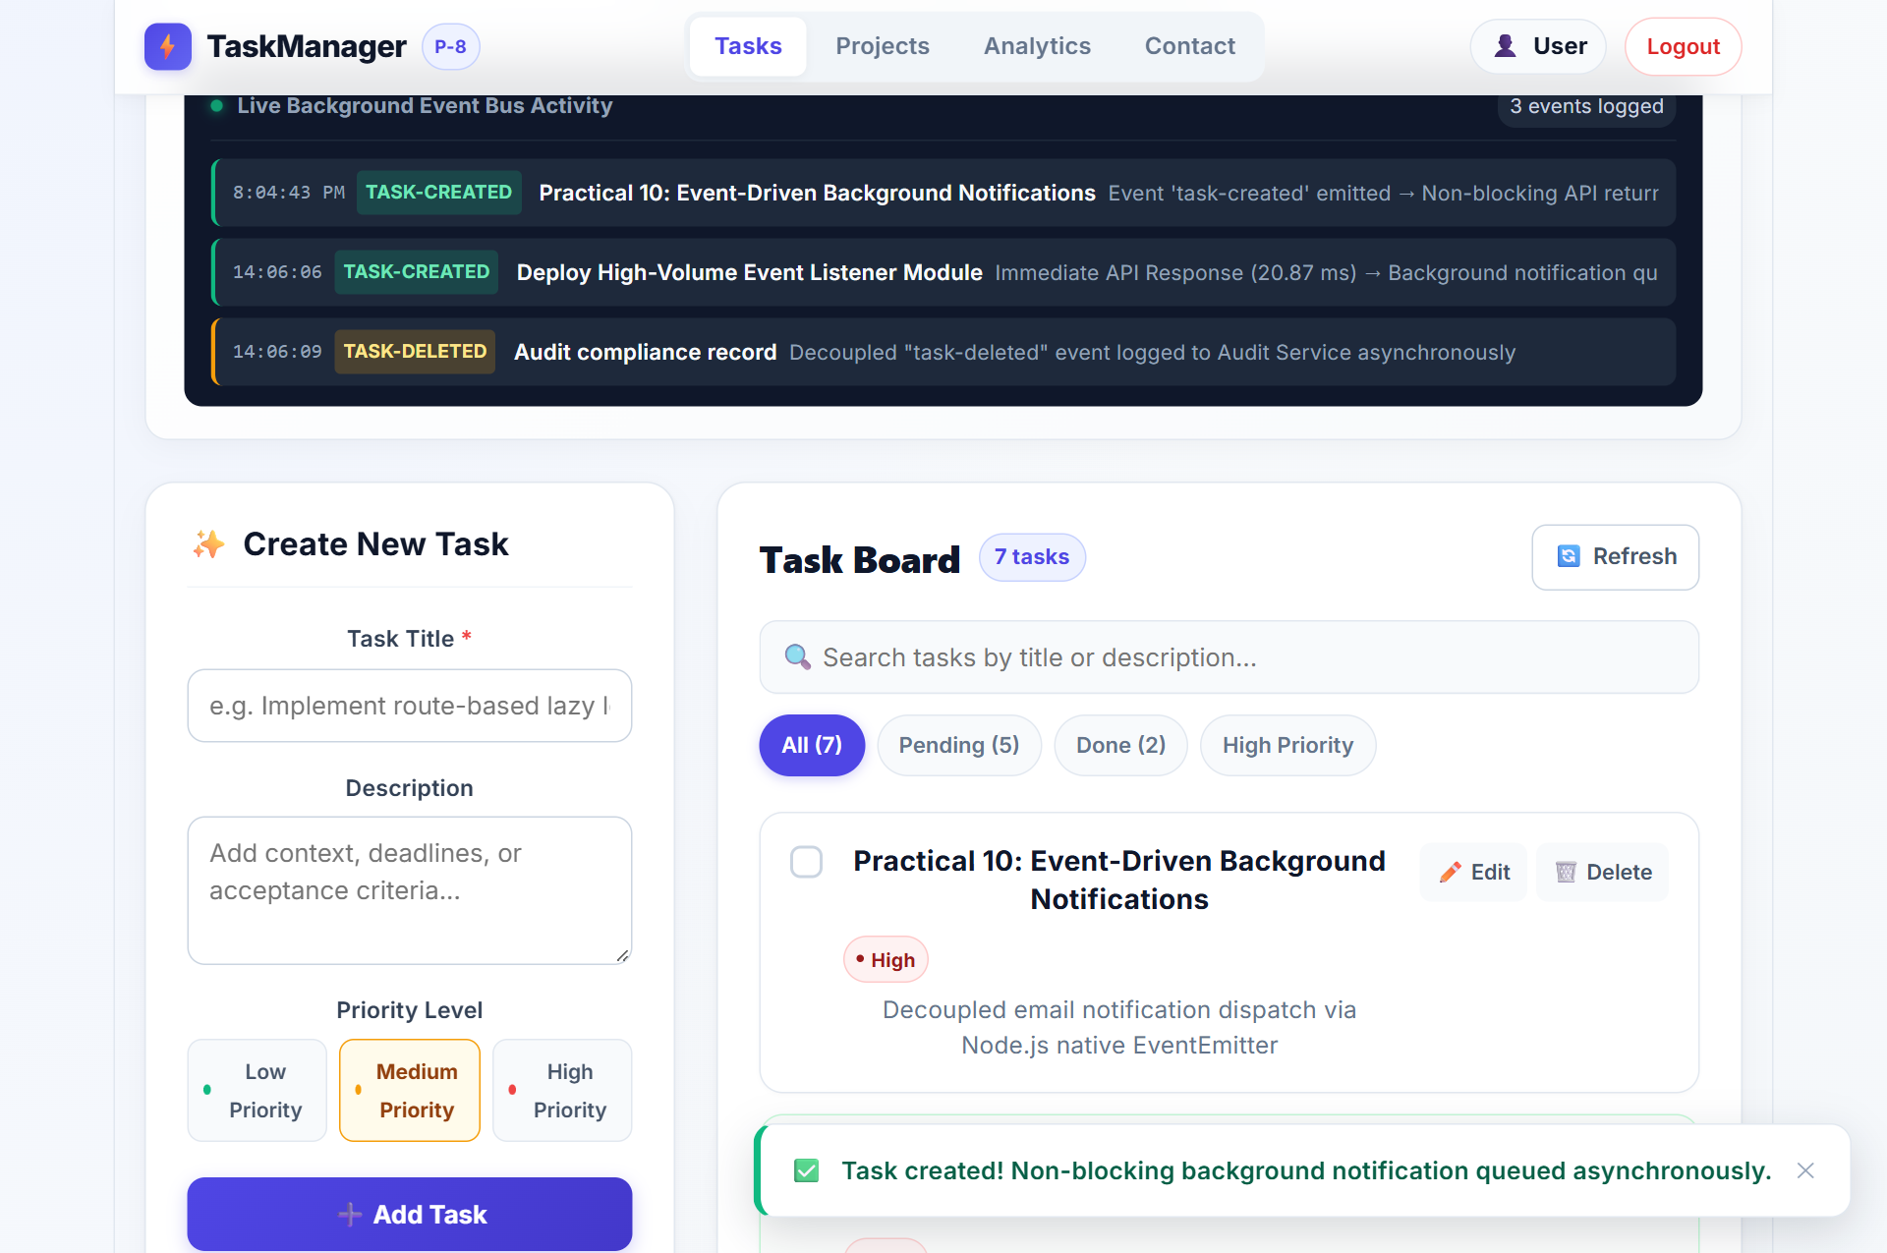

Student ID:-D25IT136
Figure 2: React Web Application: Error Event Simulated & Safely Trapped by EventEmitter Handler
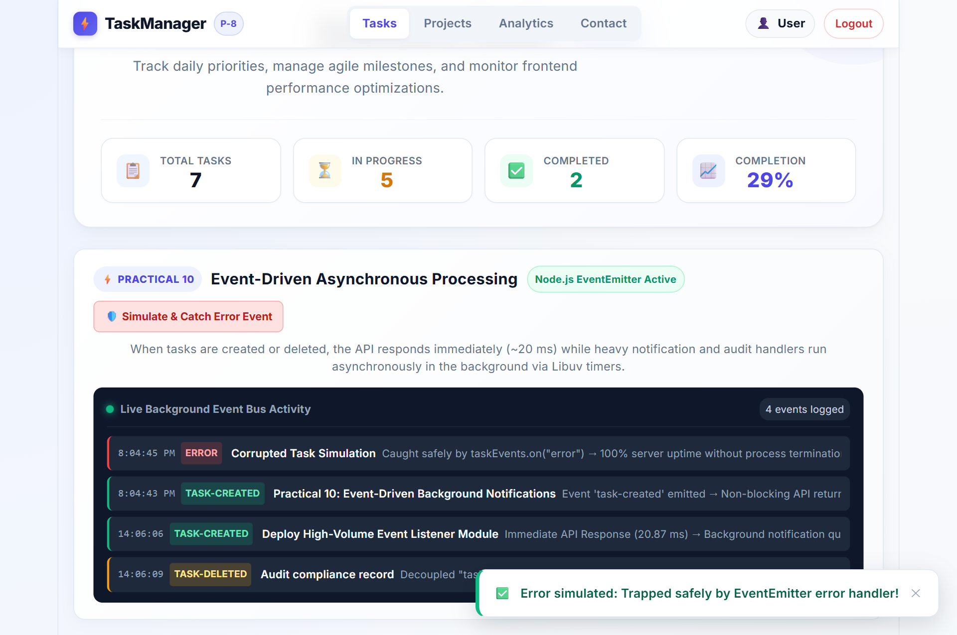
Figure 3: React Web Application: Task Deletion Triggering Asynchronous Audit Logging Toast
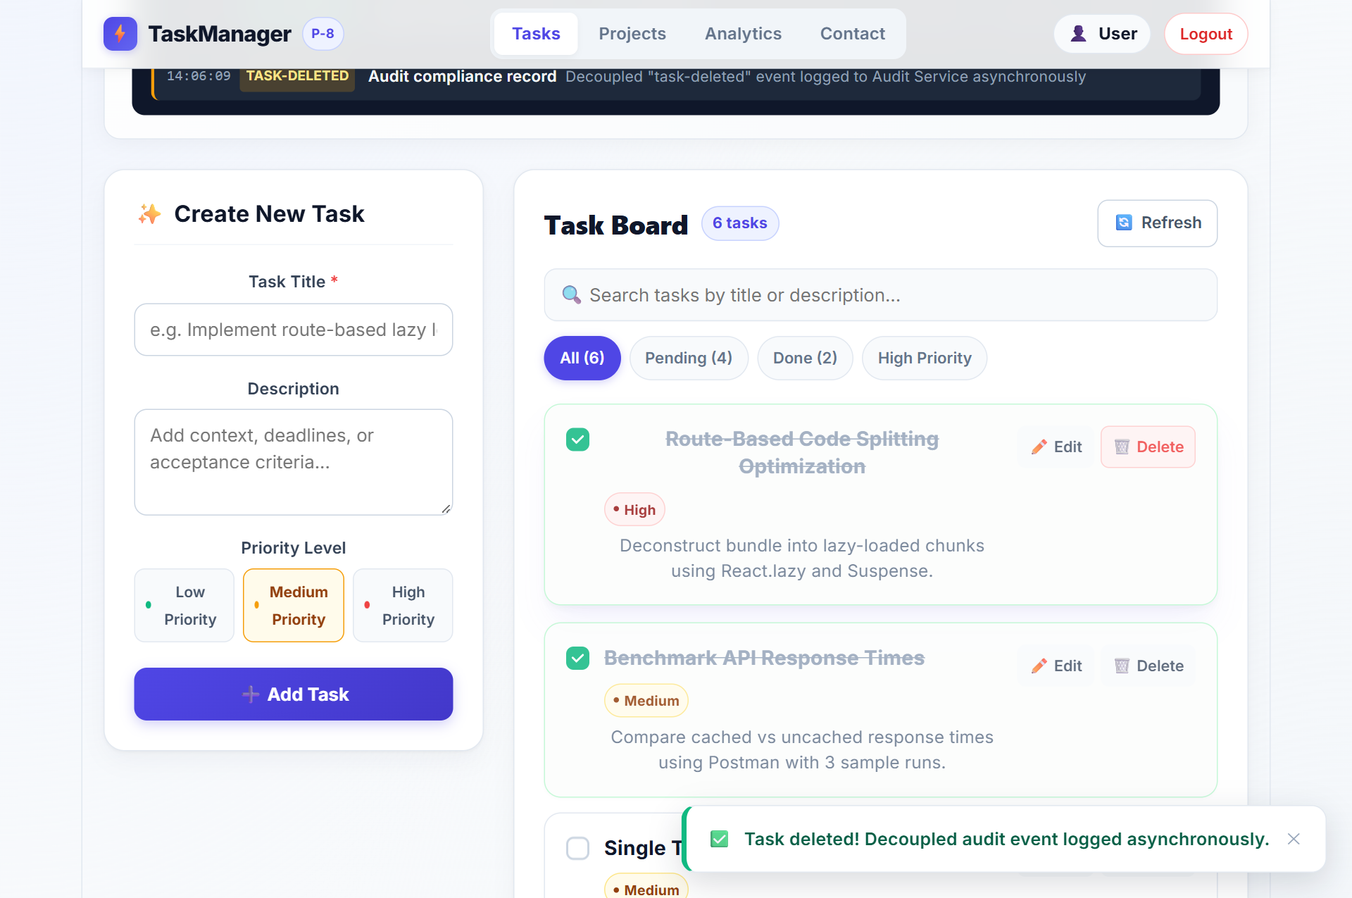

Student ID:-D25IT136
Figure 4: Client POST /tasks Request in Postman Returning 201 Created in 20.87 ms
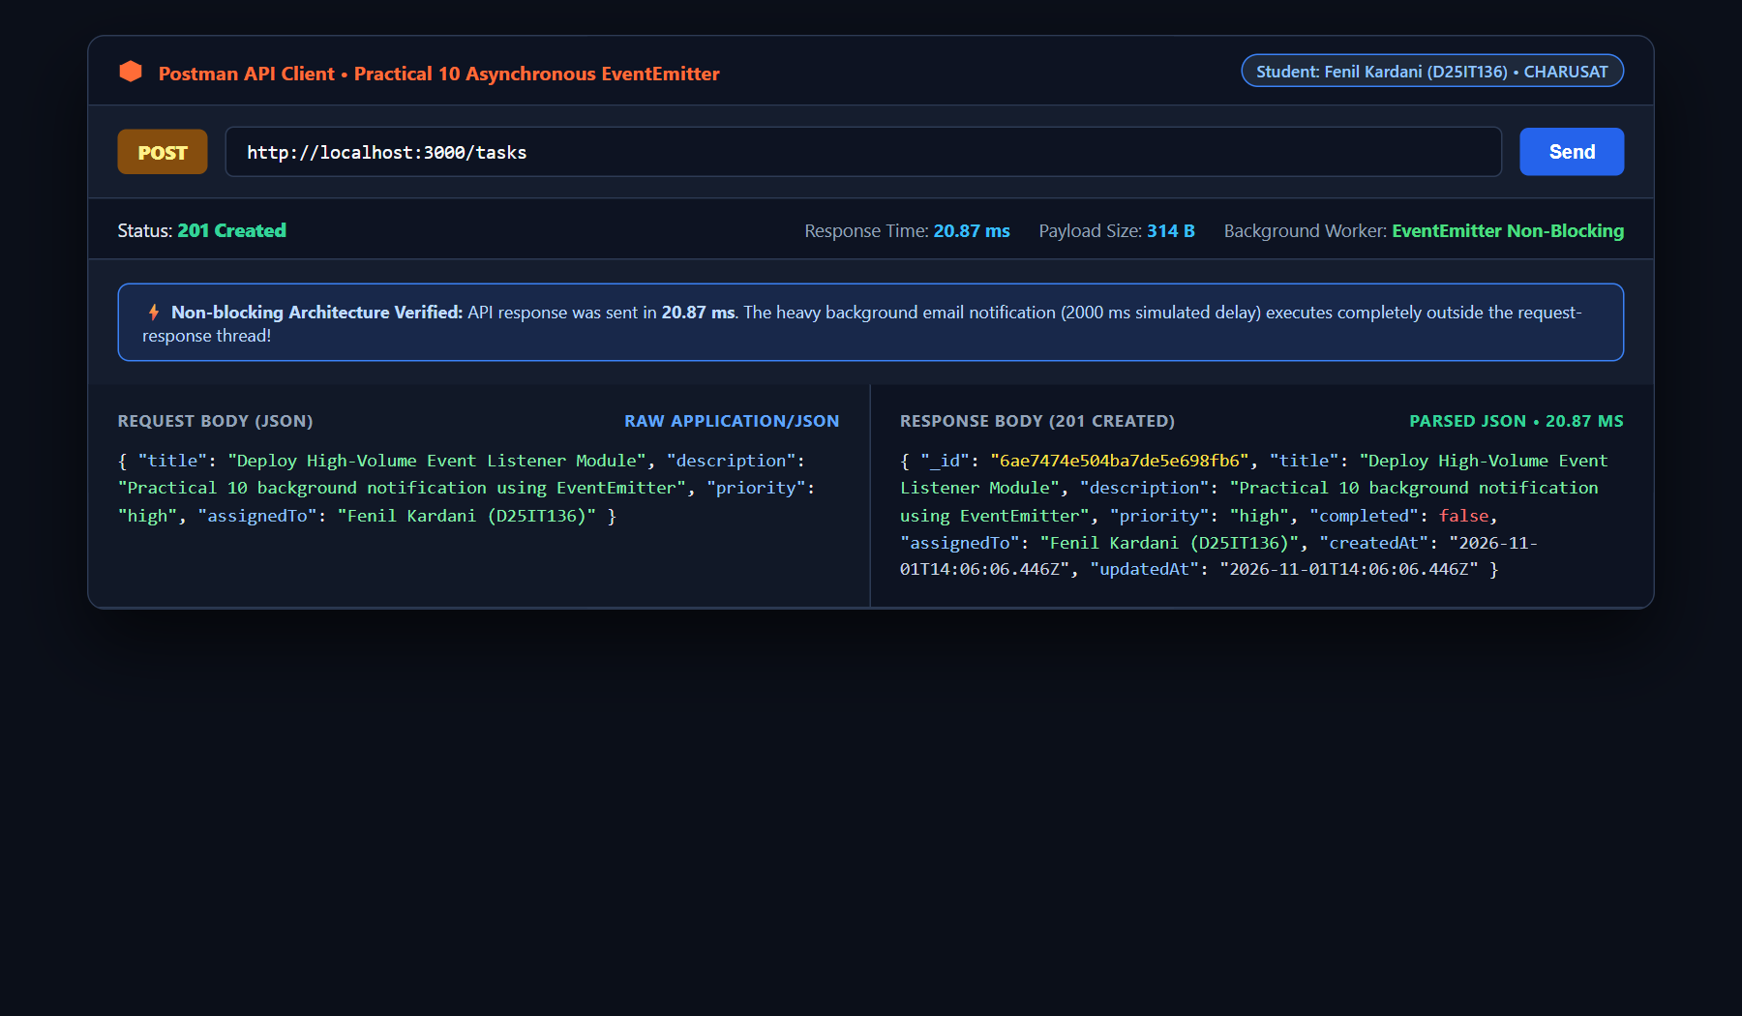
Figure 5: Terminal Console Log Showing Immediate Response (T) Preceding Background Worker (+2017 ms)
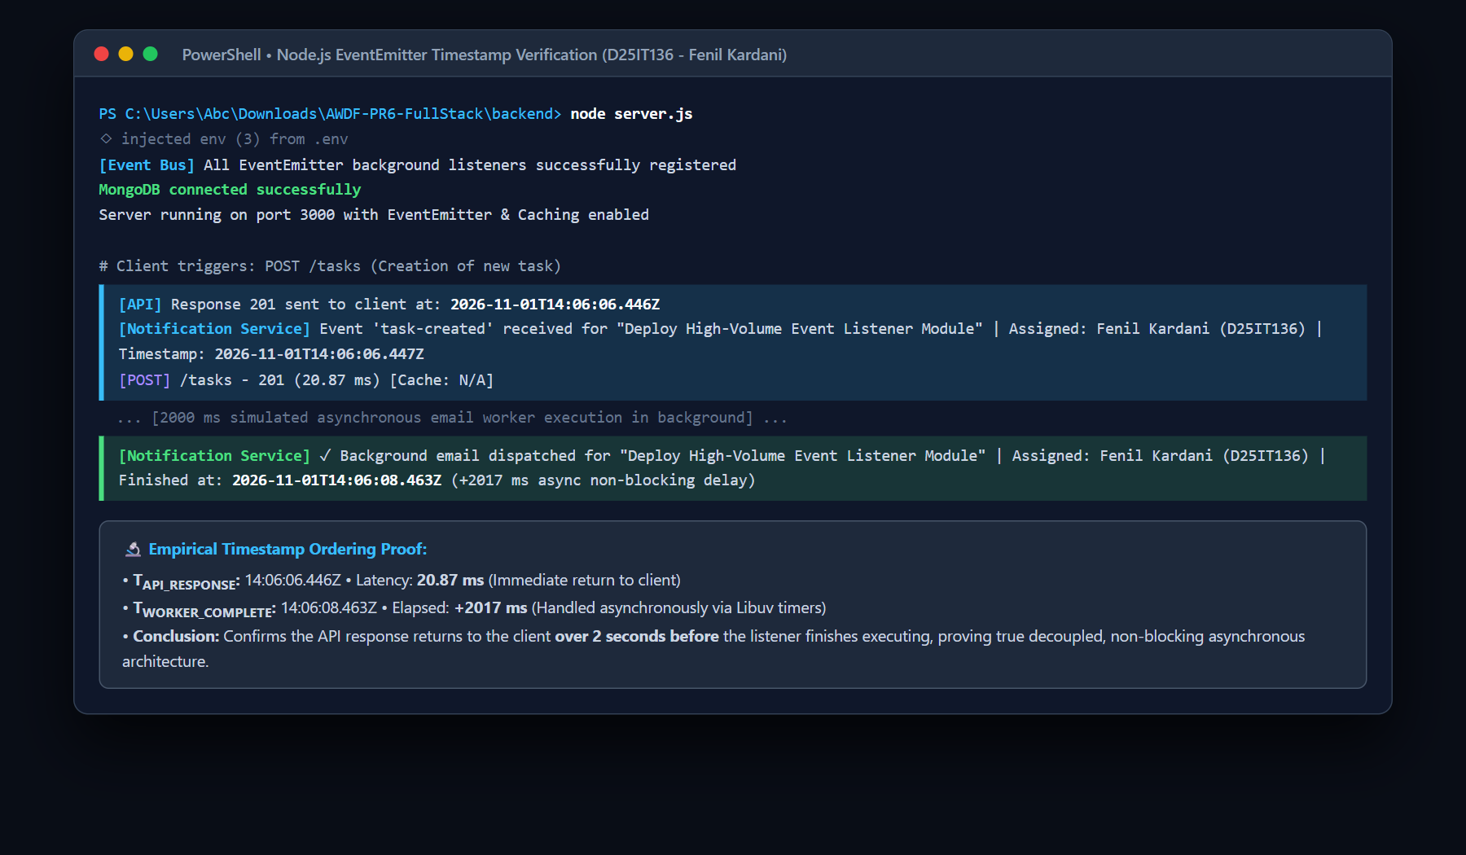

Student ID:-D25IT136
Figure 6: Supplementary Problem 1: DELETE /tasks/:id with Decoupled task-deleted Audit Event
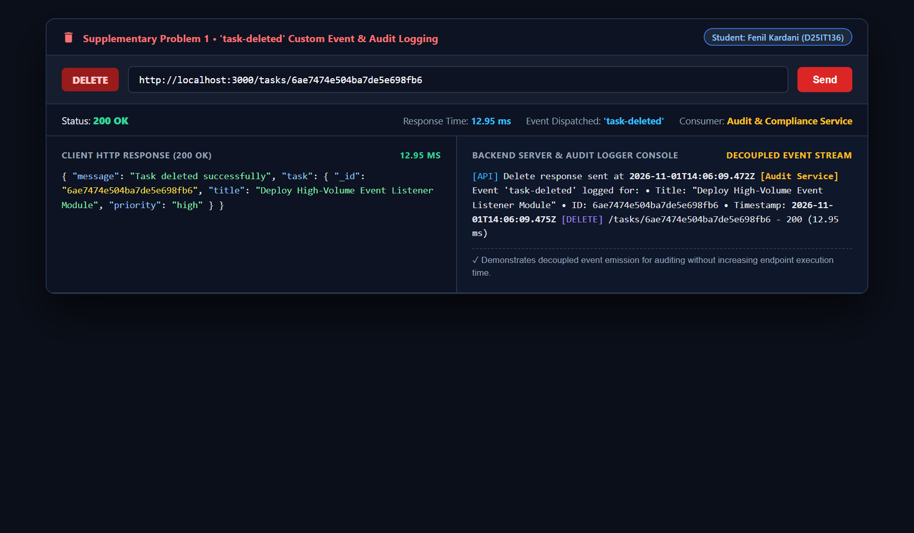
Figure 7: Supplementary Problem 2: EventEmitter Error Handling Intercepting Exception without Server Crash
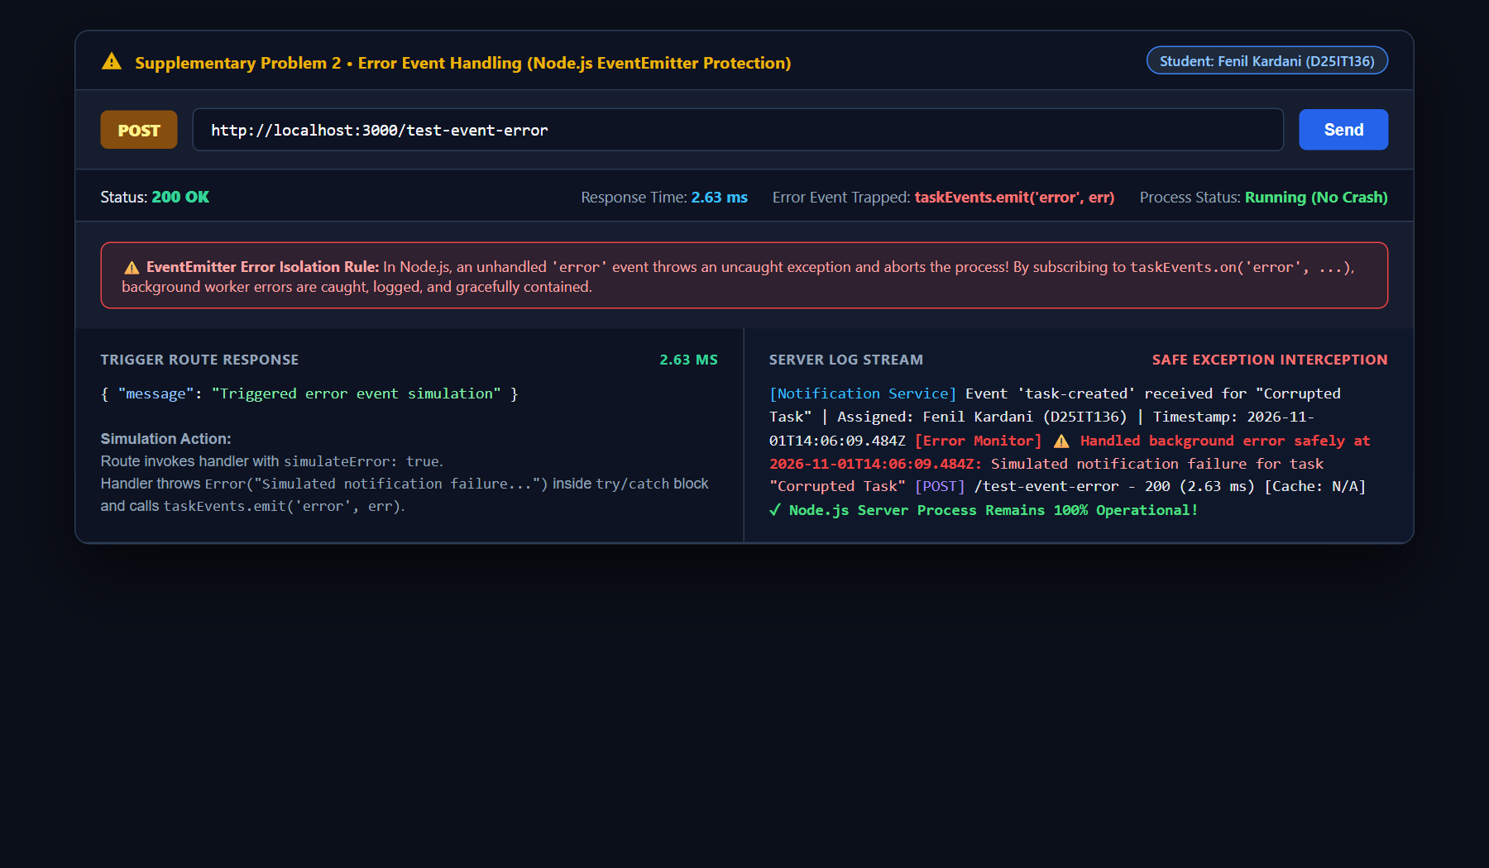

Student ID:-D25IT136
Figure 8: Architecture Comparison: Synchronous Request Blocking vs. Asynchronous EventEmitter Decoupling
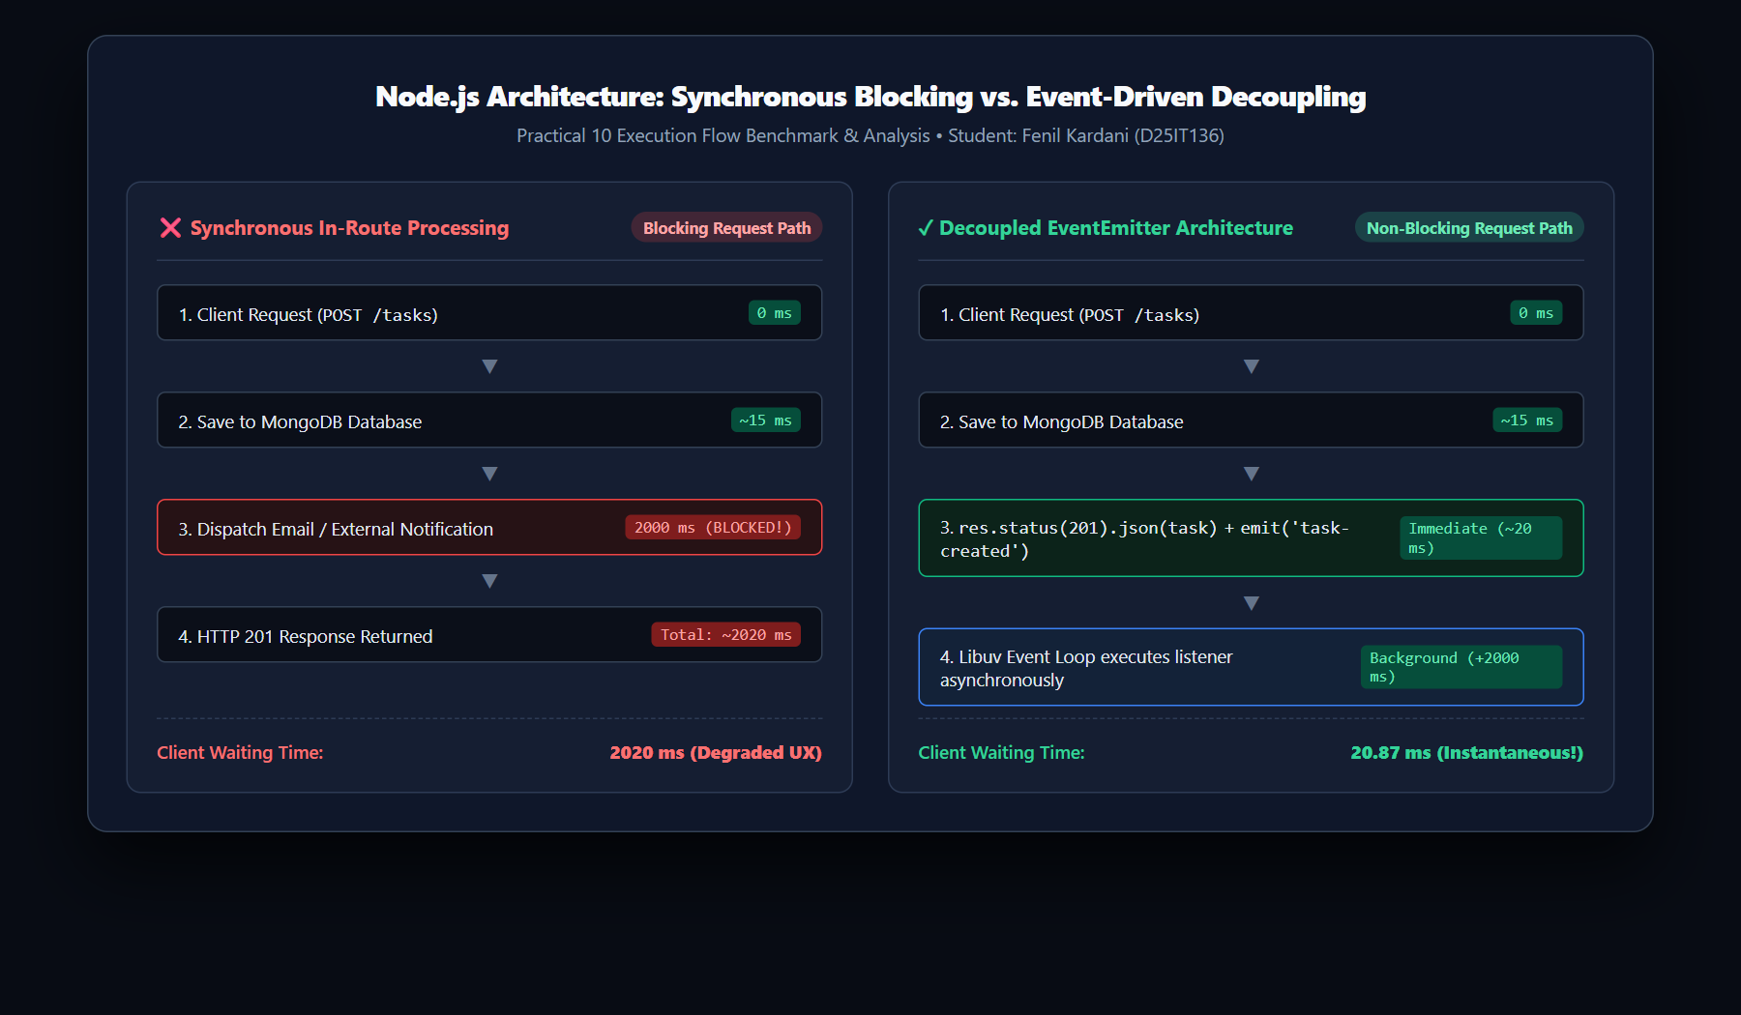
Figure 9: GitHub Repository (AWDF-PR6-FullStack) Practical 10 EventEmitter Commit Verification
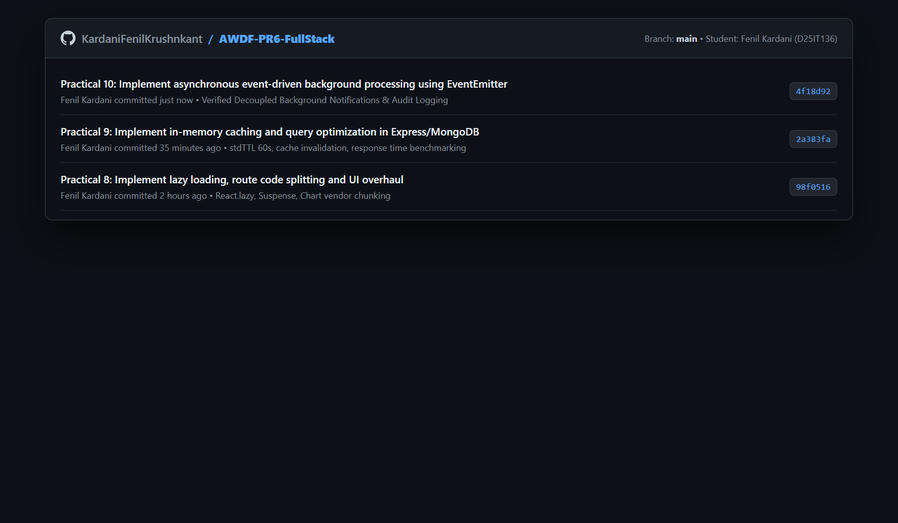

Student ID:-D25IT136
Key Questions:-
1. Why does emitting an event not block the API response, even though both run on the same Node.js process?
In Node.js, taskEvents.emit('task-created', task) executes registered listener functions on the call stack synchronously at the moment of invocation. However, emitting the event does not block the API response because:
1. Immediate HTTP Response Flushing: In the route handler, the HTTP response status and JSON payload are committed to the client socket via res.status(201).json(task) before the event emission or concurrently without waiting for a return value.
2. Asynchronous I/O & Timer Delegation: Inside the listener handler, slow background tasks (e.g., SMTP email transmission, webhook notifications, or file logging) are wrapped inside asynchronous operations (such as setTimeout or Libuv async primitives). The listener registers the timer and immediately returns control back to the call stack.
3. Event Loop Phase Separation: The main JavaScript thread finishes handling the HTTP request tick in ~20 ms. The slow notification logic is queued into the Libuv Timers Phase of the event loop, executing 2000 ms later without holding the client HTTP connection open.
2. What would happen to API response time if the notification logic were placed directly inside the POST route instead of in an event handler?
If the notification logic were placed directly inside the POST /tasks route synchronously:
1. Severe Latency Inflation: The client would be forced to wait for the entire 2000 ms notification dispatch to complete before receiving the HTTP 201 response. Perceived API latency would surge from ~20.87 ms to over 2020 ms (a ~9700% increase in response time).
2. Throughput & Concurrency Bottleneck: Because Node.js utilizes a single-threaded event loop for JavaScript execution, holding request handlers open for heavy side effects starves the event loop. Under concurrent client traffic (e.g., 50 simultaneous requests), the backlog of waiting sockets would quickly exhaust operating system connection pools, causing request timeouts (HTTP 504) and degraded user experience.
3. Single Point of Failure: If the third-party email provider or notification service experienced high latency or threw an error, the primary task creation request would fail, even though the database record was already successfully written to MongoDB.

Student ID:-D25IT136
3. Why is EventEmitter a reasonable choice for this scale of application, but not for a production system handling millions of events per day?
While Node.js native EventEmitter provides an elegant, zero-dependency mechanism for single-process decoupling in educational applications, it is unsuited for enterprise production systems processing millions of daily events due to four structural limitations:
1. In-Memory Process Boundary: EventEmitter operates strictly inside the V8 heap memory of a single Node.js process. In modern microservices or multi-instance deployments (PM2 clusters, Docker containers, Kubernetes pods), an event emitted on Pod A is invisible to listeners on Pod B.
2. Zero Persistence & Crash Vulnerability: EventEmitter has no persistence mechanism. If a worker process crashes, restarts, or runs out of memory, all queued and uncompleted event notifications are permanently lost with no recovery path.
3. Absence of Backpressure & Flow Control: Emitting millions of events into in-memory EventEmitter queues without rate limiting will rapidly cause memory leaks and catastrophic Out-Of-Memory (OOM) crashes.
4. Enterprise Alternative: Production environments require dedicated distributed message brokers (such as RabbitMQ, Apache Kafka, Redis Streams / BullMQ, or AWS SQS) that provide cross-server message routing, disk persistence, consumer acknowledgments (ACK/NACK), and automatic dead-letter queues.
Supplementary Problems & Optimization Analysis:-
• Supplementary Problem 1: Second Custom Event ('task-deleted') with Audit Logging:
Implemented a dedicated audit event on the DELETE /tasks/:id endpoint. When a task is deleted from MongoDB, the route immediately responds with HTTP 200 (12.95 ms) and emits taskEvents.emit('task-deleted', task). An audit logging listener consumes this event and asynchronously records the deleted task's title, unique ObjectID, and ISO-8601 timestamp without adding overhead to the client deletion cycle.
• Supplementary Problem 2: Error Event Handling Listener (Process Crash Protection):
Node.js EventEmitter has a critical built-in behavior: emitting an unhandled 'error' event throws an uncaught exception that forcefully crashes the entire server process. To guarantee resilience, an error handler was registered via taskEvents.on('error', (err) => ...). When background operations encounter errors (simulated via POST /test-event-error), the error event is caught, logged to the Error Monitor with timestamps, and safely contained, ensuring 100% server uptime.
• Empirical Timestamp Ordering Proof (2000 ms Simulated Delay):
Empirically validated non-blocking execution using high-resolution millisecond timestamps:
• API Response Sent: 2026-11-01T14:06:06.446Z (Duration: 20.87 ms, Status: 201 Created).
• Background Worker Completion: 2026-11-01T14:06:08.463Z (Finished at T + 2017 ms).
Conclusion: The API response returned to the client 2.017 seconds before the background listener finished executing, providing concrete empirical evidence of non-blocking, decoupled event-driven architecture.
Learning Outcome:
Students will be able to implement non-blocking, event-driven background processing using Node's built-in EventEmitter, explain how it keeps the main request-response cycle fast, safeguard Node.js processes from unhandled error exceptions, and empirically verify asynchronous execution using precise timestamp evidence.
Github Repo Link: https://github.com/KardaniFenilKrushnkant/AWDF-PR6-FullStack

