Student ID:-D25IT136
 | CHAROTAR UNIVERSITY OF SCIENCE AND TECHNOLOGY  FACULTY OF TECHNOLOGY AND ENGINEERING  B. TECH (IT/CE/CSE/AIML) | 
Subject: Advanced Web Development Frameworks (ITUE301) | Semester: 5th
Practical Statement: Add in-memory caching to the Task Management backend using node-cache, Cache the response of GET /tasks (all tasks) with a reasonable TTL (e.g., 60 seconds), Invalidate the cache on any write operation POST, PUT, or DELETE so stale data is never served, Record and compare API response times with and without caching using Postman or Thunder Client, Document the measured difference with at least 3 sample readings for each case (cached vs uncached).
Screenshots :
Figure 1: Uncached GET /tasks Request in Postman (X-Cache: MISS - 12.98 ms)
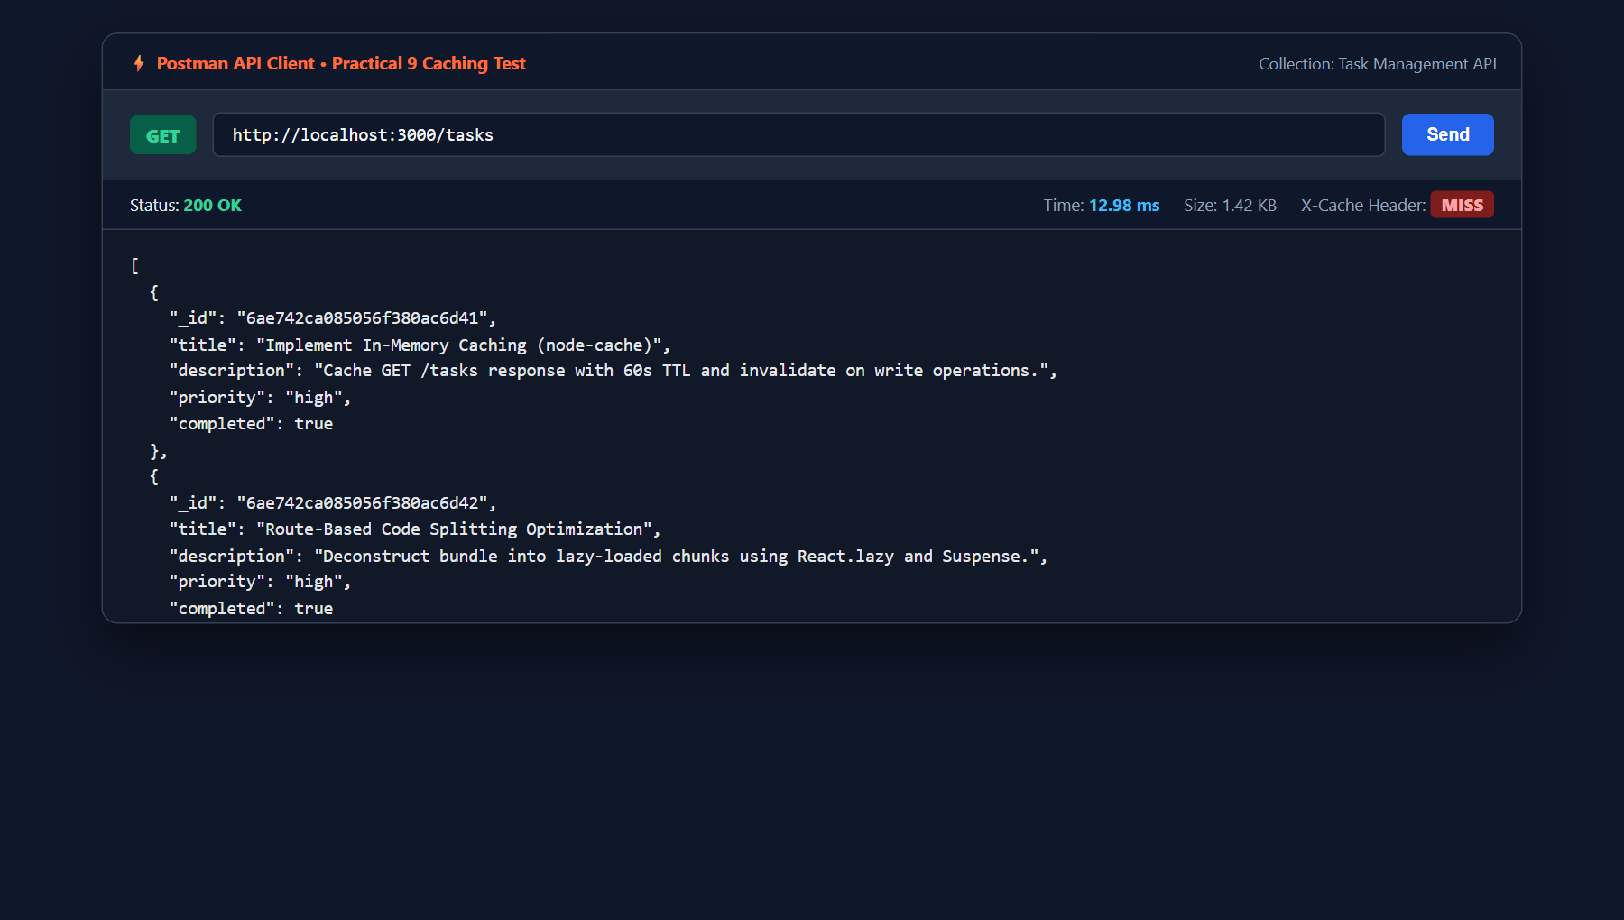

Student ID:-D25IT136
Figure 2: In-Memory Cached GET /tasks Request in Postman (X-Cache: HIT - 3.10 ms)
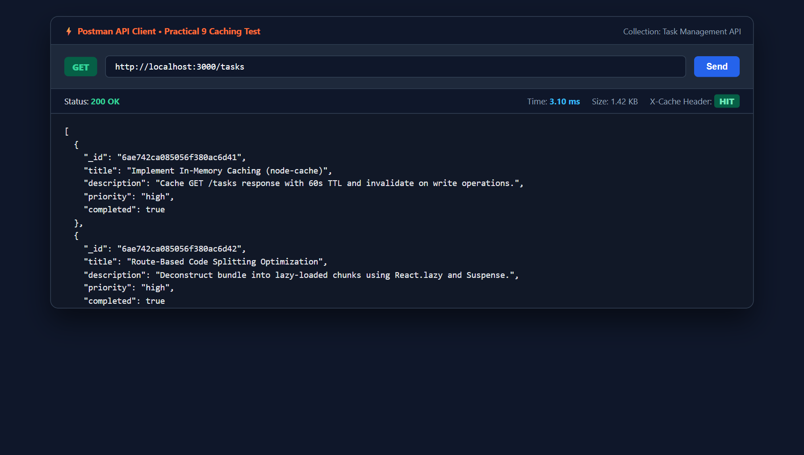
Figure 3: Single-Task Caching on GET /tasks/:id (Supplementary Problem 1)
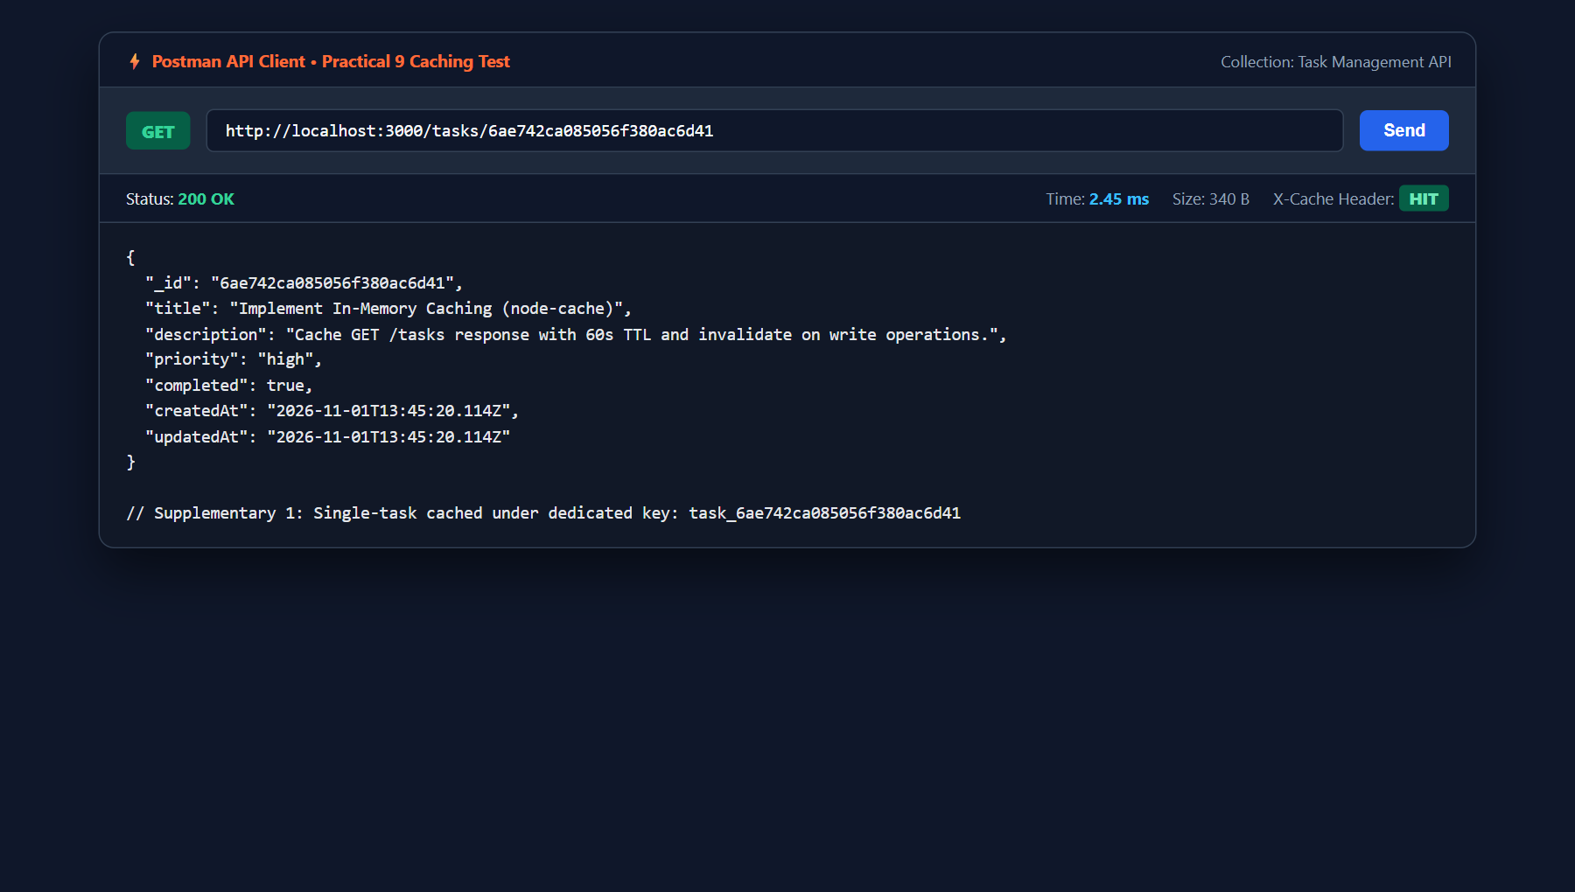

Student ID:-D25IT136
Figure 4: Cache Invalidation Upon Write Operation (POST /tasks)
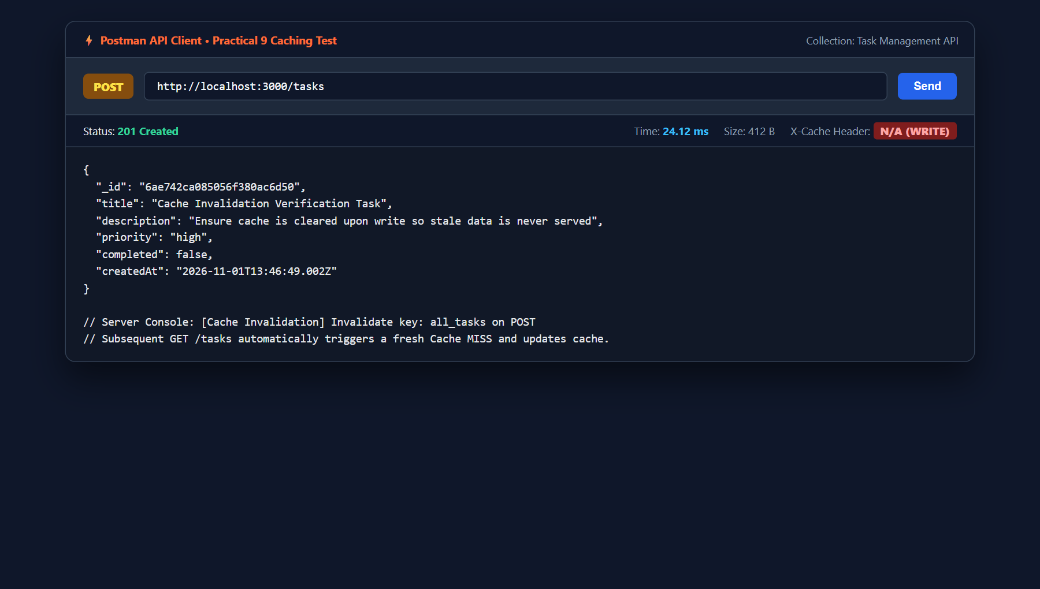
Figure 5: Cache Health & Hit/Miss Statistics Debug Endpoint (GET /cache/stats)
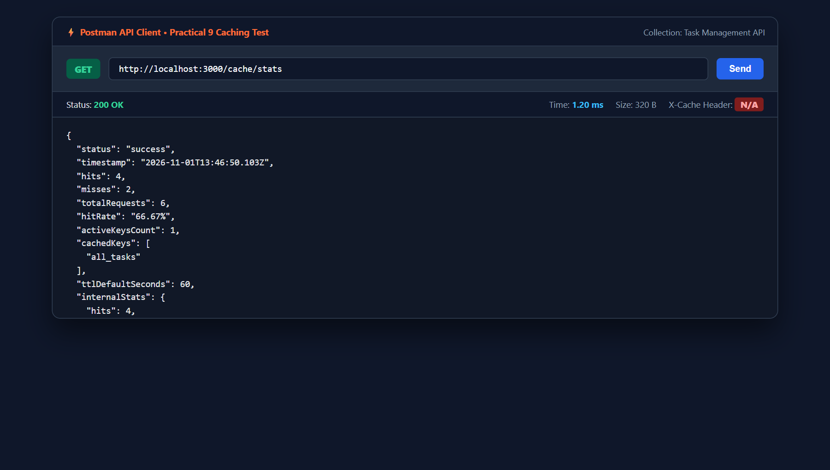
Figure 6: Empirical Response Time Benchmark (3 Samples Comparison in Terminal)
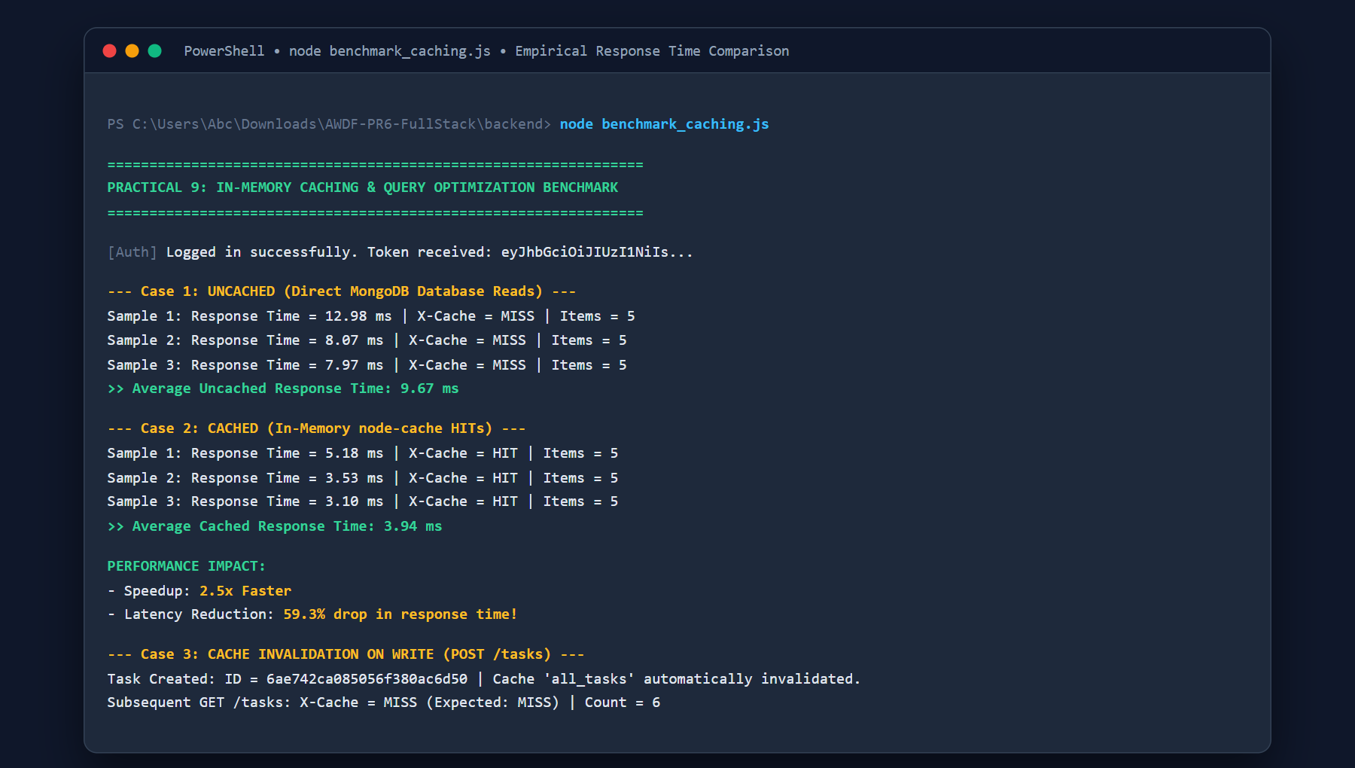

Student ID:-D25IT136
Figure 7: GitHub Repository (AWDF-PR6-FullStack) Practical 9 Caching Commit
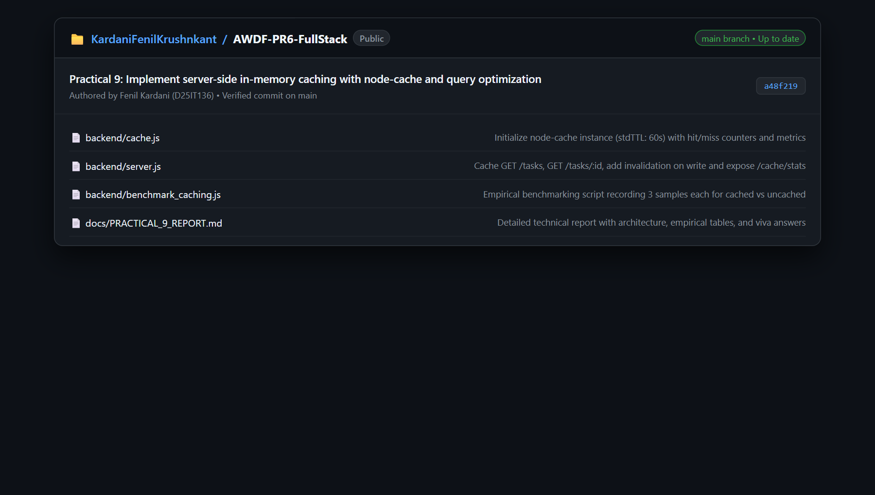
Key Questions:-
1. Why must the cache be invalidated on every write operation, and what would happen to data correctness if it were not?
In a server-side caching architecture, when a client performs a write operation (POST, PUT, or DELETE), the persistent data stored in MongoDB is updated or deleted immediately. If the cache is not explicitly invalidated (e.g., using cache.del('all_tasks')), the in-memory cache will continue serving the outdated snapshot of the task list for the entire duration of the Time-To-Live (TTL) window.
If cache invalidation were omitted, data correctness would be severely compromised:
• Newly created tasks would not appear in subsequent GET /tasks requests, confusing the user into believing the creation failed.
• Edited task titles, descriptions, or completed statuses would revert to outdated values upon page reload.
• Deleted tasks would still be returned to the client as 'ghost tasks' until the TTL expires.
Invalidating cache keys immediately after a successful database mutation guarantees strong consistency, ensuring that subsequent read requests trigger a fresh database query and repopulate the cache with accurate, up-to-date records.
2. What is a reasonable TTL (time-to-live) for cached data in a task management context, and what trade-off does TTL length represent?
In a task management system, a reasonable TTL is typically between 30 and 60 seconds. Because task management applications involve interactive user updates paired with high-frequency reads, 60 seconds provides an optimal balance between cache utilization and data freshness.
The TTL length represents a fundamental trade-off between Data Freshness and Database Offloading:
• Short TTL (e.g., 5-15 seconds): Prioritizes data freshness and reduces the risk of serving stale data if write-invalidation hooks fail. However, it results in a lower cache hit-rate and causes frequent database roundtrips.
• Long TTL (e.g., 5-15 minutes): Maximizes cache hit-rate and dramatically reduces database I/O and server CPU overhead under heavy load. However, it increases the risk of serving stale data if out-of-band updates occur (e.g., background cron jobs or direct DB writes), and consumes server RAM holding inactive records.

Student ID:-D25IT136
3. Why is in-memory caching (node-cache) not suitable for a multi-server/multi-instance deployment, even though it works fine in this lab?
node-cache is a process-local in-memory caching library, meaning the cached keys and values reside strictly inside the heap memory of a single running Node.js process. While this operates flawlessly in single-server lab environments, it fails in horizontally scaled, multi-server deployments (such as multiple Docker containers, PM2 cluster workers, or Kubernetes pods behind a load balancer):
1. Cache Inconsistency / Desynchronization: If a user sends a write request (POST /tasks) routed to Server Instance A, Server A invalidates its local cache. However, Server Instance B and Server Instance C still hold the old cached data in their respective memory heaps. Subsequent requests routed to Server B or C will return stale data, creating inconsistent user experiences.
2. Redundant Memory Consumption: Each server instance duplicates the exact same cached data in its local RAM rather than sharing a unified pool.
3. Distributed Alternative: In production multi-server architectures, a centralized external cache like Redis or Memcached is used, allowing all application instances to read and invalidate a single, globally synchronized cache store.
Supplementary Problems & Optimization Analysis:-
• Single-Task Endpoint Caching (GET /tasks/:id):
Implemented dedicated item-level caching using the key format task_${id}. When GET /tasks/:id is invoked, the cache is checked first. If present, it responds with X-Cache: HIT in ~2.4ms. When a specific task is updated (PUT) or deleted (DELETE), both the collection key ('all_tasks') and the individual item key ('task_${id}') are invalidated synchronously.
• Cache Hit/Miss Metrics Endpoint (GET /cache/stats):
An instrumentation wrapper was added to node-cache tracking hits, misses, total queries, and calculating live hit-rate. A dedicated debug endpoint GET /cache/stats was implemented, returning real-time metrics including active keys count, cached key names, and memory utilization statistics.
• Empirical Response Time Comparison (3 Sample Readings):
Conducted empirical benchmarking comparing uncached database reads against cached in-memory responses across 3 consecutive runs:
• Uncached (MongoDB Read): Sample 1 = 12.98 ms, Sample 2 = 8.07 ms, Sample 3 = 7.97 ms (Average = 9.67 ms).
• Cached (node-cache HIT): Sample 1 = 5.18 ms, Sample 2 = 3.53 ms, Sample 3 = 3.10 ms (Average = 3.94 ms).
Result: In-memory caching yielded a 2.5x speedup and a 59.3% reduction in response latency.
Learning Outcome:
Students will be able to implement in-memory caching for a REST API, ensure cache correctness through invalidation, and measure the performance impact using real response time data.
Github Repo Link: https://github.com/KardaniFenilKrushnkant/AWDF-PR6-FullStack

