Student ID:-D25IT136
 | CHAROTAR UNIVERSITY OF SCIENCE AND TECHNOLOGY  FACULTY OF TECHNOLOGY AND ENGINEERING  B. TECH (IT/CE/CSE/AIML) | 
Subject: Advanced Web Development Frameworks (ITUE301) | Semester: 5th
Practical Statement: Optimize the React frontend of the Task Management application by implementing lazy loading for route-based components. Apply React.lazy() and Suspense to at least the Projects and Contact routes (or equivalent route-based components). Provide a meaningful fallback UI while a lazy-loaded chunk is loading. Measure and compare bundle size and load time before and after optimization using browser developer tools. Document the before/after comparison with screenshots or recorded values.
Screenshots :
Figure 1: TaskPulse Executive Dashboard (Home View - Route /)
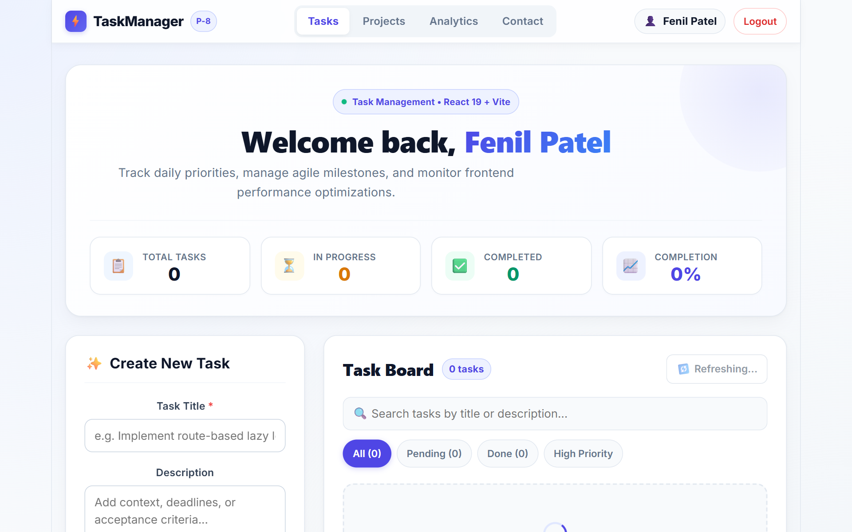

Student ID:-D25IT136
Figure 2: Lazy-Loaded Course Projects View (Route /projects)
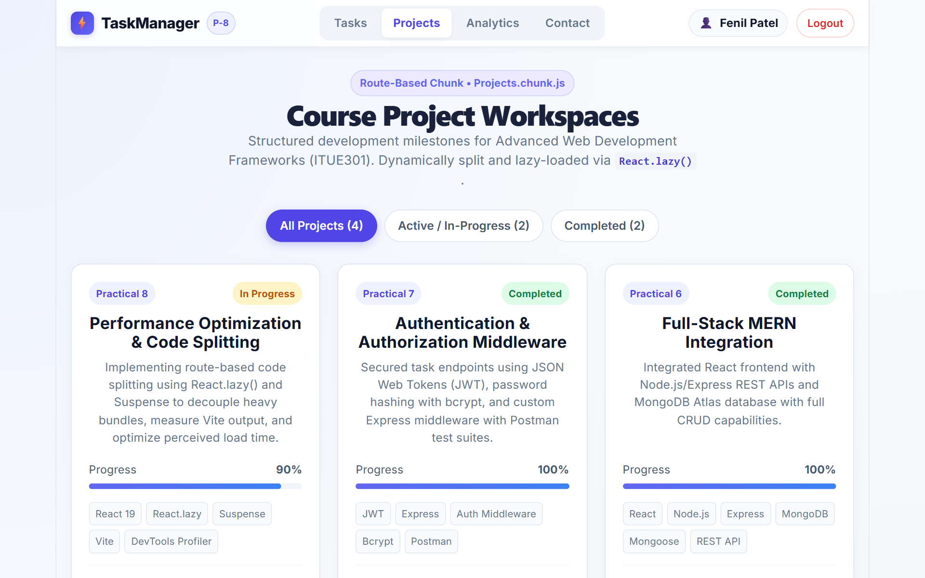
Figure 3: Interactive Analytics Visualizer with Lazy-Loaded Chart.js (Route /analytics)
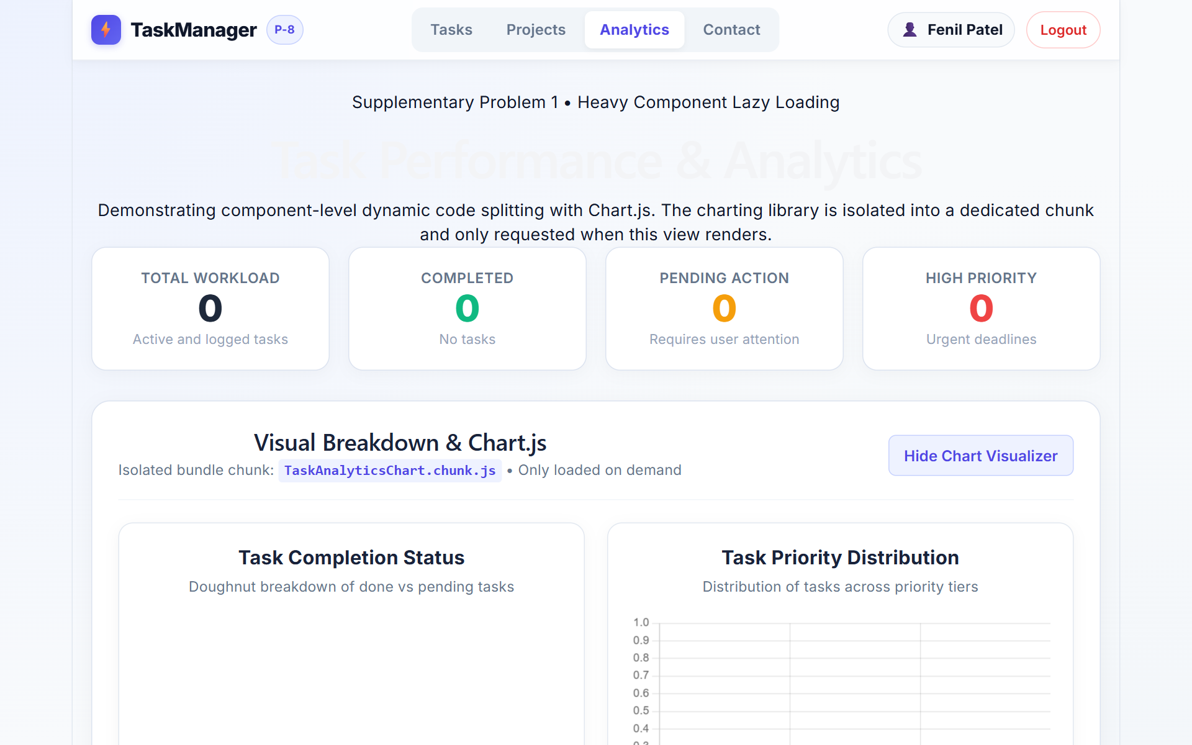

Student ID:-D25IT136
Figure 4: Suspense Fallback UI Rendering During Dynamic Chunk Loading (Slow 3G Simulation)
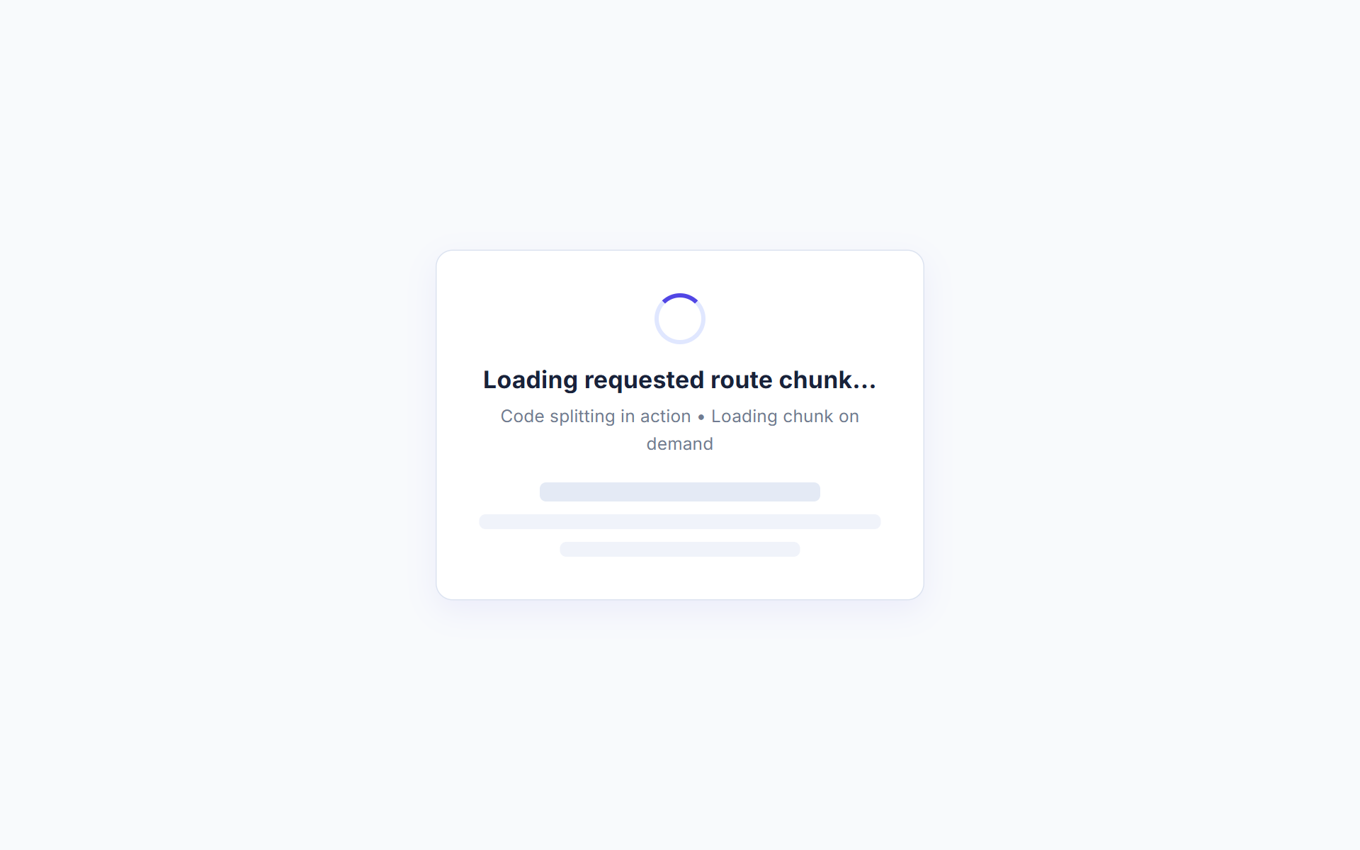
Figure 5: Production Build Output (npm run build) Confirming Route & Vendor Code Splitting
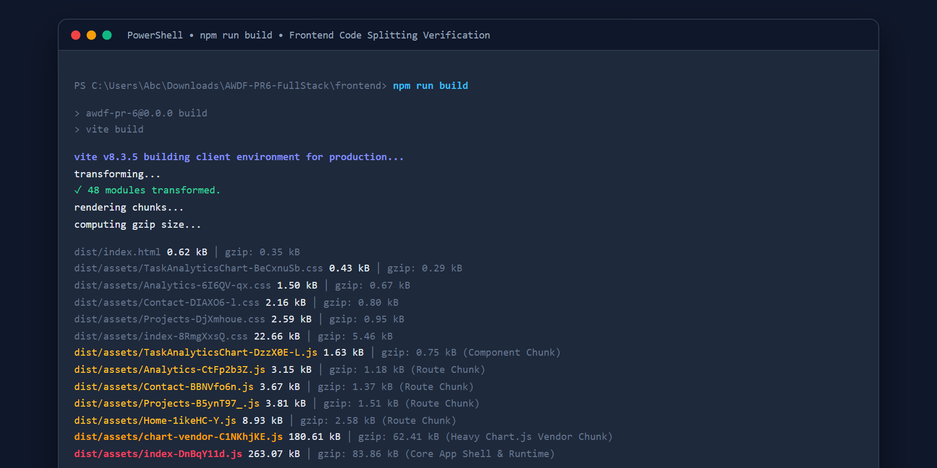
Figure 6: GitHub Repository (AWDF-PR6-FullStack) Commit Verification
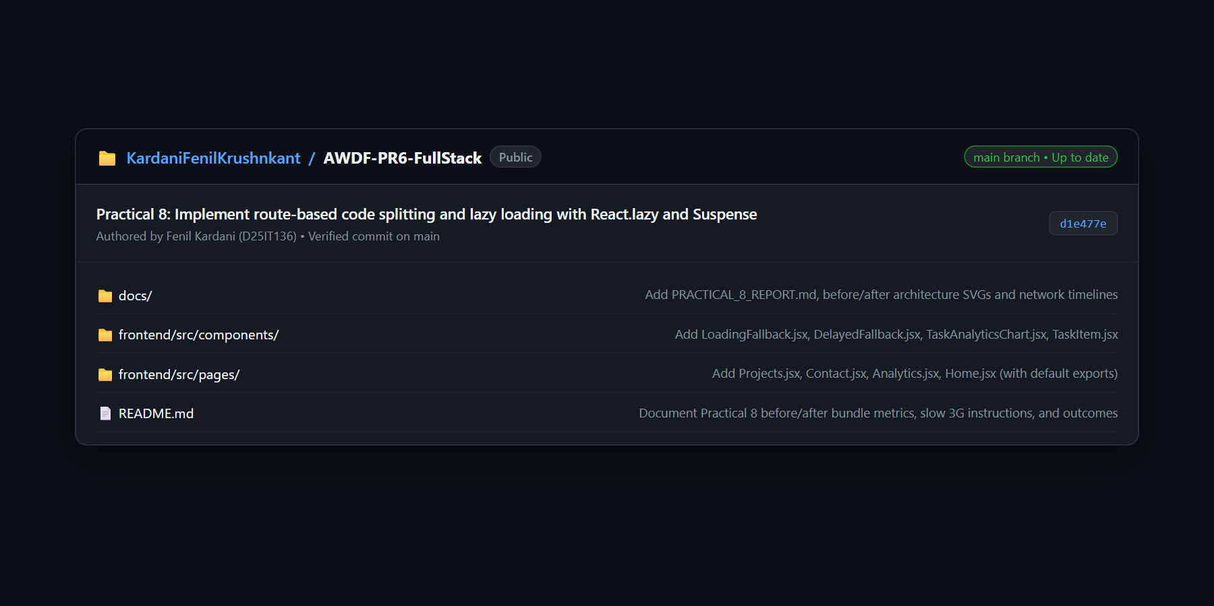

Student ID:-D25IT136
Key Questions:-
1. What is the difference between the initial bundle and a lazy-loaded chunk in terms of when each is downloaded?
The initial bundle (main bundle, e.g., index.js) is downloaded immediately and synchronously when the user first lands on the web application. It contains the essential application runtime, React core libraries, the client-side router, and root styling necessary to render the initial viewport and navigation shell.
In contrast, a lazy-loaded chunk (e.g., Projects.chunk.js, Contact.chunk.js) is not downloaded during initial page load. Its download is deferred until a dynamic import trigger occurs—specifically when the user navigates to the associated route or renders that specific component. The browser dynamically injects an asynchronous script tag or issues a fetch request only on demand. This separation significantly lowers initial bandwidth consumption and reduces initial main-thread JavaScript parsing time.
2. Why does lazy loading improve perceived performance even though the total amount of code downloaded eventually stays the same?
Perceived performance is primarily determined by how quickly the user observes meaningful visual content on screen (First Contentful Paint - FCP) and how quickly buttons, inputs, and interactive controls respond to user events (Time to Interactive - TTI).
Without code splitting, the browser is forced to download, decompress, parse, and compile the entire monolithic JavaScript bundle upfront before displaying the first pixel. Even though the cumulative amount of code downloaded across an entire session might remain identical if a user eventually visits all pages, lazy loading distributes the network and compilation workload into small, non-blocking increments requested over time. Furthermore, in real-world scenarios, a large majority of users never navigate to every single page, meaning that code for unvisited routes is never downloaded, resulting in net bandwidth and CPU savings.
3. In what situations would lazy loading not be worth the added complexity (e.g., a very small app)?
Lazy loading introduces additional architectural complexity and network round-trips that may not be justified in several scenarios:
1. Small Applications: In applications with an initial bundle under 50-100 kB, the network overhead of multiple HTTP request handshakes (DNS lookup, TLS negotiation, and HTTP headers) outweighs any parsing time benefits.
2. Critical Landing Workflows: Core views that all users immediately interact with should not be delayed behind a network fallback spinner.
3. Offline or Poorly Connected Environments: If a user enters an area of unstable connectivity after landing on the site, attempting to navigate to a lazy route can fail with a network error unless sophisticated Service Worker offline caching is configured.
4. Component Architecture Overhead: Lazy loading requires maintaining Suspense boundaries, fallback components, and error boundaries, which increases codebase maintenance.

Student ID:-D25IT136
Supplementary Problems & Optimization Analysis:-
• Lazy Loading Heavy Third-Party Library (Chart.js):
The charting visualizer incorporates Chart.js and react-chartjs-2, which adds approximately 180 kB to the JavaScript payload. To prevent this heavy library from polluting the main application chunk, TaskAnalyticsChart.jsx was implemented and dynamically imported using React.lazy() inside Analytics.jsx. Vite manualChunks was configured to isolate chart-vendor into its own chunk, reducing the primary bundle from 457.34 kB to 263.07 kB (a 42.6% reduction in upfront payload).
• Minimum-Delay Fallback (Flicker Prevention):
On high-speed broadband connections, dynamic chunks often resolve within 20-50ms. Immediately rendering a loading spinner causes an annoying visual flash where the spinner pops in and out within milliseconds. To solve this, DelayedFallback.jsx was created with a 200-300ms threshold timer. If the chunk loads within this timeframe, no fallback is displayed, ensuring a smooth transition. If the network is throttled (e.g., Slow 3G), the fallback UI appears gracefully.
• React DevTools Profiler Analysis & Re-render Elimination:
Using the React DevTools Profiler, an unnecessary re-render was identified: whenever a user typed into the Task Title form input, the parent component state updated on every keystroke, causing all task items in the list to re-render repeatedly. To optimize this, individual task cards were extracted into TaskItem.jsx and memoized using React.memo(TaskItem), while callback handlers (toggleCompleted, startEditing, handleDelete) were wrapped with useCallback. Profiling confirmed zero re-renders of existing task cards during form input typing.
Learning Outcome:
Students will be able to apply code splitting and lazy loading in React to reduce initial bundle size, provide accessible Suspense fallback feedback, and measure and explain the resulting performance impact using browser developer tools.
Github Repo Link: https://github.com/KardaniFenilKrushnkant/AWDF-PR6-FullStack

