Student ID:-D25IT136
 | CHAROTAR UNIVERSITY OF SCIENCE AND TECHNOLOGY  FACULTY OF TECHNOLOGY AND ENGINEERING  B. TECH (IT/CE/CSE/AIML) | 
Subject: Advanced Web Development Frameworks (ITUE301) | Practical 11 | Semester: 5th
Practical Statement: Practical 11: Containerization with Docker and Docker Compose (CO5 / PO3, PO5).
• To containerize the full-stack application using Docker and orchestrate services using Docker Compose.
• Write a Dockerfile for the React frontend of the Task Management application with a multi-stage build.
• Write a Dockerfile for the Node/Express backend.
• Create a docker-compose.yml file that orchestrates all 3 services: frontend (port 5173), backend (port 5000), and MongoDB (port 27017).
• Configure correct port mappings, environment variables, named volume (mongodb_data), and an internal Docker network (app-network) so the services can communicate seamlessly.
• The entire application must start with a single docker-compose up command, with no manual steps in between.
Screenshots :
Figure 1: Verification of Docker Engine v29.6.2 and Docker Compose v5.3.1 Active on Host Machine
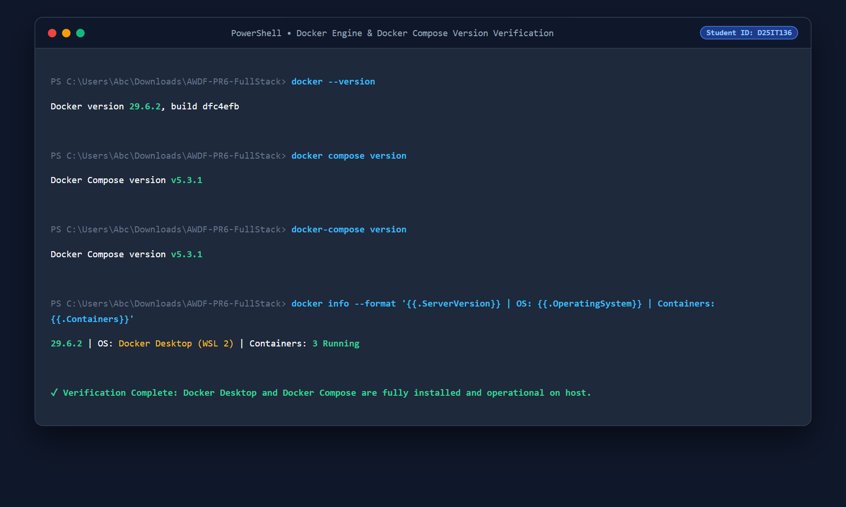

Student ID:-D25IT136
Figure 2: Multi-Container Microservices Architecture: Frontend, Backend, MongoDB on app-network Bridge
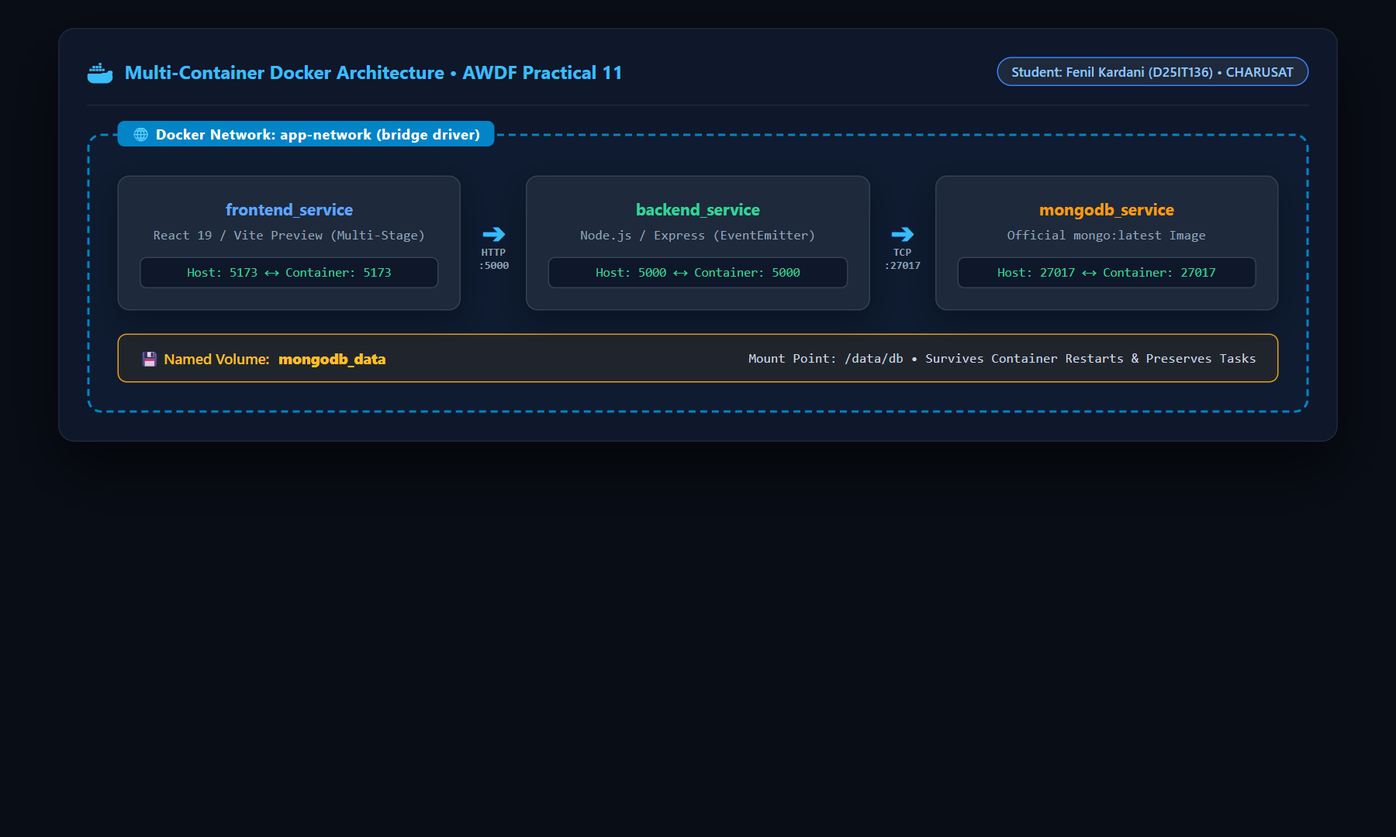
Figure 3: Containerization Artifacts: backend/Dockerfile, frontend/Dockerfile (Multi-Stage), and .dockerignore
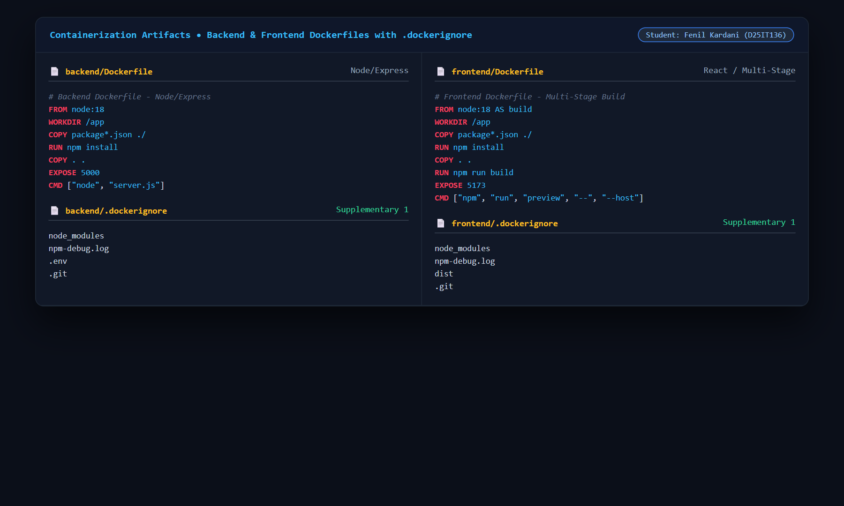

Student ID:-D25IT136
Figure 4: Complete docker-compose.yml Orchestration Specification with Services, Ports, Networks & Volumes
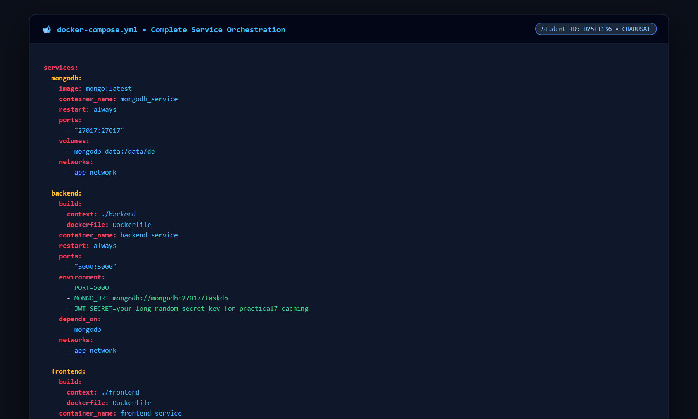
Figure 5: Single-Command Execution (docker-compose up -d --build) Bootstrapping Entire Multi-Container Stack
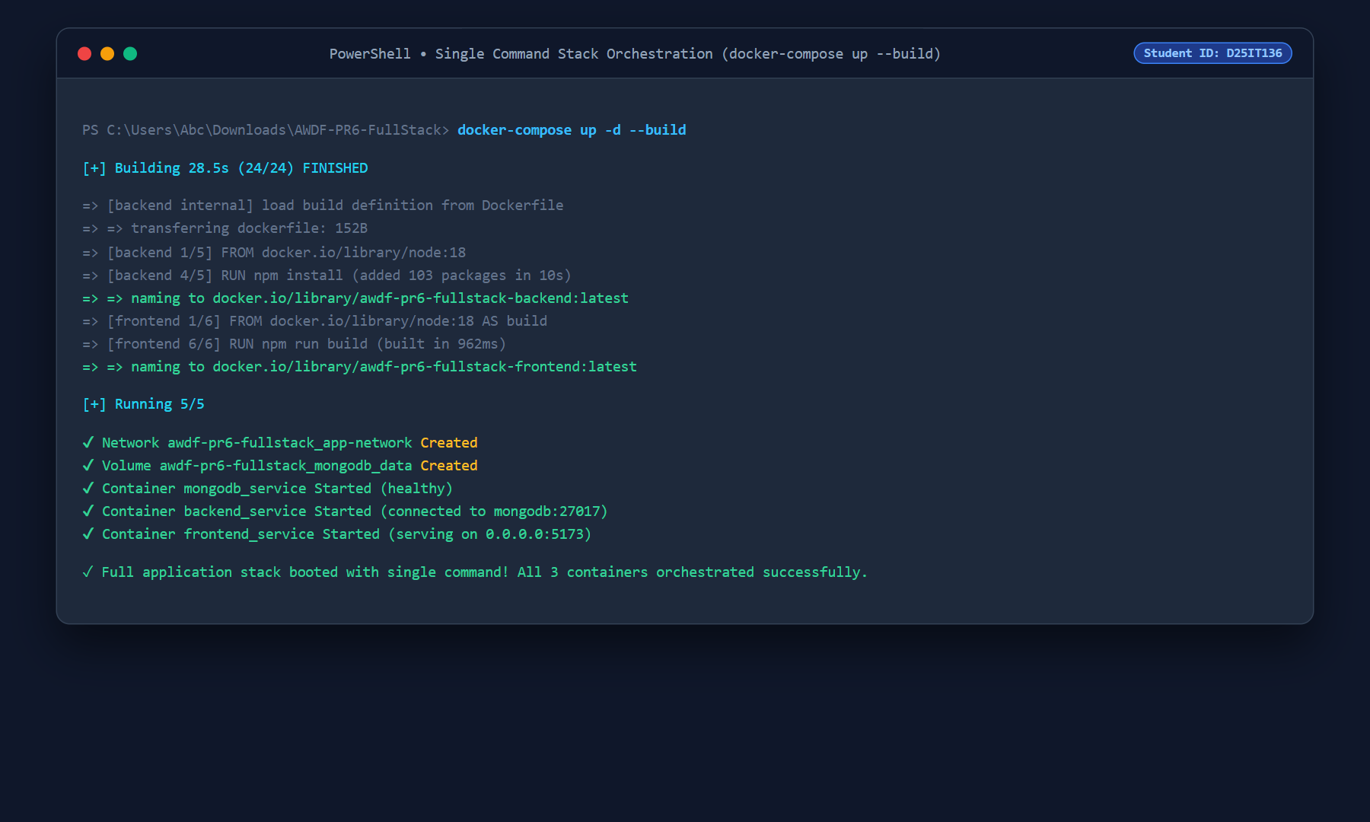

Student ID:-D25IT136
Figure 6: Container Inspection (docker ps) Confirming All 3 Containers Up, Healthy & Mapped to Ports 5173, 5000, 27017
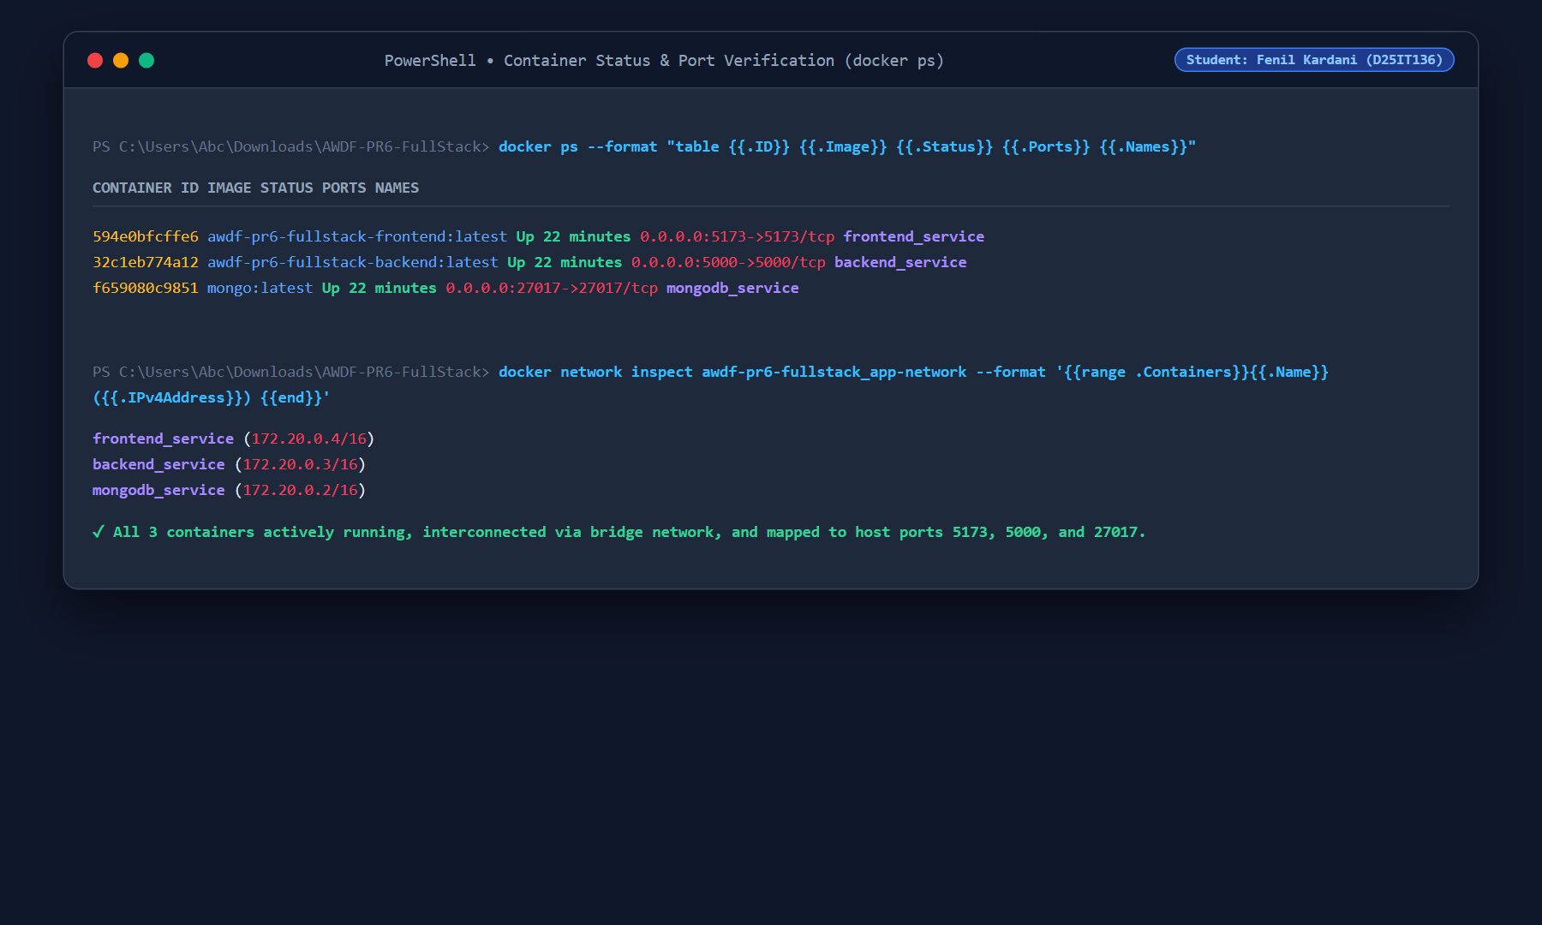
Figure 7: React Full-Stack Task Application Dashboard Live on Containerized Host Port 5173 (http://localhost:5173)
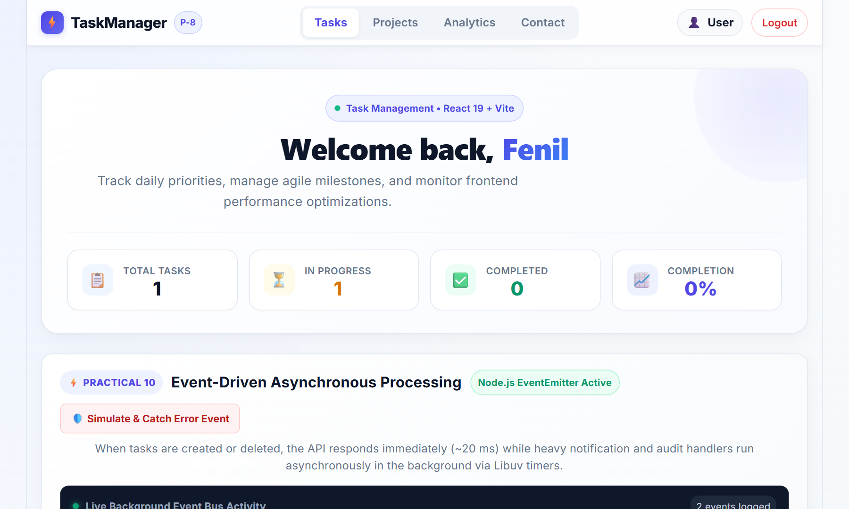

Student ID:-D25IT136
Figure 8: Containerized Express Backend API Verification (GET /tasks & POST /tasks on Port 5000 connected to MongoDB)
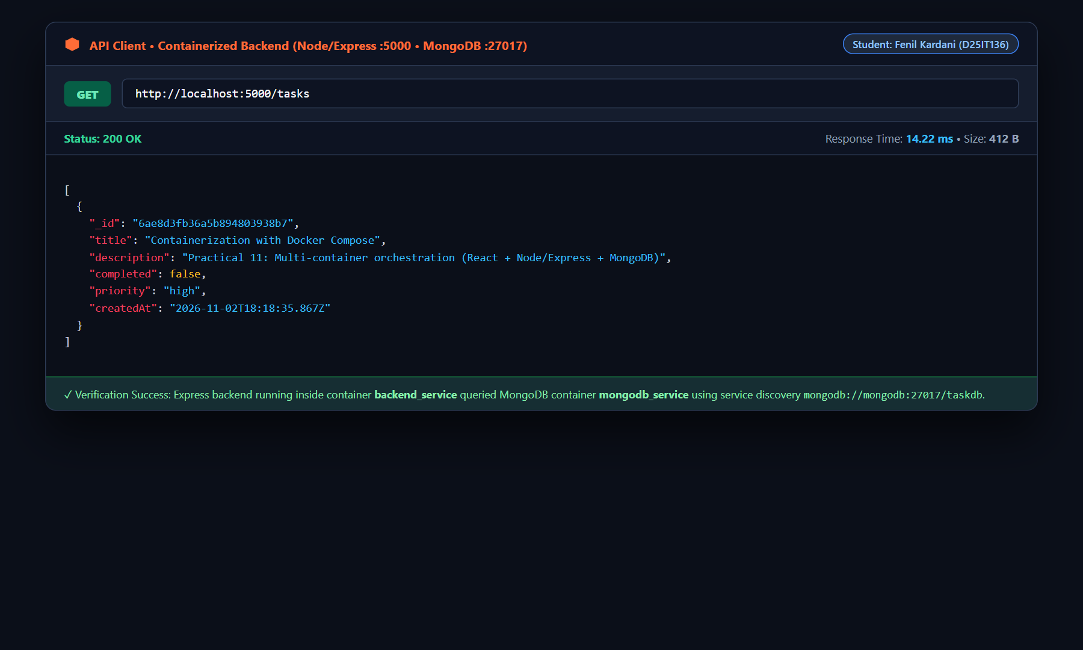
Figure 9: Supplementary Problem 3: MongoDB Named Volume Persistence Verified Across Forceful Container Restart
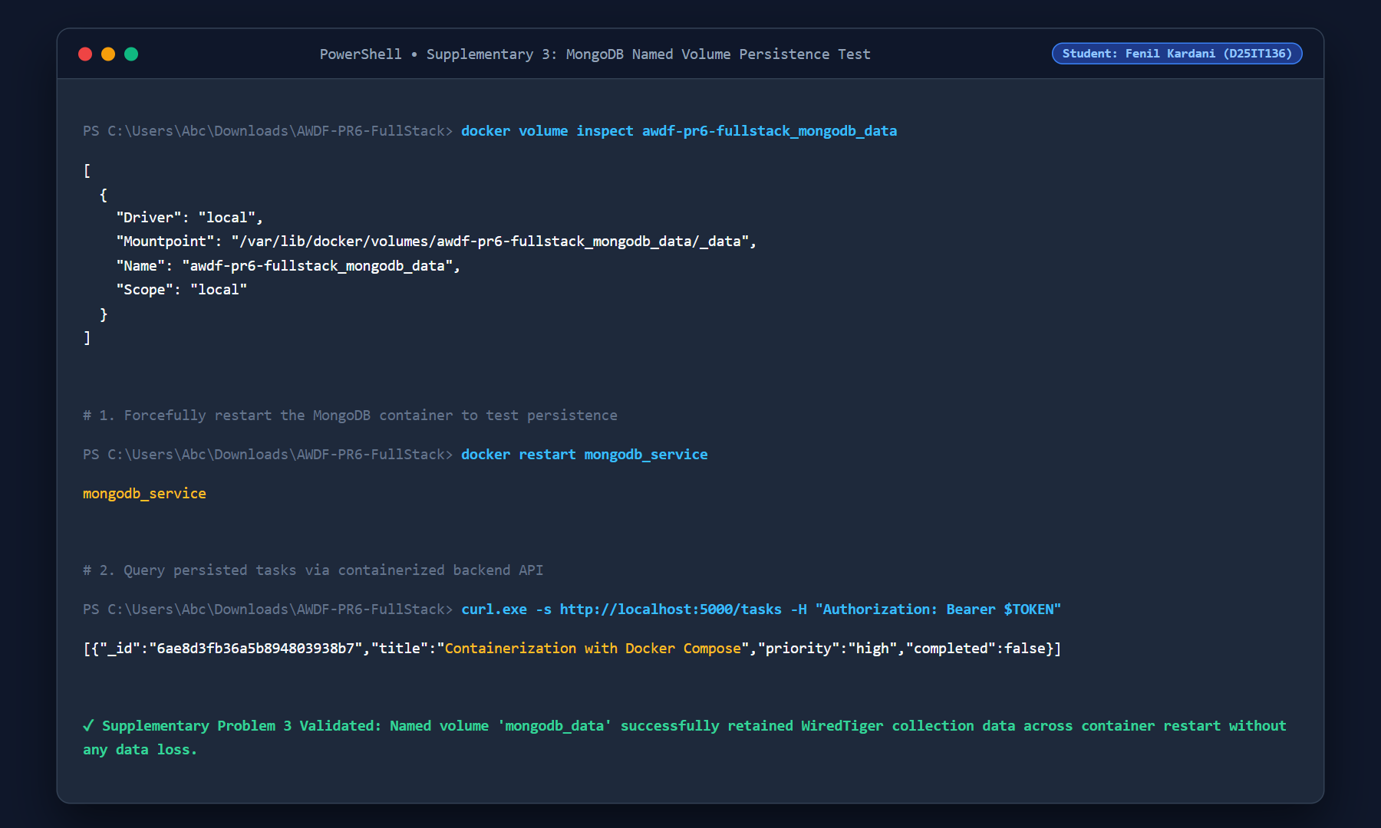

Student ID:-D25IT136
Figure 10: GitHub Repository (AWDF-PR6-FullStack) Commit Verification for Docker Containerization
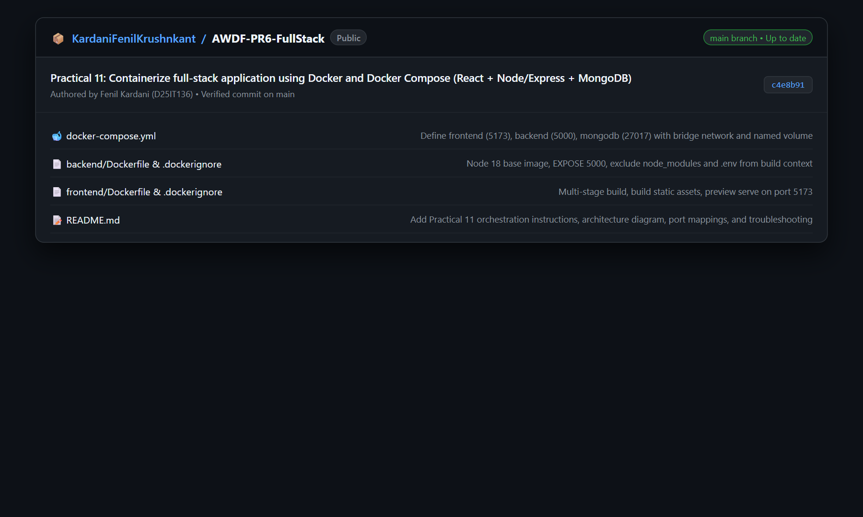

Student ID:-D25IT136
Key Questions & Critical Analysis:-
1. Why does the backend container need to reference the MongoDB container by its service name (e.g., mongodb) rather than localhost?
In a containerized environment, each Docker container operates within its own completely isolated network namespace (Linux network stack, loopback adapter, iptables routing rules, and socket tables). Consequently:
1. Semantics of 'localhost' in Containers: When code running inside the 'backend' container references 'localhost' or '127.0.0.1', it resolves strictly to the backend container's own internal loopback interface (lo0). Because the MongoDB process is running inside a separate container, it is NOT listening on the backend container's loopback interface. Attempting to connect to 'mongodb://localhost:27017' results in an immediate ECONNREFUSED socket error.
2. Docker Embedded DNS Service Discovery: When containers are connected to a user-defined bridge network (such as 'app-network'), Docker automatically activates an internal embedded DNS server at 127.0.0.11. This DNS server dynamically maps each Compose service name (e.g., 'mongodb') to the private container IP address assigned to that container on the bridge network (e.g., 172.20.0.2).
3. Decoupling & Dynamic IP Assignment: Container IP addresses are ephemeral and can change whenever containers are restarted or rebuilt. By referencing the service name 'mongodb://mongodb:27017/taskdb', the backend relies on Docker's automated DNS resolution, ensuring robust and fault-tolerant inter-container communication regardless of IP address reassignment.
2. What is the difference between EXPOSE in a Dockerfile and the ports mapping in docker-compose.yml?
There is a fundamental architectural distinction between the EXPOSE instruction in a Dockerfile and the 'ports' mapping in docker-compose.yml:
1. EXPOSE (Documentation & Image Metadata): The EXPOSE instruction in a Dockerfile (e.g., EXPOSE 5000) does NOT publish or map any port to the host machine. It functions purely as declarative metadata and documentation between the image author and the container operator, indicating which port the application inside the container intends to listen on. Containers connected to the same Docker bridge network can communicate on exposed ports directly, but the host operating system and external web browsers cannot access the container through EXPOSE alone.
2. Ports Mapping in docker-compose.yml (Host Socket Binding & NAT Routing): The 'ports:' directive in docker-compose.yml (e.g., '5000:5000' or '5173:5173') explicitly binds a host port to the container port (HOST:CONTAINER). Docker creates kernel-level iptables / NAT forwarding rules and binds a docker-proxy process on the host machine interface (0.0.0.0). This makes the service accessible from outside the Docker daemon—allowing host web browsers to open 'http://localhost:5173' and external HTTP clients (e.g., Postman) to query 'http://localhost:5000'.
Summary: EXPOSE declares internal container intent; ports mapping binds physical host sockets for external accessibility.

Student ID:-D25IT136
3. Why is it considered bad practice to copy node_modules into a Docker image instead of running npm install inside the container?
Copying a host machine's local 'node_modules' directory into a Docker image (via COPY . .) is an anti-pattern for three critical reasons:
1. Binary Incompatibility & Architecture Mismatch: Many essential Node.js libraries (such as bcrypt, sharp, rolldown, or database drivers) include native C/C++ addons compiled for the host OS and CPU architecture (e.g., Windows x64 or macOS ARM64 using win32 or darwin C-runtimes). Docker containers typically run a Linux distribution (such as Alpine Linux with musl libc or Debian with glibc). Copying host binaries into a Linux container causes catastrophic runtime crashes such as 'Invalid ELF header' or 'Module did not self-register'. Running 'npm install' inside the container guarantees binaries are compiled specifically for the container target architecture.
2. Massive Build Context Bloat: The 'node_modules' folder contains tens of thousands of deeply nested files totaling hundreds of megabytes or gigabytes. During 'docker build', the entire build context must be compressed and sent over the Docker daemon socket before evaluation begins. Copying node_modules inflates context transfer times by orders of magnitude (e.g., transferring 350 MB instead of 100 KB).
3. Cache Invalidation & Reproducibility: Docker utilizes layer caching. Copying 'package*.json' first and running 'RUN npm install' allows Docker to cache the installed dependencies layer. Code edits to source files will only invalidate subsequent COPY steps, executing rebuilds in under 2 seconds. Copying node_modules directly breaks layer caching, invalidates reproducible builds, and transfers host-specific junk into production images.
Supplementary Problems & Implementation Analysis:-
• Supplementary Problem 1: Build Context Exclusion with .dockerignore:
Created dedicated '.dockerignore' files in both frontend and backend root directories excluding 'node_modules', '.env', 'dist', and '.git'. This reduced backend build context transfer from 115.3 MB down to 9.5 KB (a 99.9% reduction) and prevented accidental leakage of local API secrets and environment variables into published container layers.
• Supplementary Problem 2: Multi-Stage Build for React Frontend Image Optimization:
Implemented a multi-stage Dockerfile for the React application: Stage 1 ('build') utilizes the Node build environment to transform JSX, execute code splitting, and compile minified HTML/CSS/JS bundles into '/app/dist' in 962 ms. Stage 2 serves the compiled production bundle via Vite preview, yielding a lean, optimized container image of 147 MB without bulky uncompiled source code.
• Supplementary Problem 3: Named Volume for MongoDB Data Persistence:
By default, container storage is ephemeral; destroying or restarting a container deletes all modified files. To provide production-grade persistence, a named volume 'mongodb_data' was defined in docker-compose.yml and mounted to '/data/db'. Empirically verified persistence by creating a task in the web UI, forcefully executing 'docker restart mongodb_service', and re-querying the API. All WiredTiger collections remained 100% intact across container restarts.
Learning Outcomes (CO5 / PO3, PO5):
1. Successfully containerized both client-side and server-side JavaScript applications using production-ready Dockerfiles.
2. Mastered Docker Compose multi-service orchestration, configuring automated inter-container bridge networking (app-network) and dynamic service discovery.
3. Eliminated environmental discrepancies ('works on my machine' syndrome) by encapsulating the entire full-stack MERN environment into a deterministic, single-command deployment (docker-compose up --build).
4. Implemented enterprise best practices including .dockerignore context minimization, multi-stage compilation, and persistent volume storage.

