Online School Performance Analytics
Case Summary Report
End-to-end business analytics project for an online school: data audit, cleaning, EDA, marketing and sales analysis, product analytics, unit economics, growth hypothesis and interactive dashboard.
Total Deals | Paid Deals | Payment Conversion | Actual Revenue | Marketing Spend | ROMI
21,593 | 858 | 3.97% | 978,651 | 149,223.45 | 2,156.74%

Project Scope
• Analyzed CRM, sales calls and marketing spend data in one reproducible analytics workflow.
• Prepared documentation, data audit, cleaning rules, cleaned datasets, business analysis, unit economics and dashboard outputs.
• Built a Plotly Dash dashboard covering funnel, acquisition, sales, products and growth economics.

1. Analytical Workflow and Business Rules
Data Dictionary | Data Audit | Cleaning Rules | Data Cleaning | EDA & Business Analysis | Unit Economics | Dashboard

• Paid deal definition: Stage = Payment Done.
• Actual revenue is based on Initial Amount Paid only for paid deals; Offer Total Amount is treated as potential contract value.
• Source is used as the main level for marketing analysis; Campaign, Term, Content, AdGroup and Ad are supporting details.
• CRM-style IDs are cleaned and processed as strings to preserve table relationships.
• Rows with data quality flags are kept in the dataset and excluded only from calculations where the issue is critical.

2. Overall Business Performance
Large deal flow with low payment conversion.
• 21,593 deals were recorded; 858 became paid deals, resulting in 3.97% payment conversion.
• The main growth challenge is conversion from created deals to paid students, not initial deal volume.
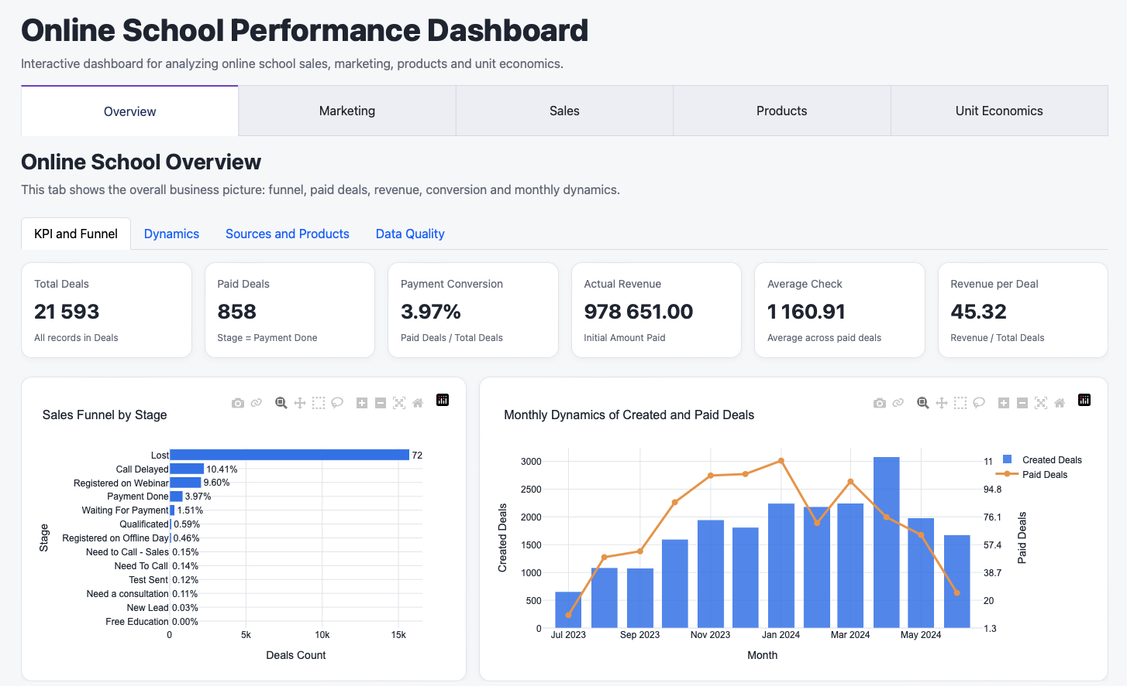

3. Marketing Performance
Acquisition channels differ by volume, conversion and revenue.
• Facebook Ads, Google Ads, Organic and SMM are the key business-driving sources.
• Source is the most reliable level for marketing conclusions; campaign analysis is used as supporting detail.
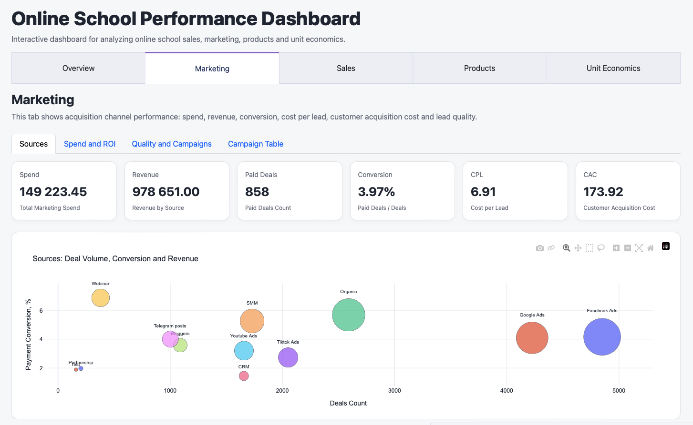

4. Sales Team Performance
Manager performance should be assessed through several metrics together.
• Workload, conversion, paid deals, revenue, average check and call activity vary materially across managers.
• High workload does not automatically equal high conversion or stronger revenue contribution.
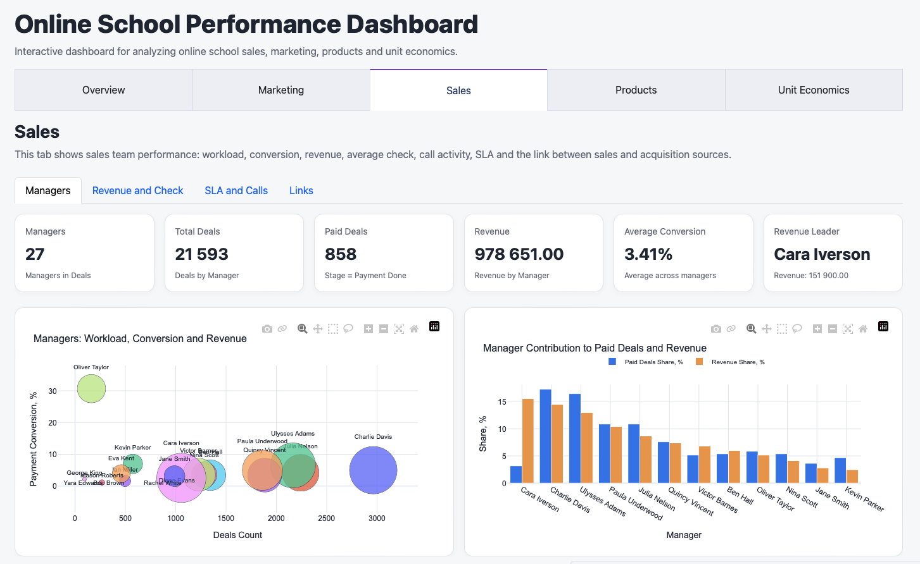

5. Product Revenue Structure
The product portfolio is concentrated around several main products.
• Digital Marketing is the leading product by paid deals and revenue.
• UX/UI Design and Web Developer also contribute, while small categories are excluded from main product charts.
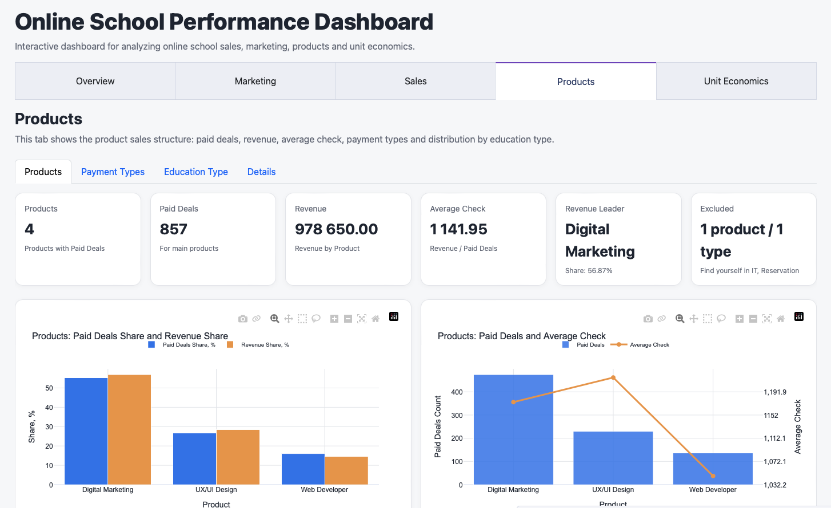

6. Unit Economics
Aggregate unit economics is positive and supports further optimization.
• Contribution margin equals 3,224,833.67 and ROMI equals 2,156.74%.
• C1 conversion was selected as the most actionable metric for a short growth experiment.
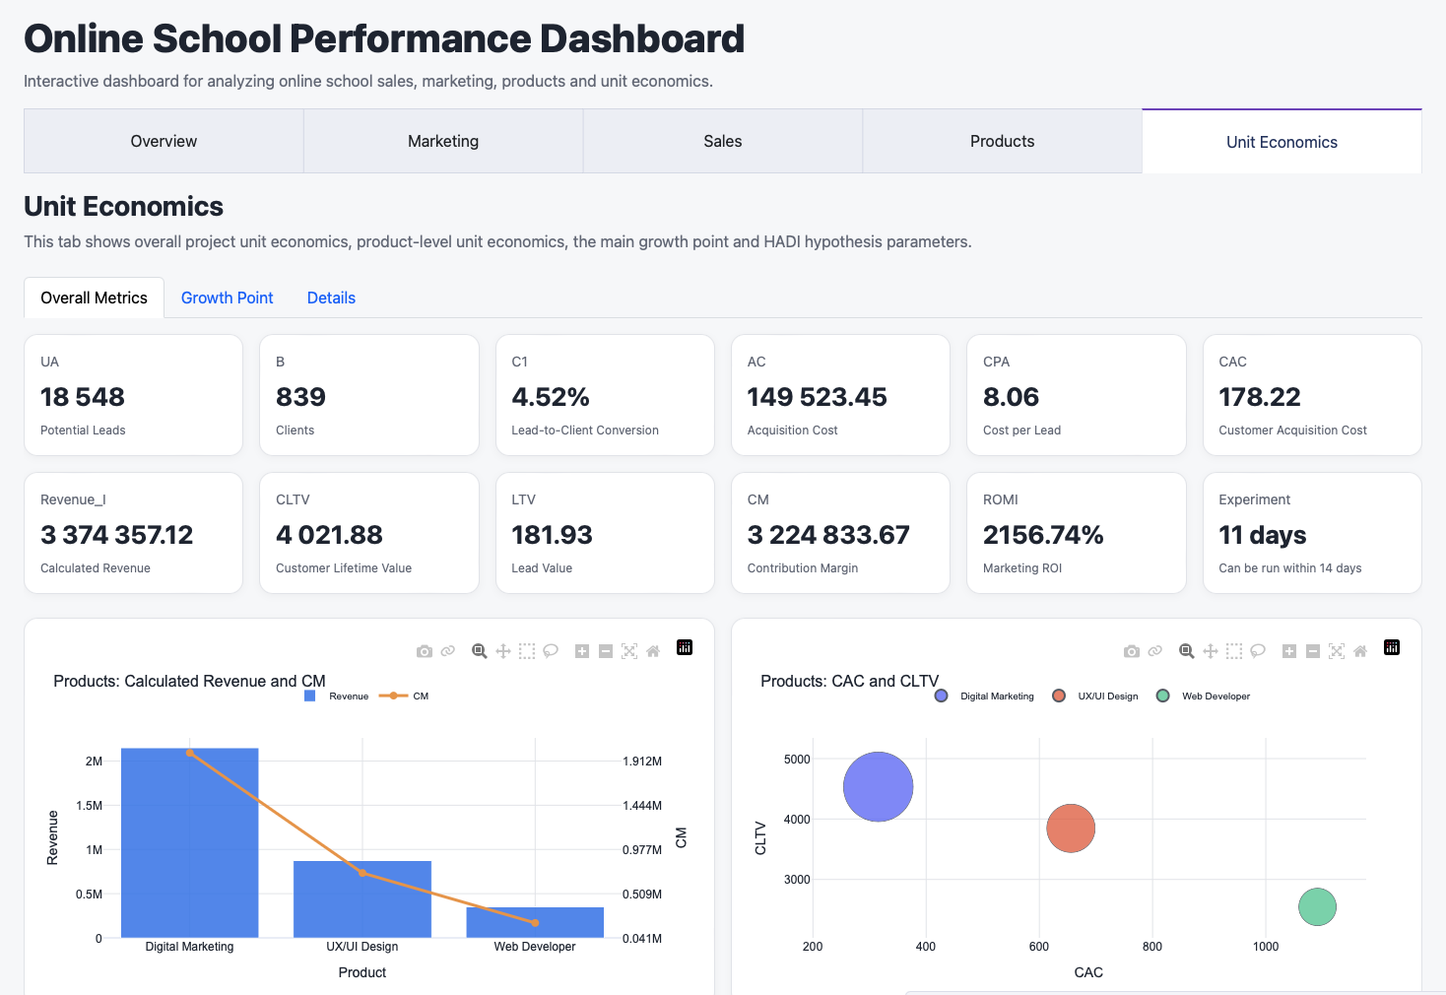

7. Growth Hypothesis and Recommended Next Step
A practical HADI hypothesis can be tested within two weeks.
• Hypothesis: an updated first-contact and follow-up script can increase lead-to-client conversion C1 by at least 10%.
• Experiment parameters: 560 leads, average flow of 51 leads per day, estimated duration of 11 days.
• The experiment can be run within 14 days and provides a manageable next step for performance improvement.
