SEPIC (Buck-Boost) Converter Számítás

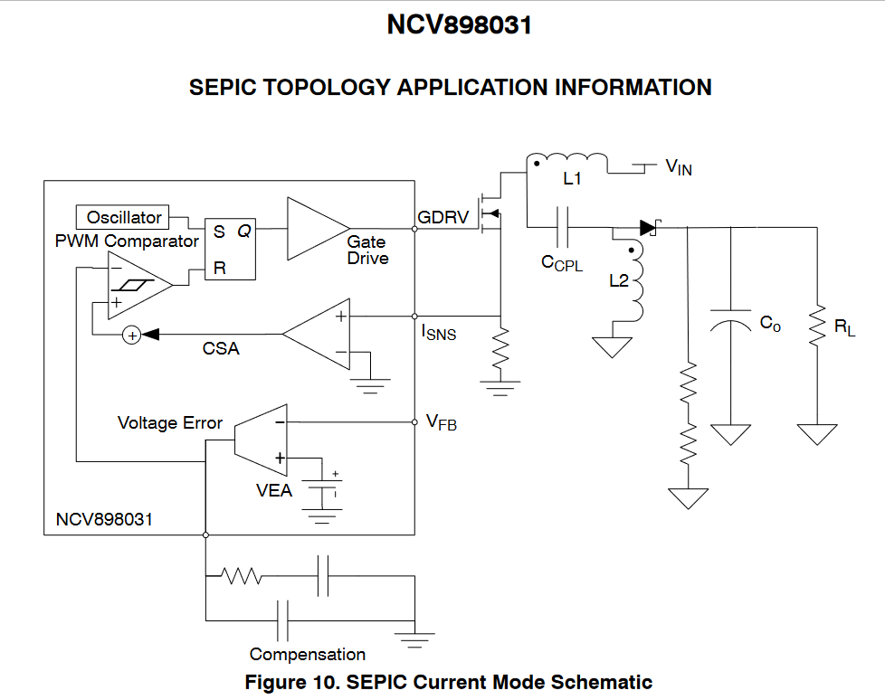
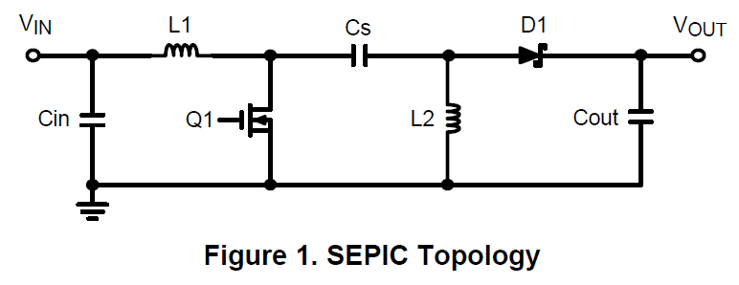
https://www.onsemi.com/products/power-management/dc-dc-power-conversion/controllers/NCV898031#overview
Kiinduló Adatok:
SEPIC:
$$V_{in(min)}=8 \left[V\right]→minimum input voltage$$
$$V_{in(max)}=32 \left[V\right]→maximum input voltage$$
$$V_{OUT}=11 \left[V\right]→output voltage$$
$$I_{out(max)}=1 \left[A\right]→maximum output current$$
$$I_{cl}=8 \left[A\right]→desired typical cycle-by-cycle current limit$$
$$V_{FWD}=0,6 \left[V\right]→diode forward voltage$$
$$V_{CL}=0,4 \left[V\right]→current limit treshold voltage$$
$$f_{s}=2*{10}^{6} [Hz]→switching frequency$$
$$η=0,9 \left[-\right]→Worst Case effectivity$$

- Define Operational Parameters
Duty Cycle
$$D_{min}=\frac{V_{OUT}}{V_{IN\left(max\right)}+V_{OUT}}=\frac{11}{32+11}=0,25581 \left[-\right]=25,58 [\%]$$
$$D_{max}=D_{WC}=\frac{V_{OUT}}{V_{IN\left(min\right)}+V_{OUT}}=\frac{11}{8+11}=0,57894 \left[-\right]=57,89 [\%]$$
Both duty cycles will actually be higher due to power loss in the conversion.
As the $D_{WC}:worst case$ is lower than $D_{max⁡(oscillator)}=85\%$ the conversion is possible.
Operating time
$$t_{on}=\frac{D_{min}}{f_{s}}=\frac{0,25581}{1,8⋅{10}^{6}}=1,42⋅{10}^{-7} \left[s\right]=14,2 \left[ns\right]$$
$$t_{on\left(min\right)}=30 \left[ns\right]=3⋅{10}^{-8} [s]$$
As $t_{on\left(min\right)}≤t_{on}$ the device will not skip pulses at high $V_{IN}$.
VDRV
Bypass the gate driver with a ceramic capacitor between 0,1 uF and 1uF depending on switching speed and charge requirements of the external mosfet. We choosed 1uF, 25V.
Capacitor:
MOSFET: https://4donline.ihs.com/images/VipMasterIC/IC/NEXP/NEXP-S-A0003060256/NEXP-S-A0003060216-1.pdf?hkey=6D3A4C79FDBF58556ACFDE234799DDF0
- Select Current sense resistor
$$R_{S}=\frac{V_{CL}}{I_{CL}}=\frac{0,4}{8}=0,05 \left[Ω\right]=50 [mΩ]$$

- Select SEPIC Inductors
$$V_{IN(WC)}=V_{IN(min)}=8 \left[V\right]→V_{IN} value as close as possible to \frac{V_{OUT}}{2}=5,5 [V]$$
The output inductor controls the current ripple that occurs over a switching period. A high current ripple will result in excessive power loss and ripple current requirements. A low current ripple will result in a poor control signal and a slow current slew rate in case of load steps.A good starting point for peak to peak ripple is around 20−40% of the inductor current at the maximum load at the worst case V_{IN}, but operation should be verified empirically.
We choosed 15%.

$$I_{out(max)}=1 [A]$$
$$∆I_{L(max)}= I_{out(max)}⋅0,15=0,15 [A]$$
$$L=\frac{V_{IN\left(WC\right)}⋅D_{WC}}{∆I_{L\left(max\right)*f_{s}}}=\frac{8⋅0,5789}{0,15⋅2⋅{10}^{6}}=1,5⋅{10}^{-5} \left[H\right]=15 [uH]$$

Maximum average Inductor Current
$$I_{L1,AVG}=\frac{V_{OUT}I_{OUT(max)}}{V_{IN(min)η}}=\frac{11⋅1}{8⋅0,9}= 1,5277[A]$$

Peak Inductor Current
$$I_{L1, peak}=I_{L1,avg}+\frac{∆I_{L1}}{2}= 1,5277+\frac{0,15}{2}=1,6027 [A]$$

$$I_{L2, peak}=I_{OUT(max)}+\frac{∆I_{L2}}{2}=1+\frac{0,15}{2}=1,075 [A]$$
As L₁=L₂ -> ∆I_{Lmax=}∆I_{L1}=∆I_{L2}.

Inductor Data Sheet: https://www.cyntec.com/upfile/products/download/(A8)%20VCSC108T%20MS6K%20Series_standard.pdf

- Select Coupling Capacitor
Budgeting 2−5% coupling capacitor ripple voltage is a reasonable guideline.
We choosed 1,3%.

$$∆V_{coupling}=\frac{I_{OUT}⋅D_{WC}}{C_{coupling}⋅f_{s}}=\frac{1⋅0,5789}{2,2⋅{10}^{-6}⋅2⋅{10}^{6}}=0,1315 [V]$$

$$f_{resonance}=\frac{1}{2π\sqrt{(L_{1}+L_{2})C_{coupling}}}= 19590[Hz]$$
$$R_{damping}=\sqrt{\frac{L_{1}+L_{2}}{C_{coupling}}}=3,69 [Ω]$$
Data sheet:
https://fr.farnell.com/en-FR/kemet/c1206x222kcrac3316/capacitor-2200pf-x7r-500v-1206/dp/4242429RL

- Select Output Capacitor
The steady state output ripple associated with the output capacitors:
$$V_{OUT\left(ripple\right)}=\frac{I_{OUT\left(max\right)}D_{WC}}{f_{s}C_{OUT}}+\left(\frac{I_{OUT\left(max\right)}}{1-D_{WC}}+\frac{V_{IN\left(min\right)}D_{WC}}{{2f}_{s}L_{2}}\right)R_{esr}= 0,1972 [V]$$

The capacitors need to survive the RMS ripple:
$$I_{Cout\left(RMS\right)}=\sqrt{I_{OUT\left(max\right)}^{2}D_{WC}+\left(I_{a}^{2}+\frac{I_{r}^{2}}{3}-I_{a}I_{r}\right)D_{WC}^{'}}= 0,401 [A]$$
$$I_{Cout\left(RMS\right)}= 0,401 \left[A\right]<0,85 \left[A\right]→OK$$

Where:
$$I_{a}=I_{L1peak}+I_{L2peak}-I_{out}=2,018 [A]$$
$$I_{r}=∆I_{L1}+∆I_{L2}=0,6 \left[A\right]$$

Data Sheet:

- Select Input Capacitor
The input capacitor reduces voltage ripple ont he input to module associated with the AC component of the input current.
$$I_{Cin(RMS)}=\frac{∆I_{L1}}{\sqrt{12}}=0,0866 \left[A\right]$$
- Select feedback Resitors
These resistors forrm a resistor divider. The lower feedback resistor can be chosen, and the upper feedback resistor value is calculated as follows:
$$R_{lower}= 5620 [Ω]$$
$$R_{upper}=R_{lower}\frac{\left(V_{out}-V_{ref}\right)}{V_{ref}}=51516 \left[A\right]$$
The total feedback resistance (Rupper + Rlower) should be in the range of 1 k – 100 k. -> OK
- Select Compensator Components
The maximum RMS current:
$$I_{D\left(max\right)}=\sqrt{D_{WC}{(I}_{Q\left(peak\right)}^{2}+\frac{{\left(∆I_{L1}+∆I_{L2}\right)}^{2}}{3}-I_{Q\left(peak\right)}(∆I_{L1}+∆I_{L2})}) = 2,072 [A]$$
$$I_{Q\left(peak\right)}=I_{L1peak}+I_{L2peak}=3,018 \left[A\right]$$
$$V_{Q\left(max\right)}=V_{out\left(max\right)}+V_{in\left(max\right)}=43 \left[V\right]$$

Data Sheet:

- Select Mosfet
In order to ensure the gate drive voltage does not drrop out the MOSFET chosen must not violate the following inequation:
$$Q_{G\left(total\right)}≤\frac{I_{drv}}{f_{s}}$$
$$I_{drv}=32 \left[A\right]$$
$$Q_{G}=\frac{I_{drv}}{f_{s}}=0,000016 [C]$$
$$Q_{G\left(total\right)}=1,1⋅{10}^{-8}≤0,000016→OK$$

Data Sheet:

- Select Diode
The average current through diode will be equal tot he output current:
$$I_{D\left(avg\right)}=I_{OUT\left(max\right)}$$
Additionally the diode must block voltage equal tot he higher of the output voltage and the maximum input voltage:
$$V_{D\left(max\right)}=V_{out\left(max\right)}+V_{in\left(max\right)}=43 \left[V\right]$$

The maximum power dissipation ont he diode:
$$P_{D}=V_{f\left(max\right)}⋅I_{OUT\left(max\right)}=1,67 \left[W\right]$$

Data Sheet:

SEPIC (Buck-Boost) Converter Analízis

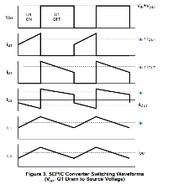
Name | U [V] | I [A]
C_{in} | 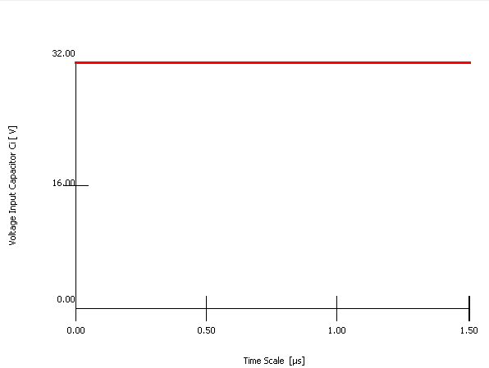 | 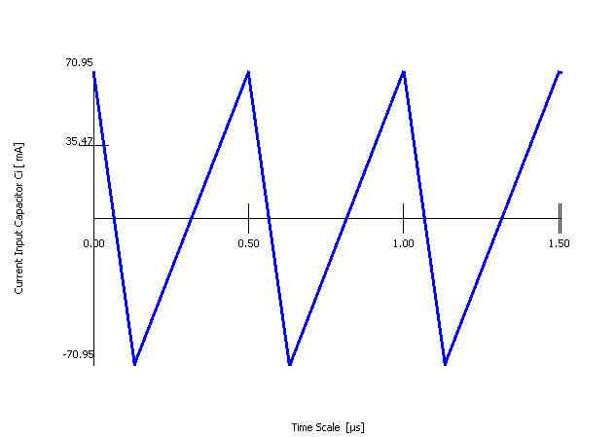
L₁ | 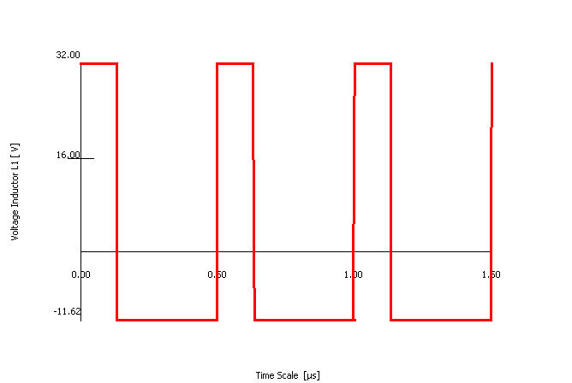 | 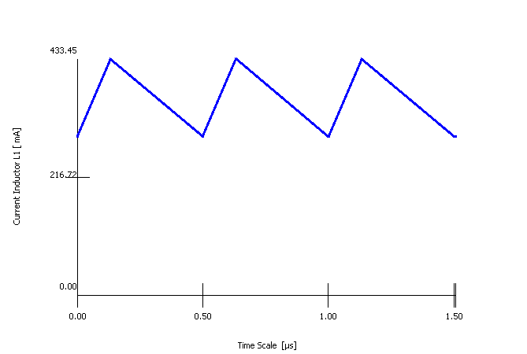
Q₁ | 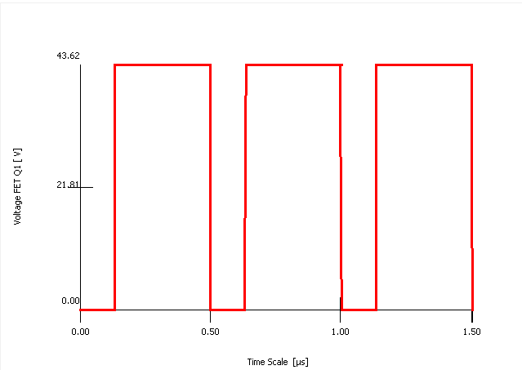 | 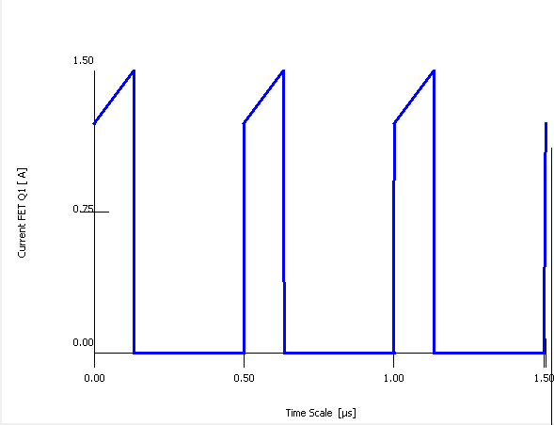
C_{s} | 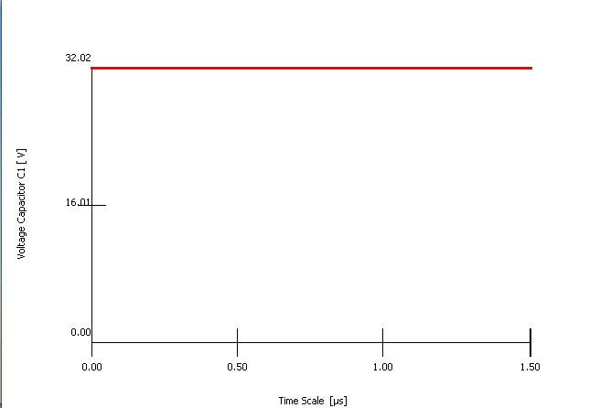 | 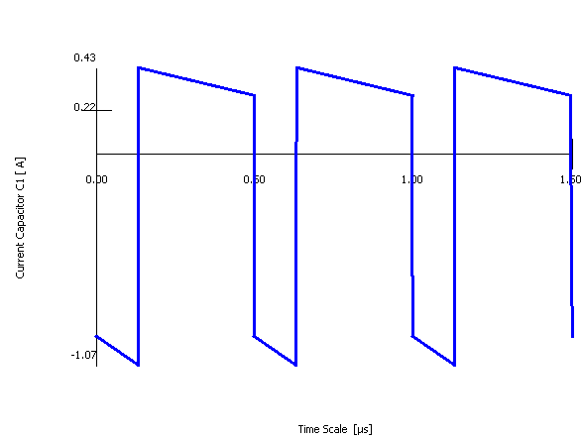
L₂ | 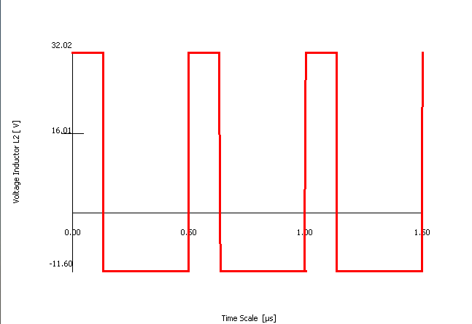 | 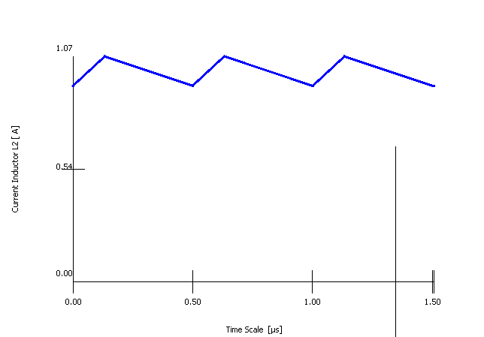
D₁ | 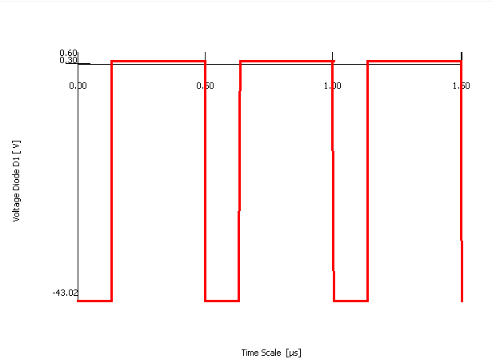 | 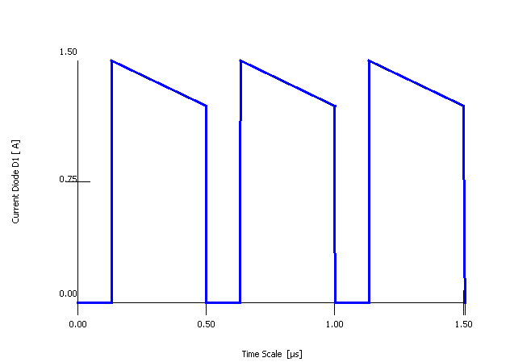
C_{out} | 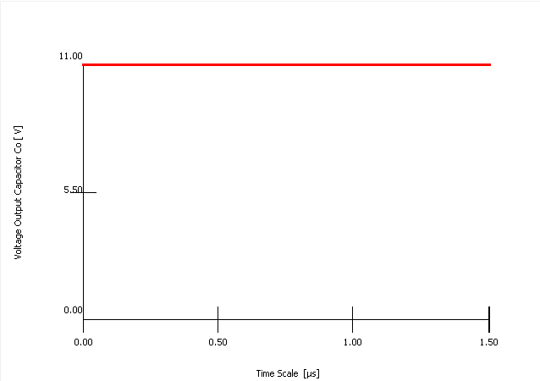 | 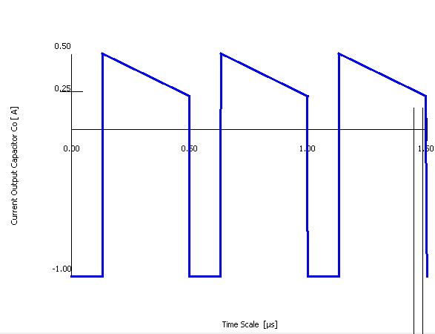
Current Analyzis
Currents must always close! This uses the Current Analysis. Its application has the goal to find out those branches of the circuit which cause common-impedance coupling. From the analysis only qualitative results are to be expected:
1. The currents of all meshes of a circuit are drawn with their closed loop and in both directions
of current
• for an analysis into the schematic or block diagram or
• as a check into the layout or the wiring diagram.
2. Parasitic impedances of connection wires are assumed – only – for the analysis idealized
with zero.
3. DC and AC analysis is regarded separately.

Rule: If currents of two or more meshes flow in the same branch, then these meshes are coupled by the real impedance of this branch. We call this impedance Coupling Impedance.
The procedure works, because the graphic structure of the layout usually is adopted from the graphic structure of the schematic diagram. With some experience in the application of this method it can be differentiated, which meshes of a schematic diagram are to be classified as critical and which current meshes can be neglected. Thus reduces the number of meshes, which must be included into the procedure.
If current loops are drawn not closing or not at all, couplings by common impedances cannot be recognized.
If capacitors lie in the coupling branch (decoupling or filter capacitors), then also their impedance is assumed idealized with zero for the analysis like parasitic line impedances.
That by this simplification the couplings are recognized correctly and completely, is a large advantage in the handling of this procedure.
The collector-emitter or drain-source branches of all not saturated transistors (also within ICs) in analog circuits are accepted for the procedure as ideal current sources. Over them only the current of the current source is drawn, all other currents are neglected.
The Current Analysis can be applied also to block diagrams. Only these currents are to be considered, which exceed the block borders (signal, supply and interference currents).
Fort he SEPIC structure:
If the SWITCH is in ON state:
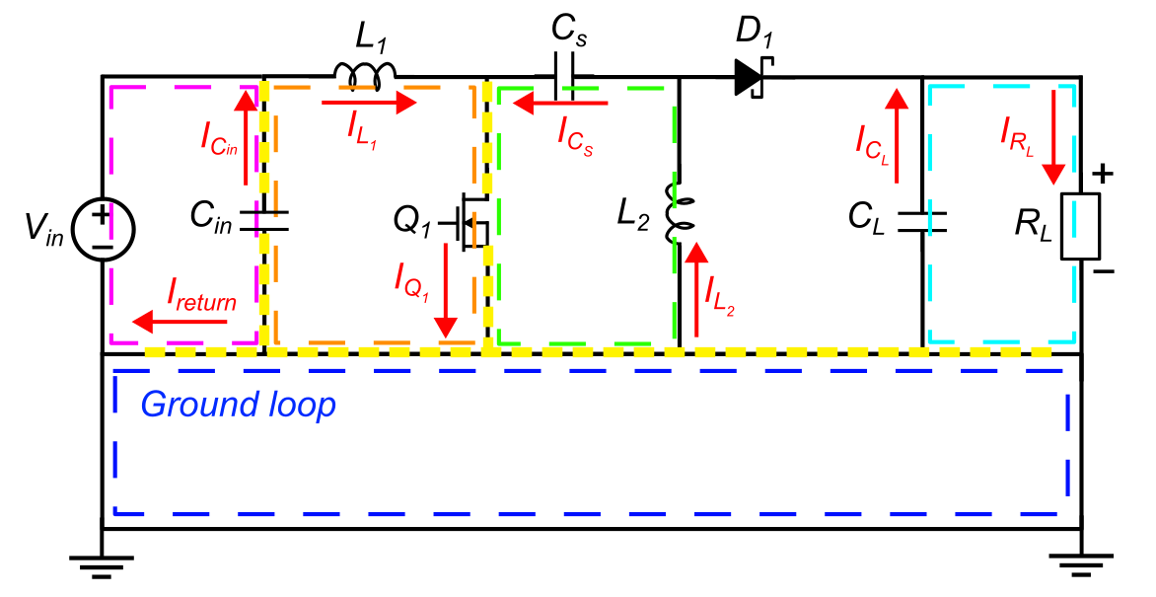
If it is on OFF State:
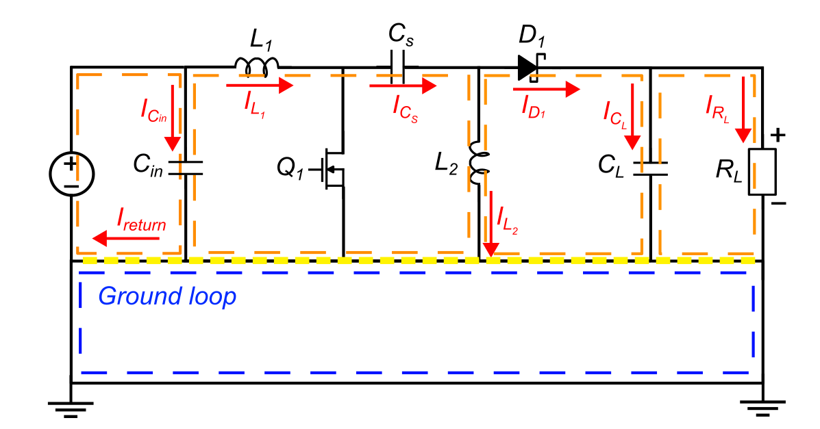
I marked each of the different meshes with separate colors. The yellow line represents the common impedance coupling paths.
Impedance coupling can be reduced by reducing the interference currents or by reducing the coupling impedance.
It leads to the procedure of Shifting the Nodes: Both nodes, which represent the ends of the branch with the common impedance, the coupling impedance, are shifted towards each other as far as possible.
- The nodes coincide in a star point
- Both the SEPIC and GROUND meshes get their own star or reference point, both are connected by a (short) line. Now the meshes do not touch themselves any longer. The impedance of the connection line increases the attenuation, it has thus decoupling effect. Such a wiring may be necessary, because the spatial expansion of the common pin can already have an inadmissible high coupling impedance.
- If capacitors or other electric components are in the branch the nodes only can be shifted up to the connectors of the capacitors.

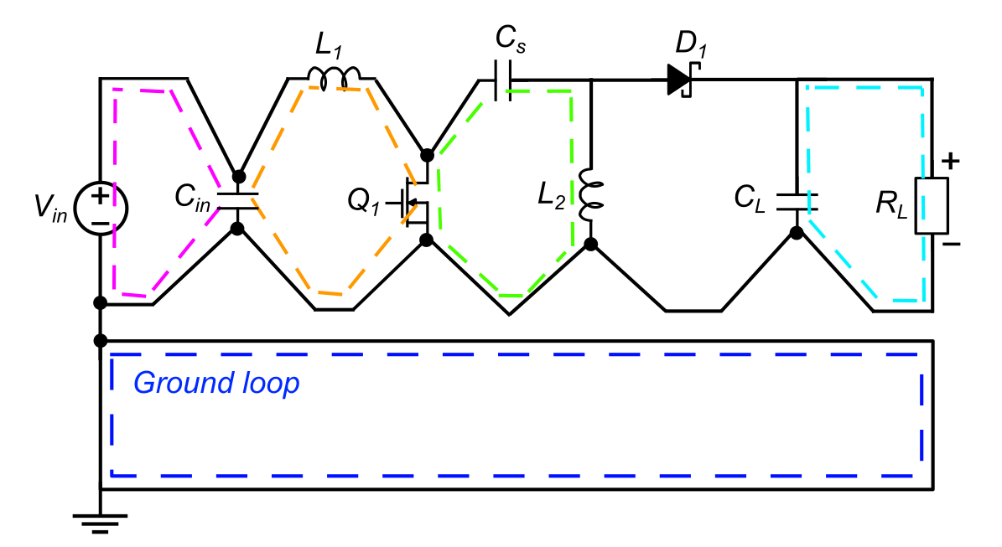
This is the mothod used on the SEPIC-A where the ground layers are separated to designated partslike GND, GNDH etc. witch is worse, than the SEPIC-B where keeping theaim is to keep the consistence of the solid ground, becouse with the first method the longer current paths cause greater loops.
A much more effective way is to make some calculation as follows, to make sure that Common-Mode Impedance is really an issue we need to worry about:
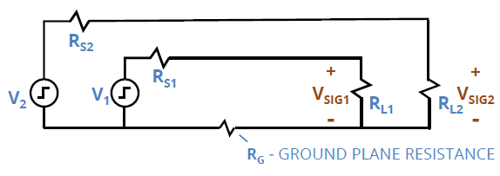
$$I_{G}≈I_{1}≈\frac{V_{SIG1}}{R_{L1}}$$
$$V_{G}=I_{G}R_{G}=P_{D}≈V_{SIG1}\frac{R_{G}}{R_{L1}}$$
$$V_{SIG2}=V_{G}\left(\frac{R_{L2}}{R_{S2}+R_{L2}}\right)≈V_{SIG1}\frac{R_{G}}{R_{L1}}\left(\frac{R_{L2}}{R_{S2}+R_{L2}}\right)$$
$$R_{G}=\frac{l}{Aσ}=\frac{plane length [m]}{5.7*{10}^{7} \left[\frac{S}{m}\right]*(trace width \left[m\right]*)}$$

$$XTALK\left(dB\right)=20\log\left(\frac{V_{SIG2}}{V_{SIG1}} | V_{S2}=0 \right)$$
$${XTALK}_{(NE)}\left(dB\right)=20\log\left(\frac{R_{G}}{R_{L1}}\left(\frac{R_{S2}}{R_{S2}+R_{L2}}\right)\right)$$
$${XTALK}_{(FE)}\left(dB\right)=20\log\left(\frac{R_{G}}{R_{L1}}\left(\frac{R_{L2}}{R_{S2}+R_{L2}}\right)\right)$$

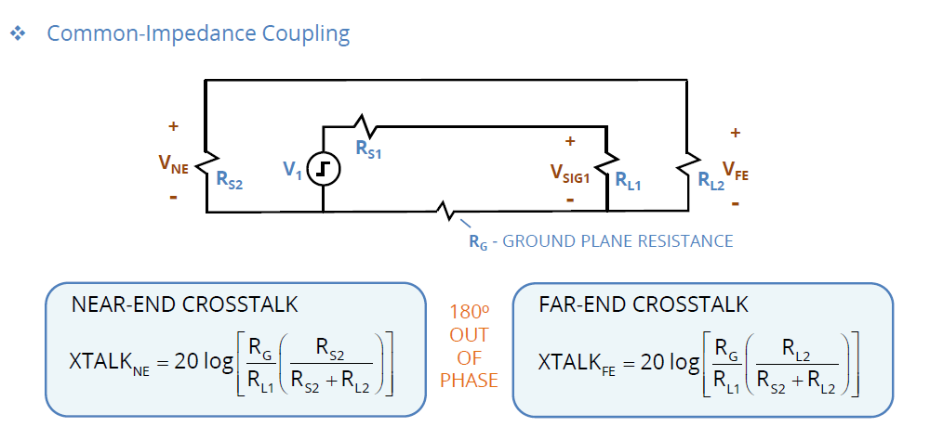
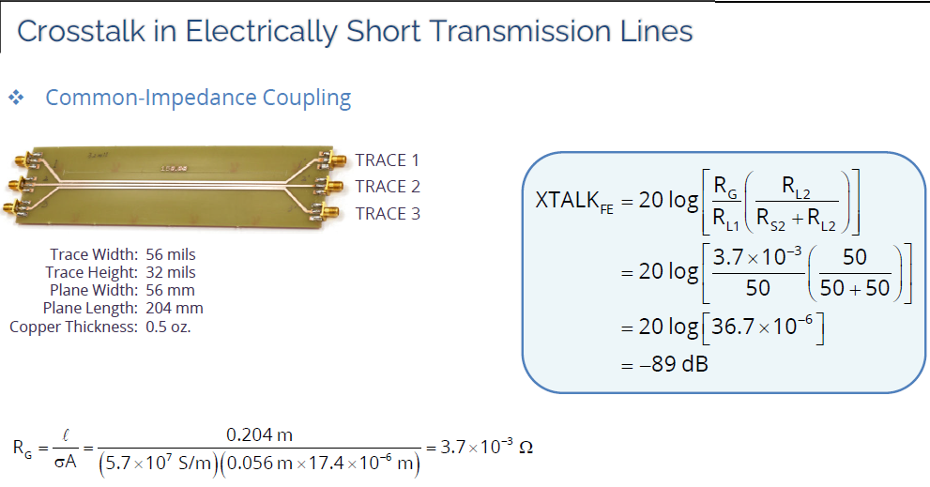
There are noumerous decoupling methods to consider:
- Meshing
If spatially distributed signal sources are connected with several spatially distributed signal sinks (e.g. as in digital circuits) meshing of the ground return can be provided either with single lines or with a continuous ground layer. Currents then cause lower voltage drops because of the smaller ground impedance. These voltage drops are not zero. A possible common-impedance coupling is not eliminated however reduced.

- Star point/ Star tree Structure
If within the circuit all ground points are shifted together, a Star Point Structure is generated. The connection lines to ground become longer. Whether this leads to coupling between the input and output meshes of the individual stages and to interferences (parasitic oscillation), must and can be examined in individual cases. Since in each case only two meshes are coupled, the conditions remain clear. The coupling impedance between the ground loop and all signal meshes except the input and output meshes is zero. These inner meshes cannot be interfered by the outside ground loop.
Unfortunately in our case it is definitely not good because of the interfering inner meshes.
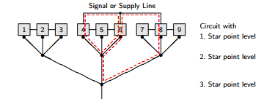

- Bypass
A special form of the star point structure is the Bypass. The coupling by ground impedances with a series ground structure can be avoided by connecting the output ground (O) over a separate line with the input ground. An interference current caused by an outside source within the ground loop now will not flow over the circuit ground. The output voltage is incorrect, but the sensitive first stages of analog circuits are not interfered. This is what is show non the picture.

- Galvanic separation
- Difference Formation
- CM-Choke
- PE-Choke
Current-Switching Analysis

If currents are switched, so that switching will only change their loop but not their value (e.g. in switching power supplies), the high slew rate of voltage and current can couple interferences by all kinds of coupling into other meshes. For the EMC analysis of this effect first the meshes with a high current slew rate must be found out, they always form a closed loop, too. We will call it Critical Mesh.
By the example with the CurrentSwitching Analysis by Holst the Critical Mesh in very simple way is to be determined formally: Into the schematic or the layout the current is drawn in a closed loop before the switching of the switch (mesh 1) and afterwards (mesh 2). Those branches, which are touched only by one of the two loops, form also a closed loop and represent the Critical Mesh (mesh 3).
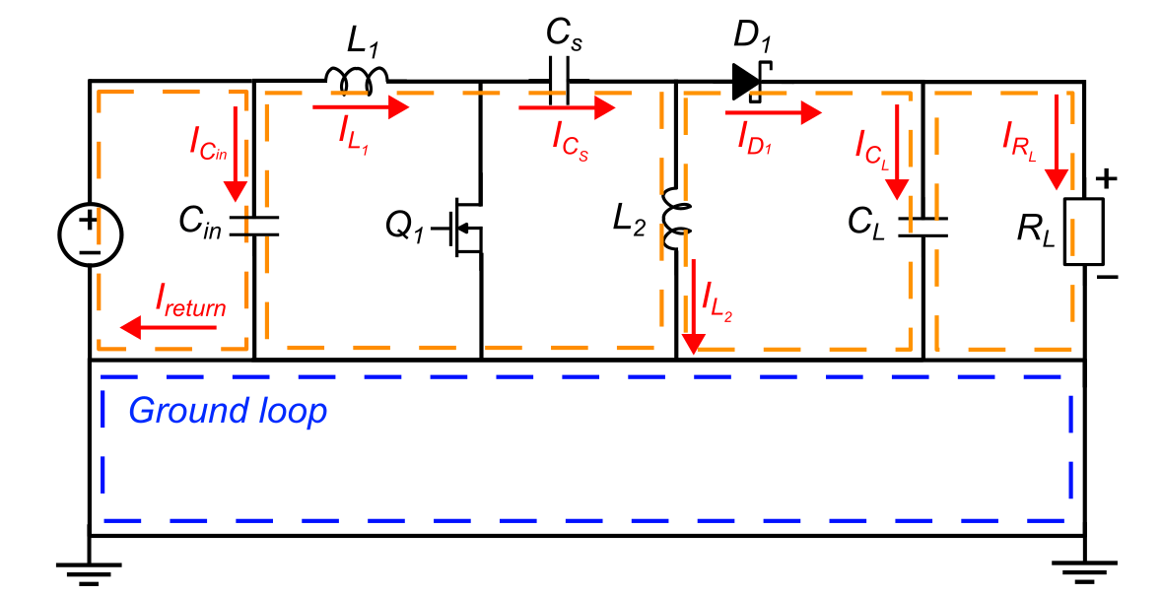
1. ábra: mesh1
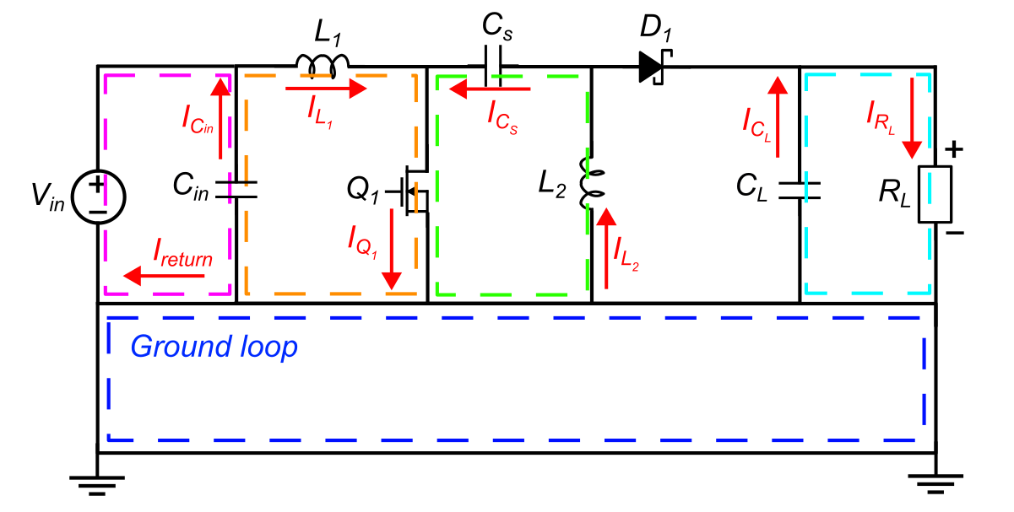
2. ábra: mesh2
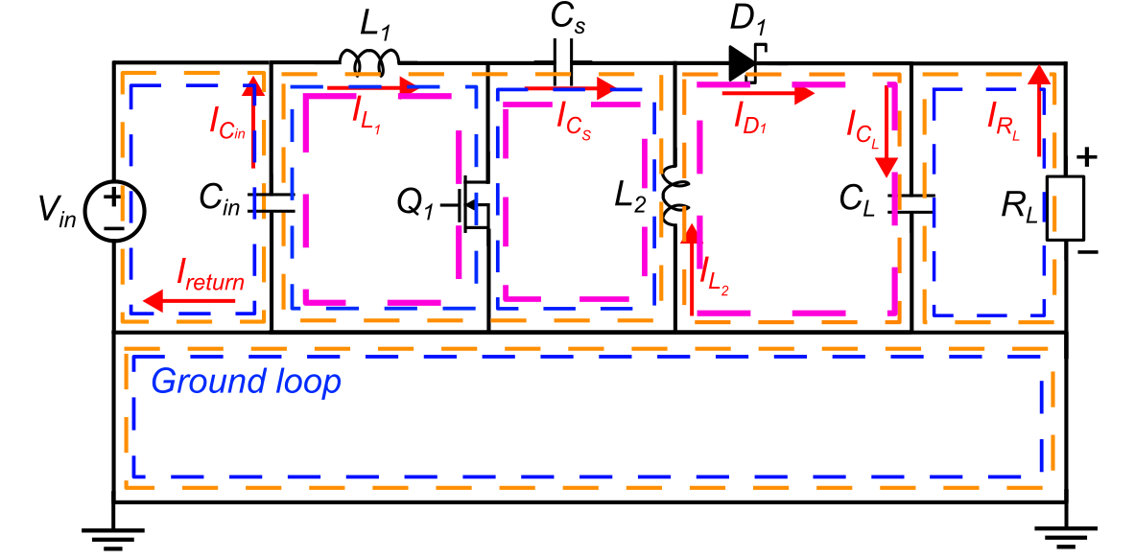
3. ábra: mesh3
I have marked the critical-meshes with magenta.
8.13 Analysis of Switching Power Supplies
Power electronics develop their interfering effects due to the high di/dt and dv/dt of the Critical Mesh also over capacitive and inductive coupling. The most unclear interferences however result from common-impedance coupling. All couple mechanisms have differentiating behavior. The linked interference voltage, related to the interference current, increases frequency-proportionally. Thus it compensates the 1/f-proportional interference spectrum of the interfering current. The height of the spectral lines of the interference voltage is frequency-independent, limited first only by the slew rate of the switched currents. The interference thus extend up to high frequencies.
For EMI-analysis the environment of the switching power supply must not be known in its details. For a qualitative analysis it is sufficient to draw in the outer ground loop into the Figure by a direct connection of input and output ground of the switching power supply (worst case). The Current Analysis makes visible the coupling of three branches of the Critical Mesh and the voltage vsw with other loops:
1. The spatial expansion of the Critical Mesh causes a parasitic inductance. It forms with
parasitic capacitances a resonant circuit which is excited by the switch. Its mutual inductance and its capacitance to the environment couple interferences into the
environment by high di/dt and dv/dt.
2. The ground impedance causes common-impedance coupling with the outer ground loop and so with other signal meshes. A filter capacitor has hardly an effect. It damps only the common-impedance coupling by the impedance of the switch branch.
3. The impedance of the branch with CL is couple impedance to loop C.
4. The impedance of the branch with the switch is couple impedance to loop B and above that
the voltage vsw will drive a current through the input of the converter.
With these realizations the following rules can be set up assigned to their causes:
1. The loop area of the Critical Mesh must be as small as possible. With the reduced inductance
and capacitance the frequency of the parasitic oscillation increases and is better damped by
the chanal resistance of the switch. The inductive and capacitive coupling to the environment
decreases. The lines connected to the collector/drain terminal of the switch have a high
dv/dt. Their capacity to the environment should be small.
2. The current of the Critical Mesh may not flow over normal ground. The Critical Mesh must
be connected to ground with a short line. Then the coupling impedance of branch b-c is zero
(Fig. 8.27).
3. The electrolytic capacitor CL has high ESR and ESL and needs a low-impedance bypass
capacitor CL,D in parallel for the high frequencies (connection length zero). CF,O of a following filter likewise is to be connected to the ground reference point (b in Fig. 8.26) as short
as possible.
4. The same is necessary to the input filter capacitor CF,I.
Thus in principle we get the circuit diagram of Fig. 8.27. In order to be able to realize such a star point structure at all in a layout design, it is to be clarified, which branches may be long. Those are all branches with low di/dt and low dv/dt. This leads to a placement of the components around the ground reference point (thick).
Figure 8.26: Principle of a Step-Up Converter with Current Analysis
Still a further problem arises: If the switch after the off-period turns on, the diode remains still leading, until the junction is charge-carrier free. During this time the load capacitor CL is short circuit over diode and switch (s. Fig. 8.25). The current steeply rises according to the inductance Lcl of the Critical Mesh (diSW/dt=VOUT/Lcl), until the diode closes. Also this pulse suggests the parasitic oscillation. The following possibilities absorb it:
Figure 8.27: Star Point Structure and filtering for avoiding common-impedance coupling
1. Use of diodes with short recovery time (Fast-Recovery Diodes, Schottky-Diodes).
2. Slow switching of the switch by its input signal (switching losses arise!).
3. Insertion of a lossy inductance (SMD component).
4. Snubber (RC) network.
The represented effects are to be considered also with the following examples.
Application examples in data sheets of IC for switching-power supplies often contain layout references in the form of suggested star points. The results of the switching-current analysis are however not considered thereby and nothing is stated about the ground connection of Cl. This must lead to the well-known interferences.

