Contact

**Address:**

Wringinharjo RT09,03 , Kec.Gandrungmangu Kab.Cilacap - Central of Java – Indonesia

**Phone:**

+6288976600324

**Email:**

[arifudinsdrj@gmail.com](mailto:arifudinsdrj@gmail.com)

**LinkedIn:**

<https://www.linkedin.com/in/ariffudin-sarno-mustar-080a04223?lipi=urn%3Ali%3Apage%3Ad_flagship3_profile_view_base_contact_details%3Boid84PapSPKjPVgw%2Fxsyng%3D%3D>

Languages

English

Indonesia

Reference

**Mr. Nilusa** - Address Downtown Hotel dubai by EMAAR, Dubai UAE

Housekeeping manager

[nilush@addresshotels.com](mailto:nilush@addresshotels.com) / +971528476113

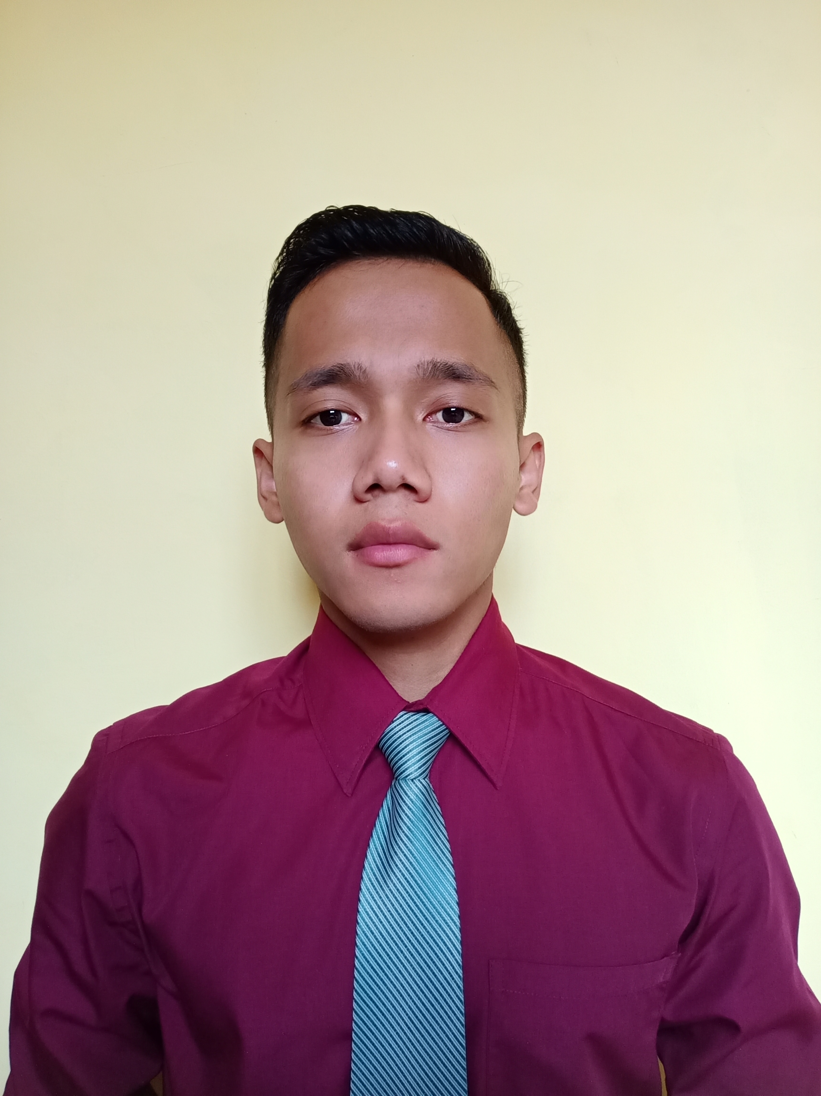

Summary

Houskeeper profesional with 4+ years experience in lead generation and lead qualification, proven customer service, and communication skills to effectively fill the housekeeping attendant role in your company.

Skill Highlights

|  |  |
| --- | --- |
| * Time management * Action plan * Hospitality background | * Ability work as a team * Innovative * Service-focused |

Experience

**Housekeeping supervisor(acting)** - 08/2021 to 01/2022

**Address downtown hotel by EMAAR**, Dubai UAE

* Train motivate housekeepers on cleaning and maintenance  tasks.
* Check rooms and common areas,including stairways and lounge area, for cleanliness ,tidiness , room freshness and hygiene standard.
* Respond to customer compliments and special  request.
* Monitor and replace cleaning projects as required.

**Room attendant –** 6/2018 to 8/2021

**Address downtown hotel by EMAAR**, Dubai UAE

* Performing a variety of cleaning, reporting ( if any damage, maintenance needs etc),managed the complain,and service with high standard.
* Ensure all the room are clean and care according standard.

**Room attendant (daily worker)** 03/2017 to 05/2018

**Aston imperium Hotel –** Purwokerto Indonesia

* Ensuring all the public area is clean and care according to standard.

Education

* King Star Academy (The Cruise, Airlines, and Hotel school) - 2017

Purwokerto , Indonesia

* SMK Yos Soedarso Sidareja (vocational high school)-2016

Certifications

Supervisor floor cross training, Circle excellent (Best employee), Runner up of bed making, CPR and Fist Aid Certificate

Ariffudin Sarno Mustar