**Lightning**

***(Unity C# Script)***

**Documentation**

*By Roy BODEREAU (Kardux)*

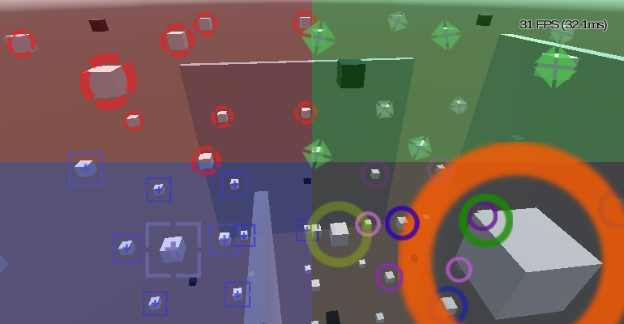

TODO

# Summary

Foreword 3

I - Usage 4

1 - Project setup 4

2 - Scene setup 4

II - Parameters 5

III - Scripting 6

IV - Links 7

# Foreword

First of all please allow me to apology in advance for my English. As non-native English speaker, I try my best to be understandable but I may fail sometimes: if you need any clarification on any point of this document, feel free to contact me and I'll be glad to help you as much as I can.

In this documentation, the following styles will be used:

- **bold** = Unity engine object (**GameObject**, **Canvas**, **Sprite**, etc…)

- ***bold/italic/grey*** = Parts of the script (***MarkerSprite***, ***MaxDistance***, etc…)

- *italic/green* = Paths (*"Assets"*, *"Assets\Editor"*, etc…)

- **bold/red** = Important notes (**MUST**, **"I highly advise […]."**, etc…)

- *italic/red* = Notes (*"Keep in mind […]."*, etc…)

# I - Usage

## 1 - Project setup

## 2 - Scene setup

# II - Parameters

# III - Scripting

# IV - Links

- Project on **GitHub**: [***https://github.com/Kardux/Lightning***](https://github.com/Kardux/Lightning)

- Project **WebGL** demo: [***TODO***](http://www.roy-bodereau.fr/hudradar_demo_en.html)

- Project thread on **Unity** forum: [***TODO***](http://forum.unity3d.com/threads/hud-radar-%5b...%5d182186/)

- This documentation **URL**: [***https://github.com/Kardux/Lightning/Documentation.pdf***](https://github.com/Kardux/Lightning/Documentation.pdf)

http://www.freesfx.co.uk