Breast Cancer AI Project
Unified client report: cancer signature, future risk, subtype, prognosis, external validation, and gene patterns

1. Executive Summary
تم تنظيم المشروع في نظام واحد لتحليل سرطان الثدي باستخدام بيانات الجينات والبيانات الإكلينيكية. النظام يغطي التنبؤ بالبصمة الجينية للسرطان، تحديد نوع الورم، تقدير الخطورة المستقبلية، تحليل الـ survival والـ recurrence، والتحقق الخارجي، مع تحليل العلاقات بين الجينات.
- Cancer molecular signature prediction from TCGA-BRCA.
- Future breast cancer incidence risk percentage from BCSC screening follow-up data.
- Tumor subtype prediction using real METABRIC CLAUDIN subtype labels.
- Survival and recurrence prognosis using METABRIC real clinical labels.
- External validation using GEO cohorts.
- Gene correlation and expression pattern analysis for explainability.
- Streamlit demo for interactive client testing.
Scientific note: TCGA Cancer Signature is cancer-like vs normal-like molecular detection. The future percentage risk component is handled separately using BCSC because it contains real follow-up diagnosis labels.

2. Results Overview
Part | Dataset | Target | Samples | Main result
Cancer molecular signature | TCGA-BRCA | Cancer vs Normal tissue | 1224 | AUC 1.000, Acc 1.000
Future incidence risk | BCSC | 1-year future diagnosis risk | 2392998 | AUC 0.639
Tumor subtype | METABRIC | Real CLAUDIN subtype | 1980 | Balanced Acc 0.748
Survival prognosis | METABRIC | Overall survival event | 1980 | Holdout AUC 0.750
Recurrence prognosis | METABRIC | Recurrence event | 1979 | Holdout AUC 0.657
External validation | GEO | Relapse, metastasis, death, RFS, OS | 1643 | AUC range 0.348 to 0.664
Gene correlation | METABRIC | Gene-gene patterns | 1980 | 232 strong pairs

3. TCGA Cancer Molecular Signature
The TCGA-BRCA model separates Primary Tumor samples from Solid Tissue Normal samples. It used 1224 samples and 18936 gene features. Holdout ROC-AUC = 1.000, accuracy = 1.000, balanced accuracy = 1.000.
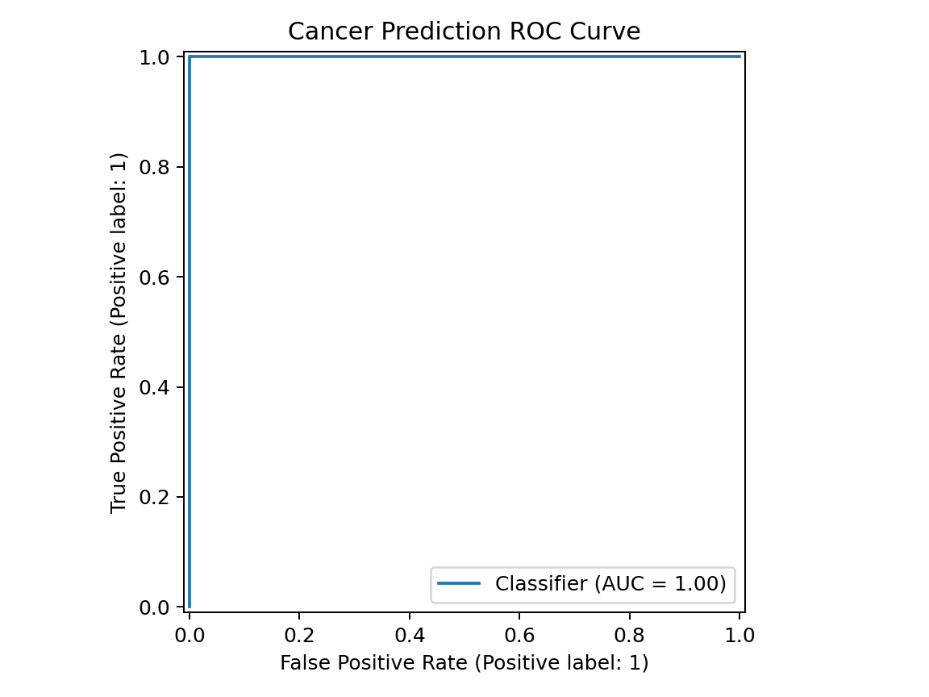
Figure 1. TCGA cancer signature ROC curve
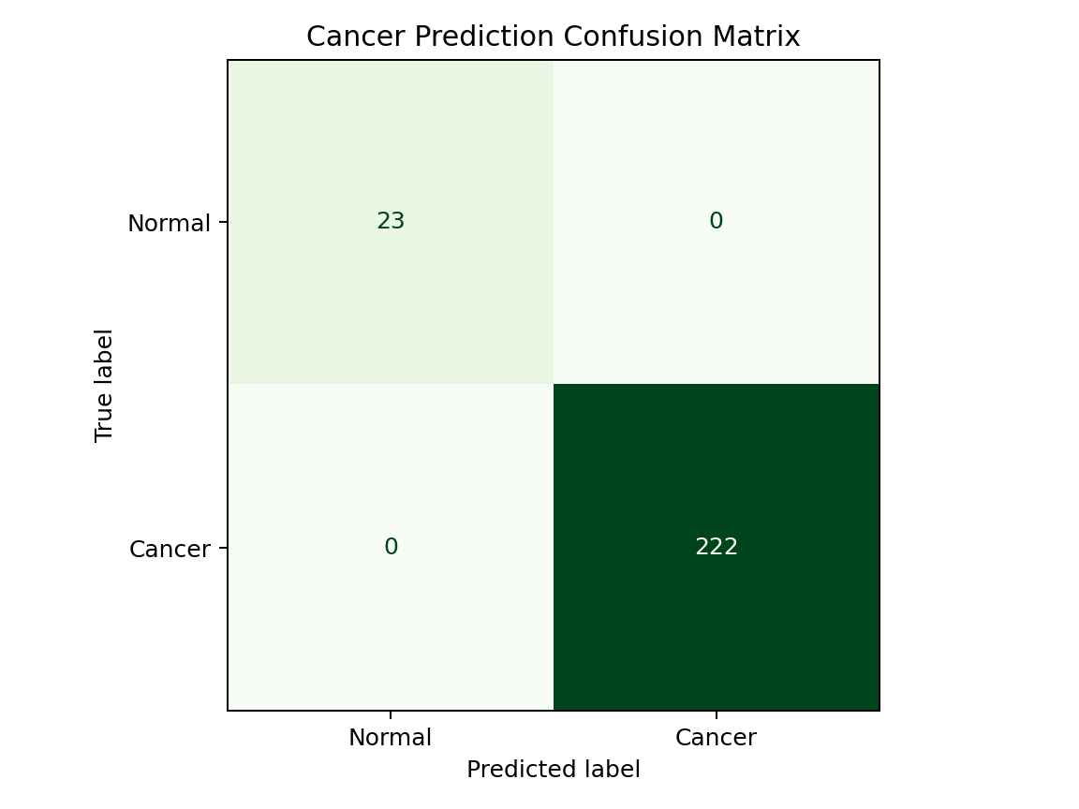
Figure 2. TCGA cancer signature confusion matrix
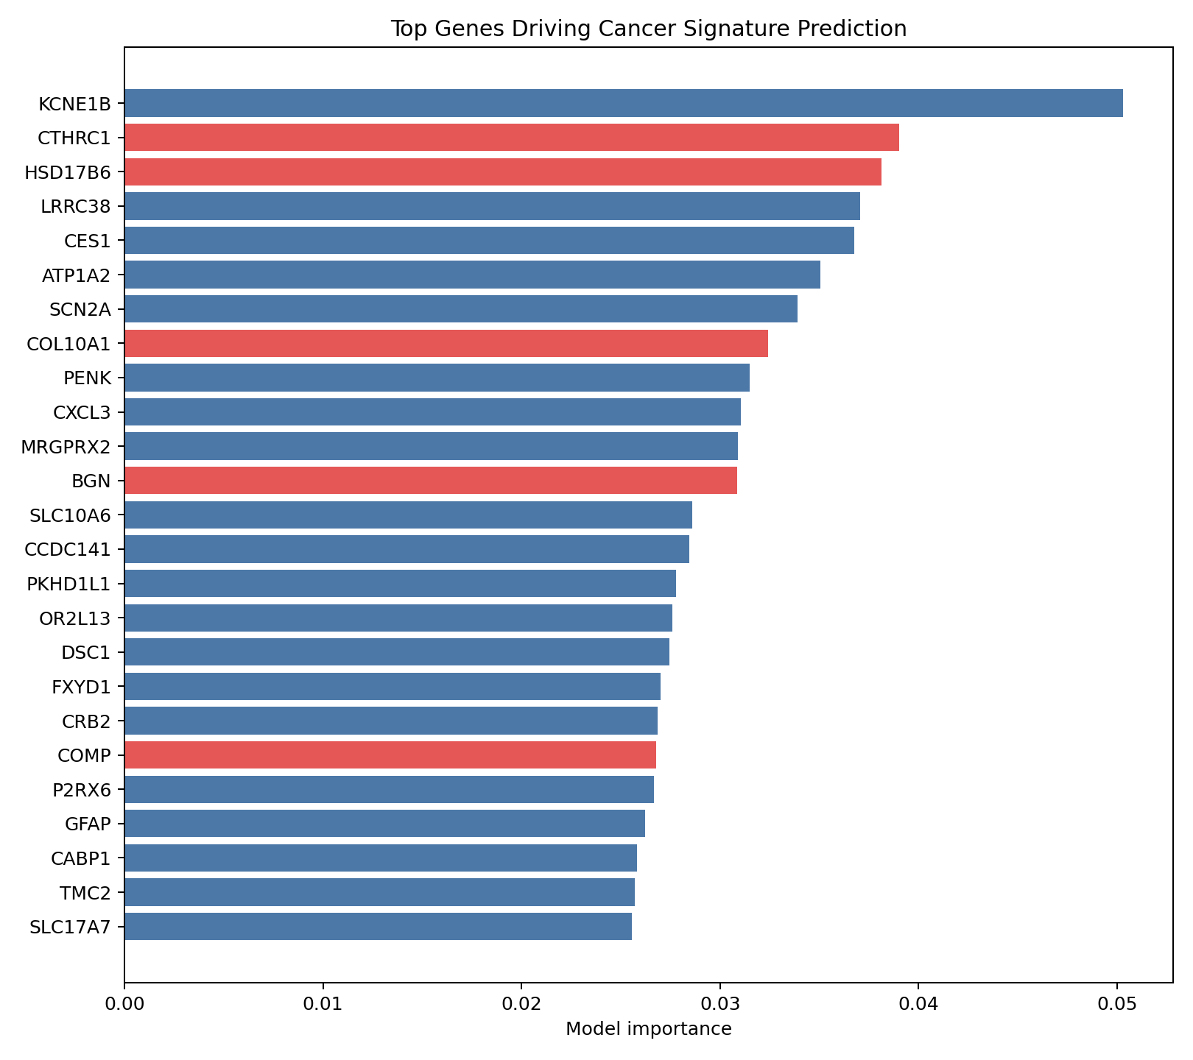
Figure 3. Top TCGA cancer signature genes

4. Future Incidence Risk Percentage
The BCSC component predicts the probability of breast cancer diagnosis within one year after screening mammography. Weighted records = 2,392,998. Validation ROC-AUC = 0.639; Brier score = 0.00477.
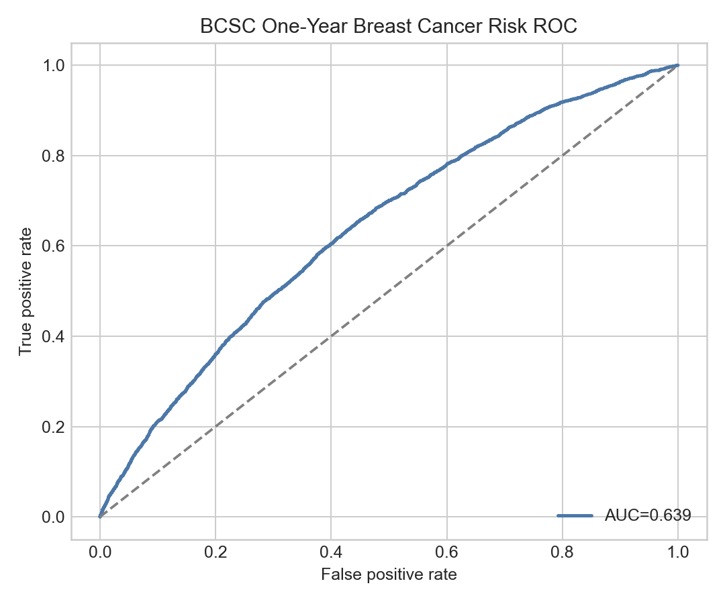
Figure 4. BCSC future risk ROC curve
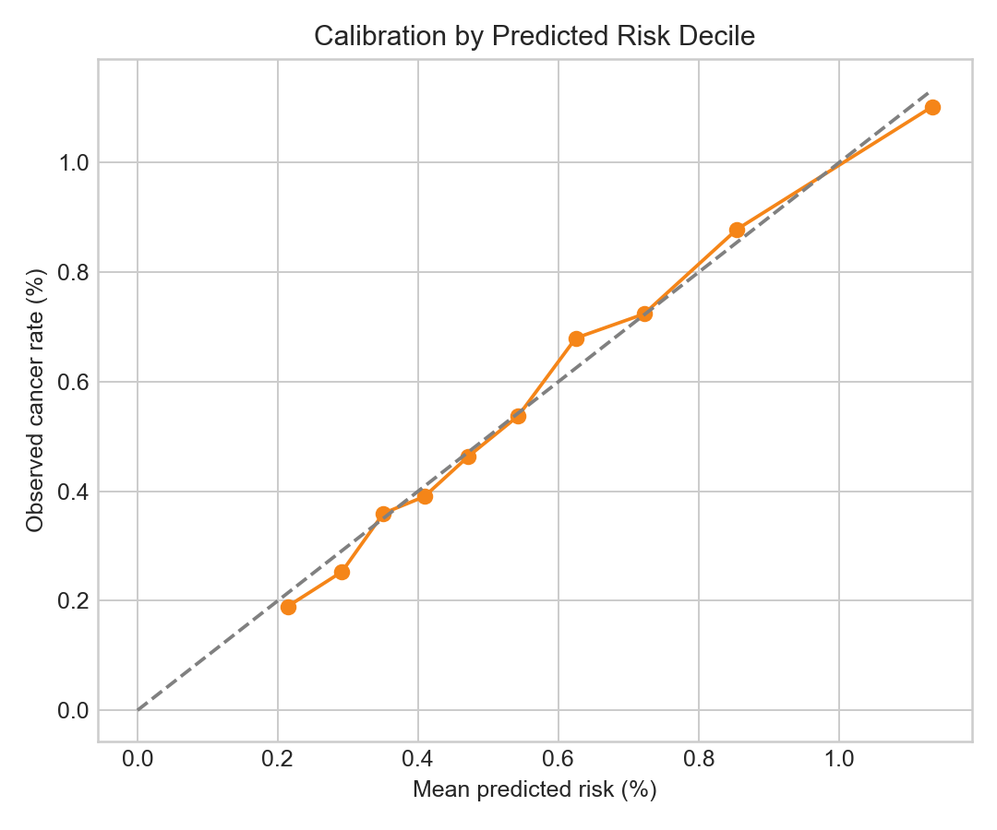
Figure 5. BCSC calibration
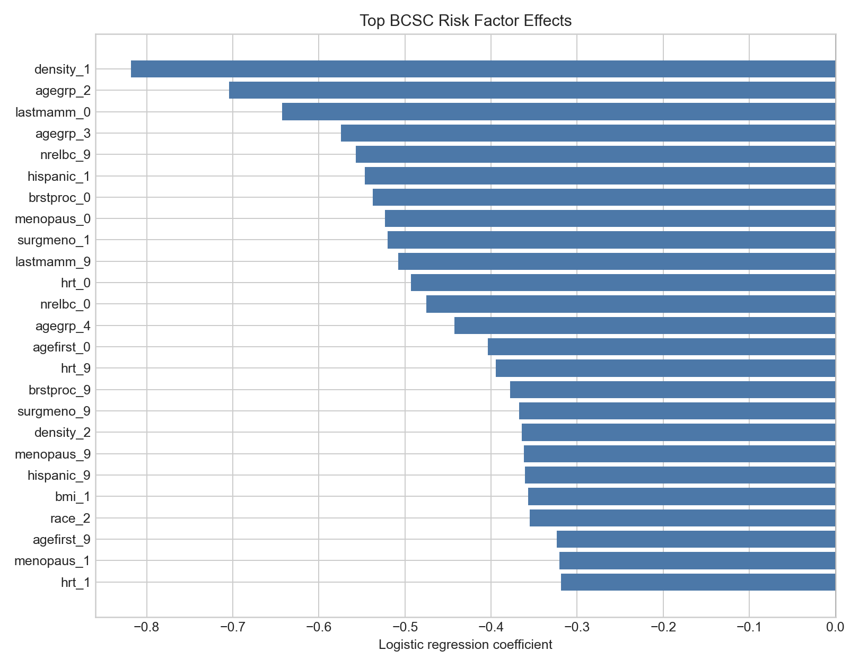
Figure 6. BCSC top feature effects

5. Tumor Subtype Prediction
The subtype component uses real METABRIC CLAUDIN subtype labels. Predicted samples = 1980; classes = Basal, Her2, LumA, LumB, Normal, claudin-low. Honest holdout accuracy = 0.762; holdout balanced accuracy = 0.748.
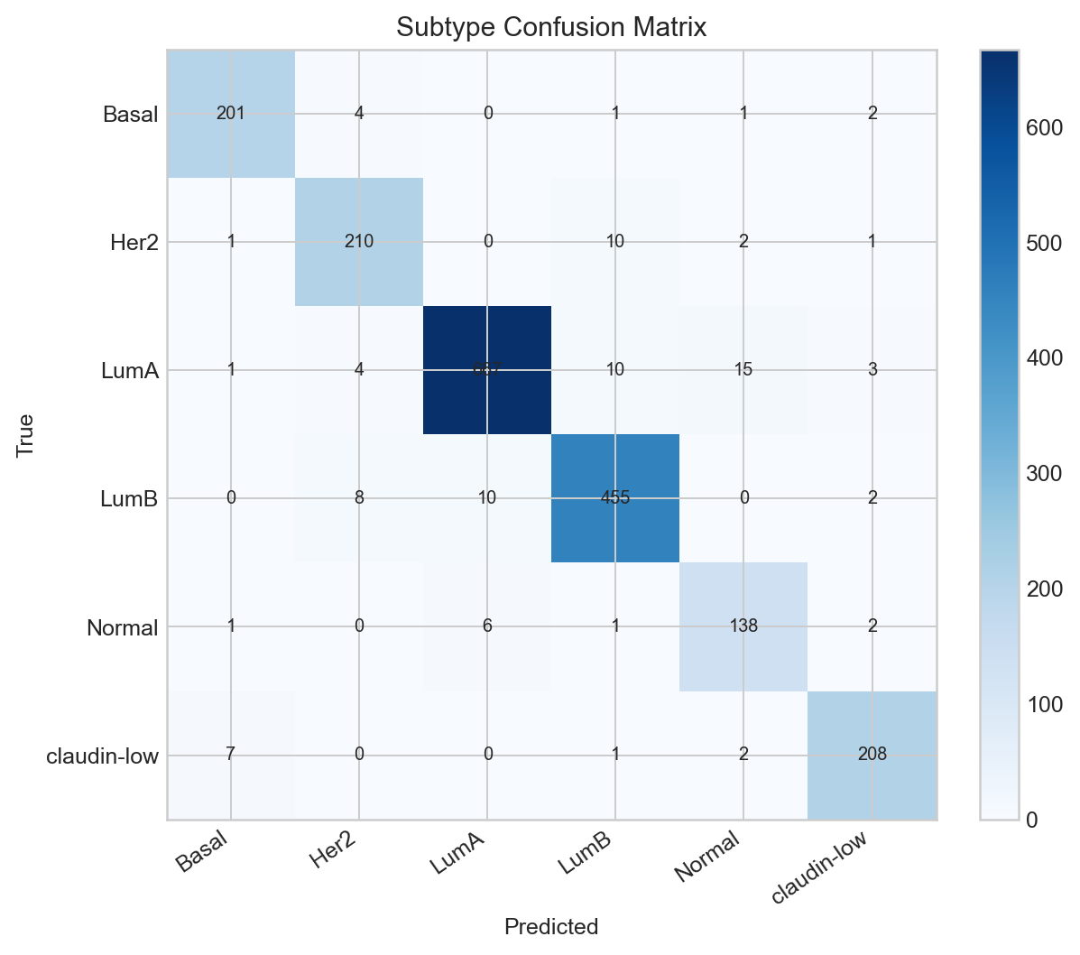
Figure 7. Tumor subtype confusion matrix
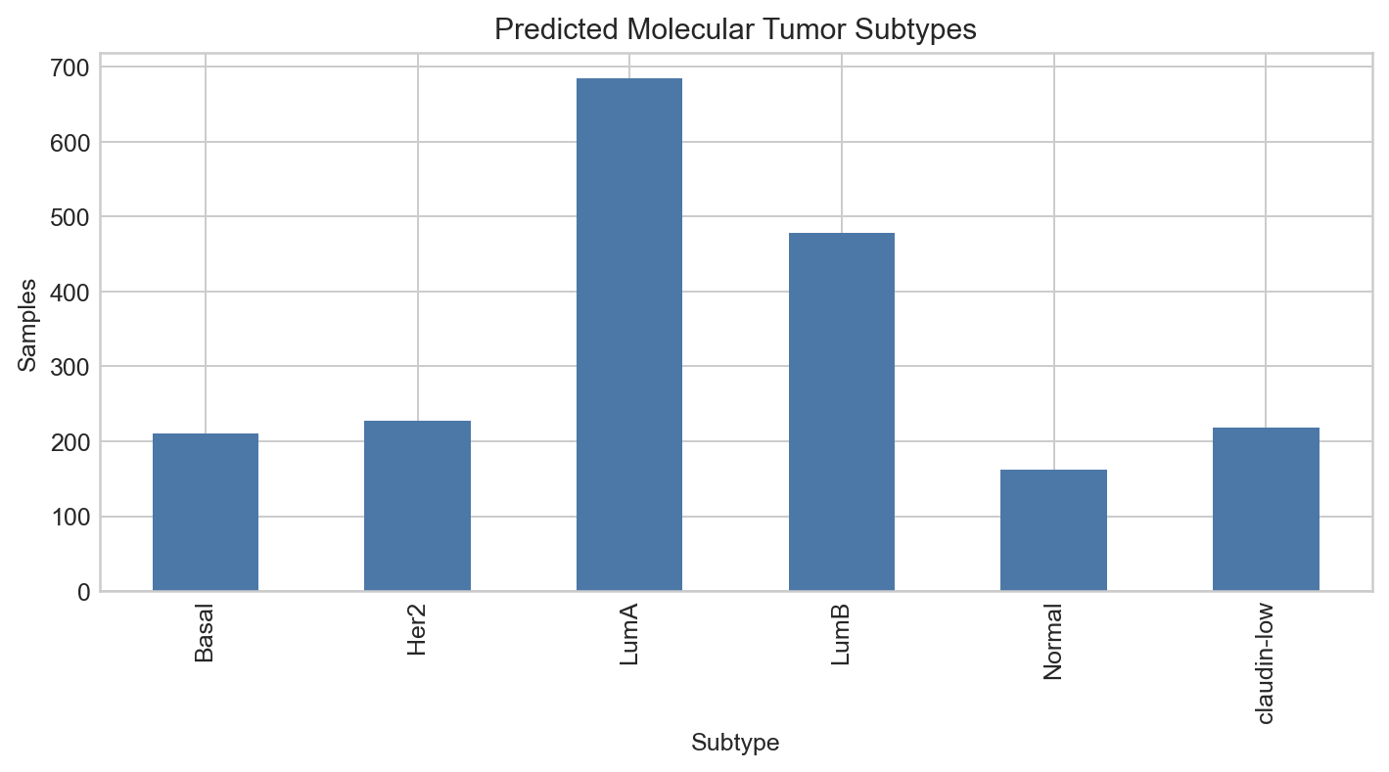
Figure 8. Predicted subtype distribution
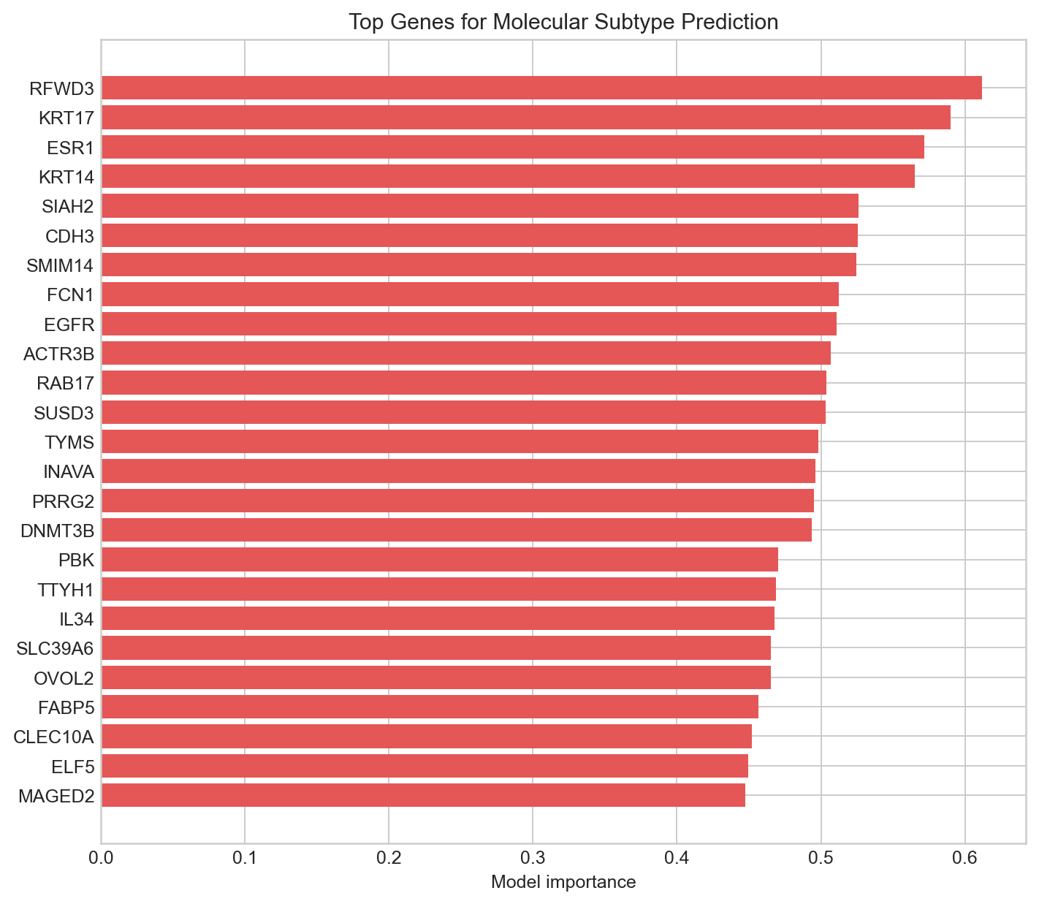
Figure 9. Top subtype genes

6. Prognosis: Survival and Recurrence
Survival best model: combined_logreg_k50; holdout ROC-AUC = 0.750; balanced accuracy = 0.680.
Recurrence best model: combined_rf_k100; holdout ROC-AUC = 0.657; balanced accuracy = 0.605.
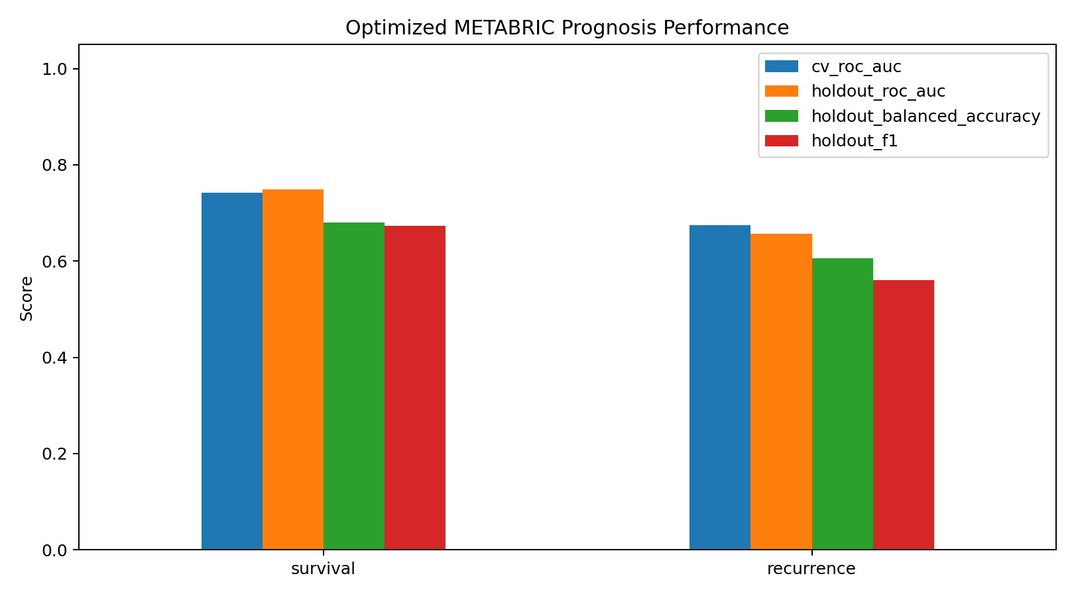
Figure 10. Optimized prognosis performance
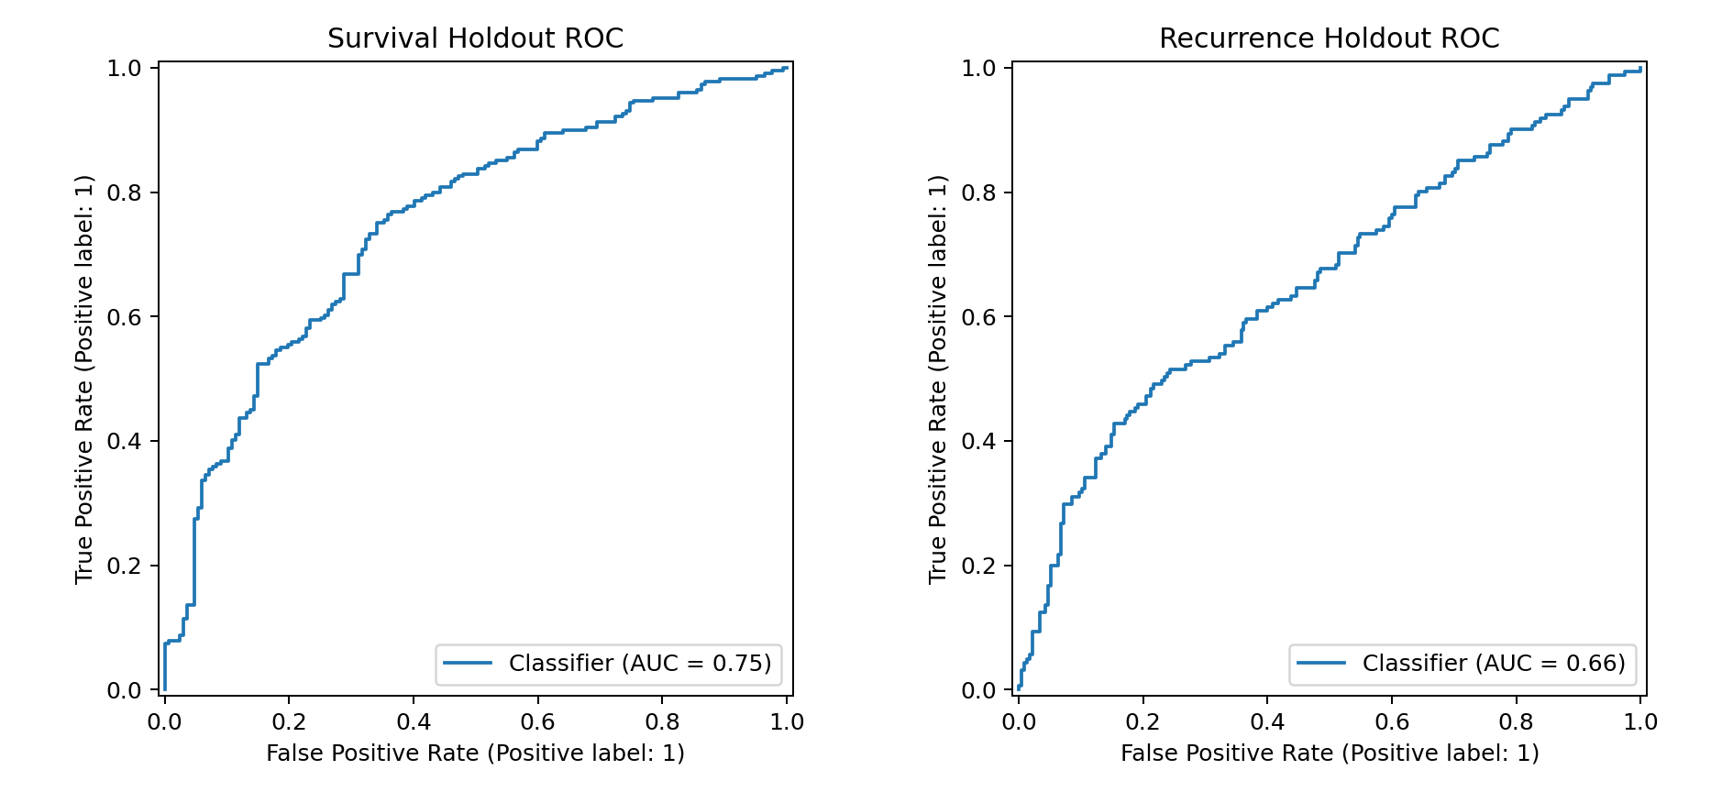
Figure 11. METABRIC holdout ROC curves
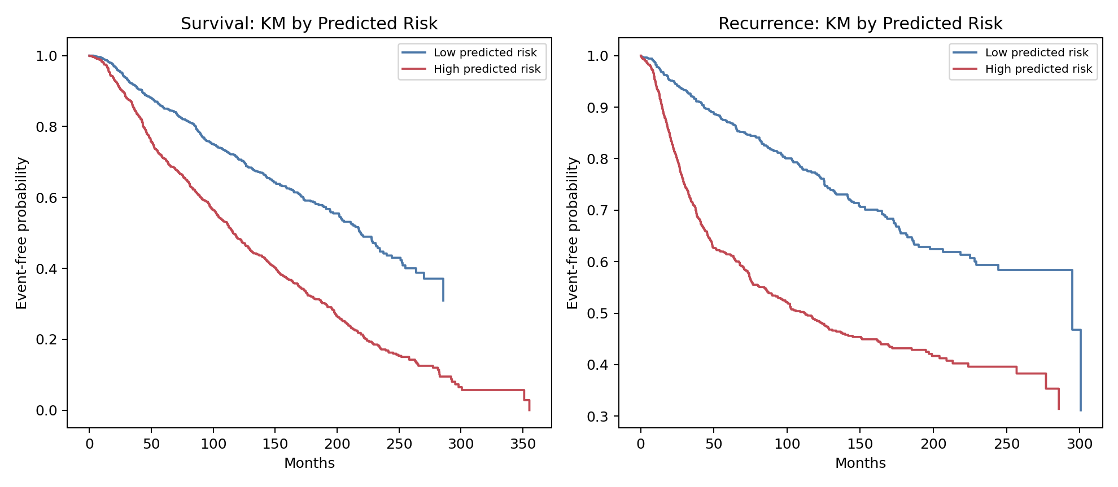
Figure 12. Kaplan-Meier risk groups

7. GEO External Validation
label_name | dataset | endpoint | samples | events | overlap_genes_used | roc_auc | balanced_accuracy | f1
GSE20685_metastasis | GSE20685 | metastasis | 327 | 83 | 48 | 0.664 | 0.585 | 0.429
GSE20685_death | GSE20685 | overall_survival | 327 | 83 | 86 | 0.631 | 0.573 | 0.418
GSE2034_relapse | GSE2034 | relapse | 286 | 107 | 42 | 0.626 | 0.590 | 0.547
GSE20685_regional_relapse | GSE20685 | regional_relapse | 307 | 25 | 48 | 0.564 | 0.523 | 0.153
GSE7390_rfs | GSE7390 | recurrence_free_survival | 198 | 91 | 42 | 0.551 | 0.533 | 0.548
GSE7390_os | GSE7390 | overall_survival | 198 | 142 | 68 | 0.348 | 0.402 | 0.587

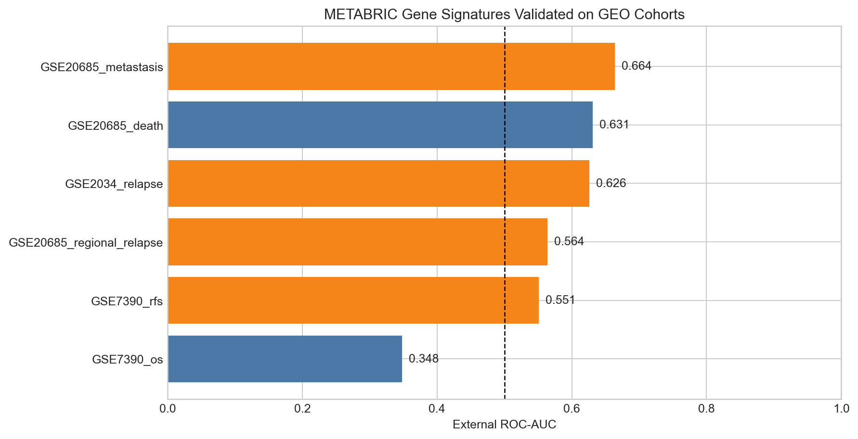
Figure 13. METABRIC-to-GEO external AUC
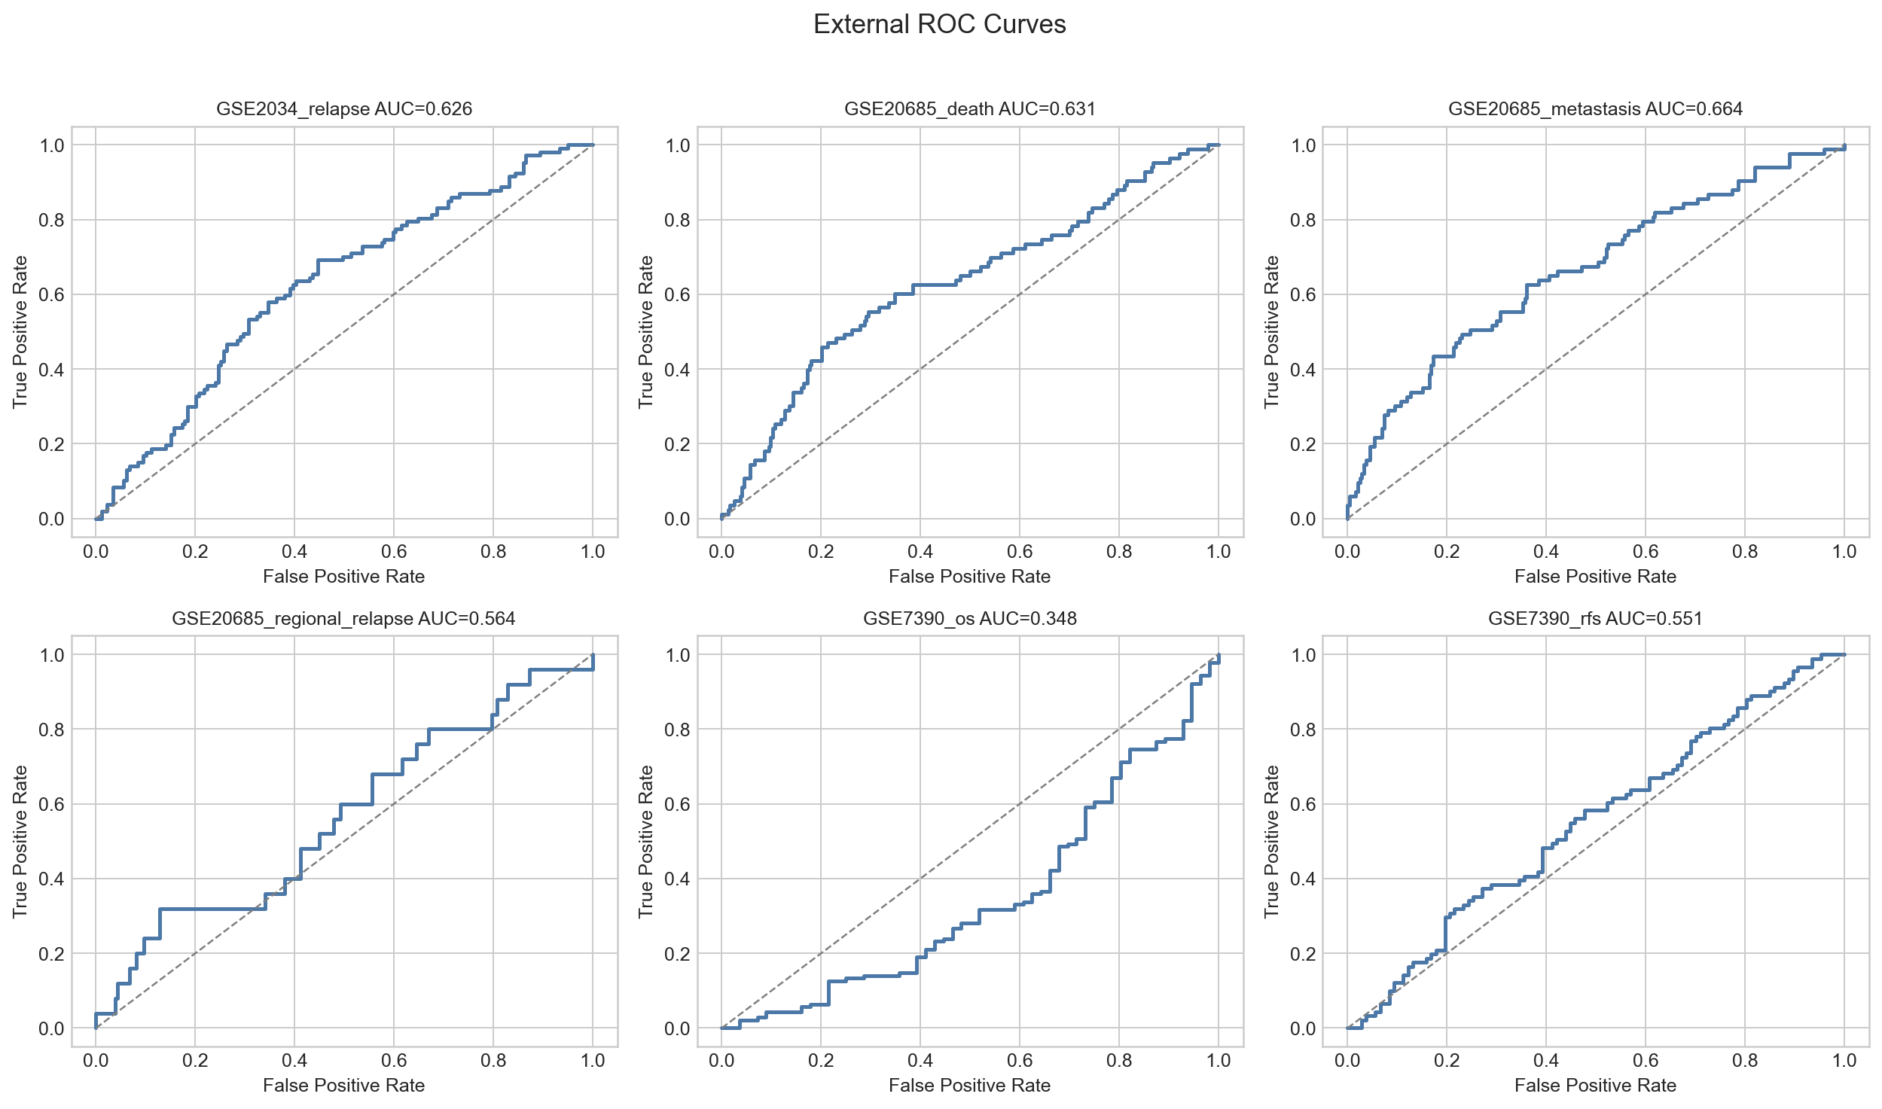
Figure 14. External validation ROC curves

8. Gene Correlation and Expression Patterns
METABRIC gene pattern analysis used 1980 samples and 70 selected genes. Detected strong gene-gene pairs with abs(correlation) >= 0.45: 232.
gene_a | gene_b | spearman_correlation | relationship | gene_a_sources | gene_b_sources
KRT17 | KRT5 | 0.879 | positive co-expression | curated_breast_cancer_marker; tumor_subtype | curated_breast_cancer_marker; tumor_subtype
KRT14 | KRT5 | 0.831 | positive co-expression | curated_breast_cancer_marker; tumor_subtype | curated_breast_cancer_marker; tumor_subtype
KRT17 | KRT14 | 0.831 | positive co-expression | curated_breast_cancer_marker; tumor_subtype | curated_breast_cancer_marker; tumor_subtype
HSD17B6 | COL10A1 | 0.826 | positive co-expression | cancer_signature | cancer_signature
RPL21 | RPL10A | 0.818 | positive co-expression | survival | survival
C1R | CFH | 0.803 | positive co-expression | survival | survival
SDHD | SELENOF | 0.775 | positive co-expression | survival | survival
CLEC10A | KLRB1 | 0.760 | positive co-expression | tumor_subtype | survival
MARCHF6 | FOXP1-IT1 | 0.743 | positive co-expression | survival | survival
MKI67 | CDC20 | 0.741 | positive co-expression | curated_breast_cancer_marker; recurrence | curated_breast_cancer_marker; recurrence
FCN1 | CLEC10A | 0.741 | positive co-expression | tumor_subtype | tumor_subtype
FCN1 | KLRB1 | 0.740 | positive co-expression | tumor_subtype | survival

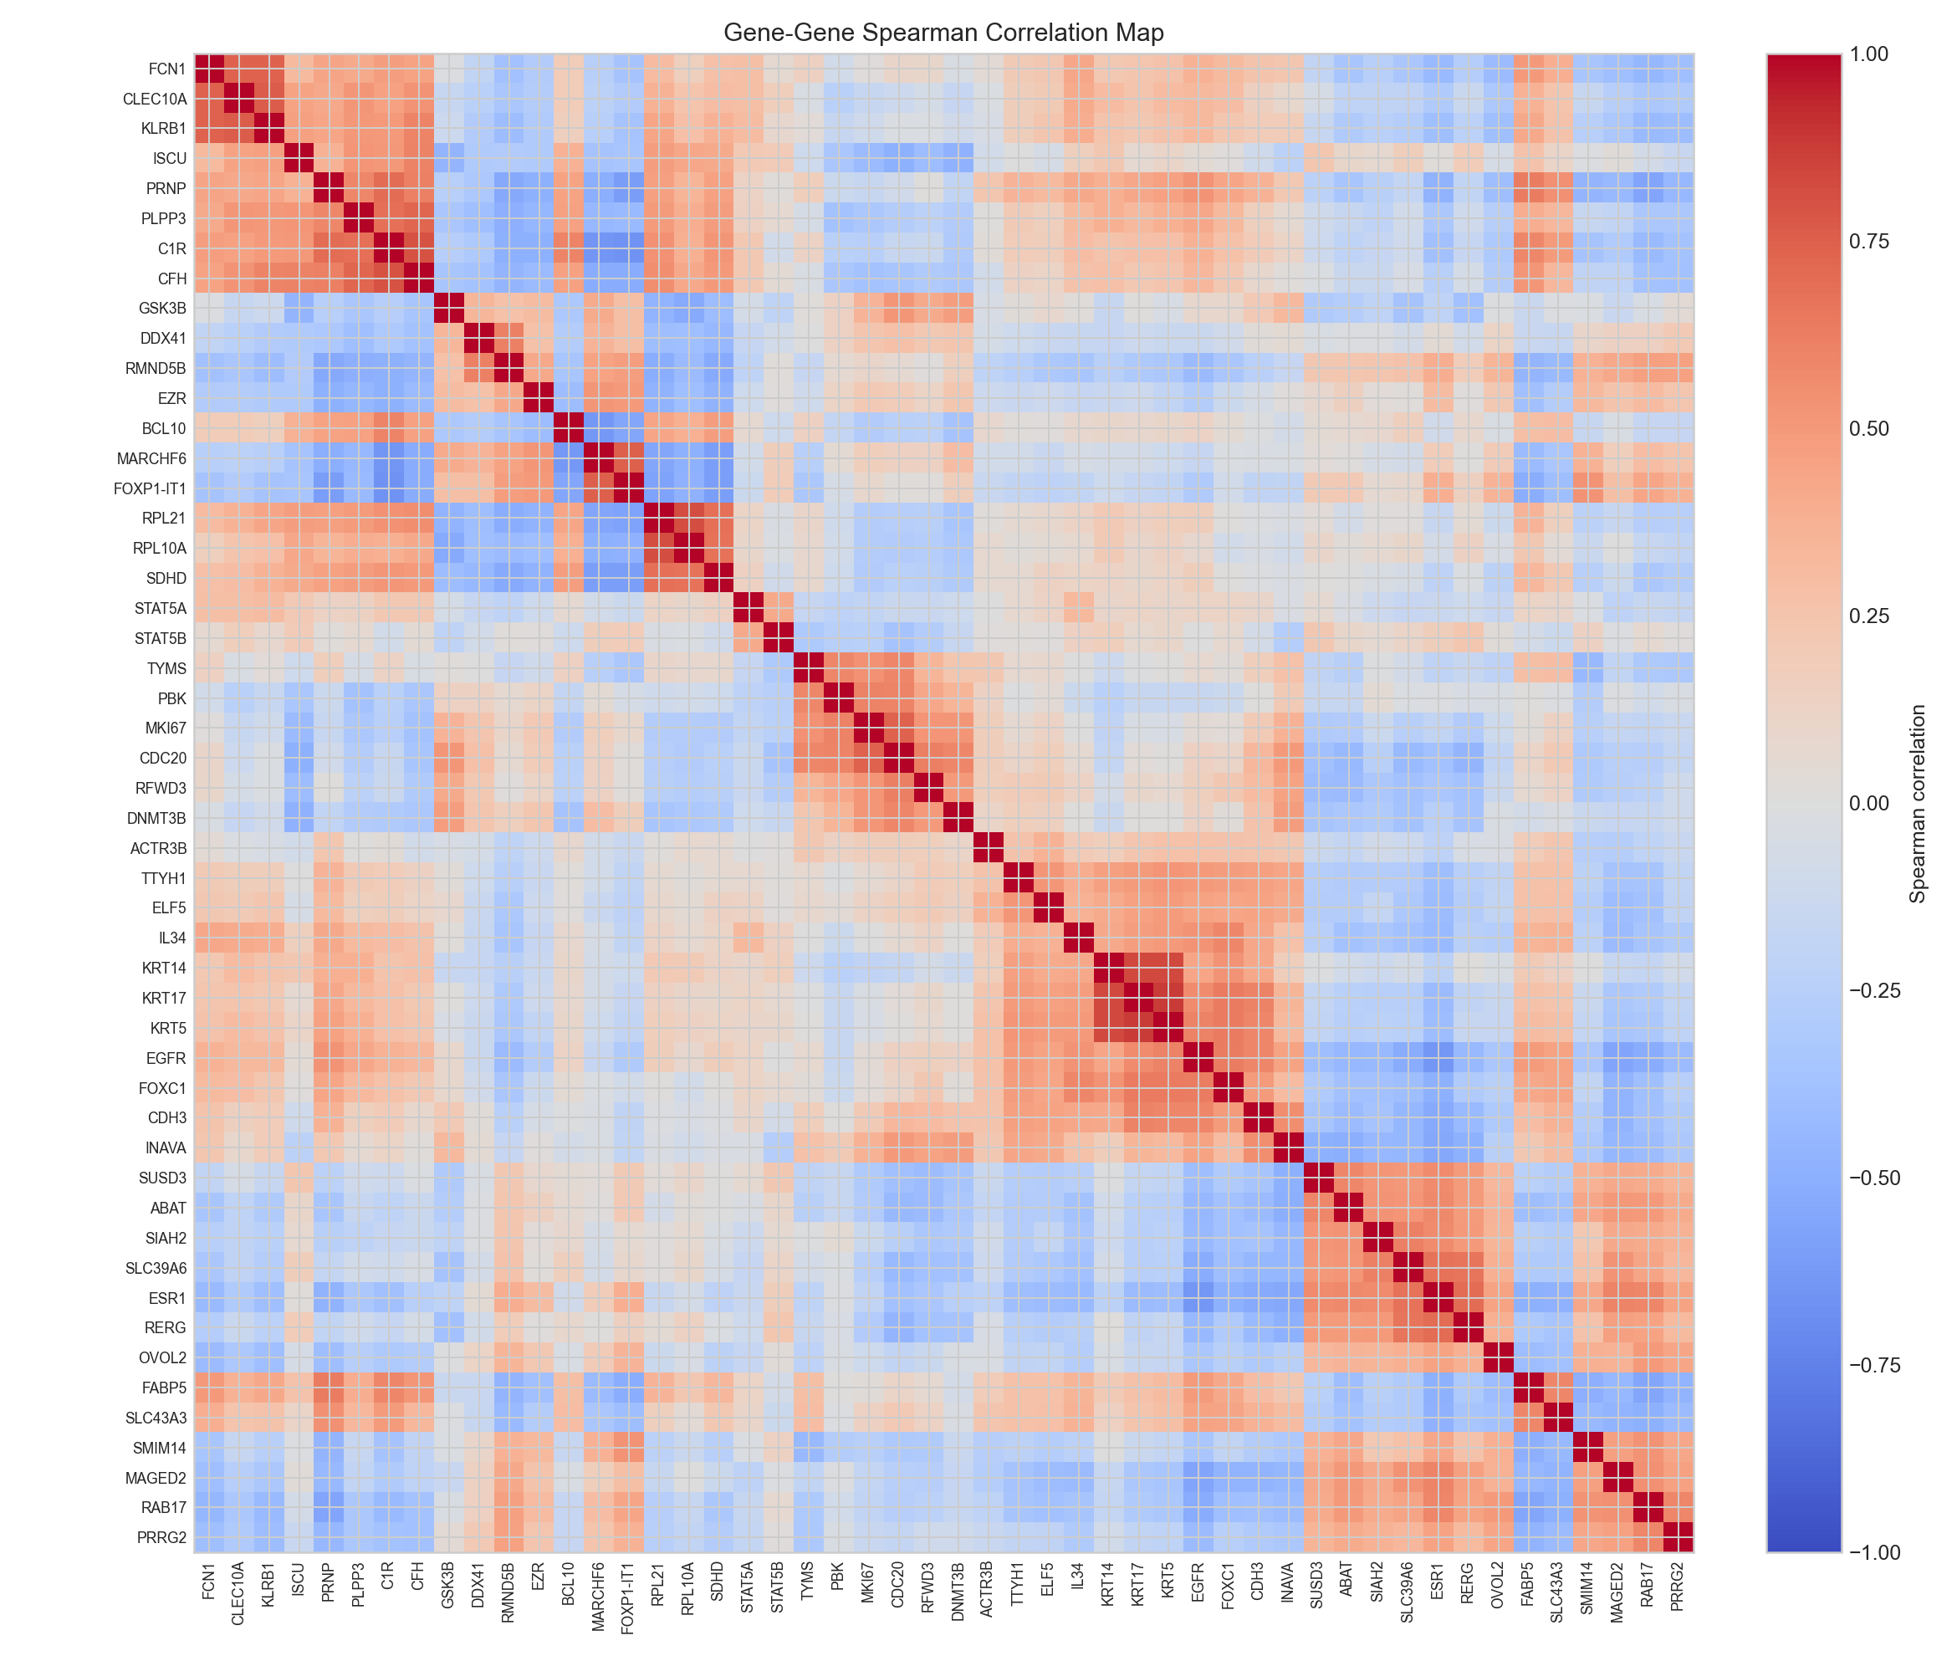
Figure 15. Gene-gene correlation heatmap
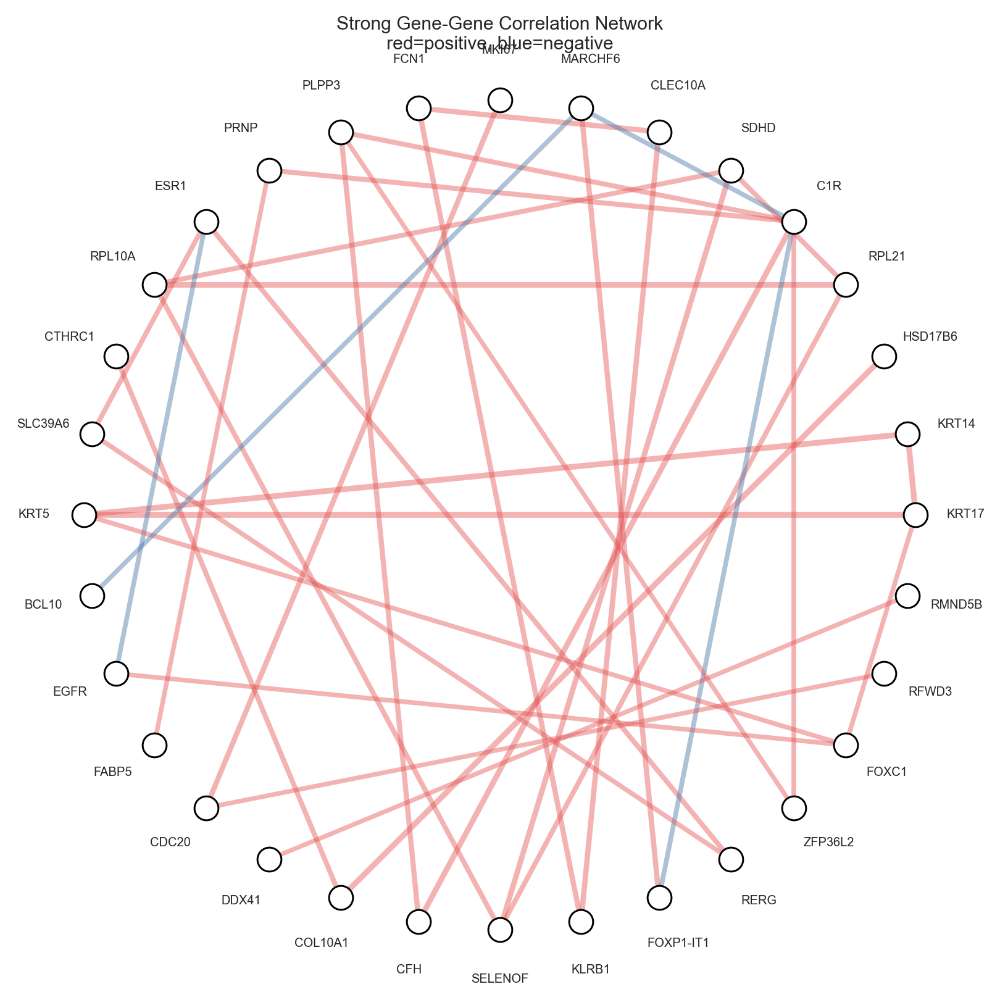
Figure 16. Strong gene correlation network
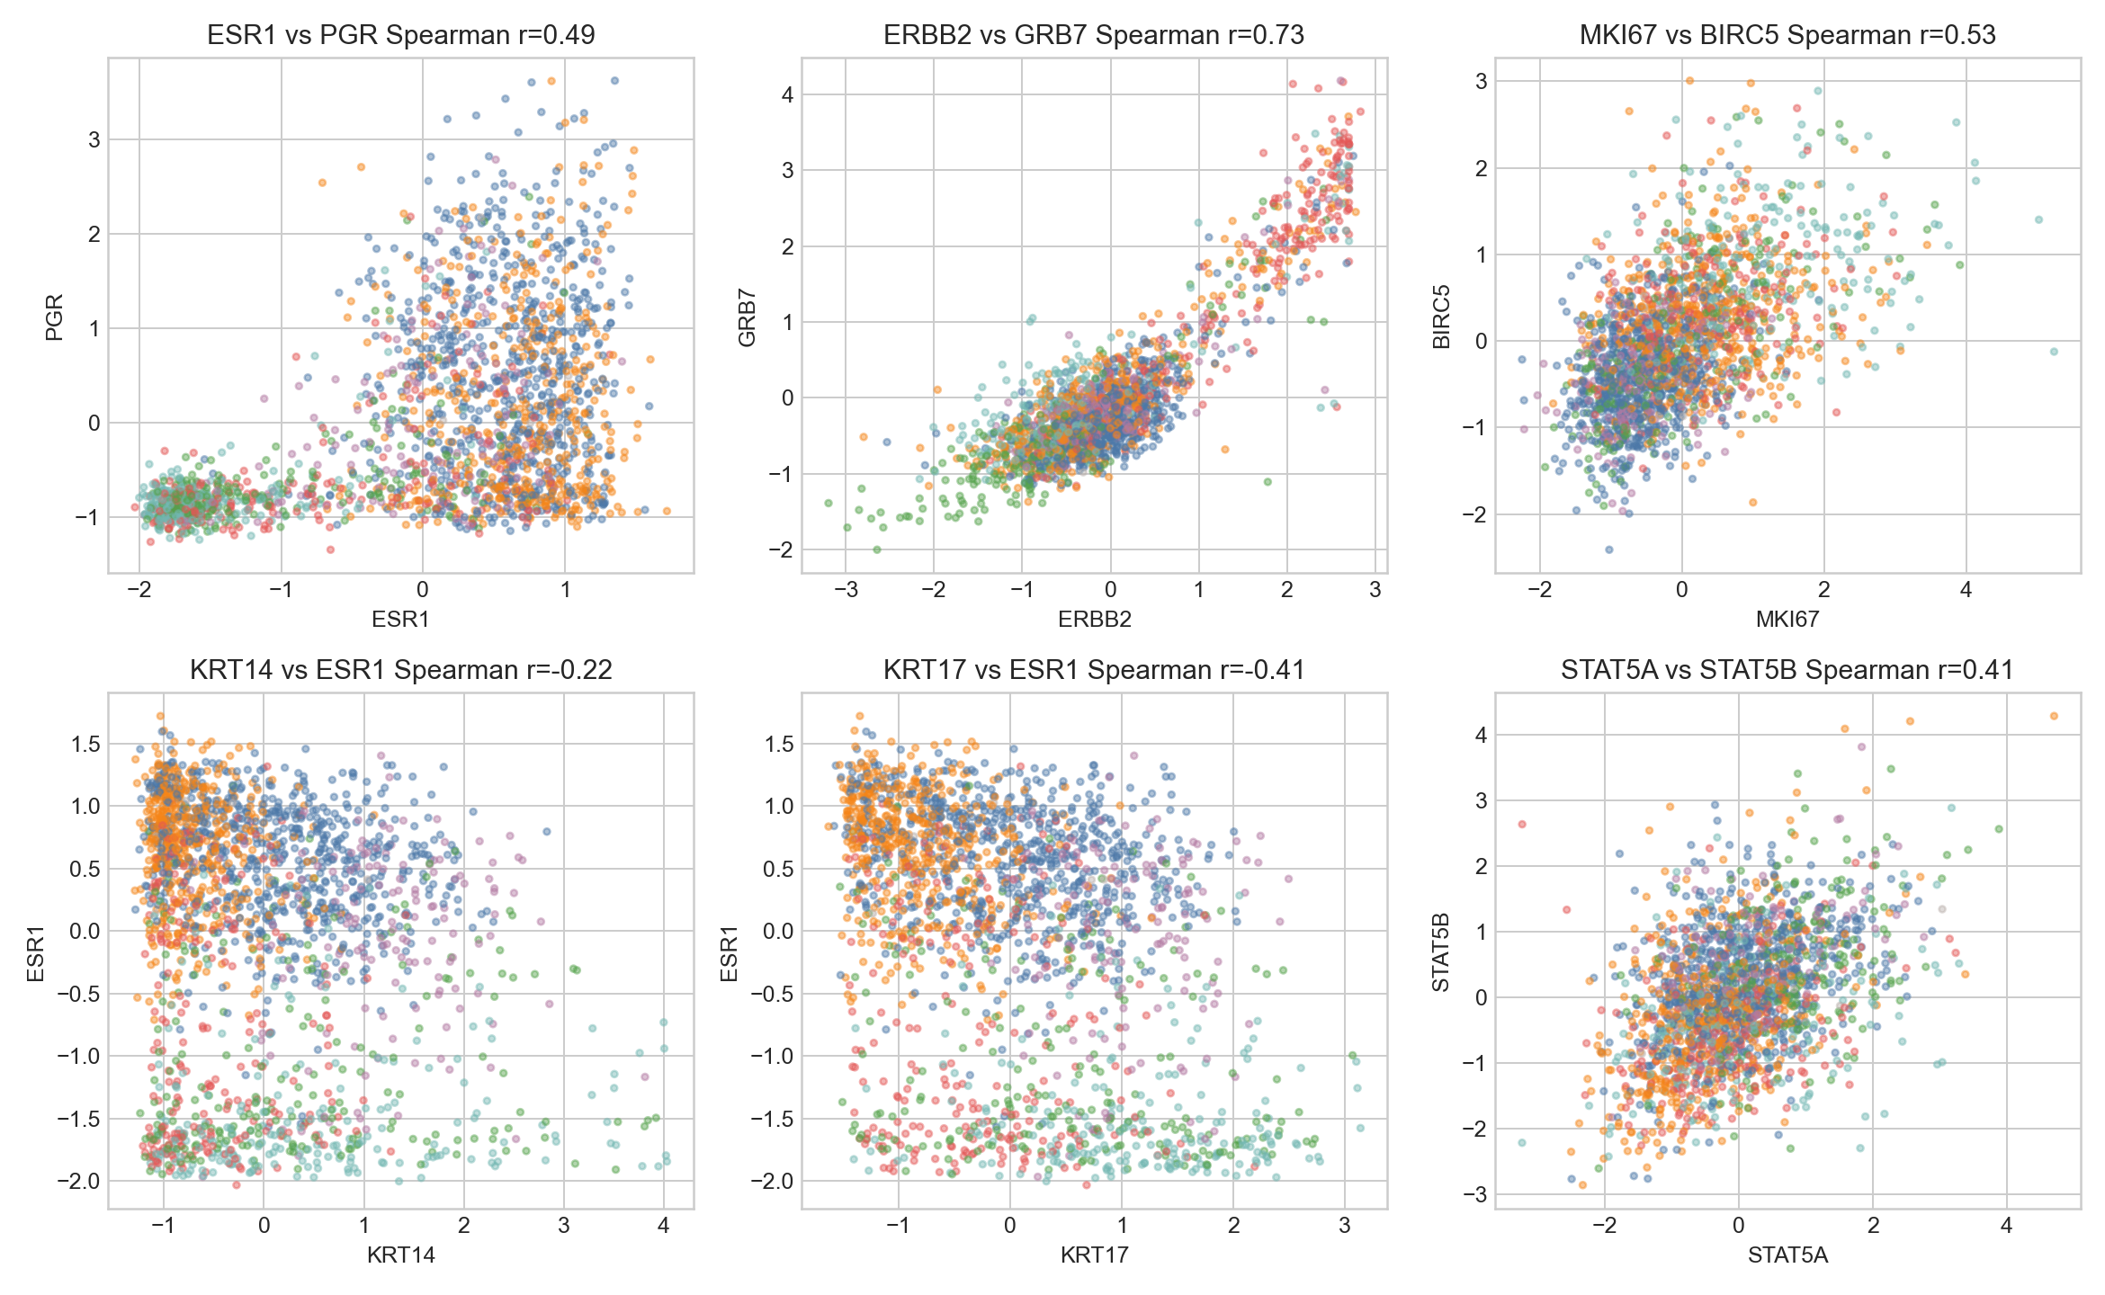
Figure 17. Gene pair scatter patterns

9. Patient-Level Outputs and Streamlit Demo
The project includes patient-level CSV outputs for cancer-signature probability, prognosis percentages, subtype confidence, and GEO external event-risk probabilities. A Streamlit application was created so the client can review results interactively and enter BCSC risk-factor profiles to calculate a future risk percentage.
- Unified notebook: client_deliverables/breast_cancer_ai_unified_client_notebook.ipynb
- Streamlit app: client_deliverables/streamlit_app.py
- HTML report: client_deliverables/final_client_report.html
- Markdown report: client_deliverables/final_client_report.md

10. Limitations and Next Improvements
- Cancer signature and future incidence risk are separate clinical questions and should be described separately.
- BCSC future risk is based on screening and clinical risk factors, not gene expression.
- Survival and recurrence tasks are harder and show moderate performance, which is expected for noisy prognosis labels.
- GEO external validation is mixed and should be reported transparently, especially weak OS transfer on GSE7390.
- Clinical support outputs are decision-support insights only, not direct treatment prescriptions.
- Next research improvements: add more external cohorts, survival-specific models, SHAP plots, and pathway enrichment.

