# Project Group 1: Sprint 0

Weiqiang (Kevin) Huang, Chih Ming Sun, Kareem Abdelshafy, Todd Brown

## Repositories

* Trello Board: <https://trello.com/invite/b/BpvBRp4O/573ef830c56176076f352d92c03cec85/cs5500>
* Larger design discussions: <https://northeastern.instructure.com/groups/2992>
* Casual discussion: Teams Project Group 1
* GIT Url: <https://github.ccs.neu.edu/huangw25/CS5500-Project-Group-1>

## Project (Epic) Story

AS A **manager of a grocery store** I NEED TO KNOW **how long my customer spends in the store (including the specific day/time)** SO THAT **there are enough workers on duty to keep customers moving through without bunching up and having to force people to wait outside.**

## User Stories

|  |  |  |
| --- | --- | --- |
| **Priority** | **Story Name** | **Points** |
| 1 | Generate a basic CSV [link](https://trello.com/c/82aFBOm8/1-setup-project-generate-a-csv) | 3 days |
| 2 | Enhance CSV to accurately reflect Non-Holidays [link](https://trello.com/c/HhaGGWQ9/2-enhance-csv-to-accurately-relfect-non-holidays) | 2 days |
| 3 | Enhance CSV to accurately reflect the Day of a Holiday [link](https://trello.com/c/UTYb5jB4/3-enhance-csv-to-accurately-relfect-the-day-of-a-holiday) | 1 day |
| 4 | Enhance CSV to accurately reflect Day before a Holiday [link](https://trello.com/c/dSOHgDQ3/17-enhance-csv-to-accurately-reflect-day-before-a-holiday) | 1 day |
| 5 | Enhance CSV to accurately reflect the Week before a Holiday [link](https://trello.com/c/5KzF3Baa/18-enhance-csv-to-accurately-reflect-the-week-before-a-holiday) | 2 days |
| 6 | Enhance CSV to accurately reflect Dinner Time rush [link](https://trello.com/c/HcLkjiiu/6-enhance-csv-to-accurately-reflect-dinner-time-rush) | 3 days |
| 7 | Enhance CSV to accurately reflect Lunch Hour rush [link](https://trello.com/c/fNx3H2Zf/8-enhance-csv-to-accurately-reflect-lunch-hour-rush) | 1 day |
| 8 | Enhance CSV to accurately reflect Senior Discount time [link](https://trello.com/c/c9LkeGcd/5-enhance-csv-to-accurately-reflect-senior-discount-time) | 2 days |
| 9 | Enhance CSV to accurately reflect Grab and Go traffic on "Very Nice Days" [link](https://trello.com/c/cWAVuFQm/4-enhance-csv-to-accurately-reflect-grab-and-go-traffic-on-very-nice-days) | 3 days |

** Point estimates in days inclusive of Implementation, Unit Testing and Documentation

## Conceptual Design

This is the initial conceptual design to our solution, given what we know now. This may change as we start to engineer the solution.

### Inputs

|  |  |
| --- | --- |
| Holiday schedule | Path to CSV – each line is an { ISO date } |
| Weather Forecast | Path to CSV – each line is an { ISO date, forecast (nice | notNice) } |
| Start traffic Forecast On | Iso DateTime to start forecast (inclusive) |
| Stop traffic Forecast On | Iso DateTime to stop forecast (inclusive) |
| Output Path | Path and filename of CSV to output |

### Outputs

A CSV in the format

|  |  |  |  |
| --- | --- | --- | --- |
| id | dateTimeOfEntry | minutesInStore | notes |
| 1 | 2020-07-02T06:00:00-400 | 55 | Senior |
| 2 | 2020-07-02T06:00:00-400 | 17 |  |
| n | 2020-07-02T06:00:00-400 | 28 |  |

### Conceptual Architecture

Break the application into three independent components each model a different aspect of the shopping experience.

The **EntryIntoStoreModel** component abstracts the distribution of the total number and rate of entries into the store, accounting for day of week, holidays and weather. We may leverage the Poisson Distribution to reflect realistic arrival times.

The **CustomerMixModel** component abstracts the distribution of different customer mixes and accounts for the day and time of entry. Initially we think the customer mix is separated into Seniors, Non-Seniors and GrabAndGo customers. GrabAndGo customers are classified across both senior and non-senior.

The **TimeInStoreModel** component abstracts the distribution a customer spends in the store, it is a function of the day of the week, the weather, the holiday type, and the Customer (or customer type). We still need to consider how to add variability to the time a customer spends in the store (e.g. Gaussian distribution).

### Diagrams

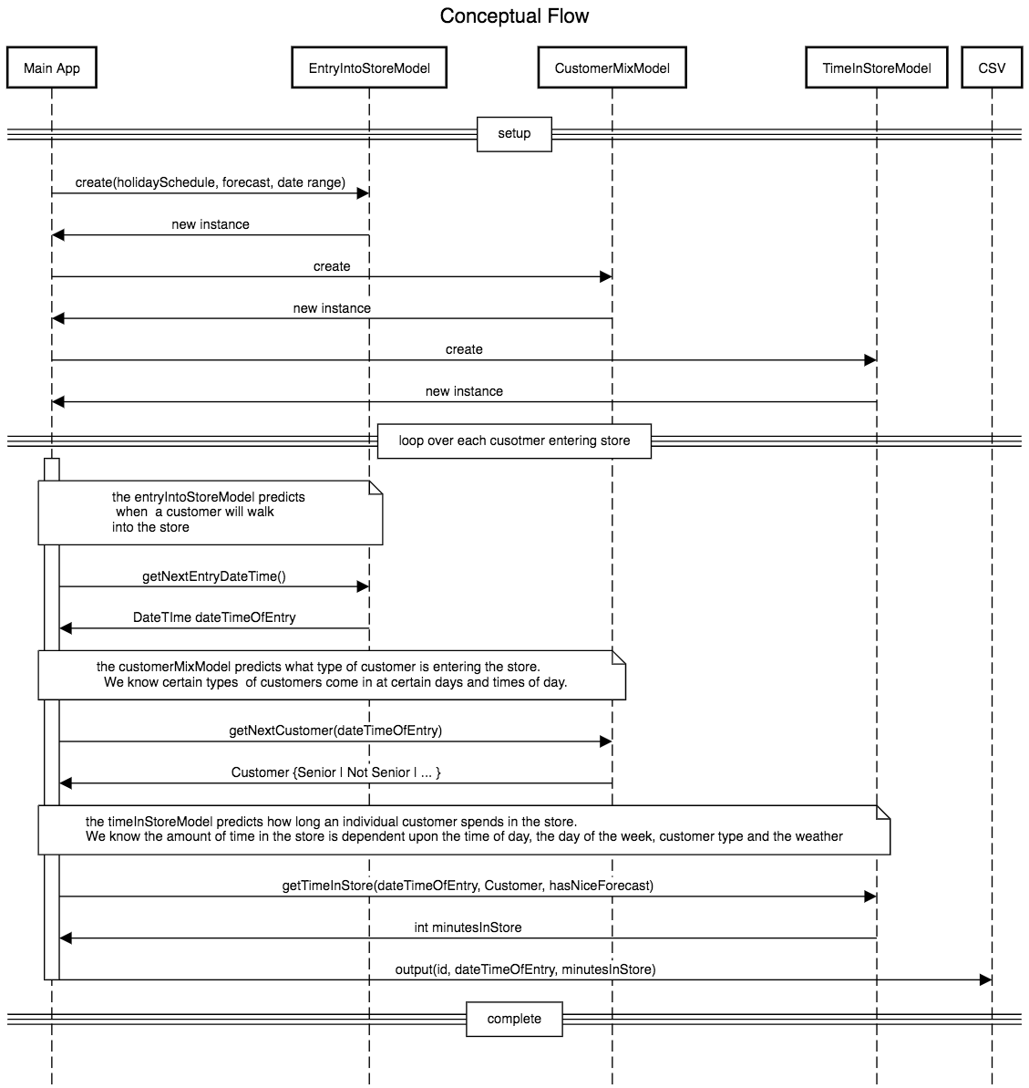

<https://bit.ly/2TjeZro>

## Libraries Identified

* GIT (CCIS Git)
* Java 8
* Junit 4
* Apache Commons Math (<http://commons.apache.org/proper/commons-math/>)