Conclusion

Stack ◼ Queue ◼ Vector ◼ List ◼ Sequence

1. Stack (push, pop, top, size, isEmpty) 1/2/3 => 3

Array-based Stack:

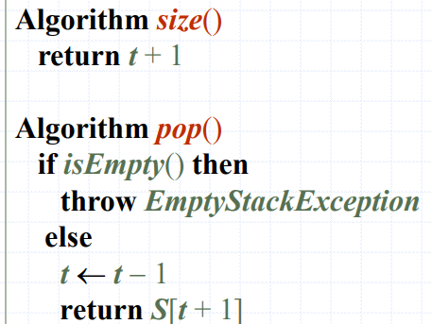 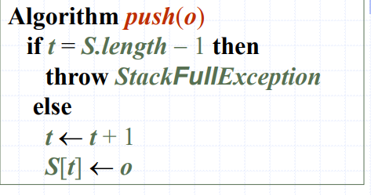

The space used is O(n)

Each operation runs in time O(1)

1. Queue (enqueuer, dequeuer, front, size, isEmpty) 1/2/3 => 1

Array-based Stack: (circular fashio)

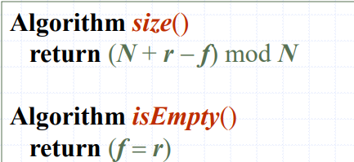 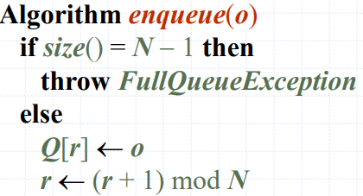 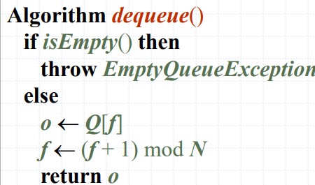

1. Vector

Array-based Vector ( stores a sequence of elements)

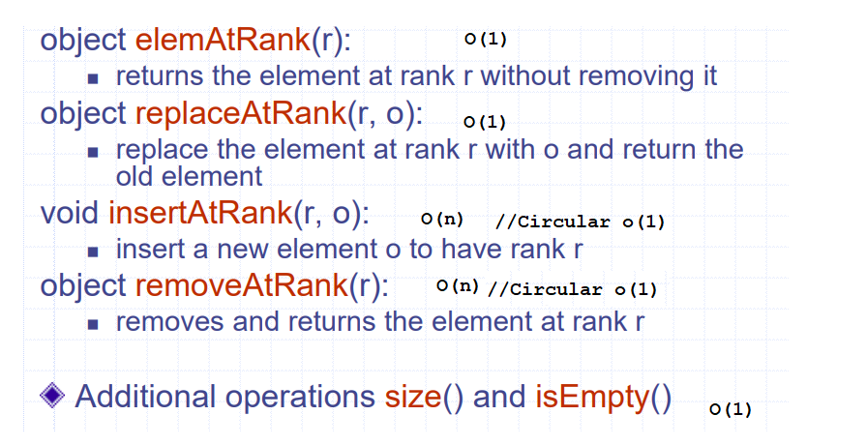

1. List

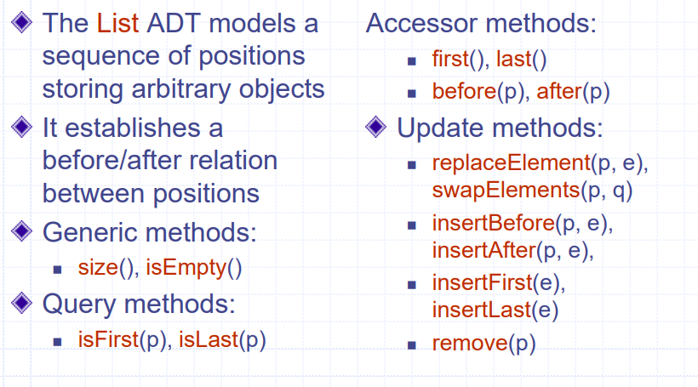

1. Double List

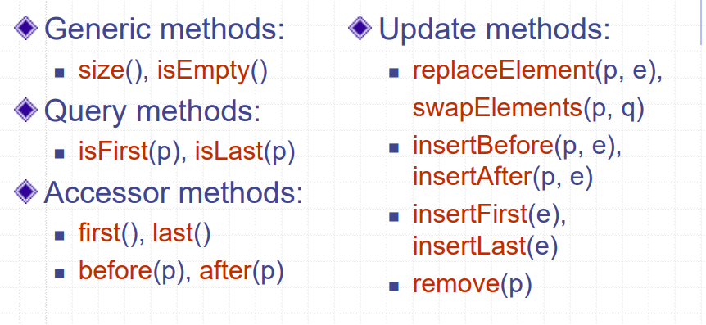

The space used by a list with n elements is O(n)

The space used by each position of the list is O(1)

All the operations of the List ADT run in O(1) time

Operation element() of the Position ADT runs in O(1) time

1. Sequence

