Homework-4-

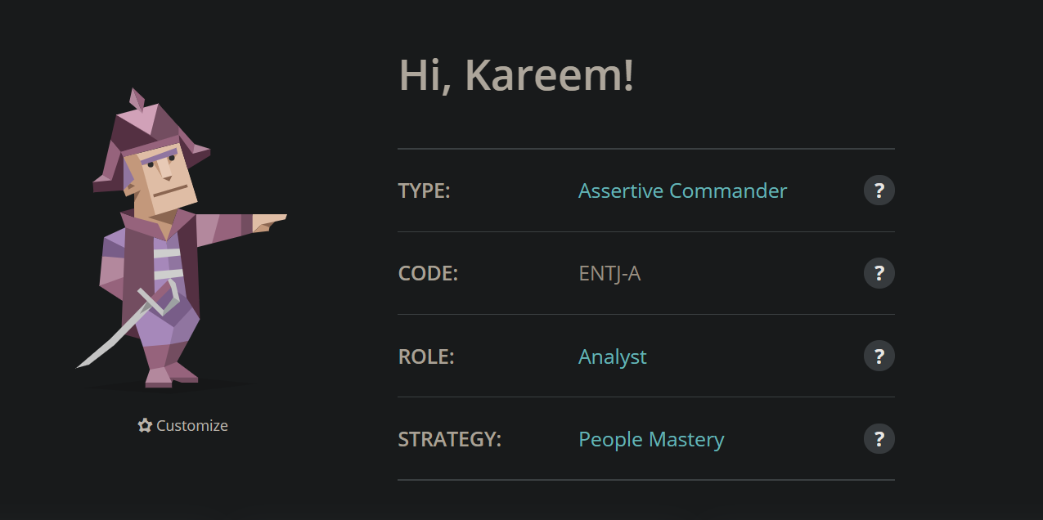

**Personality** Type: Assertive Commander

**Role**: Analyst

**Strategy**: People Mastery

**Traits**:

* Mind- 68%
* Energy-52%
* Nature-53%
* Tactics-65%
* Identity-60%

I did the test, and I don’t know it these results are accurate because I’m not agree with it,

But it’s help me to know more about my personality.

In the career paths field, it’s include the commander’s boldness and drive are truly at their best, So no every one or other kind of personality is better then commanders to per respected leader of an organization or team but I’m not respected leader I’m flexible leader but this flexibility depends on the situations.

Yes, sometimes I have different visions or stranger visions but this because I have my own plans, otherwise sometimes these plans are intelligent and determined to push my ideas through to completion, but I’m care about the obstacle.

In romantic Relationships field it’s wrote (the commanders approach dating and relationships with a set of goals and a place to achieve them), I’m agree with this sentence like to think about my relationships exactly if these relations are seriously, it’s like take leading roles in relationships from the start, assuming how smoothly thing go and working actively to ensure a mutually rewarding experience.

Also, I’m authentic person, but I can’t trust the people easily.