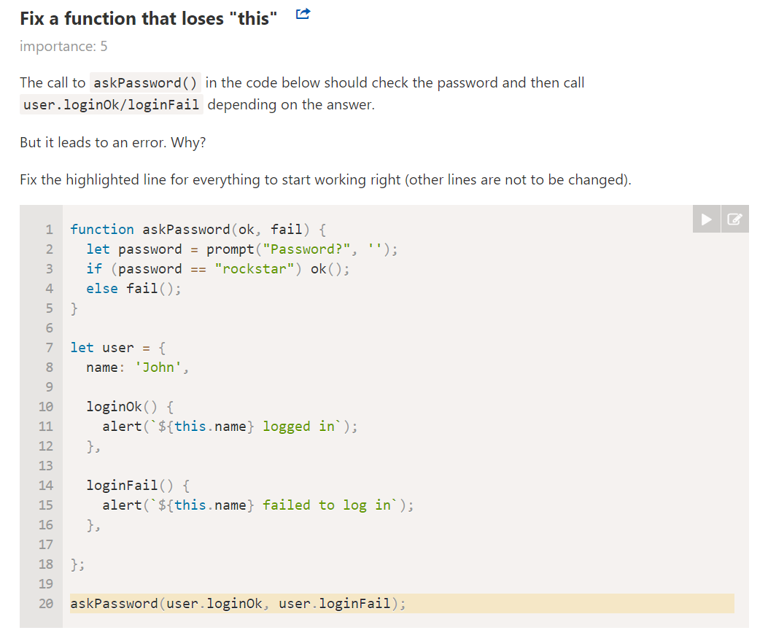

Fix Question 1 using wrapper, bind, call, apply.

askPassword(user.loginOk.bind(user),user.loginFail.bind(user));

askPassword(user.loginOk.bind(user),()=>user.loginFail.call(user));

askPassword(()=>user.loginOk.apply(user),()=>user.loginFail.call(user));

askPassword(() => user.loginOk(), ()=> user.loginFail());

* Question 2: Fix the code below using bind

let group = {

    title: "Our Group",

    students: ["John", "Pete", "Alice"],

    showList: function() {

        this.students.forEach(function(student) {

            console.log(this.title + ": " + student);

        }.apply(this));

    }

};

group.showList();