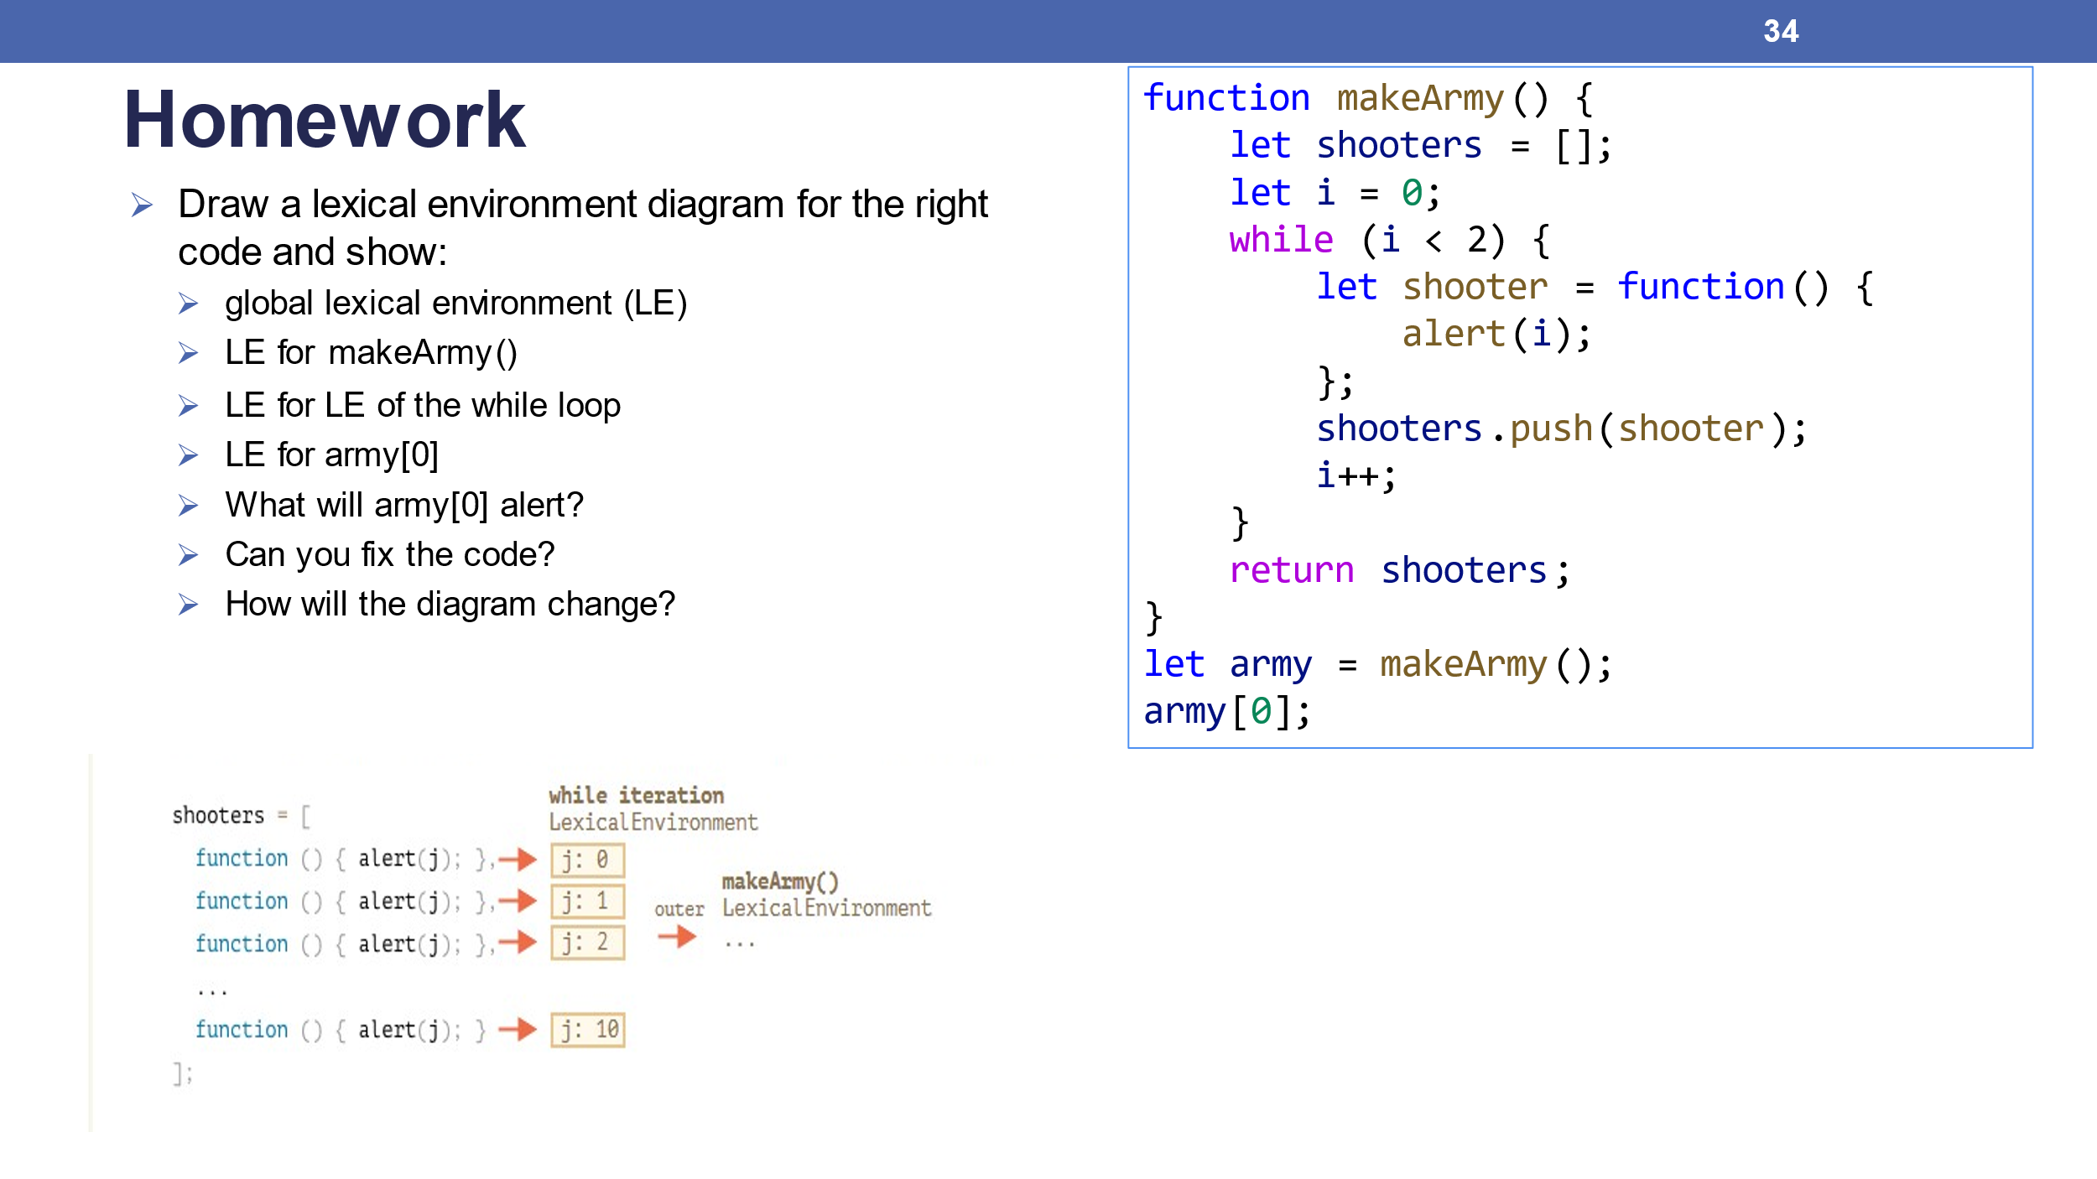

* global lexical environment (LE)
  + creation phase

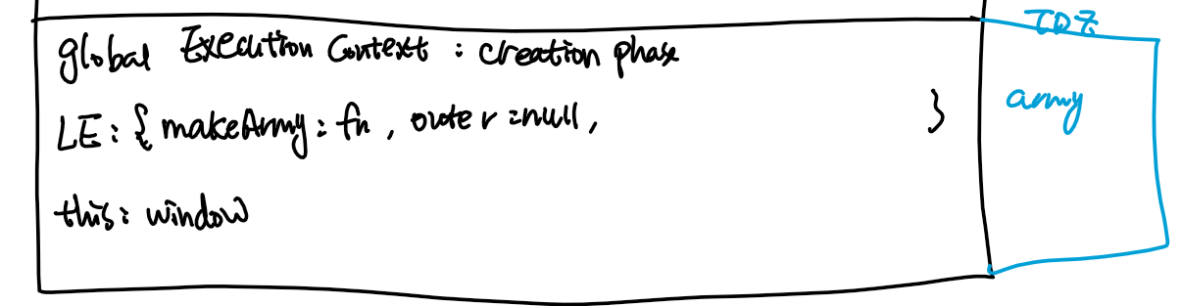

* + execution phase

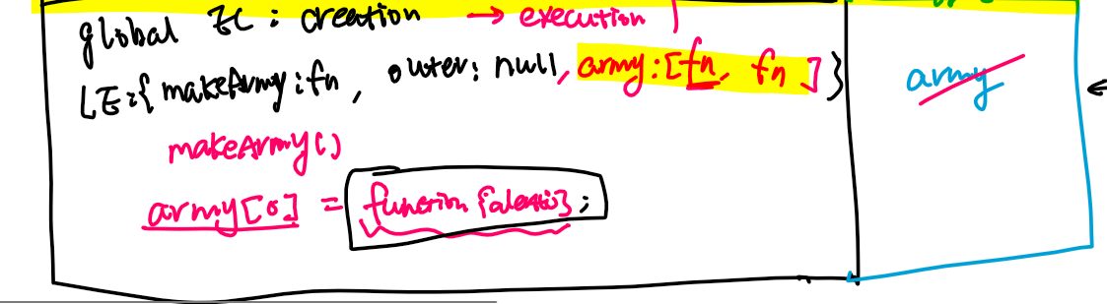

* LE for makeArmy()
  + creation phase

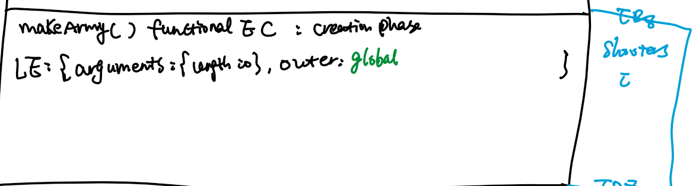

* + executon phase
    - After while-loop, changed the condition to while(i<2) to save time. The LE is being changed as below

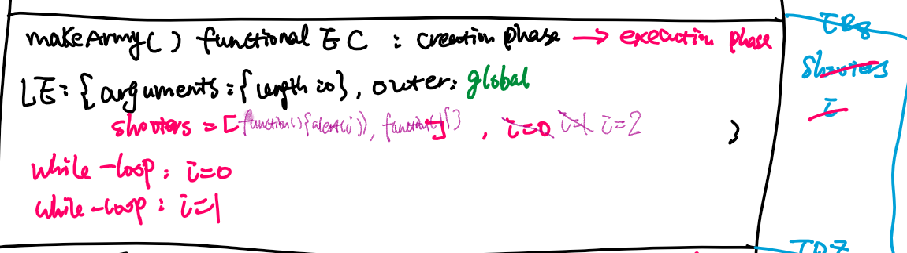

* LE for LE of the while loop
  + Each iteration of while loop has own LE, only use i=0 as example here.
  + creation phase

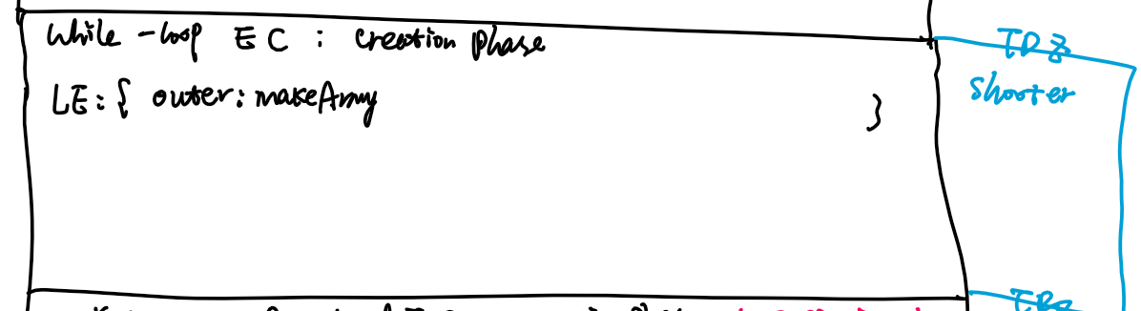

* + executon phase
* shooters.push(shooter);
* i++;

The two statements above will cause the changes in makeArmy() functional EC

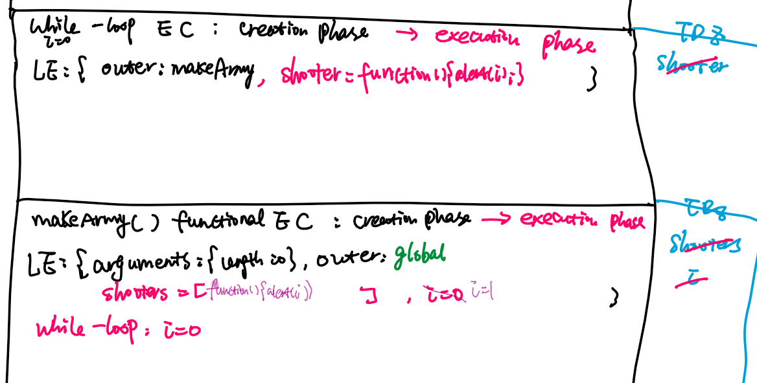

* LE for army[0]()
  + creation phase

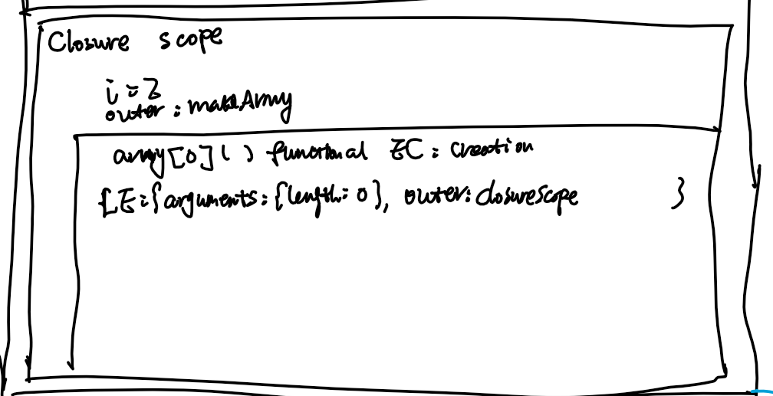

* + executon phase

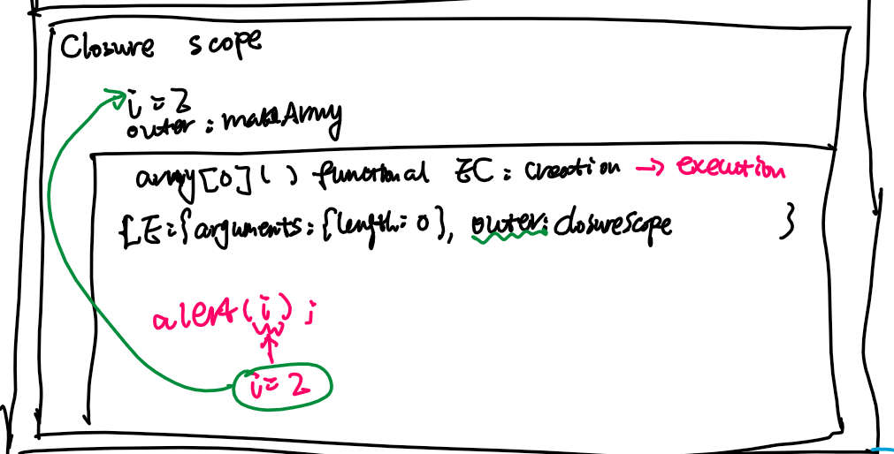

* What will army[0]() alert?

2

* Can you fix the code?

function makeArmy() {

    let shooters = [];

    let i = 0;

    while (i < 2) {

        let j = i;

        let shooter = function() {

            console.log(j);

        };

        shooters.push(shooter);

        i++;

    }

    return shooters;

}

let army = makeArmy();

army.forEach(f => f());

* How will the diagram change?

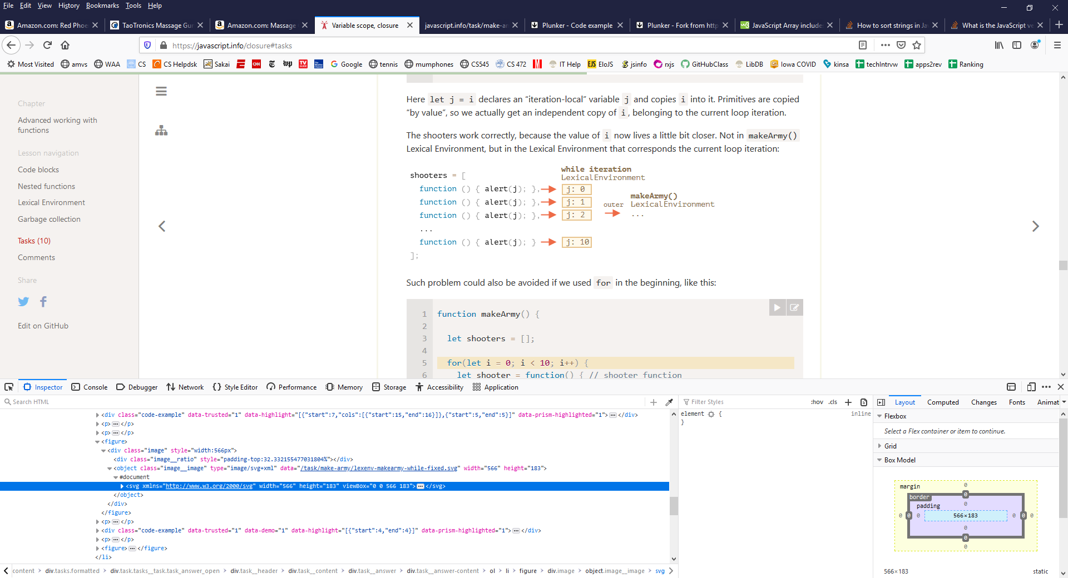

* Question 2: Write a function printNumbers(from, to) that outputs a number every second, starting from from and ending with to.

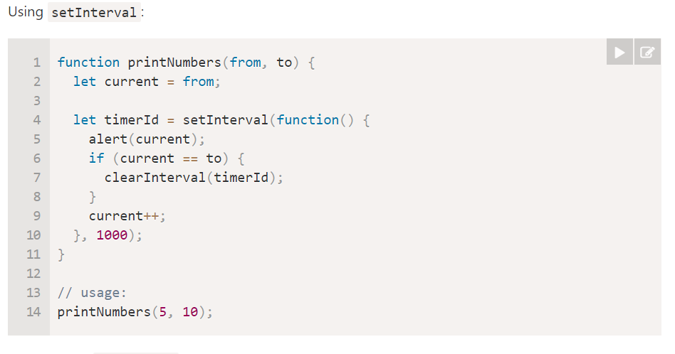

* Question 3:

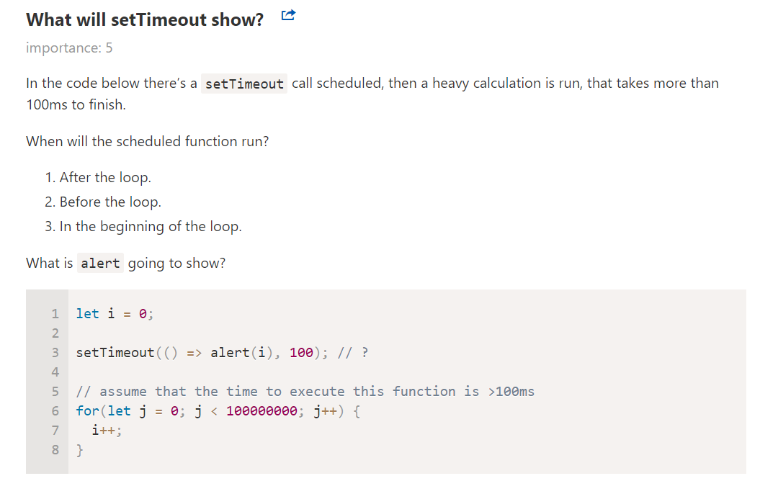

Solution:

