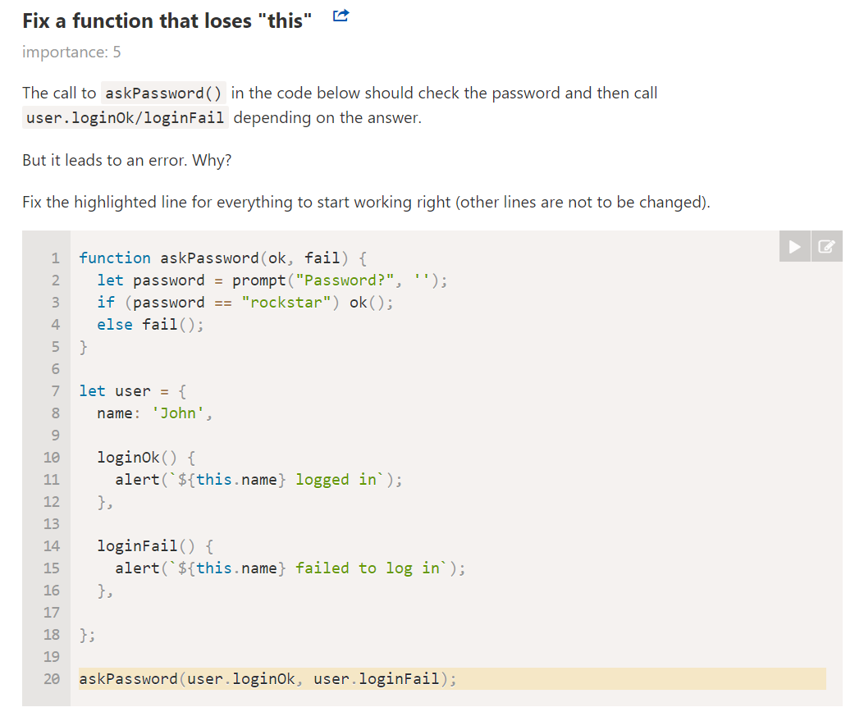

Solutions:

function askPassword(ok, fail) {

let password = prompt("Password?", '');

if (password == "rockstar") ok();

else fail();

}

let user = {

name: 'John',

loginOk() {

console.log(`${this.name} logged in`);

},

loginFail() {

console.log(`${this.name} failed to log in`);

},

};

askPassword(user.loginOk.bind(user), user.loginFail.bind(user));

askPassword(() => user.loginOk.call(user), ()=> user.loginFail.call(user));

askPassword(() => user.loginOk.apply(user), ()=> user.loginFail.apply(user));

askPassword(() => user.loginOk(), ()=> user.loginFail());

* Question 2: Fix the code below using bind

let group = {

    title: "Our Group",

    students: ["John", "Pete", "Alice"],

    showList: function() {

        this.students.forEach(function(student) {

            console.log(this.title + ": " + student);

        });

    }

};

group.showList();

Solution:

let group = {

    title: "Our Group",

    students: ["John", "Pete", "Alice"],

    showList: function() {

        this.students.forEach(function(student) {

            console.log(this.title + ": " + student);

        }.bind(this));

    }

};

group.showList();