**Name: Kareem Adel Awwad Code: C2300333**

**File Streaming Project**

Streaming involves breaking a resource that you want to receive over a network down into small chunks, then processing it bit by bit.

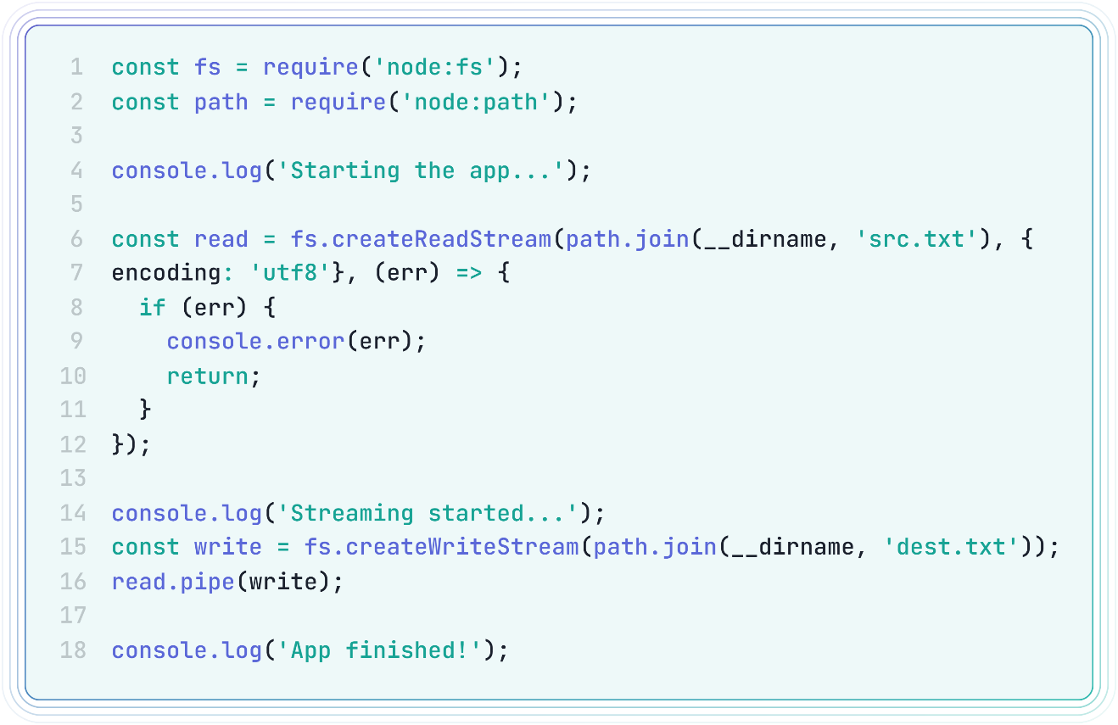

*A Node.js streaming app that reads from a file (src.txt) and writes to another file (dest.txt) using streams and pipes.*

**Let’s break it down!**

1. Importing the required modules for this app.   
   ***fs*** & ***path*** modules from *node.js*

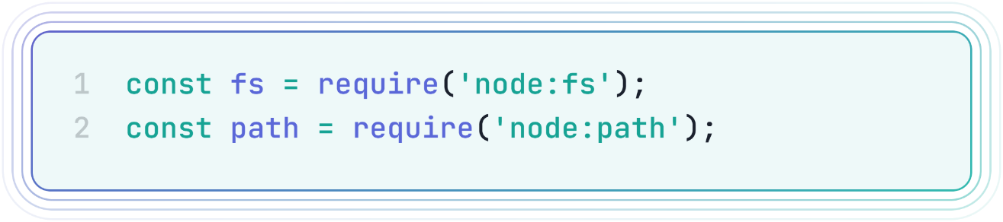

1. Creating a readable stream from the source file (src.txt)  
   We used the ***createReadStream*** function from the ***fs*** module to make a readable stream from the ***src.txt*** with *utf-8* encoding to support wide range of characters like Arabic letters or Emojis.  
   We also handled any unexpected errors using the callback function to avoid app breaking if we got any errors.

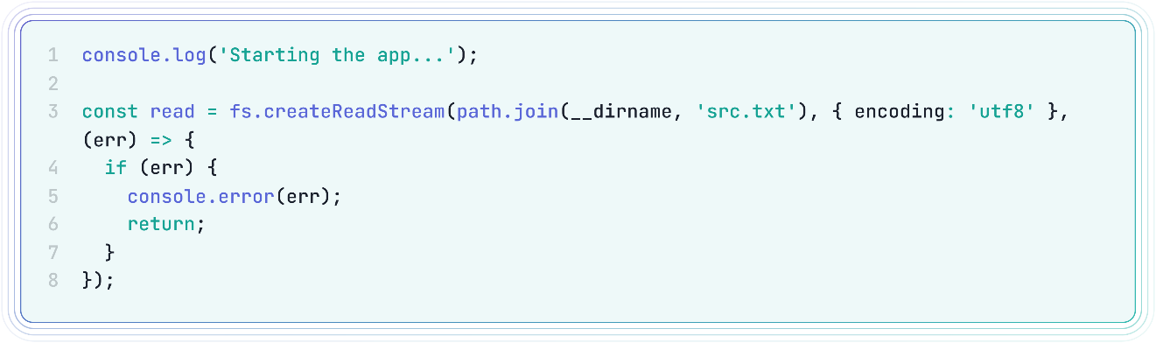

1. Creating a writable stream to the destination file (dest.txt)  
   We used the ***createWriteStream*** function from the ***fs*** module to make a writeable stream to the ***dest.txt*** file.  
     
   We used the ***pipe()*** method reads data from a readable stream as it becomes available and writes it to a destination writable stream.  
   this will allow us to see the data chunks that already been available without waiting to the rest of file, like YouTube Videos for example.

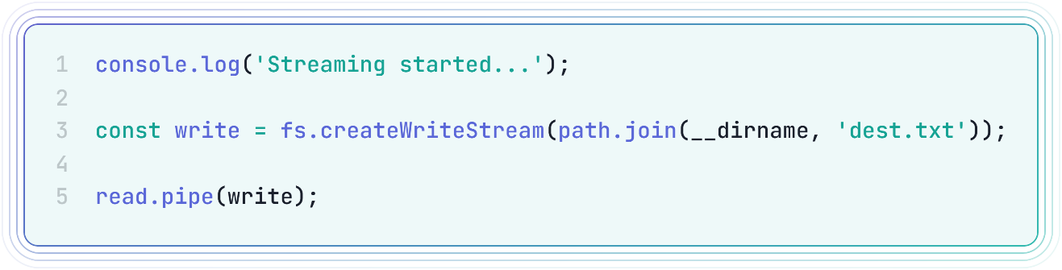

How to run this App?

1. Download the app from this [repo 🔗](https://github.com/KareemAdelAwwad/FileStreamProject/)
2. Open the terminal
3. Navigate to the directory where this file is located
4. Run the following command: node index.js
5. Check the destination file for the content from the source file