Presentation

***Team Members***

1. Kareem Mahmoud AbdElaal
2. Kareem Amr Ebrahim AbdElrahman
3. Kamal Soror Ebrahim Elmahss
4. Kareem Mohammed AbdEltwab
5. Kareem Wahdan Kotb
6. Christina Maged Makhal
7. Madonna Mamdouh Louize

Project name: **Student Assistant.**

**Description:**

1. the application is used to help students to get an explanation Of all the prescribed study materials, and to save time, efforts and money.

2-The application allows downloading lectures to listen to them

without the internet ,and there are some external books available

for free to increase the student’s knowledge of everything related

to his field of study, and allows students to determine study times

and alerts them when it’s time and it also provides some links for

YouTube lecturers.

3-The application will show the user all available lectures, every material in a separate group,send a notification if any new lectures uploaded and previous years exams, and monthly exams for each study.

4-The Project has Maximum time 13 weeks to collect all the material of university,check the safety of the materials,make the mobile application,upload all materials, lectures and

books and Testing the Application.

1. The Project has Maximum Budget 15000 L.E.
2. **Risks:**Damage in any laptop,Increase in the cost,The lack of efficiency sufficient in the teams.
3. **WBS:**

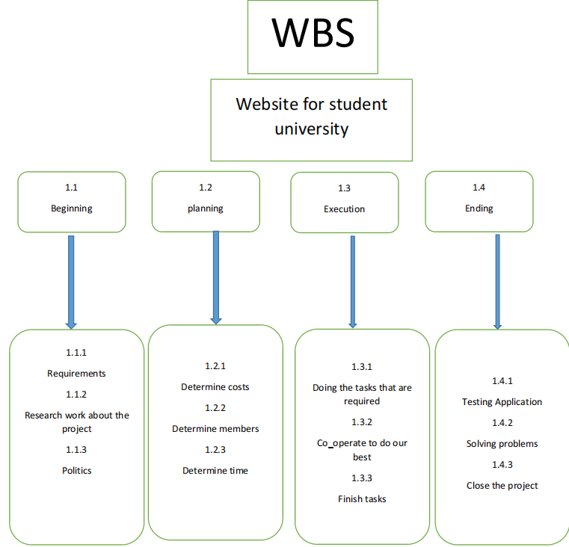

7-**Responsibility Matrix:**

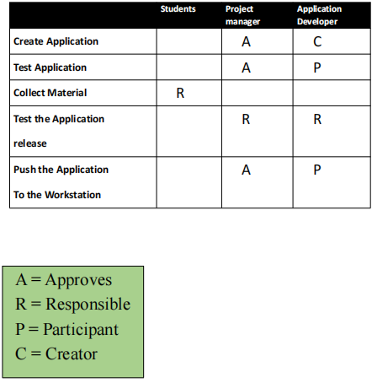

1. **Network:**

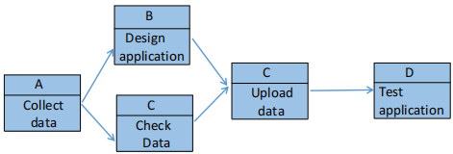

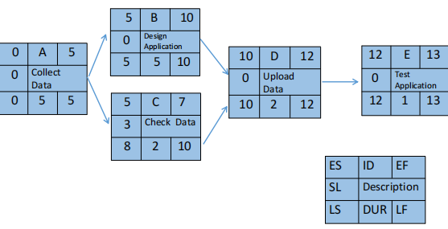

**9-Project Resource:**

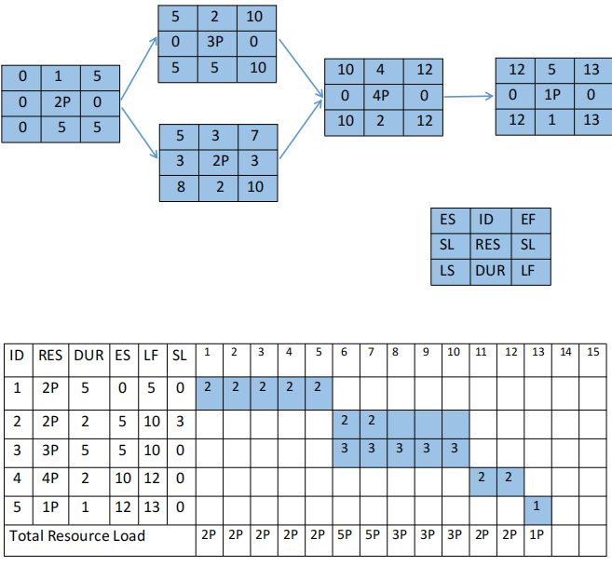

**10-Budget Baseline:**

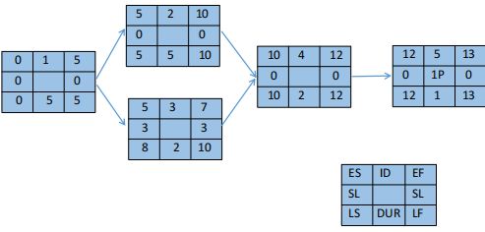

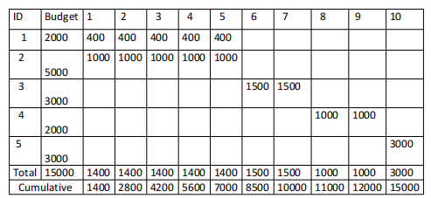

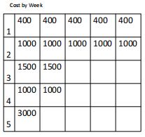

1. **Risk:**

* Negative risks:

-Hackers.

-Damage in the channels or links in the app.

-Increase in the cost.

-If the internet was weak.

-If anyone make the same app with better quality than us.

-If anyone steal the idea of our app.

-This isn’t the only app that have this idea.

* Positive risks:

-We improve old app to make a useful app.

-This app works the IOS, Android and Windows operating system.

-Make a change in the university that may improve our technology.