121 Rehab WordPress Guide
Login Details:
Link: https://121rehabcorp.com/wp-login.php?loggedout=true&wp_lang=en_US
Username: 121msablan
Password: MxF!b08#j)bc5FOZmTdS&BLg
Adding Testimonials and Blog Posts:
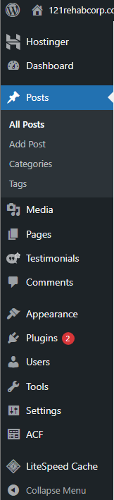
Click on Add Post for testimonials and blog posts

Inserting Content For Testimonials and Blog Posts:
Add a title and text inside the block.
- Title: Will be the title of the post
- Block/Blocks: Will be the paragraphs in the post
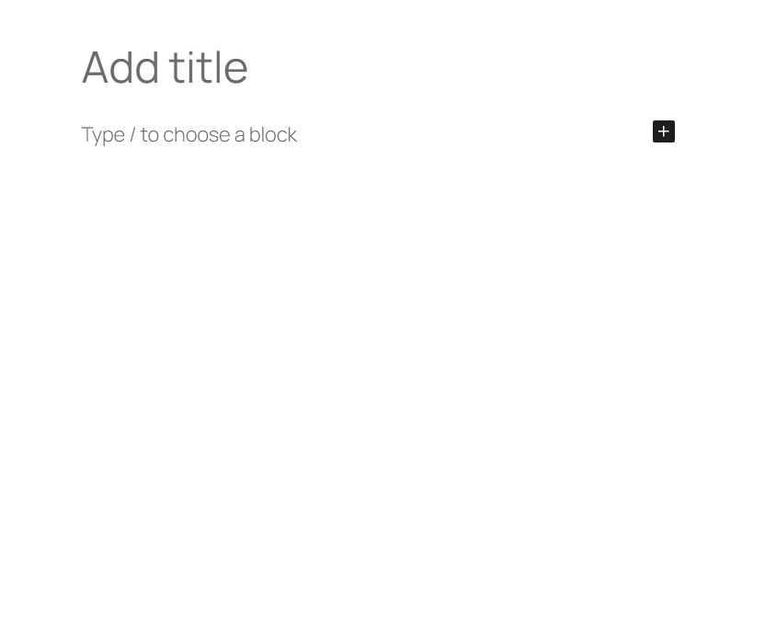
Selecting Testimonials or Blog Posts:
On the right-hand side of adding a post you will see this tab below. To select a testimonial, click on the “Testimonials” category. To select a blog post, click on the “Blog” Category.
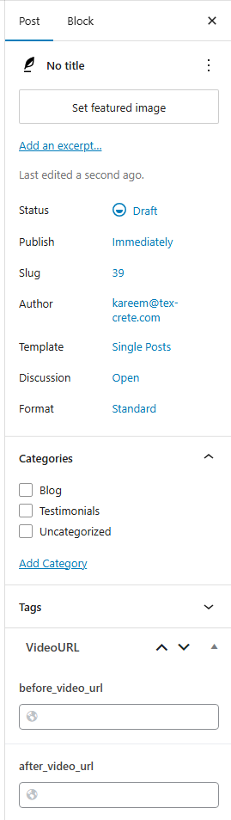
Select based on the type of post you want to create.
Inserting YouTube videos for Blog Posts:
To insert a YouTube video include links to the video in the before and after.
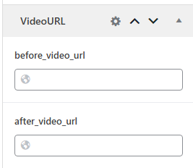
Publishing Blogs and Testimonials:
Click on publish to post. Give the website a couple of seconds to register the new post and it will show after refreshing.
