Touchstone 3: Visual Design and Responsive Layout
STUDENT EXEMPLAR
Name | Reem
Course | Introduction to Web Development
Date | September 17, 2026
Selected Client | Client A - North Star Bakery

Section 1: GitHub Link
Paste the GitHub Repository Link: [ADD PUBLIC GITHUB REPOSITORY URL AFTER UPLOAD]

Section 2: Design Explanation

Respond to each prompt below. Focus on explaining your design decisions.

Your responses should reference specific elements from your website. General descriptions without examples may receive reduced credit.

Note: Your design should use 2 to 4 colors and no more than 2 font families, applied consistently across all pages.

Client Alignment

Explain how your design choices support your selected client’s goals and audience. Include at least one specific example from your website.

The design supports North Star Bakery’s goal of attracting local families, commuters, and event customers by creating a warm and easy-to-use website. Rounded content cards, inviting bakery images, and clear calls to action make the business feel friendly and approachable. For example, the home page hero introduces fresh handmade products and gives visitors a direct button to explore the bakery menu. The same navigation and visual style appear on all four pages, so visitors can find products, business information, and the preorder form without confusion.

Color Palette
The main colors are cream (#FFF8F0), brown (#6B3E26), peach (#D88C5A), and charcoal (#2F2A26). List the 2 to 4 main colors you used (you may include hex codes). Explain how these colors support your client’s tone and ensure readability. Include one example of where you applied these colors.
The main colors are cream (#FFF8F0), brown (#6B3E26), peach (#D88C5A), and charcoal (#2F2A26). Cream and peach create a warm bakery atmosphere, while brown connects the design to bread, wood, and baked goods. Charcoal is used for body text and the footer because it gives strong contrast against the cream background. On the home page, the dark brown navigation bar and white links make each page option easy to read, while peach identifies the active link.

Typography

Identify the font or font pair you used. Explain how your choices support readability and create visual hierarchy. Include one example of how you used font size, weight, or style.

The website uses Georgia for headings and Arial for body text, navigation, buttons, and form controls. Georgia gives the major headings a traditional, handcrafted feeling that fits a neighborhood bakery, while Arial keeps longer text clear and simple. The heading sizes use a clear hierarchy, with the page title larger than section headings and section headings larger than regular paragraphs. Bold labels and button text also help users scan the preorder form and important actions.

Responsive Design

Describe how your layout adapts across screen sizes. Include at least one specific example of a layout, spacing, or content change.

The layout begins with a single-column mobile design so content stays readable on narrow screens. Flexbox stacks the navigation, content cards, product sections, and contact form vertically on small devices. At 768 pixels and wider, a media query changes major sections to side-by-side layouts, including the home page hero, product cards, team cards, and contact page. Images remain flexible with a maximum width of 100 percent, and the featured item uses the picture element to load a larger image on wider screens.

Design Challenge

Describe one design challenge you encountered. Explain how you addressed it and what change you made.

One design challenge was keeping the four pages visually consistent even though each page contains different content, including media, product cards, and a long form. I addressed this by creating reusable CSS classes for cards, buttons, page widths, grids, and section spacing. I also used the same header, navigation, color palette, fonts, and footer on every page. This reduced repeated styling and made the site feel like one connected bakery website at both mobile and desktop sizes.

Section 3: Submission Checklist
☒ Updated HTML files
☒ External CSS file
☒ Working preview link
☒ Consistent color palette (2–4 colors)
☒ Consistent typography (1–2 fonts)
☒ Styles applied across all pages
☒ Flexbox used in layout
☒ At least one media query
☒ Readable text with sufficient contrast
☒ Completed design explanation

Section 4: Screenshot
Include one screenshot of your website that demonstrates a design decision you described above.

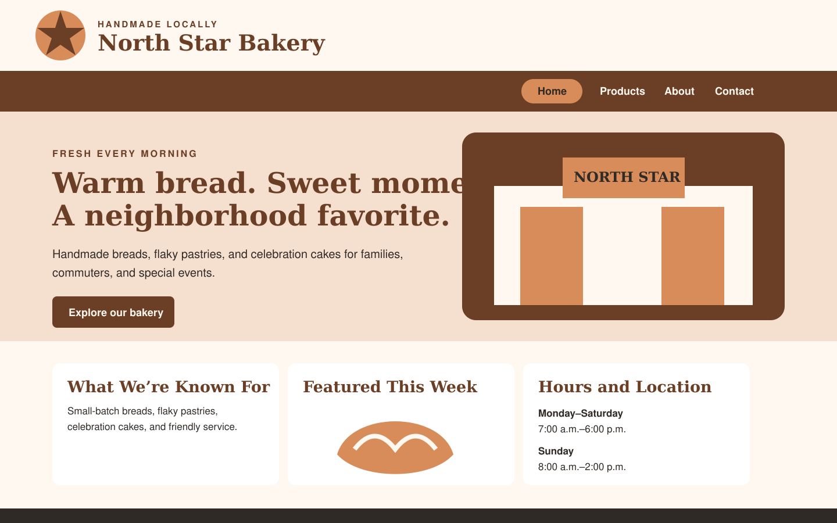
Figure 1. North Star Bakery home page showing the warm color palette, typography, navigation, responsive hero layout, and reusable content cards.

Section 5: Final Review
☒ All pages display correctly
☒ Navigation works across all pages
☒ Layout adjusts across screen sizes
☒ Design is consistent and readable

