1. Screenshots

# Selenium screenshots

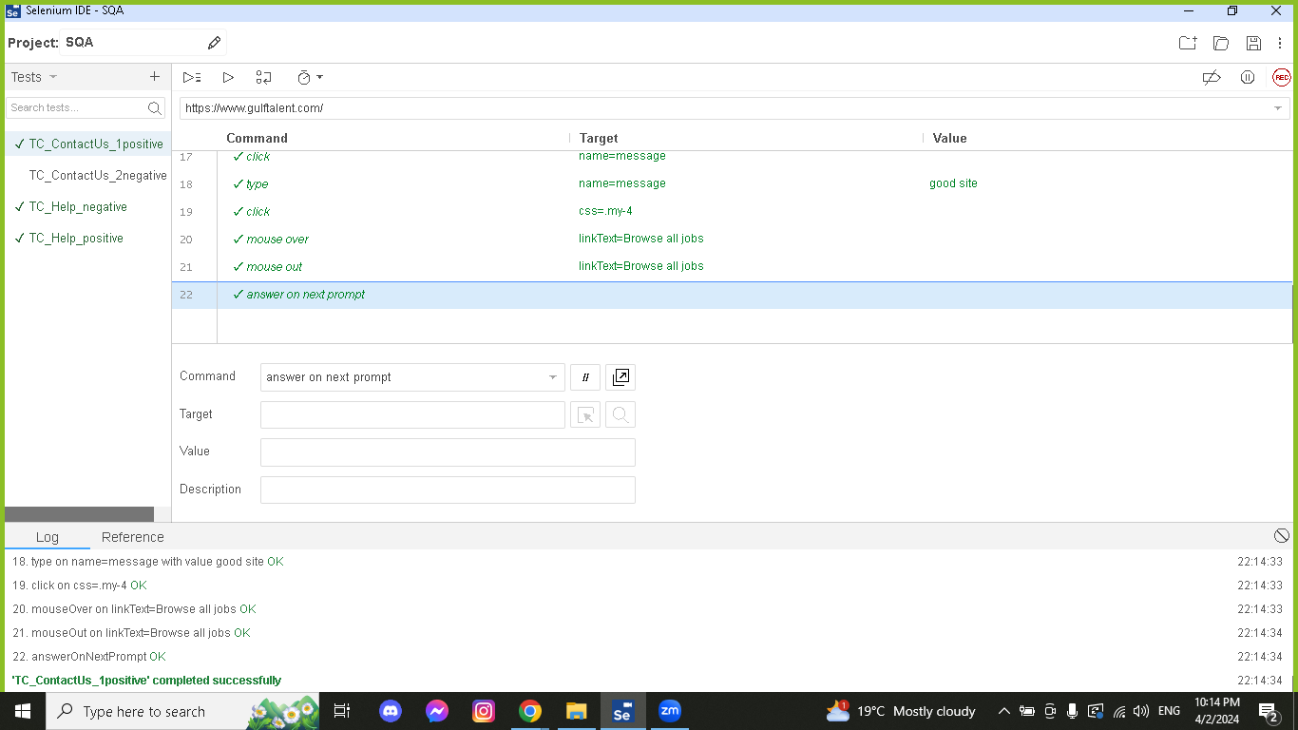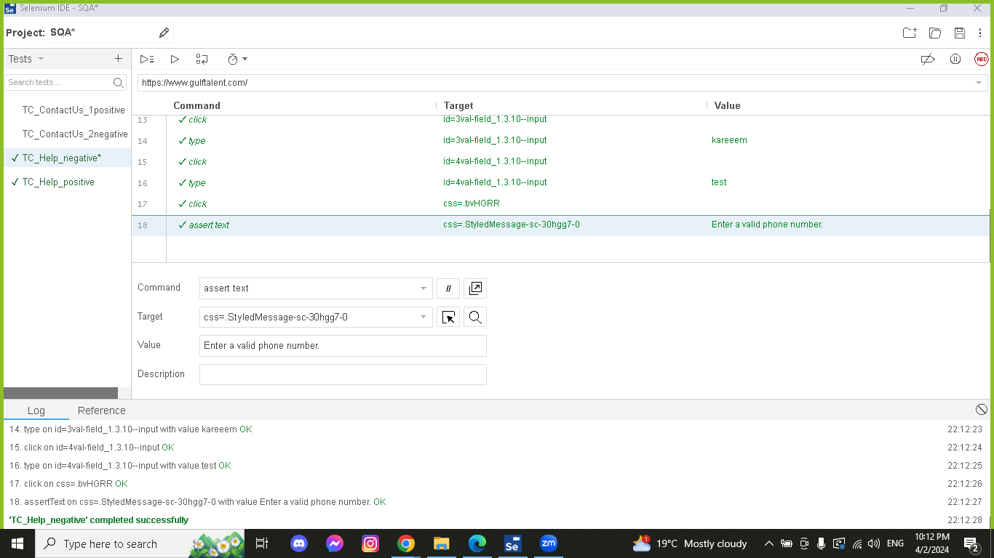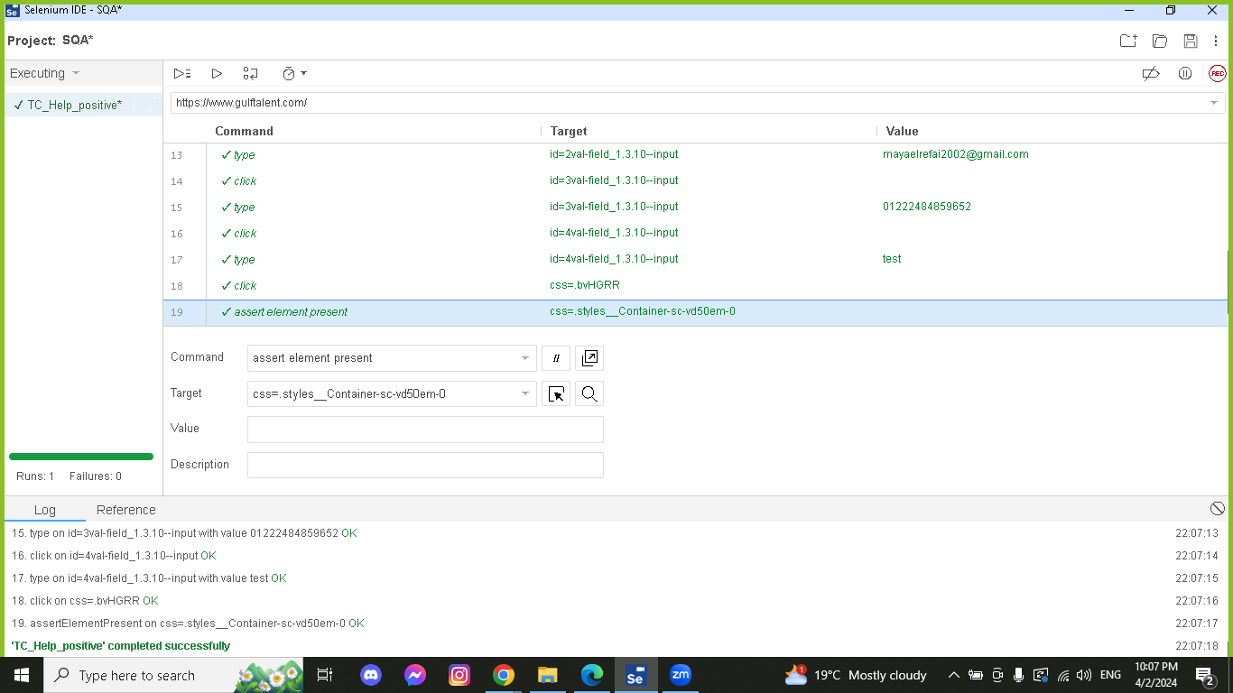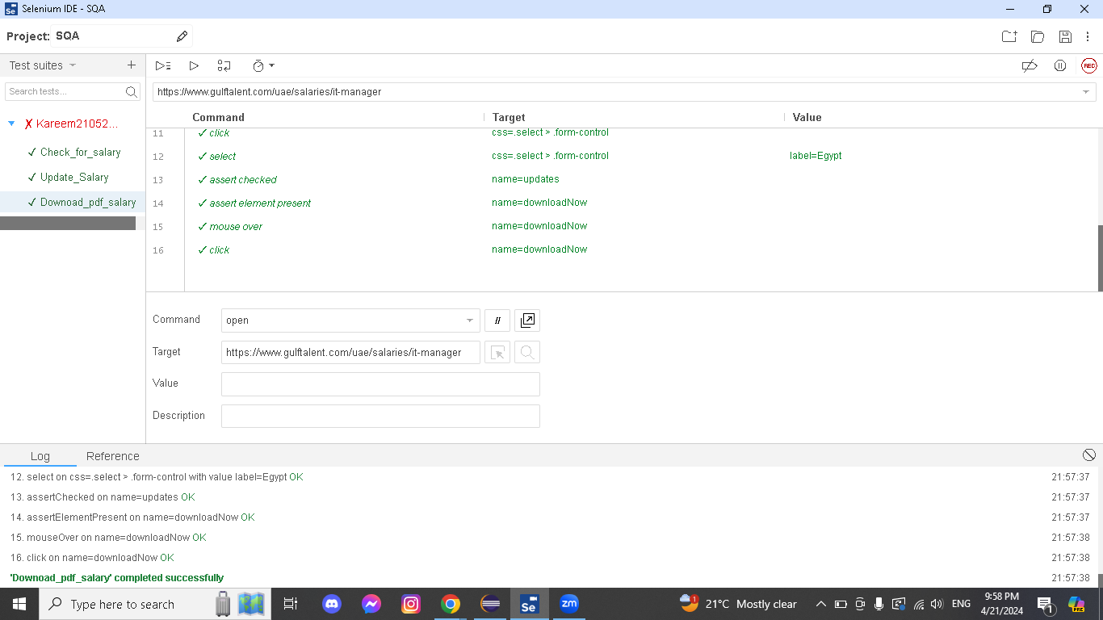

# WebDriver screenshots

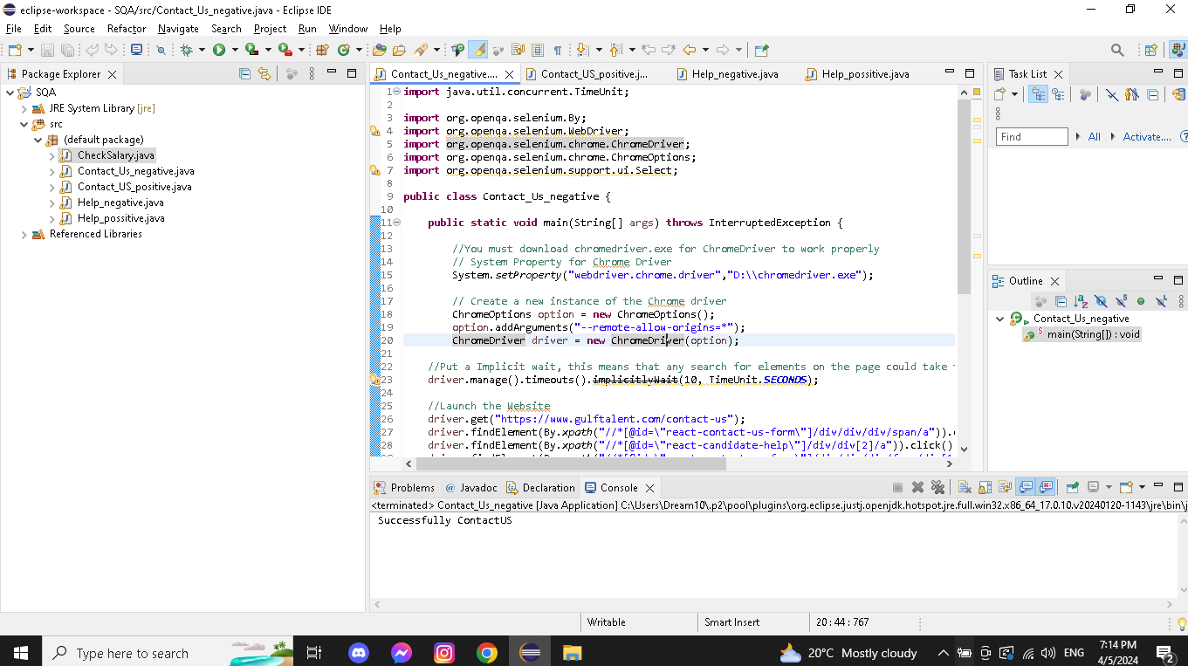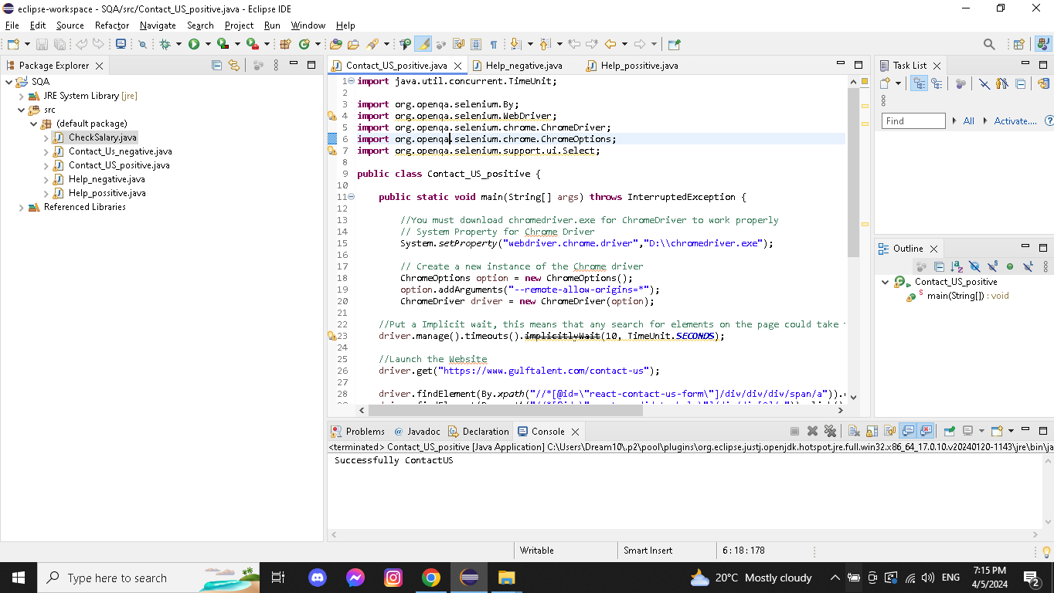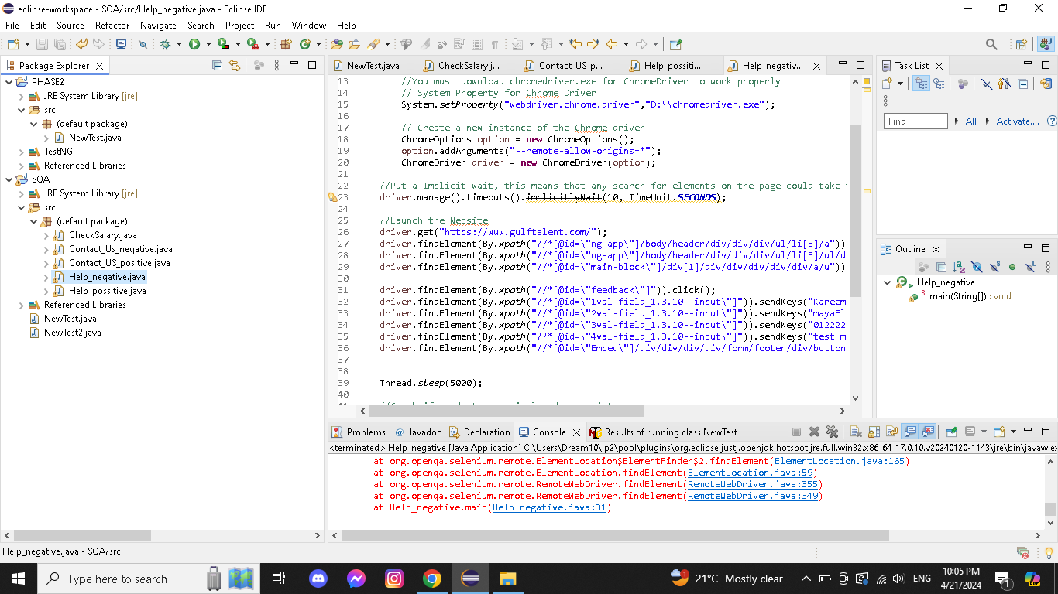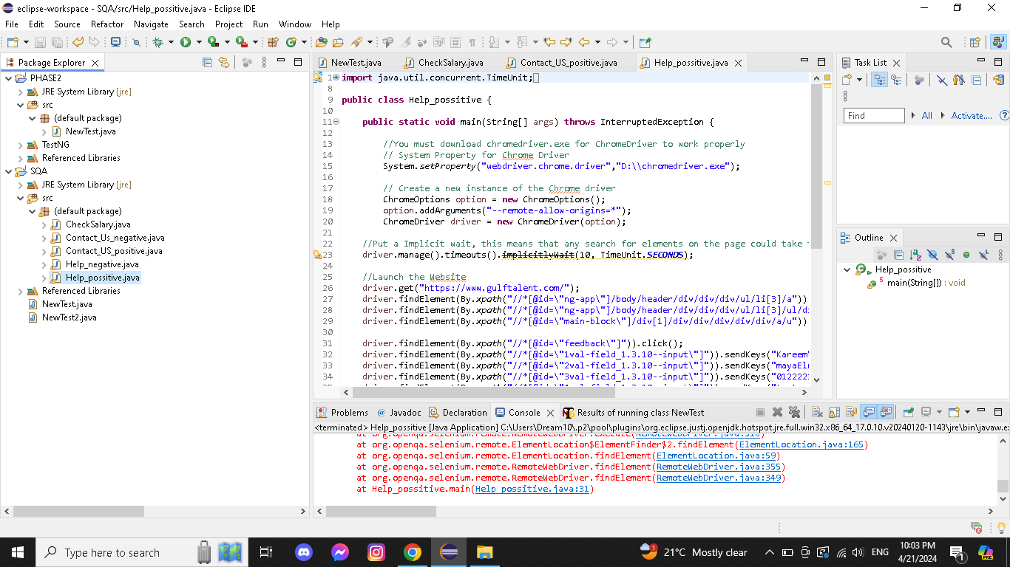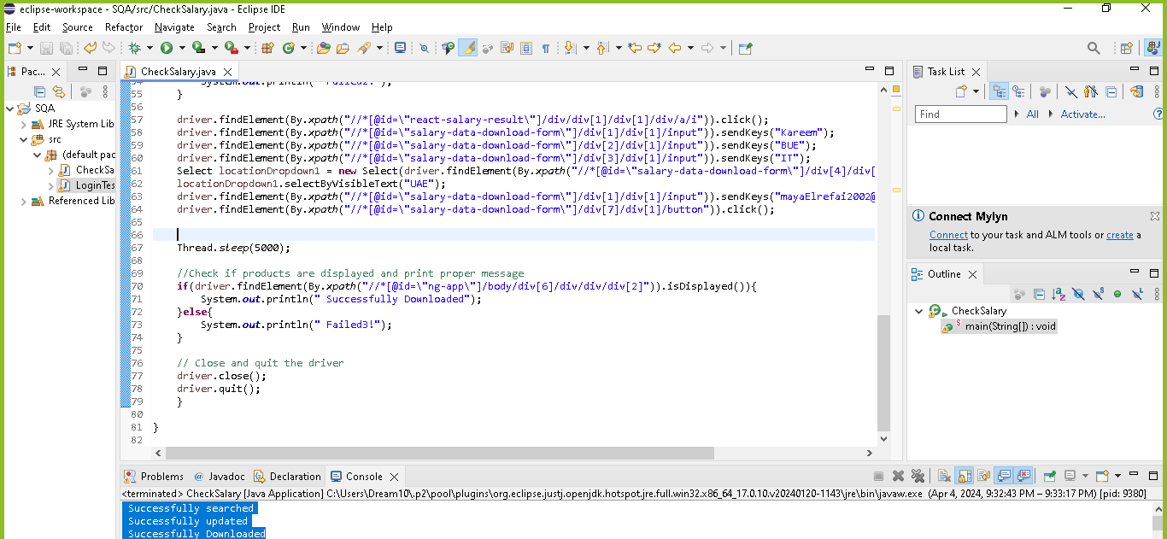

# TestNG screenshots

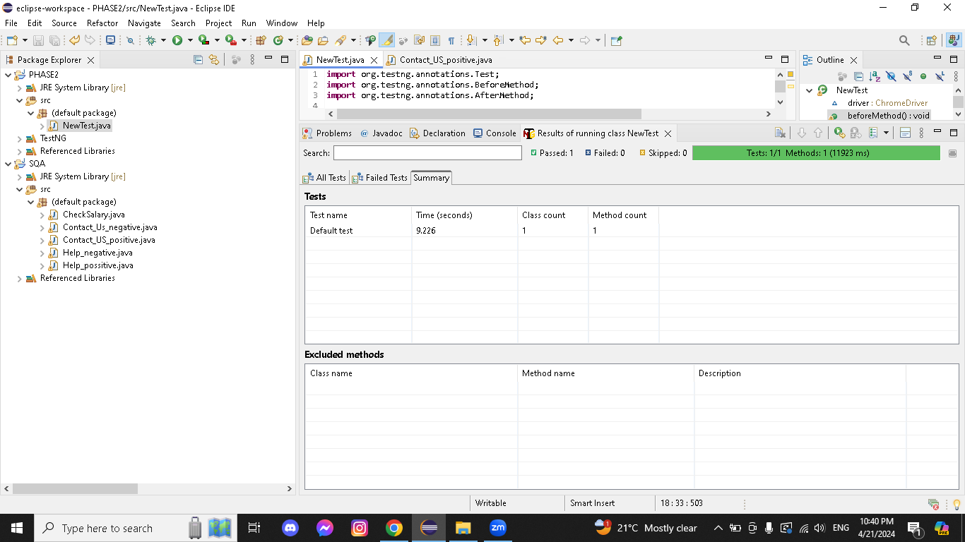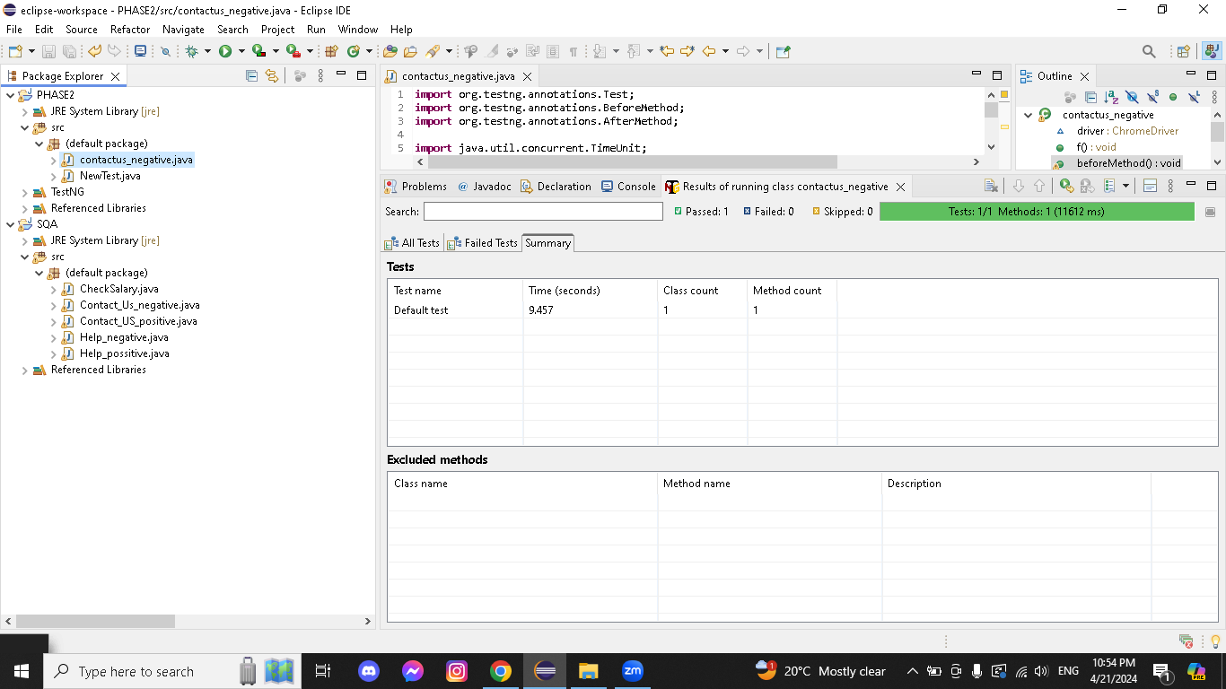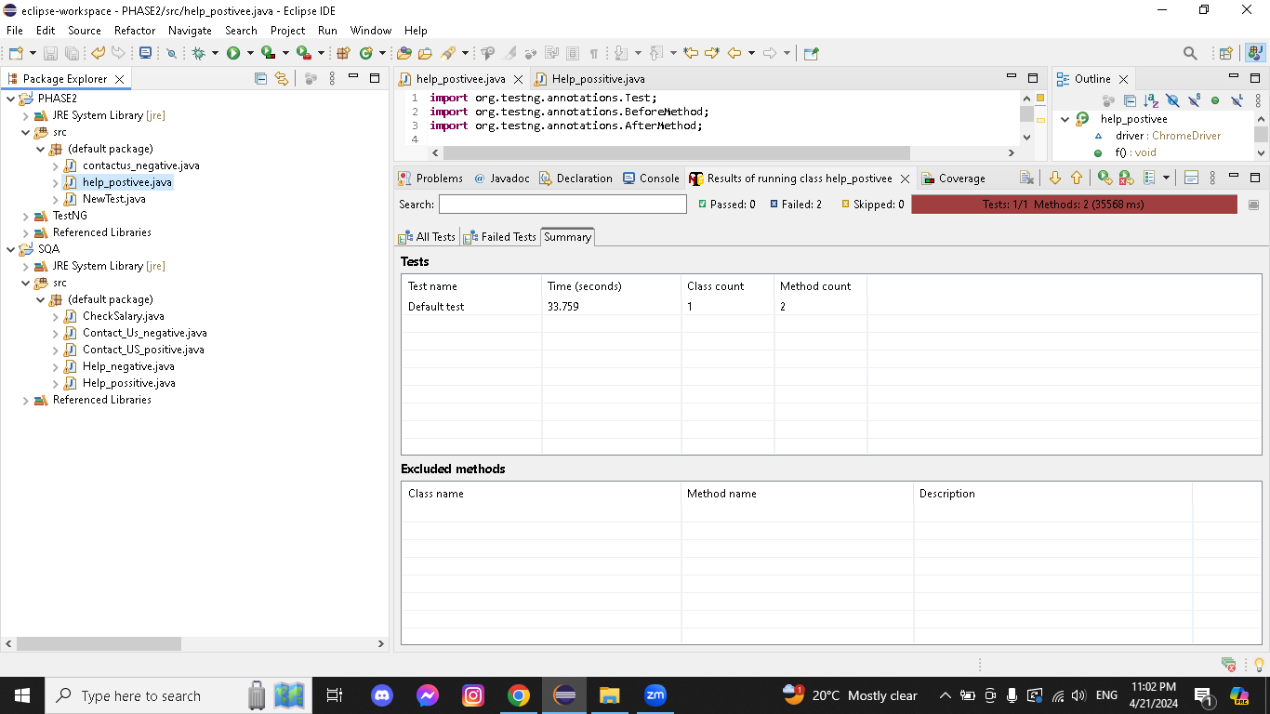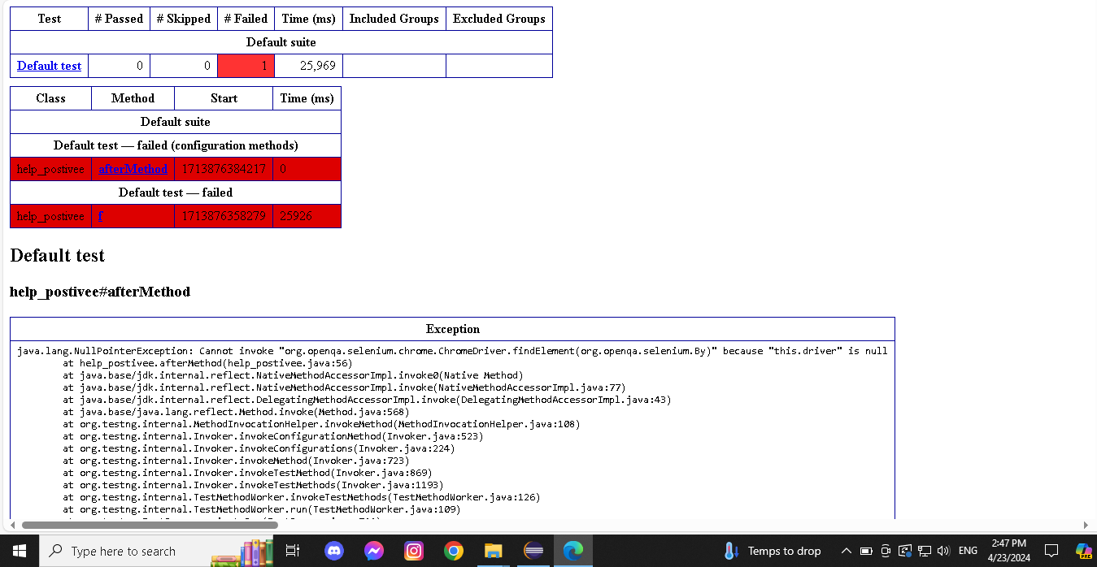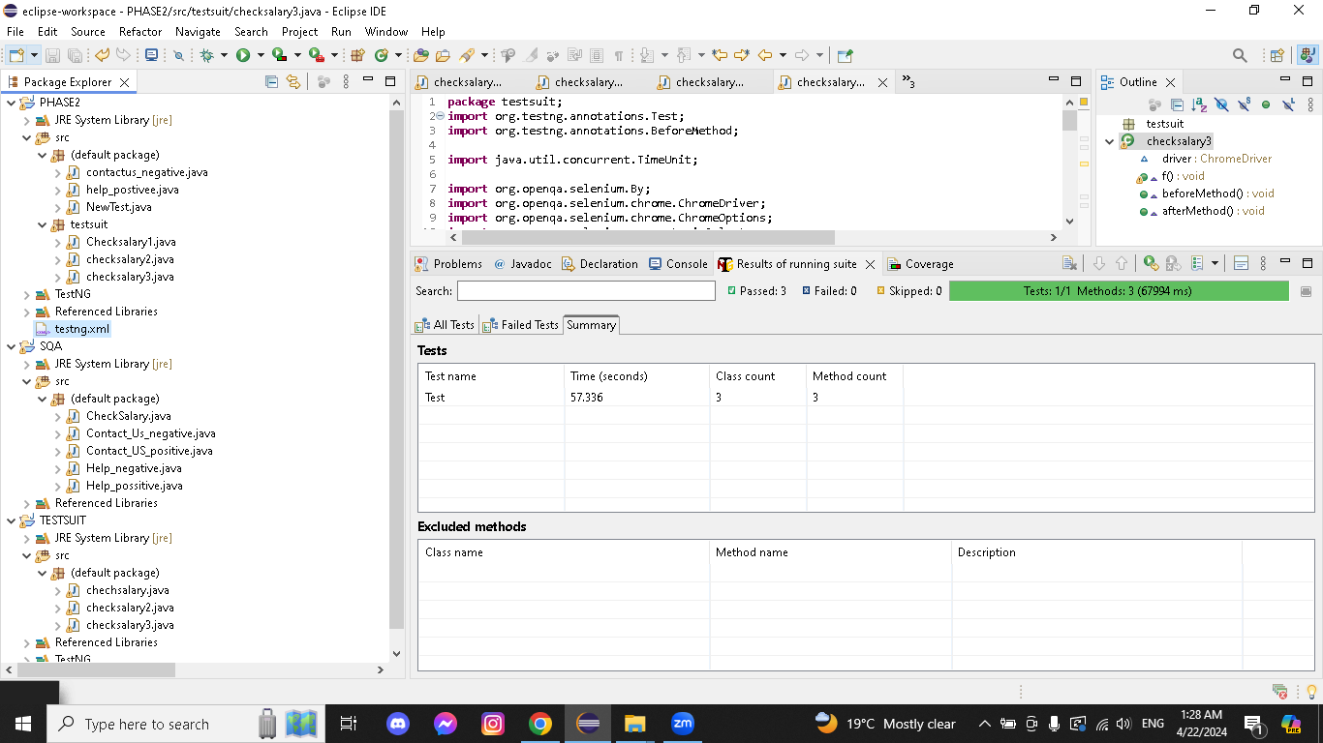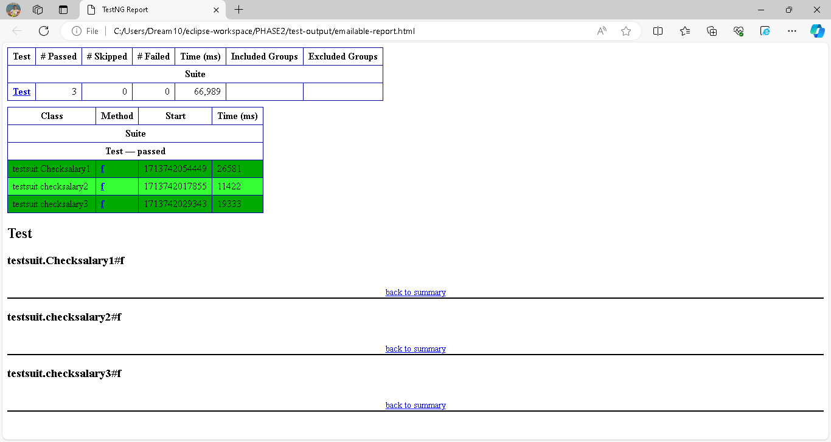

# A screenshot of a computer Description automatically generatedCucumber screenshots

# 

1. Summary report:

## Selenium ide:

Used for recording and playing back user interactions with the website , All critical functionalities of the Gulf Talent website, such as job search, user registration, and profile management, were successfully automated and tested.

### selenium WebDriver:

Selenium WebDriver scripts were then developed to execute more complex test scenarios, including user authentication, job searches, and profile updates.

## TestNG:

TestNG was used to organize test cases into suites, prioritize test execution, and generate detailed test reports for analysis, Test suites were regularly executed to detect any regressions in the website's functionality due to code changes or updates.

## Cucumber:

Test suites were regularly executed to detect any regressions in the website's functionality due to code changes or updates, TestNG-generated reports provided comprehensive insights into test execution results, including pass/fail status, execution time, and error logs.

## J-unit

JUnit was utilized for unit testing of Java components integrated with Selenium WebDriver scripts, TestNG-generated reports provided comprehensive insights into test execution results, including pass/fail status, execution time, and error logs.

1. issues and difficulties

I have faced issues with selenium WebDriver because it did not read the help icon on the gulf talent help page so the testcases was not completed