Revision History
Date | Version | Author | Comment
5/4/2016 | 2.0 | Alhassan Ali | Updated Version

Issues
Date Entered | Status | Author | Description

Table of Contents

Revision 1
1 Introduction 3
1.1 Scope 3
1.2 Purpose 3
1.3 System Overview 3
1.4 Supporting Documentation 3
2 Requirements 4
2.1 Customer Requirements 4
2.2 Software Requirements 4
3 State machine 5
4 Design 6

Introduction

Scope

Designing an automatic fan controller system that allow the user to read the current temperature and the fan speed through LCD, the system contain a temperature sensor to detect the current temperature and change the fan speed according to it automatically. There are only three possible fan speed as shown in the next table. if the temperature is less than 15 degree, the system will consider it as speed one and if the temperature is more than 30 degree, the system will consider it as speed three. There will not be any other user interface and there is no a manual user mode. The used microcontroller is from AVR family only.

Purpose
This document lay out the technical basis for the system to be created and maintained. It is intended as an introduction for customers, technical stakeholders and software developers that will be involved in the project.

System Overview
The system will be delivered as:
- Tactile switch for power controlling.
- Temperature sensor to read the air temperature.
- LCD to display the temperature and the speed.
- Microcontroller which will be responsible for controlling the system.

Supporting Documentation
The following documents were used as input to this design:
- Software Requirement Specification
- Customer Requirement Specification

Requirements

Customer Requirements
ID | Description
CRS_00_1 | Read the air temperature.
CRS_00_2 | Three speed levels for the fan system.
CRS_00_3 | Display the temperature on the LCD.
CRS_00_4 | Display the speed on the LCD.
CRS_00_5 | Make the speed corresponding to the temperature configurable.
CRS_00_6 | A switch for power controlling.
CRS_00_7 | Displaying must be on horizontal way as title of temp and speed are on the same line  and the reading for each are in another line with each reading under it's title.
CRS_00_8 | Displaying on the LCD must be static no moving text.
CRS_00_9 | LCD initialization is empty with no displaying.
CRS_00_10 | Design must be portable and battery powered.
CRS_00_11 | No fan in the system, only displaying on LCD the measured reading.
CRS_00_12 | The system must be on a PCB.
CRS_00_13 | The size of the board must be small as much as we can.
CRS_00_14 | The system cost must be as minimum as possible.

State Machine

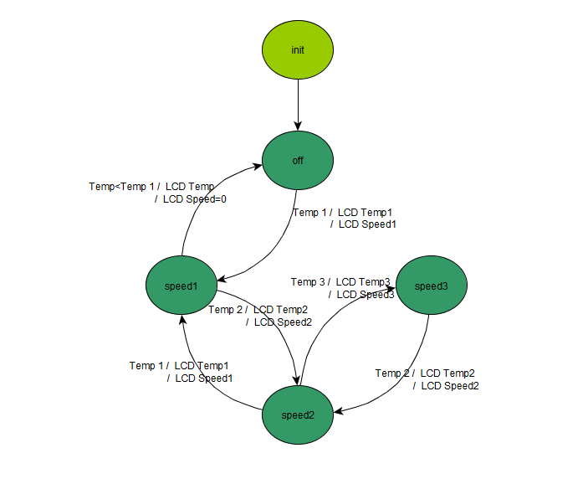

Design

System Components
