**Machine Learning Algorithms Simulator**

Kareem Jabareen – 211406343

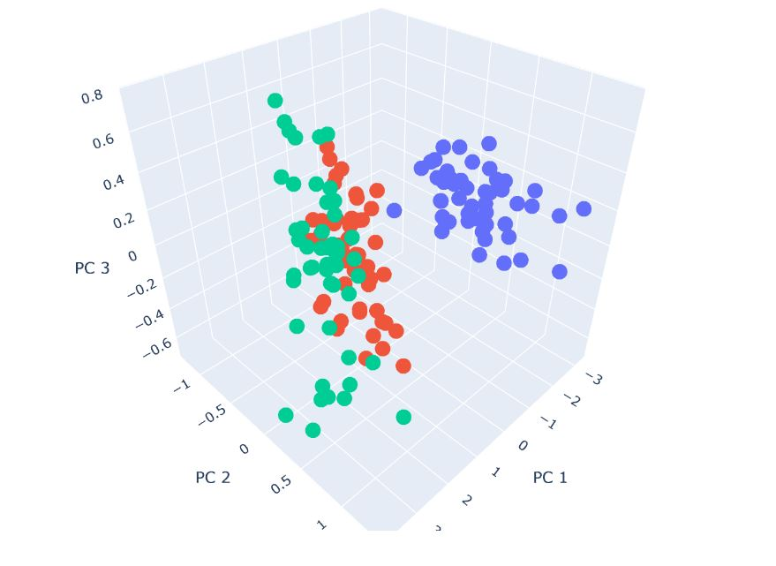

University of Haifa

2021/2022

**Table of interest**

Problem Stating -------------------------------------------- 3

Project Definition -------------------------------------------- 4

Implementation -------------------------------------------- 5

My Learning -------------------------------------------- 12

Main Difficulty --------------------------------------------

How to Improve --------------------------------------------

**Problem Stating**

Machine Learning is relatively a new field and a tough one at the same time. Many students find it challenging to learn ML algorithms, that is due to several factors like:

1. Each one of the ML algorithms has his own components that you need to learn before you can apply them.
2. Most of these algorithms require good knowledge of many aspects of mathematics especially Algebra.

Therefore, students start quitting ML courses which might slow down the ML research. When talking about ML research, it is important to mention that ML affects most of the modern applications we used almost daily. In addition, machine learning has a great influence on many other fields related to Computer Science like Computer Vision, Natural Language Processing and Computer Graphics to name a few.

Therefore, it is important to encourage others to study ML, so they develop solutions for different aspects in life.

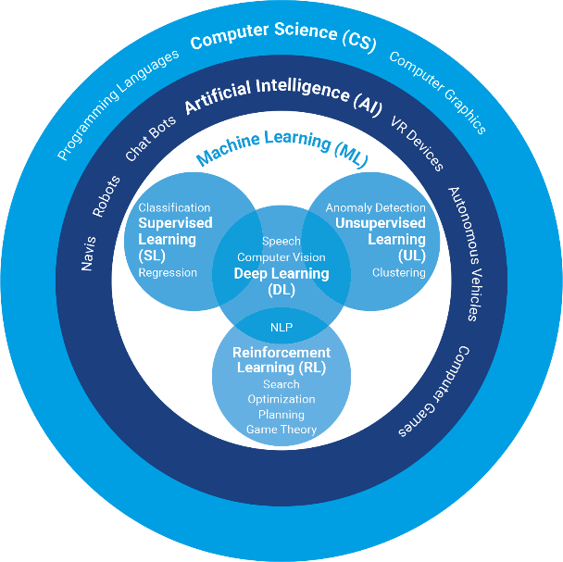

**Project Definition**

To tackle the issue I presented, I have developed a website which simulates 8 different algorithms, 7 of the algorithms are ML algorithms, while the last one is DFS.

When opening the homepage of the website, I show the user 8 cards, one for each algorithm. When clicking a card, a new page will be open and the user will be able to enter the algorithm output and to set the algorithm parameters, and he will see how the algorithm works and what its results are.

For my work I have coded all the algorithms from scratch to improve that learning ML algorithms is possible and can be fun, here are the algorithms the website has:

1. DFS
2. K-Means Clustering
3. K-Nearest Neighbors (KNN)
4. Linear Discriminant Analysis (LDA)
5. Maximum Likelihood Estimation (MLE)
6. Naïve Bayes Classifier
7. Principal Component Analysis (PCA)
8. Support-Vector Machine (SVM)

In addition, I have developed two different model types: Saved dataset model and Custom dataset model. These models are available for K-Means, KNN, LDA, MLE, Naïve Bayes Classifier and PCA since they seemed to be unclear when running them on a single dataset.

Example of K-Means running on the default dataset with 1000 input points and 8 clusters:

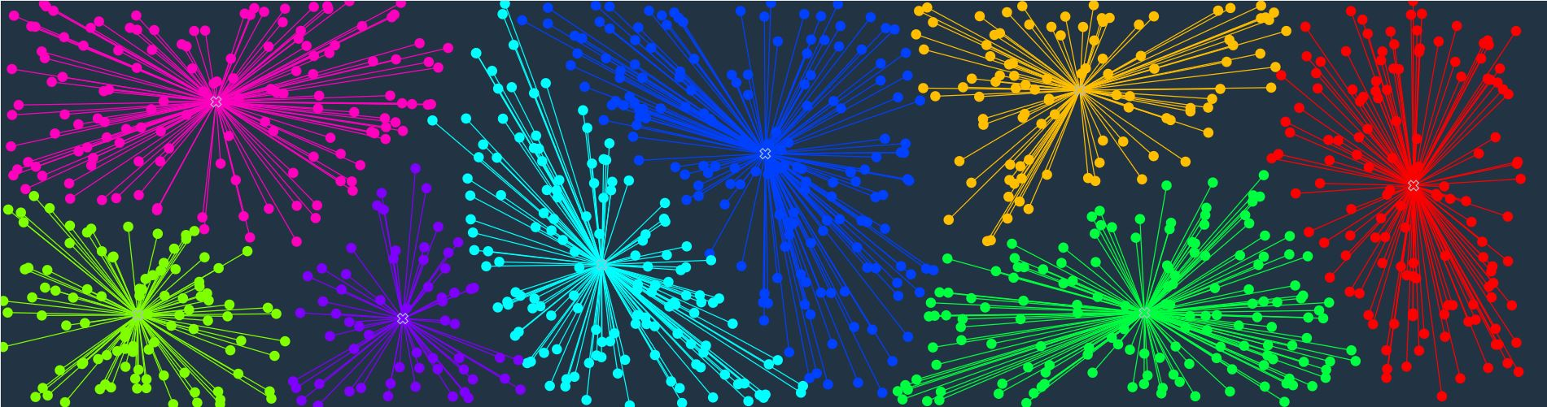

In addition to the simulation, each page has a brief explanation of the algorithm, what it is used for and a helpful link for more information.

**Implementation**

As I have mentioned earlier, I coded all the algorithms from scratch. For coding the algorithms, I have used Python programming language mainly for its easy and fast indexing. The Python part was done in Django framework for developing web apps. However, I needed to build the web templates using HTML, CSS and used JavaScript for implementing the dynamic views on the website.

I used a Django template for starting the work, implemented the 8 algorithms, then started building the templates using HTML. After that, I created the stylesheets for the web pages using CSS, and at the end I created the JavaScript files which took the biggest part of the project. The JS code enabled the interactivity of the web app, created the connection between the Backend and the Frontend using POST and GET requests. On the other hand, the Python scripts received the JS requests, processed it using the algorithms I had coded myself, and sent the processing results back to the Frontend as JSON objects.

**Results:**

**DFS:**

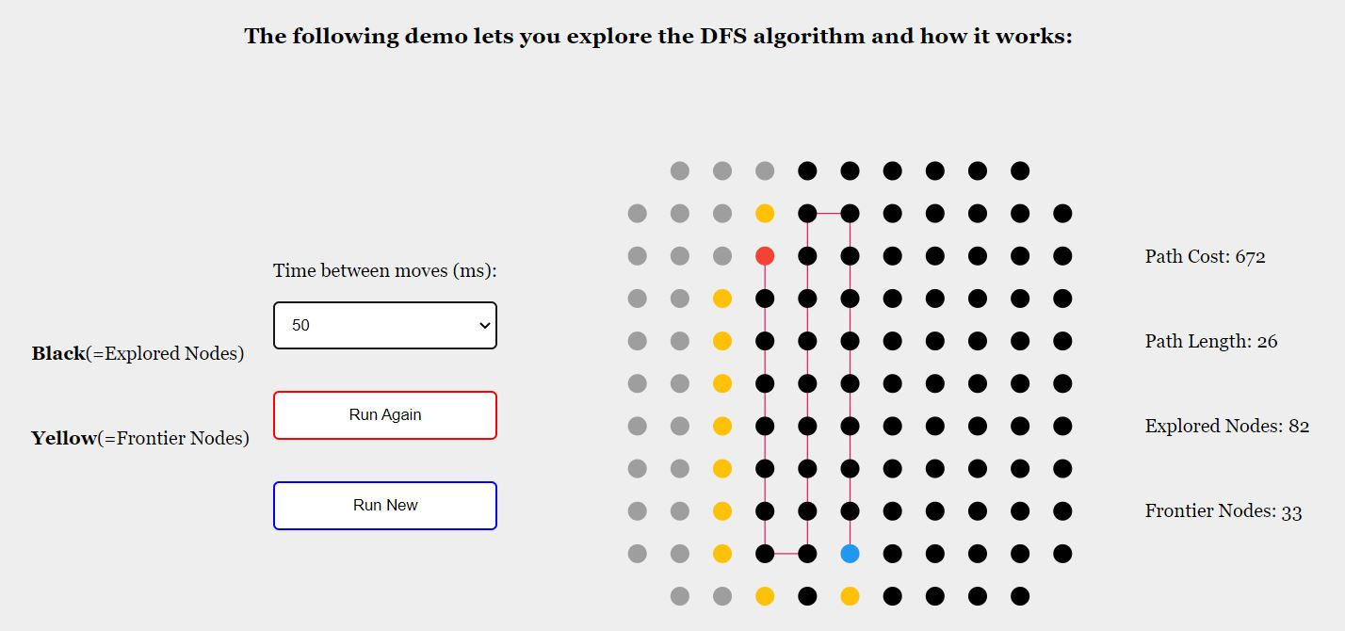

**K-Means Clustering:**

Step 1:

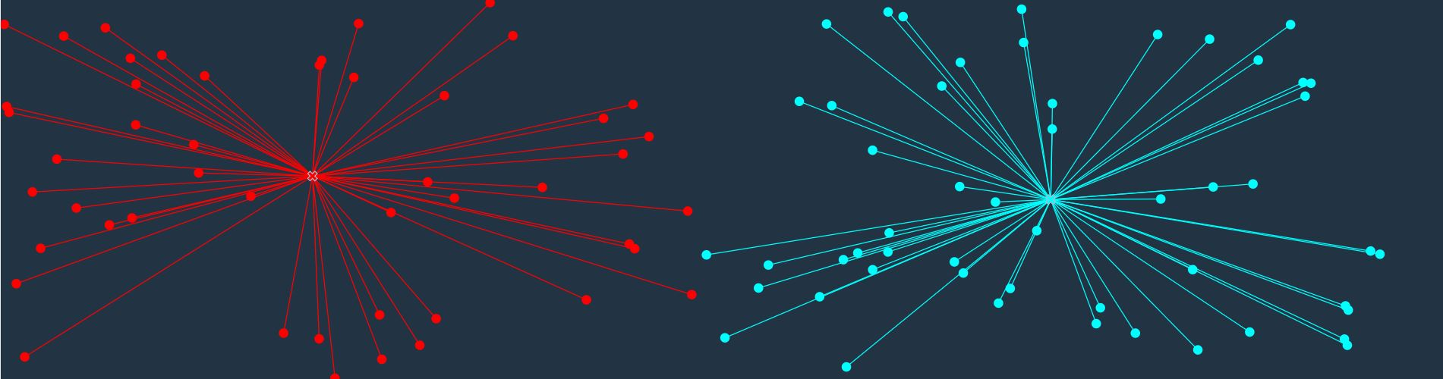

Step 2:

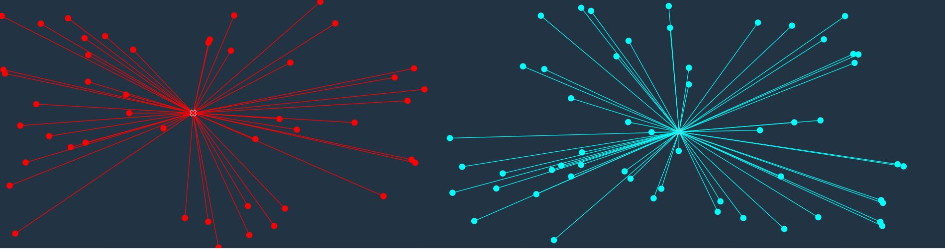

We can see in the last screenshot how the 2 furthest points from the red cluster moved to the other class which made the cyan cluster move a bit towards the red points.

**K-Nearest Neighbors (KNN):**

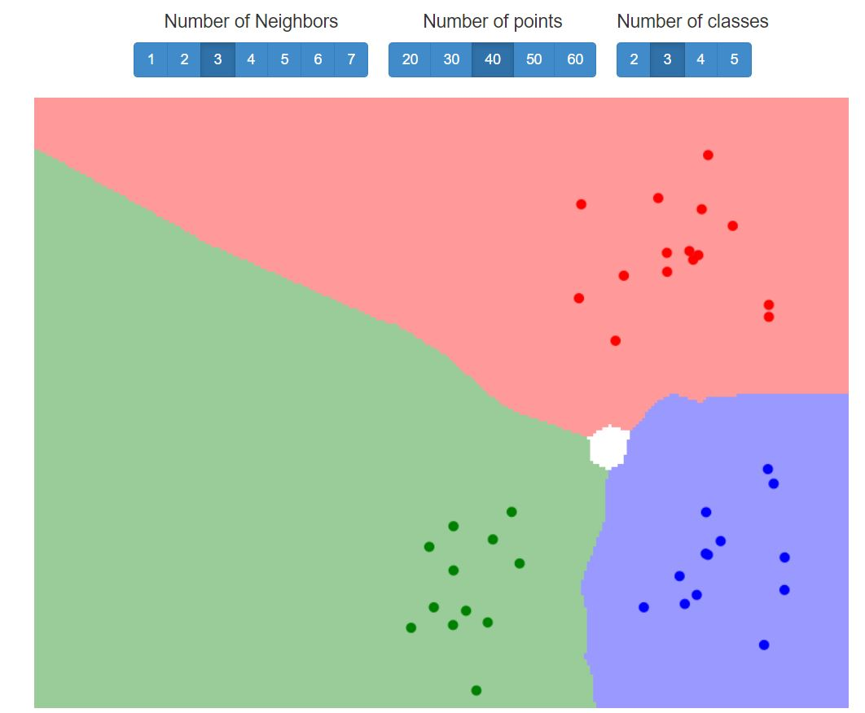

The white area are a “draw situation” in which the algorithm cannot decide to which class he should assign the points. That happens when there are at least two classes with the same number of votes for a certain point and no other class has more votes than them.

**Linear Discriminant Analysis (LDA):**

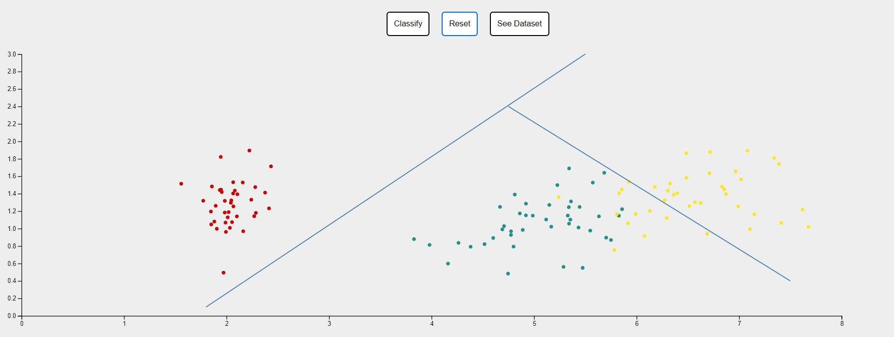

The above results are for the default dataset, however; when choosing to upload a dataset from the local machine, the user gets the following interface to clarify how the file should look with examples:

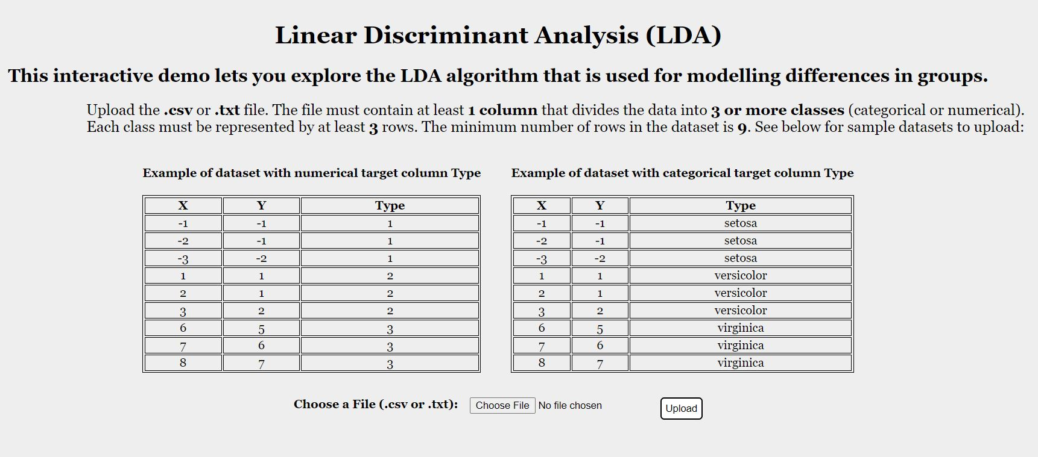

The user gets similar interfaces for all the algorithms with custom dataset option which helps the user with uploading his own data and running the chosen algorithm on it.

**Maximum Likelihood Estimation (MLE):**

Default dataset option:

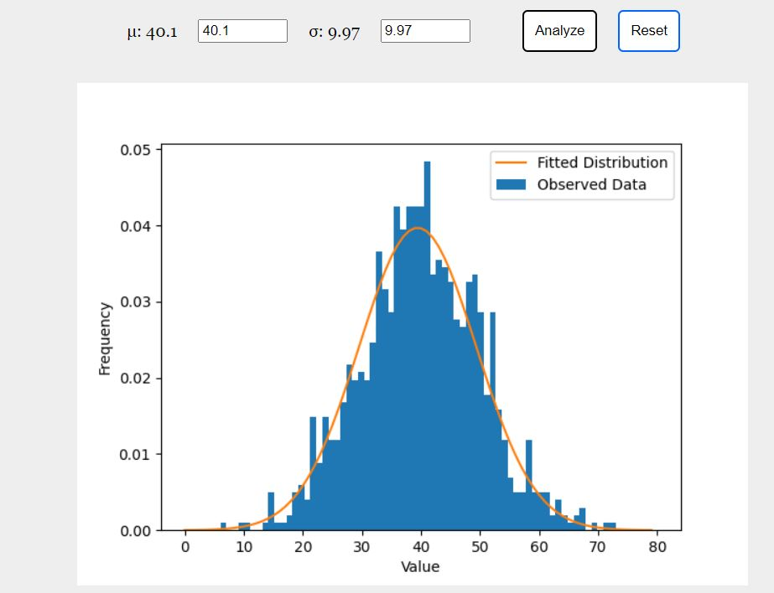

Custom dataset option:

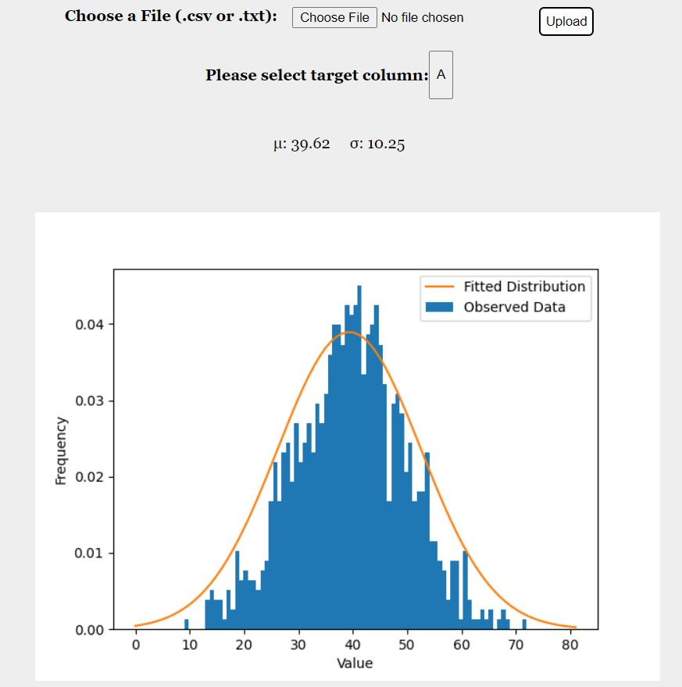

**Naïve Bayes Classifier:**

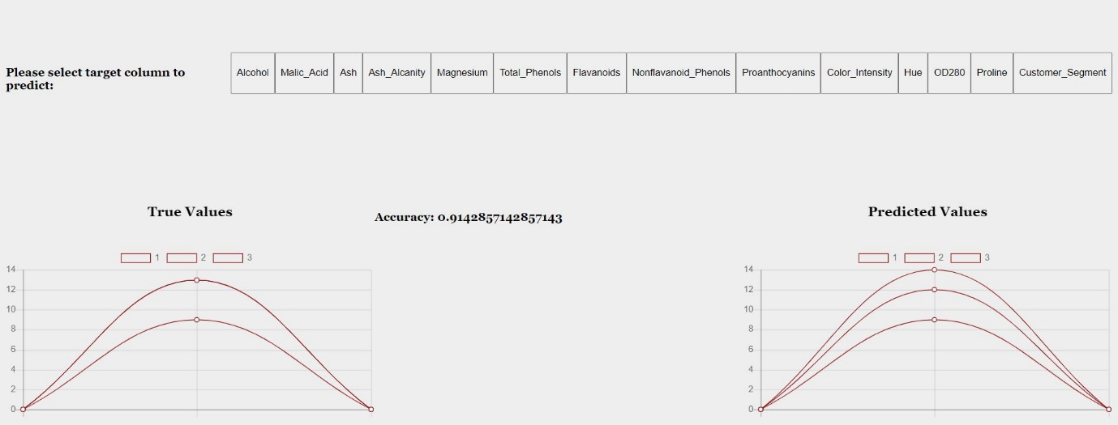

**Principal Component Analysis (PCA):**

2-Component solution:

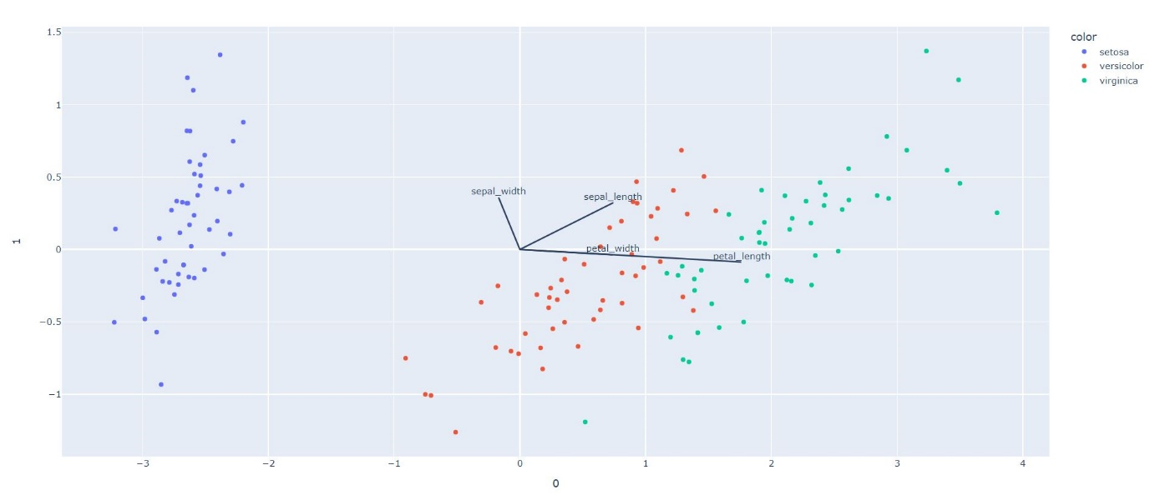

3-Component solution for the same dataset:

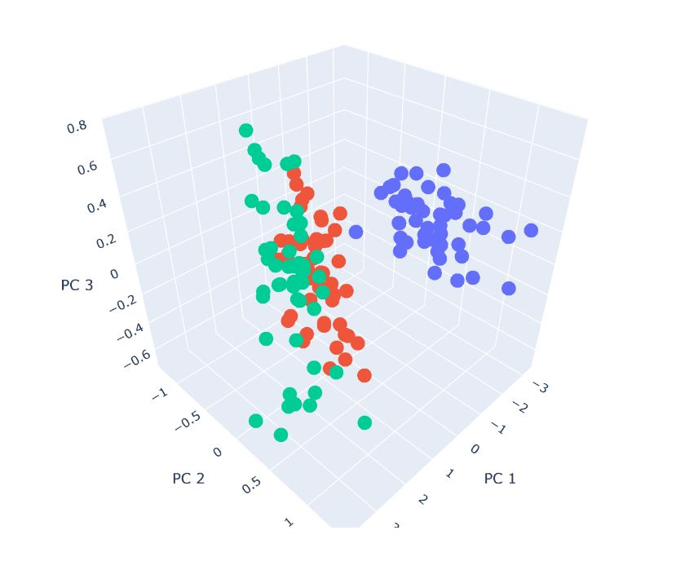

**Support-Vector Machine (SVM):**

Using the hyperparameter in the simulation, we can simulate both the hard-margin SVM and the soft-margin SVM as shown in the following screenshots:

Soft-Margin SVM:

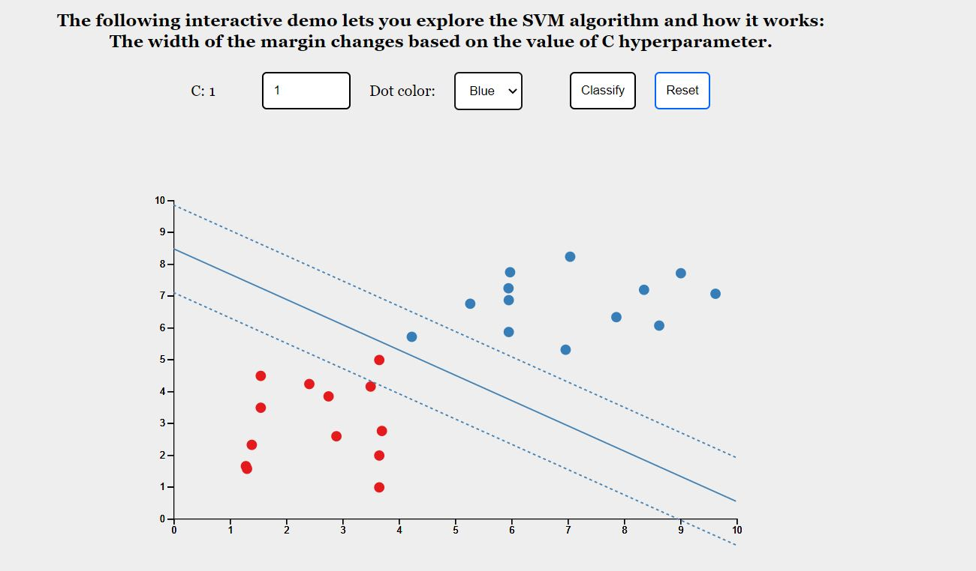

Hard-Margin SVM:

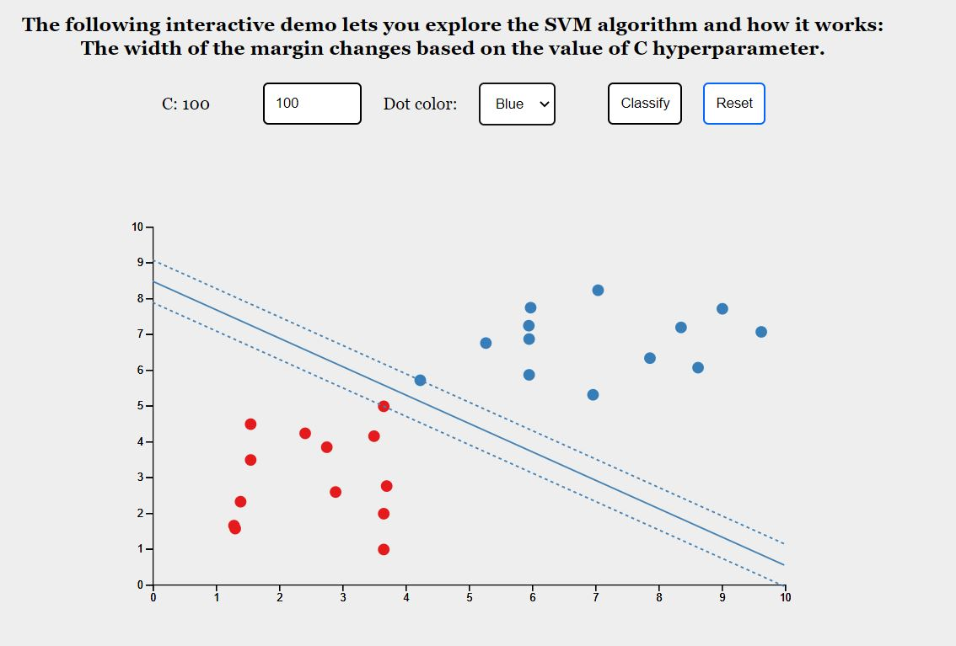

**My Learning**