**Build an 8 cat shop in shop**

Add your code (CSS & HTML only) to the relevant section of the HTML file (boilerplate).

Assets are attached.

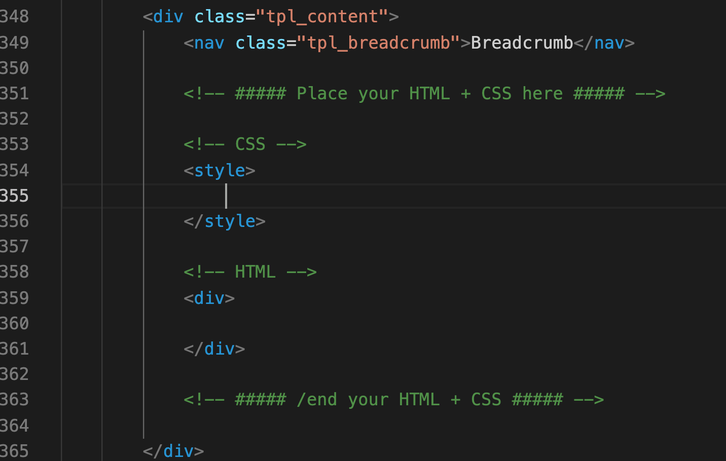

The following layout needs to be achieved in the boilerplate:

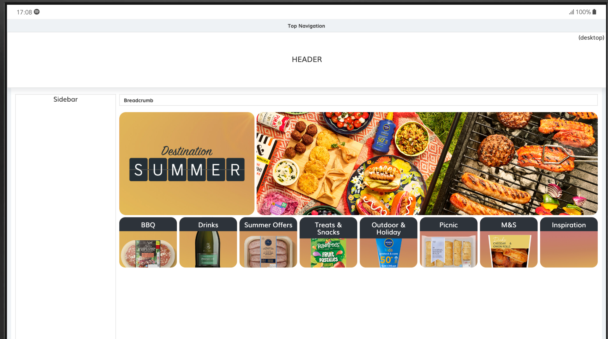

**GOOD LUCK!**